Workbook 7.7
From the Java Bootcamp Resources, launch Workbook 7.7.
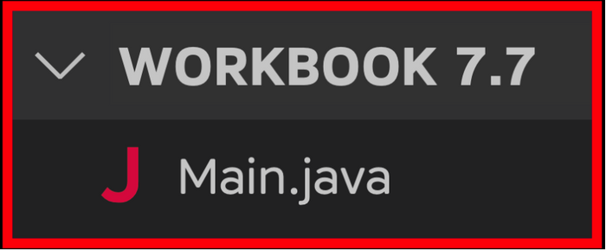
Task 1
Add a toString method to the Person class. Return a String that follows this template:
- "Name: " + <name field> + "\n" + "Nationality: " +
- <nationality field> + "\n" + "Date of Birth: " +
- <date of birth field> + "\n" + "Seat Number: " +
- <seat number field> + "\n" + "Passport: " +
- <toString of passport field> + "\n";
Task 2
Print your object. Java should internally call toString and print its return value.
- >>﻿: Name: Rayan Slim
- >>﻿: Nationality: Canadian
- >>﻿: Date of Birth: 01﻿/﻿01﻿/﻿1111
- >>﻿: Seat Number: 5
- >>﻿: Passport: [Rayan Slim, Canadian, 01﻿/﻿01﻿/﻿1111﻿]
Visualizing the Runtime
After you solve this workbook, I still recommend watching the video solution on Udemy.
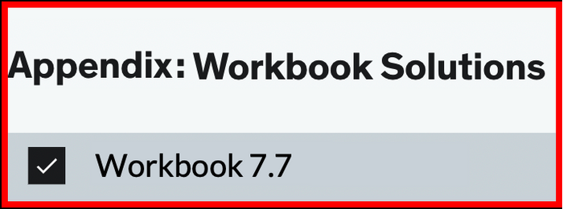
It will show you how to visualize the runtime using Visual Studio Code.

