Workbook 6.8
From the Java Bootcamp Resources, launch Workbook 6.8.
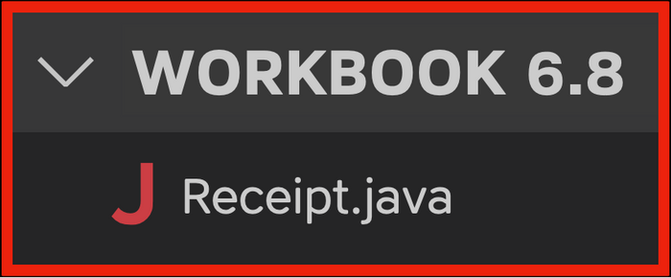
Task 1
Create an array that stores three apples you purchased:
- "Gala", "Granny Smith", "Macintosh"
Create another array that stores the price of each apple:
- 1.99, 1.49, 1.29
Task 2
Use a for loop to print each apple and its price.
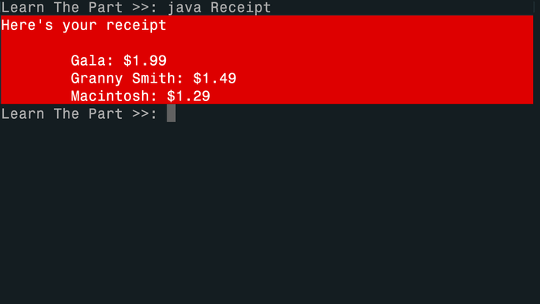
Visualizing the Runtime
After you solve this workbook, I still recommend watching the video solution on Udemy.
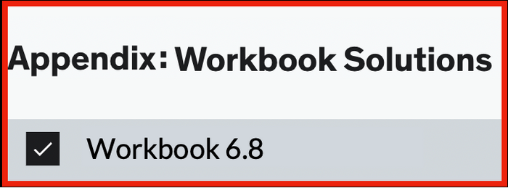
It will show you how to visualize the runtime using Visual Studio Code.

