Workbook 6.9
From the Java Bootcamp Resources, launch Workbook 6.9.
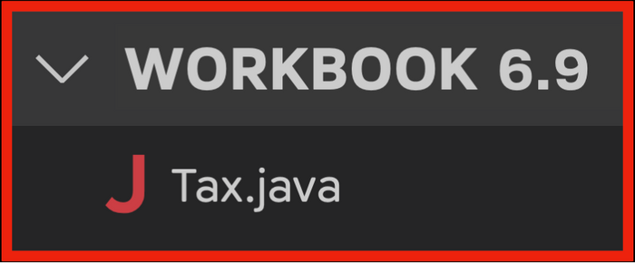
Task 1
The workbook contains an array that stores four prices.
- double[] price = {1.99, 2.99, 3.99, 4.99};
Create another array afterTax with the same length.
Task 2
Tax is 13%. Use a loop to update each element in afterTax to equal the original price + tax.
Task 3
Use Arrays.toString to print the arrays.
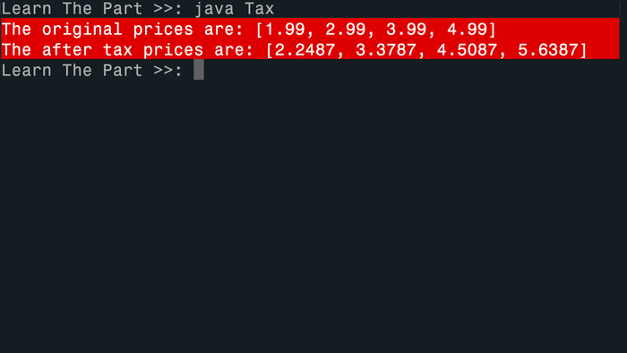
Visualizing the Runtime
After you solve this workbook, I still recommend watching the video solution on Udemy.
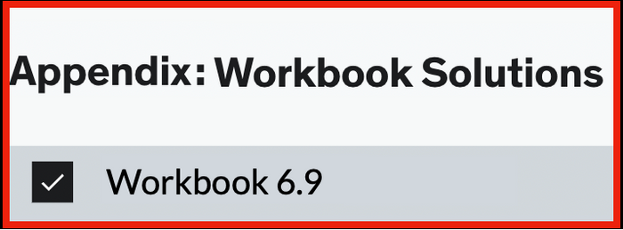
It will show you how to visualize the runtime using Visual Studio Code.

