Workbook 6.10
From the Java Bootcamp Resources, launch Workbook 6.10.
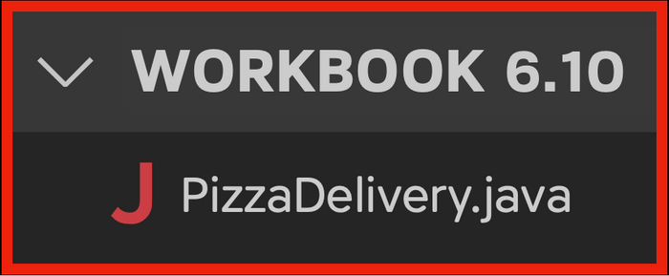
Task 1
Create a for loop that runs through the length of the toppings array. Inside the for loop:
1. Print each index number followed by a dot.

2. Beside the number, pick up the user's topping.

Store every topping the user inputs in the toppings array.
Task 2
Create a for loop that runs through the length of the array and prints each topping.
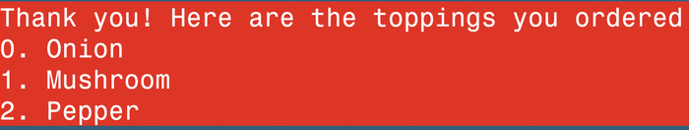
Visualizing the Runtime
After you solve this workbook, I still recommend watching the video solution on Udemy.
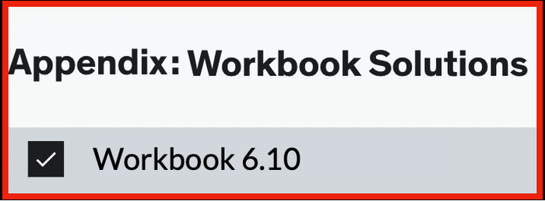
It will show you how to visualize the runtime using Visual Studio Code.

