Workbook 7.5
From the Java Bootcamp Resources, launch Workbook 7.5.
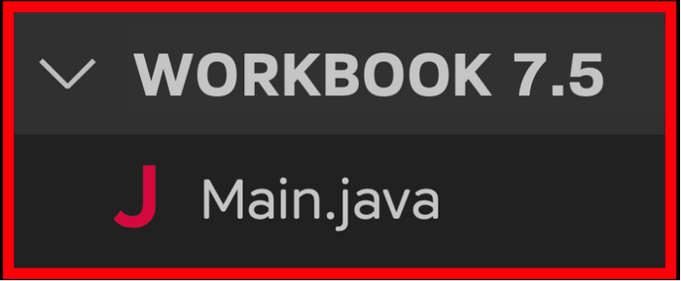
Task 1
Inside the Person class, define a function called applyPassport.
- /**
- * Function name: applyPassport
- *
- *
- *
- *
- */
The function returns a boolean and does not expect parameters.
- /**
- * Function name: applyPassport
- * @return (boolean) <----
- *
- *
- *
- */
This code randomly returns 0 or 1.
- int number = (int) (Math.random() * 2); //random int that can be 0 or 1.
Use this code to return true if the number equals 1, and false otherwise.
- /**
- * Function name: applyPassport
- * @return (boolean)
- *
- * Inside the function:
- * 1. Returns a random boolean of true or false.
- */
Do not use if - else to accomplish this task.
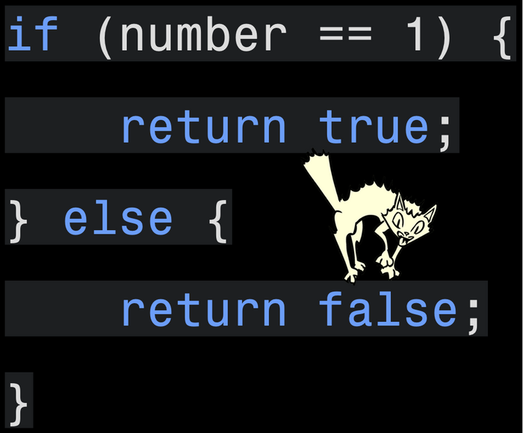
Task 2
Inside the Person class, define a function called chooseSeat.
- /**
- * Function name: chooseSeat
- *
- *
- *
- */
This code returns a random number between 1 and 11.
- (int) (Math.random() * 11 + 1);
chooseSeat must use this code to update this.seat with a random seat.
- /**
- * Function name: chooseSeat
- *
- * Inside the function:
- * 1. Sets this.seat to a random number between 1 -- 11.
- */
Task 3
Your starter project should contain one object.
- Person person = new Person("Rayan Slim", "Canadian", "01/01/1111", 5);
Call applyPassport from your object. If the function returns true:
- System.out.println("Congratulations " + person.getName() + ". Your passport was approved!");
Otherwise:
- System.out.println("We are sorry " + person.getName() + ". We cannot process your application.");
Example Output 1:
- >>﻿: Name: Rayan Slim
- >>﻿: Nationality: Canadian
- >>﻿: Date of Birth: 01﻿/﻿01﻿/﻿1111
- >>﻿: Seat Number: 10

- ﻿>>﻿: Congratulations Ray﻿an Slim. Your passport was﻿ approved!
Example Output 2:
- >>: Name: Rayan Slim
- >>: Nationality: Canadian
- >>: Date of Birth: 01﻿/﻿01﻿/﻿1111
- >>: Seat Number: 10

- >>: We are sorry Rayan S﻿lim. We cannot process you﻿r application.
Run your code multiple times. Each run should output a random result.
Task 4
Before printing the result, your object must invoke chooseSeat to "choose another seat".
Example Output 1
- >>﻿: Name: Rayan Slim
- >>﻿: Nationality: Canadian
- >>﻿: Date of Birth: 01﻿/﻿01﻿/﻿1111
- ﻿>>﻿: Seat Number: 8

- ﻿>>﻿: Congratulations Ray﻿an Slim. Your passport was﻿ approved!
Example Output 2
- >>﻿: Name: Rayan Slim
- >>﻿: Nationality: Canadian
- >>﻿: Date of Birth: 01﻿/﻿01﻿/﻿1111
- >>﻿: Se﻿at Number: 9

- >﻿>: We are sorry Rayan ﻿Slim. We cannot process yo﻿ur application.﻿
Example Output 3
- >>﻿: Name: Rayan Slim
- >>﻿: Nationality: Canadian
- >>﻿: Date of Birth: 01﻿/﻿01﻿/﻿1111
- ﻿>>﻿: Seat Number: 6

- >>﻿: Congratulations Ray﻿an Slim. Your passport was﻿ approved!
Keep testing the function. It should keep updating the person's seatNumber in the range 1 - 11.
Visualizing the Runtime
After you solve this workbook, I still recommend watching the video solution on Udemy.
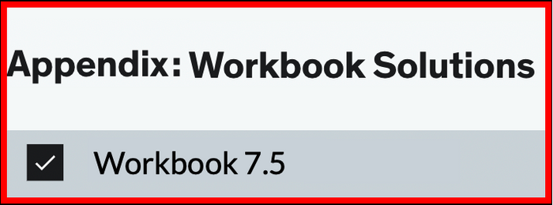
It will show you how to visualize the runtime using Visual Studio Code.

