Workbook 7.3
From the Java Bootcamp Resources, launch Workbook 7.3.
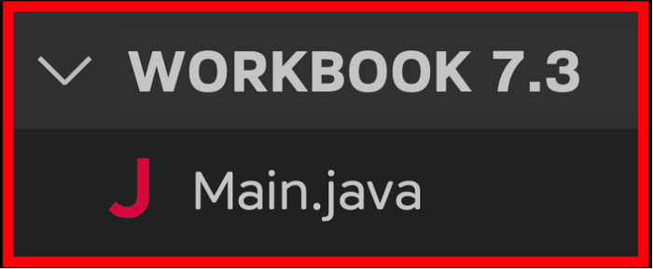
Task 1
Make each field private.
- private String name;
- private String nationality;
- private String dateOfBirth;
- private String[] passport;
- private int seatNumber;
Task 2
Add getters for name, nationality, dateOfBirth, and seatNumber.
Task 3
Call the getters from your println function and re-run the code.
- >>﻿: Name: Rayan Slim
- >>﻿: Nationality: Canadi﻿an
- >>: Date of Birth: 01/0﻿1/1111
- >>﻿: Seat Number: 5
Task 4
Add setters for name, nationality, dateOfBirth, and seatNumber.
Task 5
The person's current seat number is already taken. Update their seat number to 10 before printing the fields.
- >>﻿: Name: Rayan Slim
- >>﻿: Nationality: Canadian
- >>﻿: Date of Birth: 01﻿/﻿01﻿/﻿1111
- >>﻿: Seat Number: 10
Visualizing the Runtime
After you solve this workbook, I still recommend watching the video solution on Udemy.

It will show you how to visualize the runtime using Visual Studio Code.

Subscribe to our YouTube Channel and Unlock Valuable Content!

