Workbook 6.14
From the Java Bootcamp Resources, launch Workbook 6.14.
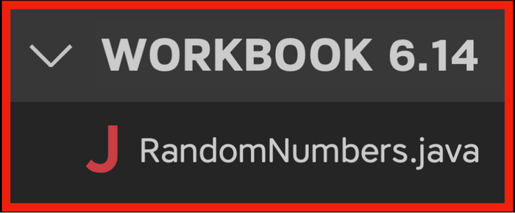
Task 1
This function returns a random number between 0 and 99. Copy it into your class.
- public static int randomNumber() {
- double randomNumber = Math.random()*100;
- return (int)randomNumber;
- }
Task 2
Write a function that prints the contents of an int[][] array.
- /**
- * Function name: print2DArray
- * @param array ( int[][] )
- *
- *
- *
- *
- *
- *
- */
The function uses a nested loop. The inner loop prints each row in one line.
- /**
- * Function name: print2DArray
- * @param array ( int[][] )
- *
- * Inside the function:
- * 1. Nested loop:
- * - Inner Loop: System.out.print(array[i][j] + " ");
- *
- */
After the inner loop runs to completion, print a new line.
- /**
- * Function name: print2DArray
- * @param array ( int[][] )
- *
- * Inside the function:
- * 1. Nested loop:
- * - Inner Loop: System.out.print(array[i][j] + " ");
- * - After the Inner Loop Completes: System.out.print("\n");
- */
Call print2DArray for the following array.
- int[][] array = {
- {48, 56, 56, 76, 0, 81, 51, 81, 99, 70},
- {38, 52, 73, 6, 10, 56, 1, 71, 47, 9},
- {85, 35, 47, 98, 91, 25, 69, 52, 2, 93}
- };
Result
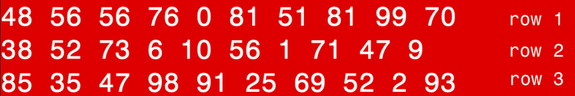
Delete the array if you achieve the result.
Task 3
Create a 2D array with 100 rows and 10 columns. Then call print2DArray.
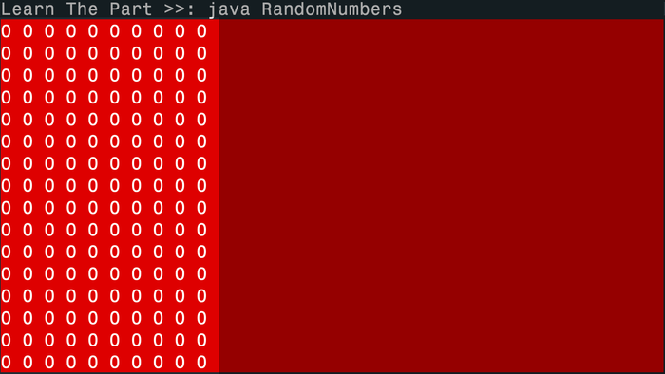
Task 4
Use a nested loop to populate the array with random numbers before calling: print2DArray.
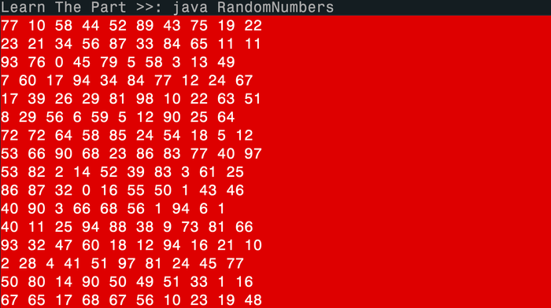
Visualizing the Runtime
After you solve this workbook, I still recommend watching the video solution on Udemy.
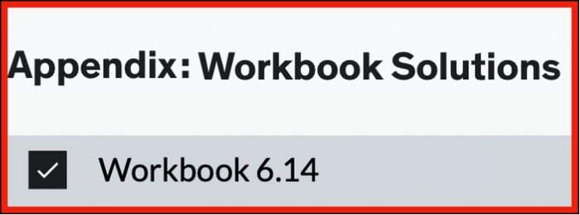
It will show you how to visualize the runtime using Visual Studio Code.

