Workbook 6.12
Workbook 6.12
From the Java Bootcamp Resources, launch Workbook 6.12.
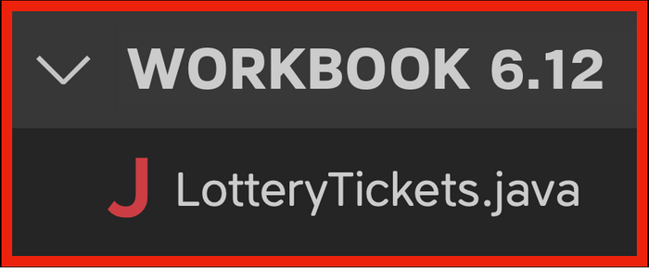
Task 1
You're feeling good about these lottery numbers.
- int[] ticket = {34, 43, 45, 65, 21, 54};
Use Arrays.copyOf() to copy all the elements of ticket into ticket2. Change the third value to 54.
- int[] ticket = {34, 43, 45, 65, 21, 54};
- int[] ticket2 = // 34 - 43 - 54 - 65 - 21 - 54.
Task 2
Create a function that prints the ticket numbers. Follow the steps below:
- /**
- * Function name -- printTicketNumbers
- * @param ticket ( int[] )
- *
- * Inside the function:
- * 1. Use a loop to print the numbers in one line.
- * System.out.print(ticket[i] + " ");
- *
- * 2. After the loop, print two new lines.
- * System.out.print("\n\n");
- *
- */
Call the function for each ticket:
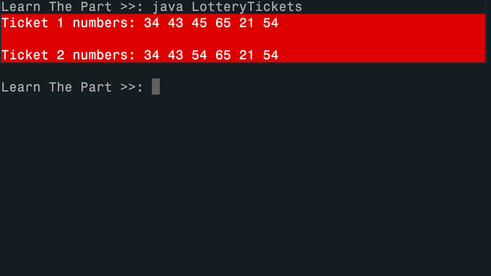
Visualizing the Runtime
After you solve this workbook, I still recommend watching the video solution on Udemy.
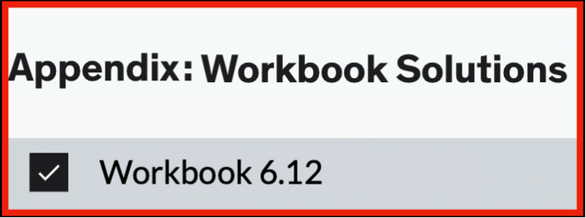
It will show you how to visualize the runtime using Visual Studio Code.
- Play
49. Roadmap
1min
- Play
50. The Boolean
2min
- Play
51. Comparison Operators
13min
- Play
52. Comparing Strings
3min
- Start
Quiz 7: Quiz 3.1
- Start
53. Workbook 3.1
1min
- Play
54. if - else statements
11min
- Start
Quiz 8: Quiz 3.2
- Start
55. Workbook 3.2
1min
- Play
56. if - else if - else
9min
- Start
Quiz 9: Quiz 3.3
- Start
57. Workbook 3.3
1min
- Start
58. Workbook 3.4
1min
- Play
59. Logical Operators
16min
- Start
Quiz 10: Quiz 3.4
- Start
Quiz 11: Quiz 3.5
- Start
60. Workbook 3.5
1min
- Play
61. Switch Statements
16min
- Start
62. Workbook 3.6
1min
- Play
63. Dealership Project
13min
- Start
64. Workbook 3.7
2min
- Start
65. Cheat Sheet
1min
- Play
115. Roadmap
1min
- Play
116. Arrays
5min
- Start
Quiz 24: Quiz
- Start
117. Workbook 6.1
1min
- Start
118. Preparing to Loop Arrays
1min
- Play
119. Looping Arrays
12min
- Start
Quiz 25: Quiz
- Start
120. Workbook 6.2
1min
- Start
121. Workbook 6.3
1min
- Start
122. Workbook 6.4
1min
- Start
123. Workbook 6.5
1min
- Start
124. Workbook 6.6
1min
- Start
125. Workbook 6.7
1min
- Start
126. Workbook 6.8
1min
- Play
127. Updating Arrays
9min
- Start
128. Workbook 6.9
1min
- Start
129. Workbook 6.10
1min
- Play
130. Reference Trap
12min
- Start
Quiz 26: Quiz
- Start
131. Workbook 6.11
2min
- Start
132. Workbook 6.12
1min
- Play
133. 2D Arrays
13min
- Start
Quiz 27: Quiz
- Start
134. Workbook 6.13
1min
- Play
135. Looping 2D Arrays
16min
- Start
Quiz 28: Quiz
- Start
136. Workbook 6.13 (Revisit)
1min
- Start
137. Workbook 6.14
1min
- Start
138. Javapedia
2min
- Play
139. Solution (Tasks 1 - 4)
10min
- Play
140. Solution (Task 5)
4min
- Start
141. Cheat Sheet
2min
- Start
142. Tic Tac Toe (Part 1)
1min
- Play
143. Solution 1
6min
- Start
144. Tic Tac Toe (Part 2)
3min
- Play
145. Solution 2
13min
- Start
146. Tic Tac Toe (Part 3)
5min
- Play
147. Solution 3
22min

