Workbook 7.2
From the Java Bootcamp Resources, launch Workbook 7.2.
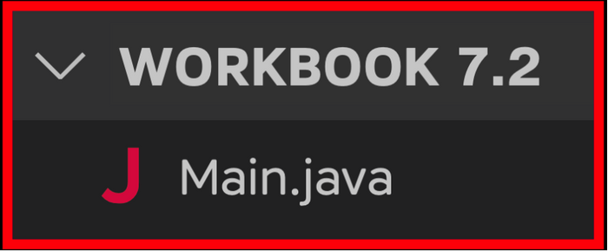
Task 1
Create a Person constructor that receives four parameters. For now, ignore passport.
- public Person(String name, String nationality, String dateOfBirth, int seatNumber) {
- // set fields equal to parameters here.
- }
Task 2
Remove the field updates from Part 1.
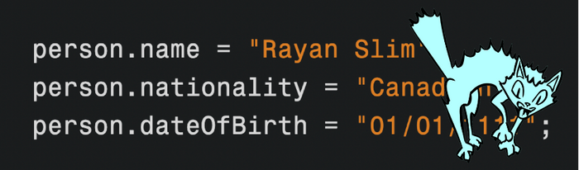
While a new object is being created, use the constructor to update its fields.
Task 3
Print every field as part of one String.
- System.out.println("Name: " + <name field> + "\n" + "Nationality: "
- + <nationality field> + "\n" + "Date of Birth: " + <birth date field> +
- "\n" + "Seat Number: " + <seat number field> + "\n");
- >>﻿: Name: Rayan Slim
- >>﻿: Nationality: Canadian
- >>﻿: Date of Birth: 01﻿/﻿01﻿/﻿1111
- >>﻿: Seat Number: 5
Visualizing the Runtime
After you solve this workbook, I still recommend watching the video solution on Udemy.

It will show you how to visualize the runtime using Visual Studio Code.

