Software Requirements Specification
For

ProConnect- AI- Powered Content Sharing Platform
Version 1.0

Prepared by

Team Number: D08

K Devi Aakash | CB.SC.U4AIE23311
N Tarun Reddy | CB.SC.U4AIE23320
V Sai Kartikeya | CB.SC.U4AIE23345
Y Sai Akhilesh | CB.SC.U4AIE23348

Project Manager:  Project Client: | Dr. T. Keerthika  D08
Course: | 22AIE311 SOFTWARE ENGINEERING
Date: | 09/02/2026

Amrita Vishwa Vidyapeetham
1 Introduction | 4
1.1 Document Purpose | 4
1.2 Product Scope | 4
1.3 Intended Audience and Document Overview | 4
1.4 Definitions, Acronyms and Abbreviations | 4
1.5 Document Conventions | 4
1.6 References and Acknowledgments | 5
2 Overall Description | 5
2.1 Product Overview | 5
2.2 Product Functionality | 5
2.3 Design and Implementation Constraints | 5
2.4 Assumptions and Dependencies | 6
3 Specific Requirements | 6
3.1 External Interface Requirements | 6
3.1.1 User Interfaces | 6
3.1.2 Hardware Interfaces | 6
3.1.3 Software Interfaces | 6
3.2 Functional Requirements | 7
3.3 Use Case Model | 7
3.3.1 Use Case #1 (Use case name and unique identifier – U1) | 7
3.3.2 Use Case #2 | 8
4 Other Non-functional Requirements | 8
4.1 Performance Requirements | 8
4.2 Safety and Security Requirements | 8
4.3 Software Quality Attributes | 9
5 Other Requirements | 9
Appendix A Activity Log | 9
Revisions
Version | Primary Author(s) | Description of Version | Date Completed
1.0 | K Aakash, N Tarun, V Sai Kartikeya, Y Sai Akhilesh | Incorporated AI-powered features and non-functional requirements. | 09/02/2026

- Introduction
ProConnect is a comprehensive content sharing platform designed for photographers, artists, and content creators to share, discover, and engage with visual content. This Software Requirements Specification (SRS) document provides a complete description of the ProConnect system, detailing its functional requirements, non-functional requirements, system features, and design constraints.

This document serves as a foundational reference for the development team, project stakeholders, and quality assurance testers. It outlines the system's capabilities including multi-provider authentication, AI-powered image analysis, social interaction features, real-time notifications, and comprehensive analytics dashboard.

1.1 Document Purpose

This Software Requirements Specification document describes the complete requirements for the ProConnect Content Sharing Platform, Version 1.0. It covers all aspects of the system including user authentication, image management, social features, AI-powered capabilities, and administrative functions.

The scope of this SRS encompasses the entire ProConnect ecosystem, including the Next.js frontend application, Express.js backend API, MongoDB database integration, Cloudinary media management, and Google Gemini AI services. This document serves as the primary reference for design, implementation, and testing activities.

1.2 Product Scope

ProConnect is a modern web-based Content sharing platform that enables users to upload, share, and discover visual content including images and short-form videos (Reels). The platform combines social networking features with AI-powered tools to enhance the user experience and content discoverability.

Key benefits of ProConnect include:
- Seamless content sharing with automatic AI-generated metadata (titles, descriptions, tags)
- Rich social interactions through likes, comments, follows, and direct messaging
- AI-powered chat assistant for personalized growth tips and content suggestions
- Comprehensive analytics dashboard for tracking engagement and performance
- TikTok-style Reels feature for short video content (up to 60 seconds)
- Responsive design supporting mobile, tablet, and desktop with dark/light themes

1.3 Intended Audience and Document Overview

- This document is intended for the following audiences:
- Development Team: To understand functional requirements and implement features accordingly
- Project Managers: To track project scope and ensure deliverables meet specifications
- Quality Assurance Testers: To develop test cases based on specified requirements
- Academic Evaluators: To assess project completeness and technical implementation.

1.4 Definitions, Acronyms and Abbreviations

Term | Definition
API | Application Programming Interface
CDN | Content Delivery Network
CRUD | Create, Read, Update, Delete operations
JWT | JSON Web Token - A compact, URL-safe means of representing claims
NoSQL | Non-relational database
OAuth | Open Authorization - An open standard for access delegation
Reel | Short-form video content (maximum 60 seconds)
REST | Representational State Transfer
SRS | Software Requirements Specification
SSR | Server-Side Rendering
UI/UX | User Interface / User Experience

1.5 Document Conventions

- This document follows IEEE formatting requirements and uses the following conventions:
- Arial font size 11-12 throughout the document
- Bold text for section headings and emphasis
- Italics for comments and notes
- Functional requirements are prefixed with 'F' (e.g., F1, F2)
- Use cases are prefixed with 'U' (e.g., U1, U2)
- Tables are used for structured data representation

1.6 References and Acknowledgments

- IEEE Std 830-1998 - IEEE Recommended Practice for Software Requirements Specifications
- Next.js Documentation: https://nextjs.org/docs
- MongoDB Documentation: https://docs.mongodb.com
- Cloudinary API Reference: https://cloudinary.com/documentation
- Google Gemini AI Documentation: https://ai.google.dev/docs
- NextAuth.js Documentation: https://next-auth.js.org
- Tailwind CSS Documentation: https://tailwindcss.com/docs

Overall Description

2.1 Product Overview

ProConnect is a new, self-contained web application designed as a comprehensive content sharing platform. It combines the visual content sharing capabilities of platforms like Instagram and Pinterest with AI-powered features for enhanced user experience. The system follows a modern client-server architecture with the following major components:

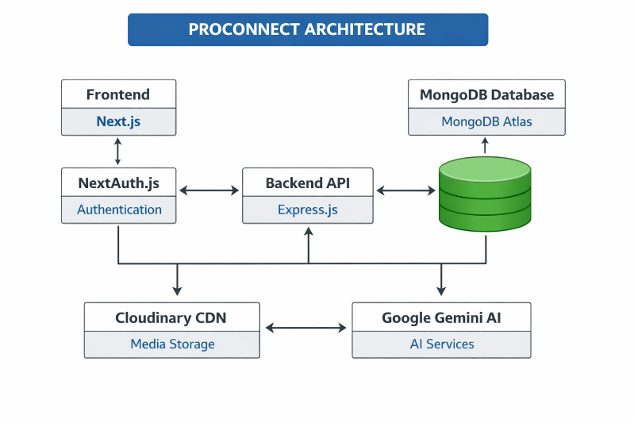
System Architecture:

The frontend communicates with the backend via RESTful APIs. Authentication is handled through NextAuth.js with JWT tokens. Media files are stored and optimized through Cloudinary CDN. AI features are powered by Google Gemini API for image analysis, chat assistance, and content moderation.

2.2 Product Functionality

- Major functions of the ProConnect platform:
- User Authentication (Email/Password and Google OAuth)
- Image Upload with AI-generated metadata (title, description, tags, category)
- Reels/Short Video Upload (up to 60 seconds)
- Social Interactions (Likes, Comments, Follows, Favourites)
- Collection Management for organizing images
- Search and Discovery with filters
- Direct Messaging between users
- Real-time Notifications
- AI Chat Assistant for personalized assistance
- AI Content Moderation for comments
- User Dashboard with Analytics
- Admin Panel for platform management

2.3 Design and Implementation Constraints

The following constraints apply to the development and implementation of ProConnect:
Technology Constraints:
- Frontend must be built using Next.js 15 with React 19
- Backend must use Express.js with Node.js 18+
- Database must be MongoDB (NoSQL)
- Styling must use Tailwind CSS with CSS variables for theming
External Service Constraints:
- Image/Video storage must use Cloudinary CDN
- AI features must use Google Gemini API
- Authentication must support both credentials and Google OAuth
Content Constraints:
- Maximum image size: 10MB
- Maximum video duration: 60 seconds
- Maximum video size: 100MB
- Supported image formats: JPEG, PNG, WebP, GIF

2.4 Assumptions and Dependencies

- Assumptions:
  - Users have access to modern web browsers (Chrome, Firefox, Edge)
  - Users have stable internet connectivity for media uploads
  - Users consent to AI-powered content analysis
  - JavaScript is enabled in user browsers
- Dependencies:
  - Cloudinary API for image/video storage and optimization
  - MongoDB Atlas for cloud database hosting
  - Google Gemini API for AI features (captioning, chat, moderation)
  - Google OAuth for social authentication
  - Nodemailer with SMTP for email notifications
- Specific Requirements

3.1 External Interface Requirements

3.1.1 User Interfaces

The ProConnect user interface provides the following screens:
- Landing Page: Hero section, features, and benefits for guests
- Login/Register: Authentication forms with OAuth options
- Dashboard: Personal stats, trending content, activity feed
- Feed: Infinite scroll image grid with category filters
- Image Detail: Full image view with metadata, comments, like/save actions
- Profile: User info, images, collections, followers/following tabs
- Upload Image: Multi-step wizard with AI assistance
- Reels: Vertical scrolling video player
- Messages: Conversation list and chat interface
- Settings: Profile, account, and security settings
- Admin Dashboard: Platform management interface (admin only)

3.1.2 Hardware Interfaces

- ProConnect is a web-based application and does not directly interface with specific hardware. However, it utilizes browser APIs to access:
  - File System: HTML5 File API for image/video uploads.
  - Camera: HTML5 Media Capture API for profile pictures.

3.1.3 Software Interfaces

External System | Interface Type | Purpose
MongoDB Atlas | Mongoose ODM | Data persistence
Cloudinary | REST API | Image/video CDN
Google OAuth | OAuth 2.0 | Social authentication
Google Gemini | REST API | AI image analysis, chat
Perspective API | REST API | Content moderation
Nodemailer | SMTP | Email notifications

3.2 Functional Requirements

Authentication Requirements:
F1: The system shall allow user registration with email and password
F2: The system shall validate email format and uniqueness
F3: The system shall enforce password minimum length of 6 characters
F4: The system shall hash passwords using bcrypt before storage
F5: The system shall support Google OAuth authentication
F6: The system shall issue JWT tokens upon successful login
F7: The system shall allow password reset via email

Image Management Requirements:
F8: The system shall support drag-and-drop image upload
F9: The system shall accept JPEG, PNG, WebP, GIF formats
F10: The system shall limit image size to 10MB
F11: The system shall generate AI metadata (title, description, tags, category)
F12: The system shall allow manual editing of image metadata
F13: The system shall support image visibility settings (public/private/followers)
F14: The system shall support image deletion with Cloudinary cleanup

Reels Requirements:
F15: The system shall support video upload up to 60 seconds
F16: The system shall generate video thumbnails automatically
F17: The system shall support reel likes, comments, and saves
F18: The system shall display reels in vertical scrolling format

Social Interaction Requirements:
F19: The system shall allow users to like and unlike images
F20: The system shall allow users to comment on images
F21: The system shall moderate comments using AI
F22: The system shall allow users to follow/unfollow other users
F23: The system shall allow users to save images to favorites
F24: The system shall send notifications for social interactions

Collection Requirements:
F25: The system shall allow creation of image collections
F26: The system shall allow adding/removing images from collections
F27: The system shall support collection visibility (public/private)

AI Features Requirements:
F28: The system shall provide AI chat assistant for user queries
F29: The system shall suggest captions and growth tips via AI
F30: The system shall detect hate speech and spam in comments
F31: The system shall generate AI reports for administrators

Messaging Requirements:
F32: The system shall allow sending direct messages between users
F33: The system shall display conversation threads
F34: The system shall show unread message count

Admin Requirements:
F35: The system shall provide admin dashboard with platform statistics
F36: The system shall allow admin to ban/unban users
F37: The system shall allow admin to view and manage reported content
3.3 Use Case Model

The following use case diagram represents the ProConnect system:
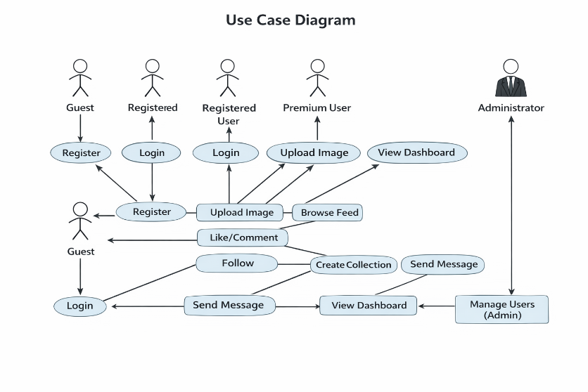

3.3.1 Use Case #1: User Registration (U1)

Author | K Aakash
Purpose | Allow new users to create an account on Pixora platform
Requirements Traceability | F1, F2, F3, F4, F5
Priority | High
Preconditions | User is not logged in and has a valid email address
Post conditions | User account is created and stored in database; User receives verification email
Actors | Guest User
Extends | None
Includes | None
Notes/Issues | Google OAuth registration creates account automatically

Flow of Events:

- Basic Flow:
Actor's Action | System's Response
1. User navigates to registration page | 1. System displays registration form
2. User enters full name, email, username, password | 2. System validates input in real-time
3. User clicks Register button | 3. System hashes password, creates account, sends verification email
4. User receives success message | 4. System redirects to login page

- Alternative Flow (Google OAuth):
Actor's Action | System's Response
1. User clicks 'Continue with Google' | 1. System redirects to Google OAuth
2. User authorizes with Google account | 2. System receives user info from Google
3. User is redirected back | 3. System creates account if new, logs in user

3. Exceptions:
Actor's Action | System's Response
User enters existing email/username | System displays 'Email/Username already exists' error
User enters password < 6 characters | System displays 'Password must be at least 6 characters' error

3.3.2 Use Case #2: Upload Image (U2)

Author | N Tarun
Purpose | Allow users to upload images with AI-generated metadata
Requirements Traceability | F8, F9, F10, F11, F12, F13, F14
Priority | High
Preconditions | User is logged in; User has image file ready
Post conditions | Image is stored in Cloudinary; Metadata saved to database; Image appears in user's profile
Actors | Registered User, System (AI)
Extends | None
Includes | AI Image Analysis (automatic)

Flow of Events:

1. Basic Flow:
Actor's Action | System's Response
1. User clicks Upload button | 1. System displays upload interface
2. User drags/drops or selects image file | 2. System validates file type and size, shows preview
3. User clicks 'Generate with AI' | 3. System sends image to Gemini AI, receives metadata
4. User reviews/edits metadata | 4. System displays editable fields with AI suggestions
5. User sets visibility and clicks Publish | 5. System uploads to Cloudinary, saves to DB, shows success

3.3.3 Use Case #3: Like Image (U3)

Author | V Sai Karthikeya
Purpose | Allow users to express appreciation for images
Requirements Traceability | F19, F24
Priority | High
Preconditions | User is logged in; Image exists and is visible to user
Post conditions | Like is recorded; Like count incremented; Notification sent to image owner
Actors | Registered User

Flow of Events:

1. Basic Flow:
Actor's Action | System's Response
1. User clicks heart icon on image | 1. System records like, updates count, fills heart icon
 | 2. System sends notification to image owner

3.3.4 Use Case #4: Follow User (U4)

Author | Y Sai Akhilesh
Purpose | Allow users to subscribe to another user's content
Requirements Traceability | F22, F24
Priority | High
Preconditions | User is logged in; Target user exists; User is not already following
Post conditions | Follow relationship created; Follower/following counts updated; Notification sent
Actors | Registered User

Flow of Events:

1. Basic Flow:

Actor's Action | System's Response
1. User clicks Follow button on profile | 1. System creates follow record
 | 2. System updates follower/following counts
 | 3. System changes button to 'Following'
 | 4. System sends notification to followed user

3.3.5 Use Case #5: AI Chat Assistant (U5)

Author | Y Sai Akhilesh
Purpose | Provide AI-powered assistance for content creation and platform guidance
Requirements Traceability | F28, F29
Priority | Medium
Preconditions | User is logged in; Gemini AI API is available
Post conditions | User receives personalized AI response
Actors | Registered User, System (Gemini AI)

Flow of Events:

1. Basic Flow:
Actor's Action | System's Response
1. User clicks AI Assistant button | 1. System opens chat interface
2. User types question or request | 2. System gathers user context (stats, recent posts)
 | 3. System sends query to Gemini AI with context
3. User views AI response | 4. System displays personalized response

Non-functional Requirements

4.1 Performance Requirements

Requirement | Target
Page Load Time | < 3 seconds on 3G network
API Response Time | < 500ms for standard requests
Image Upload Time | < 10 seconds for 10MB file
Search Results | < 1 second
Concurrent Users | Support 1000+ simultaneous users
AI Analysis Time | < 5 seconds per image
CDN Delivery | < 100ms from edge locations

4.2 Safety and Security Requirements

Data Protection:
- All communications shall use HTTPS with TLS 1.3
- Passwords shall be hashed using bcrypt with 10+ rounds
- JWTs shall expire after reasonable time period
- Session tokens shall be secure and http Only

Input Validation:
- All user inputs shall be validated and sanitized
- File uploads shall be validated for type and size
- SQL/NoSQL injection shall be prevented
- XSS attacks shall be prevented through content sanitization

Access Control:
- API endpoints shall validate authentication tokens
- Admin functions shall require elevated privileges
- Rate limiting shall be implemented to prevent abuse
- CORS shall be configured to allow only trusted origins

Content Safety:
- AI content moderation shall filter hate speech and spam
- Users shall be able to report inappropriate content
- Admins shall review and act on reported content

4.3 Software Quality Attributes

4.3.1 Reliability

The system shall maintain 99.5% uptime with a Mean Time Between Failures (MTBF) of greater than 720 hours. This is achieved through:
- Cloud-based hosting with auto-scaling (Vercel for frontend)
- MongoDB Atlas with automated backups and failover
- Cloudinary CDN with global edge distribution
- Error logging and monitoring for proactive issue detection

4.3.2 Usability

The system shall provide an intuitive user experience with:
- Responsive design supporting screen sizes from 320px to 4K
- Dark and light theme support with automatic system detection
- Loading skeletons and feedback for all user actions
- Toast notifications for success/error states
- AI assistance to simplify content creation (auto-captioning)
- Clear navigation with consistent design language

4.3.3 Maintainability

The system shall be designed for easy maintenance through:
- Modular architecture with separation of concerns (controllers, models, routes)
- Component-based frontend with reusable UI components
- RESTful API design with clear endpoint conventions
- Version control using Git with conventional commits
- Other Requirements

Legal and Compliance:
- Users must accept Terms of Service before registration
- Privacy Policy clearly discloses data collection and usage
- Users retain rights to their uploaded content
- Copyright reporting mechanism for violations

Internationalization:
- English as primary language
- UTF-8 encoding for all text content
- Date/time displayed in user's local time zone

Appendix A - Activity Log

Date | Duration | Activity | Members Present
<Date> | <Duration> | Project Planning and Requirements Gathering | All
<Date> | <Duration> | Backend Development - User Authentication | <Names>
<Date> | <Duration> | Frontend Development - UI Components | <Names>
<Date> | <Duration> | AI Integration - Gemini API | <Names>
<Date> | <Duration> | SRS Document Preparation | All

Team Member Contributions:

Member | Sections Contributed | Use Cases
K Aakash | Section 1, 2, Overall Review | U1, U2
N Tarun | Section 3.1, 3.2, 3.3 | U3, U4
V Sai Kartikeya | Section 4 | U7, U8
Y Sai Akhilesh | Section 5, Appendix | U9, U10

