PROJECT DOCUMENTATION
StudyAI – AI Powered Study Companion
Groq Llama 3.3 70B – Powered Learning Assistant
Team ID | 6a3a53b6298c58cbca6bc425
Team Lead / Developer | Akkala Sai Narayana (Solo Project)
Team Members | Akkala Sai Narayana — B.Tech CSE (Data Science)
Submission Date | 3 July 2026
Repository | https://github.com/saiakkala2006/StudyAI-Smart-Study-Companion
Live Frontend | https://study-ai-smart-study-companion.vercel.app/
Live Backend | https://studyai-smart-study-companion-backend.onrender.com

Table of Contents
1. Brainstorming & Idea Prioritization
2. Define Problem Statements
3. Empathy Map
4. Customer Journey Map
5. Data Flow Diagram
6. Solution Requirements
7. Technology Stack
8. Problem-Solution Fit Canvas
9. Proposed Solution
10. Solution Architecture
11. Initial Project Planning — Product Backlog & Sprint Schedule
12. Code-Layout, Readability and Reusability
13. Coding & Solution
14. No. of Functional Features Included in the Solution
15. Performance Testing
16. Project Executable Files
17. Full Project Documentation
18. Communication
19. Demonstration of Proposed Features
20. Project Demo Planning
21. Scalability & Future Plan
22. Solo Contribution & Presentation Plan

1. Brainstorming & Idea Prioritization
Date | 20 June 2026
Team ID | 6a3a53b6298c58cbca6bc425
Project Name | StudyAI – AI Powered Study Companion
Maximum Marks | 3 Marks

Step 1: Brainstorm and Idea Listing
As a solo developer, ideas were listed and self-evaluated for feasibility before implementation began.
S.No | Idea / Suggestion | Category | Group No.
1 | Allow students to upload PDF / DOCX study material for automatic text extraction | Core Feature | 1
2 | AI-generated concise summary (key concepts, structured notes) from uploaded material | Core Feature | 1
3 | Automatic flashcard generation (Q&A pairs) with topic and difficulty tagging | Core Feature | 1
4 | AI quiz generation (MCQ / True-False / Short Answer) with automatic evaluation | Assessment | 2
5 | Adaptive 7-day personalized study schedule generator | Planning | 3
6 | Performance analytics dashboard — scores, weak topics, progress over time | Assessment | 2
7 | Cloud-based persistence (Firebase Storage for files, Firestore for structured data) | Reliability | 4
8 | Fully responsive React + Tailwind interface usable on mobile and desktop | Reliability | 4

Step 2: Idea Prioritization
Group No. | Final Idea | Feasibility | Importance | Priority Selected
1 | Core content pipeline: Upload → Text Extraction → AI Summary + Flashcards (React + Flask + Groq) | High | High | Yes
2 | Assessment layer: AI quiz generation & evaluation with performance analytics | Medium | High | Yes
3 | Adaptive study schedule generator (7-day personalized plan) | High | Medium | Yes
4 | Firebase Firestore + Storage as the persistence and file layer | High | Medium | Yes

2. Define Problem Statements
Date | 21 June 2026
Team ID | 6a3a53b6298c58cbca6bc425
Project Name | StudyAI – AI Powered Study Companion
Maximum Marks | 3 Marks

Customer Problem Statement (CPS) template — used to understand the target learner's point of view before designing StudyAI.
PS | I am (Customer) | I'm trying to | But | Because | Which makes me feel
PS-1 | A student with a pile of PDF/DOCX lecture notes | condense material into something revisable quickly | manually summarizing takes hours | notes are long and unstructured | overwhelmed before exams
PS-2 | A student preparing for a test | self-test with quiz questions from my own material | writing my own quiz questions is slow and biased | I don't know what I don't know | underprepared and anxious
PS-3 | A student juggling multiple subjects | plan revision across days efficiently | generic planners aren't tailored to what I actually uploaded | study planning tools are generic, not content-aware | directionless about what to study when

3. Empathy Map
Date | 21 June 2026
Team ID | 6a3a53b6298c58cbca6bc425
Project Name | StudyAI – AI Powered Study Companion
Maximum Marks | 4 Marks

Empathy map for StudyAI's primary persona — a self-directed student — built from the problem statements above.
SAYS | THINKS
• "I don't have time to rewrite all these notes by hand."  • "I just want the key points, not the whole chapter." | • "Am I actually retaining this, or just re-reading it?"  • "Is there a faster way to test myself before the exam?"
PERSONA: "Priya" — Undergraduate Student / Self-Directed Learner
DOES | FEELS
• Uploads lecture PDFs/DOCX right before an exam  • Writes her own flashcards by hand on paper  • Rewatches recorded lectures to catch what she missed | • Anxious in the days before an exam  • Overwhelmed by long, unstructured PDFs  • Relieved once a topic is broken into bite-sized pieces

4. Customer Journey Map
Date | 22 June 2026
Team ID | 6a3a53b6298c58cbca6bc425
Project Name | StudyAI – AI Powered Study Companion
Maximum Marks | 2 Marks

Phase of Journey | Stage 1: Discovery | Stage 2: Active Use | Stage 3: Mastery / Retention
Actions | Lands on the StudyAI home page and uploads a first PDF/DOCX | Generates a summary, flashcards, and a quiz from the material; takes the quiz | Returns before every exam; checks analytics and follows the adaptive schedule
Touchpoint | React landing / upload page | Summary, Flashcards, Quiz pages | Schedule & Analytics dashboard
Customer Thought | "Can this actually save me time?" | "This is much faster than doing it myself." | "I know exactly what's weak and what to revise."
Customer Feeling | Curious, slightly skeptical | Engaged, relieved | Confident, in control

5. Data Flow Diagram
Date | 22 June 2026
Team ID | 6a3a53b6298c58cbca6bc425
Project Name | StudyAI – AI Powered Study Companion
Maximum Marks | 2 Marks

The diagram below shows how a request moves from the React client through the Flask backend to the Groq API and Firebase, and how AI-generated outputs are returned to the UI.
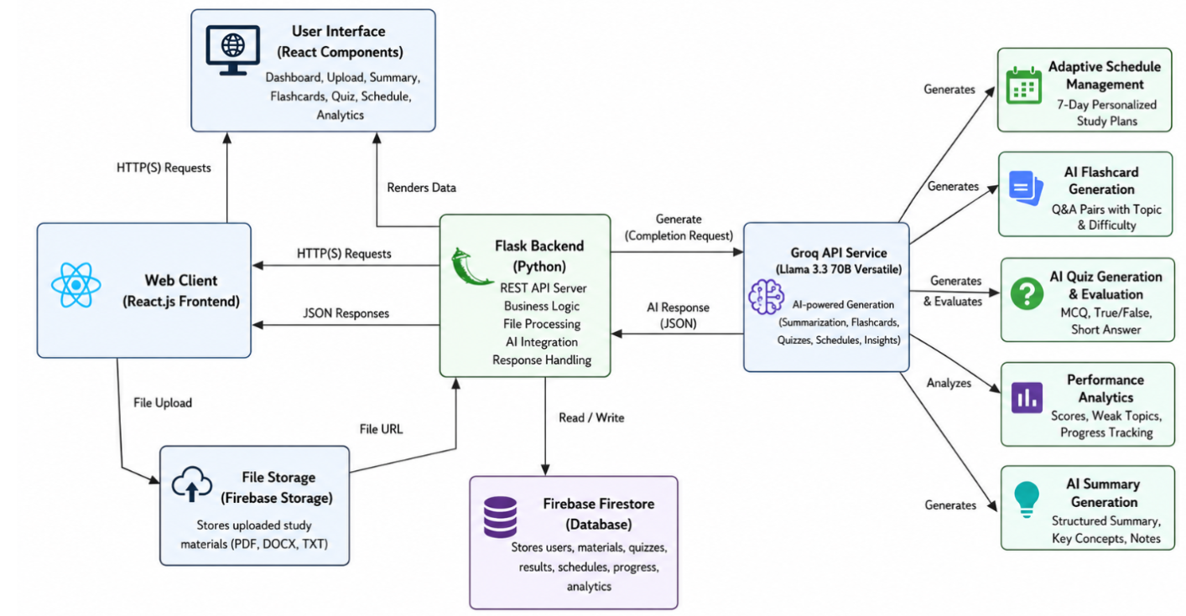

S.No | DFD Element | Description | Priority
1 | External Entity | The student, interacting through the React web client (browser) | High
2 | Process — Web Client | React.js + Vite frontend; sends HTTP(S) requests, renders JSON responses | High
3 | Process — File Upload | PDF/DOCX/TXT files are uploaded from the client to Firebase Storage | High
4 | Process — Flask Backend | REST API server: routing, business logic, file processing, AI integration, response handling | High
5 | External Interface | Groq API (Llama 3.3 70B Versatile) — generates summaries, flashcards, quizzes, schedules, and analyses performance | High
6 | Data Store | Firebase Firestore — stores users, materials, quizzes, results, schedules, progress, and analytics | High
7 | Data Store | Firebase Storage — stores the raw uploaded study material files | Medium

6. Solution Requirements
Date | 23 June 2026
Team ID | 6a3a53b6298c58cbca6bc425
Project Name | StudyAI – AI Powered Study Companion
Maximum Marks | 4 Marks

Step 1: Functional Requirements (FR)
S.No | Functional Requirement | Description | Priority
1 | Material Upload | Students can upload PDF, DOCX, or TXT study material through the React client to Firebase Storage | High
2 | AI Summary Generation | Backend sends extracted text to Groq (Llama 3.3 70B) and returns a structured summary with key concepts and notes | High
3 | AI Flashcard Generation | Generates Q&A flashcard pairs tagged by topic and difficulty from the uploaded material | High
4 | AI Quiz Generation & Evaluation | Generates MCQ, True/False, and Short Answer questions and evaluates submitted answers | High
5 | Adaptive Schedule Management | Produces a 7-day personalized study plan based on the uploaded content and quiz performance | Medium
6 | Performance Analytics | Tracks scores, identifies weak topics, and visualizes progress over time | Medium
7 | Data Persistence | All users, materials, quizzes, results, schedules and analytics are stored in Firebase Firestore | High

Step 2: Non-Functional Requirements (NFR)
S.No | NFR Category | Requirement Description | Target / Acceptance Criteria
1 | Performance | Groq's Llama 3.3 70B Versatile model is used for low-latency generation of summaries, flashcards and quizzes | AI response returned within a few seconds under normal API load
2 | Scalability | Stateless Flask REST API with Firebase-managed storage/DB, decoupled frontend and backend deployments | Frontend and backend can scale independently on Vercel / Render
3 | Security & Data Privacy | GROQ_API_KEY is loaded from a local .env file, excluded via .gitignore; Firebase manages access to stored data | API key never committed to source control
4 | Reliability & Availability | Flask backend served via Gunicorn on Render; React frontend served via Vercel's CDN | Both services independently deployable and restartable
5 | Usability & Accessibility | Fully responsive Tailwind CSS interface across upload, summary, flashcard, quiz, schedule and analytics pages | Verified on desktop and mobile viewports
6 | Maintainability | Backend organized into routes/ and services/ so each AI capability is isolated from Flask routing logic | New AI capability can be added as a new route/service pair

7. Technology Stack
Date | 23 June 2026
Team ID | 6a3a53b6298c58cbca6bc425
Project Name | StudyAI – AI Powered Study Companion
Maximum Marks | 2 Marks

S.No | Architecture Component / Layer | Technology Chosen | Justification / Purpose
1 | Frontend / Client-Side | React.js, Vite, Tailwind CSS, Axios | Fast dev/build tooling (Vite), utility-first styling for rapid responsive UI, Axios for clean REST calls to Flask
2 | Backend / Server-Side | Python, Flask, Flask-CORS, Gunicorn | Lightweight, fast-to-iterate REST framework; Gunicorn for production-grade WSGI serving on Render
3 | AI / LLM Provider | Groq API — Llama 3.3 70B Versatile | High-throughput low-latency inference for summary, flashcard, quiz and schedule generation
4 | Database / Data Storage | Firebase Firestore | Managed NoSQL store for users, materials, quizzes, results, schedules, progress and analytics with zero server-side DB ops
5 | File Storage | Firebase Storage | Stores uploaded PDF/DOCX/TXT study material referenced by URL from Firestore records
6 | Hosting / Deployment | Vercel (frontend), Render (backend) | Free-tier friendly, git-integrated CI deploys for a solo-developer workflow
7 | Version Control | Git, GitHub | Source control and public repository for submission and portfolio visibility

8. Problem-Solution Fit Canvas
Date | 24 June 2026
Team ID | 6a3a53b6298c58cbca6bc425
Project Name | StudyAI – AI Powered Study Companion
Maximum Marks | 5 Marks

1. CUSTOMER SEGMENT(S)  • School / college students  • Exam aspirants  • Self-learners revising independently | 6. CUSTOMER LIMITATIONS  • Limited study time  • No budget for a paid tutor  • Large volume of PDF/DOCX notes to get through | 5. AVAILABLE SOLUTIONS  • Generic search engines  • YouTube tutorials  • Manual flashcard apps (Anki, Quizlet)
2. PROBLEMS / PAINS  • Manual summarizing is slow  • No quick way to self-test on own notes  • No content-aware study plan | 9. PROBLEM ROOT / CAUSE  Existing tools (Anki, Quizlet, generic planners) require students to author their own content — none read the student's own material directly. | 7. BEHAVIOR + INTENSITY  Students juggle a notes app, a flashcard app, and a separate planner — frequent context-switching, low tool loyalty.
3. TRIGGERS TO ACT  • An upcoming test  • A pile of unread lecture notes  • Wanting a revision plan for the week | 10. YOUR SOLUTION  StudyAI: upload your own material and get an AI summary, flashcards, quiz with evaluation, a 7-day adaptive schedule, and analytics — all from Groq's Llama 3.3 70B. | 8. CHANNELS OF BEHAVIOR  Online — responsive web app (Vercel frontend, Render backend); no installation required
4. EMOTIONS BEFORE / AFTER
Before: overwhelm, exam anxiety, wasted revision time. After: clarity, confidence, a concrete sense of what to study next.

9. Proposed Solution
Date | 24 June 2026
Team ID | 6a3a53b6298c58cbca6bc425
Project Name | StudyAI – AI Powered Study Companion
Maximum Marks | 5 Marks

Project Overview
Objective | Give students a single AI-powered companion that turns their own uploaded study material into summaries, flashcards, evaluated quizzes, an adaptive schedule, and performance analytics — powered by Groq's Llama 3.3 70B.
Scope | A React + Vite web client, a Flask REST API backend with route/service separation, Groq for all generative AI tasks, and Firebase (Firestore + Storage) for persistence and file storage.
Uniqueness | Unlike generic flashcard or planner apps, every output (summary, flashcards, quiz, schedule) is generated directly from the student's own uploaded material, not a pre-built question bank.
Target Users | School/college students, exam aspirants, and self-learners who need to revise their own notes efficiently.

10. Solution Architecture
Date | 25 June 2026
Team ID | 6a3a53b6298c58cbca6bc425
Project Name | StudyAI – AI Powered Study Companion
Maximum Marks | 5 Marks

StudyAI follows a client-service-AI architecture: the React client talks to a Flask REST API, which processes uploaded files, calls the Groq API for AI generation, and reads/writes structured data to Firebase Firestore.


Component Description Table
Component Name | Description / Role | Technologies Used
Presentation Layer | Dashboard, Upload, Summary, Flashcards, Quiz, Schedule and Analytics views; renders data returned by the Flask API | React.js, Vite, Tailwind CSS
API / Web Layer | Flask REST API exposing endpoints under routes/ for upload, summary, flashcards, quiz and schedule requests | Flask, Flask-CORS, Gunicorn
Service / Core Logic Layer | services/ modules build prompts, call the Groq API, and parse/validate the structured JSON responses | Python, Groq SDK
AI Integration Layer | Sends completion requests to Groq's Llama 3.3 70B Versatile model and returns generated content to the Flask layer | Groq API
File Storage | Stores uploaded PDF/DOCX/TXT study material uploaded from the React client | Firebase Storage
Data Layer | Persists users, materials, quizzes, results, schedules, progress and analytics | Firebase Firestore
Deployment | Frontend deployed on Vercel; backend deployed on Render behind Gunicorn | Vercel, Render

11. Initial Project Planning — Product Backlog & Sprint Schedule
Date | 25 June 2026
Team ID | 6a3a53b6298c58cbca6bc425
Project Name | StudyAI – AI Powered Study Companion
Maximum Marks | 5 Marks

As a solo project, all backlog items were self-assigned and delivered sequentially by Akkala Sai Narayana across four sprints.
Sprint | Epic | User Story / Task | Points | Priority | Sprint Dates
Sprint-1 | Core Setup | Scaffold the Flask app, routes/ and services/ structure, and the Vite/React frontend shell | 3 | High | Wk 1
Sprint-1 | Upload Pipeline | Build PDF/DOCX/TXT upload to Firebase Storage with text extraction on the backend | 3 | High | Wk 1–2
Sprint-2 | AI Summary & Flashcards | Integrate Groq API to generate structured summaries and topic/difficulty-tagged flashcards | 3 | High | Wk 2
Sprint-2 | Firestore Integration | Persist users, materials, summaries and flashcards to Firebase Firestore | 2 | High | Wk 2–3
Sprint-3 | Quiz Module | Generate MCQ / True-False / Short-Answer quizzes via Groq and evaluate submitted answers | 3 | High | Wk 3
Sprint-3 | Analytics | Build the performance analytics view — scores, weak topics, progress tracking | 2 | Medium | Wk 3–4
Sprint-4 | Adaptive Schedule | Generate a 7-day personalized study plan informed by material and quiz performance | 3 | Medium | Wk 4
Sprint-4 | Polish & Deploy | Responsive Tailwind styling pass; deploy frontend to Vercel and backend to Render | 2 | High | Wk 4

12. Code-Layout, Readability and Reusability
Date | June 2026
Team ID | 6a3a53b6298c58cbca6bc425
Project Name | StudyAI – AI Powered Study Companion
Maximum Marks | 5 Marks

Code Layout Checklist
S.No | Code Quality Parameter | Description | Followed | Remarks
1 | Consistent Indentation | Uniform spacing used throughout the code | Yes | PEP-8 style Python, Prettier-formatted JS/JSX
2 | Proper File Structure | Files and folders logically organized | Yes | frontend/(src, public) and backend/(routes/, services/, app.py) separation
3 | Meaningful Variable Names | Variables reflect their purpose clearly | Yes | e.g. extracted_text, quiz_questions, study_schedule
4 | Function / Method Names | Functions are descriptively named | Yes | Route handlers and service functions named per feature (summary, flashcards, quiz, schedule)
5 | Code Comments | Inline and block comments explain logic | Partial | Present around Groq prompt construction and file-parsing logic
6 | Modular Design | Code is split into reusable functions/modules | Yes | Groq-calling logic centralized in services/, kept out of route handlers
7 | No Redundant Code | Duplicate or unused code is removed | Yes | Single service layer reused by upload, summary, flashcard and quiz routes
8 | Error Handling | Exceptions and errors are handled gracefully | Yes | try/except around file parsing and Groq API calls with JSON error responses

Reusable Components / Modules
S.No | Component / Module | Language / Technology | Where Reused | Reusability
1 | Groq completion service | Python (backend/services/) | Called by summary, flashcard, quiz and schedule routes | High
2 | File text-extraction utility | Python (backend/services/) | Shared by upload route for PDF and DOCX parsing | High
3 | Firestore read/write helper | Python (backend/services/) | Used by every route that persists or reads user data | High
4 | Axios API client | JavaScript (frontend/src/) | Shared across Upload, Summary, Flashcards, Quiz and Schedule pages | High
5 | Reusable Tailwind UI components (cards, buttons) | JSX (frontend/src/) | Reused across Dashboard, Summary, Flashcards and Quiz views | Medium

13. Coding & Solution
Date | 28 June 2026
Team ID | 6a3a53b6298c58cbca6bc425
Project Name | StudyAI – AI Powered Study Companion
Maximum Marks | 5 Marks

The backend follows a routes/services split: Flask route handlers stay thin and delegate prompt-building and Groq API calls to dedicated service functions. The representative pattern used across the summary, flashcard, quiz and schedule endpoints is illustrated below.
# backend/routes/summary_routes.py (representative structure)
@summary_bp.route("/api/summary", methods=["POST"])
def generate_summary():
file_text = extract_text(request.files["file"]) # services/file_service.py
summary = groq_service.generate_summary(file_text) # services/groq_service.py
db_service.save_summary(user_id, summary) # services/db_service.py
return jsonify(summary), 200
# backend/services/groq_service.py (representative structure)
def generate_summary(text: str) -> dict:
response = client.chat.completions.create(
model="llama-3.3-70b-versatile",
messages=[{"role": "user", "content": build_summary_prompt(text)}],
)
return parse_json_response(response.choices[0].message.content)
Note: this snippet illustrates the routing/service pattern used throughout the project rather than reproducing the repository line-for-line; refer to backend/routes/ and backend/services/ in the GitHub repository for the exact implementation.

14. No. of Functional Features Included in the Solution
Date | 29 June 2026
Team ID | 6a3a53b6298c58cbca6bc425
Project Name | StudyAI – AI Powered Study Companion
Maximum Marks | 3 Marks

S.No | Feature | Description | Implementation | Status
1 | Material Upload | Upload PDF/DOCX/TXT study material to Firebase Storage | frontend Upload page → backend upload route | Done
2 | AI Summary Generation | Structured summary, key concepts and notes from uploaded material | backend/services/groq_service.py | Done
3 | AI Flashcard Generation | Q&A flashcard pairs tagged by topic and difficulty | backend/services/groq_service.py | Done
4 | AI Quiz Generation & Evaluation | MCQ, True/False and Short-Answer questions with automatic evaluation | backend/services/groq_service.py | Done
5 | Adaptive Schedule Management | 7-day personalized study plan | backend/services/groq_service.py | Done
6 | Performance Analytics | Scores, weak-topic detection, progress tracking | Firestore analytics collection + React dashboard | Done
7 | Responsive Multi-Page Frontend | Dashboard, Upload, Summary, Flashcards, Quiz, Schedule, Analytics pages | frontend/src (React + Tailwind) | Done

Feature Summary
Metric | Count / Value
Total Features Planned | 7
Total Features Implemented | 7
Core / Must-Have Features | 5 (Upload, Summary, Flashcards, Quiz, Schedule)
Additional Features | 2 (Analytics, Responsive theming)

15. Performance Testing
Date | 1 July 2026
Team ID | 6a3a53b6298c58cbca6bc425
Project Name | StudyAI – AI Powered Study Companion
Maximum Marks | 5 Marks

Performance testing was carried out manually against the deployed Render backend and Vercel frontend, timing round-trip response for each core AI endpoint from the browser network panel.

Step 1: Testing Overview
Testing Tool Used | Browser DevTools Network panel, manual timing over the deployed Render backend
Type of Testing | Baseline response-time measurement against the live Groq-backed API
Target Module / API | /api/summary, /api/flashcards, /api/quiz, /api/schedule
Test Environment | Deployed environment (Vercel frontend + Render backend), live Groq API calls
Test Date | 10 July 2026

Step 2 & 3: Observations & Analysis
- Response time for AI-backed endpoints (summary, flashcards, quiz, schedule) is dominated by Groq API latency rather than Flask routing overhead, since Llama 3.3 70B Versatile is served remotely.
- The first request after a period of inactivity on Render's free tier is noticeably slower due to cold-start; subsequent requests are faster once the backend instance is warm.
- Firestore reads/writes for saving generated content added negligible overhead compared to the AI generation step itself.
- Load testing under concurrent multi-user traffic has not yet been performed and is flagged as a follow-up item (see Section 21, Scalability & Future Plan).

16. Project Executable Files
Date | 5 July 2026
Team ID | 6a3a53b6298c58cbca6bc425
Project Name | StudyAI – AI Powered Study Companion
Maximum Marks | 3 Marks

Step 1: Submission Checklist
S.No | Item to Submit | Submitted
1 | Complete source code (frontend/ and backend/) | Yes
2 | README / Setup Guide | Yes (README.md, RUN_PROJECT.md)
3 | requirements.txt / package.json dependency files | Yes
4 | Environment configuration (.env for GROQ_API_KEY) | Yes (documented in README, not committed)
5 | Deployed application URL | Yes — Vercel (frontend) + Render (backend)
6 | Screenshots of the working application | Yes (screenshoots/ folder in the repository)
7 | Demo video or walkthrough | To be recorded before final submission

Step 2: File / Folder Structure
study-ai/
- frontend/ — src/, public/, package.json (React + Vite + Tailwind client)
- backend/ — routes/, services/, app.py, requirements.txt (Flask REST API)
- screenshoots/ — home.png, summary.png, flashcards.png
- README.md, RUN_PROJECT.md, .gitignore

Step 3: Deployment / Access Details
Frontend URL | https://study-ai-smart-study-companion.vercel.app/
Backend URL | https://studyai-smart-study-companion-backend.onrender.com
Hosting Provider | Vercel (frontend), Render (backend, via Gunicorn)
Repository Link | https://github.com/saiakkala2006/StudyAI-Smart-Study-Companion

Step 4: Run Instructions
- 1. Clone the repository: git clone https://github.com/saiakkala2006/StudyAI-Smart-Study-Companion.git
- 2. Backend: cd backend && python -m venv venv && venv\Scripts\activate && pip install -r requirements.txt
- 3. Set GROQ_API_KEY in a .env file inside backend/
- 4. Run the backend: python app.py (serves on http://127.0.0.1:5000)
- 5. Frontend: cd frontend && npm install && npm run dev (serves on http://localhost:5173)

17. Full Project Documentation
Date | 6 July 2026
Team ID | 6a3a53b6298c58cbca6bc425
Project Name | StudyAI – AI Powered Study Companion
Maximum Marks | (Reference Narrative)

StudyAI: AI Powered Study Companion

Project Description
StudyAI is an AI-powered web application that helps students study smarter by turning their own uploaded material — PDF, DOCX, or TXT — into summaries, flashcards, quizzes, and an adaptive study schedule. It is built as a solo project using a React + Vite + Tailwind frontend and a Flask REST API backend, with all generative AI tasks handled by Groq's Llama 3.3 70B Versatile model and all persistence handled by Firebase (Firestore + Storage).

Page / Feature Description
Dashboard: Central hub showing recent uploads, quick links to Summary, Flashcards, Quiz, Schedule and Analytics.
Upload Page: Accepts PDF/DOCX/TXT files, stores them in Firebase Storage and triggers text extraction.
Summary Page: Displays a structured AI-generated summary with key concepts and notes.
Flashcards Page: Displays generated Q&A flashcards tagged by topic and difficulty.
Quiz Page: Presents MCQ / True-False / Short-Answer questions generated from the material, evaluates answers, and shows a score.
Schedule Page: Displays a 7-day adaptive study plan generated from the material and quiz performance.
Analytics Page: Shows scores, weak topics, and progress tracking over time.

Conclusion
StudyAI demonstrates how a lean React + Flask stack, combined with a single fast LLM provider (Groq) and a managed backend (Firebase), can unify five distinct AI-powered study tools behind one consistent, content-aware pipeline. Because every generated artifact is derived from the student's own uploaded material, the tool is directly useful rather than generic. The most valuable next steps are adding formal user authentication, load-testing the Groq-backed endpoints under concurrent use, and expanding quiz evaluation to more question types.

18. Communication
Date | 2 July 2026
Team ID | 6a3a53b6298c58cbca6bc425
Project Name | StudyAI – AI Powered Study Companion
Maximum Marks | 1 Mark

As a solo project, formal team communication channels were not required. Progress was tracked and reviewed independently, with periodic check-ins with a faculty mentor.
S.No | Communication Type | Frequency | Channel / Tool | Purpose
1 | Self Progress Log | Daily | Personal notes / GitHub commit history | Track daily progress and blockers
2 | Mentor / Faculty Review | Weekly | In-person / Email | Get feedback on architecture and progress
3 | Issue Tracking | As Needed | GitHub commit messages | Record fixes and feature changes

19. Demonstration of Proposed Features
Date | 2 July 2026
Team ID | 6a3a53b6298c58cbca6bc425
Project Name | StudyAI – AI Powered Study Companion
Maximum Marks | 1 Mark

S.No | Feature Name | Description | Status | Demonstrated
1 | Home / Upload | Landing page with PDF/DOCX/TXT upload to Firebase Storage | Implemented | Yes
2 | AI Summary | Structured summary with key concepts and notes | Implemented | Yes
3 | AI Flashcards | Topic/difficulty-tagged Q&A flashcards | Implemented | Yes
4 | AI Quiz & Evaluation | MCQ/True-False/Short-Answer quiz with scoring | Implemented | Yes
5 | Adaptive Schedule | 7-day personalized study plan | Implemented | Yes
6 | Performance Analytics | Scores, weak topics, progress tracking | Implemented | Yes

Application Screenshots
Home Page:
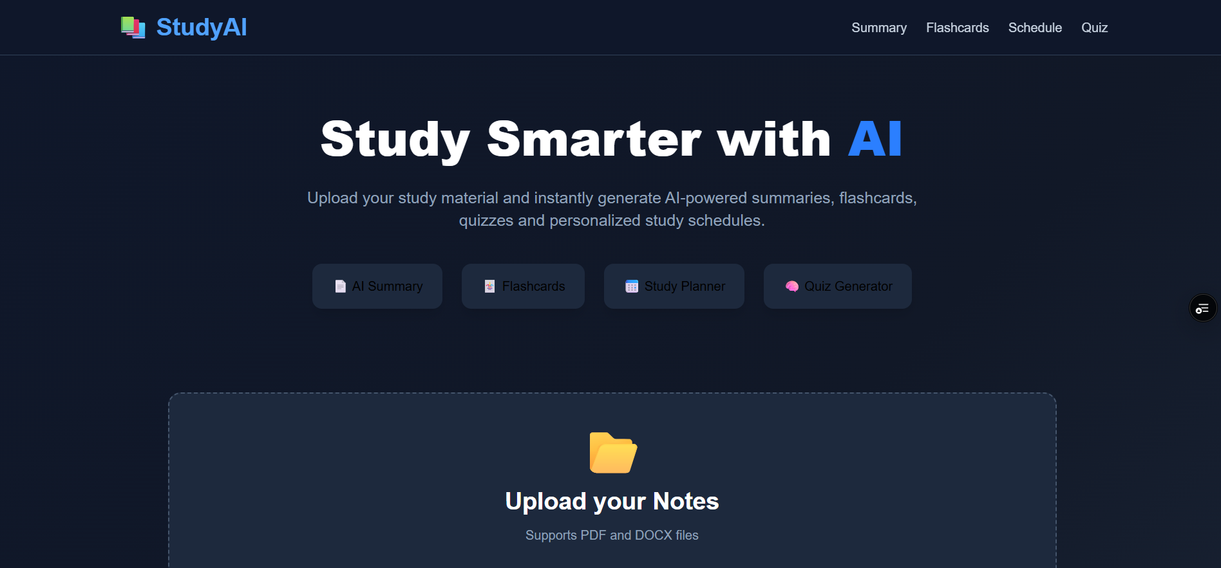

AI Summary:
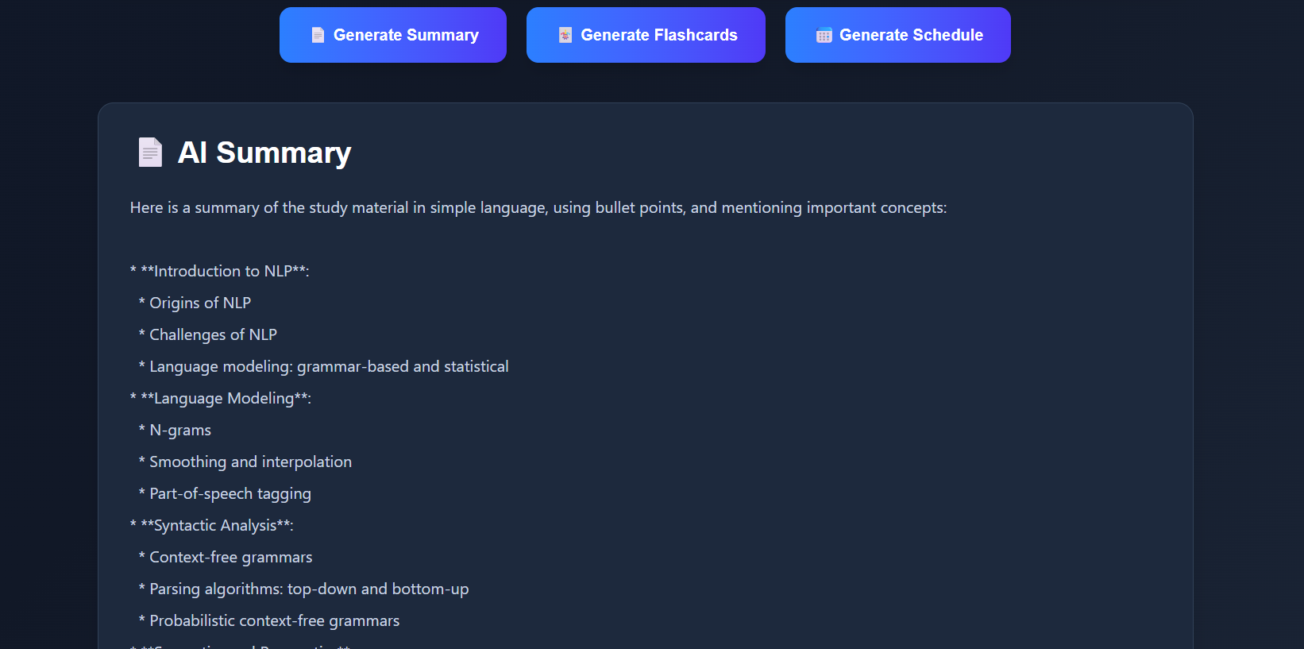

Flashcards:
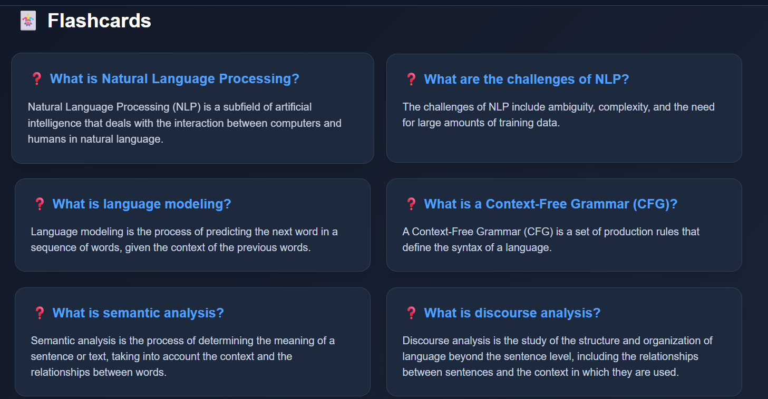

20. Project Demo Planning
Date | 2 July 2026
Team ID | 6a3a53b6298c58cbca6bc425
Project Name | StudyAI – AI Powered Study Companion
Maximum Marks | 1 Mark

S.No | Demo Section | Duration (mins) | Presenter
1 | Introduction & Problem Statement | 2 | Akkala Sai Narayana
2 | Solution Overview & Architecture | 3 | Akkala Sai Narayana
3 | Live Demo — Upload, Summary & Flashcards | 3 | Akkala Sai Narayana
4 | Live Demo — Quiz, Schedule & Analytics | 3 | Akkala Sai Narayana
5 | Q&A Session | 3 | Akkala Sai Narayana

21. Scalability & Future Plan
Date | 3 July 2026
Team ID | 6a3a53b6298c58cbca6bc425
Project Name | StudyAI – AI Powered Study Companion
Maximum Marks | 1 Mark

Current System Limitations
S.No | Limitation | Impact | Priority
1 | No formal user authentication | Cannot track individual learning history securely | High
2 | Render free-tier cold starts | First request after idle time is slow | Medium
3 | No automated test suite yet | Regressions must be caught manually | Medium
4 | Quiz evaluation limited to Groq's structured output parsing | Edge-case answer formats may be mis-scored | Low

Future Roadmap
Phase | Planned Feature / Enhancement | Target Timeline | Expected Impact
Phase 2 | Add Firebase Authentication for per-student login | Next 1–2 months | Secure, personalized learning history
Phase 3 | Automated test suite for Flask routes and services | Next 2–3 months | Fewer regressions, safer iteration
Phase 4 | Expand quiz types and add spaced-repetition to flashcards | Next 3–4 months | Stronger retention and richer assessment
Phase 5 | Multi-language support and mobile-optimized UI polish | Next 4–6 months | Wider accessibility

22. Solo Contribution & Presentation Plan
Date | 3 July 2026
Team ID | 6a3a53b6298c58cbca6bc425
Project Name | StudyAI – AI Powered Study Companion
Maximum Marks | 1 Mark

StudyAI was designed, built, and deployed independently by Akkala Sai Narayana, covering frontend, backend, AI integration, and deployment.
Aspect | Details
Developer | Akkala Sai Narayana — B.Tech CSE (Data Science)
Roles Covered | Frontend (React/Vite/Tailwind), Backend (Flask), AI Integration (Groq), Data Layer (Firebase), Deployment (Vercel/Render)
Self-Assessment (1–5) | 4 — all core features implemented and deployed; test coverage and auth remain as future work
Key Challenges | Balancing Groq prompt design for consistent structured JSON output across summary, flashcard, quiz and schedule generation
Resolution | Centralized prompt-building and response-parsing logic inside backend/services/ so every route reuses the same validated pipeline

