**A**

**Project Report**

**On**

**“College Chat Bot**

**Prepared by**

**Sai Akshay Erupaka(1992619)**

**Gopi Chand Kandula(1993584)**

**Sai Praneeth Inupamula(1992488)**

**Under the guidance of**

**Mr. Yash Seth**



Contents

LIST OF FIGURES 2

1.Introduction: 3

2.Problem: 3

3.Limitations: 3

4.Requirement 4

4.1 Software Requirement: 4

4.2 Hardware Requirement: 4

6.DESIGN: 5

6.1 USE CASE DIAGRAM: 5

6.2 DATA FLOW DIAGRAM 6

7.REFERENCES: 6

# 

# 1.Introduction:

# A chat bot (also known as a talk bot, Bot, chatterbox, Artificial Conversational Entity) is a computer program which conducts a conversation via auditory or textual methods. Such programs are often designed to convincingly simulate how a human would behave as a conversational partner, thereby passing the Turing test. Chat bots are typically used in dialog systems for various practical purposes including customer service or information acquisition. Chat bots are often integrated into the dialog systems of, for example, automated online assistants, giving them the ability of, for example, small talking or engaging in casual conversations unrelated to the scopes of their primary expert systems.

# 2.Problem:

The college enquiry chat bot will be built using artificial algorithms that analyzes user’s queries and understand user’s message. This System will be a web application which provides answer to the query of the student very effectively. Students just have to put their query to the bot which is used for chatting. The system will use the artificial intelligence algorithms to give appropriate answers to the user. If the answer is found invalid, then some system to declare the answer as invalid can be incorporated. These invalid answers can be deleted or modified by the admin of the system. The student will not have to go to the college for enquiring something. Student can use the chat bot to get the answers to their queries. Students can use this web based system for making enquiries at any point of time. This system may help students to stay updated with the college activities.

# 3.Limitations:

If the input from the user is not appropriate then the user is not going to get the desired output.

# 4.Requirement

## 4.1 Software Requirement:

Windows 7

XAMPP Server

My SQL

## 4.2 Hardware Requirement:

i3 Processor Based Computer

4GB-Ram

320GB Hard Disk

**5.Content diagram:**

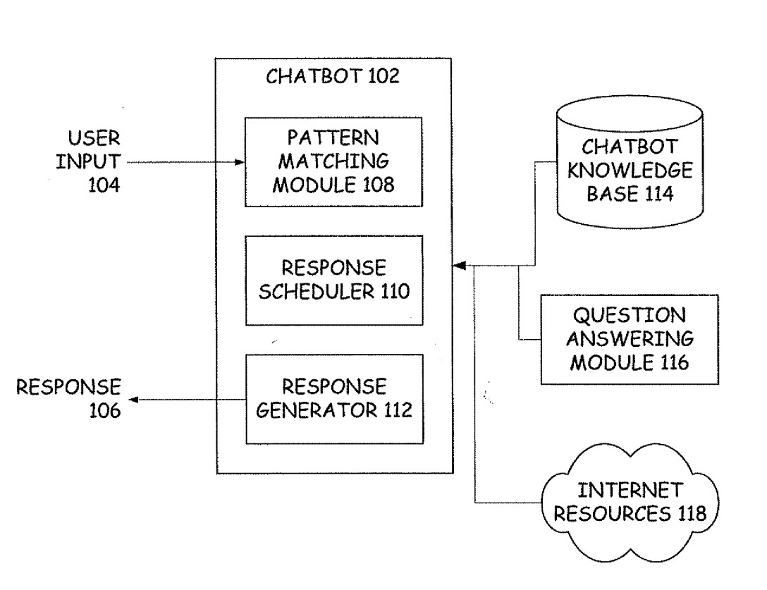

# 6.DESIGN:

## 6.1 USE CASE DIAGRAM:

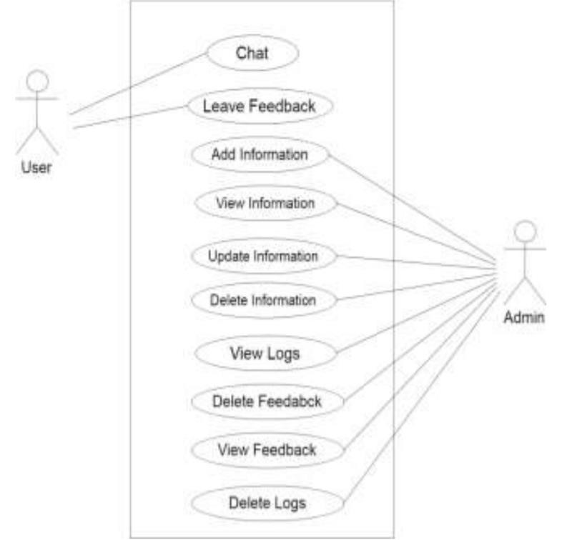

## 6.2 DATA FLOW DIAGRAM

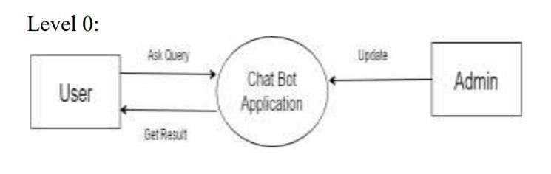

# 7.REFERENCES:

Stackoverflow.com, W3schools.com, tutorialspoint.com, quora.com,geeksforgeeks.com,youtube.com.