## horizontal line



Coordinates and Edgelist Automation Tool Guide

# 

# 

# 

**1. How to use?**

**Step 1:**

To start with, first of all clone the following project :

<https://github.com/saiakshitharthi/Tool>

To use, just paste the path of index.html file into your browser. Type the name of the picture you want to use as canvas in the following text box. (The picture should be in the same directory where you pasted your tool. Click on Submit button.

**Picture 1:**

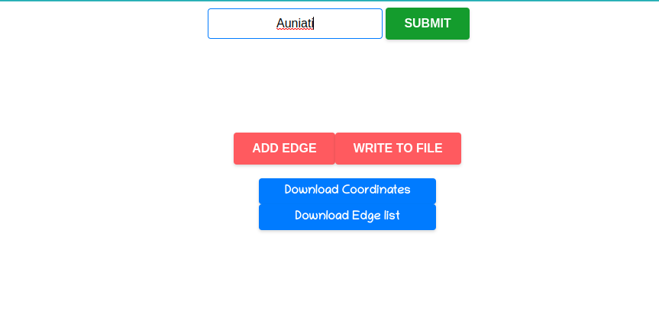

**Step 2:**

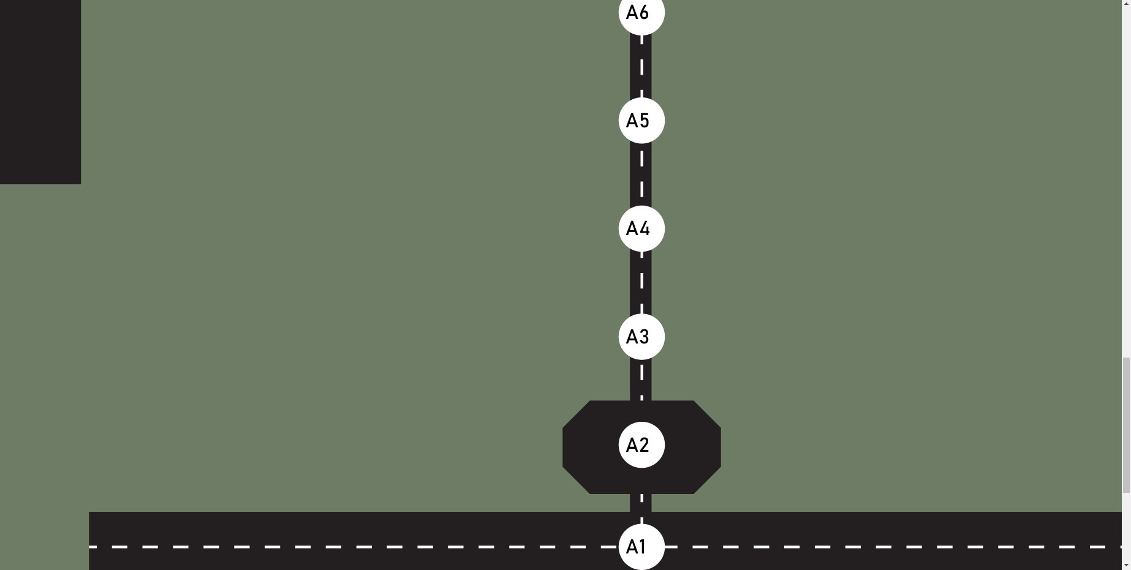

You will get the above picture , now you just double click on any point and give the name, and press enter to add new node.



**Step 3:**



Click on Add Edge button to add edges.

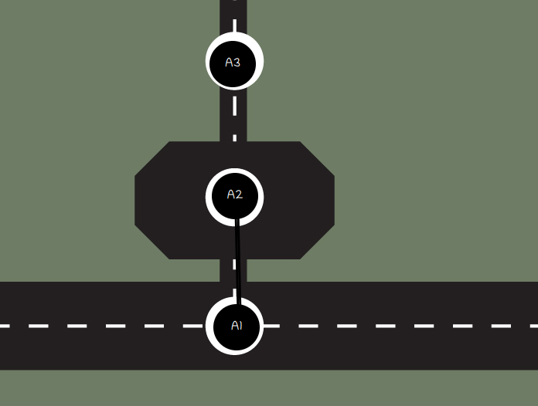

Click on the two points where you want to add edge. Suppose you want to add edge between A1 and A2, just click on A1, then on A2 to get an edge between A1 and A2.

**Step 4:**

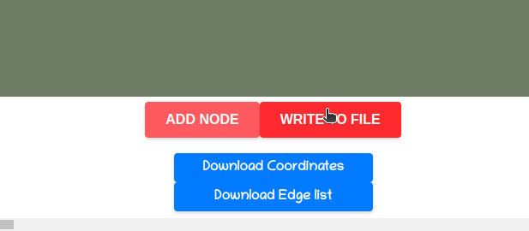

Click on the Write to File button, and then click on the Download coordinates button and Download Edge list button.

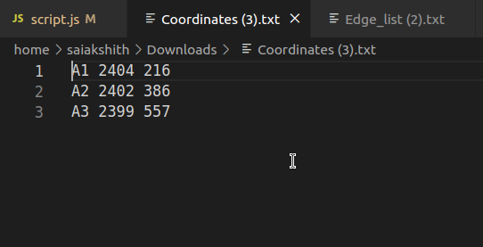

You get the Coordinates.txt and Edge_list.txt file which corresponds to the coordinates and edge_list. Paste them as mentioned in user manual.

