**Financial Analytics Group Project**

**Johnson & Johnson Stock Analysis Report  
__________________________________________________________**

**Group 3**

**Aashish Kurimilla - W0833509**

**Nrupendra Kumar - W0836757**

**Sai Anudeep Janapareddy - W0836698**

**Chaithanya Keshavabhakthula - W0851954**

**Syed Mohamed Yousuf Ismail Maraika - W0837472**

1. **Business Summary:**

Johnson & Johnson (J&J), established in 1886 by the visionary brothers Robert Wood Johnson, James Wood Johnson, and Edward Mead Johnson, initially made its mark in the production of ready-to-use sterile surgical dressings. Over time, J&J has evolved into a leading global healthcare company, with a dedicated focus on three primary areas: pharmaceuticals, medical devices, and consumer health products.

Current Operations:

In 2023, J&J strategically spun off its consumer health division to establish Kenvue, thereby enabling a renewed focus on its core pharmaceutical and medical device operations. This pivotal move is complemented by a significant $14.6 billion acquisition of Intra-Cellular Therapies in January 2025, reinforcing its commitment to advancing neurological treatments. Additionally, J&J's ambitious plan to invest over $55 billion in U.S. manufacturing and research facilities over the next four years demonstrates a strong dedication to enhancing domestic capabilities.

Macroeconomic Environment and Business Cycle:

The healthcare sector is currently experiencing a surge driven by demographic shifts, technological advancements, and a dynamic regulatory environment, all of which are prompting J&J’s proactive investments in research and development to address emerging healthcare needs.

Current Industry Environment:

The pharmaceutical and medical device industries are characterized by rapid innovation, stringent regulatory standards, and intense competition. Companies are leaning towards specialized therapies, personalized medicine, and digital health solutions. J&J's strategic acquisitions and investments showcase its ambition to lead in these evolving areas.

Top Industrial Competitors and Market Share:

In the pharmaceutical sector, J&J competes alongside major players such as Pfizer, Merck, and Novartis, holding approximately a 12.3% share of the global market. In the medical devices arena, it faces tough competition from companies like Medtronic, Abbott, and Stryker, while retaining about a 9.7% global market share. The consumer health segment, now encompassed by Kenvue, once contended with giants like Unilever and Procter & Gamble, previously accounting for around a 6.5% market share. J&J's distinguished history, strategic realignment, and proactive investments exemplify its steadfast commitment to leading the global healthcare landscape.

1. **Valuation:**

This section evaluates Johnson & Johnson’s stock value using two widely recognized models: the Capital Asset Pricing Model (CAPM) and the Dividend Growth Model (DGM). According to CAPM, the expected return of JNJ stock is 8.2733%, calculated using a risk-free rate of 4.25%, a market return of 12.9962%, and a beta of 0.46 (on 22nd March 2025). This relatively low beta indicates that JNJ exhibits less volatility than the broader market, making it a conservative investment suitable for risk-averse portfolios.

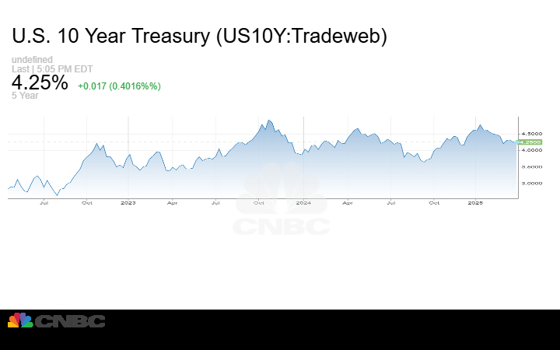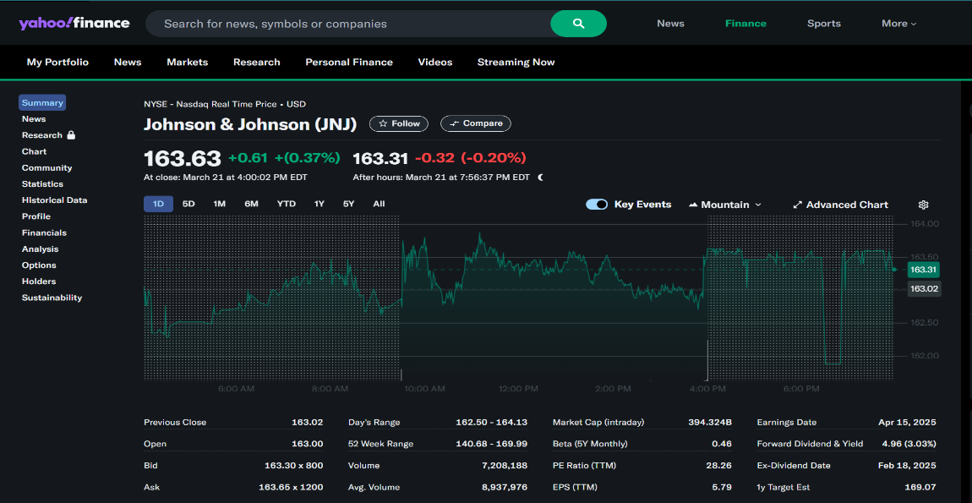

*Fig 1. Beta value Fig 2. Risk-free rate*

In parallel, the Dividend Growth Model, which estimates intrinsic value based on dividend projections, produced an intrinsic value of $128.53 per share. This was derived using an expected dividend of $5.1206, a required return of 8.273%, and a dividend growth rate of 4.289%. Given the market price of $163.63, the DGM suggests that the stock may be slightly overvalued. However, this does not factor in qualitative aspects like brand equity and strategic expansion, which continue to support the company’s long-term investment appeal.

1. **Financial Ratio Calculation:**

Johnson & Johnson exhibits a robust financial profile, characterized by strong profitability, efficient operations, stable liquidity, and prudent leverage. The company's gross profit margin of 69.07% indicates that a substantial portion of revenue is retained after covering the cost of goods sold, reflecting superior production efficiency and pricing power. Its operating profit margin of 54.35% demonstrates excellent control over operating expenses, while a net profit margin of 15.84% highlights solid bottom-line profitability.

Return-based metrics further underscore the company’s financial strength. A return on assets (ROA) of 7.81% reveals effective utilization of company assets to generate earnings, and a return on equity (ROE) of 19.68% indicates impressive shareholder value creation. Additionally, earnings per share (EPS) stand at $5.8164, suggesting a healthy earning capability on a per-share basis.

In terms of liquidity, J&J maintains a current ratio of 1.11, confirming adequate resources to meet short-term liabilities. The quick ratio, at 0.86, while slightly below the ideal threshold, remains reasonable given J&J’s diversified operations. Its cash ratio of 0.49 shows a conservative liquidity position, which is acceptable due to the predictability of its cash flows.

From a market perspective, the company’s price-to-earnings (P/E) ratio of 28.13 suggests strong investor confidence and favourable expectations for future growth. The dividend payout ratio is notably high at 80.44%, emphasizing J&J’s commitment to returning capital to shareholders, though this does limit the amount available for reinvestment. The firm’s debt-to-equity ratio of 0.5124 signals balanced leverage and a stable capital structure, while its sustainable growth rate (SGR) of 3.85% demonstrates the company's ability to achieve steady, internally funded growth over time.

Overall, Johnson & Johnson’s financial ratios reinforce its position as a well-managed, shareholder-friendly, and consistently performing blue-chip company. It is well-positioned to maintain long-term stability while delivering reliable returns to investors.

1. **Technical Analysis & Monte Carlo Simulation:**

The Bollinger Bands analysis of JNJ’s stock in 2024 reveals a consistent and relatively low-volatility trading pattern. For most of the year, the stock price remained within the upper and lower bands, indicating price stability. Periods of band contraction, particularly between May and July, suggest consolidation, while expansions in March-April and again in August-October correspond to increased market activity. Toward the end of the year, the bands widen once more, coupled with a downward movement in price, suggesting elevated volatility and growing bearish momentum. This trend implies cautious sentiment in the short term, although for long-term investors it may signal emerging value opportunities.

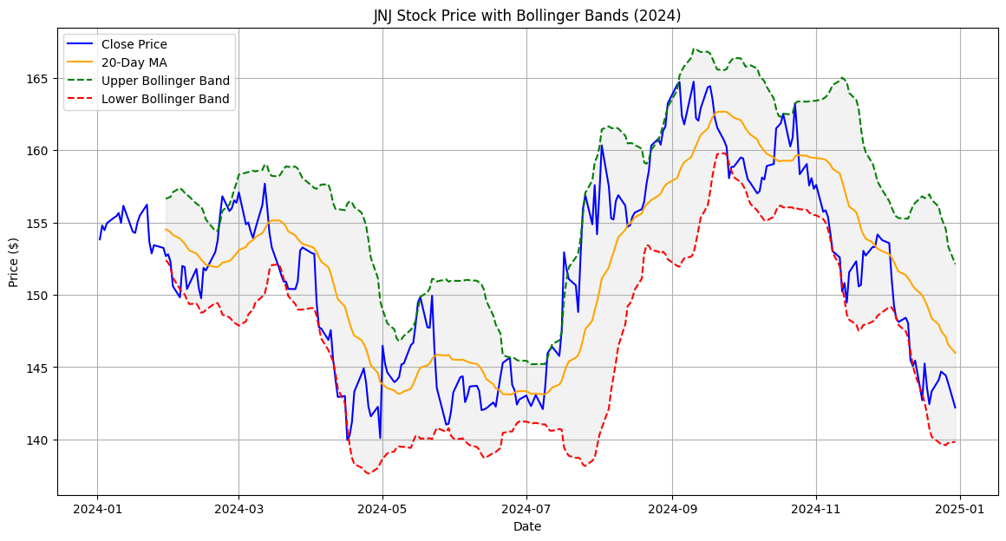

A Monte Carlo simulation was conducted to forecast JNJ stock performance through 2025 using historical returns and volatility. The simulation, based on 10,000 potential price paths, started from an initial value of $142.20. The expected average return was estimated at -10.82%, with a standard deviation of 16.24%. The end-of-year prices are most likely to fall within a range of $130 to $160, with fewer outcomes outside this band. The majority of the simulated outcomes suggest price stagnation or slight decline, aligning with the company’s defensive nature and suggesting a limited short-term upside. Nevertheless, the likelihood of severe drawdowns remains low, reinforcing JNJ's reputation as a low-risk stock.

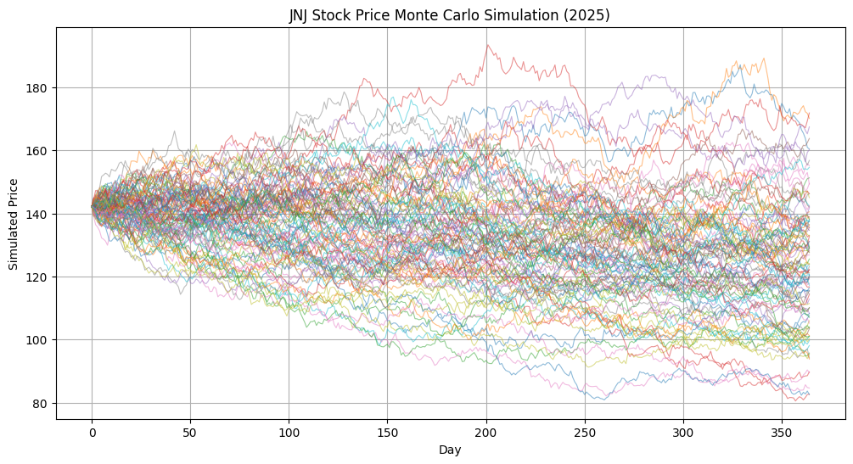

The most likely scenario is that JNJ will remain between $130 and $160 by the end of 2025. The risk outlook indicates a high probability of mild losses or sideways movement, with a low chance of severe losses or windfall gains. This aligns with JNJ’s profile as a mature, dividend-paying stock in a defensive sector.

1. **Stock Signals:**

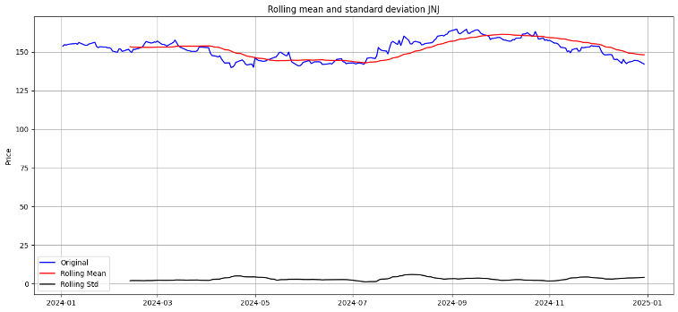Technical indicators based on moving averages provide further insight into JNJ’s price action. Rolling mean and standard deviation charts further emphasize JNJ’s characteristic stability. Except for brief periods of heightened volatility during the Q3 rally and the Q4 correction, the rolling standard deviation remained relatively flat. The rolling average closely followed the actual price, affirming that JNJ experienced minor fluctuations and continued to trade within expected bounds.

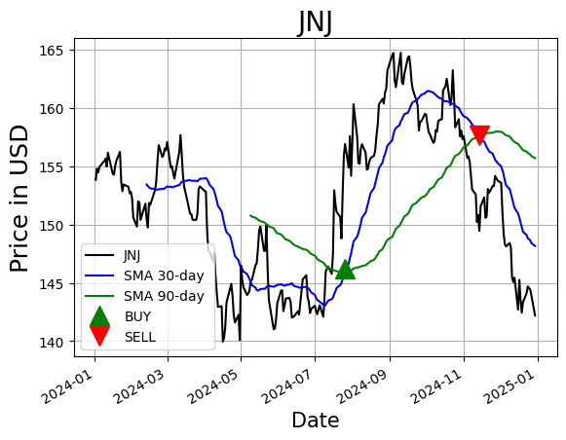The Simple Moving Average (SMA) analysis using 30-day and 90-day windows revealed a buy signal on July 26, 2024, when the short-term SMA crossed above the long-term SMA, suggesting bullish momentum. This was followed by a sell signal on November 14, 2024, as the short-term SMA dipped below the long-term average, indicating a reversal. These crossovers correspond closely with market activity, marking the beginning and end of a notable uptrend.

The Exponential Moving Average (EMA), which reacts more sensitively to price changes, provided several timely signals throughout the year. Buy signals were generated on January 3, February 29, and July 25, while sell signals were issued on February 1, March 21, and November 15. These EMA-based crossovers effectively captured short-term trend shifts and provided actionable insights for momentum-based strategies.

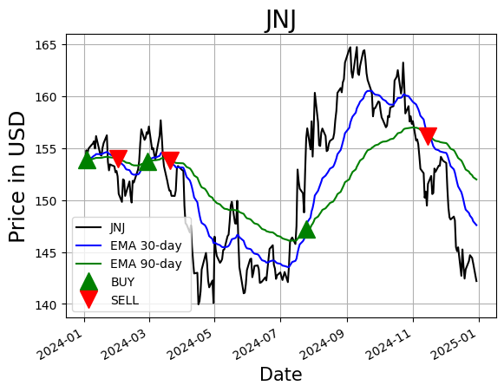

The SMA crossover method provided clear long-term trend signals, especially around July and November. The EMA crossover method captured short-term momentum shifts, providing timely entry/exit points. The rolling metrics reinforced that JNJ is a low-to-moderate volatility stock, aligning with its reputation as a defensive blue-chip investment.

1. **Facebook Prophet:**

The Facebook Prophet model was applied to Johnson & Johnson’s (JNJ) stock using historical daily closing prices from 2024, with a forward projection of 365 days into 2025. The model was enhanced by including known earnings release dates as custom holiday events to account for stock volatility around those periods.

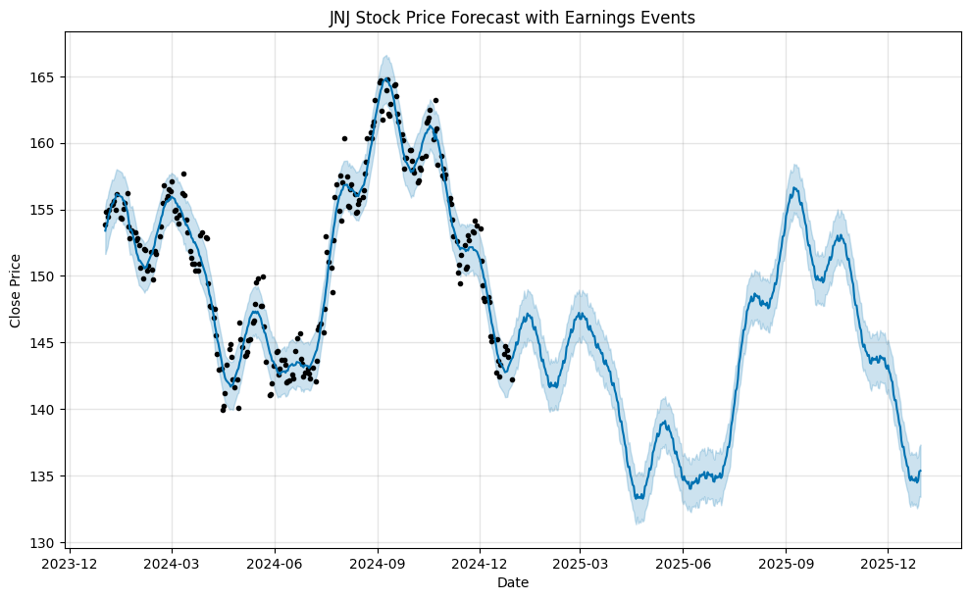

The forecast output reveals a repeating seasonal pattern, with price surges during the mid-year months (especially around September) and declines during the start and end of the calendar year. This pattern is consistent with the stock’s learned yearly seasonality, even within the constraint of one-year historical data. Importantly, the forecast shows a gradual downward trend, where the stock is expected to drop from around $155 in early 2024 to approximately $137–$140 by the end of 2025. This indicates a potential bearish outlook if the macroeconomic and market conditions persist unchanged.

The shaded region around the forecasted price curve represents the 95% confidence interval. It becomes wider toward the end of 2025, suggesting increasing uncertainty in longer-term predictions, a standard behaviour in time series models.

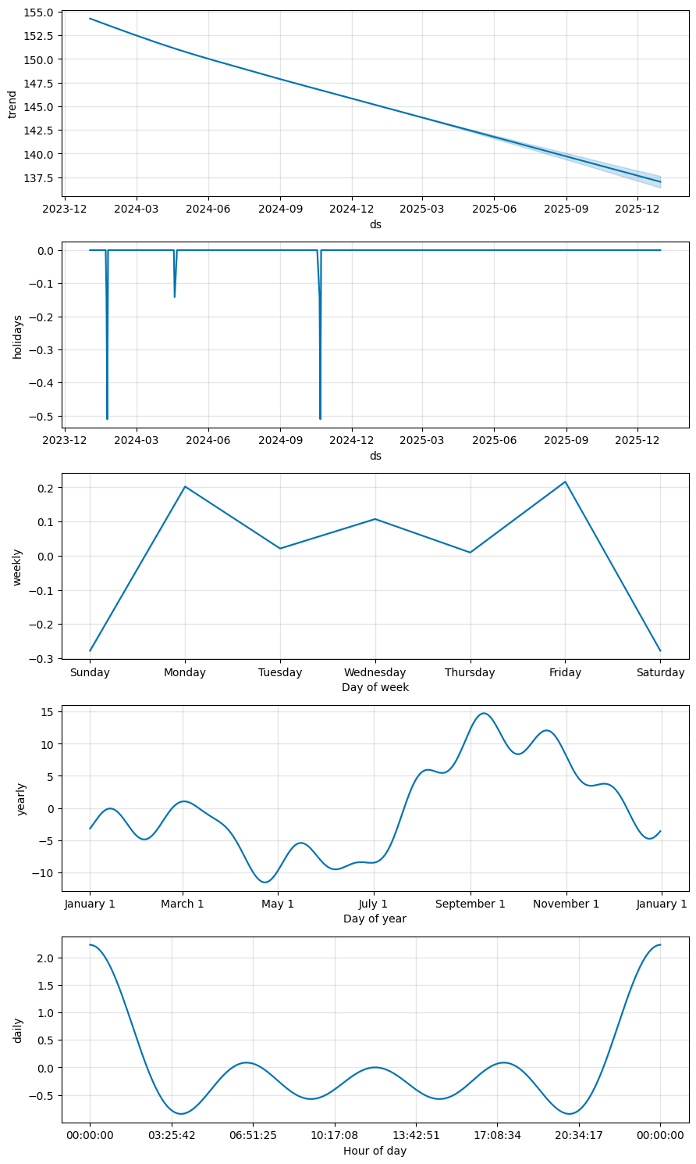

From the forecast components plot, we gain several valuable insights:

• The trend component confirms a steady decline across the forecast horizon, aligning with observed market signals.

• The holiday component reflects negative impacts during specific earnings dates, suggesting that JNJ's stock has historically experienced mild sell-offs or volatility around these events.

• The weekly seasonality indicates stronger performance at the start (Monday) and end (Friday) of the trading week, while Sunday and Saturday negatively impact, consistent with weekend gaps and institutional trading behavior.

• The yearly seasonality reveals that the stock typically performs better from August to November, while dips are common around April and May.

• A daily seasonality pattern is also evident, with peaks around midnight and late afternoon. Although JNJ does not trade 24/7, this pattern may emerge due to intraday historical sampling or default assumptions in Prophet.

Overall, the Prophet model demonstrates a mildly bearish outlook with seasonal recoveries, especially in late Q3 and Q4 of 2025. While the forecast leans toward conservatism due to the limited input horizon, the inclusion of earnings-related events and Prophet’s flexible components allows for a more nuanced interpretation of JNJ’s potential performance.

1. **Recommendation:**

Based on the comprehensive analysis of Johnson & Johnson’s stock through valuation models, financial ratios, technical indicators, and time series forecasting, the stock demonstrates strong fundamentals but a cautious short-term outlook.

The valuation models (CAPM and Dividend Growth Model) suggest that the stock may be slightly overvalued in the current market. However, J&J's financial ratios reflect a solid foundation — high profitability, disciplined expense management, strong returns on equity, and a healthy dividend payout. The company maintains a stable capital structure and shows the ability to grow organically through retained earnings.

From a technical analysis standpoint, moving averages indicate trend reversals with signals of recent weakening momentum. Bollinger Bands and Monte Carlo simulations confirm that while the stock is generally stable, its near-term upside appears limited. Furthermore, the Facebook Prophet forecast shows a gradually declining trend throughout 2025, although seasonal recoveries may offer short-term trading opportunities. Earnings dates also seem to introduce mild volatility.

Taking all these factors into account, Johnson & Johnson appears to be best suited for a HOLD recommendation at this time. For existing shareholders, maintaining the position is advisable. For new investors, a more attractive entry point may arise following market corrections or price stabilization in response to macroeconomic shifts.