Windows PowerShell
Copyright (C) Microsoft Corporation. All rights reserved.

PS C:\Users\saian\Downloads\MLOps_Labs\Lab3_Model_Serving_Microservice> dir

Directory: C:\Users\saian\Downloads\MLOps_Labs\Lab3_Model_Serving_Microservice

Mode LastWriteTime Length Name
---- ------------- ------ ----
-a---- 28-09-2026 13:02 65 .dockerignore
-a---- 28-09-2026 13:02 6724 api.py
-a---- 28-09-2026 13:02 907 common.py
-a---- 28-09-2026 13:02 1157 compose.yaml
-a---- 28-09-2026 13:02 437 consume_model.py
-a---- 28-09-2026 13:02 207 Dockerfile.dev
-a---- 28-09-2026 13:02 335 Dockerfile.service
-a---- 28-09-2026 13:02 738 drift.py
-a---- 28-09-2026 13:02 886 export_champion.py
-a---- 28-09-2026 13:02 1474 generate_data.py
-a---- 28-09-2026 13:02 8865 Lab3_Colab.ipynb
-a---- 28-09-2026 13:02 3579 labctl.py
-a---- 28-09-2026 13:02 1064 load_test.py
-a---- 28-09-2026 13:02 1010 probe_service.py
-a---- 28-09-2026 13:02 1368 register_model.py
-a---- 28-09-2026 13:02 235 requirements.txt
-a---- 28-09-2026 13:02 1917 run_lab1.py
-a---- 28-09-2026 13:02 51 serve_churn.py
-a---- 28-09-2026 13:02 7361 START_HERE.html
-a---- 28-09-2026 13:02 7047 START_HERE.md
-a---- 28-09-2026 13:02 3264 SUBMISSION_TEMPLATE.html
-a---- 28-09-2026 13:02 551 train_auto.py
-a---- 28-09-2026 13:02 562 train_no_tracking.py
-a---- 28-09-2026 13:02 3125 train_tracked.py
-a---- 28-09-2026 13:02 4259 VALIDATION.md
-a---- 28-09-2026 13:02 3499 WRITTEN_ANSWERS.md

PS C:\Users\saian\Downloads\MLOps_Labs\Lab3_Model_Serving_Microservice> docker info
Client:
Version: 26.1.1
Context: default
Debug Mode: false
Plugins:
agent: Docker AI Agent Runner (Docker Inc.)
Version: v1.140.0
Path: C:\Users\saian\.docker\cli-plugins\docker-agent.exe
ai: Docker AI Agent - Ask Gordon (Docker Inc.)
Version: v1.31.0
Path: C:\Users\saian\.docker\cli-plugins\docker-ai.exe
buildx: Docker Buildx (Docker Inc.)
Version: v0.37.1
Path: C:\Users\saian\.docker\cli-plugins\docker-buildx.exe
compose: Docker Compose (Docker Inc.)
Version: v5.5.1
Path: C:\Users\saian\.docker\cli-plugins\docker-compose.exe
debug: Get a shell into any image or container (Docker Inc.)
Version: 0.0.47
Path: C:\Users\saian\.docker\cli-plugins\docker-debug.exe
desktop: Docker Desktop commands (Docker Inc.)
Version: v0.4.4
Path: C:\Users\saian\.docker\cli-plugins\docker-desktop.exe
dev: Docker Dev Environments (Docker Inc.)
Version: v0.1.2
Path: C:\Program Files\Docker\cli-plugins\docker-dev.exe
dhi: CLI for managing Docker Hardened Images (Docker Inc.)
Version: v0.0.7
Path: C:\Users\saian\.docker\cli-plugins\docker-dhi.exe
extension: Manages Docker extensions (Docker Inc.)
Version: v0.2.31
Path: C:\Users\saian\.docker\cli-plugins\docker-extension.exe
feedback: Provide feedback, right in your terminal! (Docker Inc.)
Version: v1.0.4
Path: C:\Program Files\Docker\cli-plugins\docker-feedback.exe
init: Creates Docker-related starter files for your project (Docker Inc.)
Version: v1.4.0
Path: C:\Users\saian\.docker\cli-plugins\docker-init.exe
mcp: Docker MCP Plugin (Docker Inc.)
Version: v0.43.3
Path: C:\Users\saian\.docker\cli-plugins\docker-mcp.exe
model: Docker Model Runner (Docker Inc.)
Version: v1.2.6
Path: C:\Users\saian\.docker\cli-plugins\docker-model.exe
offload: Docker Offload (Docker Inc.)
Version: v0.6.27
Path: C:\Users\saian\.docker\cli-plugins\docker-offload.exe
pass: Docker Pass Secrets Manager Plugin (beta) (Docker Inc.)
Version: v0.2.2
Path: C:\Users\saian\.docker\cli-plugins\docker-pass.exe
sandbox: "docker sandbox" is deprecated, use Docker Sandboxes instead (Docker Inc.)
Version: v0.13.0
Path: C:\Users\saian\.docker\cli-plugins\docker-sandbox.exe
sbom: View the packaged-based Software Bill Of Materials (SBOM) for an image (Anchore Inc.)
Version: 0.6.0
Path: C:\Program Files\Docker\cli-plugins\docker-sbom.exe
scout: Docker Scout (Docker Inc.)
Version: v1.24.0
Path: C:\Users\saian\.docker\cli-plugins\docker-scout.exe

Server:
Containers: 0
Running: 0
Paused: 0
Stopped: 0
Images: 7
Server Version: 26.1.1
Storage Driver: overlay2
Backing Filesystem: extfs
Supports d_type: true
Using metacopy: false
Native Overlay Diff: true
userxattr: false
Logging Driver: json-file
Cgroup Driver: cgroupfs
Cgroup Version: 2
Plugins:
Volume: local
Network: bridge host ipvlan macvlan null overlay
Log: awslogs fluentd gcplogs gelf journald json-file local splunk syslog
Swarm: inactive
Runtimes: runc io.containerd.runc.v2
Default Runtime: runc
Init Binary: docker-init
containerd version: e377cd56a71523140ca6ae87e30244719194a521
runc version: v1.1.12-0-g51d5e94
init version: de40ad0
Security Options:
seccomp
Profile: unconfined
cgroupns
Kernel Version: 6.18.33.2-microsoft-standard-WSL2
Operating System: Docker Desktop
OSType: linux
Architecture: x86_64
CPUs: 12
Total Memory: 3.674GiB
Name: docker-desktop
ID: e3776b19-fb4c-4c66-a67a-6e0076e43583
Docker Root Dir: /var/lib/docker
Debug Mode: false
HTTP Proxy: http.docker.internal:3128
HTTPS Proxy: http.docker.internal:3128
No Proxy: hubproxy.docker.internal
Labels:
com.docker.desktop.address=npipe://\\.\pipe\docker_cli
Experimental: false
Insecure Registries:
hubproxy.docker.internal:5555
127.0.0.0/8
Live Restore Enabled: false

WARNING: daemon is not using the default seccomp profile
PS C:\Users\saian\Downloads\MLOps_Labs\Lab3_Model_Serving_Microservice> $env:LAB_AUTHOR="Sai 2025AE05621_3"
PS C:\Users\saian\Downloads\MLOps_Labs\Lab3_Model_Serving_Microservice> python labctl.py init
[+] Building 4.5s (12/12) FINISHED
=> [internal] load local bake definitions 0.0s
=> => reading from stdin 608B 0.0s
=> [internal] load build definition from Dockerfile.dev 0.1s
=> => transferring dockerfile: 250B 0.1s
=> [internal] load metadata for docker.io/library/python:3.11-slim 2.7s
=> [auth] library/python:pull token for registry-1.docker.io 0.0s
=> [internal] load .dockerignore 0.0s
=> => transferring context: 105B 0.0s
=> [1/4] FROM docker.io/library/python:3.11-slim@sha256:e41613d42d4891e4930f79523f93f81bbc7632584ec65e36ab055f41 0.0s
=> [internal] load build context 0.0s
=> => transferring context: 280B 0.0s
=> CACHED [2/4] WORKDIR /workspace 0.0s
=> CACHED [3/4] COPY requirements.txt /tmp/requirements.txt 0.0s
=> CACHED [4/4] RUN pip install --no-cache-dir -r /tmp/requirements.txt 0.0s
=> exporting to image 0.1s
=> => exporting layers 0.0s
=> => writing image sha256:dd505a4518148d767a8290cc2d42b35c5f84acd1227ea3655143c7e2e51411ba 0.0s
=> => naming to docker.io/library/cartvista-dev:lab 0.0s
=> resolving provenance for metadata file 0.1s
[+] build 1/1
✔ Image cartvista-dev:lab Built 4.9s
[+] run 2/2
✔ Volume cartvista_lab3_project Created 0.0s
✔ Network cartvista-lab3_default Created 0.2s
Container cartvista-lab3-bootstrap Creating
Container cartvista-lab3-bootstrap Created
860d8976b1c35ef2cfa9cf968b17e2e5482de95dd79a31b742a93421a723ab52
Successfully copied 2.05kB to cartvista-lab3-bootstrap:/workspace/.dockerignore
Successfully copied 8.7kB to cartvista-lab3-bootstrap:/workspace/api.py
Successfully copied 2.56kB to cartvista-lab3-bootstrap:/workspace/common.py
Successfully copied 3.07kB to cartvista-lab3-bootstrap:/workspace/compose.yaml
Successfully copied 2.05kB to cartvista-lab3-bootstrap:/workspace/consume_model.py
Successfully copied 2.05kB to cartvista-lab3-bootstrap:/workspace/Dockerfile.dev
Successfully copied 2.05kB to cartvista-lab3-bootstrap:/workspace/Dockerfile.service
Successfully copied 2.56kB to cartvista-lab3-bootstrap:/workspace/drift.py
Successfully copied 2.56kB to cartvista-lab3-bootstrap:/workspace/export_champion.py
Successfully copied 3.07kB to cartvista-lab3-bootstrap:/workspace/generate_data.py
Successfully copied 10.8kB to cartvista-lab3-bootstrap:/workspace/Lab3_Colab.ipynb
Successfully copied 5.12kB to cartvista-lab3-bootstrap:/workspace/labctl.py
Successfully copied 3.07kB to cartvista-lab3-bootstrap:/workspace/load_test.py
Successfully copied 2.56kB to cartvista-lab3-bootstrap:/workspace/probe_service.py
Successfully copied 3.07kB to cartvista-lab3-bootstrap:/workspace/register_model.py
Successfully copied 2.05kB to cartvista-lab3-bootstrap:/workspace/requirements.txt
Successfully copied 3.58kB to cartvista-lab3-bootstrap:/workspace/run_lab1.py
Successfully copied 2.05kB to cartvista-lab3-bootstrap:/workspace/serve_churn.py
Successfully copied 9.22kB to cartvista-lab3-bootstrap:/workspace/START_HERE.html
Successfully copied 8.7kB to cartvista-lab3-bootstrap:/workspace/START_HERE.md
Successfully copied 5.12kB to cartvista-lab3-bootstrap:/workspace/SUBMISSION_TEMPLATE.html
Successfully copied 2.56kB to cartvista-lab3-bootstrap:/workspace/train_auto.py
Successfully copied 2.56kB to cartvista-lab3-bootstrap:/workspace/train_no_tracking.py
Successfully copied 5.12kB to cartvista-lab3-bootstrap:/workspace/train_tracked.py
Successfully copied 6.14kB to cartvista-lab3-bootstrap:/workspace/VALIDATION.md
Successfully copied 5.12kB to cartvista-lab3-bootstrap:/workspace/WRITTEN_ANSWERS.md
cartvista-lab3-bootstrap
Initialized. Run python labctl.py prepare next. Do not repeat init on an active project.
PS C:\Users\saian\Downloads\MLOps_Labs\Lab3_Model_Serving_Microservice> $SourceVolume="cartvista_lab2_project"
PS C:\Users\saian\Downloads\MLOps_Labs\Lab3_Model_Serving_Microservice> docker volume inspect $SourceVolume
[
{
"CreatedAt": "2026-09-28T10:53:07Z",
"Driver": "local",
"Labels": {
"com.docker.compose.config-hash": "e2305a962e8b218a8962fc01a48d36da6dd6a41baf0bfd41d271bd501aebea9f",
"com.docker.compose.project": "cartvista-lab2",
"com.docker.compose.version": "5.5.1",
"com.docker.compose.volume": "project"
},
"Mountpoint": "/var/lib/docker/volumes/cartvista_lab2_project/_data",
"Name": "cartvista_lab2_project",
"Options": null,
"Scope": "local"
}
]
PS C:\Users\saian\Downloads\MLOps_Labs\Lab3_Model_Serving_Microservice> docker compose run --rm --no-deps --user 0:0 -v "${SourceVolume}:/previous:ro" tools sh -c 'test -f /previous/mlflow.db && test -d /previous/mlruns && test ! -e /workspace/mlflow.db && cp /previous/mlflow.db* /workspace/ && cp /previous/churn_data.csv /workspace/ && cp -a /previous/mlruns /workspace/ && chown -R 50000:0 /workspace/mlflow.db* /workspace/mlruns /workspace/churn_data.csv'
Container cartvista-lab3-tools-run-6f4036cb118b Creating
Container cartvista-lab3-tools-run-6f4036cb118b Created
PS C:\Users\saian\Downloads\MLOps_Labs\Lab3_Model_Serving_Microservice> docker compose run --rm tools python consume_model.py
Container cartvista-lab3-tools-run-f1842582f8d3 Creating
Container cartvista-lab3-tools-run-f1842582f8d3 Created
{
"version": 2,
"run_id": "f0dc4382ba9840789fd4d27177ad45a5",
"predictions": [
0,
0,
0,
0,
0
],
"probabilities": [
0.0877304659981777,
0.018408666625937913,
0.06312212385713238,
0.03516482773043705,
0.11565878631896061
]
}
PS C:\Users\saian\Downloads\MLOps_Labs\Lab3_Model_Serving_Microservice> $env:SERVICE_MODULE="serve_churn"
PS C:\Users\saian\Downloads\MLOps_Labs\Lab3_Model_Serving_Microservice> docker compose up -d --force-recreate api
[+] up 1/1
✔ Container cartvista-lab3-api-1 Started 0.6s
PS C:\Users\saian\Downloads\MLOps_Labs\Lab3_Model_Serving_Microservice> docker compose ps
NAME IMAGE COMMAND SERVICE CREATED STATUS PORTS
cartvista-lab3-api-1 cartvista-dev:lab "uvicorn serve_churn…" api 10 seconds ago Up 8 seconds 127.0.0.1:8000->8000/tcp
PS C:\Users\saian\Downloads\MLOps_Labs\Lab3_Model_Serving_Microservice> docker compose logs --tail 100 api
api-1 | INFO: Started server process [1]
api-1 | INFO: Waiting for application startup.
api-1 | INFO: Application startup complete.
api-1 | INFO: Uvicorn running on http://0.0.0.0:8000 (Press CTRL+C to quit)
PS C:\Users\saian\Downloads\MLOps_Labs\Lab3_Model_Serving_Microservice> docker compose run --rm tools python probe_service.py --url http://api:8000 | Tee-Object -FilePath .\Lab3_Submission\Prediction_Tests.txt
Container cartvista-lab3-tools-run-c09d2ef33dd0 Creating
Container cartvista-lab3-tools-run-c09d2ef33dd0 Created
out-file : Could not find a part of the path
'C:\Users\saian\Downloads\MLOps_Labs\Lab3_Model_Serving_Microservice\Lab3_Submission\Prediction_Tests.txt'.
At line:1 char:1
+ docker compose run --rm tools python probe_service.py --url http://ap ...
+ ~~~~~~~~~~~~~~~~~~~~~~~~~~~~~~~~~~~~~~~~~~~~~~~~~~~~~~~~~~~~~~~~~~~~~
+ CategoryInfo : OpenError: (:) [out-file], DirectoryNotFoundException
+ FullyQualifiedErrorId : FileOpenFailure,Microsoft.PowerShell.Commands.OutFileCommand

PS C:\Users\saian\Downloads\MLOps_Labs\Lab3_Model_Serving_Microservice> docker compose run --rm tools python probe_service.py --url http://api:8000 | Tee-Object -FilePath .\Lab3_Model_Serving_Microservice\Prediction_Tests.txt
Container cartvista-lab3-tools-run-7ea3f49ccdd0 Creating
Container cartvista-lab3-tools-run-7ea3f49ccdd0 Created
out-file : Could not find a part of the path 'C:\Users\saian\Downloads\MLOps_Labs\Lab3_Model_Serving_Microservice\Lab3_
Model_Serving_Microservice\Prediction_Tests.txt'.
At line:1 char:1
+ docker compose run --rm tools python probe_service.py --url http://ap ...
+ ~~~~~~~~~~~~~~~~~~~~~~~~~~~~~~~~~~~~~~~~~~~~~~~~~~~~~~~~~~~~~~~~~~~~~
+ CategoryInfo : OpenError: (:) [out-file], DirectoryNotFoundException
+ FullyQualifiedErrorId : FileOpenFailure,Microsoft.PowerShell.Commands.OutFileCommand

PS C:\Users\saian\Downloads\MLOps_Labs\Lab3_Model_Serving_Microservice> docker compose run --rm tools python probe_service.py --url http://api:8000 | Tee-Object -FilePath .\Lab3_Submission\Prediction_Tests.txt
Container cartvista-lab3-tools-run-054cc8724dab Creating
Container cartvista-lab3-tools-run-054cc8724dab Created
{
"health": {
"status": 200,
"body": {
"status": "ok",
"model_loaded": true
}
},
"model": {
"status": 200,
"body": {
"model": "cartvista-churn",
"alias": "champion",
"version": 2,
"run_id": "f0dc4382ba9840789fd4d27177ad45a5"
}
},
"at_risk": {
"status": 200,
"body": {
"churn_prediction": 1,
"churn_probability": 0.8805979175205052,
"model_version": 2,
"inference_ms": 1.953
}
},
"loyal": {
"status": 200,
"body": {
"churn_prediction": 0,
"churn_probability": 0.002663625308117632,
"model_version": 2,
"inference_ms": 1.311
}
},
"invalid": {
"status": 422,
"body": {
"detail": [
{
"type": "greater_than_equal",
"loc": [
"body",
"tenure_months"
],
"msg": "Input should be greater than or equal to 0",
"input": -5,
"ctx": {
"ge": 0
}
}
]
}
},
"empty_batch": {
"status": 422,
"body": {
"detail": [
{
"type": "too_short",
"loc": [
"body",
"customers"
],
"msg": "List should have at least 1 item after validation, not 0",
"input": [],
"ctx": {
"field_type": "List",
"min_length": 1,
"actual_length": 0
}
}
]
}
}
}
PS C:\Users\saian\Downloads\MLOps_Labs\Lab3_Model_Serving_Microservice> docker compose run --rm tools python load_test.py --url http://api:8000 | Tee-Object -FilePath .\Lab3_Submission\Latency_Test.txt
Container cartvista-lab3-tools-run-6d7081dd5040 Creating
Container cartvista-lab3-tools-run-6d7081dd5040 Created
{
"n": 300,
"warmup": 10,
"p50_ms": 2.9135155000403756,
"p95_ms": 4.938374549237779,
"p99_ms": 6.239943468572159,
"max_ms": 123.1467090001388,
"single_300_seconds": 1.062995296999361,
"batch_3x100_seconds": 0.011480930999823613,
"speedup": 92.58790049480241
}
PS C:\Users\saian\Downloads\MLOps_Labs\Lab3_Model_Serving_Microservice> Invoke-RestMethod http://localhost:8000/model-info | ConvertTo-Json | Tee-Object -FilePath .\Lab3_Submission\Model_Before.json
{
"model": "cartvista-churn",
"alias": "champion",
"version": 2,
"run_id": "f0dc4382ba9840789fd4d27177ad45a5"
}
PS C:\Users\saian\Downloads\MLOps_Labs\Lab3_Model_Serving_Microservice> docker compose run --rm tools python register_model.py
Container cartvista-lab3-tools-run-dc1aa0cf72bd Creating
Container cartvista-lab3-tools-run-dc1aa0cf72bd Created
Registered model 'cartvista-churn' already exists. Creating a new version of this model...
Created version '3' of model 'cartvista-churn'.
{
"alias": "champion",
"version": 3,
"run_id": "9d56073a3f454c8aba3d10fe61d999b1",
"test_auc": 0.7495794388998274
}
PS C:\Users\saian\Downloads\MLOps_Labs\Lab3_Model_Serving_Microservice> Invoke-RestMethod http://localhost:8000/model-info | ConvertTo-Json | Tee-Object -FilePath .\Lab3_Submission\Model_After_Alias_Move.json
{
"model": "cartvista-churn",
"alias": "champion",
"version": 2,
"run_id": "f0dc4382ba9840789fd4d27177ad45a5"
}
PS C:\Users\saian\Downloads\MLOps_Labs\Lab3_Model_Serving_Microservice> docker compose restart api
[+] restart 0/1
- Container cartvista-lab3-api-1 Restarting 3.6s
PS C:\Users\saian\Downloads\MLOps_Labs\Lab3_Model_Serving_Microservice> Invoke-RestMethod http://localhost:8000/model-info | ConvertTo-Json | Tee-Object -FilePath .\Lab3_Submission\Model_After_Restart.json
{
"model": "cartvista-churn",
"alias": "champion",
"version": 3,
"run_id": "9d56073a3f454c8aba3d10fe61d999b1"
}
PS C:\Users\saian\Downloads\MLOps_Labs\Lab3_Model_Serving_Microservice> python labctl.py export
Container cartvista-lab3-tools-run-133245439d1b Creating
Container cartvista-lab3-tools-run-133245439d1b Created
Exported 3 to /workspace/model_export
Container cartvista-lab3-copy Creating
Container cartvista-lab3-copy Created
d20a22353403d3b8c30f0b9bb9b13e962f3430b7430ebcee7bce26ab02029fc3
Successfully copied 18.9kB to C:\Users\saian\Downloads\MLOps_Labs\Lab3_Model_Serving_Microservice\model_export
cartvista-lab3-copy
PS C:\Users\saian\Downloads\MLOps_Labs\Lab3_Model_Serving_Microservice> docker build -f Dockerfile.service -t cartvista-api:v1 .
[+] Building 81.1s (12/12) FINISHED docker:default
=> [internal] load build definition from Dockerfile.service 0.0s
=> => transferring dockerfile: 382B 0.0s
=> [internal] load metadata for docker.io/library/python:3.11-slim 1.6s
=> [auth] library/python:pull token for registry-1.docker.io 0.0s
=> [internal] load .dockerignore 0.0s
=> => transferring context: 105B 0.0s
=> [1/6] FROM docker.io/library/python:3.11-slim@sha256:e41613d42d4891e4930f79523f93f81bbc7632584ec65e36ab055f41a800b41e 0.0s
=> [internal] load build context 0.0s
=> => transferring context: 15.53kB 0.0s
=> CACHED [2/6] WORKDIR /app 0.0s
=> [3/6] COPY requirements.txt /tmp/requirements.txt 0.0s
=> [4/6] RUN pip install --no-cache-dir -r /tmp/requirements.txt 74.6s
=> [5/6] COPY model_export/ model_export/ 0.1s
=> [6/6] COPY api.py common.py drift.py serve_churn.py ./ 0.1s
=> exporting to image 4.4s
=> => exporting layers 4.4s
=> => writing image sha256:e36de15781c79b1a4817b0ddd8d8bfa52b59521650e8b00330b7b1dee69014f5 0.0s
=> => naming to docker.io/library/cartvista-api:v1 0.0s

What's Next?
View a summary of image vulnerabilities and recommendations → docker scout quickview
PS C:\Users\saian\Downloads\MLOps_Labs\Lab3_Model_Serving_Microservice> docker images cartvista-api
REPOSITORY TAG IMAGE ID CREATED SIZE
cartvista-api v1 e36de15781c7 21 seconds ago 926MB
PS C:\Users\saian\Downloads\MLOps_Labs\Lab3_Model_Serving_Microservice> docker compose stop api
[+] stop 1/1
✔ Container cartvista-lab3-api-1 Stopped 5.1s
PS C:\Users\saian\Downloads\MLOps_Labs\Lab3_Model_Serving_Microservice> docker run --rm -p 127.0.0.1:8000:8000 cartvista-api:v1
INFO: Started server process [1]
INFO: Waiting for application startup.
INFO: Application startup complete.
INFO: Uvicorn running on http://0.0.0.0:8000 (Press CTRL+C to quit)
INFO: 172.17.0.1:42474 - "GET /health HTTP/1.1" 200 OK
INFO: 172.17.0.1:42474 - "GET /favicon.ico HTTP/1.1" 404 Not Found
INFO: 172.17.0.1:42476 - "GET /model-info HTTP/1.1" 200 OK
INFO: 172.17.0.1:42486 - "GET /docs HTTP/1.1" 200 OK
INFO: 172.17.0.1:42486 - "GET /openapi.json HTTP/1.1" 200 OK
INFO: 172.17.0.1:58126 - "POST /predict HTTP/1.1" 200 OK
INFO: 172.17.0.1:58126 - "POST /predict HTTP/1.1" 200 OK
INFO: Shutting down
INFO: Waiting for application shutdown.
INFO: Application shutdown complete.
INFO: Finished server process [1]

Aborted!
PS C:\Users\saian\Downloads\MLOps_Labs\Lab3_Model_Serving_Microservice> docker compose stop api mlflow
[+] stop 1/1
✔ Container cartvista-lab3-api-1 Stopped 0.0s
PS C:\Users\saian\Downloads\MLOps_Labs\Lab3_Model_Serving_Microservice> docker compose run --rm --no-deps tools python -c "from pathlib import Path; p=Path('mlflow.db'); b=Path('mlflow.db.lab3-backup'); assert p.exists() and not b.exists(), 'Check database and backup before proceeding'; p.rename(b); print('Registry temporarily renamed')"
Container cartvista-lab3-tools-run-2c84556e9875 Creating
Container cartvista-lab3-tools-run-2c84556e9875 Created
Registry temporarily renamed
PS C:\Users\saian\Downloads\MLOps_Labs\Lab3_Model_Serving_Microservice> docker compose up -d api
[+] up 1/1
✔ Container cartvista-lab3-api-1 Started 0.5s
PS C:\Users\saian\Downloads\MLOps_Labs\Lab3_Model_Serving_Microservice> docker compose stop api
[+] stop 1/1
✔ Container cartvista-lab3-api-1 Stopped 0.8s
PS C:\Users\saian\Downloads\MLOps_Labs\Lab3_Model_Serving_Microservice> docker compose run --rm --no-deps tools python -c "from pathlib import Path; p=Path('mlflow.db'); b=Path('mlflow.db.lab3-backup'); assert b.exists() and not p.exists(), 'Check files before restoring'; b.rename(p); print('Registry restored')"
Container cartvista-lab3-tools-run-77a412cab1e2 Creating
Container cartvista-lab3-tools-run-77a412cab1e2 Created
Registry restored
PS C:\Users\saian\Downloads\MLOps_Labs\Lab3_Model_Serving_Microservice> docker compose up -d api
[+] up 1/1
✔ Container cartvista-lab3-api-1 Started 0.4s
PS C:\Users\saian\Downloads\MLOps_Labs\Lab3_Model_Serving_Microservice> python labctl.py collect
Container cartvista-lab3-copy Creating
Container cartvista-lab3-copy Created
1ba025f3c13ddae76c230b5b0ec9bde19452bce42b76af76e060d5929e2e848a
Successfully copied 6.66kB to C:\Users\saian\Downloads\MLOps_Labs\Lab3_Model_Serving_Microservice\my_results\evidence
Successfully copied 18.9kB to C:\Users\saian\Downloads\MLOps_Labs\Lab3_Model_Serving_Microservice\my_results\model_export
Successfully copied 108kB to C:\Users\saian\Downloads\MLOps_Labs\Lab3_Model_Serving_Microservice\my_results\churn_data.csv
cartvista-lab3-copy
Saved evidence in C:\Users\saian\Downloads\MLOps_Labs\Lab3_Model_Serving_Microservice\my_results
PS C:\Users\saian\Downloads\MLOps_Labs\Lab3_Model_Serving_Microservice>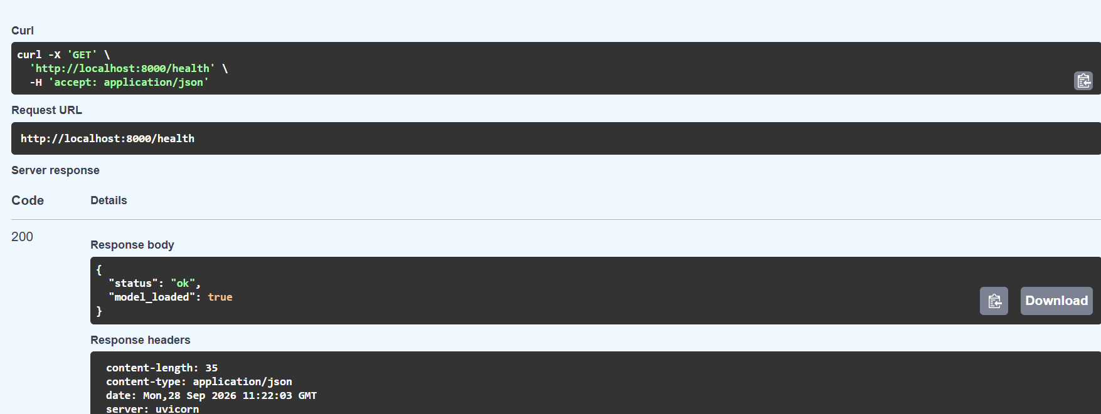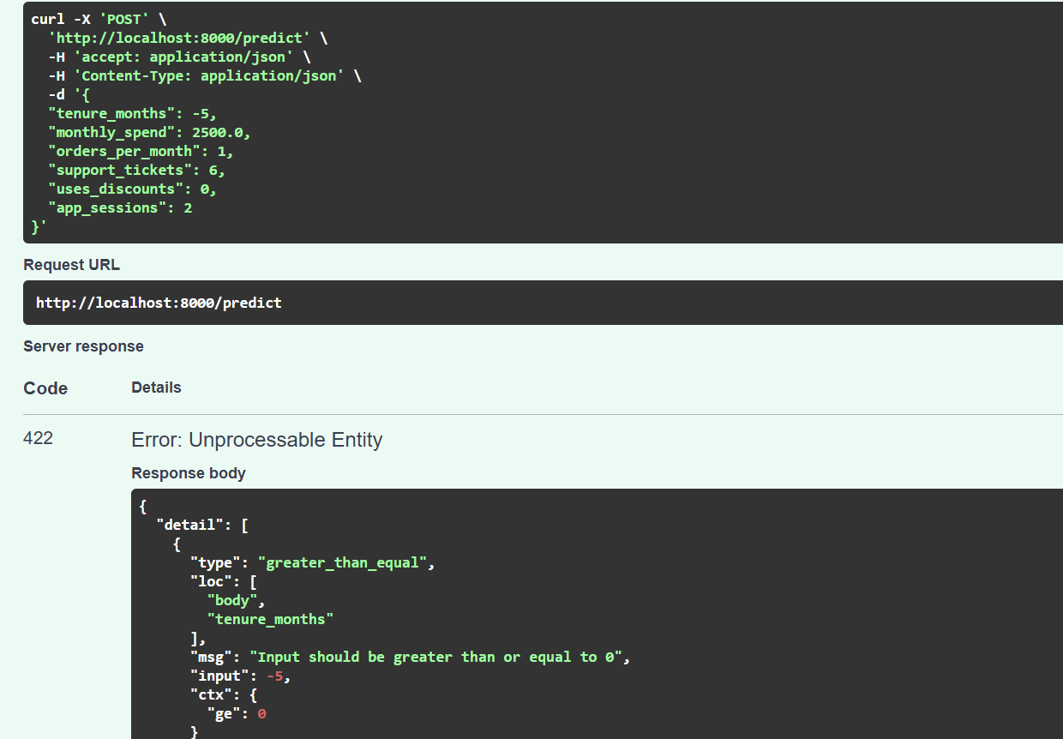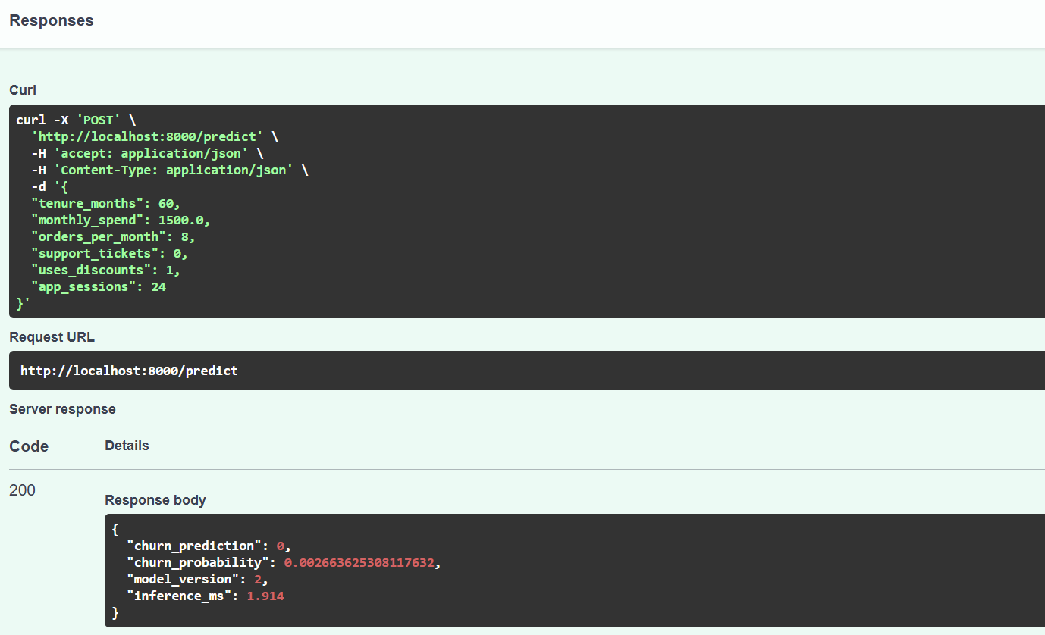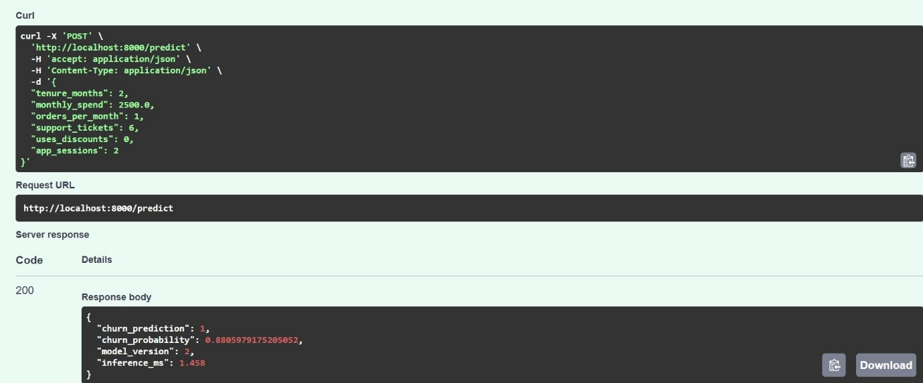 {
"health": {
"status": 200,
"body": {
"status": "ok",
"model_loaded": true
}
},
"model": {
"status": 200,
"body": {
"model": "cartvista-churn",
"alias": "champion",
"version": 2,
"run_id": "f0dc4382ba9840789fd4d27177ad45a5"
}
},
"at_risk": {
"status": 200,
"body": {
"churn_prediction": 1,
"churn_probability": 0.8805979175205052,
"model_version": 2,
"inference_ms": 1.953
}
},
"loyal": {
"status": 200,
"body": {
"churn_prediction": 0,
"churn_probability": 0.002663625308117632,
"model_version": 2,
"inference_ms": 1.311
}
},
"invalid": {
"status": 422,
"body": {
"detail": [
{
"type": "greater_than_equal",
"loc": [
"body",
"tenure_months"
],
"msg": "Input should be greater than or equal to 0",
"input": -5,
"ctx": {
"ge": 0
}
}
]
}
},
"empty_batch": {
"status": 422,
"body": {
"detail": [
{
"type": "too_short",
"loc": [
"body",
"customers"
],
"msg": "List should have at least 1 item after validation, not 0",
"input": [],
"ctx": {
"field_type": "List",
"min_length": 1,
"actual_length": 0
}
}
]
}
}
}