DBA4301 – Business Analytics Solutions: Development and Deployment

Individual Assignment 2
Name: Sai Ashwin Kumar Chandramouli
ID No: A0329294U

Task A (Problem Formulation):
Business Question: Can we predict the expected sales demand and revenue for each product across stores/customer segments in the next sales period using historical sales transactions and related dimension data?
Business Challenge/Opportunity: From the previous Individual Assignment, the data warehouse contains a detailed fact_store_sales table connected to key dimensions such as product, customer/store, time, and salesperson. This allows the business to understand not just what was sold, but also where it was sold, when it was sold, who sold it, and which customer or store segment generated the sale.
The main business challenge is that sales demand is not constant. It can change depending on product categories and subcategories, store locations, customer territories, seasonal periods, salesperson performance, customer buying behaviour, pricing, discounts, and product cost or margin patterns.
Without predictive analytics, the business mainly relies on historical reports and reacts after sales have already happened. This can result in inaccurate inventory planning, missed sales opportunities, excess stock for slow-moving products, and less effective sales targeting.
By predicting future product-level demand or revenue, the business can plan inventory more accurately, identify high-demand products earlier, improve stock allocation across stores, support sales teams with better forecasts, and make better revenue and profit margin plans.
Overall, the opportunity is to move from purely descriptive reporting to more forward-looking sales planning, where historical sales data is used to support better business decisions before the next sales period begins.
Analytics solution to be implemented: The proposed analytics solution is to build a supervised machine learning regression model to predict future sales demand or revenue at a product-store-period level.
The main dependent variable for the model is next_period_net_sales, which represents the expected net sales for the next sales period. To create this target variable, the transaction-level data from fact_store_sales can be aggregated into a monthly product-store dataset. For example, each row can represent a specific product sold to a specific store or customer segment in a particular month, with fields such as total quantity sold, net sales, margin, discount, and related product, customer, time, and salesperson attributes.
The model then learns historical sales patterns from these aggregated records and predicts the next period’s net sales value. Since the output is a continuous numerical value, this is a regression prediction problem.
In business terms, the solution predicts the expected net sales amount for a product in a store or customer segment in the next month. This allows the business to move from simply reviewing past sales to proactively forecasting demand and planning inventory, sales targeting, and revenue expectations more effectively.

Task B (Model Development):
The model development process started with a baseline supervised regression model to predict next_period_net_sales, which represents the expected net sales for a product-store/customer combination in the next sales period. The independent variables included product attributes, store/customer information, salesperson information, time-based features, current-period sales measures, lag features such as previous_month_sales, rolling demand features such as rolling_avg_sales_3m, margin, discount, and other engineered business features. The dataset was split into 70% training, 10% validation, and 20% testing to ensure that model selection and final evaluation were kept separate.
The baseline model used Linear Regression, with standard preprocessing steps including missing value imputation, scaling for numerical variables, and one-hot encoding for categorical variables. Three alternative models were then developed: Ridge Regression, Random Forest Regressor, and Gradient Boosting Regressor. Ridge Regression was included as a regularised linear model to reduce overfitting compared to ordinary linear regression, while Random Forest and Gradient Boosting were included because tree-based ensemble models can capture non-linear relationships and interaction effects between product, store, pricing, discount, and historical demand variables. All models were evaluated using the same metrics: MAE, RMSE, and R², so that performance could be compared consistently.
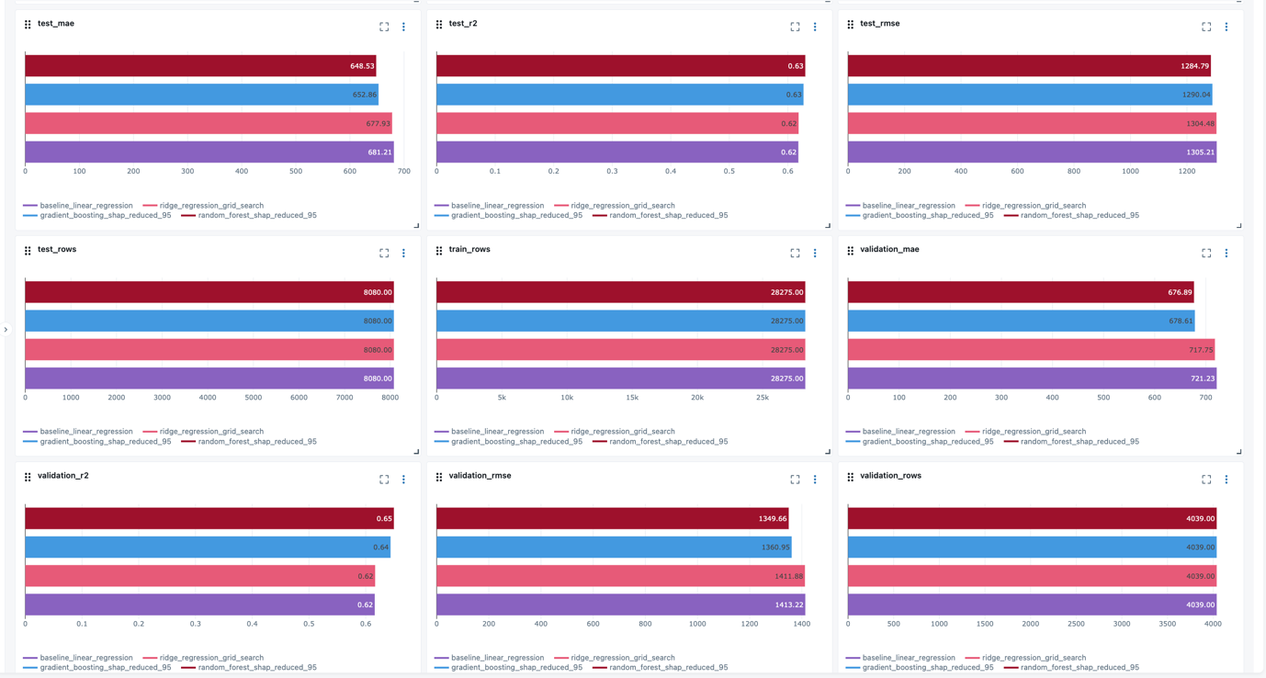
Figure B1: MLflow experiment comparison chart showing Linear Regression, Ridge Regression, Random Forest, and Gradient Boosting with validation/test MAE, RMSE, and R².
MLflow was used to track the full model development lifecycle. For each model, the experiment logged the algorithm, hyperparameters, preprocessing pipeline, evaluation metrics, model signature, input example, and registered model artifact. This made it possible to compare model performance in a structured way and reproduce each experiment later. After the initial model comparison, the two strongest production candidates, Random Forest and Gradient Boosting, were further refined using SHAP-based feature importance. The SHAP values were sorted in descending order of absolute feature importance, and only the features required to capture approximately 95% of the total feature importance were retained. This reduced the number of input features, making the final models easier to explain, deploy, and use in the web application, while still preserving most of the predictive signal.
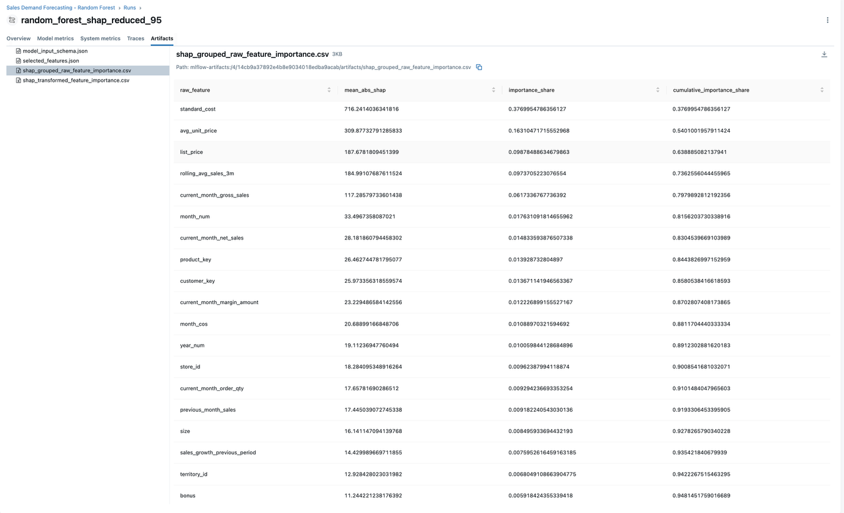
Figure B2: SHAP feature importance table for Random Forest showing selected features and cumulative importance up to 95%.
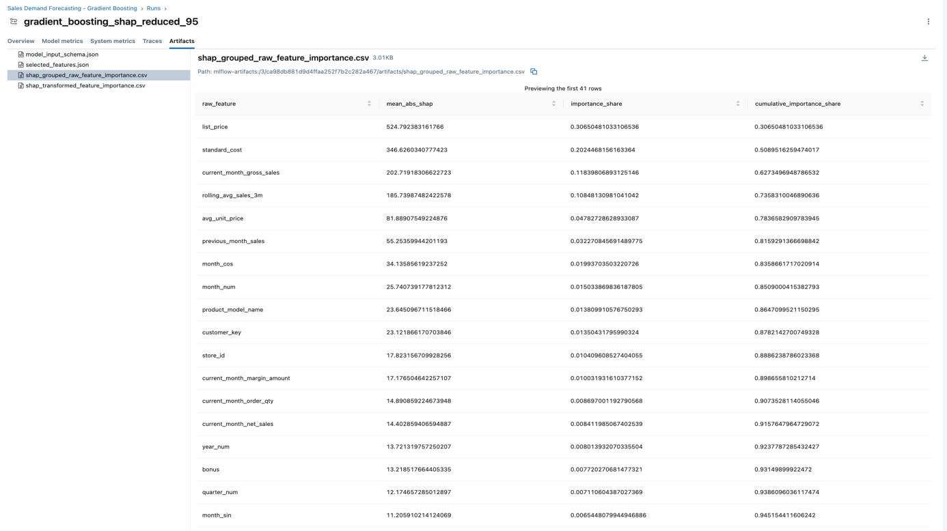
Figure B3: SHAP feature importance table for Gradient Boosting showing selected features and cumulative importance up to 95%.
Based on the MLflow evaluation results, the best model selected for productionisation was Random Forest, because it achieved the best or most acceptable balance of predictive performance and deployability. Compared with the baseline Linear Regression model, the selected model achieved a lower test RMSE of 1284.79 compared to the baseline RMSE of 1305.21, and a better R² of 0.65 compared to 0.62. The improvement suggests that the selected model was better able to capture complex demand patterns across products, stores/customer segments, time periods, discount behaviour, margin patterns, and historical sales trends. In addition, the reduced SHAP-selected feature set made the production model more suitable for deployment, because the web application only needs to collect the most important business inputs from the user, while derived features such as quarter, seasonality flags, discount percentage, and sales growth can be calculated automatically.
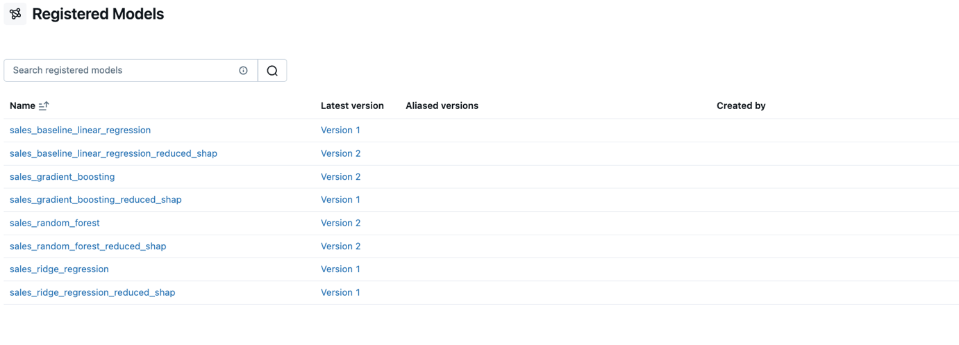
Figure B4: MLflow registered models page showing the registered versions of Linear Regression, Ridge Regression, Random Forest, and Gradient Boosting.
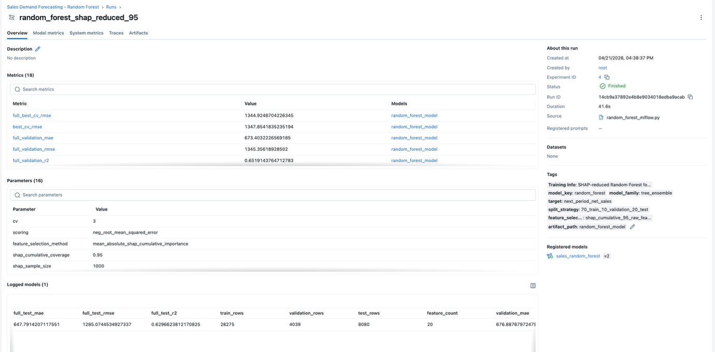
Figure B5: Best model run page in MLflow showing logged parameters, metrics, model artifact, and registered model version.
Model | Feature Set | Key Hyperparameters | Test MAE | Test RMSE | Test R² | Remarks
Linear Regression | Full features (41) | Default | 681.21 | 1305.21 | 0.62 | Baseline
Ridge Regression | Full features (41) | alpha = 100.0 | 677.93 | 1304.48 | 0.62 | Regularised linear model
Random Forest | SHAP-reduced (20) | n_estimators = 200, max_depth = 12,  min_samples_leaf = 2,  min_samples_split = 2 | 652.86 | 1290.04 | 0.63 | Non-linear ensemble
Gradient Boosting | SHAP-reduced (19) | n_estimators = 100, learning_rate = 0.1, max_depth = 4 | 648.53 | 1284.79 | 0.63 | Boosted ensemble

Table : Test-set performance comparison of the four regression models.

Task C (Model Productionisation):
For model productionisation, the selected forecasting solution was deployed as a REST web service using FastAPI and packaged inside a Docker container so that the prediction service could run in a consistent and reproducible environment. The API was integrated with the MLflow workflow and designed to load production-ready model artifacts at runtime, rather than relying on manually copied model files. This ensures that the deployed model remains aligned with the model tracked and registered during experimentation. Although one best model was identified for production based on evaluation metrics, the two strongest candidate models, Gradient Boosting and Random Forest, were both exposed through the API to support A/B testing in the downstream web application. This design allows the system to compare two strong production candidates under real usage conditions while still keeping the deployment architecture simple and model-driven. The deployed service exposes operational endpoints such as /health, /models, and /predict. The /health endpoint was used to verify that the containerised service was running correctly and that the model loading step had completed successfully. As shown in Figure C1, the health check returned a healthy status and confirmed that the service had successfully loaded both candidate models.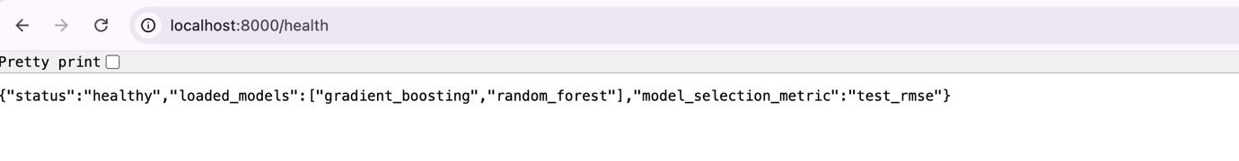
Figure C1: FastAPI /health endpoint confirming successful service startup and model loading
The /models endpoint was also used to inspect the loaded model metadata, including model name, required features, MLflow run information, and the evaluation metric used for model selection. As shown in Figure C2, this endpoint confirmed that the deployed service was connected to the MLflow model artifacts and had access to the required production model details.
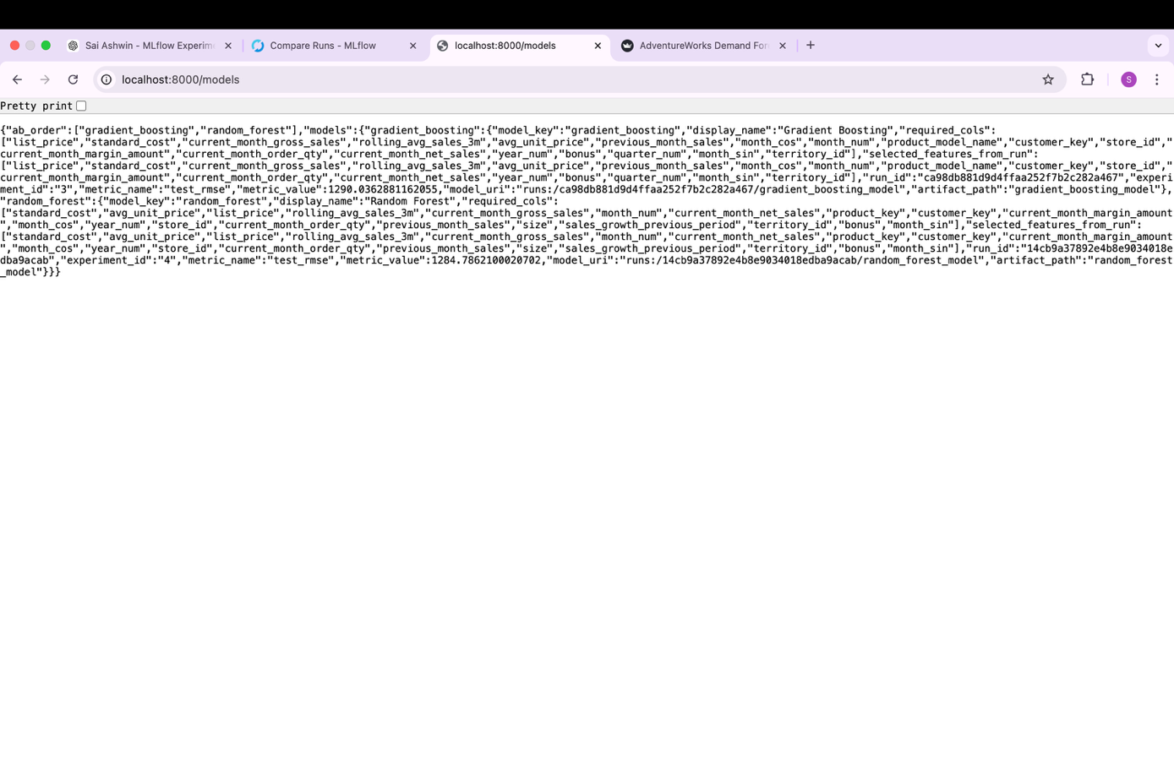
Figure C2: FastAPI /models endpoint showing deployed model metadata and MLflow-linked model details
To validate the inference service, the /predict endpoint was tested using Postman with a realistic JSON payload containing product, customer/store, time, and sales-related input variables. The API returned a successful HTTP 200 response together with a predicted next_period_net_sales value, demonstrating that the deployed model could accept structured business inputs and generate inference results correctly. As shown in Figure C3, the prediction endpoint returned a numerical sales forecast of approximately 120.83, which is a plausible output for the sample business scenario provided. This supports the face validity of the deployed service, since the prediction is consistent with the scale and nature of the historical sales inputs used in the request.
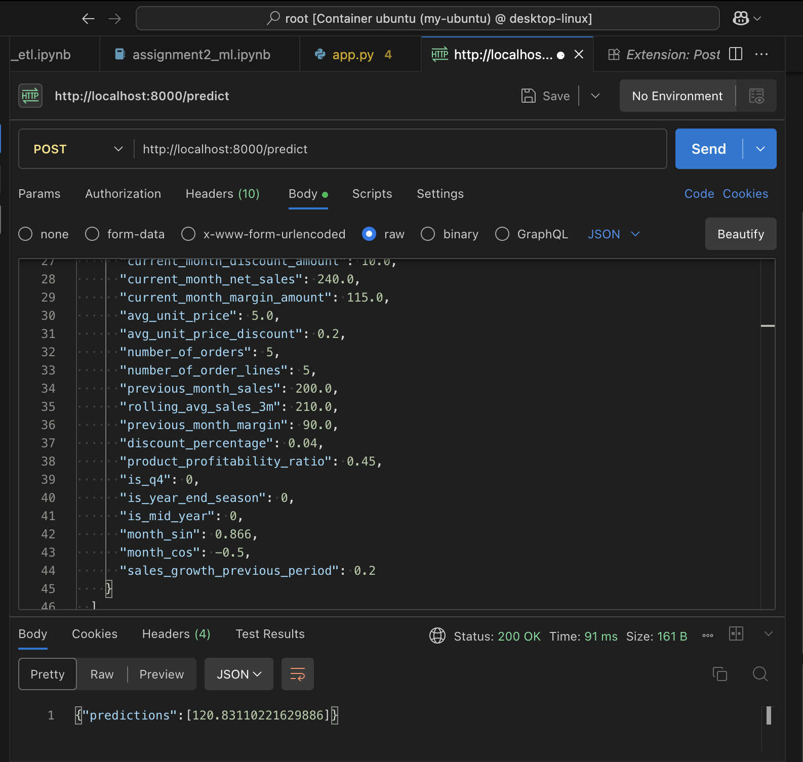
Figure C3: Postman test of the /predict endpoint with a realistic JSON payload and returned sales forecast

Overall, this demonstrates that the production API is operational, containerised successfully, connected to MLflow-managed model artifacts, and ready to serve prediction requests for downstream applications, while also providing the flexibility needed for A/B testing in the web application described in Task D.

Task D (Monitoring and Feedback Loop):
For Task D, a Streamlit-based web application was developed to consume the REST web service created in Task C and support forward-looking sales planning. The web application addresses the business problem by allowing the user to generate next-period demand forecasts at a product-store/customer level using realistic historical patterns rather than arbitrary manual inputs. As shown in Figure D1, the application includes a Data Explorer tab that summarises historical product-store combinations using reference data derived from the training dataset. This helps the user understand realistic sales patterns, such as which product-store combinations have higher average monthly sales, and supports selection of a historical combination as a starting point for prediction. 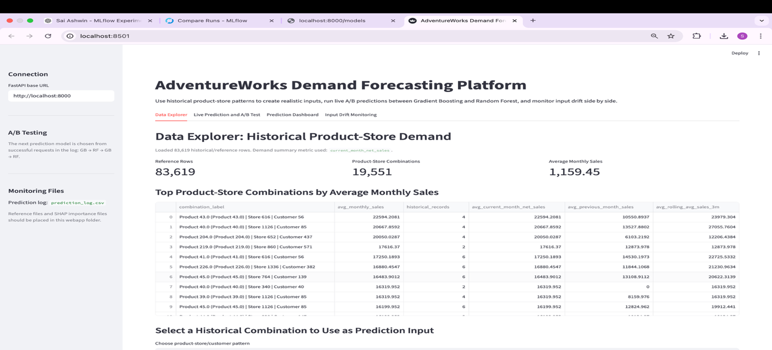
Figure D1: Data Explorer tab showing top product-store combinations by average monthly sales and historical reference summary
After a combination is chosen, the form is automatically pre-filled with representative historical values, and the user can then adjust key business variables such as month, current sales, discount amount, and previous month sales before running a forecast. As shown in Figure D2 and Figure D3, the Live Prediction page also displays the selected model’s input features in descending order of SHAP importance, together with each feature’s contribution to total importance, making the interface more interpretable and explainable from a business perspective.
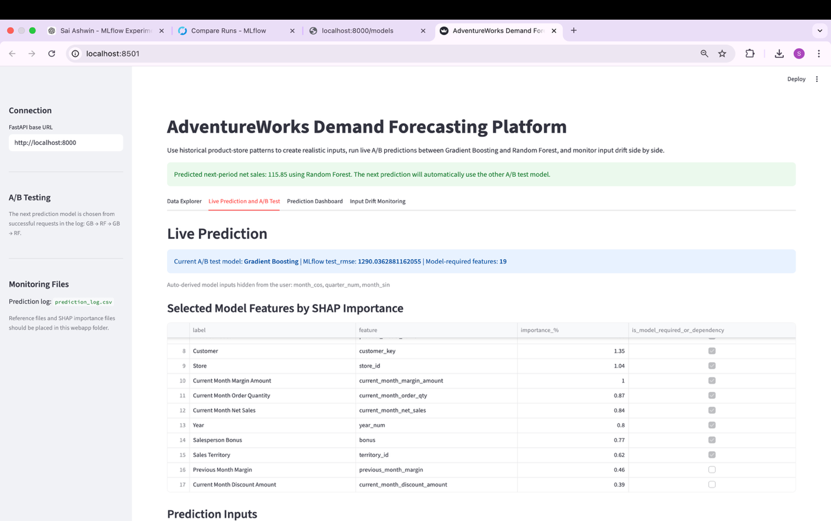
Figure D2: Web application after a prediction, showing successful forecast generation using A/B testing
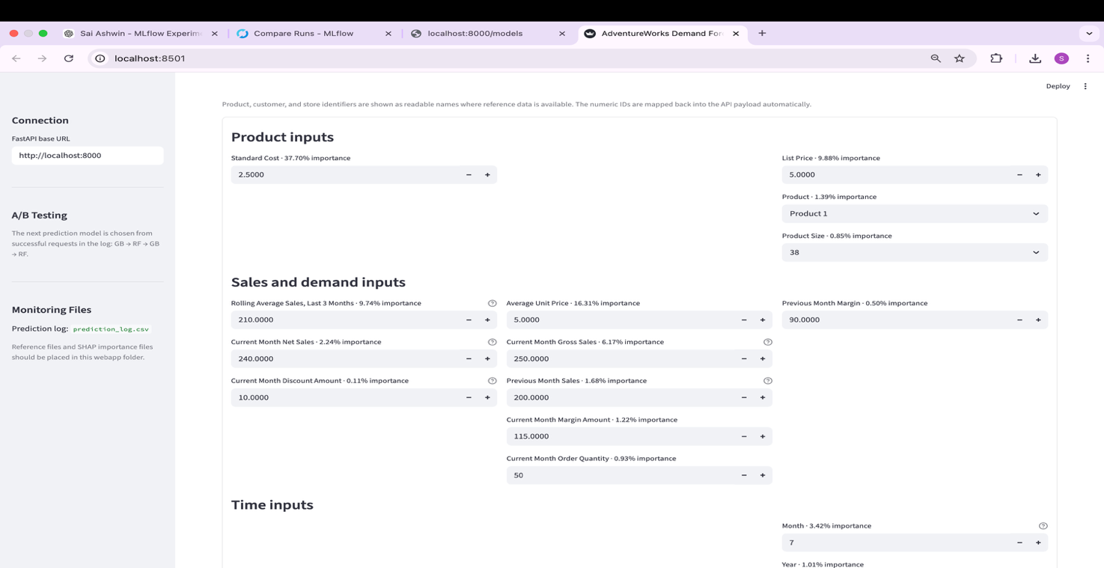
Figure D3: Live Prediction tab showing SHAP-ranked model features and user-adjustable business inputs
The same web application also implements a monitoring and feedback loop using input drift detection. In addition to supporting live predictions, the platform runs A/B testing between the two strongest production candidates, Gradient Boosting and Random Forest, by alternating predictions between the two models and logging the requests. As shown in Figure D4, the Prediction Dashboard compares both models side by side using post-production prediction counts, average predicted sales, latest prediction values, and the tracked MLflow performance metric. This provides a simple operational view of how each candidate model is being used in the production setting.
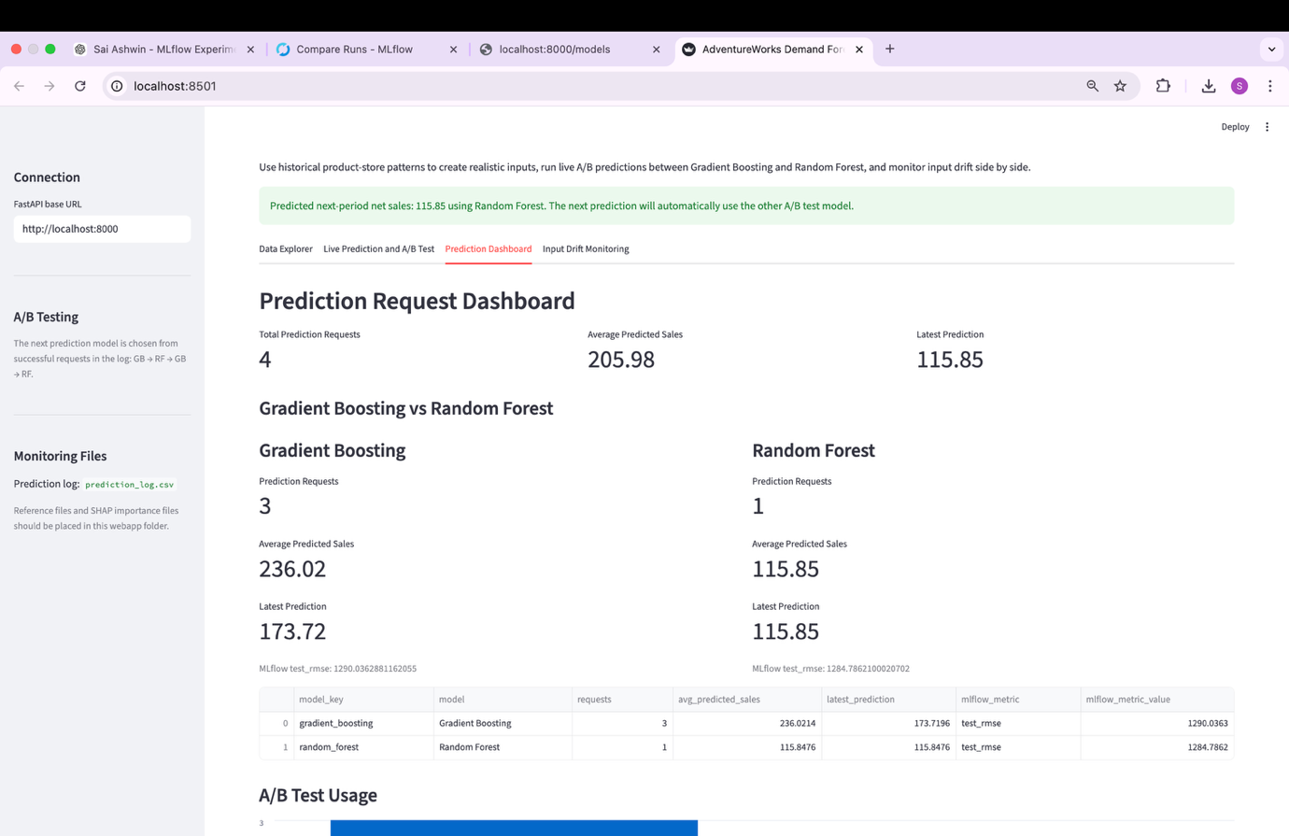
Figure D4: Prediction Dashboard comparing Gradient Boosting and Random Forest side by side
For monitoring, the application captures the post-production input data from live prediction requests and compares them against reference training input data for each model using univariate statistical tests and frequency-based checks. Specifically, numerical features are monitored using the Kolmogorov–Smirnov (KS) test, while categorical features are checked using category frequency shift. As shown in Figure D5, the Input Drift Monitoring tab presents a side-by-side comparison for Gradient Boosting and Random Forest, including reference record counts, production record counts, number of features with possible drift, and detailed drift tables. A combined drift detail table is also shown to consolidate drift signals across both models.
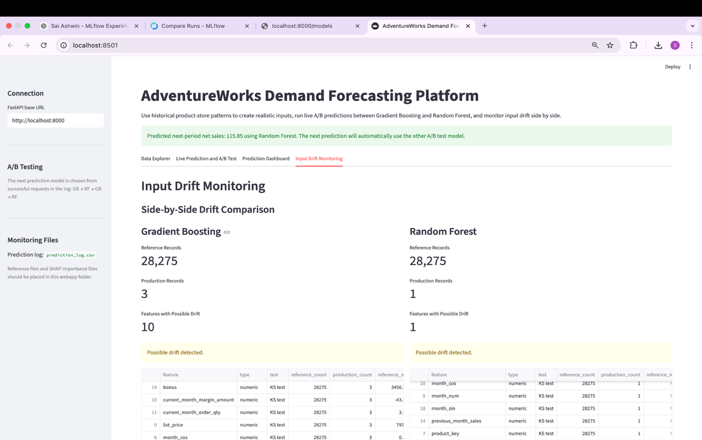
Figure D5: Input Drift Monitoring tab showing side-by-side drift comparison across both deployed models
Overall, this web application demonstrates not only how the production prediction service can be consumed to support business decision making, but also how post-deployment monitoring can be built into the same interface to track data quality and model reliability over time.
AI Declaration: I used ChatGPT 5.4 to assist with idea generation, code drafting, debugging, refinement of the MLflow, FastAPI, Docker, and Streamlit components, as well as improving the clarity and presentation of the written report sections for this assignment. All outputs were reviewed, adapted, tested, and validated by me, and I take full responsibility for the final submission.

