Name:saiba pathan
Rollno-09
Div-C
Lab-3
Lab Title : Docker Containerization & AWS ECR (CloudShell-Based Lab Manual)

Docker Containerization and Pushing Images to AWS Elastic Container Registry (ECR) Objective:
Build a Docker image from a simple web application and push it to AWS ECR (Elastic Container Registry) using AWS CloudShell.

Duration:
2 hours

Pre-requisites:
- AWS Free Tier account with ECR access
- GitHub account (optional)
- AWS CLI and Docker installed (CloudShell comes preconfigured)

Part A: Setup & Create Sample Docker App (15 mins)

1. Launch AWS CloudShell
- Open: https://console.aws.amazon.com/cloudshell
2. Create a Sample Web App with Dockerfile
3. Create a Dockerfile
Part B: Create ECR Repository (15 mins)

1. Create a new ECR repository
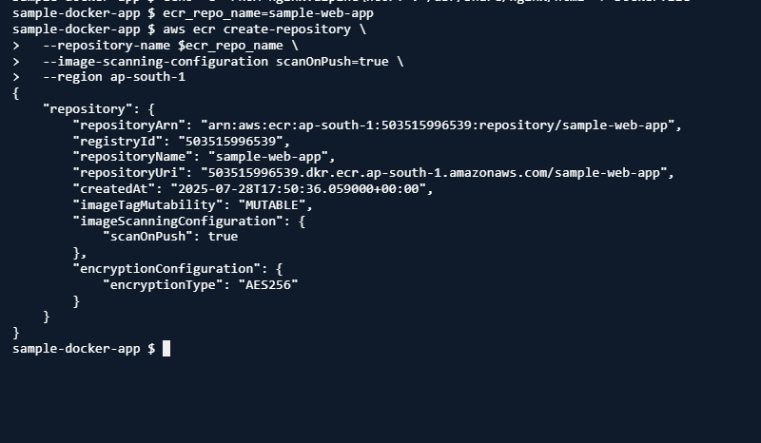Note down the repository URI returned by the command.
"503515996539.dkr.ecr.ap-south-1.amazonaws.com/sample-web-app",

Part C: Authenticate Docker to ECR (10 mins)

1. Authenticate Docker CLI to ECR
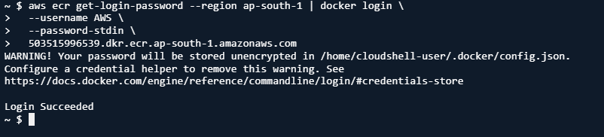
aws sts get-caller-identity --query Account --output text

Part D: Build and Tag the Docker Image (20 mins)

1. Build the Docker Image
docker build -t sample-web-app
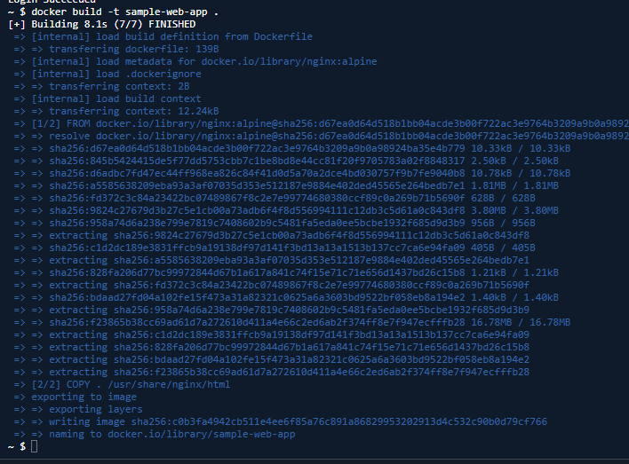 . 2. Tag the Image for ECR
repo_uri=<your-repo-uri-from-earlier> docker tag sample-web-app:latest $repo_uri:latest

Part E: Push Docker Image to ECR (15 mins)

1. Push the Tagged Image
docker push $repo_uri:latest
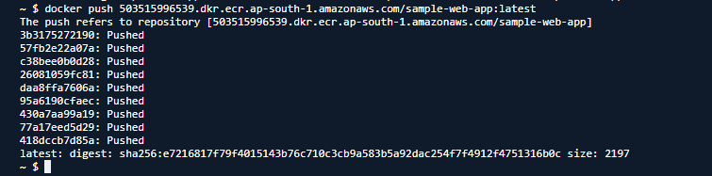
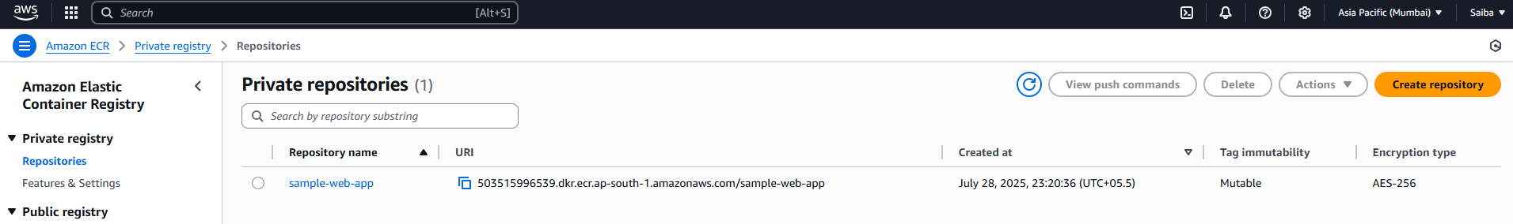
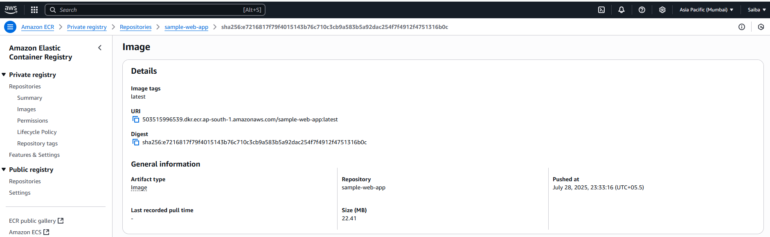

Part F: Cleanup (Optional)
If you wish to clean up after the lab:
aws ecr delete-repository --repository-name sample-web-app --force
To delete local image:
docker rmi $repo_uri:latest
