Name:- Saiba Pathan
Roll_no:- 09
Div:- C

Lab – 09
Title: Automating AWS Resource Management with AWS CLI in CloudShell
Objective:
Learn how to use AWS Command Line Interface (CLI) via CloudShell to automate the creation,
management, and deletion of AWS resources such as S3, EC2, IAM, and more.

Duration:
Approximate time taken to complete the lab: 2 Hours

Pre-requisites:
• AWS Free Tier account
• AWS CloudShell access
• Basic knowledge of Bash and AWS services

Lab Steps:
Part A – Introduction to AWS CLI & CloudShell

What is AWS CLI?
· A unified tool to manage AWS services via terminal commands.
· Useful for scripting and automation.
What is AWS CloudShell?
· A browser-based shell pre-authenticated with your AWS account.
· Pre-installed with AWS CLI and other tools.

Part B – Verify Environment

- Open CloudShell:
https://console.aws.amazon.com/cloudshell
- Check AWS CLI version:
- View Current IAM Identity:
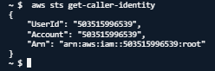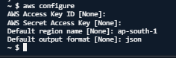
Part C – Automate S3 Operations
1. Create an S3 Bucket
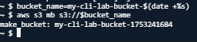
2. Upload a file:
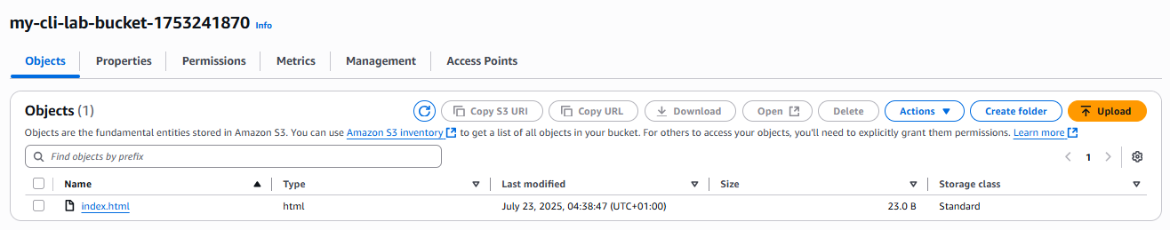
3. Enable static website hosting:
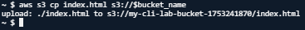
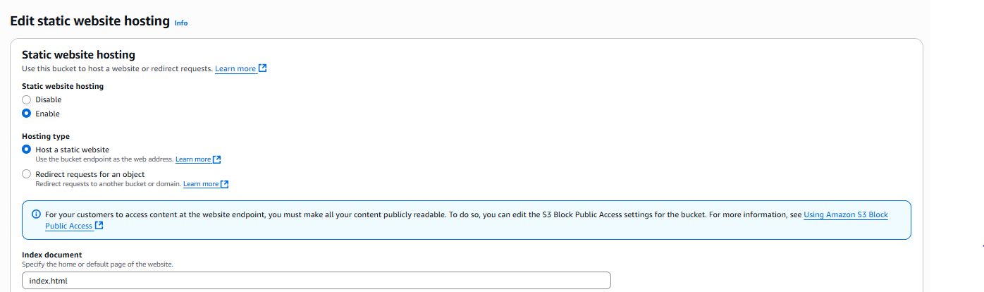

3.1 Allow public access: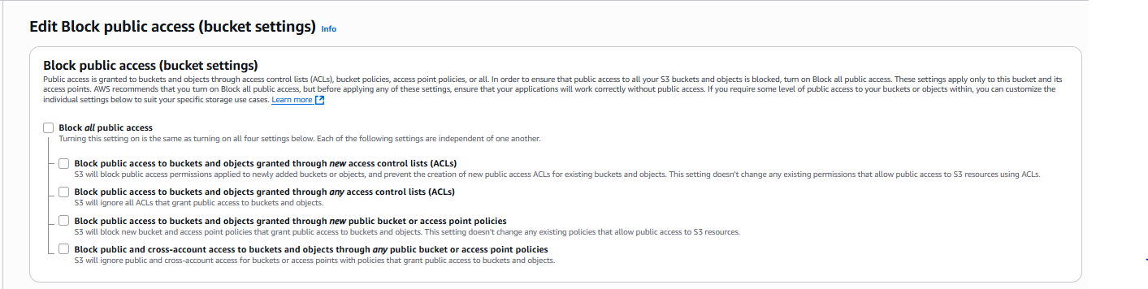
4. Make file public using bucket policy:
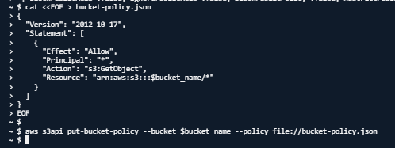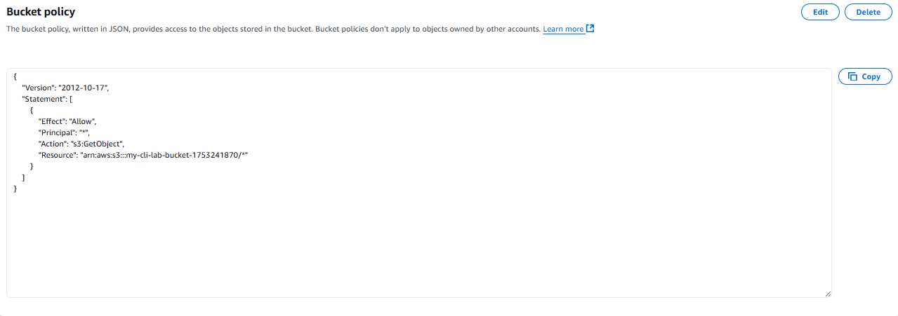
5. Test the static website URL:
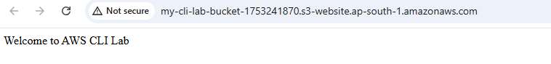
Part D – Automate EC2 Instance Launch
Launch EC2 instance:
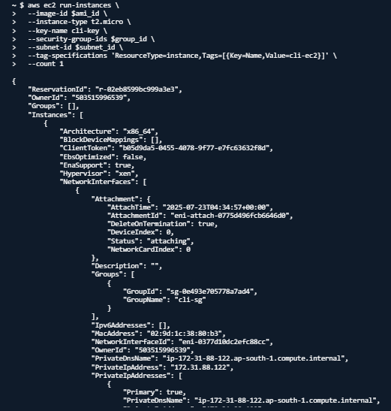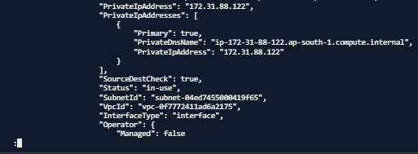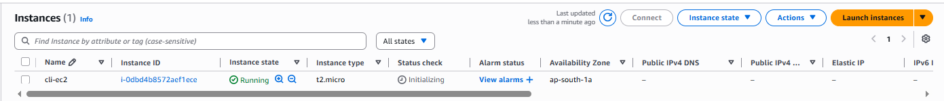
Part E – Automation Script Example
Create a reusable EC2 launch script:
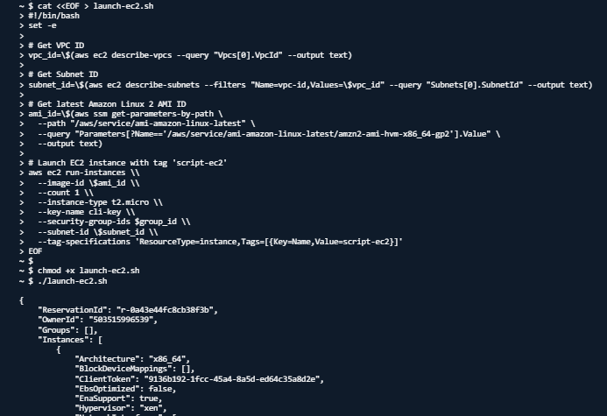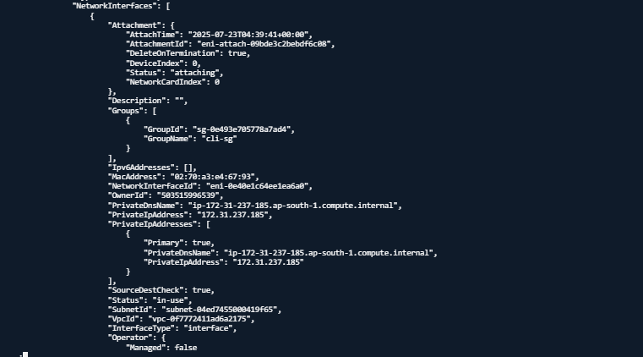
Part F – Cleanup Resources
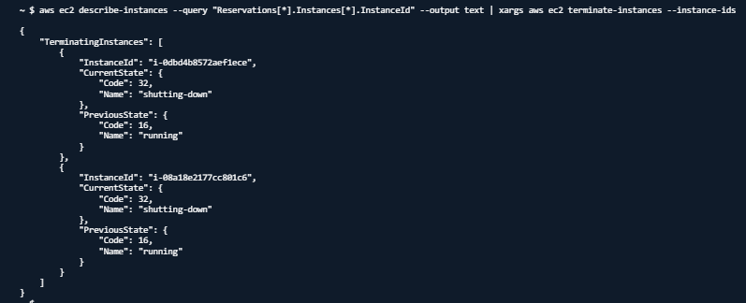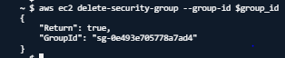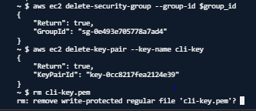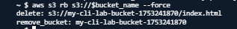
Observations / Challenges
• Be careful with variable references inside scripts (\$ami_id)
• Ensure region is set correctly in CloudShell
• Verify that subnet and VPC are correctly identified
• Some commands require permissions (e.g., IAM or EC2 actions)
Instructor Remarks
