Name:- Saiba pathan
Roll_no:- 09
Div:- C

Lab – 11
Title: Static Website Hosting with Amazon S3
Objective:
To host a simple static website using Amazon S3 by uploading an HTML file, enabling static website hosting, and accessing it via a public S3 endpoint.

Duration:
Approximate time taken to complete the lab: 2 Hours

Pre-requisites:
- AWS Free Tier account
- Simple index.html file (local or already created)
- Basic AWS Console navigation skills
- Public internet access to test the hosted page

Lab Steps:
Part A – Upload index.html to S3

- Go to AWS Console > S3
- Click Create Bucket
- Name: your-unique-bucket-name
- Region: e.g., ap-south-1
- Uncheck Block all public access
- Acknowledge the warning
- Click Create Bucket
- Open the bucket → Click Upload → Upload your index.html
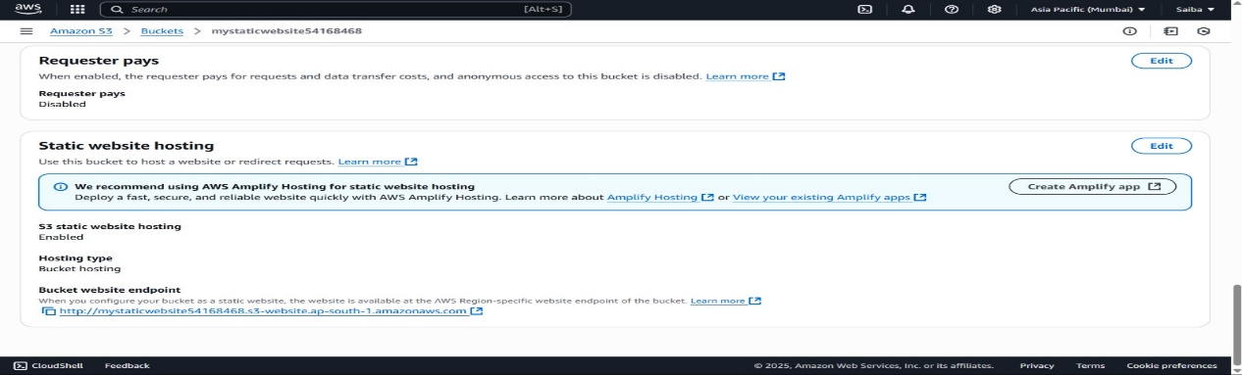
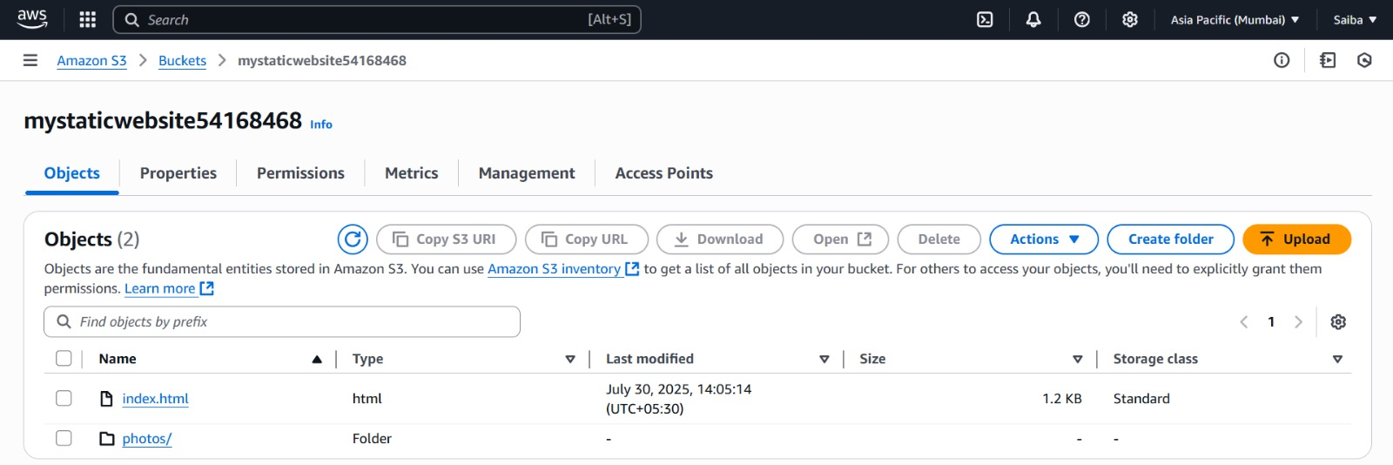

Part B – Enable Static Website Hosting
- In the same bucket, go to Properties
- Scroll down to Static Website Hosting
- Click Edit
- Choose Enable
- Enter:
- Index document: index.html
- Click Save
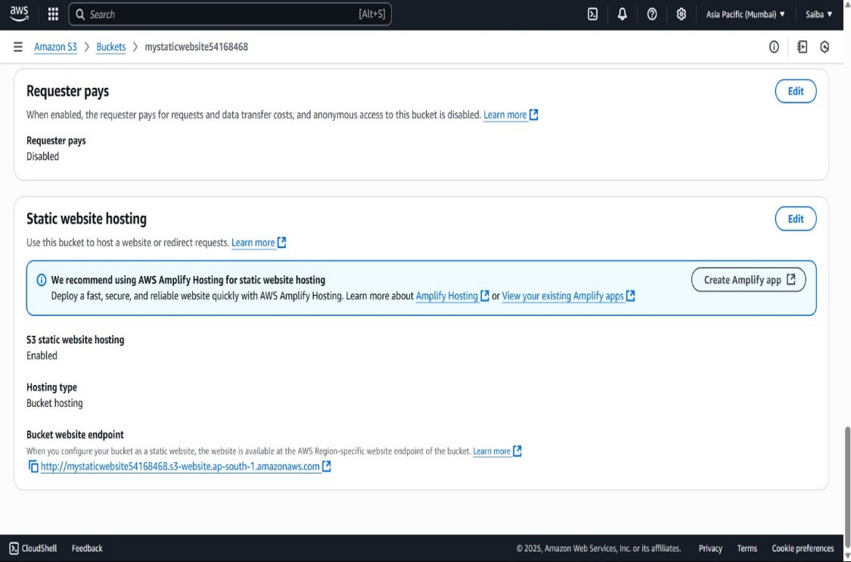
Screenshot 2: Static website hosting settings with endpoint URL
Part C – Set Bucket Policy to Allow Public Access
- Go to the Permissions tab
- Scroll to Bucket Policy → Click Edit
- Add the following policy:
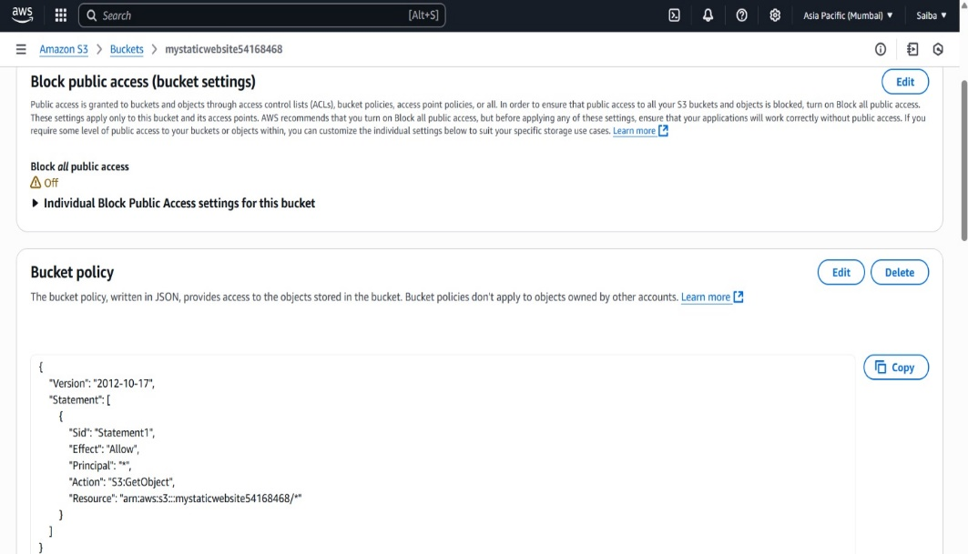
Screenshot 3: Bucket policy allowing public read
Part D – Access the Website
- Go to Properties > Static Website Hosting
- Copy the Endpoint URL
- Paste in browser → You should see your hosted HTML page
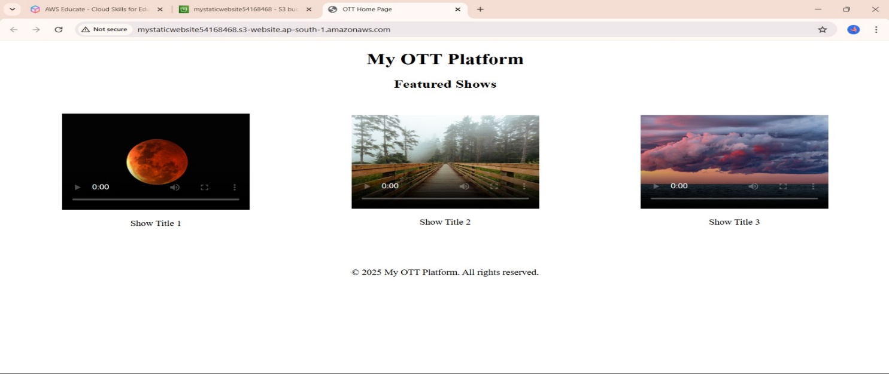
Screenshot 4: Webpage rendered using S3 public URL

Part E-(optional) • Open AWS Console → Go to CloudFront
Click “Create Distribution”
Under Origin domain, select:
S3 bucket
or EC2/static website
or custom domain
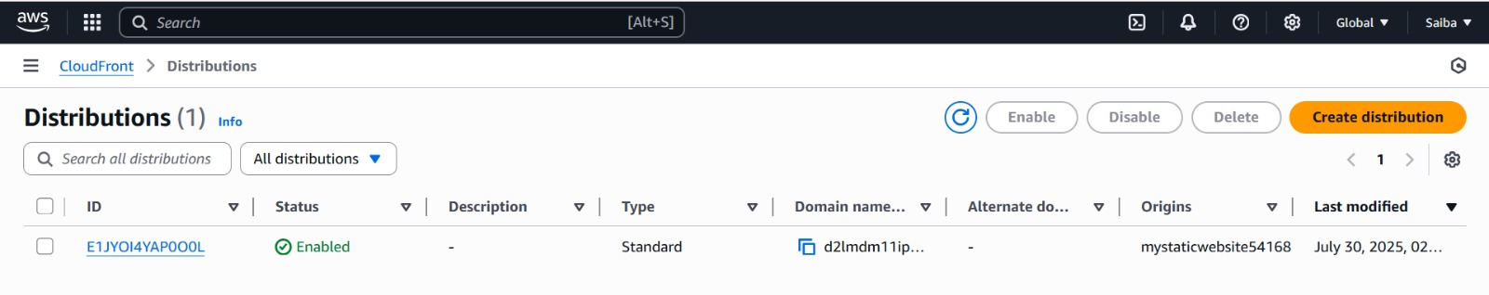
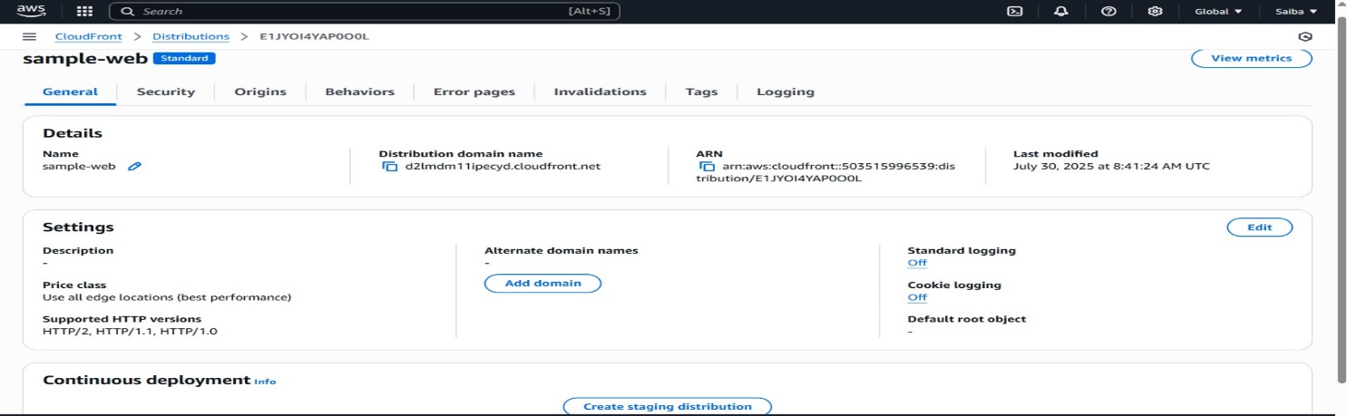
(optional)

CDN Testing / Website Performance Tools
These tools check how “soft” (i.e., fast, optimized, cacheable, CDN-ready) your website is:

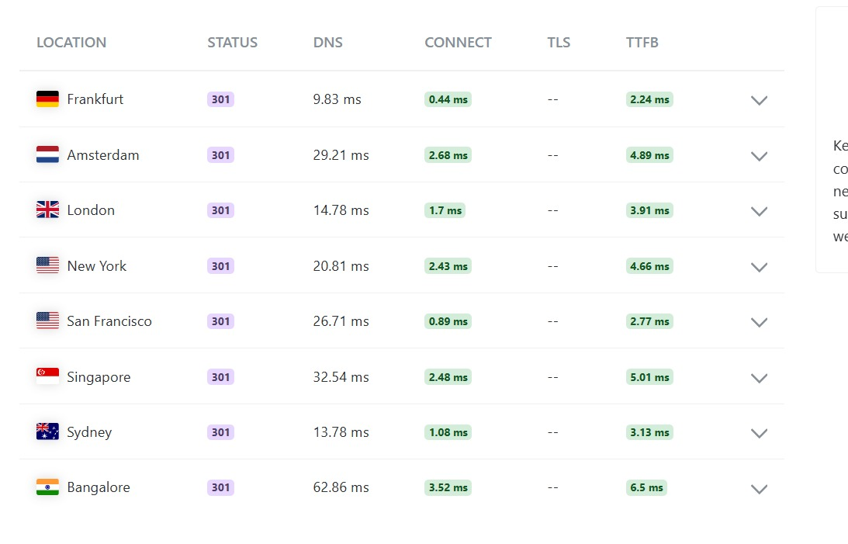

Observations / Challenges
- Forgot to uncheck "Block all public access" → page won’t load
- Bucket policy error → use correct JSON format and replace bucket name
- Using Index.html (capital I) → doesn't work unless exactly matched
Instructor Remarks

