Name: Saiba Pathan
Roll No: 09
Div: C
Lab 3A
Title : Getting Started with Docker in AWS Cloud Shell
Objective
- Understand and run basic Docker commands
- Build and run your own Docker container
- Use AWS Cloud Shell environment
Duration
Approximate time to complete the lab: 1.5 hours
Pre-requisites
- AWS Free Tier Account
- AWS Cloud Shell (pre-installed with Docker + AWS CLI)
PART A: Introduction and Setup (10 mins)
- OpenAWsCloudSel
URL: https://console.aws.amazon.com/cloudshell Choose region (e.g., ap-south-1)
- Verify Docker Installation docker --version docker info
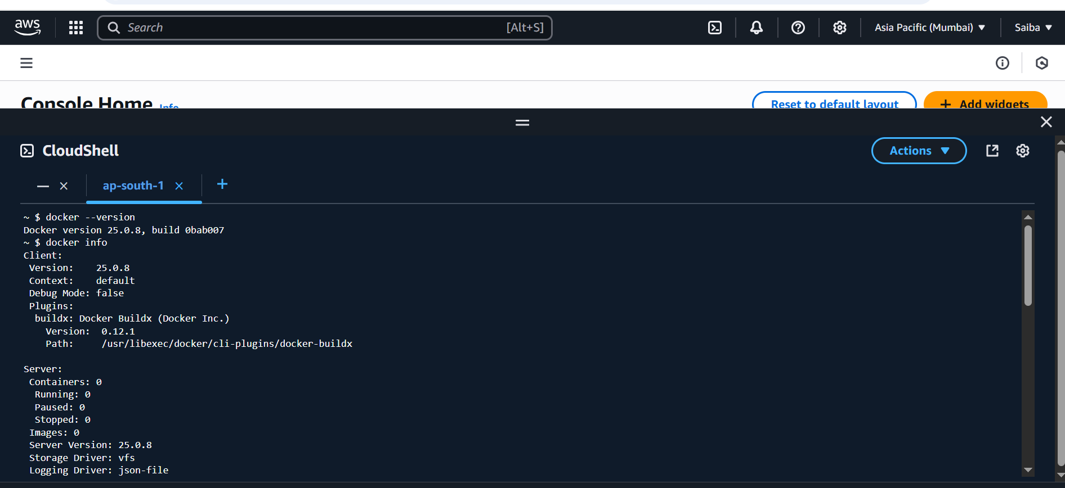

PART B: Run and Explore Docker Container (20 mins)
- Run a Simple Container docker run hello-world
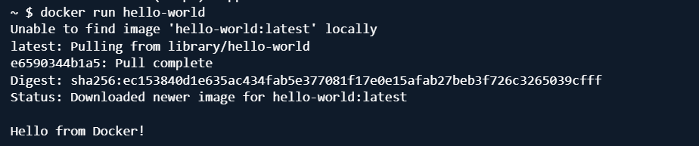
- Run Interactive Ubuntu Container docker run -it ubuntu /bin/bash
Inside container:
ls
uname -a exit
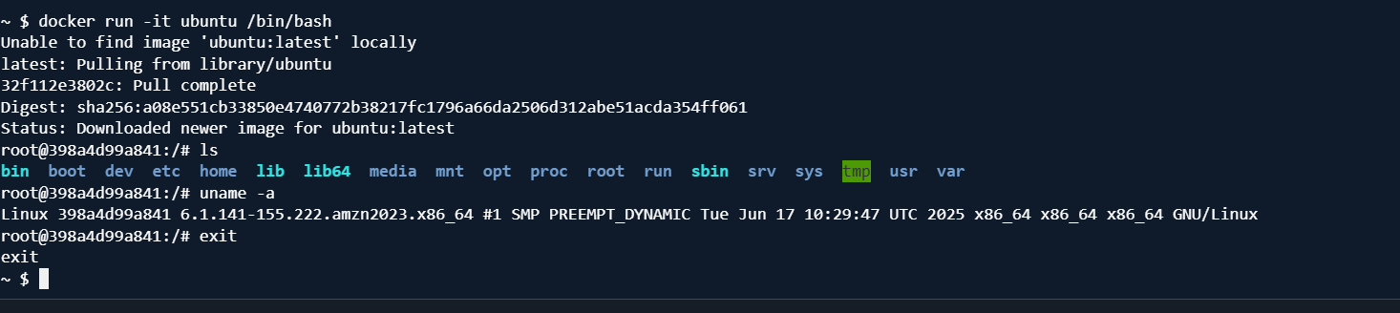
- List Containers docker ps , docker ps –a
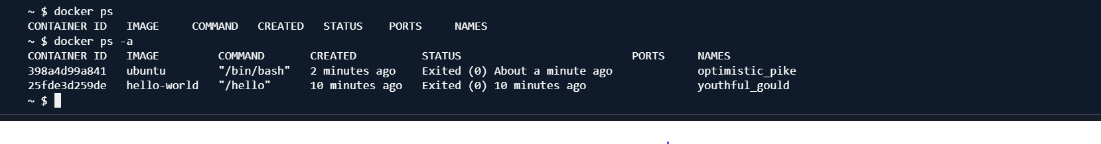
PART C: Docker Images and Lifecycle (30 mins)
1. Search and Pull Alpine Image docker search alpine docker pull alpine
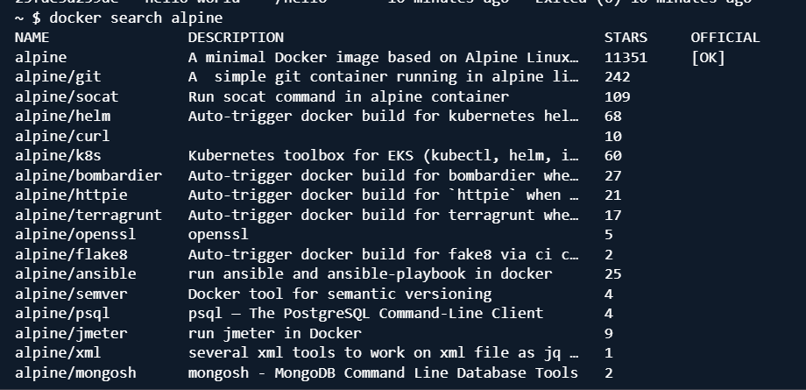
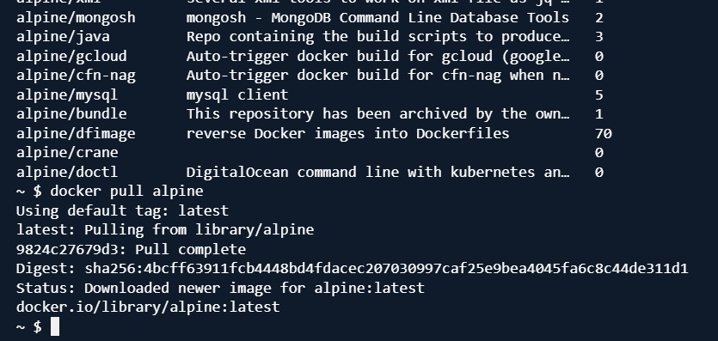
docker run alpine echo "Docker is awesome!"
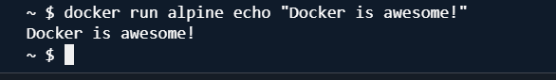
- Image Inspection & Cleanup docker images , docker rmi alpine docker system prune -f
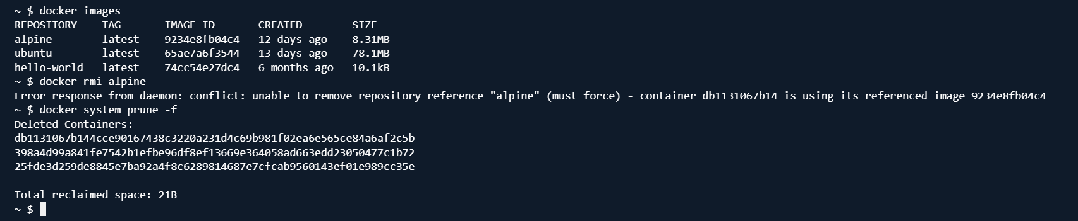
PART D: Build Your Own Docker Image (30 mins)
- Create Web App Files
mkdir ~/docker-lab && cd ~/docker-lab echo '<h1>Hello from Docker!</h1>' > index.html
- Create Dockerfile echo -e 'FROM nginx:alpine\nCOPY . /usr/share/nginx/html' > Dockerfile
- Build Docker Image docker build -t my-web-app .
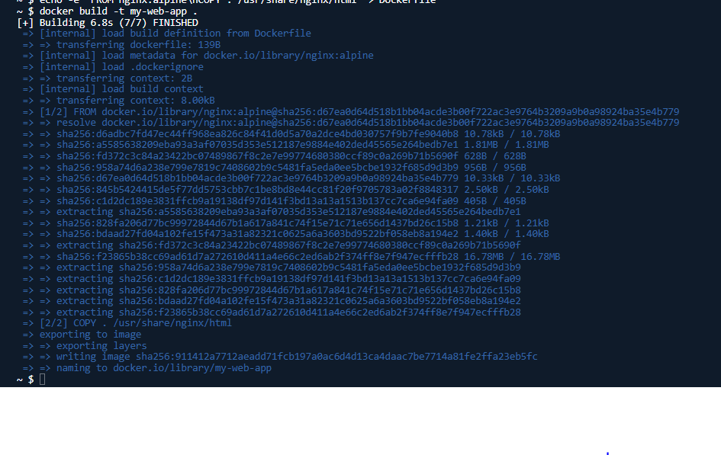
- Run Container from Image docker run -d -p 8080:80 my-web-app
- Preview App
In CloudShell:

Key Takeaways
- Run and explore Docker containers using AWS CloudShell
- Build your own Dockerfile and image
- Host a basic web page with NGINX in Docker

