Practice: Process management and monitoring commands

Here are detailed questions (with examples and screenshots) on process management and monitoring commands in Linux:

ps – Report a snapshot of current processes

1.How would you use ps to display all processes running on the system, not just those owned by the current user?

Use the ps aux command:

2. What is the difference between ps -e , ps -f , and ps -ef ?

Provide examples.

ps -e : Displays all processes.

ps -f : Provides a full-format listing with additional details.

ps -ef : Combines both to show all processes in full format.

Example:

3. How can you use ps to find the PID of a specific process (e.g., nginx )?

Use the grep command with ps :

4. How can you display hierarchical information about parent and child processes using ps ?

Use the ps --forest option (or --ppid for specific parent PIDs):

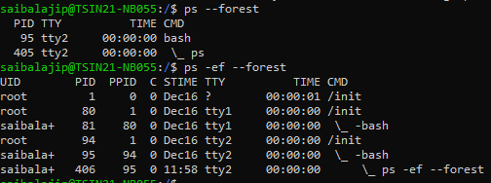

top / htop – Display real-time process information

5. What is the difference between top and htop ? Why might you prefer one over the other?

top is a standard CLI tool but lacks interactivity.

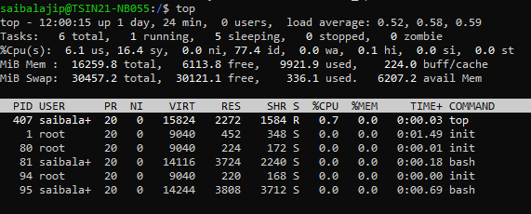

htop is more user-friendly with an interactive interface for killing processes, filtering, and sorting.

6. How can you sort the output of top by memory usage instead of CPU usage?

While in top , press M to sort by memory.

7. How can you monitor processes belonging to a specific user using top ?

Use the -u option followed by the username:

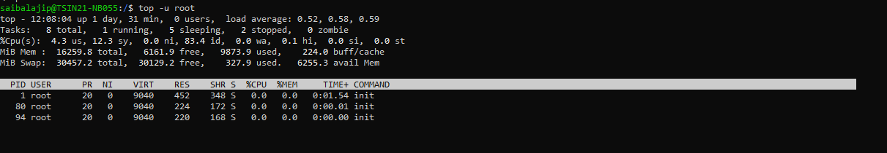

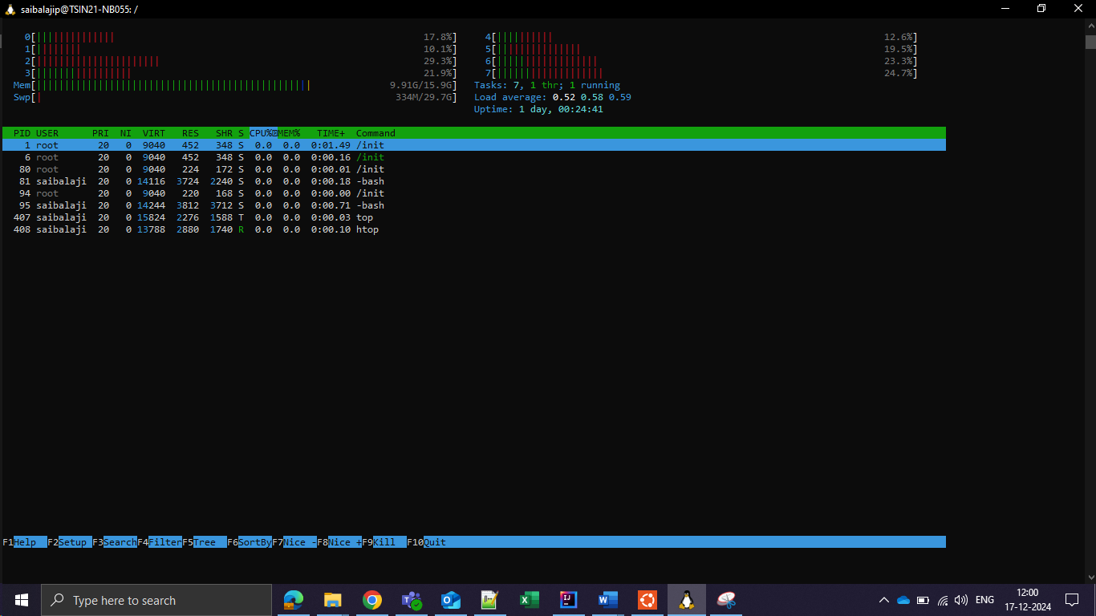

8. How can you use htop to search for a specific process?

Press / in htop and type the process name to search.

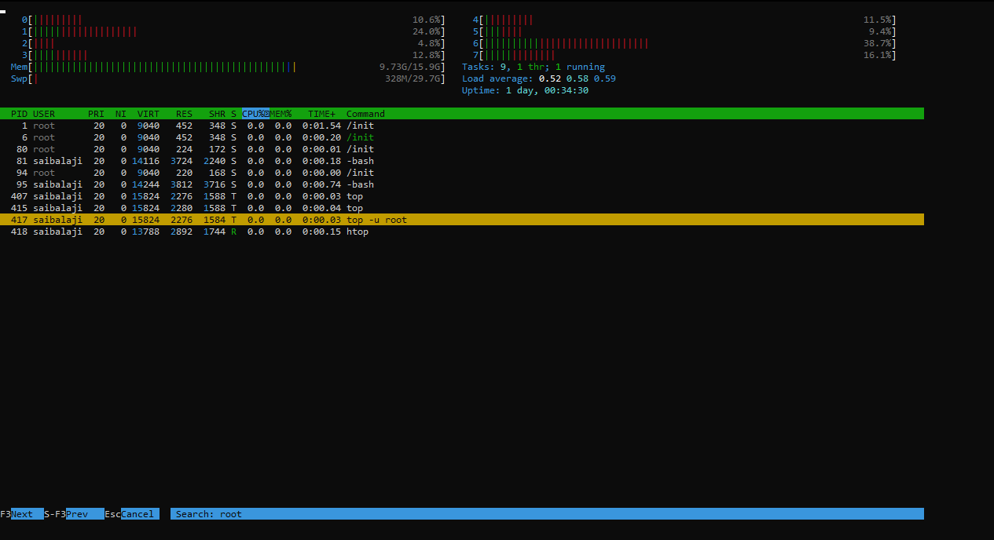

9. Explain the significance of the load average displayed in top . What do the three numbers represent?

Load average indicates the average number of processes waiting to run over the last 1, 5, and 15 minutes. Example:

10. How can you kill a process directly from htop ?

Highlight the process using arrow keys and press F9 to kill it.

kill – Terminate processes by PID

11. What is the syntax for using kill to terminate a process with a known PID?

Use the kill command followed by the PID:

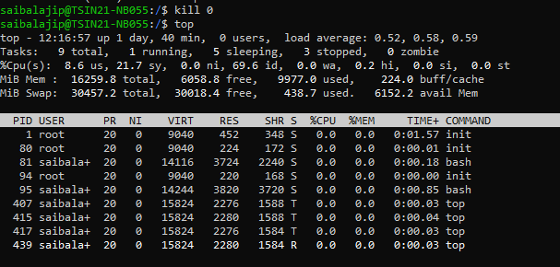

12. What does kill -9 do? Why is it different from kill -15 ?

kill -9 : Sends a SIGKILL signal to forcefully terminate the process.

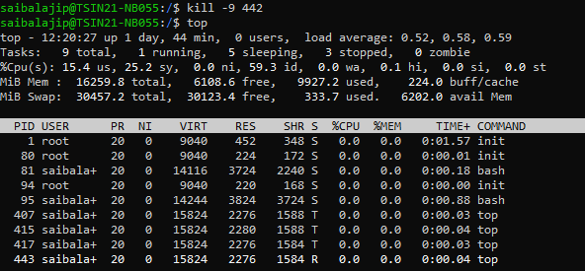

kill -15 : Sends a SIGTERM signal, allowing the process to exit gracefully. Example

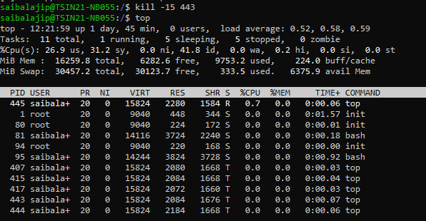

13. How can you kill all processes owned by a specific user using kill ?

Use kill with the output of the ps command:

kill -9 $(ps -u username -o pid=)

pkill – Kill processes by name

14. How is pkill different from kill ?

Provide an example of each.

pkill : Kills processes by name.

kill : Requires specifying the PID.

15. How can you ensure pkill only terminates processes owned by a specific user?

Use the -u option:

16. How can you send a specific signal (e.g., SIGHUP) using pkill ?

Use the -SIGHUP

option: 2 1 kill -15 1234 2 kill -9 1234 3 1 kill -9 $(ps -u username -o pid=) 2 1 pkill nginx 2 1 kill 1234 2 1 pkill -u username process_name 2 1 pkill -SIGHUP process_name 2 nice / renice – Change process priority

17. What is the purpose of nice ? How do you start a process with a lower priority?

Use nice followed by the priority value and command:

18. How can you change the priority of a running process using renice ?

Use the renice command followed by the priority and PID:

19. What is the range of priority values in nice ? What do negative and positive values signify? Range: -20 (highest priority) to 19 (lowest priority). Negative values indicate higher priority.

20. How can you check the priority of a process?

Use the ps -l command: nohup – Run processes immune to hangups

21. What does nohup do, and why is it useful? Provide an example.

Runs a command immune to hangups (e.g., closing the terminal):

22. Where does nohup store the output of a command by default? How can you change this?

By default, output goes to nohup.out . You can redirect it: bg / fg – Move processes to the background/foreground

23. How can you send a running process to the background?

Press Ctrl+Z to suspend it, then use bg to resume in the background: 1 nice -n 10 my_program 2 1 renice 5 -p 1234 2 1 ps -l 2 1 nohup my_program & 2 1 nohup my_program > my_output.log & 2

24. How can you bring a background process to the foreground?

Use fg followed by the job number:

25. What is the difference between backgrounding a process with & and using Ctrl+Z + bg ? & starts a process in the background directly.

Ctrl+Z + bg suspends and resumes a foreground process in the background.

26. How can you list all background jobs in the current shell session?

Use the jobs command:

