Title: Insurance Premium Data
Name: Saiba Sifat
Date: 2nd December, 2025
Tool Used: SQL and Tableau
Dataset: Insurance Premium Dataset (Kaggle)

Dataset Description
This is a basic health insurance dataset where each row represents one policyholder. The data captures demographic, lifestyle, and regional attributes that influence insurance premium charges.
Columns included:
- Age – Age of the policyholder
- Gender – Gender of the policyholder
- BMI – Body Mass Index of the policyholder
- Children – Number of children covered under the policy
- Smoker – Indicates whether the policyholder is a smoker or non-smoker
- Region – Region where the policyholder resides
- Charges – Insurance premium charged
Methodology
Data Cleaning & Preparation
- Verified data quality and consistency using Excel
- No major missing or duplicate values were identified
- Renamed columns for clarity and consistency
- Created calculated fields in Tableau: Age Range (18–25, 26–35, 36–45, 46+), BMI Category (Underweight, Normal, Overweight, Obese), Children Group, Smoker / Non-Smoker
Data Exploration (EDA)
- Used SQL to compute summary statistics and grouped aggregations.
- Computed mean-based aggregations in SQL and extended the analysis using SQL window functions to calculate median charges and perform IQR-based outlier detection. Tableau was used for interactive visualization and dashboard development.
- Explored relationships between demographic, lifestyle, and financial variables.
- Used Tableau to visualize trends and patterns through interactive dashboards, including a smoker × BMI interaction analysis.
Executive Summary
This project analyses key factors affecting insurance premium charges. Smoking status is the single strongest driver of cost, and its effect compounds sharply with BMI: obese smokers average $41,558, roughly double the $19,942 average for normal-weight smokers, while the same BMI difference barely moves cost for non-smokers ($8,863 vs $7,600). Charges are right-skewed (mean $13,270 vs median $9,382), so mean-based figures throughout this report should be read alongside the median. Age shows a positive relationship with insurance charges across policyholders. Regional variations exist, with the Southeast region exhibiting higher average charges. Gender shows minimal impact on premium amounts.

Objective of the Project
- To identify key drivers of insurance premium charges
- To analyse the impact of health, lifestyle, and demographic factors
- To support data-driven pricing and risk segmentation decisions
Analysis & Dashboards
Dashboard 1: Customer Demographics
- Age and gender distribution of policyholders
- Customer distribution across regions
- Average charges by age group
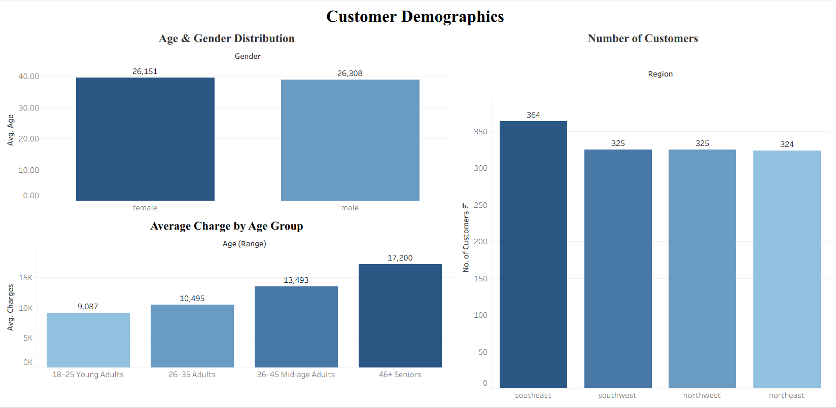
Dashboard 2: Health & Lifestyle Impact
- Comparison of average and median charges for smokers vs non-smokers
- Average and median charges by BMI category
- Relationship between age and charges segmented by smoker status (per-record scatter plot)
- Charges by BMI category, split by smoker status — shows the smoker×BMI interaction (obese smokers average roughly double normal-weight smokers)
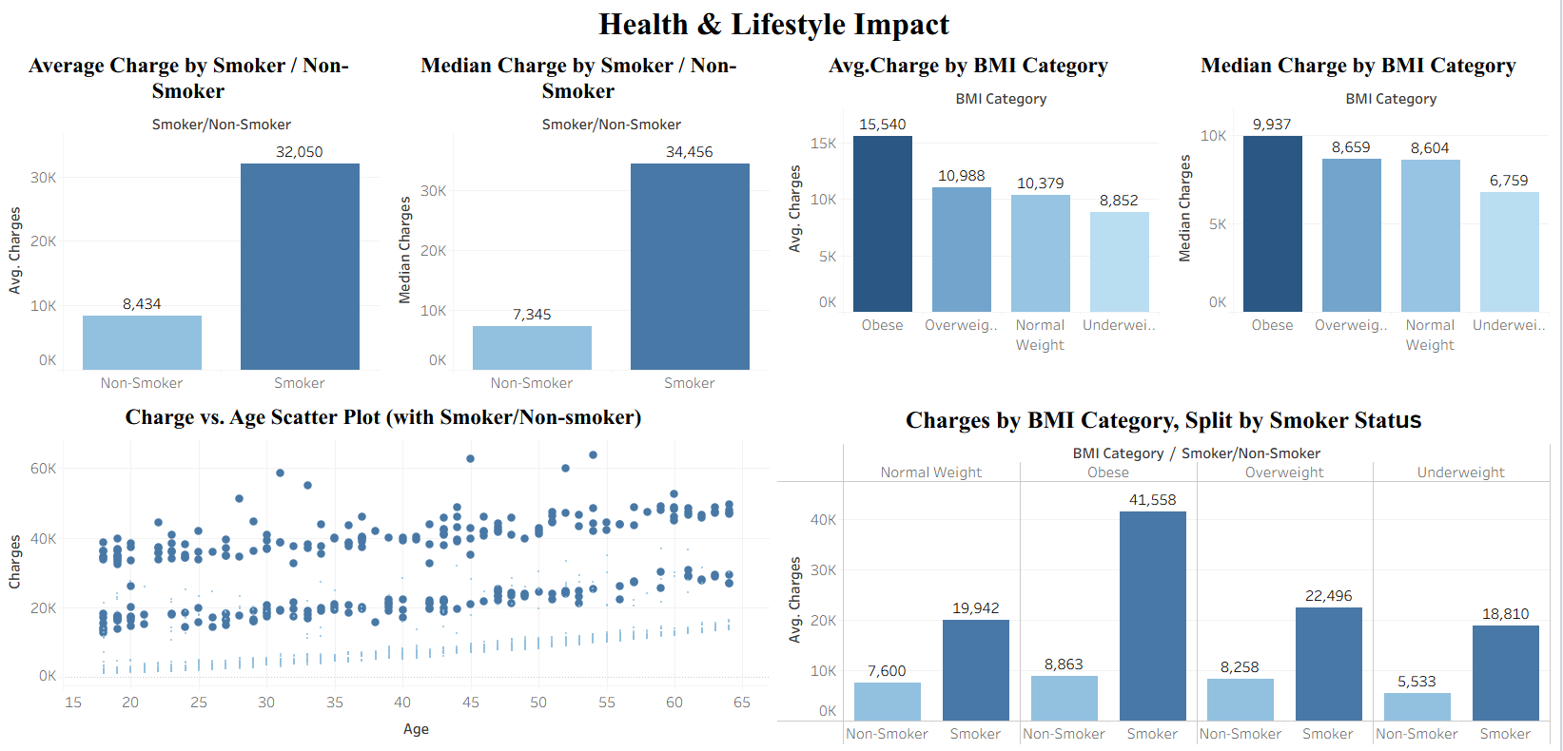

Dashboard 3: Family & Financial Insights
- Average and median charges by number of children, with sample size (n=) labelled on each bar
- Average and median charges by region
- Combined filters for smoker status, children, and region
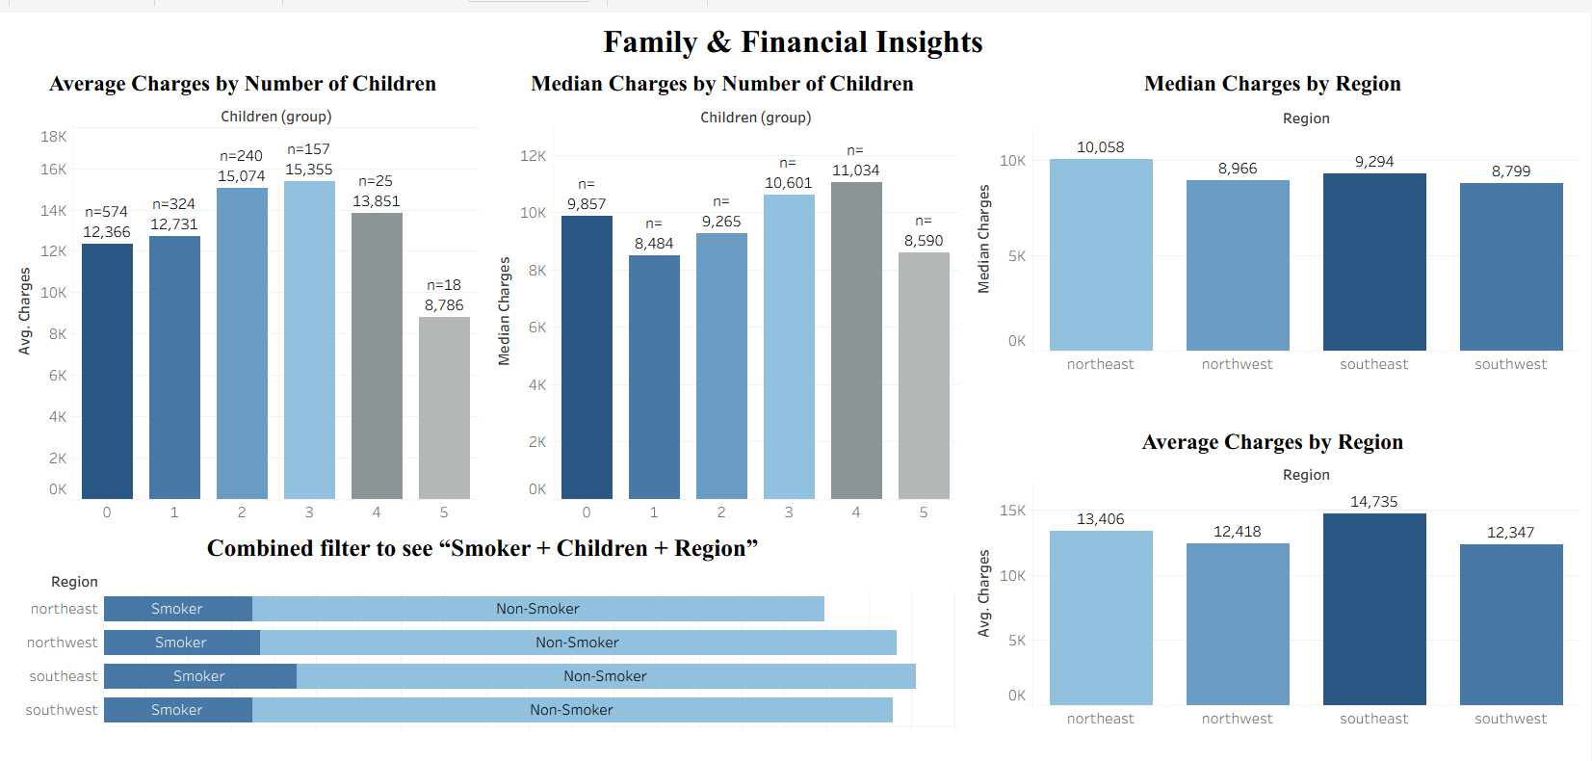
Supporting Analysis (SQL Outputs)
- Total Policyholders: 1,338
- Average Age: 39.2 years
- Average BMI: 30.66
- Average Insurance Charges: $13,270
- Median Insurance Charges: $9,382
Additional SQL analysis showed:
- Smokers have significantly higher average and median charges than non-smokers.
- Insurance charges increase with BMI, with obese customers having the highest average and median costs.
- The combined effect of smoking and obesity produces the highest insurance charges, making obese smokers the highest-risk customer segment.
- Insurance charges generally increase with the number of children up to 2–3 dependents.
- Smokers in the Southeast region represent the highest-cost customer segments.
- An IQR-based outlier assessment was performed separately for smokers and non-smokers to evaluate extreme charge values while preserving legitimate high-risk observations.
Key Insights
- Smoking is the strongest driver of insurance costs, with smokers paying approximately 3–4 times higher premiums than non-smokers.
- The impact of BMI is substantially stronger among smokers. Obese smokers average $41,558 compared with $19,942 for normal-weight smokers, while obesity increases non-smoker charges only modestly ($8,863 vs $7,600).
- Insurance charges generally increase with age, indicating a positive relationship between age and healthcare risk.
- The Southeast region records the highest average insurance charges among all regions. Regional comparisons depend on which average is used: the Southeast has the highest mean charges, but the Northeast has the highest median ($10,058), indicating Southeast's higher mean is driven by a concentration of high-cost cases rather than a uniformly higher typical cost.
- Insurance charges tend to increase with family size up to 2–3 children; the decline observed for policyholders with 5 children is based on a very small sample size (n=18) and should not be interpreted as a broader trend.
- Insurance charges exhibit a right-skewed distribution, as reflected by the gap between the mean ($13,270) and median ($9,382).
- A within-group outlier assessment (IQR method, applied separately to smokers and non-smokers) found 46 potential outliers among non-smokers and none among smokers, confirming that high smoker charges reflect a genuinely different cost distribution rather than data errors; no records were removed.
- Gender has minimal influence on insurance premium amounts compared with health and lifestyle factors.
Conclusion
This analysis demonstrates that insurance premiums are driven primarily by health and lifestyle characteristics rather than demographic attributes. Smoking status is the most influential factor affecting insurance charges, and its impact becomes significantly stronger when combined with high BMI. The smoker × BMI interaction revealed that obese smokers represent the highest-risk and highest-cost customer segment, paying roughly double the premiums of normal-weight smokers. Charges are also right-skewed, so mean-based comparisons throughout this analysis should be interpreted alongside the median.
The findings also indicate that insurance charges generally increase with age and vary across regions, with the Southeast showing the highest average costs. In contrast, gender has relatively little influence on premium amounts.
These insights can support more effective risk-based pricing strategies, customer segmentation, and preventive healthcare initiatives within the insurance industry.
Limitations
- Absence of claim history and medical condition details
- No time-based data to analyse trends over multiple years
- Premium charges treated as static values
- Limited external socioeconomic variables
- While SQL was extended to calculate median and outlier statistics, additional distributional analysis and validation were performed in Tableau to support dashboard development and exploratory analysis.
Future Work
- Build predictive models to estimate insurance charges using demographic and lifestyle factors.
- Incorporate claim history, claim frequency, and claim severity data for more comprehensive risk assessment.
- Perform customer segmentation using clustering techniques to identify distinct risk profiles.
- Extend the analysis using Python and machine learning models.
- Align SQL and Tableau BMI category boundaries to ensure complete consistency across analytical outputs.
- Expand the SQL analysis to include percentile distributions, variance measures, and advanced risk-segmentation metrics.
Tableau Public Link
The interactive Dashboards accompany this report, allowing exploration of
https://public.tableau.com/app/profile/saiba.sifat/viz/InsuranceCharges1_17881567884900/Dashboard1
https://public.tableau.com/app/profile/saiba.sifat/viz/InsuranceCharges2/Dashboard2
https://public.tableau.com/app/profile/saiba.sifat/viz/InsuranceCharges3/Dashboard3

