 | BY R.P.A.D
{{ current_ref_no }} |  | Date: {{ date }}
REFERENCE OF DISPUTE TO ARBITRATION
To,
- {{ borrower_name }},
{{ borrower_address }}
{% if co_borrower_name %}
- {{ co_borrower_name }} (Co-Borrower),
{{ co_borrower_address }} {% endif %}
{% if guarantor_name %} {% if co_borrower_name %}
3.{% else %}2.{% endif %} {{ guarantor_name }} (Guarantor),
{{ guarantor_address }} {% endif %}

REF: Loan cum hypothecation Agreement No: {{ contract_no }}, Dated {{ agreement_date }}
Sir/Madam,
- We refer to the Loan cum hypothecation Agreement cited above, executed between yourself and M/s. HINDUJA LEYLAND FINANCE LIMITED ("The Company") for the finance of the asset {{ asset_description }} bearing {{ reg_chassis_phrase }}.
- We further refer to our Loan Recall Notice (LRN) dated {{ lrn_date }} (Ref No: {{ lrn_ref_no }}) sent to you by RPAD, calling upon you to clear the outstanding dues.
- Despite the receipt/service of the said Legal Notice, you have failed to discharge your liability and the outstanding amount remains unpaid. As on {{ claim_date }}, a sum of Rs. {{ claim_amount }} /- ({{ claim_amount_words }}) is due and payable by you to the company.
- Since the dispute remains unresolved, and in accordance with the Arbitration Clause contained in the said Agreement, we have decided to refer the dispute to Arbitration.
- We hereby refer the entire dispute, including the claim for the outstanding amount and interest, to M/s. Sai & Sai Arbitration Centre, an institutional arbitration centre, for adjudication.
- The Institution shall proceed with the constitution of the Arbitral Tribunal as per the terms of the Agreement and their procedural rules. You will receive further communication directly from the Institution regarding the appointment of the Arbitrator.
- Kindly note that this reference is without prejudice to our rights to initiate/continue proceedings under the SARFAESI Act or any other criminal proceedings as applicable.
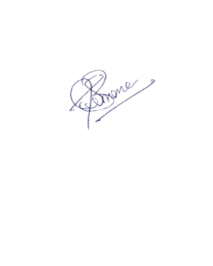
For HINDUJA LEYLAND FINANCE LIMITED,

(Authorized Signatory)

