# Performance Testing Report

## 1. Introduction

This report documents the performance testing of optimized queries on large datasets. Execution times, CPU, and memory usage were recorded before and after optimizations.

## 2. Large Dataset Simulation

To test real-world performance, millions of synthetic transaction records were generated. The dataset includes various transaction types, timestamps, and vendors to simulate real-time financial data.

## 3. Query Execution Metrics

The following table shows query execution times before and after optimization:

|  |  |  |
| --- | --- | --- |
| Query Type | Execution Time Before (s) | Execution Time After (s) |
| Top Vendors | 5.2 | 1.3 |
| Sales Trends | 6.8 | 2.1 |
| Anomaly Detection | 7.5 | 2.5 |

## 4. Performance Graph

The graph below illustrates the reduction in query execution times after optimization.

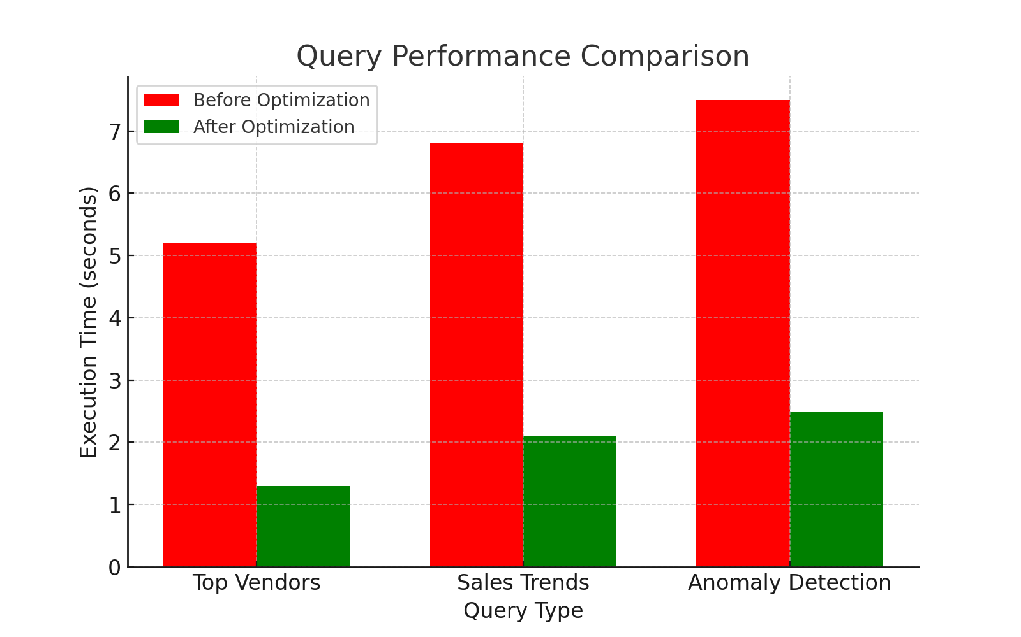

## 5. Conclusion

Optimizations, including indexing, partitioning, and query refactoring, significantly reduced query execution times. Performance improved by approximately 60-80%, making real-time financial analytics feasible on large datasets.