**Beldari Sai kumar**

Rajiv Gandhi University of Knowledge Technologies Dharmavaram

E-mail: beldarisaikumar@gmail.com Phone:9182783521

**Career objective :**

To work in a company where I can share my knowledge and contribute to the growth of the company and thereby enhance my professional skills.

**Education:**

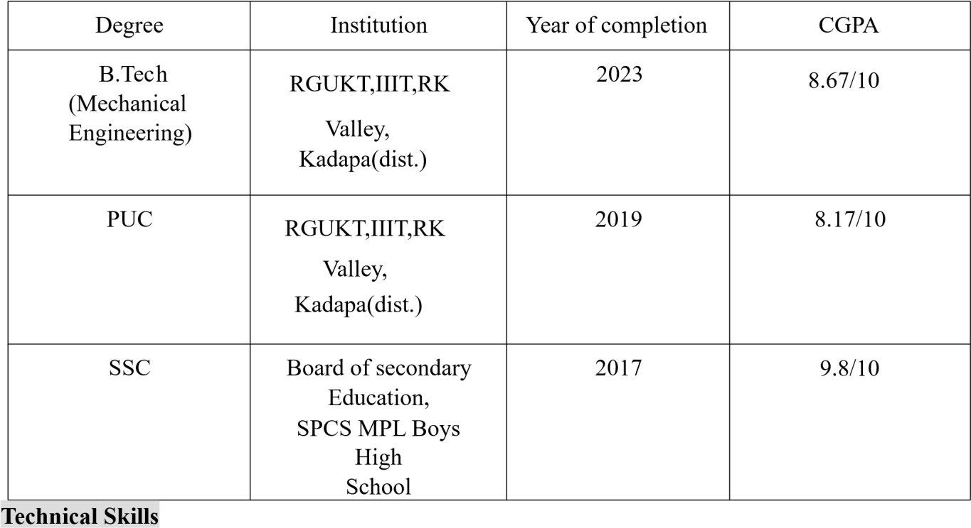

* Programming Languages : Java, SQL, JavaScript
* Web Technologies : HTML,CSS
* Operating Systems : Windows, Linux

**Projects:**

* **3D PRINTED HUMANOID ROBOT BASED ON THE AURDINO MEGA:**

Designed a robot based on the aurdino mega 2560 with servo motors to perform hand and leg gestures which we gave through the aurdino software and installed a bluetooth voice module with ultrasonic sensor to calculate the distance through the robo eye

* **STARGELAM EDUCATION WEBSITE :**

Worked as a fronted developer using my internship experience in Maang Technologies pvt.Ltd

**Internships:**

* Six months internship in Maang Technologies pvt.Ltd as a technical intern.

**Certifications:**

* Certification in Java by Shiash Info Solutions pvt.Ltd.
* Certification in JavaScript by KG Coding.

**Achievements:**

* Voluntered and also Participated in a Tech fest conducted by the Andhra Pradesh Design Innovation Centre(APDIC) in RGUKT RK VALLEY AP IIIT
* Actively participated in many competitions and seminars in school and college level.

**Extra-Curricular/Co-Curricular Activities:**

* An active volunteer in **National Service Scheme(NSS)** team of our university.
* South zone Cricket Player for RGUKT
* 2 Times District champions in Eenadu cricket tournament conducted by the Eenadu e paper and also 1 Time District champion of Sakshi premier league conducted by Sakshi e paper
* Served as a SPL in school level and Served as a Home leader for our respective Branch in University sports meet
* participated as student organizer in National level fest **Abhiyanth** tech fest conducted in RGUKT,RK VALLEY.
* Conducted a competition named **MECHAVANZA** in our university tech fest.

**Personal profile**

* Date of Birth :24TH MARCH 2002
* Father's Name :B.BHASKAR
* Mother's Name :B.KRISHNAMMA
* Gender :Male
* Polyglot :Telugu, English, Hindi
* Nationality :Indian
* Hobbies :Playing Cricket, listening to music, Reading books
* Personality Traits :Team worker and a quick learner **Declaration:**

I hereby declare that all the facts stated above are all true to the best of my knowledge and belief.

Date: 15-06-2023

Place: Bangalore (B Saikumar)