**Auto Cert Rotation Standalone Project Setup Guide**

***Version: 1.0***

***Date: 12/28/2016***

***Master Document Location:***

# Revision History

|  |  |  |  |  |
| --- | --- | --- | --- | --- |
| Version | Date | Section(s) | Description of Change | By |
| 1.0 | 12/28/2016 |  | Draft Document | Kumar Mukesh |
|  |  |  |  |  |
|  |  |  |  |  |

Auto Cert Rotation Standalone Project Setup

**Step 1)** Checkout StandaloneCertRotationTesting project from SVN URL <https://conexus.prod.fedex.com:9443/subversion/framework/branches/RB-7.0.0/StandaloneCertRotationTesting>.

Note:- By default it will ask for project name while checking out, provide the name of the project as CertRotation.

Project structure after checkout in eclipse is given below.

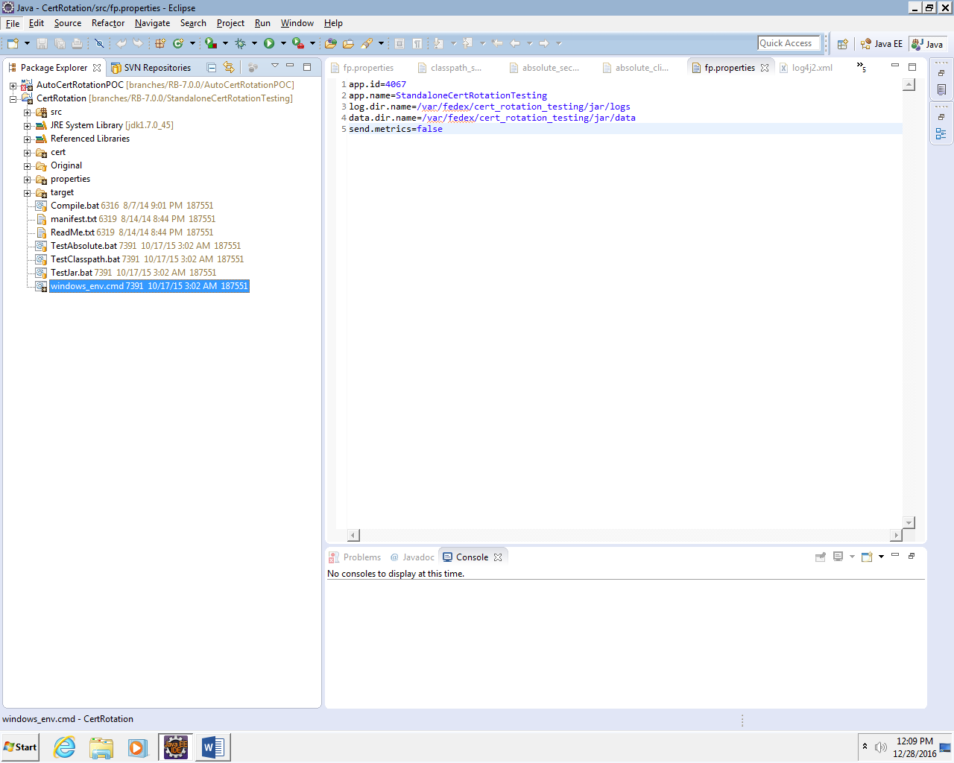

**Step 2)** Open windows_env.cmd and edit the entry based on your VDI. Sample working file entry is given below.

REM Change This

set FRAMEWORK_VERSION=7.0.0

set JAVA_HOME=C:\Program Files\Java\jdk1.7.0_45

REM These will change based on the test being run

REM set TEST_KEYSTORE=.\cert\APP5378_InfosecTestCA.p12.new

REM set TEST_CLIENT_PROPS=.\properties\classpath_client.properties.new

REM set TEST_KEYSTORE=.\cert\APP5378_InfosecTestCA.p12.old

REM set TEST_CLIENT_PROPS=.\properties\classpath_client.properties.old

REM set TEST_KEYSTORE=.\properties\classpath_client.properties.new

set TEST_KEYSTORE=.\cert\APP5378_InfosecTestCA.p12.old

set TEST_CLIENT_PROPS=.\properties\absolute_client.properties.old

REM Done change this

set Path=C:\windows\system32;C:\windows;%JAVA_HOME%\bin;.\bin

set CLASSPATH=.

for %%i in ("Y:\cs-framework\%FRAMEWORK_VERSION%\lib\*.jar") do (

set CLASSPATH=!CLASSPATH!;%%i

)

**Step 3)** Download PackageFramework-7.0.0.zip from <http://nexus.test.cloud.fedex.com:8081/nexus/content/repositories/devframeworkrepo/devframework/PackageFramework/7.0.0/> and extract in cs-framework folder inside your network drive.

Structure of extracted file is shown below.

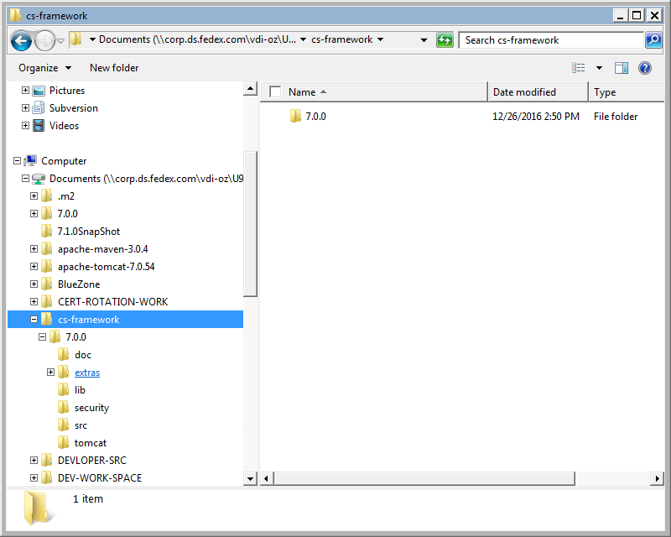

**Step 4)** Add all the jar files which is inside of lib directory of extracted zip file to the build path of the project.

**Step 5)** Add fp.properties, authorization.roles and authorization.rules in the class path of the project. You can do it by simply dropping these files to the src folder.



**Step 6)** Edit classpath_client.properties.new and absolute_security.properties files. Sample file is attached below.

  

**Step 7)** Copy all these files to your VDI network drive under cert directory of the project



**Step 8)** Run the project

Right click on CertRotation.java class and then click on Run as -> Run Configurations and provide the arguments as

true true Y:\CERT-ROTATION-WORK\CertRotation\properties\classpath_client.properties.new Y:\CERT-ROTATION-WORK\CertRotation\properties\absolute_security.properties true

and then click on Run button, you can see stats of certificate on console like given below.

client properties: Y:\CERT-ROTATION-WORK\CertRotation\properties\classpath_client.properties.new

security properties: Y:\CERT-ROTATION-WORK\CertRotation\properties\absolute_security.properties

ERROR StatusLogger No log4j2 configuration file found. Using default configuration: logging only errors to the console.

13:08:55.007 [main] ALL com.fedex.framework.logging.FedExLoggerLog4j2Impl - Framework Version: 7.0.0

13:08:57.405 [main] ALL com.fedex.security.client.KeystoreExpirationCheck.all - First time bootstraping application: initializing certRotation configuation checks

13:08:57.421 [main] ALL com.fedex.security.client.KeystoreExpirationCheck.all - lock file not exist and dates are match .

13:08:57.551 [main] ALL com.fedex.security.client.PkcTokenGeneratorImpl.all - Expiration Date of the APP4067 Application Certificate on the filesytem is (Thu Sep 14 22:07:00 IST 2017)

13:08:58.001 [main] ALL com.fedex.security.client.KeystoreExpirationCheck.all - Inside delete lock file, lock file deleted .

13:08:58.002 [main] ALL com.fedex.security.client.KeystoreExpirationCheck.all - Current cert nearing expiration and the cert in CDS is invalid .

13:08:58.058 [main] ALL com.fedex.security.bootstrap.CSSBootstrap15.all - ...CSS Bootstrap Completed...

End Of Document