**UNIVERSITY OF CENTRAL MISSOURI**

**UCM Library**

**Sai Bhargav Pothuguntla**

**700638595**

**Advanced System Project (5670)**

**October 2016**

**Table of Contents:**

* **Introduction. 3-3**
* **Domain Analysis. 3-3**
* **Description of Users. 3-4**
  + **Librarian.**
  + **User.**
* **Actors and Responsibilities. 5-5**
* **Librarian.**
* **User.**
* **Use Case Descriptions. 6-23**
* **UML Diagrams. 24-29**
  + **Use Case Diagram.**
  + **Class Diagram.**
  + **Sequence Diagram.**
  + **User Activity.**
  + **Librarian Activity.**
  + **Entity-Relationship Diagram.**
* **DB Connection. 30-30**
* **SQL Queries. 30-30**
* **Project Logs. 31-31**
  + **Technologies.**
  + **Tools.**
* **Work Break-Down Structure. 32-32**
* **References. 33-33**

**Introduction:**

I choose to develop the UCM Library Web portal, and I am developing this project using Object Oriented PHP with HTML, CSS and JAVASCRIPT. I am using TOMCAT and MYSQL to store and retrieve the back end data of my project from the database. In past I have learned the procedural oriented PHP. So, to advance my knowledge skills now I am choosing object oriented PHP and MYSQL as well. As I am in the learning stage of these two technologies I will refer through some references which help in developing of my project.

**Domain Analysis:**

The main objective of this web portal is to create a user-friendly environment where user puts less effort to understand how to interact with the system. And also one more main objective is the web portal is totally organizational based so the way it runs depends upon the user. So to attract users to use this facility is our motto. So the first thing is to let the user know about this facility available in the organization in a broad way and help to make them utilize this website to boost up their knowledge in every aspect. The basic rule for the functionality is to have a brief description about the portal and also have to maintain user-friendly relation between the users.

**Description of Users:**

Before discussing about the actors and their responsibilities, first we need to know their credentials to get into the system.

**Librarian:** username: admin.

Password: admin.

**User:** Email: [sxp85950@ucmo.edu](mailto:sxp85950@ucmo.edu)

Password: po

Email: [axb95950@ucmo.edu](mailto:axb95950@ucmo.edu)

Password: pothu

Email: [mxb96960@ucmo.edu](mailto:mxb96960@ucmo.edu)

Password: pothuguntla

**Librarian:**

Librarian is the high privileged user throughout the project. This user has almost all the access to the website. His major role is to maintain books and their priorities in the website. He can add, update and delete the books in the website. He can also upload eBooks which are free to download by the users. However the most part of his work is to maintain the available library books in the website to reach out the user, so that the user can know the available books in the library through this website. As he uploads a particular book into his librarian account, every user who registered into the web portal can be seen that book into their authorized account after they logged in. Librarian can also view bookings made by the individuals whoever needs it. After they have done with it, they can return it in the library. After returning back then librarian change the book status so that it can be seen by other users. The book can only visible when it is available in the library; otherwise it cannot be visible to anyone. Librarian can also see the feedbacks given by the user with their ID.

**User:**

User is the one who utilize the website to book their books or materials they actually need. Initially user has to register to the portal to generate an authorized blog for them in the portal individually. After signing into their account with their user id and password, they can see available books in the library on their blog. As it is difficult to find the book in the large list of books available in the library, user can also search for their required books by using search option. There are two kinds of search option, one for paid books and other for free books. User has a facility to download free books which are available in the web portal just with one click. User also has a facility to let the librarian know whatever they require in the web portal in the form of feedback, so that librarian analyzes their requirement and help them. Online games are available for the users to get them entertained. And it actually meant for user to attract them into the web portal to visit and find their materials which helps to their courses.

**Actors and Responsibilities:**

**Librarian**

* Add free books.
* Add paid books.
* View free books.
  + Edit/Delete free books.
* View paid books.
  + Edit/Delete paid books.
* View Bookings.
* View Feedback.

**User**

* Home.
* Profile.
* Search free books.
* Search paid books.
* Booking.
  + Book.
* View Bookings.
* Feedback.
* Games.
* Change Password.

**Use Case Descriptions:**

|  |  |
| --- | --- |
| Use Case | 1 |
| Title | User Registration. |
| Description | To access the system by the user. First user needs to register into the system by filling his details. So that he can get an authorized account where he can utilize the system. |
| Primary Actor | User. |
| Pre conditions | New user needs to fill all the required fields with valid information to register. |
| Post Condition | User creates an authorized account with his credentials. |
| Main | User clicks new user register here from the login page. |
| Success Scenario | * 1. System shows required fields to fill the information.   2. User fills the appropriate info into the system.   3. User click submit button.   4. User successfully creates an account in the system. |
| Failure Scenario | * + 1. System displays error message please fill the fields for each blank field.   1.2.1 System displays error message showing invalid email id.   * + 1. System displays error message showing invalid details. |
| Extensions | * + 1. After successfully registered, user can have a personal account.     2. User can have authorized credentials for his personal account. |

|  |  |
| --- | --- |
| Use Case | 2 |
| Title | User Login. |
| Description | After user registered to the system. User have an access to login to the system and process whatever needs they required. |
| Primary Actor | User. |
| Pre conditions | Registered user needs to provide valid login details which are confidential. |
| Post Condition | User successfully logs into his account and can view options in his personal account. |
| Main | User navigates to user login page from the navigation bar. |
| Success Scenario | * 1. System shows required fields to give login credentials.   2. User fills exact login details into the fields.   3. User click login button.   4. User successfully enters into the account. |
| Failure Scenario | * + 1. System displays error message please fill the fields for each blank field.     2. System displays error message showing invalid login credentials please try again.     3. System still remains in the login page.     4. System cannot enter into account. |
| Extensions | * + 1. After successfully logged in, user can enters into his personal account.     2. User initially navigates into home page of his personal account.     3. User can see latest free/paid books available in the library. |

|  |  |
| --- | --- |
| Use Case | 3 |
| Title | Home Page. |
| Description | After user successfully login to the system, he navigates into the home page where he can see latest books available in the library. |
| Primary Actor | User. |
| Pre conditions | User needs to login to his account by giving required credentials. |
| Post Condition | User can find latest books and book them from here itself. |
| Main | User clicks on login button in the login page and it navigates into this. |
| Success Scenario | * 1. User enters into his account with proper credentials.   2. User navigates directly to home page after he logged in.   3. User finds latest books in this page.   4. User can book from this page itself. |
| Failure scenario | * + 1. System displays error message while login if credentials were wrong.     2. System displays error message showing 404 page not found error if page was not found.     3. System shows session error if session was closed unexpectedly. |
| Extensions | * + 1. User can find the required book and book it for rent from this page.     2. User can navigate through different pages from the home page. |

|  |  |
| --- | --- |
| Use Case | 4 |
| Title | Profile |
| Description | We can go to this page when the user logs in to the system. User can update their personal details in this page. |
| Primary Actor | User. |
| Pre conditions | User needs to change or update his personal profile before updating into database. |
| Post Condition | User can change their personal data and click on update button to update the details. |
| Main | User navigates to profile page to find his personal profile. |
| Success Scenario | * 1. System shows required fields to fill the information.   2. User fills the appropriate info into the system.   3. User click update button.   4. User successfully updates his details after clicking the button.. |
| Failure Scenario | * + 1. System displays error message if the field is empty.     2. System displays error message if update was unsuccessful. |
| Extensions | 4.4.1 User updates their information after changing the details. |

|  |  |
| --- | --- |
| Use Case | 5 |
| Title | Search E-Book |
| Description | We can go to this page when the user logs in to the system. User can search available free books in the library. |
| Primary Actor | User. |
| Pre conditions | User needs to give name of the book in the search box and it displays the book if available. Can download here. |
| Post Condition | After user enters the book name it gives the resulting book if available in the library. |
| Main | User navigates to the search free book page to search for free books. |
| Success Scenario | * 1. System shows a search box to give the book name.   2. User gives appropriate book name he is looking for.   3. User click search button.   4. User can download the book if found successfully. |
| Failure Scenario | * + 1. System displays error message if the field is empty.     2. System displays error message if no book was found with the given name. |
| Extensions | 5.4.1 User can download the book if he finds the appropriate book he is looking for. |

|  |  |
| --- | --- |
| Use Case | 6 |
| Title | Search Library Book |
| Description | We can go to this page when the user logs in to the system. User can search available books in the library. |
| Primary Actor | User. |
| Pre conditions | User needs to give name of the book in the search box and it displays the book if available. Can book here. |
| Post Condition | After user enters the book name it gives the resulting book if available in the library. |
| Main | User navigates to the search library book page to search for library books. |
| Success Scenario | * 1. System shows a search box to give the book name.   2. User gives appropriate book name he is looking for.   3. User click search button.   4. User can book it if found successfully. |
| Failure Scenario | * + 1. System displays error message if the field is empty.     2. System displays error message if no book was found with the given name. |
| Extensions | 6.4.1 User can proceed for booking if he finds the appropriate book he is looking for. |

|  |  |
| --- | --- |
| Use Case | 7 |
| Title | Rent Book |
| Description | We can go to this page when the user logs in to the system. User can find all books and can make booking from this page. |
| Primary Actor | User. |
| Pre conditions | User selects the required book and click on rent to book. |
| Post Condition | After user selects the book and proceed for booking it process to payment page to schedule booking. |
| Main | User navigates to the booking page to find the required book. |
| Success Scenario | * 1. System shows the list of all books.   2. User looks for appropriate book he is looking for.   3. User click booking button.   4. User can book it by proceeding to payment. |
| Failure Scenario | * + 1. System displays error message if page was not found.     2. System displays error message if the session was closed unexpectedly. |
| Extensions | 7.4.1 User can proceed for payment page after clicking on rent. |

|  |  |
| --- | --- |
| Use Case | 8 |
| Title | View Bookings |
| Description | We can go to this page when user logs into the system. User can find his booking history along with date span he had booked for previously. |
| Primary Actor | User. |
| Pre conditions | User may book at least one book previously. |
| Post Condition | User can see his logs for the bookings he had made previously. |
| Main | User navigates to the view bookings page to find the bookings log. |
| Success Scenario | * 1. System shows the booking logs.   2. User understands when he has booked previously.   3. User also understands how many days he has rented the book.   4. User understands the payment he has made for the booking. |
| Failure Scenario | * + 1. System displays error message if the view bookings page was not found.     2. System displays error message if the session was closed unexpectedly. |
| Extensions | 8.2.1 If no bookings made by the user previously, he finds the message no bookings found. User has to make bookings to view his previous logs. |

|  |  |
| --- | --- |
| Use Case | 9 |
| Title | Feedback |
| Description | We can go to this page when the user logs in to the system. User can give his feedback about anything so that it reaches to librarian to maintain the site effectively. |
| Primary Actor | User. |
| Pre conditions | User navigates on to the feedback menu and enters the feedback he wants to give. |
| Post Condition | After user has given the feedback he has to click the submit button to submit the feedback to librarian. |
| Main | User navigates to the feedback page to find the text area where user enters the feedback and submit button to submit the given feedback. |
| Success Scenario | * 1. System shows the feedback page with student id, text area and a submit button.   2. User cannot change his student id in this area.   3. User can able to enter the feedback content into the text area.   4. User can able to click on submit button to submit the feedback.   5. After submitted user can see submit successful message. |
| Failure Scenario | * + 1. System displays error message if the feedback page was not found.     2. System displays error message if the session was closed unexpectedly.     3. System shows error message if the text area was empty. |
| Extensions | 9.5.1 After user submits the feedback, the feedback has been inserted into feedback table and it can be retrieved into the librarian page to reach to librarian. |

|  |  |
| --- | --- |
| Use Case | 10 |
| Title | Games |
| Description | We can go to this page when the user logs in to the system. User can play games from this page. |
| Primary Actor | User. |
| Pre conditions | User navigates to the games menu and selects the game he wants to play from that page. |
| Post Condition | After user chooses the game then the game panel has been opened to play. |
| Main | User navigates to games page and he can find the list of games available and opens the game while clicking on the particular game. |
| Success Scenario | * 1. System shows the list of games in the games page.   2. Student selects a particular game what he wants to play.   3. System opens the appropriate game on to the panel. |
| Failure Scenario | * + 1. System displays error message if the games page was not found.     2. System displays error message if the session was closed unexpectedly.     3. System shows error message if the selected game was empty. |
| Extensions | 10.3.1 After user selects the game he can play the game on the panel and get the score. |

|  |  |
| --- | --- |
| Use Case | 11 |
| Title | Change password. |
| Description | We can go to this page when the user logs in to the system. User can change his password credential to login to the account from this page. |
| Primary Actor | User. |
| Pre conditions | User navigates to the change password page and changes the password to login by giving the old password and new password. |
| Post Condition | After user fills all the text fields required he clicks on the change button to change the password for his login credentials. |
| Main | User navigates to the change password page and he fills the required fields to change the password. |
| Success Scenario | * 1. System shows the fields like Email ID, Old password, new password, confirm password and a change button.   2. User makes sure that he cannot change his Email ID ever from this page.   3. User has to confirm that he knows the old password.   4. User has to fill the new password field with his new password.   5. User successfully confirms the new password by giving it again.   6. User successfully clicks on change button to replace the old password with new one. |
| Failure Scenario | * + 1. System displays error message if the change password page was not found.     2. System displays error message if the session was closed unexpectedly.     3. System shows error message if the text fields were empty.     4. System shows error message if the old password was incorrect.     5. System shows error message if the new and confirm passwords do not match. |
| Extensions | 11.6.1 After user successfully change the password the user table has been updated by replacing the old password with new one. |

|  |  |
| --- | --- |
| Use Case | 12 |
| Title | Booking link |
| Description | We can go to this page when user selects the book anywhere in his account and attempts to book that particular book. |
| Primary Actor | User. |
| Pre conditions | User navigates on to this page for booking the book. And fills the required fields. |
| Post Condition | After user has been made booking. The book has been booked and he can collect either in store or through home delivery. |
| Main | User navigates to booking link and fills the date to give number of days he wants to rent the book and clicks on booking to book. |
| Success Scenario | * 1. System shows the book id, user id, from date, to date, delivery type and amount fields.   2. Student cannot change anything except to fill from date and to date.   3. Student can choose from date and to date from calendar shown.   4. Student can able to click on booking button to make the booking.   5. After submitted user can see booking successful message. |
| Failure Scenario | * + 1. System displays error message if the booking link page was not found.     2. System displays error message if the session was closed unexpectedly.     3. System shows error message if the date fields and delivery type (chooses store by default) were empty. |
| Extensions | 12.5.1 After user done with booking it should be added to the booking list. |

|  |  |
| --- | --- |
| Use Case | 13 |
| Title | Add E-Books |
| Description | This page is available in the admin account. Admin can add books which are free like E-Books from this page where user can download these books after they login into their account. |
| Primary Actor | Admin. |
| Pre conditions | Admin navigates to add e-books page and adds documents of e books from this page. |
| Post Condition | After admin adds the book into the system he clicks on the add book button and the uploaded book adds into the system. |
| Main | Admin navigates to add e-books page and fills the required fields and uploads the document to add the book. |
| Success Scenario | * 1. System shows add e-book page with required text fields along with the upload button to upload file from the local system.   2. After admin fills all the fields and uploads the particular document he then clicks the add book button to add the book into system.   3. After adding the book into the system the uploaded document can be available to download for the user. |
| Failure Scenario | * + 1. System displays error message if the add e-book page was not found.     2. System displays error message if the session was closed unexpectedly.     3. System shows error message if the text fields were empty.     4. System shows error message if the uploaded document does not supports the required format. |
| Extensions | 13.3.1 After admin clicks on the add book button the book can be available in the view books page and also in the user login account. |

|  |  |
| --- | --- |
| Use Case | 14 |
| Title | Add Library Books |
| Description | This page is available in the admin account. Admin can add books which user can rent the books from his account by paying certain amount for the book. |
| Primary Actor | Admin. |
| Pre conditions | Admin navigates to add library books page and adds the cover page of the particular book in the form of image format. |
| Post Condition | After admin adds the book into the system he clicks on the add book button and the uploaded book adds into the system. |
| Main | Admin navigates to add library books page and fills the required fields and uploads the image file to add the book. |
| Success Scenario | * 1. System shows add library books page with required text fields along with the upload button to upload cover image from the local system.   2. After admin fills all the fields and uploads the particular image he then clicks the add book button to add the book into system.   3. After adding the book into the system the uploaded image with details can be available to rent by the user. |
| Failure Scenario | * + 1. System displays error message if the add library book page was not found.     2. System displays error message if the session was closed unexpectedly.     3. System shows error message if the text fields were empty.     4. System shows error message if the uploaded document does not supports the required format. |
| Extensions | 14.3.1 After admin clicks on the add book button the book can be available in the view books page and also in the user login account. |

|  |  |
| --- | --- |
| Use Case | 15 |
| Title | View E-Books |
| Description | This page is available in the admin account. Admin can see details of uploaded e-book along with edit and delete options. |
| Primary Actor | Admin. |
| Pre conditions | Admin navigates to view e-books page and can see the list of books he added in to the system. |
| Post Condition | Admin can edit and delete the available book from this page using edit and delete options. |
| Main | Admin navigates to view e-books and can see the list of available books in the system. |
| Success Scenario | * 1. System shows list of all e-books which were added in the system by the admin.   2. Admin can successfully edit the book details by clicking the edit link.   3. Admin can also successfully delete the particular book from this page. |
| Failure Scenario | * + 1. System displays error message if view e-book page was not found.     2. System displays error message if the session was closed unexpectedly. |
| Extensions | 15.1.1 Admin can view the list of added books where these books can be available for the user to download from their account. |

|  |  |
| --- | --- |
| Use Case | 16 |
| Title | View Library Books |
| Description | This page is available in the admin account. Admin can see details of paid books which were added along with edit and delete options. |
| Primary Actor | Admin. |
| Pre conditions | Admin navigates to view library books page and can see the list of books he added in to the system. |
| Post Condition | Admin can edit and delete the available book from this page using edit and delete options. |
| Main | Admin navigates to view library books and can see the list of available books in the system. |
| Success Scenario | * 1. System shows list of all books available in the libraries, which were added in the system by the admin.   2. Admin can successfully edit the book details by clicking the edit link.   3. Admin can also successfully delete the particular book from this page.   4. The book won’t be available in the list if it was booked by any user. |
| Failure Scenario | * + 1. System displays error message if view library book page was not found.     2. System displays error message if the session was closed unexpectedly. |
| Extensions | 16.1.1 Admin can view the list of added books where these books can be available for the user in their account to rent them. |

|  |  |
| --- | --- |
| Use Case | 17 |
| Title | View Bookings |
| Description | This page is available in the admin account. Admin can see the list of bookings made by multiple users from their account. |
| Primary Actor | Admin. |
| Pre conditions | User has to rent a book from his account and all the rented books made by multiple users can be seen by admin from this page. |
| Post Condition | After user rent the book it goes unavailable from the list of books and adds to this list. The admin has to click on return to return back the book to the books list. |
| Main | Admin navigates to view bookings page to see the list of all books which has been rented. |
| Success Scenario | * 1. System shows list of all books which were currently booked by the users.   2. The books available in this page should not be available for the users to book.   3. Admin successfully clicks on the return link to return back the book.   4. The book successfully returns back to the list of available books. |
| Failure Scenario | * + 1. System displays error message if view bookings page was not found.     2. System displays error message if the session was closed unexpectedly.     3. System displays error message if the return page was not found. |
| Extensions | 17.4.1 The book which admin clicks on return can be disabled from this list and returns back to the available books. |

|  |  |
| --- | --- |
| Use Case | 18 |
| Title | View Feedbacks |
| Description | This page is available in the admin account. Admin can see feedbacks given by the different users. He can classify who ever given the feedback with their user id. |
| Primary Actor | Admin. |
| Pre conditions | Users have to give their feedbacks from their account to reach to the admin. And these feedbacks can be added to list of feedbacks that can be viewed by admin. |
| Post Condition | Admin can see the feedbacks and process according to that to give great service to the users. |
| Main | Admin can navigate to the view feedbacks page and can see the list of feedbacks given by different users. |
| Success Scenario | * 1. System shows list of feedbacks to admin which were given by the multiple users.   2. Admin can successfully see the feedbacks given by the user.   3. System can successfully add these feedbacks into the feedback database. |
| Failure Scenario | * + 1. System displays error message if feedbacks page was not found.     2. System displays error message if the session was closed unexpectedly.     3. System displays nothing if the feedback was not submitted successfully. |
| Extensions | 18.2.1 Admin can see the feedbacks given by the user and that helps for admin to give better service to the users. |

**UML Diagrams:**

**Use Case Diagram:**

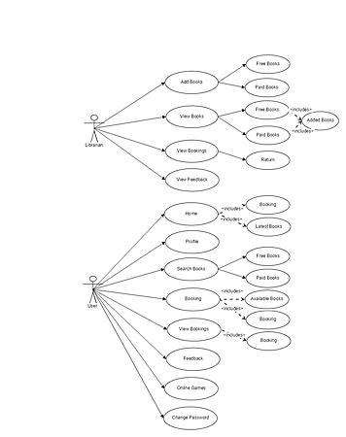

System

**Class Diagram:**

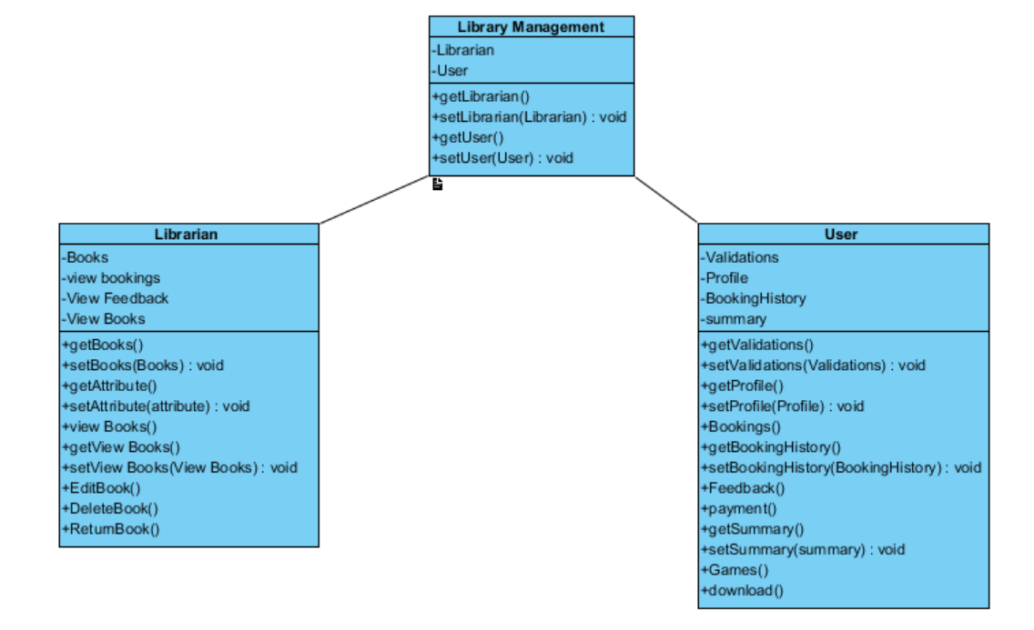

**Sequence Diagram:**

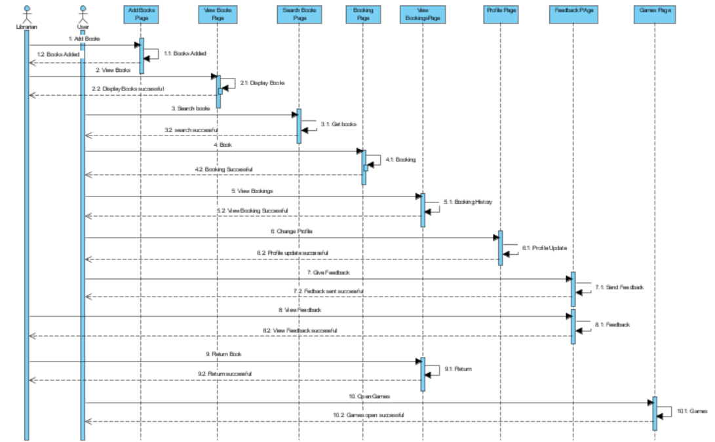

**User Activity:**

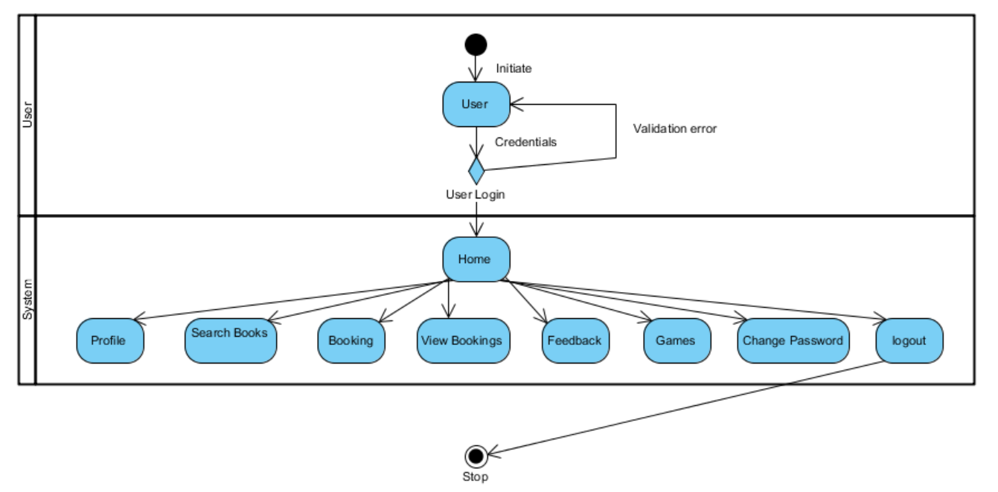

**Admin Activity:**

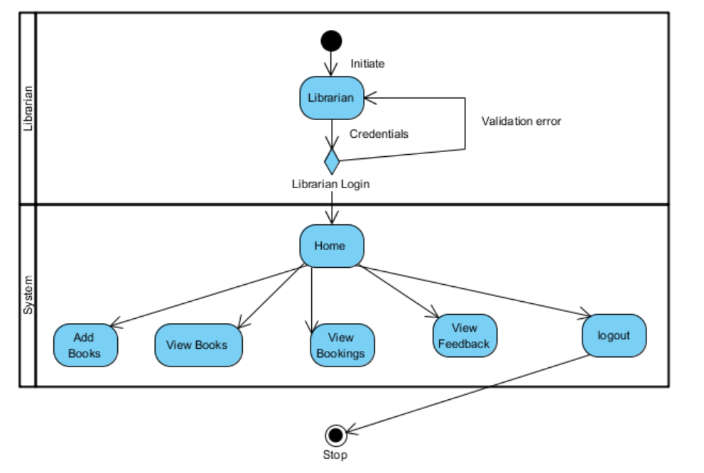

**Entity-Relationship Diagram:**

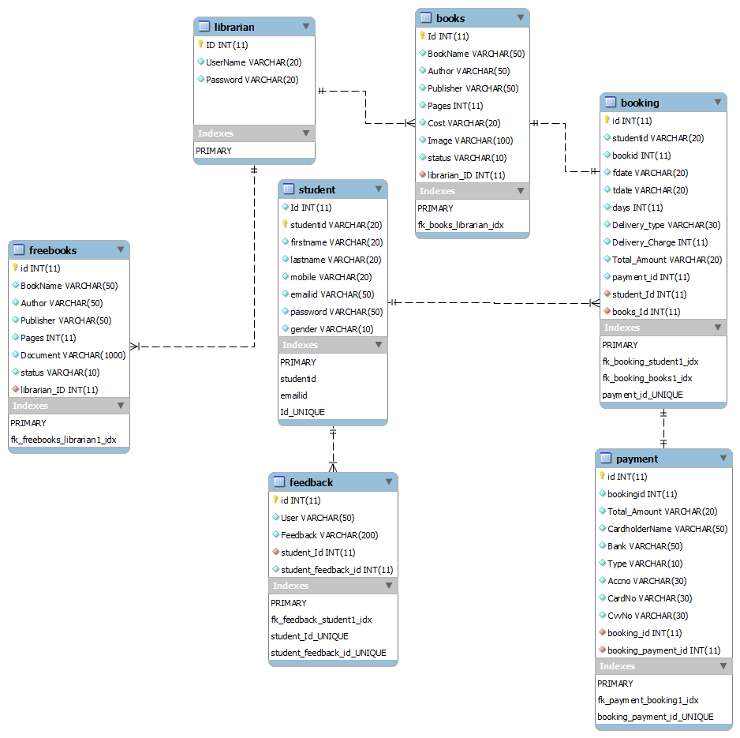

**DB Connection:**

$servername = "localhost";

$username = "root";

$password = "";

$mysql_database = "ucmlibrary";

$conn = new mysqli($servername, $username, $password, $mysql_database);

**Some SQL Queries used in the System:**

1. select * from librarian where UserName='".$_REQUEST["username"]."' and Password='".$_REQUEST["password"]."'"
2. Insert into student(studentid,firstname,lastname,mobile,emailid,password,gender) values('".$stdid."','".$fname."','".$lname."','".$mobile."','".$email."','".$pwd."','".$gender."')"
3. update student set firstname='".$fname."',lastname='".$lname."',mobile='".$mobile."',gender='".$gender."',emailid='".$email."' where studentid='".$stdid."'";
4. select * from books where status='True'";
5. update student set password='".$new."' where emailid='".$email."' and password='".$old."'";
6. insert into booking(studentid,bookid,fdate,tdate,days,Delivery_type,Delivery_Charge,Total_Amount) values('".$_POST["stdid"]."','".$_POST["bid"]."','".$_POST["fdate"]."','".$_POST["tdate"]."','".$_SESSION['days']."','".$_POST["dtype"]."','0','".$charge."')";
7. select booking.fdate,booking.tdate,booking.days,booking.Delivery_Type,booking.Delivery_Charge,booking.Total_Amount,books.BookName,books.Cost,books.Image from booking inner join books on booking.bookid=books.Id where booking.studentid='".$stdid."' ";

**Support Logs:**

**Technologies:**

* PHP:

[**http://php.net/manual/en/**](http://php.net/manual/en/)

* JQuery: By Kud Venkat

<https://www.youtube.com/watch?v=a59kOE2Ma1Q&list=PL6n9fhu94yhVDV697uvHpavA3K_eWGQap&index=1>

http://api.jquery.com/

* HTML, CSS, JavaScript:

<http://www.w3schools.com/>

Stack-Overflow

**Tools:**

* + **Notepad++.**
  + **Visual Paradigm.**
  + **Work Bench.**

**Work Break-Down Structure:**

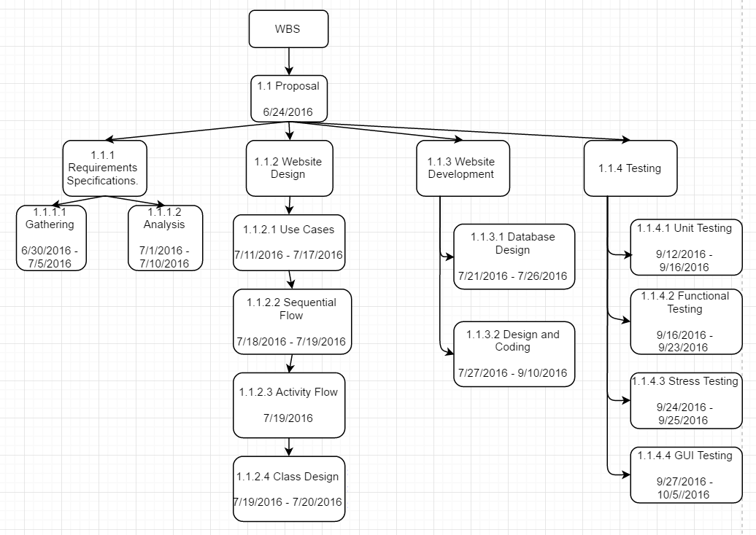

**Reference:**

BY: Timothy James.

[**https://www.youtube.com/watch?v=gN0fXvWbJSk&list=PLJnkyVAO-LM6IgtfN83wQ-dj5Oj1mNETN**](https://www.youtube.com/watch?v=gN0fXvWbJSk&list=PLJnkyVAO-LM6IgtfN83wQ-dj5Oj1mNETN)

<https://www.youtube.com/watch?v=aCRw-aUhpBM>

BY: Adam Khoury

https://www.youtube.com/watch?v=c_ohDPWmsM0