Quiz Manager Functional Specification Document

# Purpose:

* The purpose of the document is to show the end to end specifications of the project Identity management system.

# Introduction:

This project helps to do CRUD operations and get the questions based on the difficulty level.

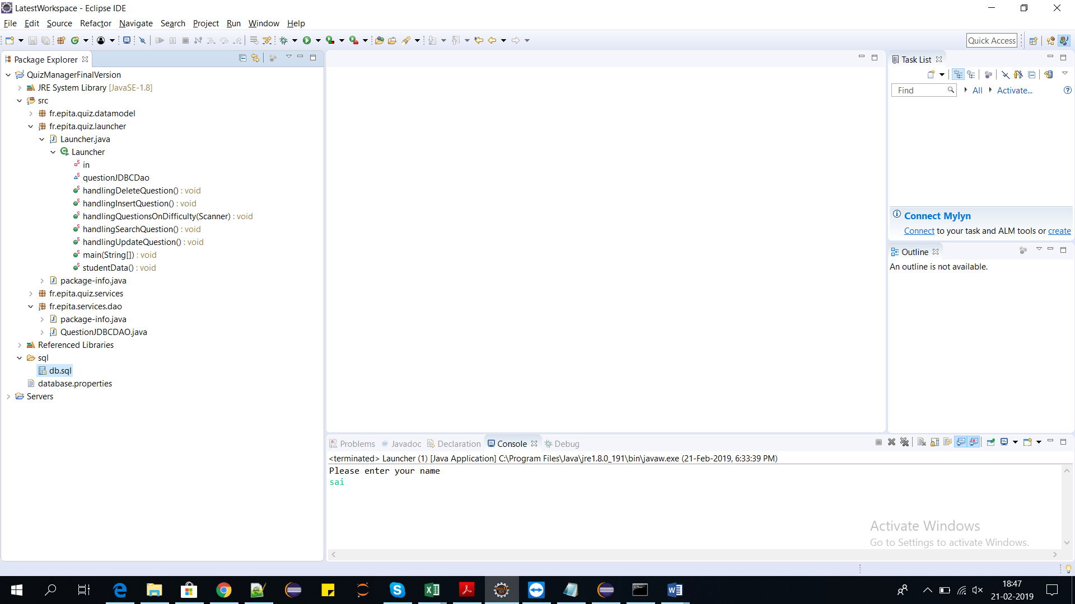

# Classes:

**Launcher class**



**Datamodel classes**



**Services**



# Database:

This project is using H2 database and the table details are given in the db.sql file in the sql folder.

The H2 jar file.



# Parameters:

The main parameters used in this project are question name, topics and difficulty. These variables perform all the operations.