Challenge 5 - Proof of Parity

First checked png file metadata and a desciption found contains large pattern of words like snow door etc. This means flag clue is in this data.

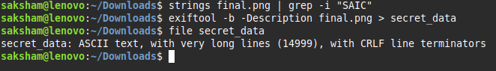
First I extracted this data in file secret_data
Now this file size is around 47 mb
It has a lot of words in it so I thought that these words are representing colors byte that when convert in image flag comes out
First I found unique words and then distinguish them on basis of their color in python script
and result -
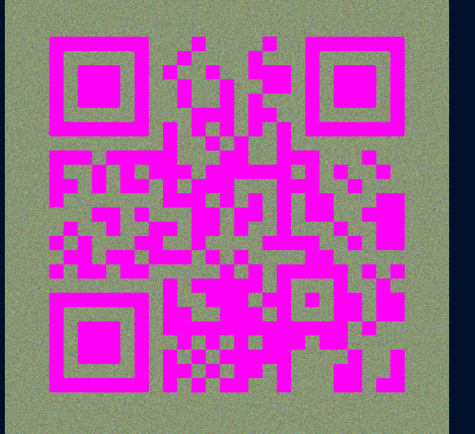

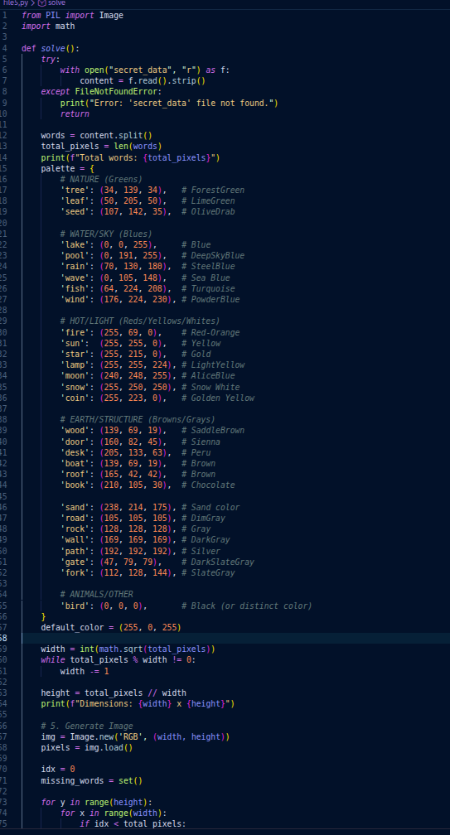
But qr code not scannable.
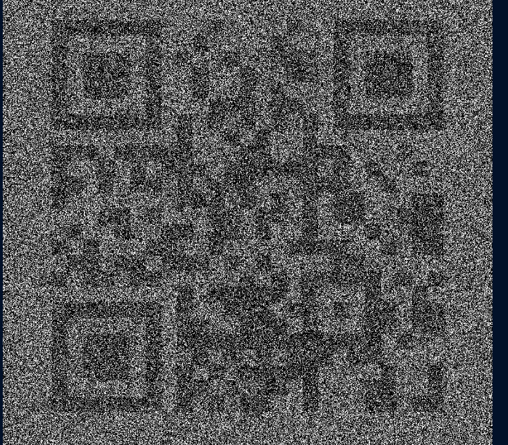
This clears that it is data for qr code then just find correct pattern so I change pattern like only keeping light color object to be 0 white and dark to be black then image is

Yet not scannable
So I changed approach that question is about parity means odd or even so even length words color length 0 because of their rem with 2 is 0 and odd color black then image I got is
Scannable it give link -
https://pastebin.com/raw/TqmxjXEK

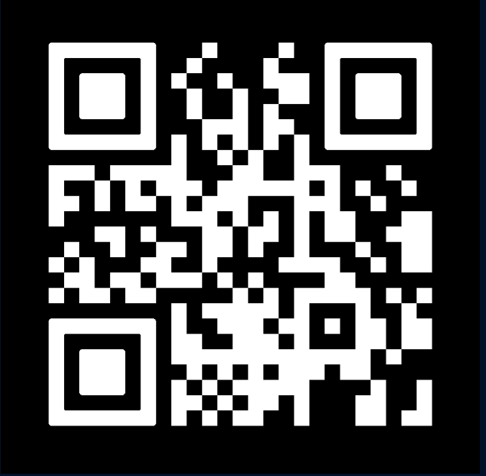

In this link there is (38.0027512,23.7135893) only if it is coordinates then place is athens in greece which is linked with trojan and in cybersecurity trojan means harmless software but contains secret payload so flag is
SAIC{ 38.0027512,23.7135893}

