Internship at Skill Lync

CRUD Application

By B Sai Chaitanya Goud

INTRODUCTION

1.Overview

CRUD is an acronym that comes from the world of computer programming and refers to the four functions that are considered necessary to implement a persistent storage application: create, read, update and delete. Persistent storage refers to any data storage device that retains power after the device is powered off, such as a hard disk or a solid-state drive. In contrast, random access memory and internal caching are two examples of volatile memory - they contain data that will be erased when they lose power.

2.Purpose

1. Create database
2. Create collection
3. Insert documents
4. Delete documents
5. Update documents
6. Read document

3.Flow chart

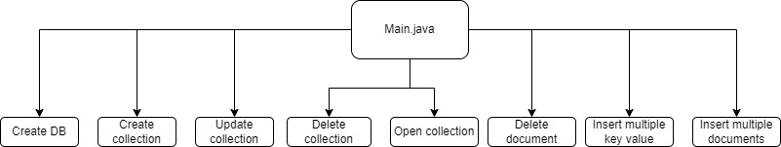

4.System design

The system is divided into some parts these are Register system, Login System, Search System, Buying

System, Order Received System, Viewing System side with database represent the server using PHP ,

MYSQL and APACHE with XAMPP server. System diagram and system database diagram

The system is divided into some parts these are Register system, Login System, Search System, Buying

System, Order Received System, Viewing System side with database represent the server using PHP ,

MYSQL and APACHE with XAMPP server. System diagram and system database diagram

The system is divided into some parts these are Register system, Login System, Search System, Buying

System, Order Received System, Viewing System side with database represent the server using PHP ,

MYSQL and APACHE with XAMPP server. System diagram and system database diagram

The system is divided into some parts these are Register system, Login System, Search System, Buying

System, Order Received System, Viewing System side with database represent the server using PHP ,

MYSQL and APACHE with XAMPP server. System diagram and system database diagram

The system is divided into some parts these are Register system, Login System, Search System, Buying

System, Order Received System, Viewing System side with database represent the server using PHP ,

MYSQL and APACHE with XAMPP server. System diagram and system database diagram

The system is divided into some parts these are Register system, Login System, Search System, Buying

System, Order Received System, Viewing System side with database represent the server using PHP ,

MYSQL and APACHE with XAMPP server. System diagram and system database diagram

The system is divided into some modules these are Main, create database, create collection, insert document, delete document, update document

Hardware and Software Requirement

6.1 Hardware Required

* Processor: Pentium IV or Above
* RAM: 2GB or above
* Hard Disk: 50GB or above
* Input Devices: Keyboard, Mouse
* Output Devices: Monitor

6.2 Software Required

Operating System: Linux, Ubuntu, Mac, Windows XP, 7, 8, 8.1, 10

Backend : Java, Mongo DB

Mongo db

MongoDB is a source-available cross-platform document-oriented database program. Classified as a NoSQL database program, MongoDB uses JSON-like documents with optional schemas. MongoDB is developed by MongoDB Inc. and licensed under the Server-Side Public License (SSPL) which is deemed non-free by several distributions.

Java

Java is a high-level, class-based, object-oriented programming language that is designed to have as few implementation dependencies as possible. It is a general-purpose programming language intended to let programmers write once, run anywhere (WORA), meaning that compiled Java code can run on all platforms that support Java without the need to recompile. Java applications are typically compiled to bytecode that can run on any Java virtual machine (JVM) regardless of the underlying computer architecture. The syntax of Java is similar to C and C++, but has fewer low-level facilities than either of them. The Java runtime provides dynamic capabilities (such as reflection and runtime code modification) that are typically not available in traditional compiled languages. As of 2019, Java was one of the most popular programming languages in use according to GitHub, particularly for client–server web applications, with a reported 9 million developers.

Program Output

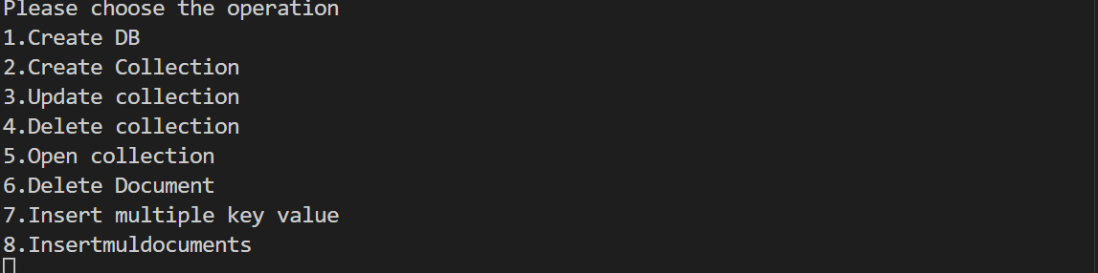

1.Create DB

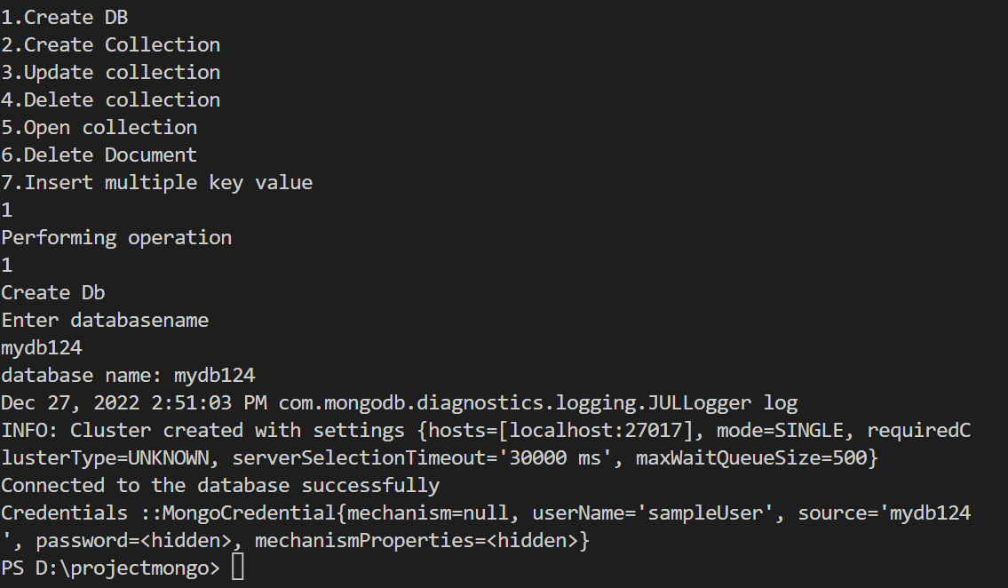

2.Create Collection

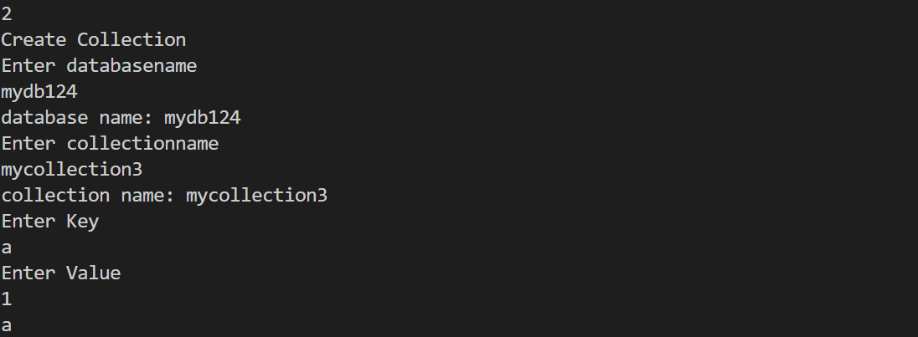

3.Update collection

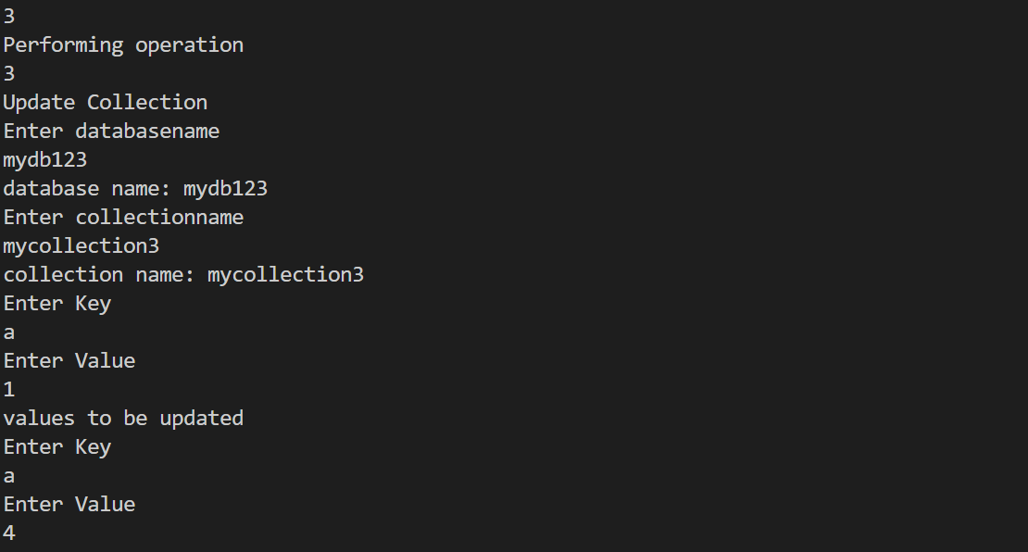

4.Delete collection

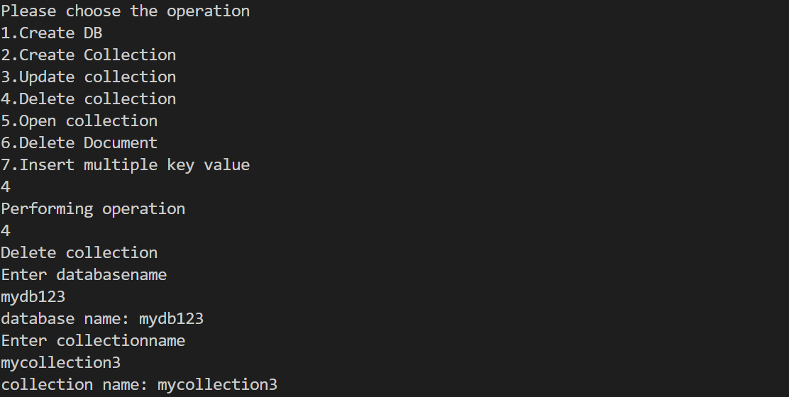

5.Open collection

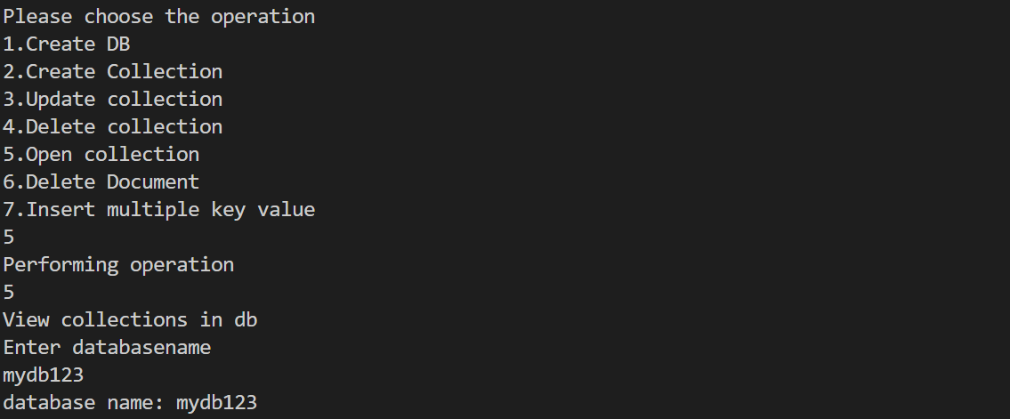

6.Delete Document

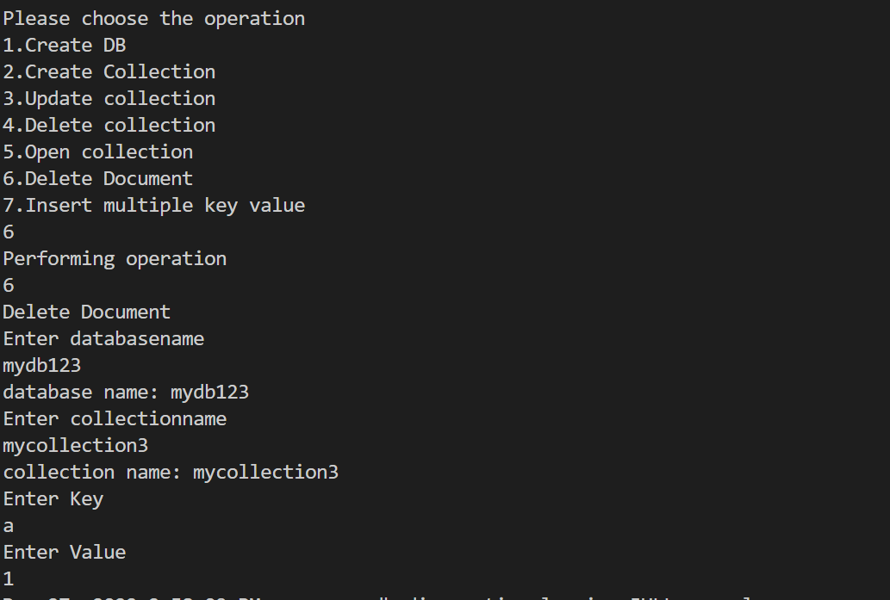

7.Insert multiple key value

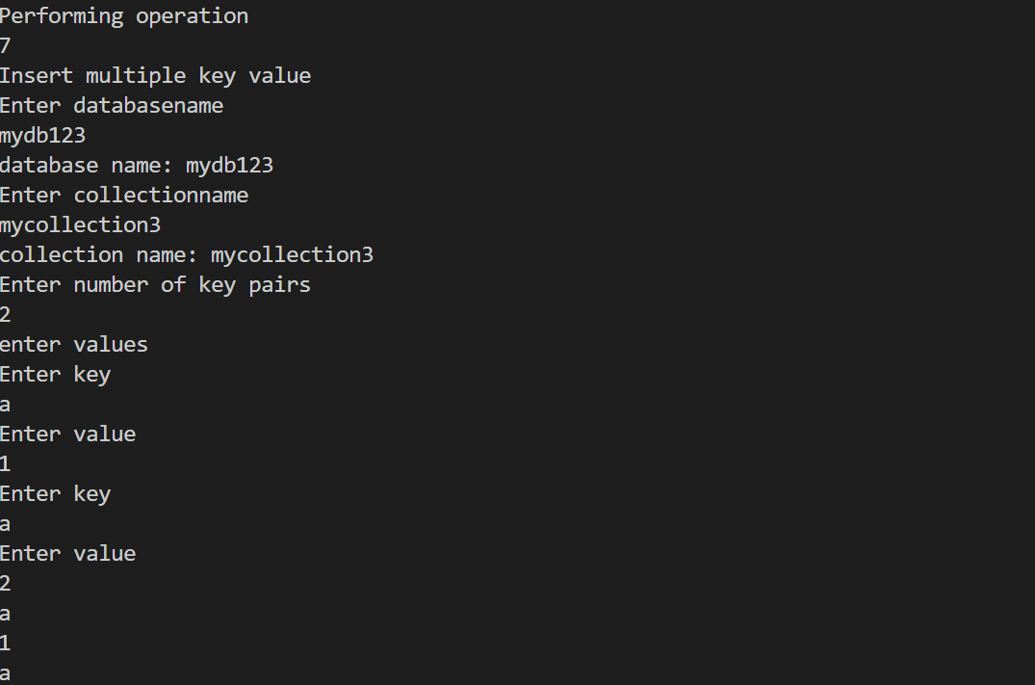

8.Insert multiple documents

