Equity Analysis Report: NVIDIA Corporation (NVDA)
Fundamental and Technical Analysis of NVDA

1. Company Selection
For this analysis, I have selected NVIDIA Corporation, as it currently represents the epicentre of the generative AI shift. Given the volatility and rapid growth of the semiconductor industry, NVIDIA provides an excellent case study for analysing how explosive revenue growth translates into stock price action. I chose NVIDIA not just because of the hype, but because I wanted to see if the profit margins actually justified the stock price—and they actually do.

2. Financial Performance Analysis
The following data is derived from NVIDIA’s latest annual filings. The leap between the last two financial years is one of the most significant in recent corporate history, driven almost entirely by the demand for H100 GPUs.
Table 1: Key Financial Metrics (FY2023 vs FY2024)
Metric | FY 2023 (USD) | FY 2024 (USD) | Variance (%)
Total Revenue | $26.97 Billion | $60.92 Billion | +125.8%
Net Profit | $4.37 Billion | $29.76 Billion | +581.0%
Net Profit Margin | 16.2% | 48.8% | +32.6% (Absolute)

3. Net Profit Margin Calculation
The Net Profit Margin is a critical indicator of how much of every dollar earned actually turns into profit after all expenses.
- FY 2023 Calculation: $($4.37\text{B} / $26.97\text{B}) \times 100 = \mathbf{16.2%}$
- FY 2024 Calculation: $($29.76\text{B} / $60.92\text{B}) \times 100 = \mathbf{48.8%}$
Observation: A jump from 16% to nearly 49% is extraordinary. This suggests that NVIDIA hasn't just increased its sales volume, but has gained massive "pricing power," allowing them to charge a premium for their AI chips while keeping operational costs relatively stable.

4. Technical Analysis (Stock Chart)
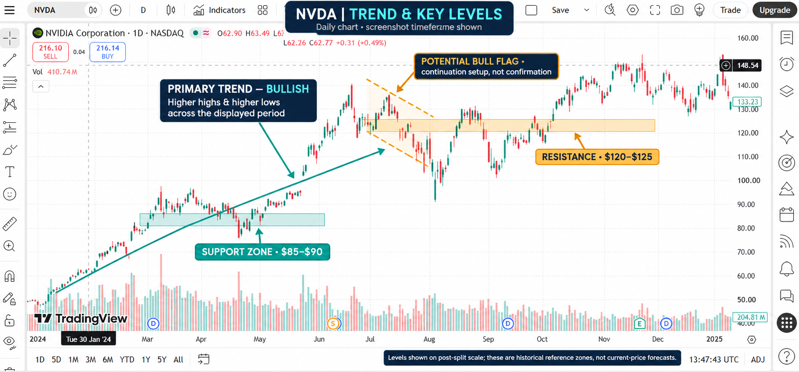
A. Trend Identification: The primary trend for NVDA is Strongly Bullish. On the weekly and daily timeframes, the stock is consistently making "Higher Highs" and "Higher Lows." Despite short-term corrections, the trajectory remains steeply upward, driven by quarterly earnings beats.
B. Key Levels (marked on the chart above):
- Support Level: I have identified a strong support zone around the $850 - $900 range (pre-split adjusted) or $85 - $90 (post-split). This is where buyers historically step in to prevent further declines.
- Resistance Level: The immediate resistance is sitting at the $1,200 - $1,250 range (pre-split) or $120 - $125 (post-split). This is the "ceiling" where selling pressure has increased recently.
C. Chart Pattern: The stock recently exhibited a "Bull Flag" pattern. After a massive vertical rally, the price entered a tight, downward-sloping consolidation channel. This is typically a continuation pattern, suggesting that the stock was simply "resting" before its next leg upward.

5. Strategic Conclusion
Looking at the synergy between the financials and the chart, NVIDIA is in a rare position of "fundamental-technical alignment."
Usually, when a stock price rises this sharply, it becomes "overvalued" (the price grows faster than the profit). However, NVIDIA’s net profit grew by over 580% in one year, which justifies the aggressive rally seen on the price chart.
The expansion of the net profit margin to 48.8% is the most impressive statistic here; it shows the company is operating with extreme efficiency. While the stock is currently testing resistance levels, the underlying financial health suggests that as long as AI infrastructure spending remains high, the bullish trend is likely to persist. From a strategic standpoint, any dip toward the support level would be viewed by the market as a buying opportunity rather than a reversal.

