FUNDAMENTAL ANALYSIS OF A LISTED COMPANY USING ITS ANNUAL REPORT
A Case Study of Reliance Industries Limited
Financial Year 2025–26

1. Introduction
Fundamental analysis is a method of evaluating a company's financial position, profitability, efficiency and future prospects by studying its financial statements, annual reports and business operations.
For this project, I have selected Reliance Industries Limited (RIL), one of India's major diversified business groups. Its activities include oil and chemicals, retail, digital services, media and entertainment, and new energy.
I have used the company's Integrated Annual Report for FY 2025–26, covering the financial year ended 31 March 2026. The report provides information about the company's revenue, profits, earnings per share, debt, returns and cash flows.
2. Objectives of the Study
- To understand the financial performance of a listed company.
- To examine revenue and profit growth over two financial years.
- To study earnings per share, debt-equity ratio, ROE and ROCE.
- To analyse cash flow and the company's ability to finance its operations.
- To identify two major strengths and two weaknesses.
- To evaluate the company's financial position and investment potential using factual evidence.
3. Company Profile
Particular | Details
Company name | Reliance Industries Limited
Stock exchange | NSE and BSE, India
NSE symbol | RELIANCE
Chairman and Managing Director | Mukesh D. Ambani
Major sectors | Energy, retail, digital services, media and new energy
Financial year studied | 2025–26
Main source | Integrated Annual Report 2025–26

Reliance is an interesting company for fundamental analysis because it operates in several industries. This diversification can reduce dependence on a single business, although some of its activities remain exposed to changes in commodity prices and economic conditions.
The figures below are taken from Reliance's official annual-report materials and consolidated financial statements.

4. Revenue and profit growth analysis
Consolidated figures, ₹ crore
Financial indicator | FY 2024–25 | FY 2025–26
Revenue | 10,71,174 | 11,75,919
EBITDA | 1,83,422 | 2,07,911
Profit after tax (PAT) | 81,309 | 95,754
Cash profit | 1,46,917 | 1,71,258
Source: Reliance Industries — Financial Performance and Review, FY 2025–26.

Year-on-year growth
Revenue

+9.8%
EBITDA

+13.4%
Profit after tax

+17.8%
Bars illustrate relative growth rates, not the absolute amounts of revenue or profit.

Calculation of revenue growth
\[ \text{Revenue Growth}=\frac{\text{Current Revenue}-\text{Previous Revenue}}{\text{Previous Revenue}}\times100 \]
\[ =\frac{11,75,919-10,71,174}{10,71,174}\times100 \]
\[ =\boxed{9.78\%\text{ (approximately)}} \]

Calculation of profit growth
\[ \text{Profit Growth}=\frac{95,754-81,309}{81,309}\times100 \]
\[ =\boxed{17.77\%\text{ (approximately)}} \]
Interpretation: Revenue grew by approximately 9.8%, while profit after tax increased by 17.8%. Profit therefore grew faster than revenue, indicating improved overall profitability during FY 2025–26. The increase in EBITDA also suggests stronger operating performance. However, one year's improvement does not guarantee that the trend will continue.

5. Earnings Per Share (EPS)
EPS measures the profit attributable to each equity share and helps shareholders assess the earnings generated by their investment.
Indicator | FY 2024–25 | FY 2025–26
EPS | ₹51.5 | ₹59.7
Source: Official ten-year financial highlights.

EPS growth calculation
\[ \text{EPS Growth}=\frac{59.7-51.5}{51.5}\times100 \]
\[ =\boxed{15.92\%} \]
Interpretation: EPS increased by approximately 15.9%. This indicates improved earnings per share over the period. The company issued bonus shares in the past, so EPS comparisons should use the company's adjusted figures rather than unadjusted historical numbers.

6. Debt-Equity Ratio
The debt-equity ratio indicates the relationship between debt and shareholders' equity. It helps evaluate a company's financial leverage.
\[ \text{Debt-Equity Ratio}=\frac{\text{Total Debt}}{\text{Shareholders' Equity}} \]
The annual report's key-indicator table reports a debt-equity ratio of approximately 0.41:1 for FY 2025–26. This particular ratio is disclosed on the basis specified in the report's notes.
Interpretation: A ratio of 0.41:1 means that the relevant measure of debt is approximately ₹0.41 for every ₹1 of equity. This suggests moderate leverage on that measurement basis. It should not be confused with the company's consolidated net debt, which is a different measure.
The report also states that consolidated gross debt stood at ₹3,74,421 crore and net debt at ₹1,24,717 crore as of 31 March 2026. These figures show that, despite substantial cash resources, debt remains an important consideration.

7. Return on Equity (ROE) and Return on Capital Employed (ROCE)
ROE measures how effectively a company generates returns on shareholders' equity.
\[ \text{ROE}=\frac{\text{Profit After Tax}}{\text{Average Shareholders' Equity}}\times100 \]
ROCE measures how effectively a company uses its capital to generate operating returns.
\[ \text{ROCE}=\frac{\text{EBIT}}{\text{Capital Employed}}\times100 \]
The annual report's management discussion reports the following FY 2025–26 ratios:
Ratio | FY 2024–25 | FY 2025–26
Return on Net Worth (adjusted) | 8.2% | 10.1%
Return on Capital Employed | 14.6% | 20.7%
Source: Management Discussion and Analysis — Financial Performance and Review.
Interpretation: Both reported returns improved. The rise in adjusted return on net worth suggests better profitability relative to the relevant equity base, while the improvement in ROCE suggests more efficient use of capital under the company's reported methodology.
It is important to use the annual report's stated definitions when comparing ratios because adjustments and calculation methods can differ between financial statements and financial-data websites.

8. Cash Flow Analysis
Cash flow shows how money moves into and out of a business. A company may report accounting profits, but it also needs actual cash to pay employees, suppliers, interest and taxes and to finance expansion.
According to Reliance's consolidated cash flow statement for FY 2025–26:

Cash flow indicator | FY 2024–25 | FY 2025–26
Operating profit before working capital changes | ₹1,66,904 crore | ₹1,89,224 crore
Cash generated from operations | ₹1,90,628 crore | ₹2,01,721 crore
Taxes paid, net | ₹11,925 crore | ₹9,608 crore
Net cash flow from operating activities | ₹1,78,703 crore | ₹1,92,113 crore
Amounts in ₹ crore. Operating cash flow is calculated after the reported tax payments.

Calculation of operating cash flow growth
\[ \frac{1,92,113-1,78,703}{1,78,703}\times100 =\boxed{7.50\%} \]

Interpretation
Reliance generated approximately ₹1.92 lakh crore in net cash from operating activities during FY 2025–26, an increase of around 7.5% over the previous year. This indicates that its established businesses continued to generate substantial cash.
The company also reported capital expenditure of ₹1,44,271 crore, directed towards growth projects in oil-to-chemicals, new energy, digital services and retail.
The cash flow figures indicate financial capacity to support business expansion. Nevertheless, large investments require careful monitoring because projects may take time to generate adequate returns.

9. Two Major Strengths of Reliance Industries
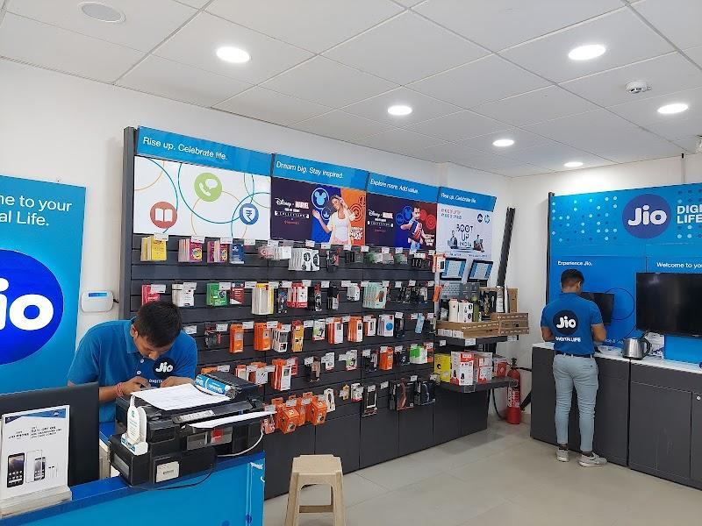
Strength 1: Diversified business operations
Reliance operates across energy, retail, telecommunications, digital services and media. Its digital-services EBITDA grew by 17.8% during FY 2025–26, while retail EBITDA grew by 7.7%. This diversification gives the company multiple sources of operating earnings and reduces its dependence on any single business.

Strength 2: Strong earnings and operating cash generation
Revenue increased by 9.8%, profit after tax increased by 17.8%, and operating cash flow reached ₹1,92,113 crore in FY 2025–26. These figures demonstrate the company's ability to generate earnings and cash to support operations, investment and debt servicing.
Source: Reliance Industries, FY 2025–26 Integrated Annual Report.

10. Two Major Weaknesses of Reliance Industries

Weakness 1: Exposure to energy-market volatility
A substantial part of Reliance's operations is connected with oil, refining and petrochemicals. Changes in crude-oil prices, global demand, supply conditions and refining margins can affect profitability. The company's diverse operations provide some protection, but they do not eliminate this risk.
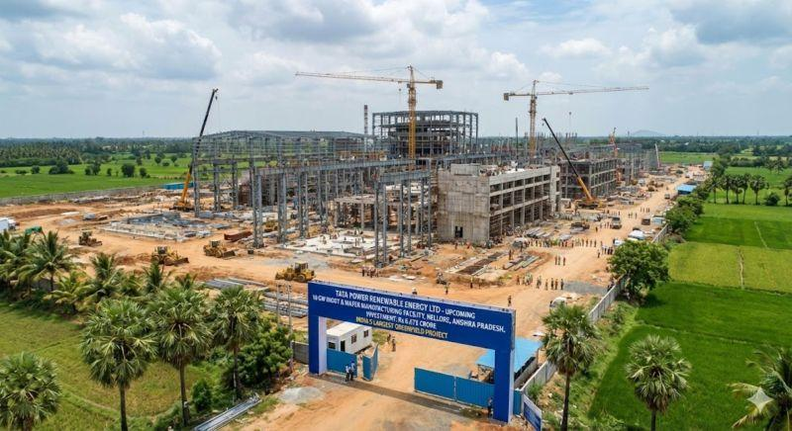
Weakness 2: High capital requirements and debt exposure
Reliance invested ₹1,44,271 crore in capital expenditure during FY 2025–26 and reported consolidated net debt of ₹1,24,717 crore at year-end. Large investments may support future growth, but they also create execution, financing and return-on-investment risks if new projects perform below expectations.
Source: Official annual-report financial review.

11. Overall Fundamental Assessment
The following table summarises the evidence gathered from the annual report.
Parameter | Finding | Assessment
Revenue growth | 9.8% | Positive
Profit growth | 17.8% | Strong improvement
EPS growth | Approximately 15.9% | Positive
Debt-equity ratio | Approximately 0.41:1 on the report's specified basis | Monitor leverage
Adjusted return on net worth | 10.1% | Improved
Reported ROCE | 20.7% | Improved
Operating cash flow | ₹1,92,113 crore | Strong cash generation
The findings suggest that Reliance's FY 2025–26 financial performance improved across several important indicators. However, the debt-equity ratio, return ratios and consolidated debt figures use different accounting measures and should not be interpreted as directly interchangeable.

12. Conclusion
After studying the Integrated Annual Report of Reliance Industries Limited for FY 2025–26, I conclude that the company demonstrated strong financial performance during the year. Its revenue increased by 9.8%, while profit after tax rose by 17.8%. Earnings per share also improved, and the company generated more than ₹1.92 lakh crore in operating cash flow.
One of the most important observations from my analysis is that profit grew faster than revenue. This suggests an improvement in overall profitability. The company's presence in several industries, particularly retail and digital services, provides opportunities for further growth.
However, Reliance is not free from risks. Its energy and petrochemical operations are affected by global market conditions, and its large capital expenditure and outstanding debt require careful management. Future performance will depend on whether its investments generate sufficient returns and whether profitability can be maintained.
My final assessment is that Reliance Industries has a strong business base and encouraging financial indicators, making it a company worth studying for its long-term business potential. However, financial strength alone does not establish that its shares are attractively priced. A complete investment decision would also require examining the current market price, valuation ratios, future earnings prospects and the investor's risk tolerance.
This project helped me understand that fundamental analysis involves examining both the positive and negative aspects of a company instead of judging it only by its size or reputation.

13. References and Bibliography
1. Reliance Industries Limited. Integrated Annual Report 2025–26. Official company report.
Read the complete annual report
2. Reliance Industries Limited. Financial Performance and Review, FY 2025–26.
Read the financial performance analysis
3. Reliance Industries Limited. Ten-Year Financial Highlights.
View financial indicators and historical figures
4. Reliance Industries Limited. Consolidated Financial Statements — Statement of Cash Flows.
Read the consolidated cash flow statement

