AgriInsight AI
AI-Powered Crop Yield & Farm Decision Analytics Platform

Project Report
Submitted by: Thodupunuri Sai Charan
B.Tech - Computer Science and Engineering (Data Science)
CMR College of Engineering & Technology
AICTE | IBM SkillsBuild - Data Analytics with AI Internship 2026
Project Domain: Agriculture + Data Analytics + Machine Learning

1. Abstract
AgriInsight AI is a data analytics and machine-learning project that converts historical crop, climate and agricultural-input records into decision-ready information. The project covers data cleaning, exploratory data analysis (EDA), KPI calculation, crop and area comparisons, trend analysis, machine-learning yield prediction and reliability-aware decision support.
The main objective is to make agricultural data understandable before a prediction is used. The dashboard therefore separates descriptive analytics from AI prediction and clearly shows the role of model validation. It does not prescribe fertilizer or pesticide dosage.

2. Problem Statement
Agricultural datasets may contain thousands of historical records, but raw rows do not directly answer practical questions such as which crops show higher historical yield, how yield changes over time, where performance is strongest, which variables may be associated with variation, and whether a predictive model is reliable enough to support a decision.
AgriInsight AI addresses this gap through a simple workflow: clean the data, identify KPIs and patterns, validate prediction models, and present risk/opportunity notes through a clear dashboard.

3. Project Objectives
- Clean and prepare the crop-yield dataset using a reproducible Python workflow.
- Calculate clear KPIs such as record count, crop count, area count and average yield.
- Visualize crop-wise, area-wise and year-wise yield patterns.
- Explore rainfall, temperature and pesticide-use relationships with yield.
- Train and compare a baseline model and a non-linear machine-learning model.
- Evaluate model quality using MAE, RMSE and R² on a held-out test set.
- Show prediction reliability together with the predicted value.
- Present results through an interactive Streamlit dashboard.

4. Dataset
Dataset: Crop Yield Prediction Dataset. The working file contains 28,242 records, 101 countries/areas and 10 crop types, covering the years 1990 to 2013. The variables used by the project include Area, Item (crop), Year, average rainfall, pesticide use, average temperature and crop yield (hg/ha).
Primary source reference: https://www.kaggle.com/datasets/patelris/crop-yield-prediction-dataset
Public code mirror used for reproducible loading: https://github.com/ManikantaSanjay/crop_yield_prediction_regression

5. Tools and Technologies
- Python - project programming language.
- Pandas and NumPy - data cleaning, transformation, KPI calculation and EDA.
- Matplotlib - report charts and exploratory visualizations.
- Scikit-learn - preprocessing, Linear Regression, Random Forest, and model evaluation.
- Streamlit - interactive dashboard with Executive Overview, Data Analytics, AI Prediction and Method & Reliability sections.
- Jupyter Notebook - step-by-step analysis file for internship submission.
- Git and GitHub - project repository and reproducible file structure.
- IBM SkillsBuild / IBM Bob integration - AI-assisted problem/KPI planning, dataset review, project-file review, dependency checking, approval checkpoints and GitHub-ready submission review. The Streamlit app generates a Bob-ready brief from the live dataset and model-validation results.

6. Data Analytics Methodology
- Data collection: load the crop-yield CSV and confirm required columns.
- Data cleaning: remove index columns, convert numeric fields, handle missing values and duplicates, and reject invalid negative values.
- EDA: calculate KPIs, crop averages, area averages, historical trends and exploratory correlations.
- Preprocessing: one-hot encode Area and Item; standardize numeric features inside a Scikit-learn pipeline.
- Model comparison: train Linear Regression as a baseline and Random Forest Regressor as the non-linear model.
- Validation: evaluate MAE, RMSE and R² on a fixed 25% held-out test set.
- Decision support: interpret prediction position against crop-specific historical quartiles and display reliability notes.

6.1 Dataset Profile
Measure | Value
Records | 28,242
Countries / Areas | 101
Crop Types | 10
Time Period | 1990-2013
Overall Average Yield | 7.71 t/ha
Prediction Target | hg/ha_yield

6.2 Project Output Structure
- Executive Overview - dataset KPIs and major yield trends.
- Data Analytics - crop, area, time-series and relationship analysis.
- AI Prediction - model-based yield estimate with reliability status.
- Method & Reliability - model comparison, validation and limitations.

7. Dashboard Output - Executive Overview
The Executive Overview is the first project portal. It summarizes the dataset before the user moves to detailed analysis or prediction. Large KPI values are used so the main information can be read quickly.
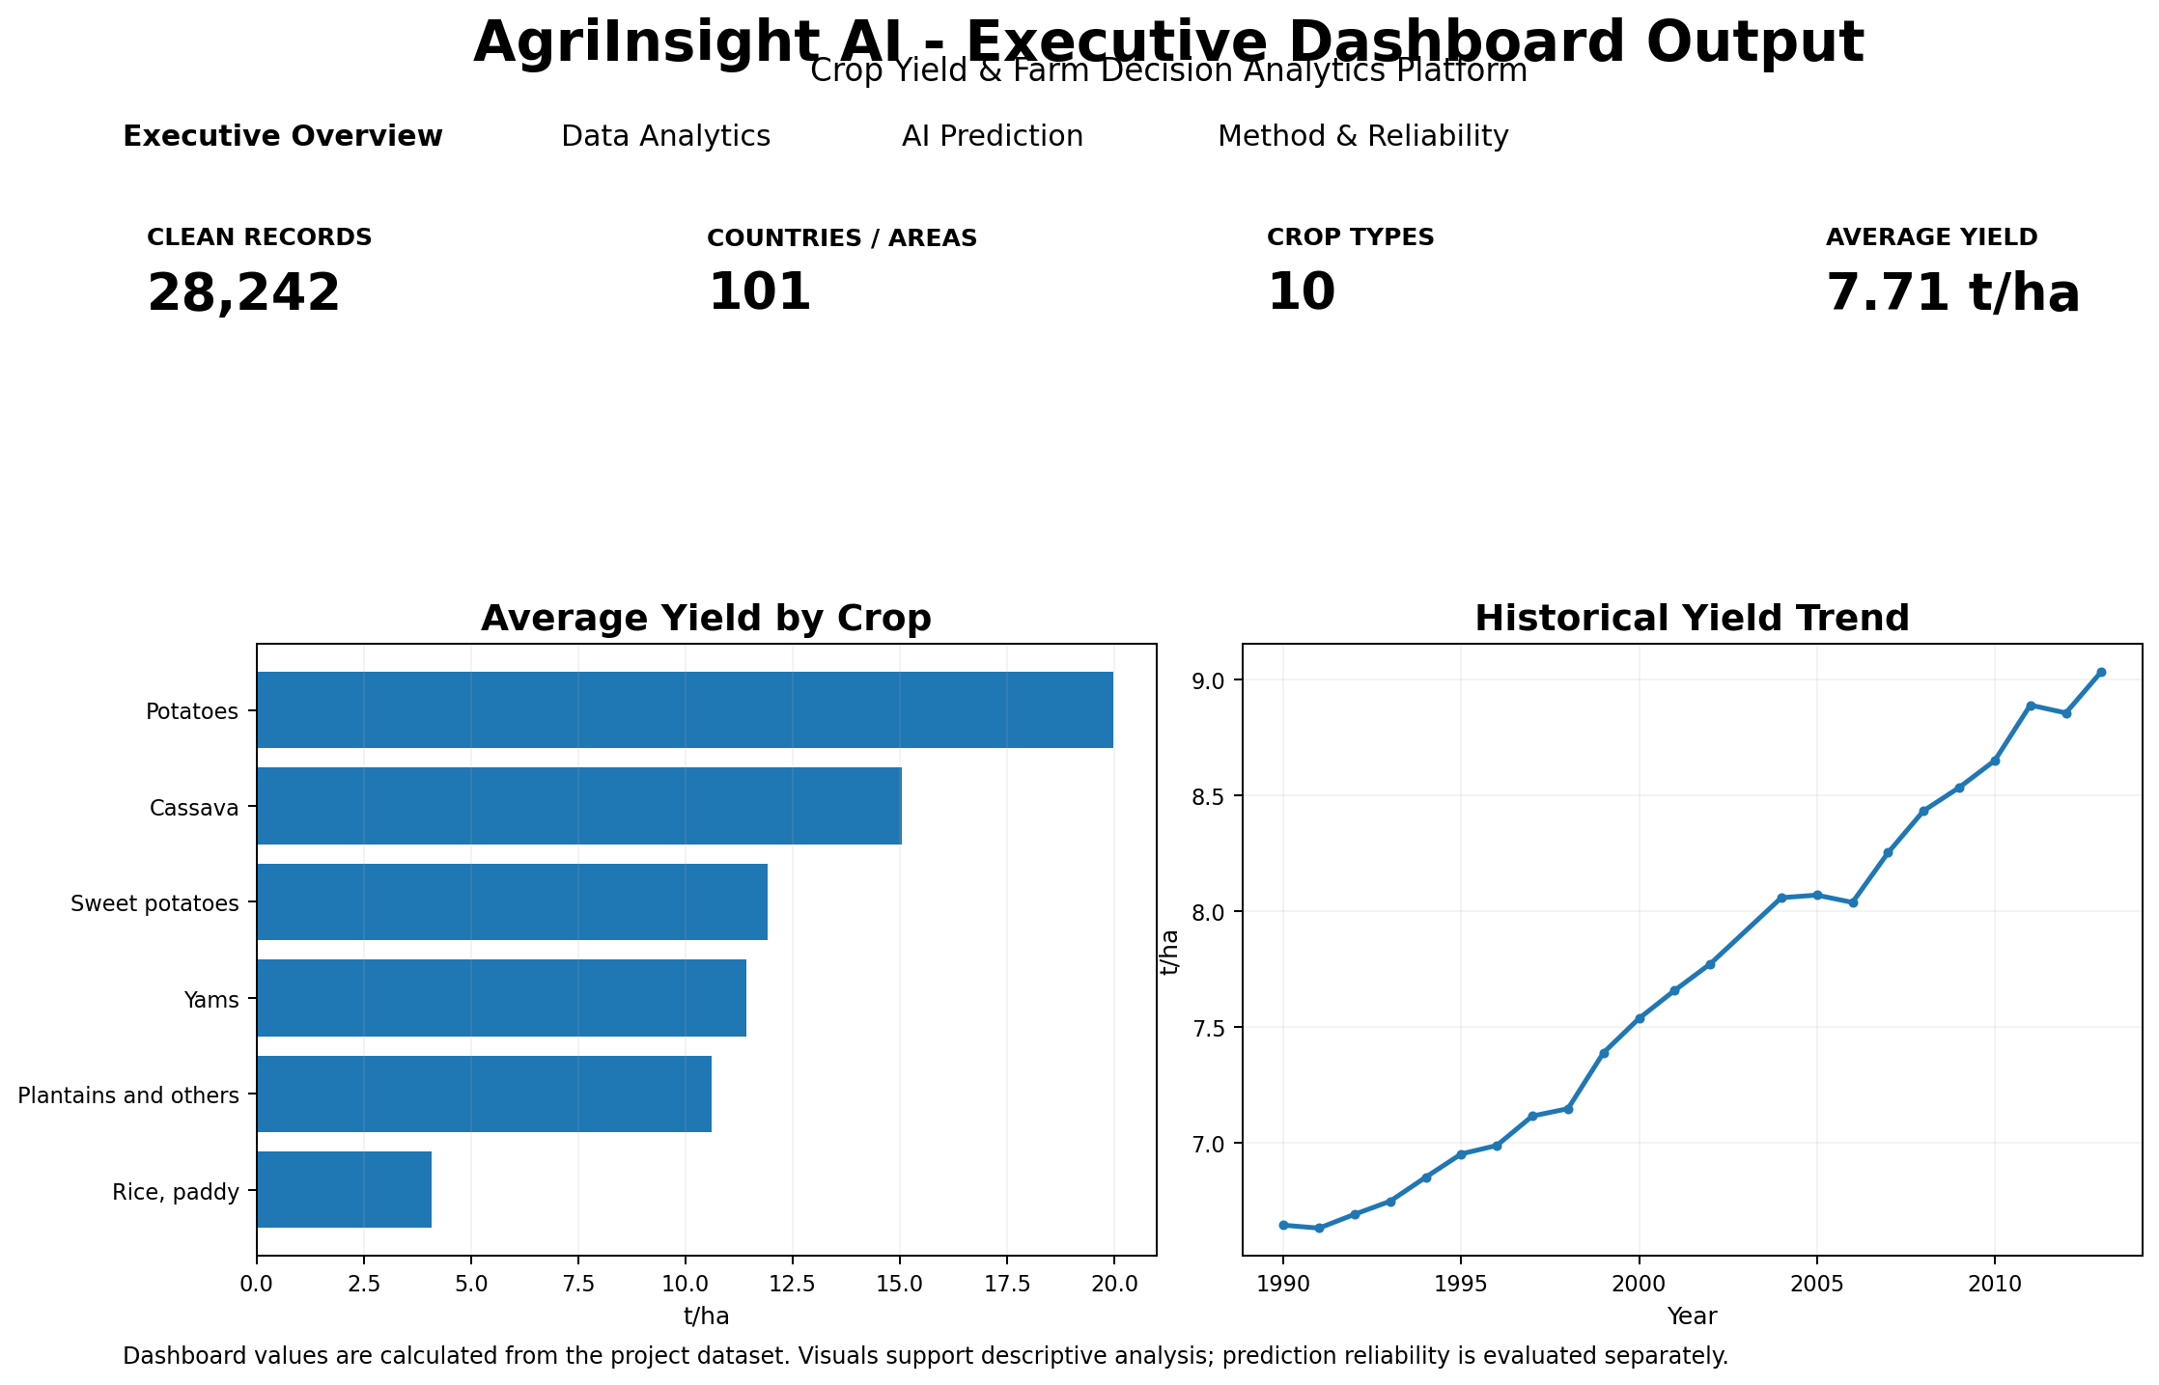
Figure 1. Executive dashboard output based on the project dataset.
Observed project KPIs: 28,242 records, 101 countries/areas, 10 crop types and an overall average yield of approximately 7.71 t/ha.

8. Crop-Level Yield Analysis
Crop-wise aggregation shows that historical yield levels vary substantially across crop categories. This chart is descriptive and is not used by itself to recommend a crop for a specific farm because location, season, soil and other variables also matter.
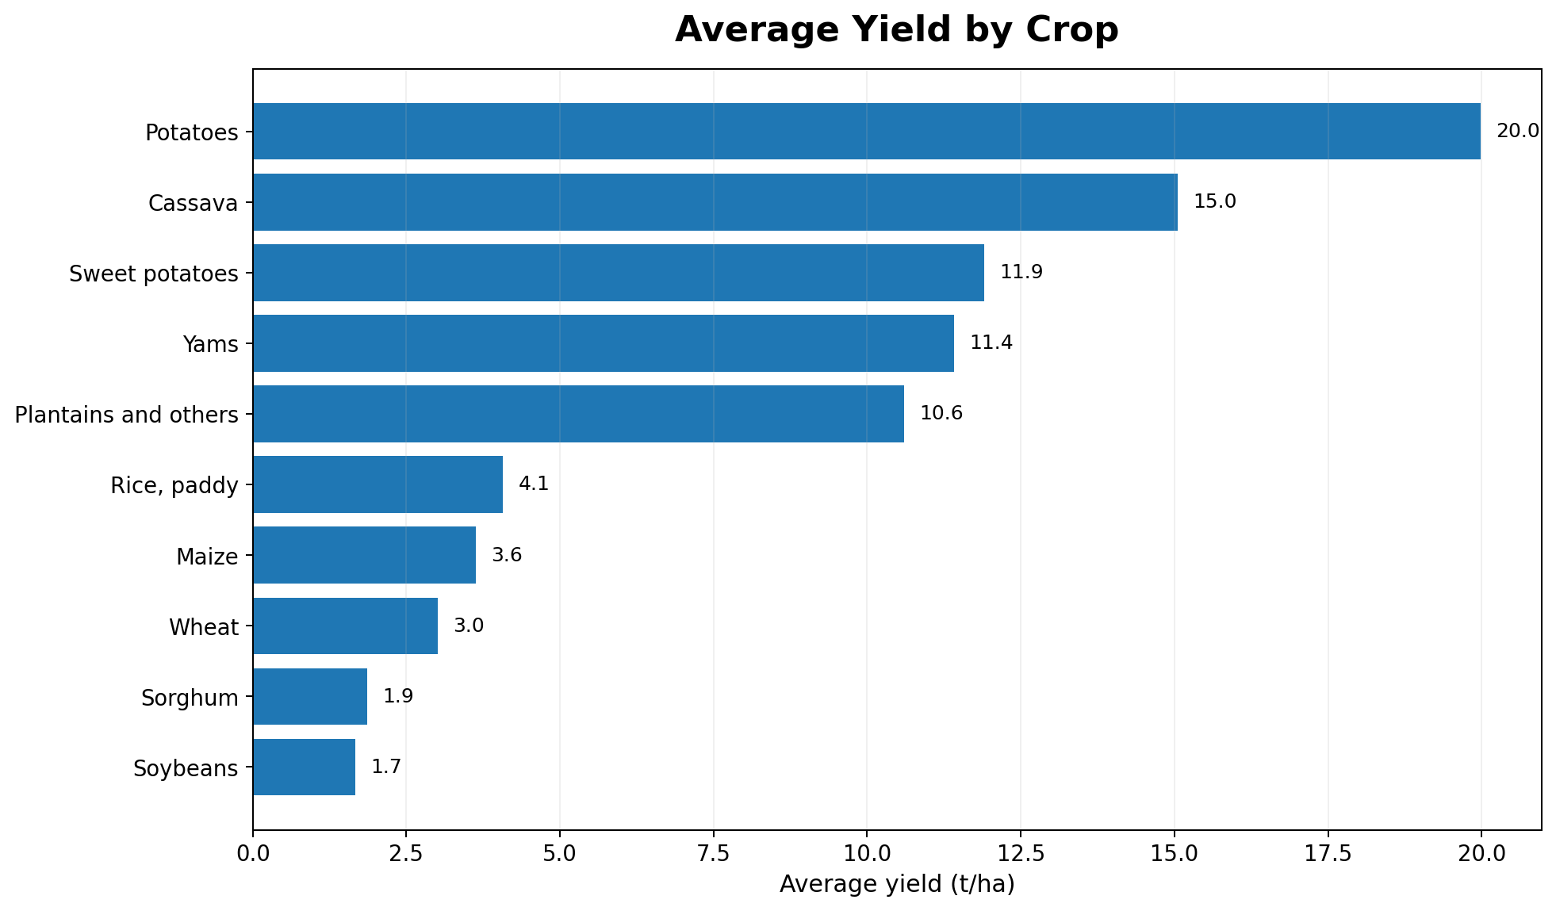
Figure 2. Average historical yield by crop, converted from hg/ha to t/ha.
In this dataset, potatoes have the highest average yield at about 19.98 t/ha, followed by cassava at about 15.05 t/ha. Soybeans and sorghum have lower average yield values in this historical dataset. These values represent dataset-level averages, not guaranteed field outcomes.

9. Historical Yield Trend
The time-series view answers whether the dataset shows a long-term change in average recorded yield. It helps a user see the direction of historical performance before looking at individual countries or crops.
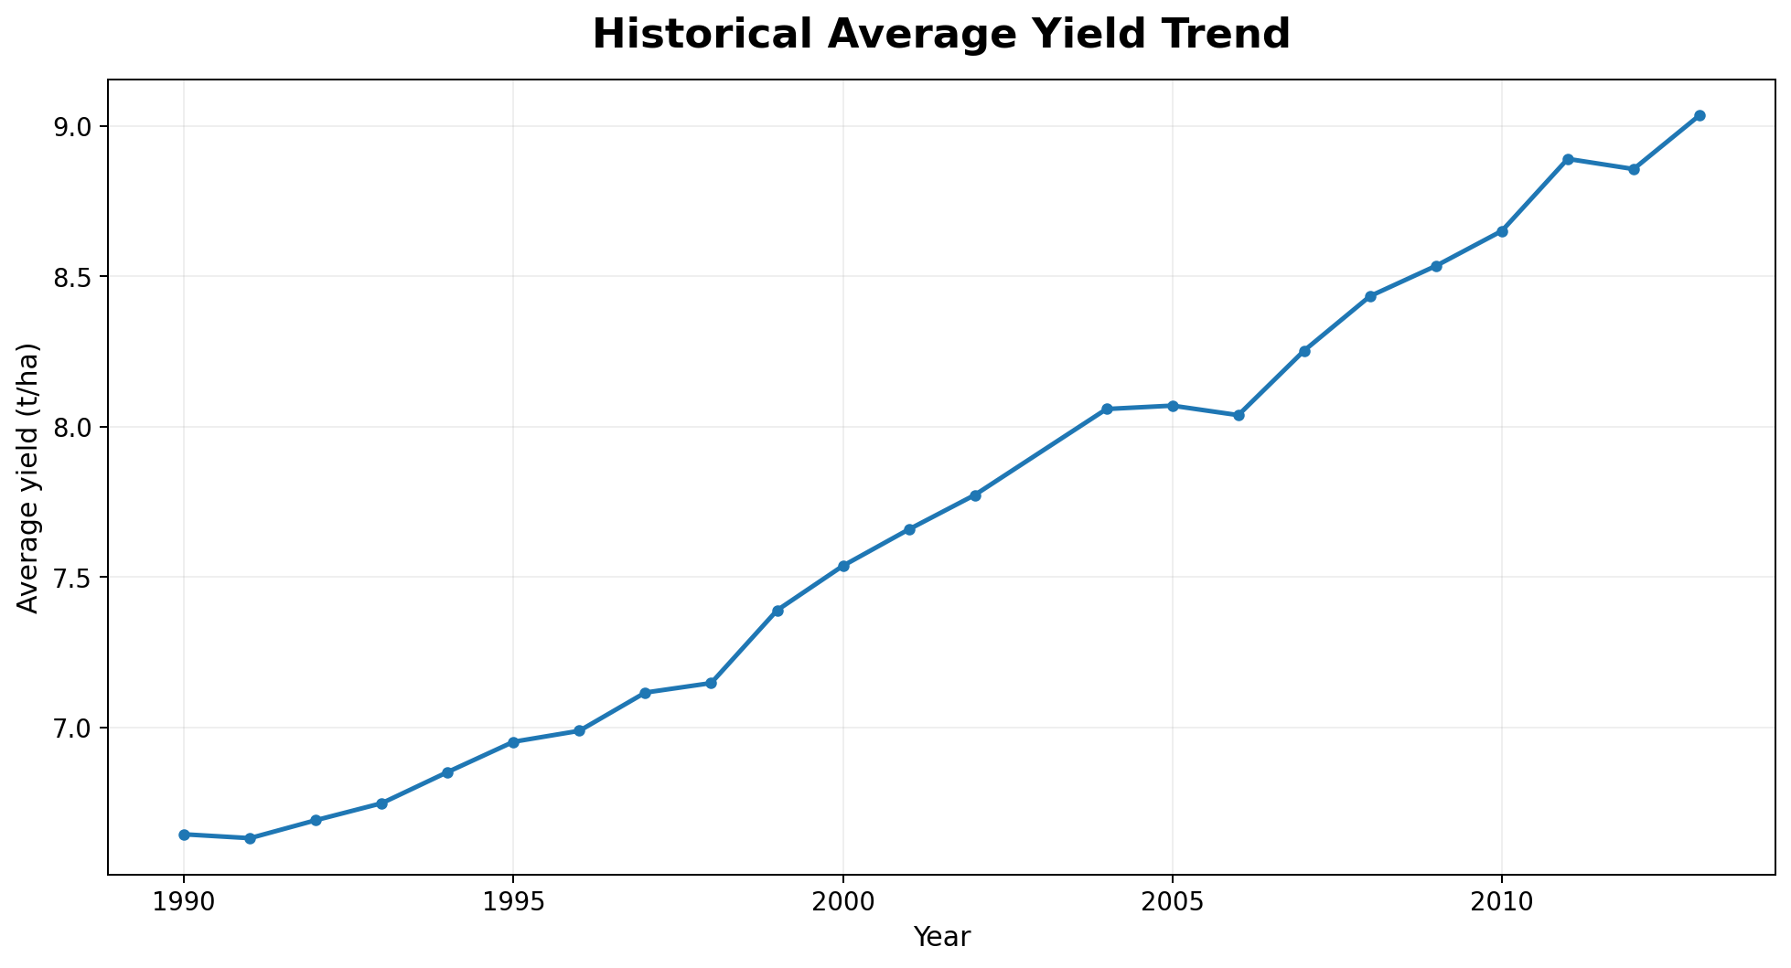
Figure 3. Historical average yield trend from 1990 to 2013 (2003 is absent from the working dataset).
Average yield in the dataset rises from approximately 6.64 t/ha in 1990 to about 9.04 t/ha in 2013. This is an aggregate trend across countries and crops; it should not be interpreted as a causal effect of any single input variable.

10. Area-Level Comparison
Area comparison identifies where high average yields occur in the historical records. It is useful for finding records that deserve deeper analysis, but it does not prove that a location itself causes higher yield.
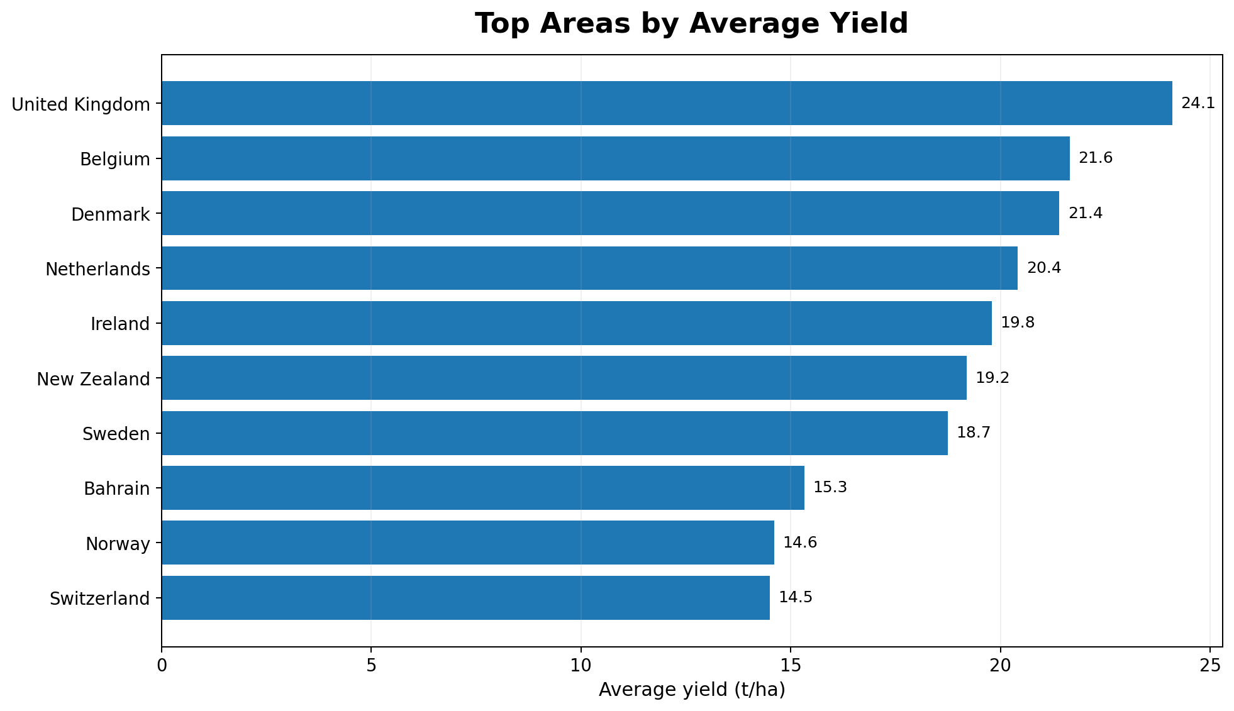
Figure 4. Top areas by average historical yield in the project dataset.
The United Kingdom is the highest area-level average in this aggregation at about 24.10 t/ha, followed by Belgium and Denmark. The dashboard allows the user to move from this summary into crop-specific analysis.

11. Driver / Correlation Analysis
The project calculates Pearson correlation as an exploratory signal. Correlation is not treated as causation, because agricultural yield is influenced by many interacting factors and the dataset does not contain every field-level condition.
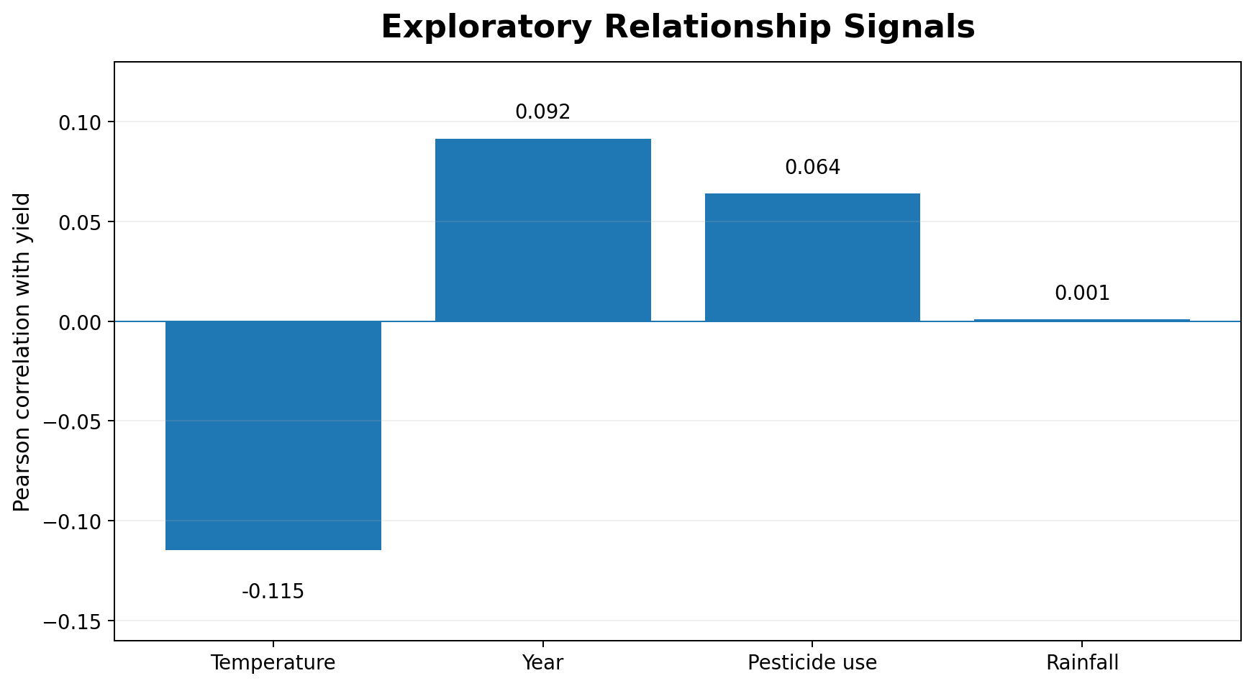
Figure 5. Exploratory correlation of selected numeric variables with yield.
The observed full-dataset correlations are weak: rainfall is approximately 0.001, pesticide use 0.064, year 0.092 and average temperature -0.115. Because these are small associations, the project avoids simplistic claims such as “more rainfall always increases yield.”

12. Data Analytics Portal
The Data Analytics portal brings the area comparison and driver analysis into one screen. The goal is to let the user move from a high-level KPI to a more detailed pattern without adding unnecessary charts.
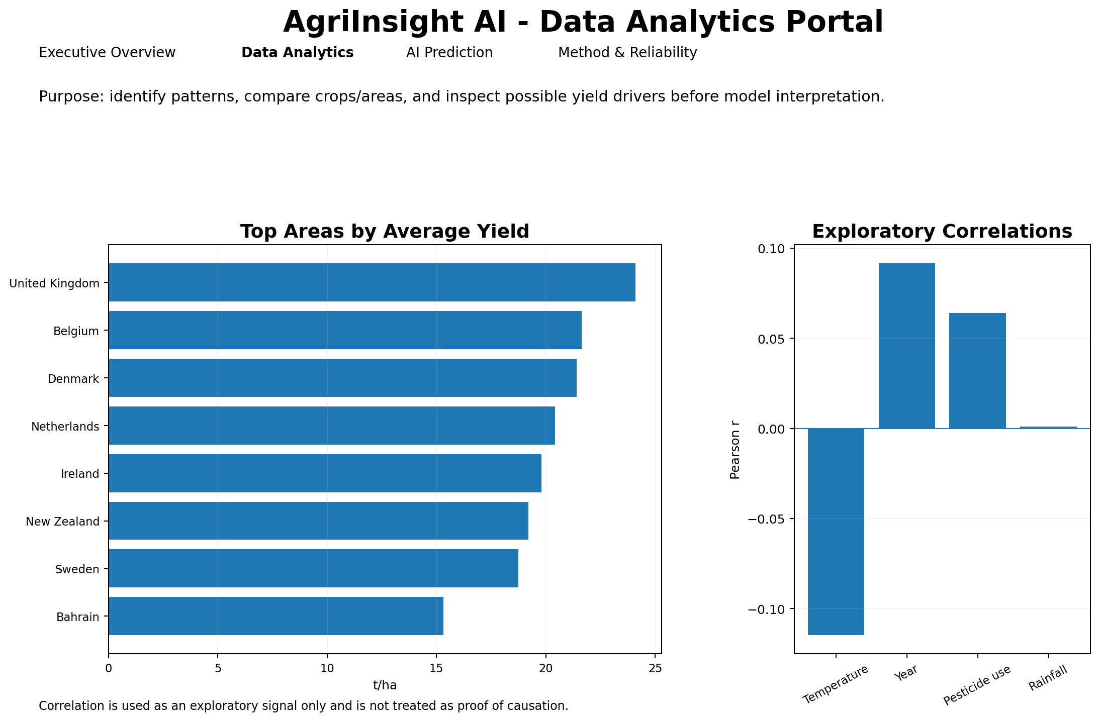
Figure 6. Data Analytics portal showing area comparison and exploratory relationships.

12.1 Main Questions Answered
- Which crops have higher or lower average yield in the historical dataset?
- How has average yield changed over time?
- Which countries/areas show higher averages?
- Do rainfall, temperature, pesticide use or time show a simple linear relationship with yield?
- Which patterns require deeper model-based or agronomic review?

13. AI Prediction and Decision-Support Portal
The prediction section accepts Area, Crop, Year, average rainfall, pesticide use and average temperature. The code compares Linear Regression and Random Forest on a held-out test set, selects the better validation model, and shows a reliability label before the prediction is interpreted.
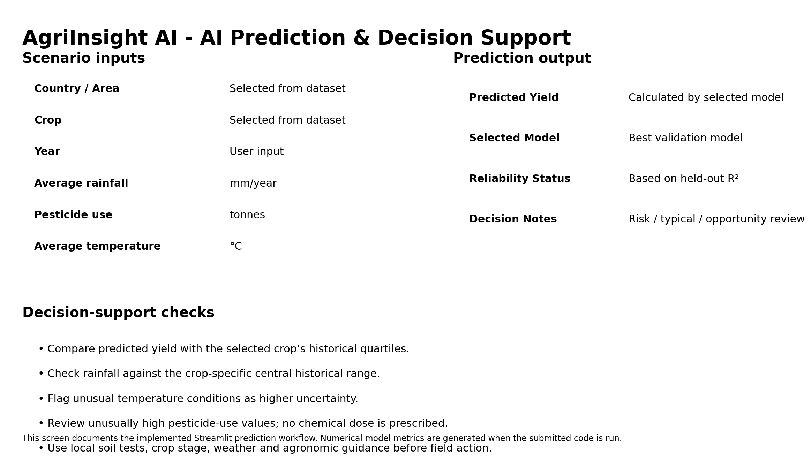
Figure 7. Implemented prediction and decision-support screen structure.

13.1 Model Inputs and Target
- Categorical inputs: Area and Item (crop).
- Numeric inputs: Year, average rainfall, pesticide use and average temperature.
- Prediction target: hg/ha_yield, converted to t/ha for dashboard display.

13.2 Reliability Gate
MAE measures average absolute prediction error, RMSE gives more weight to larger errors, and R² measures how much held-out variation is explained by the model. The project does not hard-code evaluation values in the report; they are generated from the submitted code so they remain consistent with the exact dataset and installed package versions used during evaluation.

14. Decision Intelligence
A prediction is converted into a simple decision-support message rather than presented as a final agricultural instruction. The predicted yield is compared with crop-specific historical quartiles, and environmental/input values are checked against the central historical range for that crop.
- Lower historical yield quartile: flag for yield-risk review.
- Upper historical yield quartile: flag for opportunity review.
- Rainfall below the lower quartile: check water availability and irrigation planning.
- Rainfall above the upper quartile: check drainage and waterlogging risk.
- Temperature outside the central crop range: treat the prediction as higher uncertainty.
- Pesticide use above the upper quartile: review integrated pest-management practices and local guidance.
The project does not provide pesticide or fertilizer dose recommendations. Field decisions require local crop stage, soil-test results, product-label instructions, weather conditions and agronomic guidance.

15. IBM SkillsBuild / IBM Bob Alignment
IBM Bob is integrated at the repository and review-workflow level, following the plan-first and approval-based development approach demonstrated in the internship. It is not used as a hidden yield-prediction API. The submitted Python notebook and Streamlit application remain the reproducible source of truth for data cleaning, EDA, model metrics and predictions.
- Problem statement and KPI planning are prepared before any code change.
- The dataset and project files are attached/referenced so the review remains data-driven rather than UI-only.
The repository includes a project-level IBM Bob Skill that instructs Bob to review the notebook/application structure and check requirements.txt against the code.
- README and project-report content are reviewed against the current code and dataset scope.
- A final GitHub-ready repository check verifies the required files and reproducible structure.

15.1 Implemented IBM Bob Handoff
The Streamlit dashboard contains a dedicated IBM Bob Integration tab. It creates a project brief directly from the current cleaned dataset and model-validation table. The repository also includes `.bob/skills/agriinsight-review/SKILL.md`, which defines the Bob review workflow for dataset fidelity, EDA, ML validation, dependencies, documentation consistency and responsible-use constraints.
The same handoff is included as IBM_Bob_Project_Brief.txt together with IBM_Bob_Integration_Guide.md. When the repository is opened in IBM Bob Advanced mode, the project skill can be activated automatically or invoked with `use_skill agriinsight-review`, so the review uses the same scope as the submitted Python files.

15.2 Approval and Review Workflow
- Plan first: the Bob skill requires a short review plan before any material file change.
- Review the data pipeline: Bob is instructed to check cleaning, EDA, KPIs and visualizations against the attached/referenced dataset.
- Review AI/ML: Bob is instructed to check the baseline model, Random Forest, held-out metrics and reliability gate.
- Review required files: the Bob workflow checks that code, requirements.txt, README and report remain mutually consistent.
- Approval before material changes: the skill asks for proposed revisions first so the student can approve relevant changes.
- Final repository check: the skill includes a GitHub-ready structure and required-file check before submission.

16. Key Results
- The project converts 28,242 raw historical records into clear executive KPIs and visual summaries.
- Crop-level analysis reveals large differences in historical average yield across the 10 crop types.
- Historical average yield increases from about 6.64 t/ha in 1990 to about 9.04 t/ha in 2013 in the aggregated dataset.
- Area-level aggregation highlights high historical averages but is presented as descriptive evidence, not causal proof.
- Simple full-dataset correlations between yield and rainfall, pesticide use, temperature and year are weak, supporting the need for multivariable modelling rather than single-variable conclusions.
- The prediction module separates model validation from agronomic decision support and explicitly communicates uncertainty.

17. Limitations
- The dataset is historical and country-level; it is not a substitute for current field measurements.
- It does not contain field-level soil tests, crop stage, irrigation schedules, variety, local disease pressure or weather forecasts.
- Historical association does not prove causal response.
- Prediction quality depends on how similar the new scenario is to the training data.

18. Conclusion
AgriInsight AI demonstrates the complete Data Analytics with AI workflow expected from the internship: collect and clean data, calculate KPIs, create visual analysis, identify trends and possible drivers, build and validate machine-learning models, and convert the result into an understandable decision-support dashboard. The focus is not on adding many charts, but on using data to move from raw records to a clear analytical decision.

19. Submission Files
- AgriInsight_AI.ipynb - main notebook/code file for the Google Form.
- requirements.txt - Python dependencies.
- AgriInsight_AI_Project_Report.docx - complete project report with dashboard and chart outputs.
- README.md - project overview, setup, dataset and working instructions.
- AgriInsight_AI.py - Streamlit dashboard application included in the GitHub project package.
- AgriInsight_AI_Project_Report.pdf - PDF copy of this report.
- IBM_Bob_Project_Brief.txt - Bob-ready project context, review tasks and approval instructions.
- IBM_Bob_Integration_Guide.md - step-by-step IBM Bob repository integration and review workflow.
.bob/skills/agriinsight-review/SKILL.md - project-level IBM Bob review skill included in the repository.

20. References
- AICTE | IBM SkillsBuild Data Analytics with AI Internship 2026 - internship masterclasses and project discussion.
- Crop Yield Prediction Dataset: https://www.kaggle.com/datasets/patelris/crop-yield-prediction-dataset
- Public dataset mirror/code reference: https://github.com/ManikantaSanjay/crop_yield_prediction_regression
- Scikit-learn documentation: https://scikit-learn.org/
- Streamlit documentation: https://docs.streamlit.io/
IBM Bob Skills documentation: https://bob.ibm.com/docs/ide/features/skills
IBM SkillsBuild - Learn with IBM Bob: https://skillsbuild.org/learn-with-ibm-bob

