Environment Setup

Step 1 :

Setting up the Python Environment

Download Windows x86-64 web-based installer

<Help > :: search for python download in google

under downloads go to windows

Step 2 :

Dwonlaod Xampp Software by using this Link

<https://www.apachefriends.org/download.html>

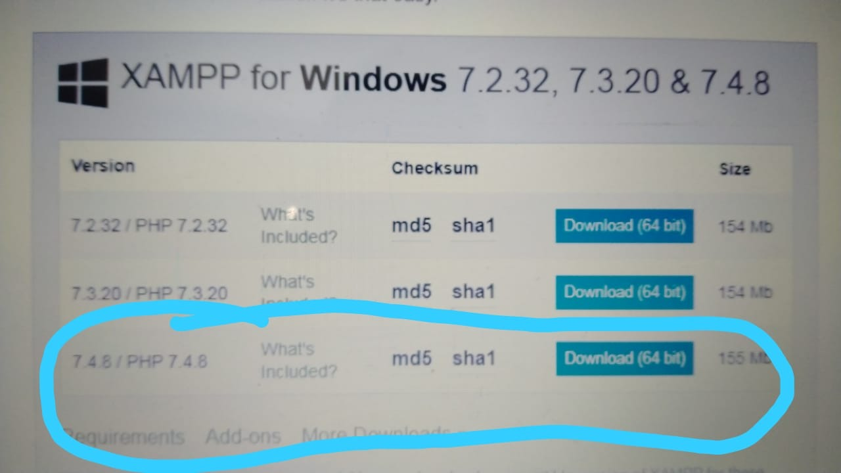

Step 3:

Install Xampp Software by searching in google after installation of xampp

We should get screen like this when we click on Xampp Control Plane in our system.

After that click on start button on both Apache and MySql.

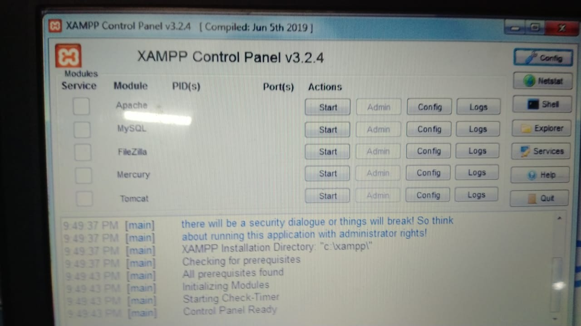

step4:

After that Go to Command Prompt and type python --version

We will get lastest installed python version

create one floder in any localdisk and go to that floder in command prompt and do this steps

create environment in your system

virtualenv new

For windows to activate environment :

new/Scripts/activate.bat

After that create Django project floder by doing this step

django-admin startproject education

go to that education floder in command prompt and create dajngo app

python manage.py startapp B.Tech

This step is used to sync with database what changes u did in project

python manage.py makemigrations

This step is used to sync with database what changes u made and it will implement it in database did in project

python manage.py migrate

This step is used to run the server

python manage.py runserver