Research Report about IoT in real life
IoT Applications in Smart Agrculture

Introduction

The Internet of Things (IoT) refers to a network of connected devices that collect, share, and analyze data through the internet. These devices include sensors, controllers, cameras, and smart machines. IoT technology has become very useful in many areas such as homes, healthcare, industries, and agriculture. Among these, agriculture has benefited greatly because farming depends heavily on weather, soil, water, and crop conditions. By using IoT, farmers can monitor and manage their fields more effectively.

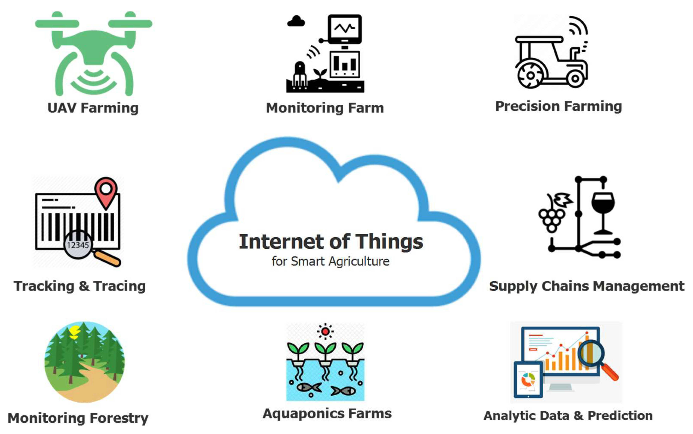

Smart agriculture is the use of advanced technologies like IoT, automation, and data analysis to improve farming. It helps farmers make better decisions, reduce waste, and increase crop productivity. With the growing population and increasing demand for food, smart agriculture has become important for sustainable farming and efficient use of natural resources.

Working of IoT in Agriculture

In smart agriculture, IoT devices are placed in fields, greenhouses, or storage units. These devices collect real-time information such as soil moisture, temperature, humidity, light intensity, and water levels. The collected data is sent through the internet to cloud platforms or mobile applications. Farmers can view the data on smartphones or computers and take action when needed.

For example, if soil moisture becomes low, the system can automatically switch on irrigation. If weather conditions become harmful for crops, the farmer receives an alert. This reduces manual work and allows better control over farming operations.

Major Applications of IoT in Smart Agriculture

1. Smart Irrigation

Water management is one of the most important parts of farming. IoT-based irrigation systems use moisture sensors to check how much water is available in the soil. When moisture drops below a required level, irrigation starts automatically.

This system helps save water, prevents overwatering, and improves plant growth. It is especially useful in places where water resources are limited.

2. Soil Monitoring

Soil quality directly affects crop production. IoT sensors can monitor pH level, nutrient content, moisture, and temperature of the soil.

By studying this data, farmers can know when fertilizers are needed and which crops are suitable for the land. This improves soil health and increases yield.

3. Weather Monitoring

Weather changes can affect crops suddenly. IoT weather stations measure rainfall, wind speed, humidity, and temperature.

Farmers receive updates and alerts about climate conditions. This helps them plan irrigation, harvesting, and crop protection at the right time.

4. Crop Monitoring

Crops can be monitored using cameras, drones, and sensors. These devices check plant growth, identify diseases, and detect pest attacks.

Early detection helps farmers protect crops before damage spreads. This reduces crop loss and improves quality.

5. Livestock Monitoring

IoT is also used in animal farming. Smart collars and wearable devices monitor the health, movement, and feeding patterns of animals.

Farmers can track livestock location and identify health issues early. This improves animal care and productivity.

6. Storage and Supply Chain Monitoring

After harvesting, crops need proper storage. IoT devices monitor temperature and humidity inside storage units.

This prevents spoilage and keeps products fresh during transportation. It improves food quality and reduces losses.

Advantages of IoT in Smart Agriculture

IoT offers many benefits in farming

- Higher productivity: Better monitoring leads to healthy crop growth and improved yield.
- Water conservation: Smart irrigation avoids wastage.
- Reduced labor: Many tasks become automatic.
- Real-time monitoring: Farmers can check conditions anytime.
- Early problem detection: Diseases and pests can be identified quickly.
- Better decision-making: Data helps farmers choose the right actions.
- Cost savings: Efficient use of resources reduces expenses.

Challenges of IoT in Agriculture

Even though IoT has many benefits, there are some challenges:

- High initial cost: Sensors and smart devices may be expensive.
- Internet connectivity: Rural areas may have weak network coverage.
- Technical knowledge: Farmers need training to use IoT systems.
- Maintenance issues: Devices need regular checking and repairs.
- Data security: Information stored online must be protected.

These challenges can be reduced through government support, affordable technology, and awareness programs.

Future of IoT in Agriculture

The future of agriculture is becoming more advanced with IoT. New technologies like artificial intelligence and machine learning can work with IoT to predict crop diseases and weather conditions more accurately.

Drones and robotics may handle spraying and harvesting automatically. Farmers will be able to manage large farms with less effort and better accuracy. IoT will help agriculture become more productive, sustainable, and environmentally friendly.

Conclusion

IoT has transformed traditional farming into smart agriculture. It helps farmers monitor soil, crops, weather, irrigation, and livestock with better accuracy and less effort. This improves productivity, saves resources, and supports sustainable farming.

Although there are some challenges such as cost and connectivity, the long-term benefits are significant. As technology continues to develop, IoT will play an important role in meeting food demands and building a smarter agricultural future.

