**Machine Learning Assignment-1**

**Name: Sammeta Jaya Sai Charan**

**Student ID: 700739775**

**Github link:** https://github.com/saicharan255/machinelearning.git

**Videolink:**https://drive.google.com/file/d/1o4kGPPvEhDzYGK6GinaF7ZTcUHZz6M3C/view?usp=sharing

**#Question 1-**

The following is a list of 10 students ages: ages = [19, 22, 19, 24, 20, 25, 26, 24, 25, 24]

* Sort the list and find the min and max age
* Add the min age and the max age again to the list
* Find the median age (one middle item or two middle items divided by two)
* Find the average age (sum of all items divided by their number)
* Find the range of the ages (max minus min)

**Source code:**

#Importing library called statistics which helps in calculating mathematical data

import statistics

ages = [19, 22, 19, 24, 20, 25, 26, 24, 25, 24]

# Sorts age list in ascending order by default

ages.sort()

print ("Sorted age:", ages) # Displays sorted values

# Minimum age

# Displays min value as we used min() method

print ("Min age:", min(ages))

# Maximum age

 # Displays max value as we used max() method

print ("Max age:", max(ages))

# Adding again min and max values so we use append() method to insert values to the list

ages.append(min(ages))

ages.append(max(ages))

#Displays the list again with new values

print ("Added min and max values again:",ages)

# Median (one middle item or two middle items divided by two, as we imported statistics library it calculates easily and provides the opt)

mdn_age = statistics.median(ages)

print ("Median age:", mdn_age)

# Average age

average= sum(ages)/len(ages)

print ("Avg age = ", average)

# Range

rng=max(ages)-min(ages)

print ("Range = ", rng)

**Description:**

In The Above Source Code Firstly We Imported A Library Called Statistics Which Will Be Useful For Our Calculations. Then We Have Inserted A Data With Integer Type In List, We Performed Finding Minimum And Maximum Age Using Min() And Max() Functions On Next We Added Them Using Append() And Then We Calculated Median, Average And Range Using Formulas And Function.

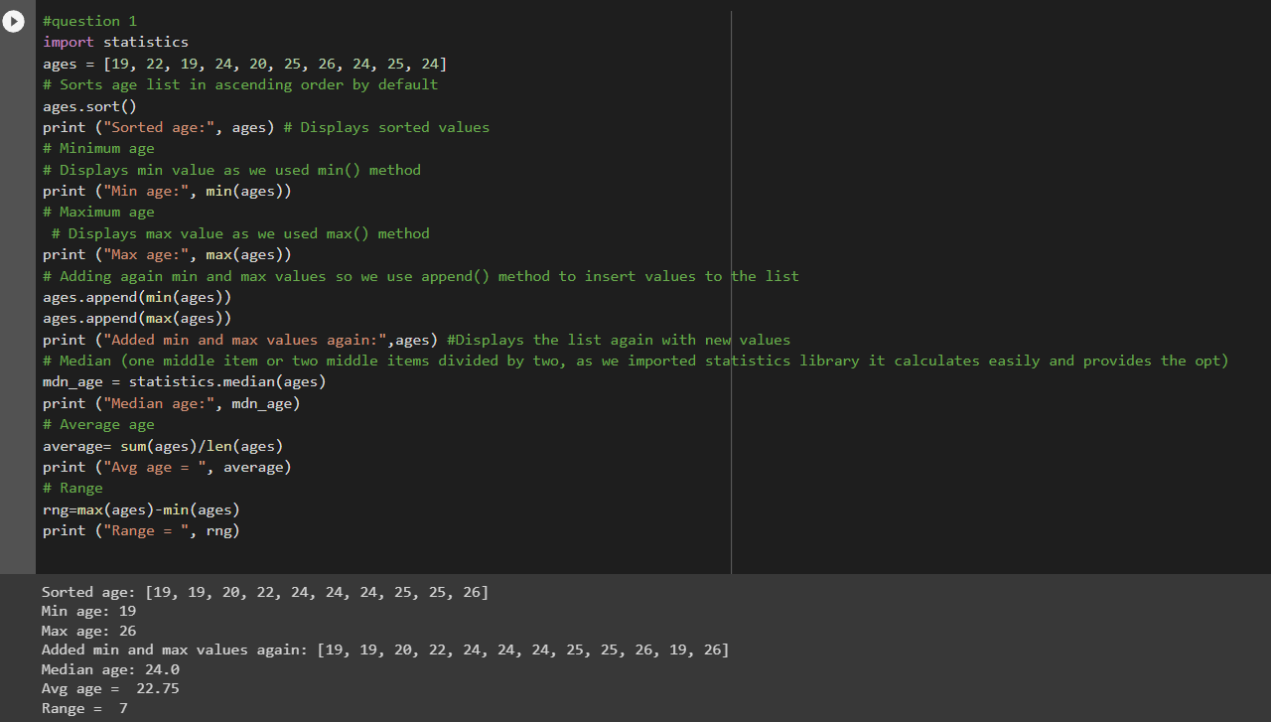

**#Question 2-**

* Create an empty dictionary called dog
* Add name, color, breed, legs, age to the dog dictionary
* Create a student dictionary and add first_name, last_name, gender, age, marital status, skills, country, city and address as keys for the dictionary
* Get the length of the student dictionary
* Get the value of skills and check the data type, it should be a list
* Modify the skills values by adding one or two skills
* Get the dictionary keys as a list
* Get the dictionary values as a list

**Source code:**

# Dog dictionary is created

dog = {}

print("empty dictionary dog is created",dog)

# keys and values are added to the dog

dog = {"name":"gipsy","color":"black","breed":"Doberman","legs":"4","age":"6"}

print ("Dog Dictionary:",dog)

# Student dictionary is created with given key and values

student = {"first_name":"jaya sai charan","last_name":"sammeta","Gender":"male","age":"23","marital_status":"single","skills":["games"],"Country":"us","City":"kansas","Address":"111 oneplus street"}

print ("Student Dictionary Created:",student)

# Find the length of student dictionary

print ("Length of student:", len(student))

# Check the datatype of skills

print ("Datatype fo skills:",type(student["skills"]))

# Get values of skills dictionary

print ("value of skills:",student["skills"])

# Add one item to skills

student["skills"].extend(["Coder"])

print ("New skill added:",student["skills"])

# Get dog and student key and values

print ("Dog keys:",dog.keys())

print ("Student values:",student.values())

**Description:**

In the above source code we have created dictionary called dog added keys and values and printed them on screen, again we created student and skills dictionary and given values and printed them onscreen. Now we calculated length, datatype using len() and type().we added an item to skill then printed the dog keys and student values using print().

**#Question3-**

* Create a tuple containing names of your sisters and your brothers (imaginary siblings are fine)
* Join brothers and sisters tuples and assign it to siblings • How many siblings do you have?
* Modify the siblings tuple and add the name of your father and mother and assign it to family_members

**Source code:**

#creating a tuple sisters and brothers

my_sisters = ('neelima', 'uma')

my_brothers = ('ravi','karthik','surya')

# Create another tuple as siblings and join the sister’s and brother’s tuple

siblings = my_sisters + my_brothers

# Displays siblings’ output and length of siblings

print("Siblings:", siblings)

print("how manySiblings:", len(siblings))

# Create another tuple as family_members and add father and mother name to it

family_members = siblings + ('lakshmi','venkat')

# Displays family_members output

print("Family_members:",family_members)

**Description:**

In The Above Source Code We Have Created A Tuple Sisters And Brothers And The Created Another Tuple Siblings And Added sisters and brother tuple, Displayed By Using Print(). Now We Created Family_Members  Tuple And Printed Them.

**#Question 4-**

it_companies = {'Facebook', 'Google', 'Microsoft', 'Apple', 'IBM', 'Oracle', 'Amazon'}

A = {19, 22, 24, 20, 25, 26}

B = {19, 22, 20, 25, 26, 24, 28, 27} age = [22, 19, 24, 25, 26, 24, 25, 24]

* Find the length of the set it_companies
* Add 'Twitter' to it_companies
* Insert multiple IT companies at once to the set it_companies
* Remove one of the companies from the set it_companies
* What is the difference between remove and discard
* Join A and B
* Find A intersection B
* Is A subset of B
* Are A and B disjoint sets
* Join A with B and B with A
* What is the symmetric difference between A and B
* Delete the sets completely
* Convert the ages to a set and compare the length of the list and the set.

**Source code:**

it_companies = {'Facebook', 'Google', 'Microsoft', 'Apple', 'IBM', 'Oracle', 'Amazon'}

print("Length of it_companies:", len(it_companies))

#Add twitter

it_companies.add('Twitter')

print("After adding another item:",it_companies)

#Add multiple it_companies

it_companies.update({'Infosys','Capgemini','Wipro','TCS'})

print("After adding multiple items:",it_companies)

#Remove

it_companies.remove('TCS')

print("After removing one company:",it_companies)

#Discard

it_companies.discard('TCS')

print("After discarding  company:",it_companies)

#Discard doesn't raise any error if any item is not present in the set

#Join A & B

A = {19, 22, 24, 20, 25, 26}

B = {19, 22, 20, 25, 26, 24, 28, 27}

print("Join A and B:", A.union(B))

#Intersection

print("Intersection of A and B:", A.intersection(B))

#Subset

print("Subset of A and B:", A.issubset(B))

#Disjoint

print("Disjoint:", A.isdisjoint(B))

#Convert list to set

age = [22, 19, 24, 25, 26, 24, 25, 24]

print("Converting list to set:", set(age))

#Length of set

print("Length of set:",len(set(age)))

#Length of list

print("Length of list:",len(age))

#Symmetric diff- returns values which are not in common with other set

print("Symmetric diff:",A.symmetric_difference(B))

#delete set

A.clear()

print(A)

B.clear()

print(B)

**Description:**

Initially we assigned some values to the list. We have performed several operation like find length, adding values, remove, discard, using len(),add(),remove(),discard(). Next we performed basic operations like union, intersection, subset, disjoint, length, symmetric difference and deletion of sets.

**#Question 5-**

The radius of a circle is 30 meters.

* Calculate the area of a circle and assign the value to a variable name of _area_of_circle_
* Calculate the circumference of a circle and assign the value to a variable name of _circum_of_circle_

Take radius as user input and calculate the area.

**Source code:**

# Initialise r where r value can be read from user inpt

r = int(input("enter r:"))

# Calculate area of circle and circumference of circle

_area_of_circle = 3.14*r*r

_circum_of_circle = 2*3.14*r

# Display area of circle and circumference of circle

print("Area of Circle:",_area_of_circle)

print("Circumference of Circle:",_circum_of_circle)

**Description:**

In the above code we have created an input variable R that takes input from the user, from the given input we calculated area of the circle, circumference of the circle using formulas(3.14*r*r, 2*3.14*r) and print them on the screen.

**#Question 6-**

“I am a teacher and I love to inspire and teach people”

* How many unique words have been used in the sentence? Use the split methods and set to get the unique words.

**Source code:**

#assigning a string to st

st = "I am a teacher and I love to inspire and teach people"

# Use split method to separate the words and set to get the unique values

spt=set(st.split(" "))

print(spt)

#print length

print("Length:",len(spt))

**Description:**

In the above code we assigned a string "I am a teacher and I love to inspire and teach people" to st by using the split () we found the unique words in the given string and the print the unique values in the display. Now we find the length using len() and print it on the screen.

**#Question 7-**

Use a tab escape sequence to get the following lines.

**Name Age Country City**

**Asabeneh 250 Finland Helsinki**

**Source code:**

# **\**t indicates white spaces tab character

a= "Name\t Age\tCountry\tCity\t\nAsabeneh 250\tFinland\tHelsinki"

print(a)

**Description:**

The above code uses tab escape sequence to print the data in particular format. So we used \t which gives a tab space in between the words which we can see below. It also provides a space at the precise location where the escape sequence is added.

**#Question 8-**

Use the string formatting method to display the following: radius=10

area = 3.14 * radius ** 2

“The area of a circle with radius 10 is 314 meters square.”

**Source code:**

#Using String format method

print(f'radius = 10')

print(f'area = 3.14*radius**2')

print(f'"The area of circle with radius {raidus} is {3.14*raidus*raidus} meters square"')

**Description:**

From the above code we used string formatting method to display “The area of a circle with radius 10 is 314 meters square.”. the code first prints radius = 10 then prints area = 3.14*radius**2. Now it prints The area of circle with radius 10 is 314 meters square.

**#Question 9-**

Write a program, which reads weights (lbs.) of N students into a list and convert these weights to kilograms in a separate list using Loop. N: No of students (Read input from user)

Ex: L1: [150, 155, 145, 148]

Output: [68.03, 70.3, 65.77, 67.13]

**Source code:**

#Creating a list(L1) for weights(lbs) of N students

L1=[int(num) for num in input().split(" ")]

#Creating another list called W_kg

W_kg=[]

#Using for loop to iterate the values and appending the list

for i in L1:

W_kg.append(round(i/2.205,2))

#Displaying the values in kgs after conversion

print ("Values are:",W_kg)

**Description:**

From the above code firstly we created a list l1 that takes input from the user and w_kg. initializing for loop to convert the weights we used a formula and append() then printed the converted weights.

**#Question 10**

The diagram below shows a dataset with 2 classes and 8 data points, each with only one feature value, labeled f. Note that there are two data points with the same feature value of 6. These are shown as two x’s one above the other. Provide stepwise mathematical solution, do not write code for it.

1. Divide this data equally into two parts. Use first part as training and second part as testing. Using KNN classifier, for K=3, what would be the predicted outputs for the test samples? Show how you arrived at your answer.
2. Compute the confusion matrix for this and calculate accuracy, sensitivity and specificity values.

