

Name: S. Sai Charan

Roll no: 45

Section: KE016

Course Code: INT 301

Registration number: 11905336

Submitted to: Dr Manjot Kaur

Use any open source software to extract addons, bookmarks, cookies, downloads, form fill-ups data, history from your browser and export the data obtained after extraction either in a json file or plain text file

Abstract: Firefox is a free and open-source web browser developed by the Mozilla Foundation. It is available for Windows, macOS, Linux, and Android, and is known for its speed, security, and privacy features. Firefox allows users to browse the internet, manage their downloads, bookmarks, and addons, and also provides a range of customization options to suit individual preferences. It is one of the most popular open-source web browsers in the world, with a user-friendly interface and a strong community of developers who contribute to its ongoing development and improvement.

Introduction: Firefox is a dedicated to promoting an open and accessible internet. The browser was first released in 2004 and has since become one of the most widely used browsers in the world, with millions of users across multiple platforms.And offers a range of customization options to allow users to tailor their browsing experience to their individual needs. It is also a free and open-source software, which means that anyone can view and modify its source code, and contribute to its development and improvement. Firefox has a user-friendly interface and provides a range of features, including tabbed browsing, a download manager, built-in spell-checking, and support for a wide range of plugins and extensions. It also has a strong focus on privacy, with features such as a built-in tracker blocker, and support for the use of virtual private networks (VPNs).
Objectives:

1. Firefox aims to provide a fast and responsive browsing experience to its users, with features like tab prioritization, predictive browsing, and faster page loading times.

2. Firefox is designed to be accessible to all users, with features such as support for screen readers and high-contrast mode to make browsing easier for users with visual impairments.

3. Mozilla Firefox is considered a browser that assists users with an intelligent address bar and a simplified user interface. Tabbed Browsing allows you to open a lot of websites in multiple tabs at the same time, between which you can switch back and forth easily
Description:
This report provides a detail description of how to use firefox a free open source software to extract addons, bookmarks, cookies, downloads, form fill-ups data, history from our browser and export the data obtained after extraction either in a json file or plain text file. To use the firefox open source software we must first download and install the software on windows operating system. Once installed the software provides a user friendly interface. Overall it also allows for a greater degree of customization and flexibility for users who may want to modify the software to better suit their needs. Additionally, being open-source promotes the use of free software and the sharing of knowledge, which can have a positive impact on the tech industry as a whole.

Scope:
The scope of this report is to provide a comprehensive guide on firefox open source software. The report covers the basic usage of extensions to extract and export obtained data that are in firefox open source software.
Mainly the report covers the Firefox open source software which provides several ways to extract various types of data, including downloads, history, cookies, bookmarks, addons, form fill ups data, and export them into plain text files or json files
While the report focuses on the use of firefox open source software on windows operating systems, the software is also comapatible with other operating systems such as linux and macos.
Overall, Firefox is a open source software provides several ways to extract data and export it to plain text files or json file.

System description of fire fox open source software in detail:

Step 1: Download and install firefox open source software
The first step is to download and install firefox open source software from its official website. The software is compatible with any operating system.

Step 2: Launch the firefox
After installing the software Look for the Firefox icon on your desktop or in your Applications folder. Double-click on the icon to launch Firefox. Alternatively, you can use the search bar on your computer and type in "Firefox," then click on the application when it appears in the search results.

Step 3: View hardware components
Firefox itself does not have the ability to view hardware components. However, we can use certain Firefox add-ons or extensions that can provide information about our computer's hardware components. Some of them them are Speccy, System Information Viewer, Hardware Monitor and this addons allows us to view detailed information about our computer's hardware components, including CPU usage, RAM usage, and hard drive activity.

Step 4: Customize tool bar
Once we click on Customize Toolbar the Customize Toolbar screen will appear. This screen displays an overview of Firefox's user interface and allows us to customize the toolbar to our liking. The Customize Toolbar screen displays various elements of the Firefox user interface, including the address bar, the search bar, the bookmarks toolbar, and the menu bar. It also displays icons for various Firefox features, such as the download manager, the history panel, and the Add-ons Manager.

Step 5: System summary
One of Firefox's key features is its privacy and security features. It has a built-in tracker blocker that prevents websites from tracking users' online activities. It also supports HTTPS encryption, which encrypts all data sent between the browser and websites to prevent eavesdropping and tampering.

Analysis Report

Basically i have used the firefox opensource software extensions to extract addons, bookmarks, cookies, downloads, form fill ups data, history and exported the data obtained after extraction in a json file or plain text file

Addons
Here for addons i have use about support page to extract a list of installed addons.
Save the file as a text file.The text file will contain a list of all the addons.

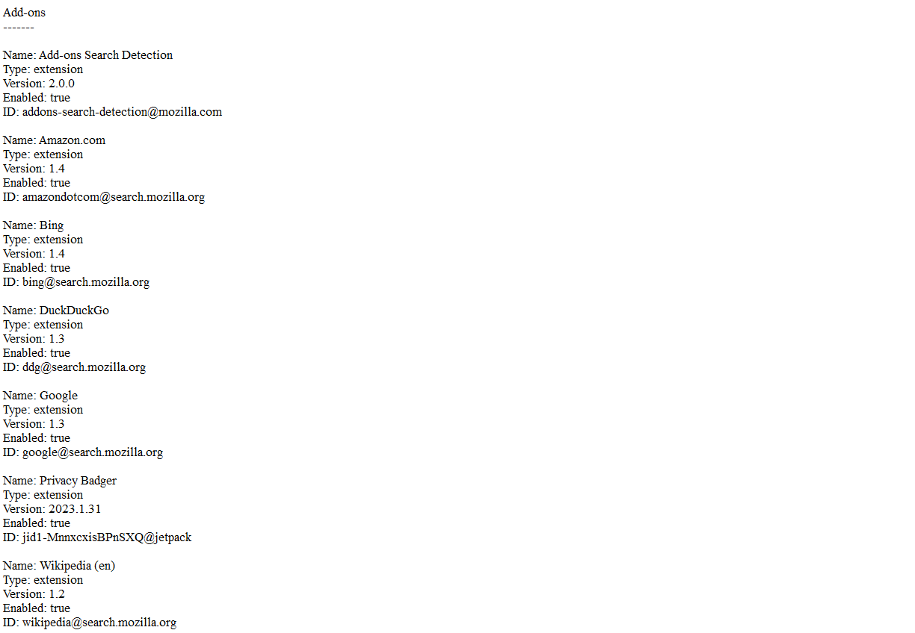

Bookmarks

For extracting bookmarks In the Library window click on Import and Backup located on the toolbar. Select Export Bookmarks from the options. Choose a location on our computer where we want to save the exported file and i have saved in plain text format

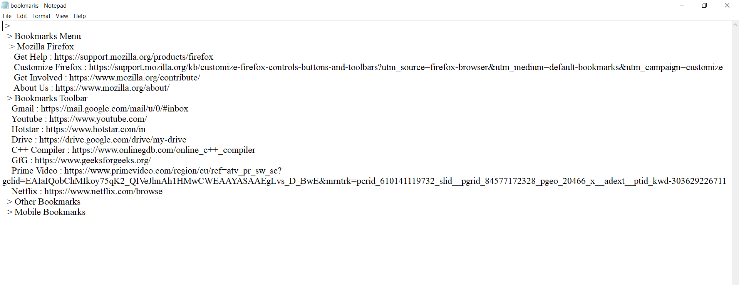
Cookies
For extracting cookies i have used the cookie quick manager extension Cookie Quick Manager is a Firefox extension that allows us to manage cookies on a per-site basis. It provides a quick and easy way to view, edit, delete, and protect cookies and also export cookies to a file. Here i have exported into text file.
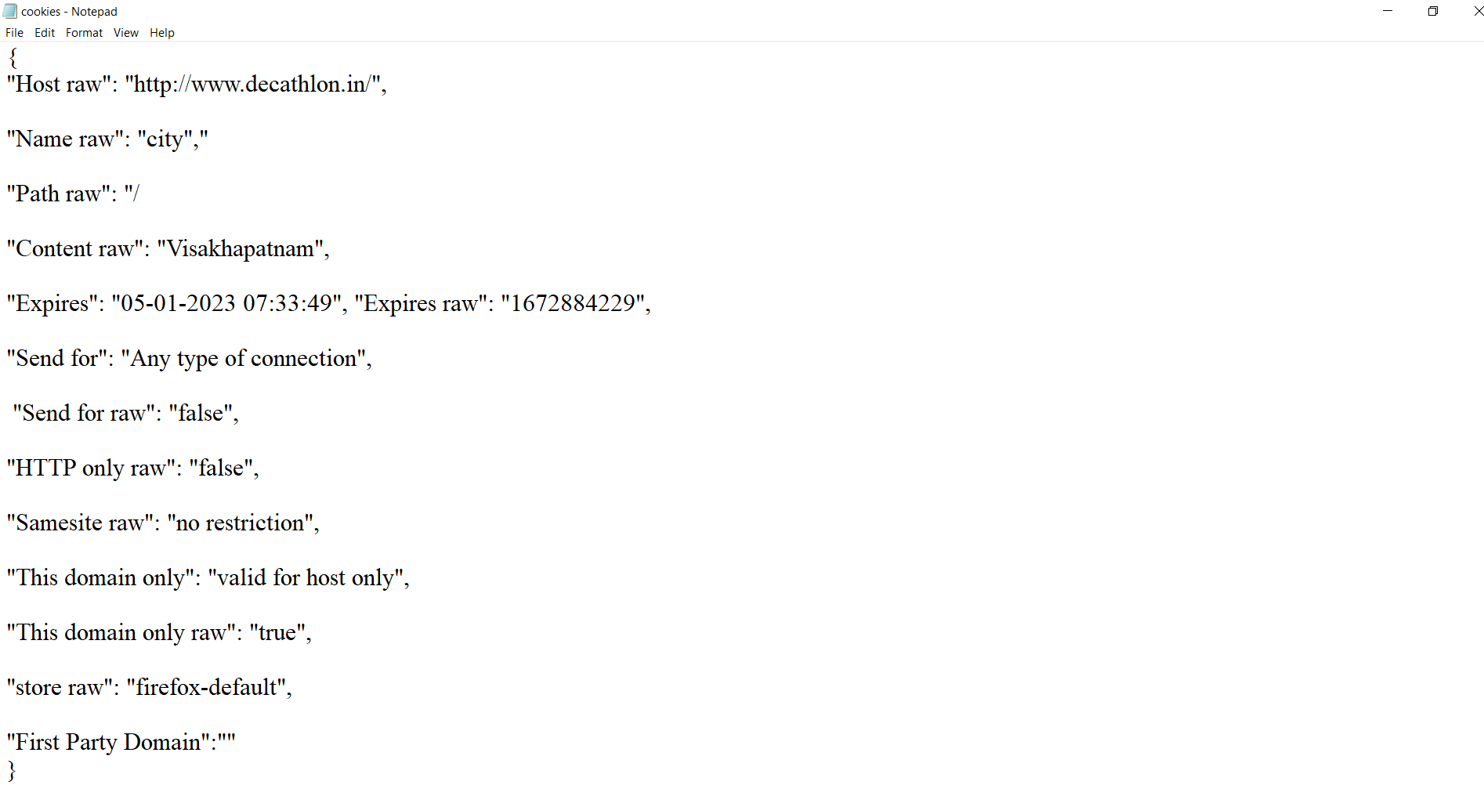
Downloads
For extracting and exporting downloads i have used download theme all extension
it helps us to export the data in text file

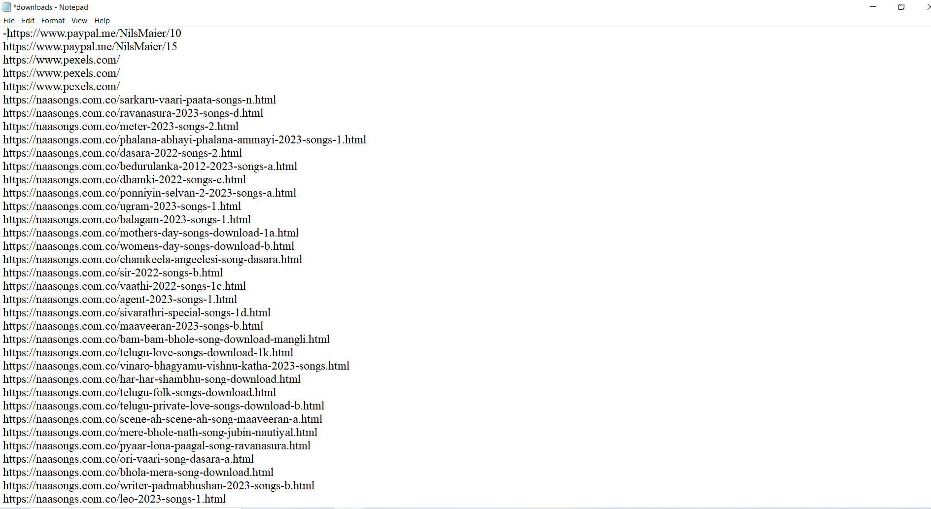
Form fill ups data
For extracting and exporting the form fill ups data i have used form history control extension available in firefox open source software and saved the exported data after extraction in json format
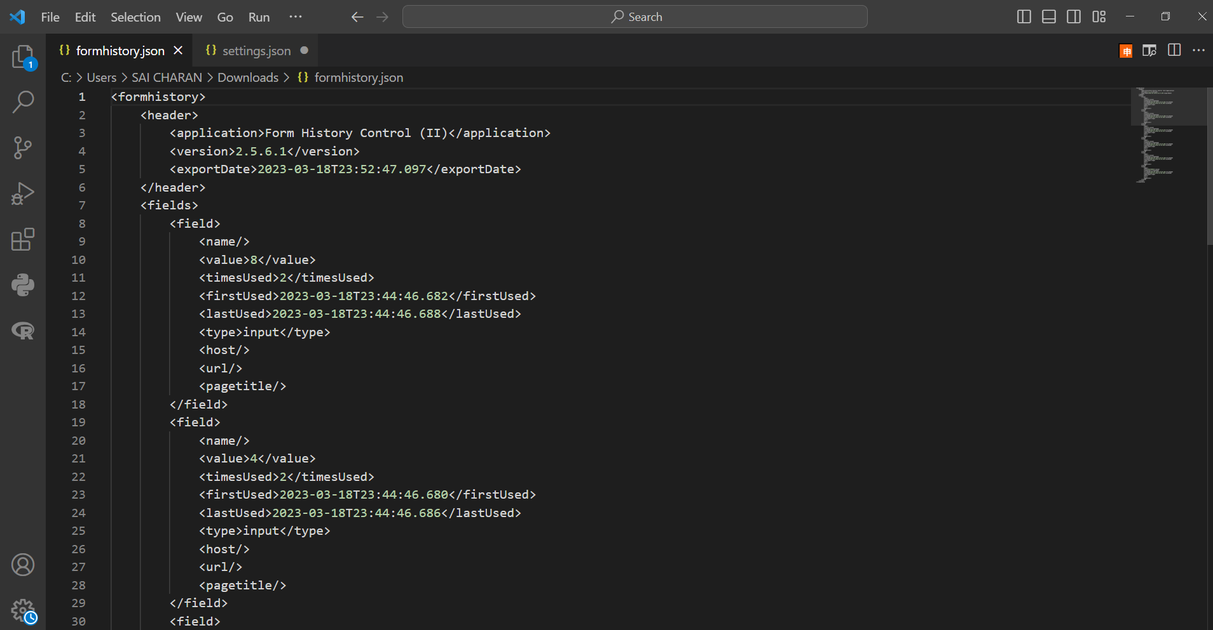
History
For extracting and exporting the history i have used history master extension that is available in firefox open source software and saved the exported data after extraction in json format
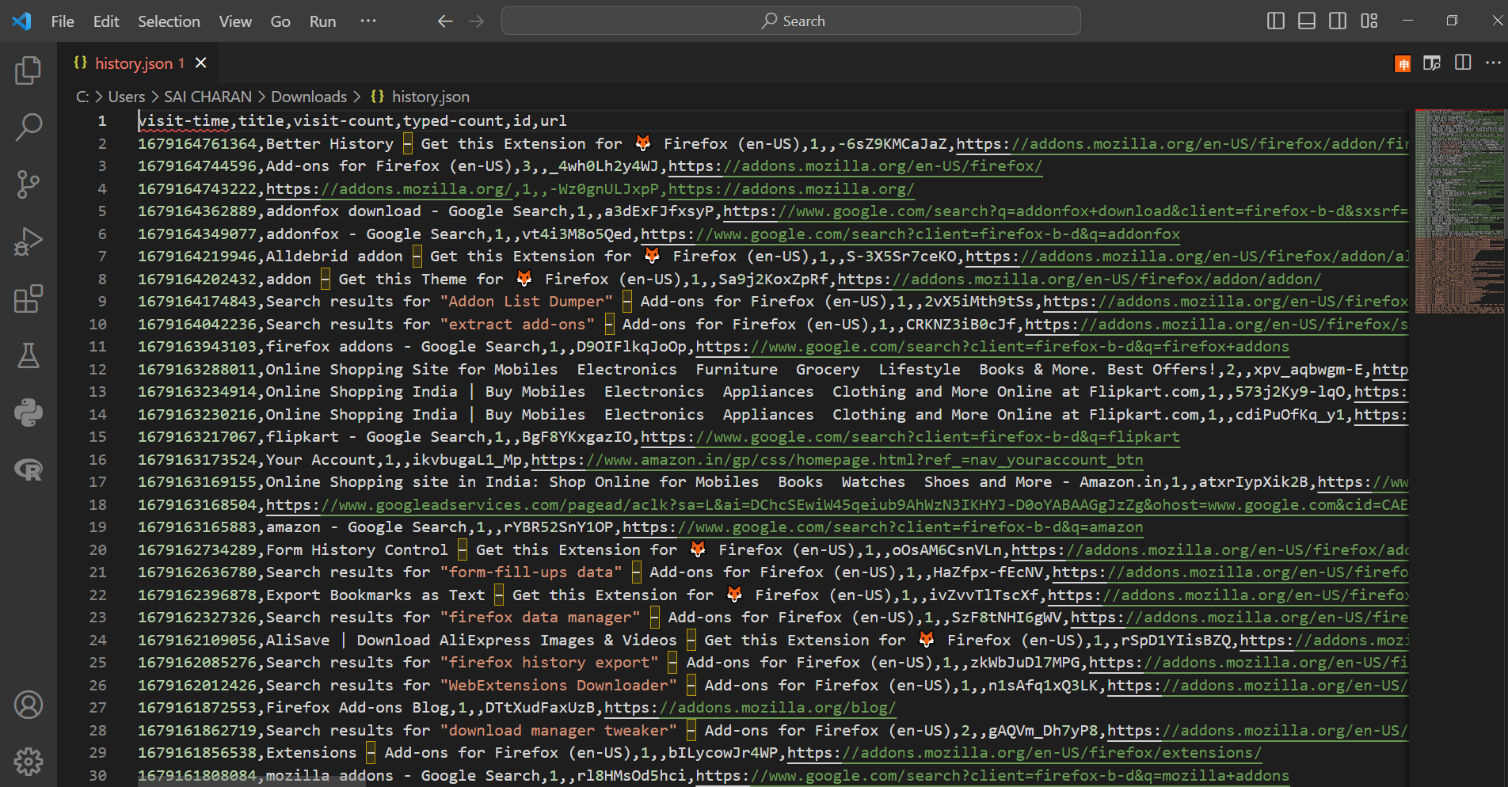
Result and disscussion:
Here i have used different extension separately for each data item and extracted data and saved the data that is exported in json and text file format.

GitHub Link: https://github.com/saicharan321-creator/opensource

References:
1. Festa, Paul (May 7, 2003). "Mozilla's Firebird gets wings clipped". CNET. Archived from the original on June 29, 2018. Retrieved January 30, 2007.
2. "The Mozilla Firefox Open Source Project on Open Hub: Languages Page". www.openhub.net. Archived from the original on October 7, 2021. Retrieved October 15, 2021.
3.Brinkmann, Martin (May 4, 2019). "Your Firefox extensions are all disabled? That's a bug!". GHacks. Archived from the original on May 4, 2019. Retrieved May 4, 2019.

