**EXP1:** Create a simple cloud software application for Flight Reservation System using any Cloud Service Provider to demonstrate SaaS include the necessary fields such as one way, round trip, From, to, Departure, Departure, Travelers & Class, Fare Type, International and Domestic Flights etc.

**PROCEDURE:**

**STEP 1:** GO TO ZOHO.COM

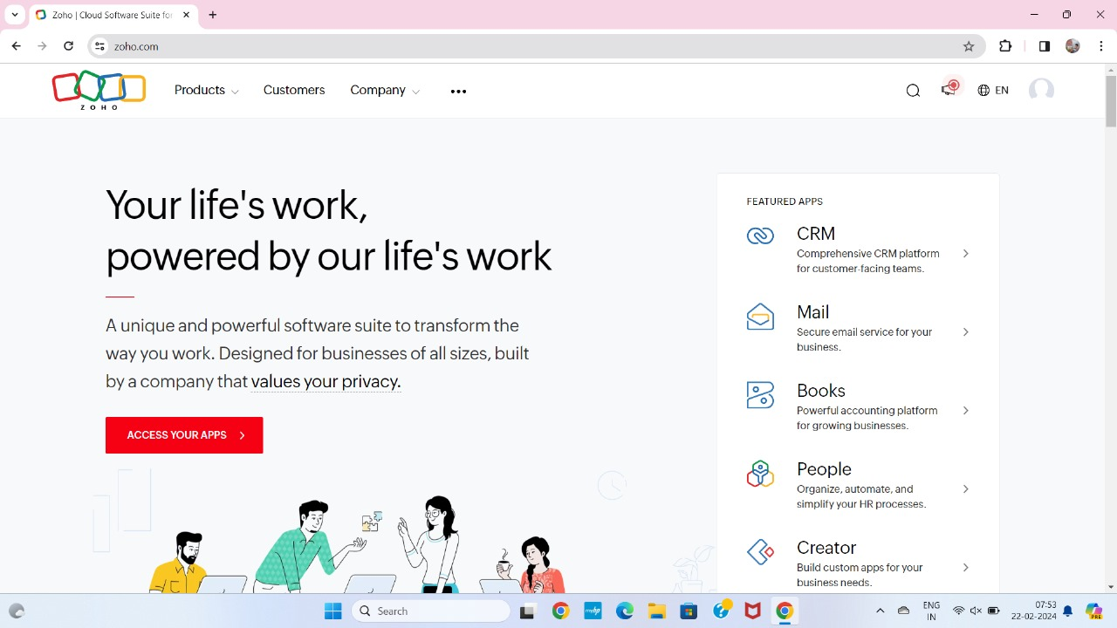

**STEP 2:** LOGIN TO ZOHO.COM

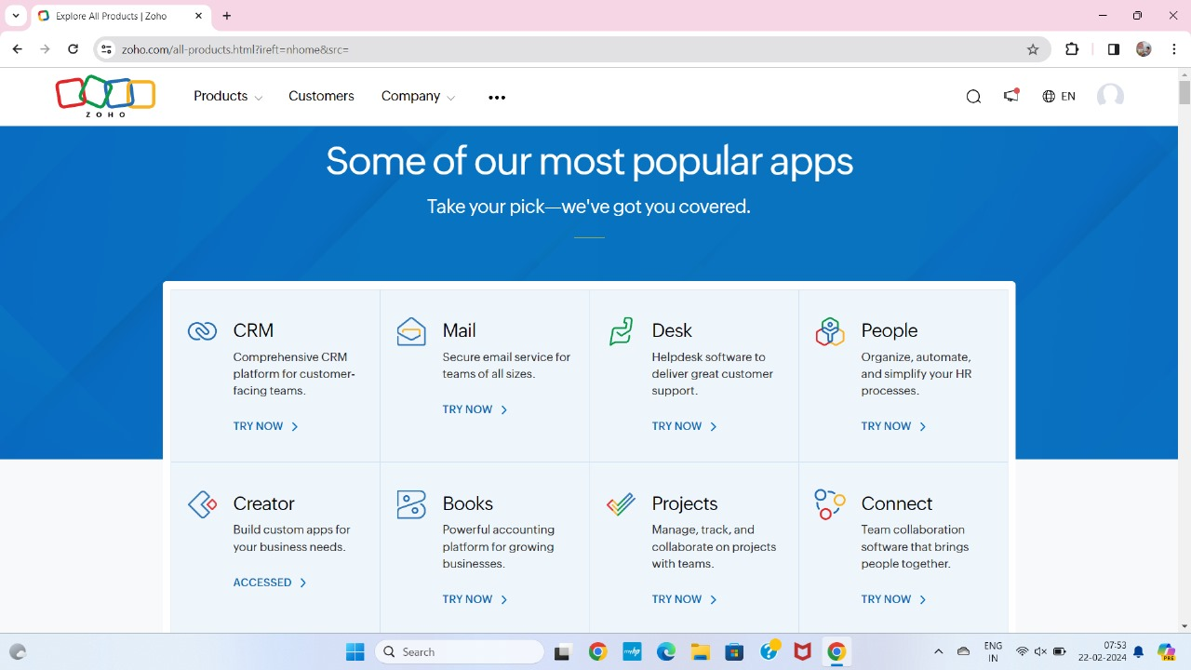

**STEP 3**: SELECT THE CREATE FROM SCRATCH

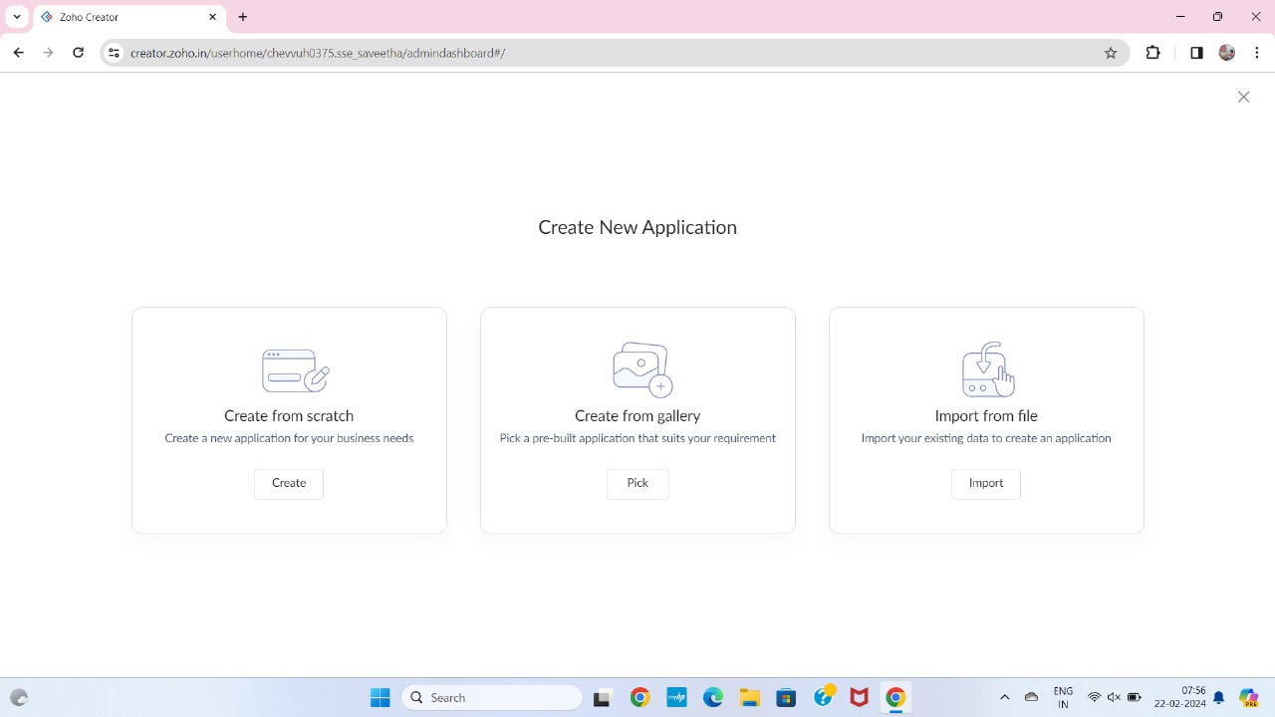

**STEP 4:** SELECT APPLICATION NAME AS FLIGHT SEATS

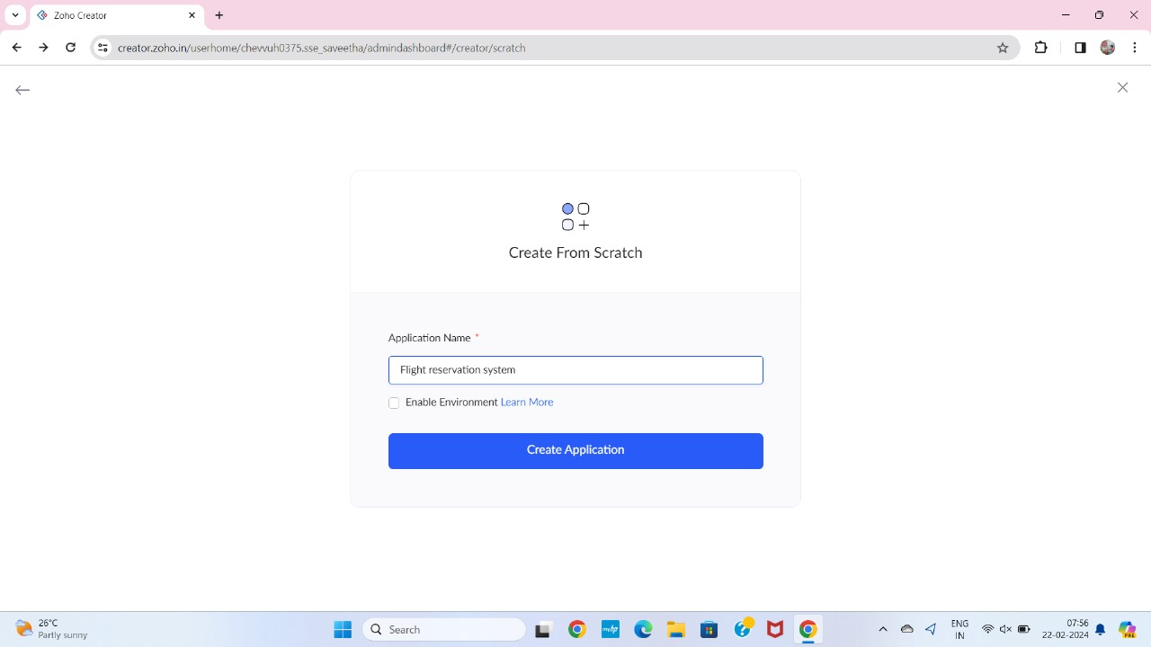

**STEP 5:** CREATE A NEW FORM

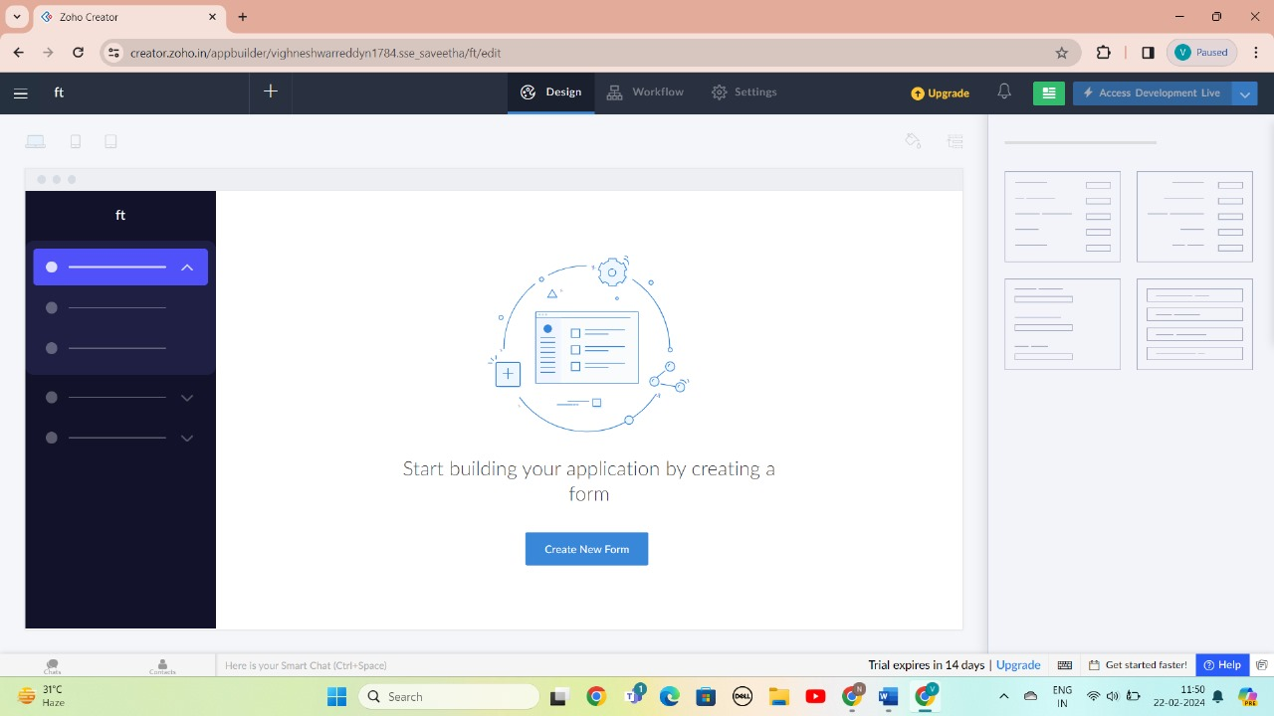

**STEP 6:** SELECT A BASIC FORM GIVEN BELOW AND DEVELOP APPLICATION

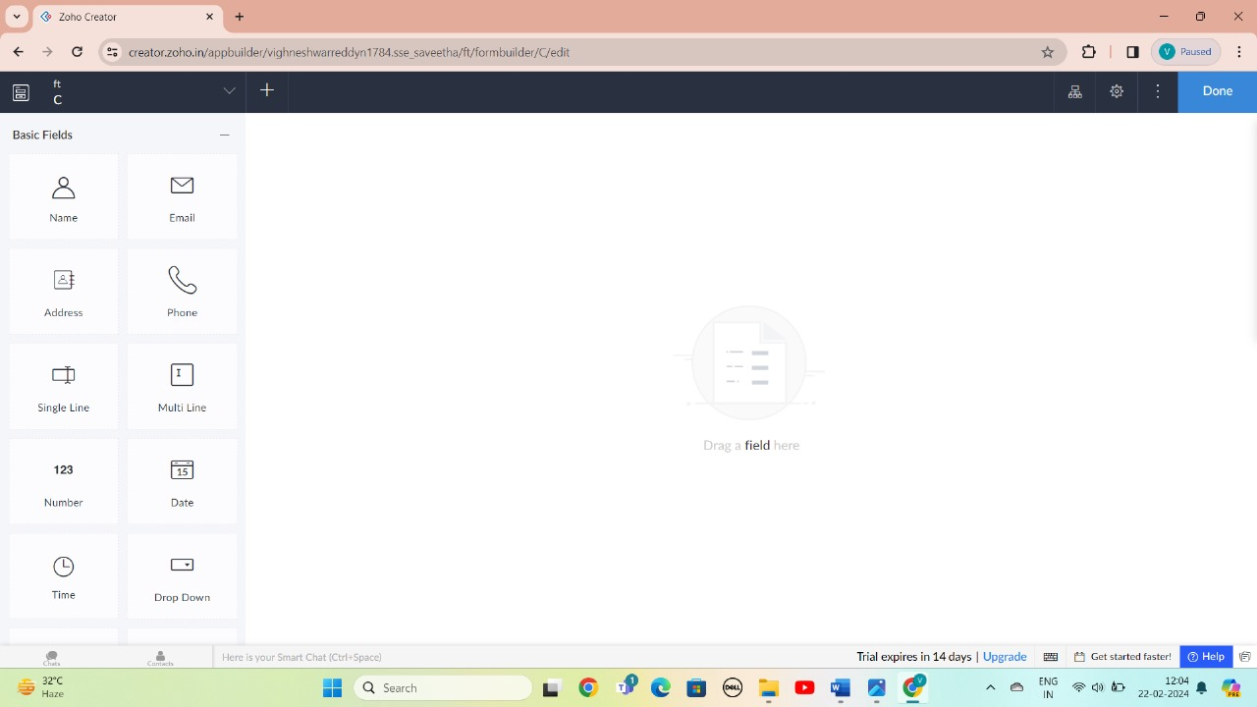

**STEP 7:** THE SOFTWARE HAS BEEN CREATED LOGIN PAGE

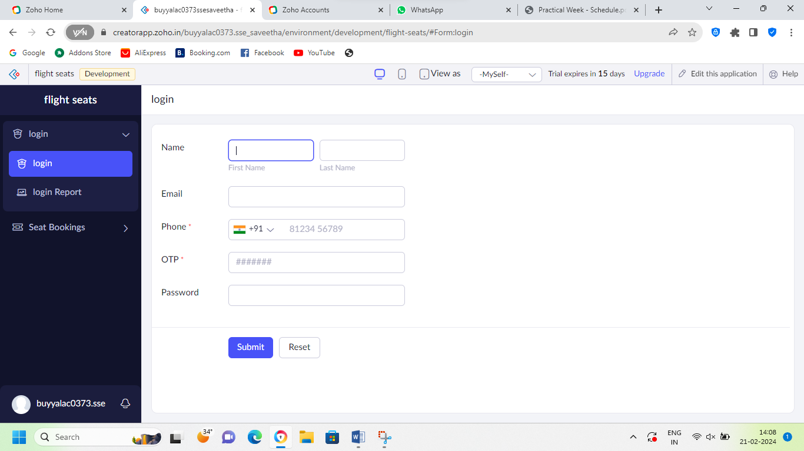

**STEP 8:** THE S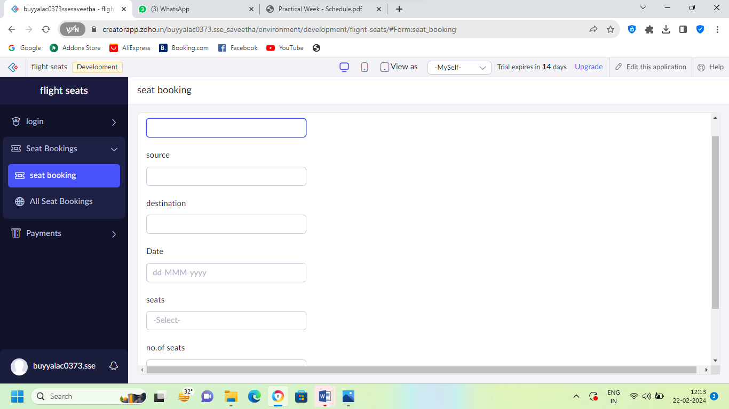OFTWARE HAS BEEN CREATED SEAT BOOKING

**STEP 9**: THE SOFTWARE HAS BEEN CREATED PAYMENTS OF SEAT BOOKINGS

