**LAB-3 Assignment 6.4**

**Roll No:** 2403A52081

**Batch:** 4

**Name:** S. Sai Charan Reddy

**Task 1:**

Start a Python class named Student with attributes name, roll_number, and marks. Prompt  
GitHub Copilot to complete methods for displaying details and checking if marks are above  
average.

**Prompt:**

Complete methods for displaying details and checking if marks are above average.

**Code:** 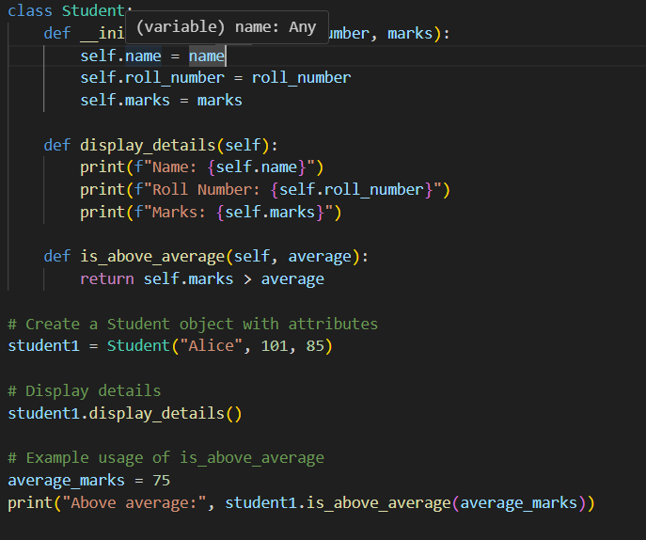

**Output:**

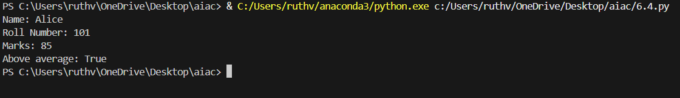

**Observations:**

Github Copilet swiftly understood the given prompt and generated the Student class with appropriate methods, I had to give it another prompt to call the function.

**Task 2:**

Write the first two lines of a for loop to iterate through a list of numbers. Use a comment  
prompt to let Copilot suggest how to calculate and print the square of even numbers only.

**Prompt:**

complete the code to print the square of even numbers in the list.

**Code:**

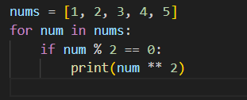

**Output**:

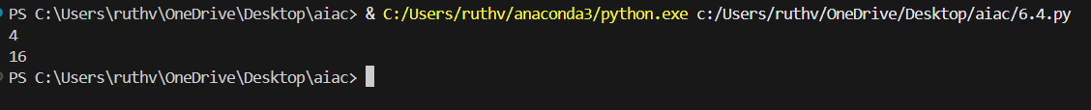

**Observations:**

Github Copilet understood the command and finished my code to execute the desired output. It printed the squares of only the even numbers in the list, i.e 2, 4.

**Task #3:**

Create a class called BankAccount with attributes account_holder and balance. Use Copilot to  
complete methods for deposit(), withdraw(), and check for insufficient balance.

**Prompt:**

Write deposit() and withdraw() methods for this class.

**Code:**

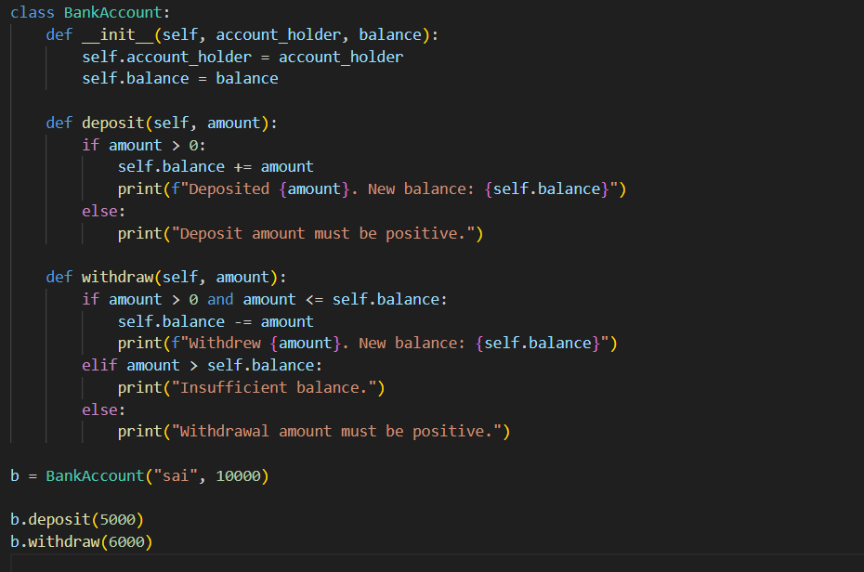

**Output:**



**Obsevation:**

Copliet instantly generated the desired methods deposit() and withdraw() in the BankAccount().

**Task #4:**

Define a list of student dictionaries with keys name and score. Ask Copilot to write a while  
loop to print the names of students who scored more than 75.

**Prompt:**

generate a loop to print the names of the students who scored more than 75 marks from the above dictionary.

**Code:**

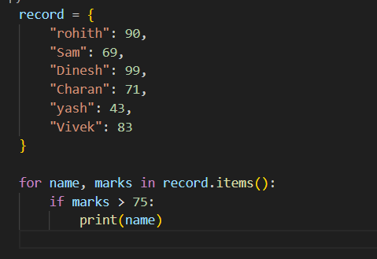

**Output:**

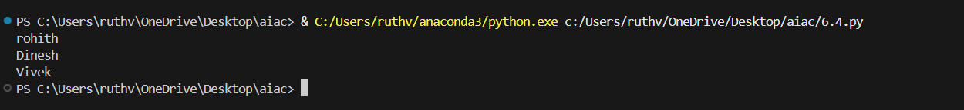

**Observation:**

Copliet understood the assignment and created a loop that considers both keys and values of the dictionary and prints the names of the students who scored more than 75.

**Task #5:**

Begin writing a class ShoppingCart with an empty items list. Prompt Copilot to generate  
methods to add_item, remove_item, and use a loop to calculate the total bill using conditional  
discounts.

**Prompt:**

Add methods to the class, add_item and remove_item.

**Code:**

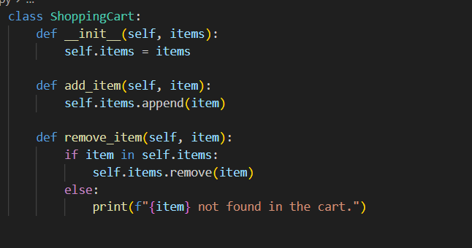

**Observation:**

Copilet successfully added the required methods.