**PROJECT REPORT**

**Project Name:** **Calculator**

Contents

1. [Certificates](https://github.com/sumeet2908/M1_Operations_Utility/tree/main/0_Certificates)
2. [Requirements](https://github.com/sumeet2908/M1_Operations_Utility/tree/main/1_Requirements)
3. [Architecture](https://github.com/sumeet2908/M1_Operations_Utility/tree/main/2_Architecture)
4. [Implementation](https://github.com/sumeet2908/M1_Operations_Utility/tree/main/3_Implementation)
5. [Test Plan And Output](https://github.com/sumeet2908/M1_Operations_Utility/tree/main/4_TestPlanAndOutput)
6. [Report](https://github.com/sumeet2908/M1_Operations_Utility/tree/main/5_Report)
7. [Image And Video](https://github.com/sumeet2908/M1_Operations_Utility/tree/main/6_ImageAndVideo)
8. [Other](https://github.com/sumeet2908/M1_Operations_Utility/tree/main/7_Other)**.**

* **Certificates:**
* Sololearn certification in ‘C’ language
* Cisco NDG linux
* Screenshot of firstdayongithub learning
* Screenshot of hackerearth points
* **Requirements**
* High Level Requirements
* Low Level Requirements
* SWOT
* 5W's and 1H's
* **Architecture**
* Design
* Structure
* Behavioral
* flowchart
* use case diagram
* **Implementation**

* Inc
* Src
* Test
* Unity
* **Test plan and Output**
* for every feature, define a test case
* how to run that feature
* define expected behavior
* capture the actual result
* **Report**

* **Image And Video**
* Output image

* **Other**
* References

**Description:**

**Simple Calculator**

## **Introduction:** Simple Calculator helps users to calculate simple calculations with great speed and accessibility.

* Simple calculator is a project to allow users to calculate basic four operations in mathematics, they are addition, subtraction, multiplication, division.
* But in this Project also included three additional operations such as square, square root, cube of given number. However, the input has to be in the form "number1 operator1 number2 "(i.e., 2+4). •
* The input includes the command such as we can give numbers based on the operation for example for addition, we give 1 as a command and that particular operation works. Moreover, this calculator is smart enough to operate multiplication/division/subtraction.

**Requirements :**

**High Level Requirements:**

|  |  |  |  |
| --- | --- | --- | --- |
| **ID** | **Description** | **Category** | **Status** |
| HR01 | User shall be able to specify their operation choice. | Technical | IMPLEMENTED |
| HR02 | User should able to select the operation. | Technical | IMPLEMENTED |
| HR03 | User shall be able to add the numbers | Technical | IMPLEMENTED |
| HR04 | User shall be able to subtract the numbers | Technical | IMPLEMENTED |
| HR05 | User shall be able to multiply the number | Technical | IMPLEMENTED |
| HR06 | User shall be able to find division | Technical | IMPLEMENTED |
| HR06 | User shall be able square , square root and cube. | Technical | IMPLEMENTED |

## **Low Level Requirements**

|  |  |  |  |
| --- | --- | --- | --- |
| **ID** | **Description** | **Category** | **status** |
| LR01 | If the calculations is impossible the calculator has to display information helping the user to resolve the erroneous situation. | Technical | IMPLEMENTED |
| LRO2 | On encountering a division by 0 the display should read "Cannot divide by 0" and typing the key “C” should reset the calculator |  |  |
| LR03 | On calculating the square root value of a negative operand, the display should read "Wrong operand" | |  | | --- | | Technical | | IMPLEMENTED |

**SWOT: STRENGTHS**: The ultimate strength of Calculators is its innovative, user-friendly and long lasting etc.

• **WEAKNESSES**: Do not include all the operations rather have only addition, subtraction multiplication, division, square, square root and cube.

• **OPPORTUNITIES**: This is very good calculator for beginner

• **THREATS:** The slower growth in technological innovation will also bring a significant threat in the upcoming dynamic world.

**5W's and 1H's**

**Who**

* Students who want to solve mathematics related problems for their academic work.
* People working on machine learning , data science applications which majorly involve calculations Software engineer.
* Researchers and mathematicians.

**What**

* Calculate the sum, difference, multiplication, division , square, square root and cube of given number

**When**

* Students facing a difficulty in solving a matrix related problem, can use this program to conform their outputs.
* Researchers can use it for getting a quick calculation output.
* Comes to a great use when calculating for matrices of huge order.

**Why?**

* For beginners even basic calculations are tough. To make sure that they feel better and to give them the confidence in arithmetic operations I have made this

**Where:**

* Students, employees and researchers all over the world.

**How:**

* This program can be executed in a system which has Linux or Windows operating system.

**Architecture**

**Design:**

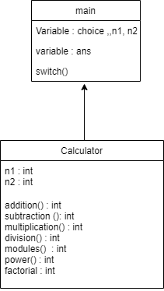

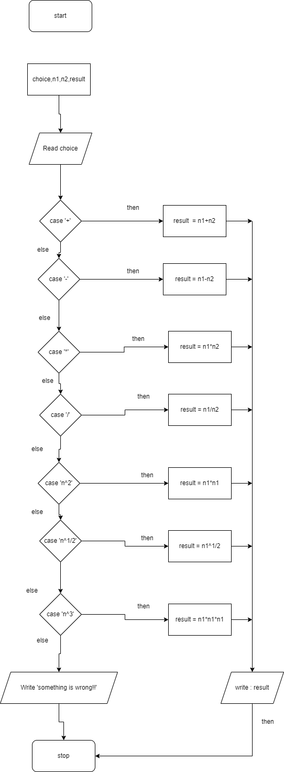**UML DIAGRAM**

**Test plan & output:**

## High Level test Plan

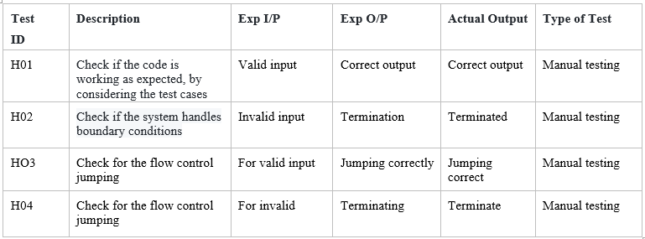

Low Level test Plan

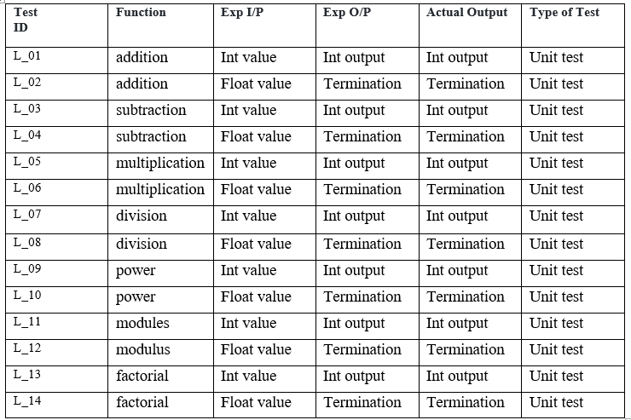

## **Features**

## This calculator can be used to do simple math calculation in very fast and efficient way.

* Beginner Friendly

## **Future scope of the project**

* Trigonometric calculations can be added.
* We can make this calculator for octa decimal, hexadecimal logic and many more…

**References:**

https://www.programiz.com/c-programming/examples/calculator-switch-case