Installing Terraform on your PC

Download terraform zip file from website then extract and paste in programfiles terraform in local

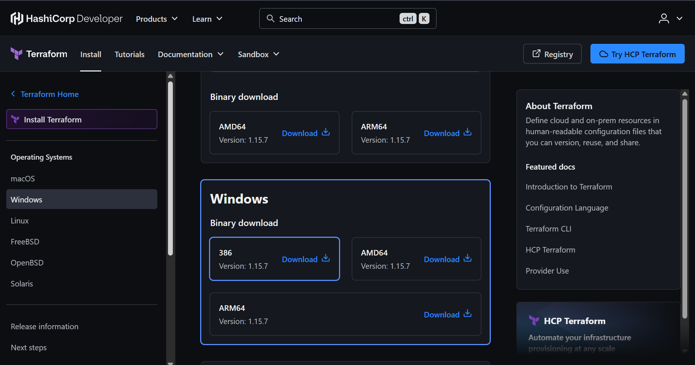

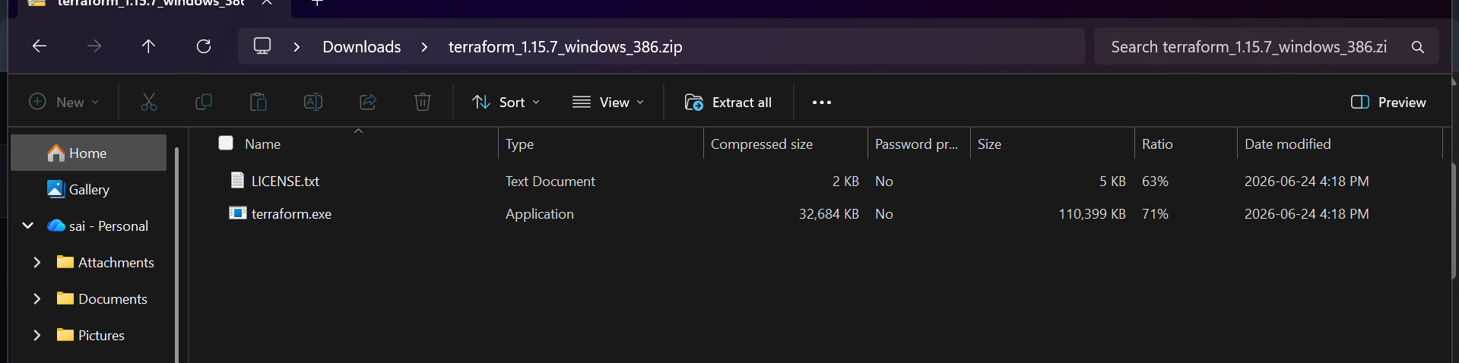

Paste this in program files terraform folder

Create a new folder named Terraform

Add this path in the system environment variables

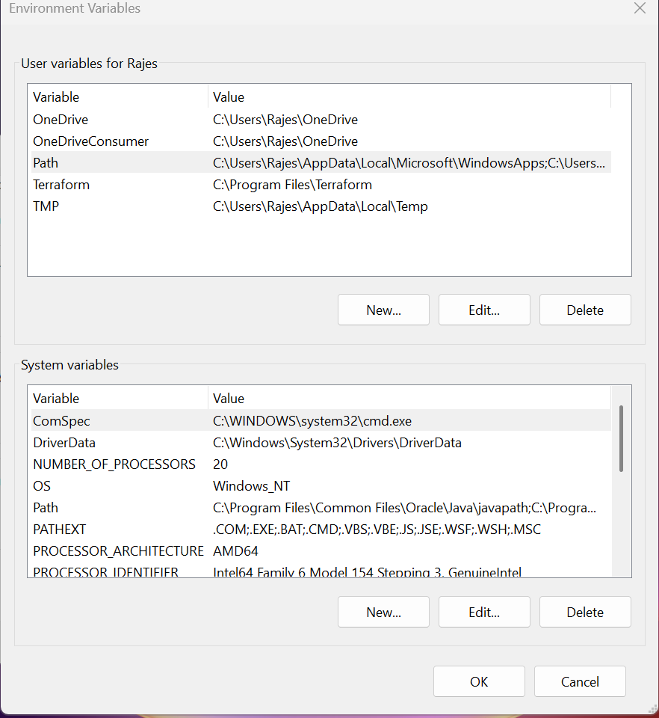

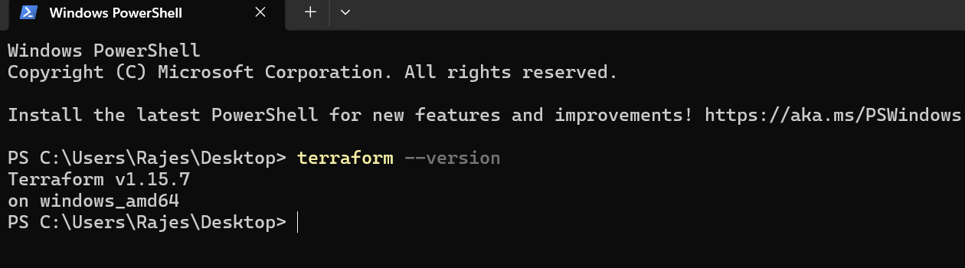

Executing the templates

First creating a new file with .tf extension

Then writing a sample template in the file

Installing the extensions first

To help the template

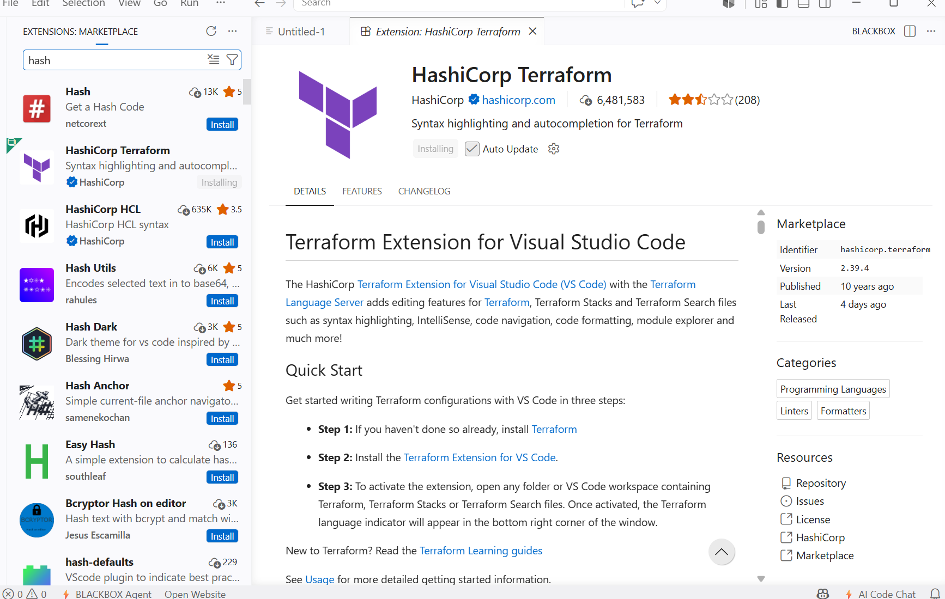

Created a new text file with .tf extension then we can see the file has been converted into terraform file
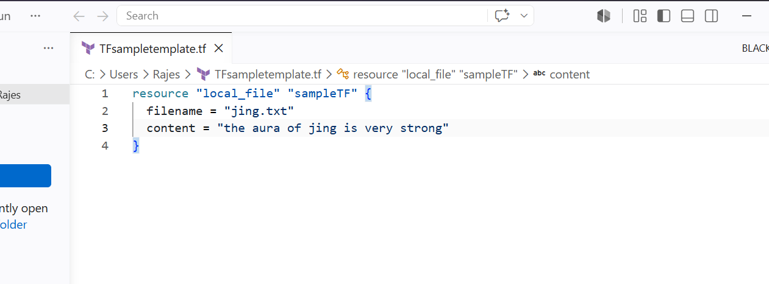

Then I will be using the terraform init to initialize and terraform plan to see the change that will happen during terraform apply

Then use command terraform apply to make the changes

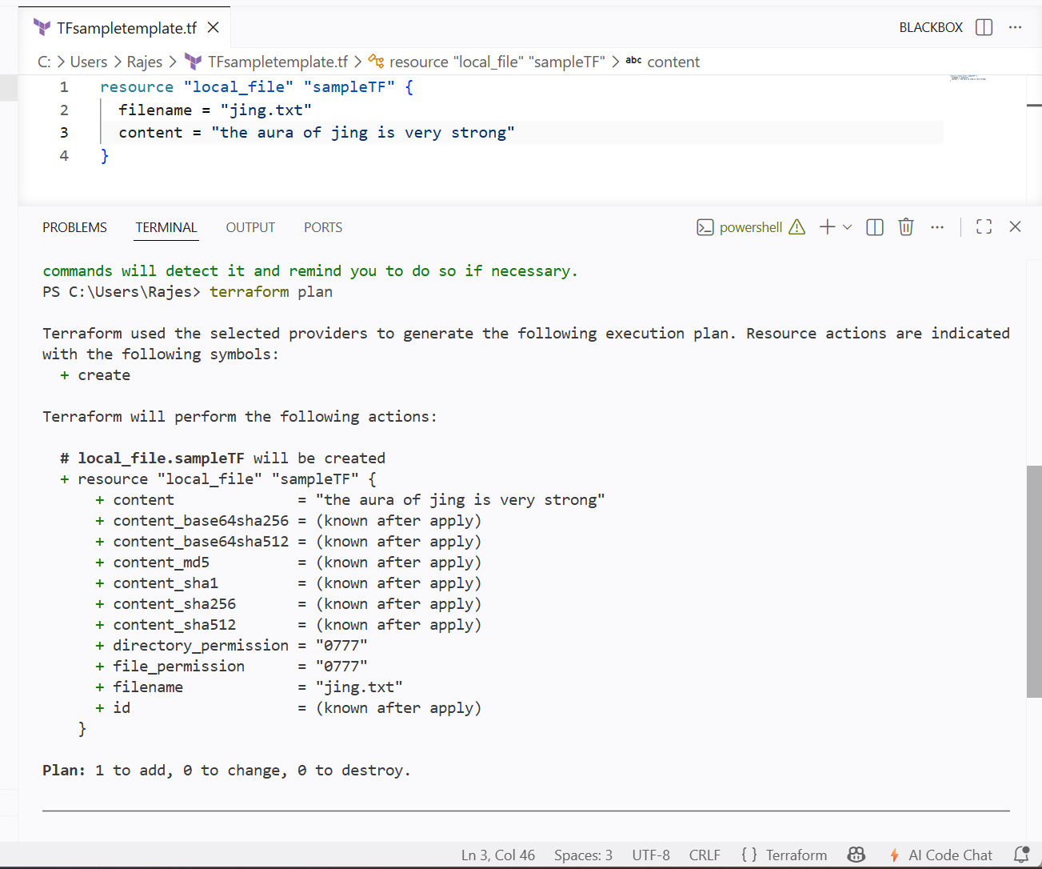

We can see the changes to be done through terraform plan
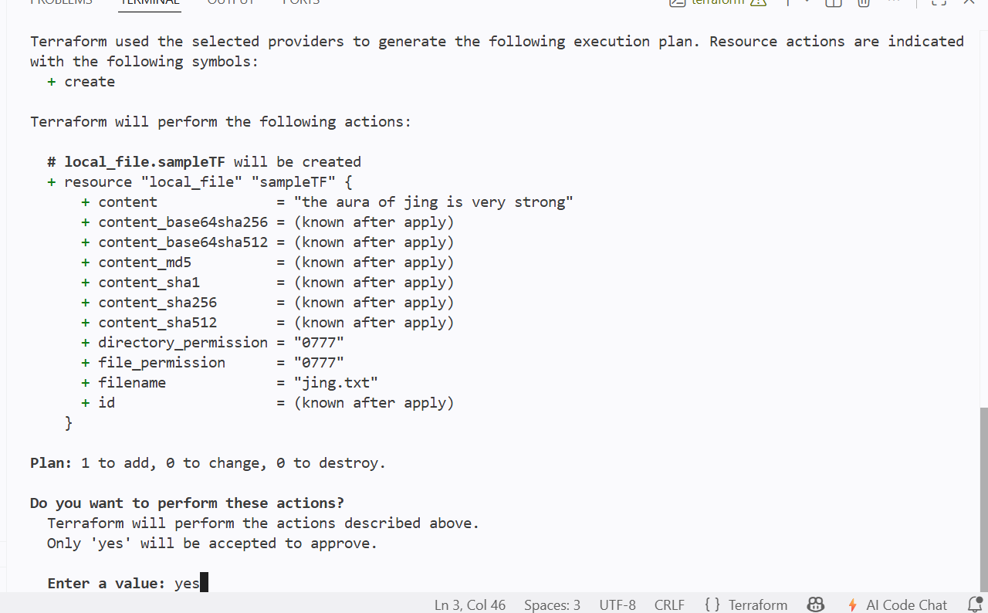

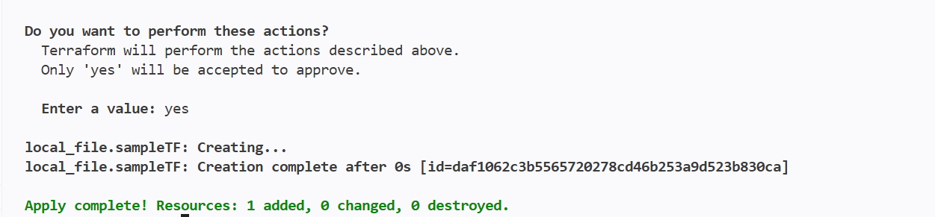

And another sample template that contains the random_pet

Random_pet is a resource that gives random human readable names to the file id

It will create a new id with random name

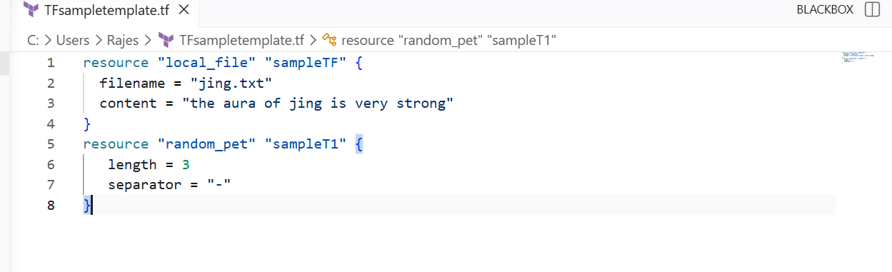

We can see that I have created a new resource for my file name from random_pet

We can see it from terraform apply

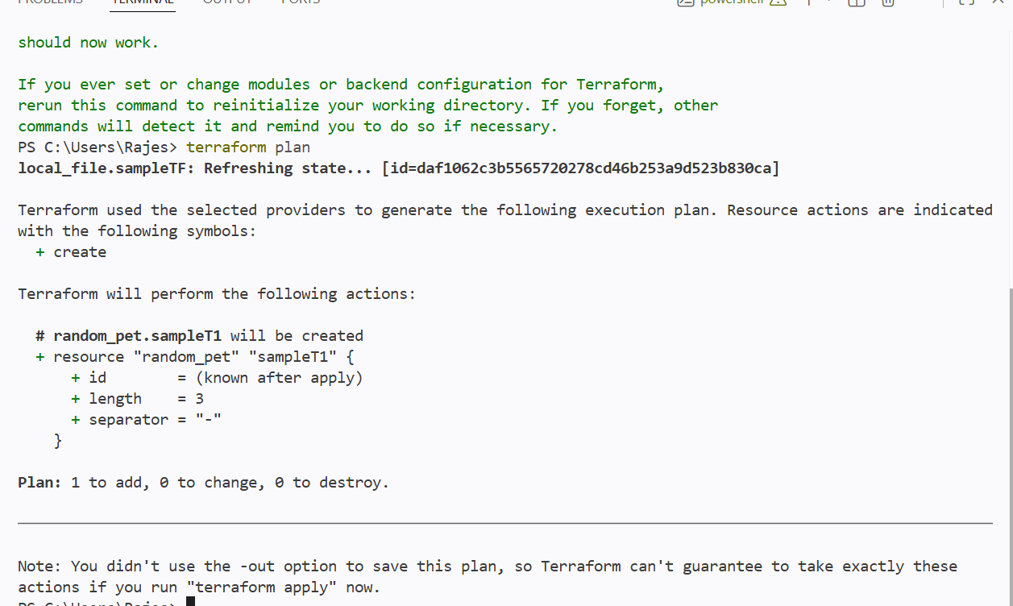

As I have changed the template and used another resource then I will be using the terraform init and terraform plan to see the changes

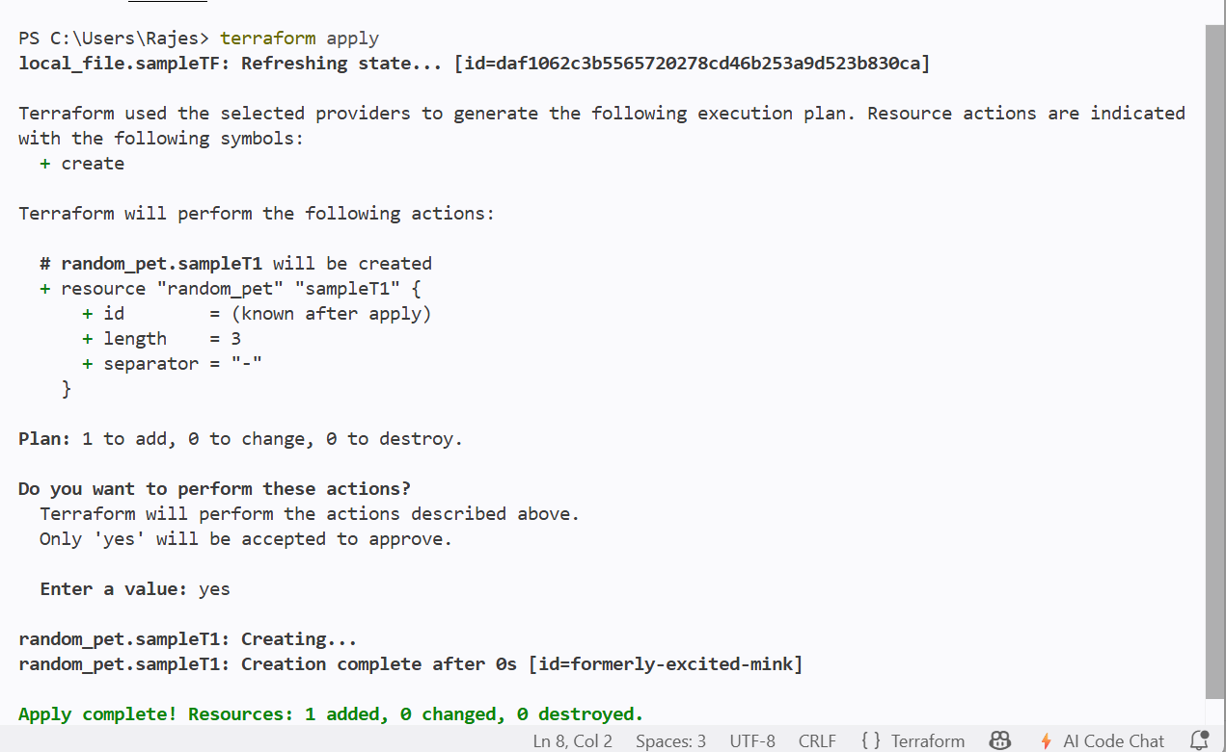

We can see here a new id with 3 names has been separated with - as mentioned in the resource and new random id has been created

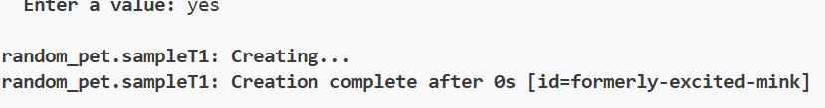

And new files has been created
With .tfstate extension in the same path

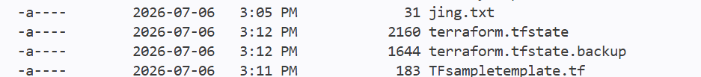

============================================================================================================================================================

Terraform Init
The terraform init command initializes a Terraform working directory. It is the first command that should be executed after creating or cloning a Terraform project.

Syntax
terraform init
When executed, Terraform: Downloads all required provider plugins, Creates the .terraform directory.
TERRAFORM PLAN

The terraform plan command previews the infrastructure changes Terraform intends to make without modifying any resources.

Syntax
terraform plan

Purpose
- Terraform compares:The Terraform configuration, The current infrastructure state, The Terraform state file.

TERRAFORM APPLY
he terraform apply command executes the actions generated by the execution plan and updates the infrastructure.

Syntax
terraform apply
Terraform displays the execution plan and requests confirmation:
Do you want to perform these actions?

Only 'yes' will be accepted to approve.
Type: yes
To skip confirmation:
terraform apply -auto-approve

TERRAFORM PROVIDERS

A Provider is a plugin that enables Terraform to communicate with cloud platforms or services such as AWS, Azure, Google Cloud, Docker, or VMware. Every Terraform configuration requires at least one provider.

Why Providers are Needed
Providers allow Terraform to: Create infrastructure resources,Modify existing resources, Delete resources, Read the current state of infrastructure

INTEGRATING A SAMPLE TEMPLATE WITH JENKINS

Now first we need to install the terraform in jenkins server

Then configure in manage jenkins sytem

Install terraform in jenkins server

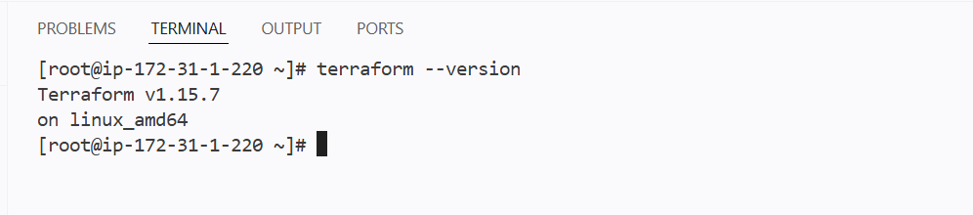

I have copied my .tf file template to github

Then cloned the repo to jenkins

Then ran terraform commands in the pipeline

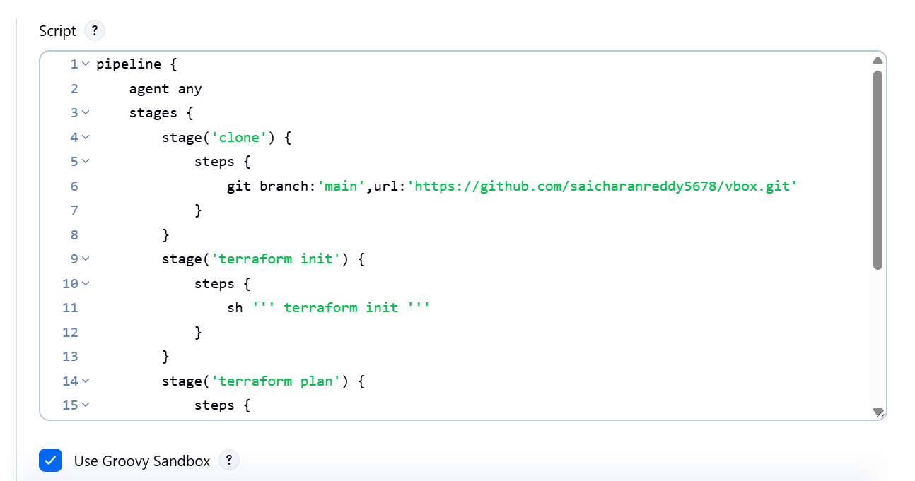

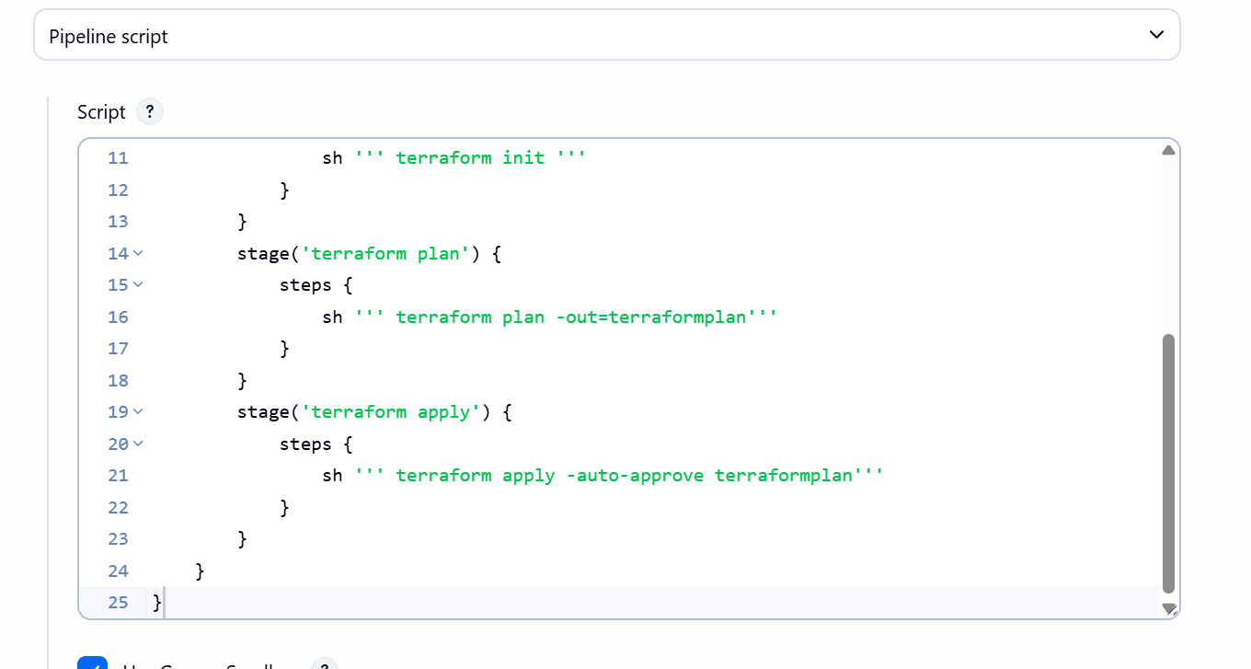
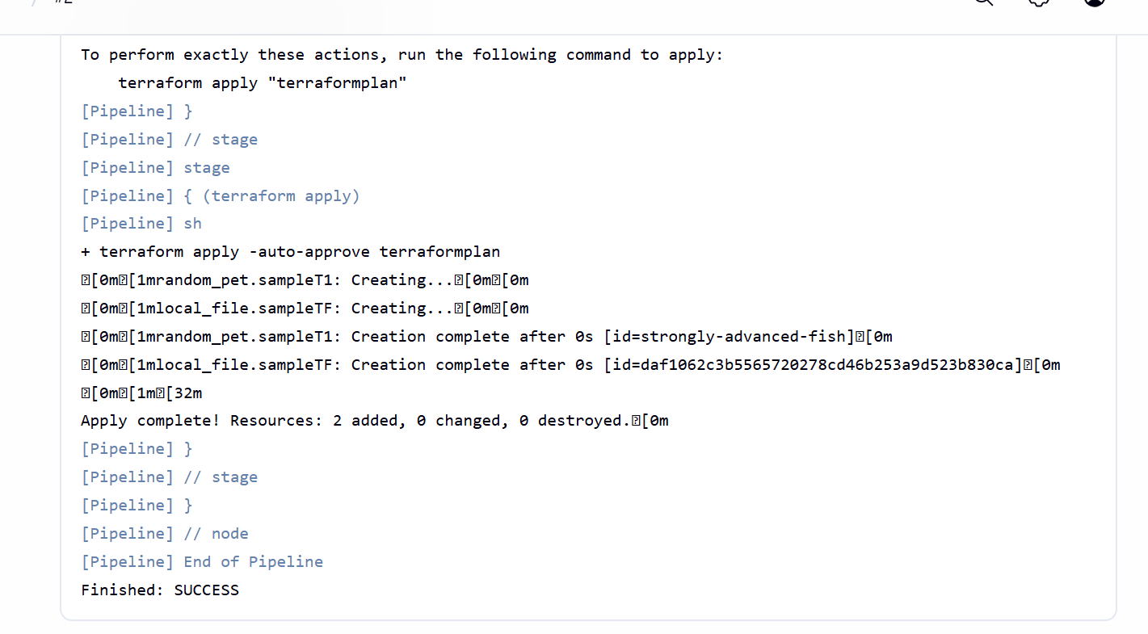

We can see file has been created in the jenkins workspace



