Terraform tfstate and tfsate.backup

These files will be created when we use terraform apply

And If I make any changes next and done terraform appply again it will create a new backup file of old data

A .tfstate file is the Terraform state file. It stores the current state of the infrastructure Terraform manages

As we can see in below ss

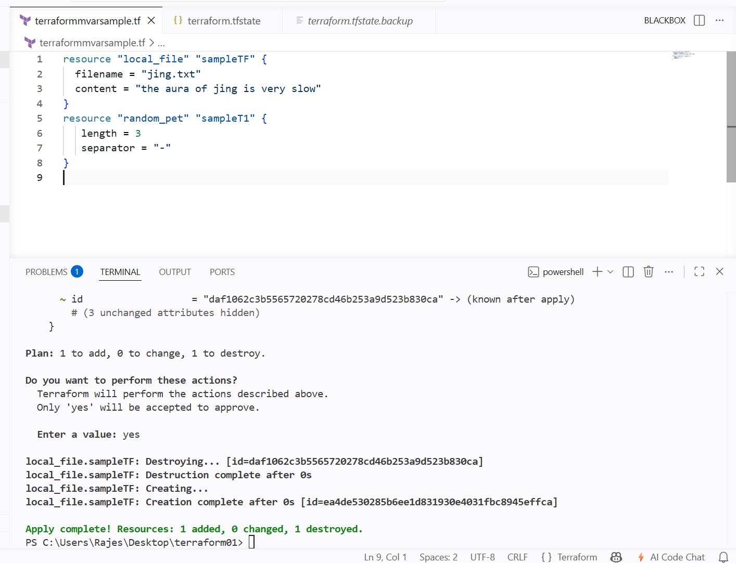

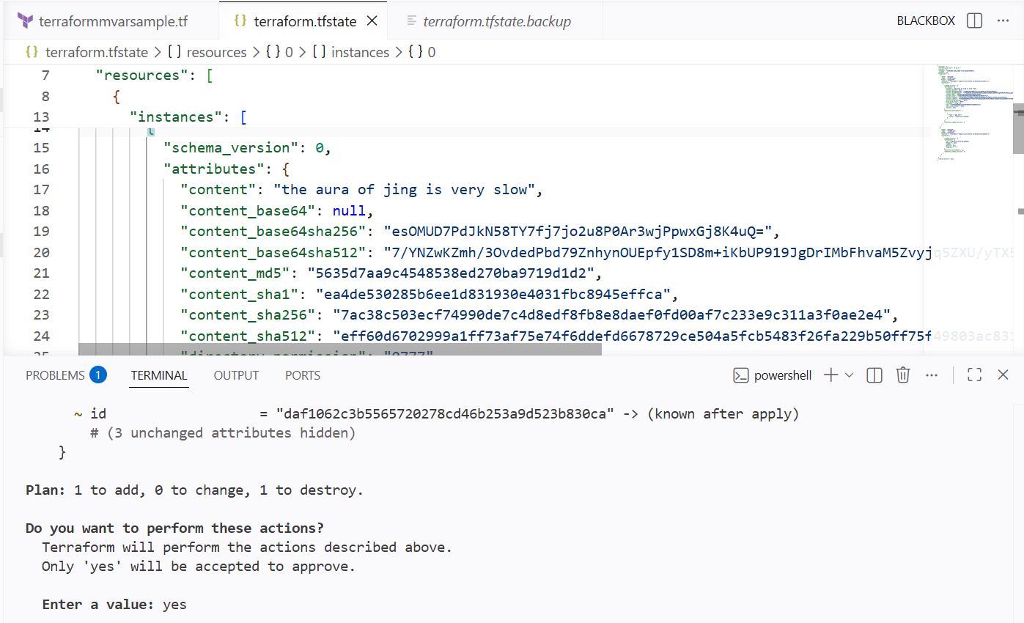

We can see the terraform.tfstate.backup file has old data

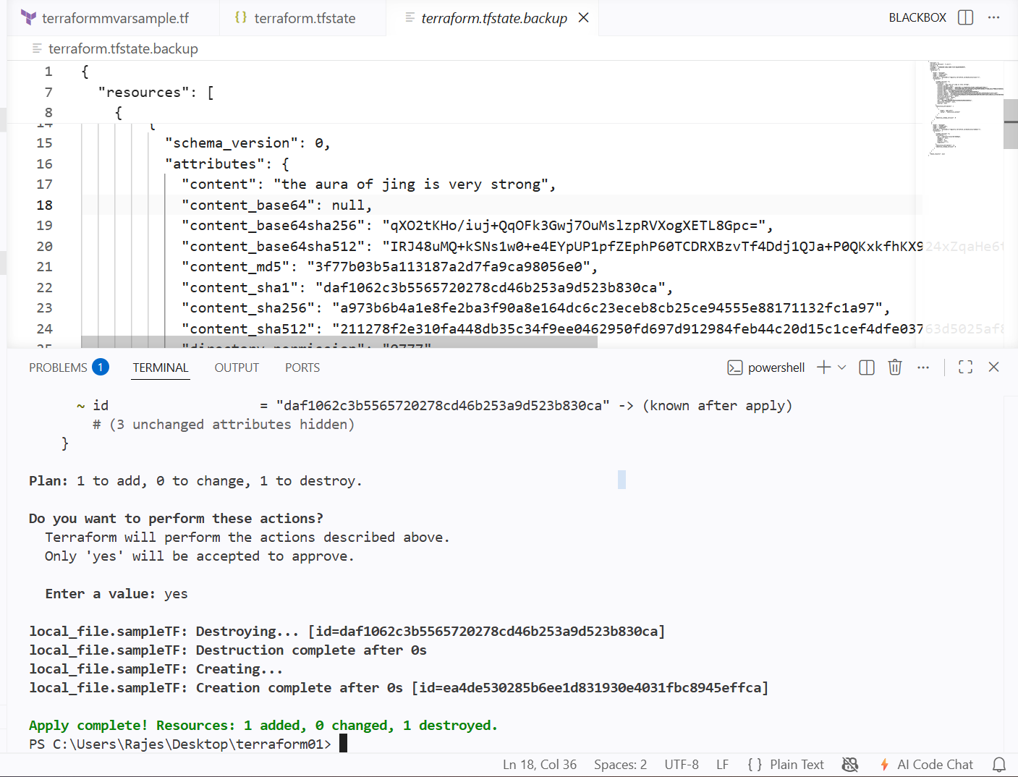

We have 4 configuration DIRECTOIRES

1 terraform script file
2 variable.tf file
3 output.tf
4 provider.tf

Terraform script file

It is nothing but the main file that we edit for script

Variable.tf

Instead of hard coding the values or names in script we can use variables.tf file for giving the variables to the script

Step 1:-- we need to create a new file named variabel.tf

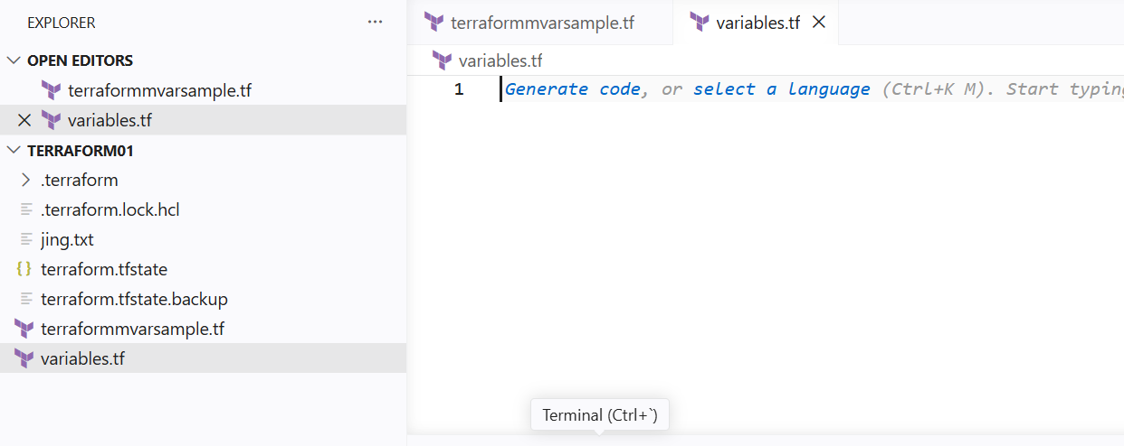

Now we need to add variables

I have changed my .tf file script by using the variables

Wherever I need to use the variables I will be creating the new variable block and add the default and type of default value

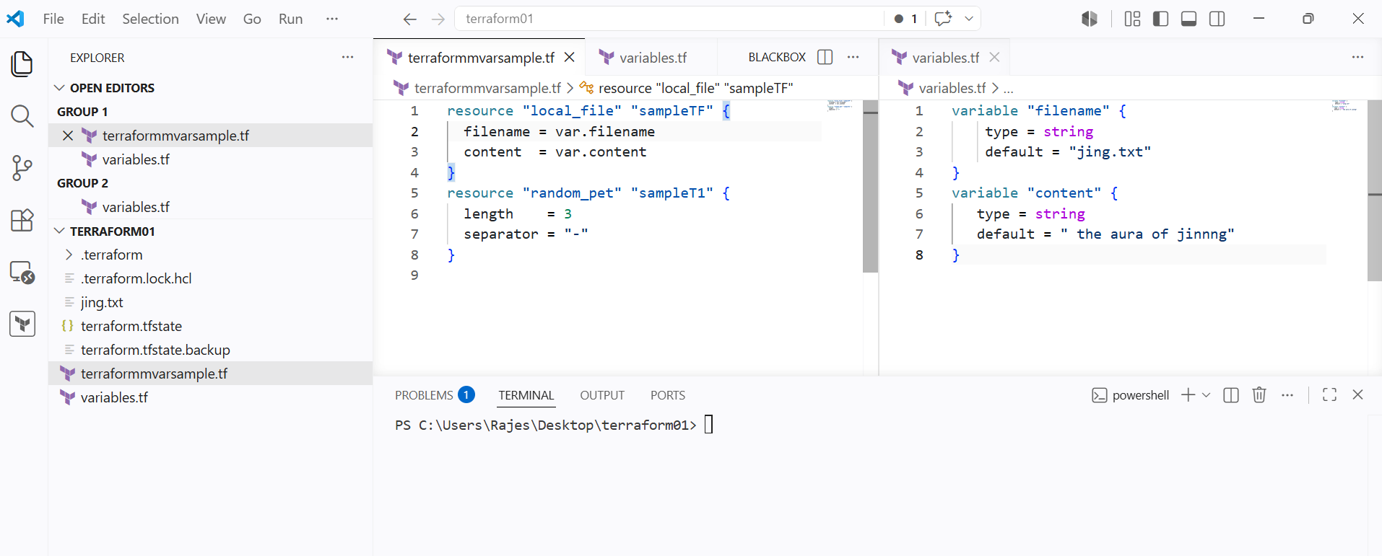

Now when I do the terraform apply it will execute as same

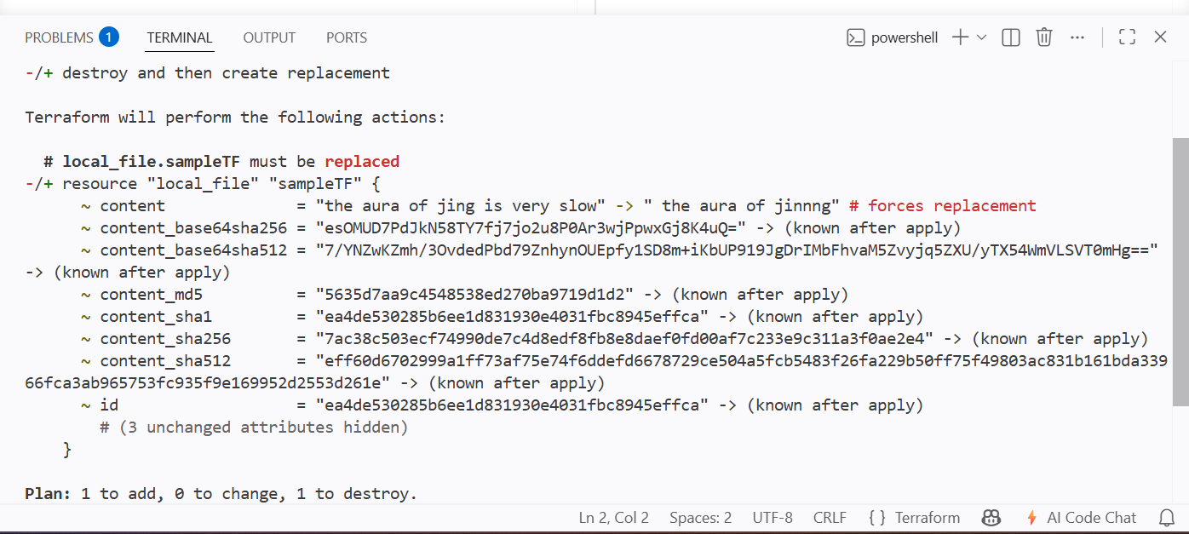

As we can see the output is same as hardcoding the values

This is how variables.tf file works for mainfile

Output.tf

If we want to see the output of a particular resource

We need to create a new file named output.tf and

Write an output block for what outputs we want to see

I have created anew output block in output.tf file

I want to see the content of my file as an output

I will be giving the output name and value of what should be given

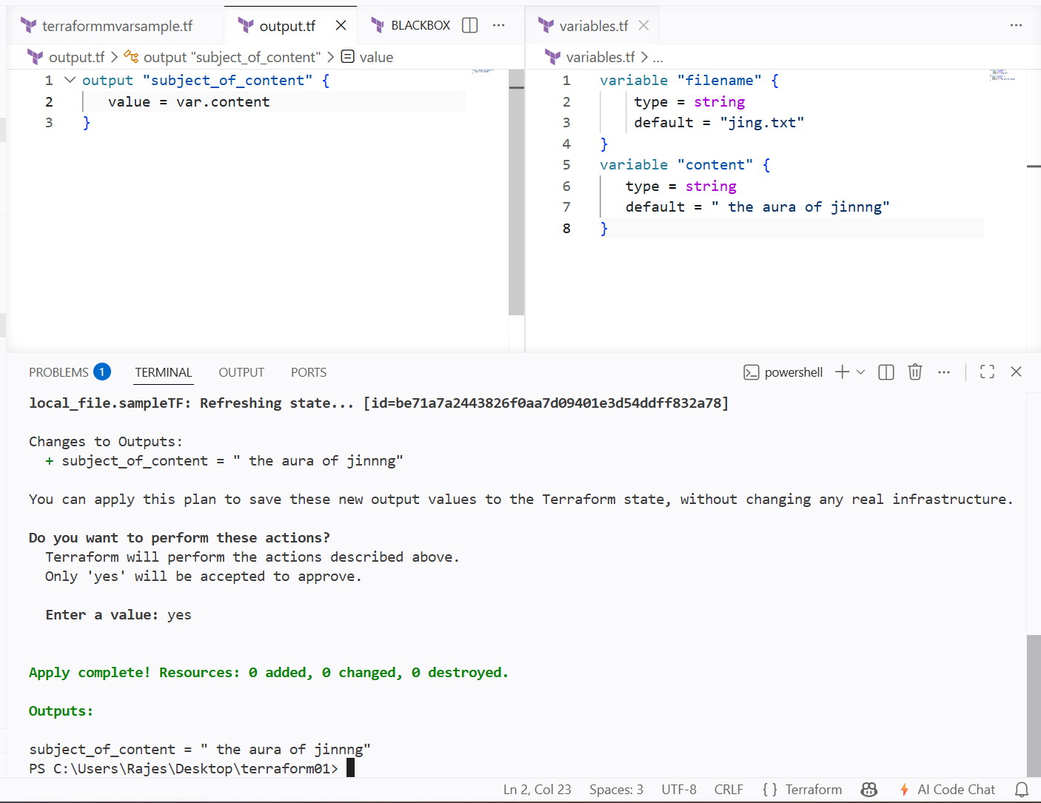

LIFECYCLES OF TERRAFORM

- Create_before_destroy
- Prevent_destroy
- Ignore_changes

Create_before_destroy

Whenever we change the script of terraform file we can see at the terraform apply

It says destroying the old id or data

And then creating a new id or data

To prevent from destroying it first we can use 1st lifecycle

Create_before_destroy = true

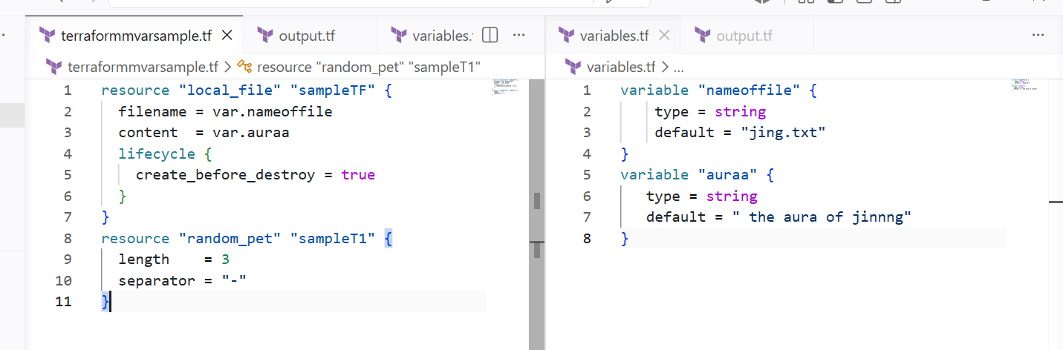

I have added a new block called lifecycle

In lifecycle block I will be giving the rules

In below ss it has clearly visible that first it is created and then it is destroyed

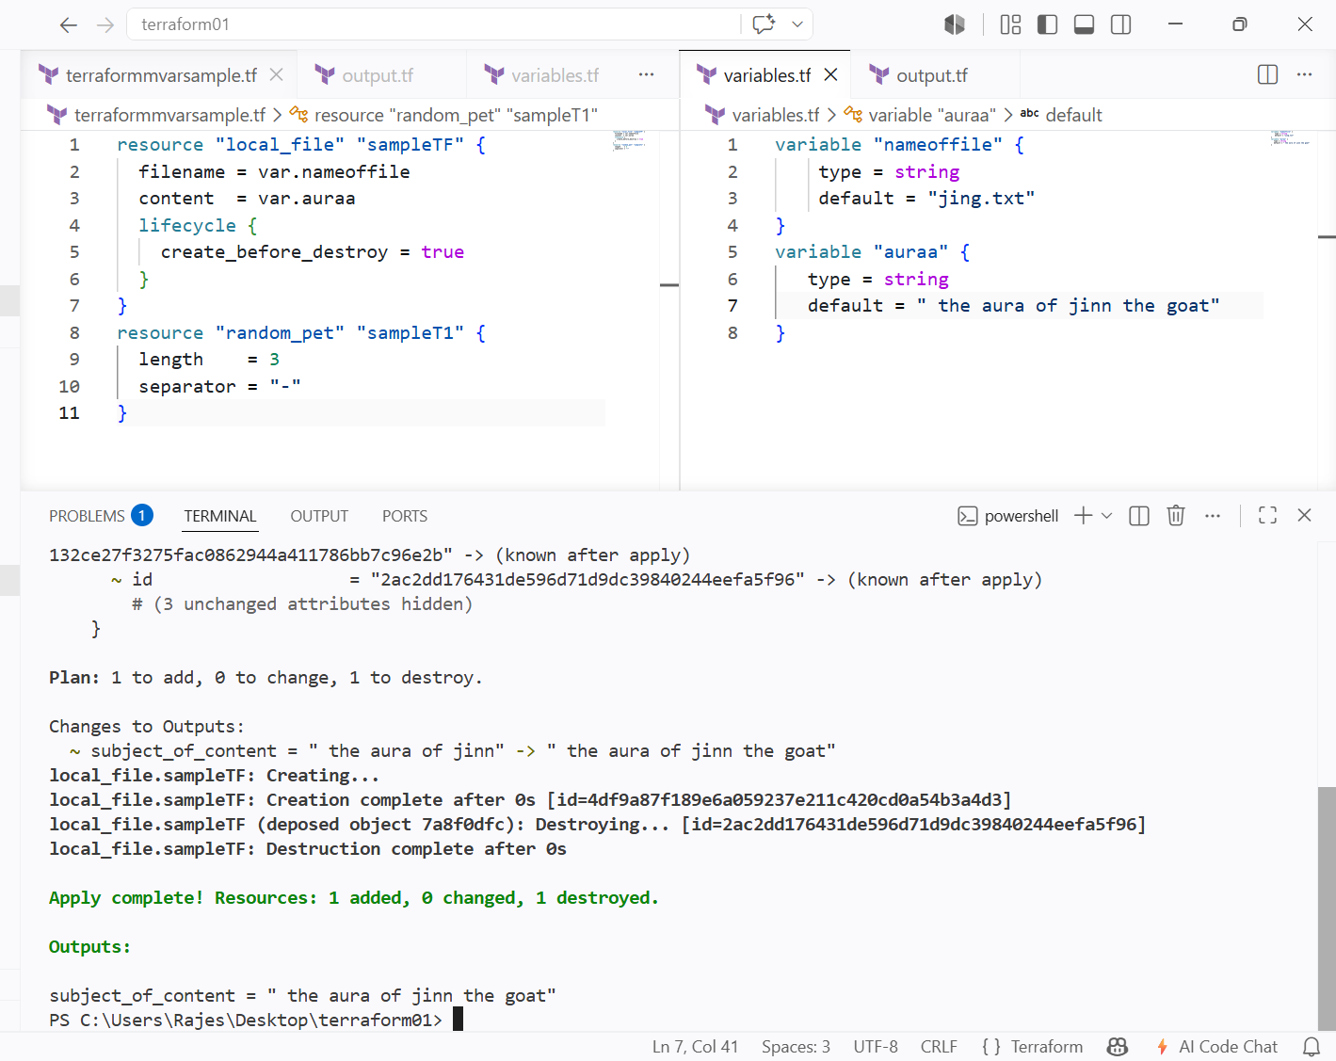

Prevent_destroy

It is used for modifying any changes in the script

If the prevent_destriy lifecycle is enabled then terraform apply wont work and shows an error that lifecyle is enabled

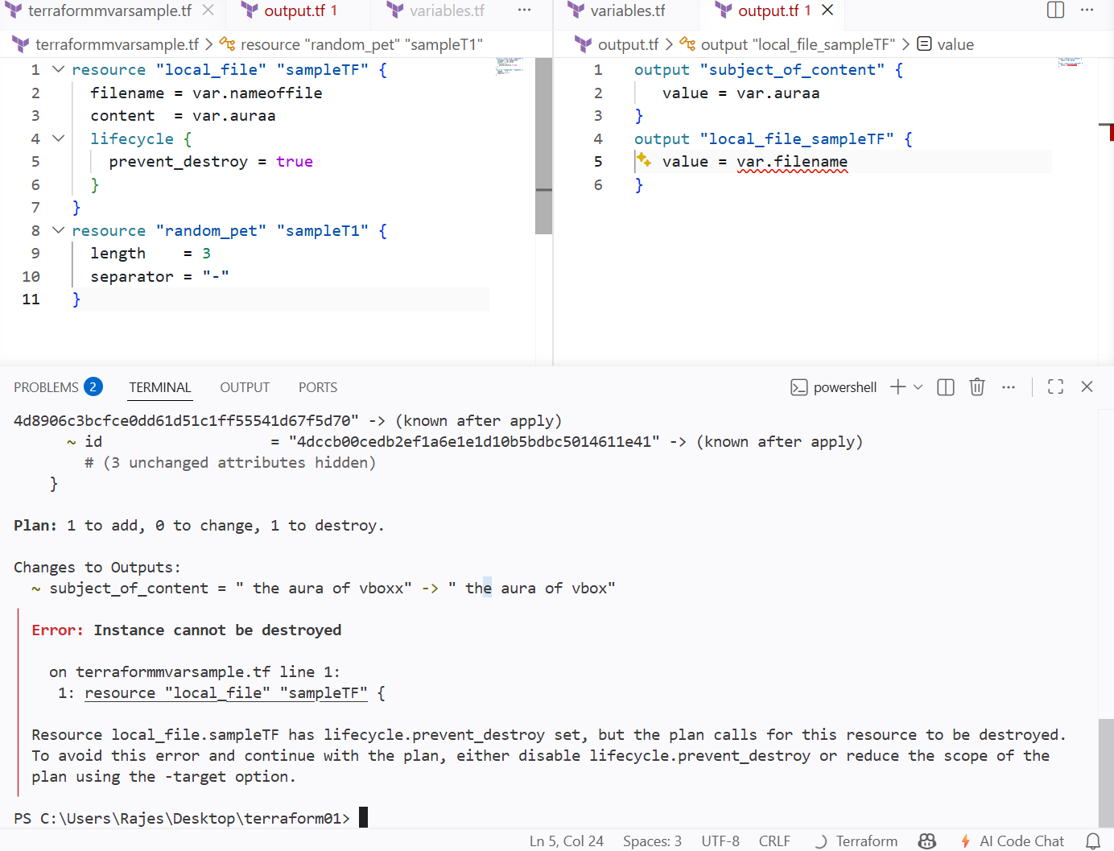

Ignore_changes

This lifecycle is used for ignoring the changes happened in the script

We need to enable this lifecycle in the script itself to be enabled

That is

I have added ignore changes in the lifecycle block

And then I have changed the content of the content

Then mentioned the content in the ignore_changes block

Then it we can see the output block result in apply has changed but it has not changed in the text file

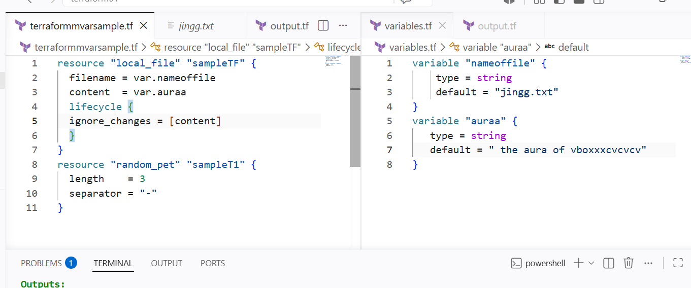

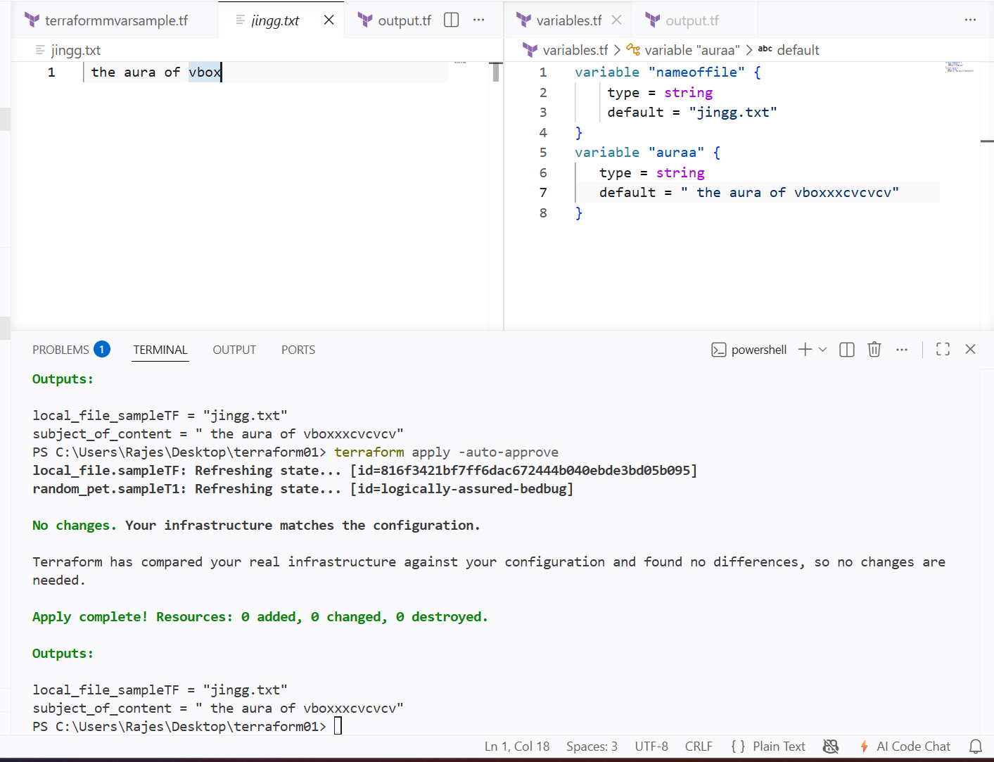

Using variables directly at the command line

Instead of giving the varibales at the variables.tf file

We can give the variables at the syntax

But for that varibales.tf varibale block should be available and should be empty

That is

I have mentioned the defaultt value in the variable block

Now when I apply it is asking for the values

This is one method

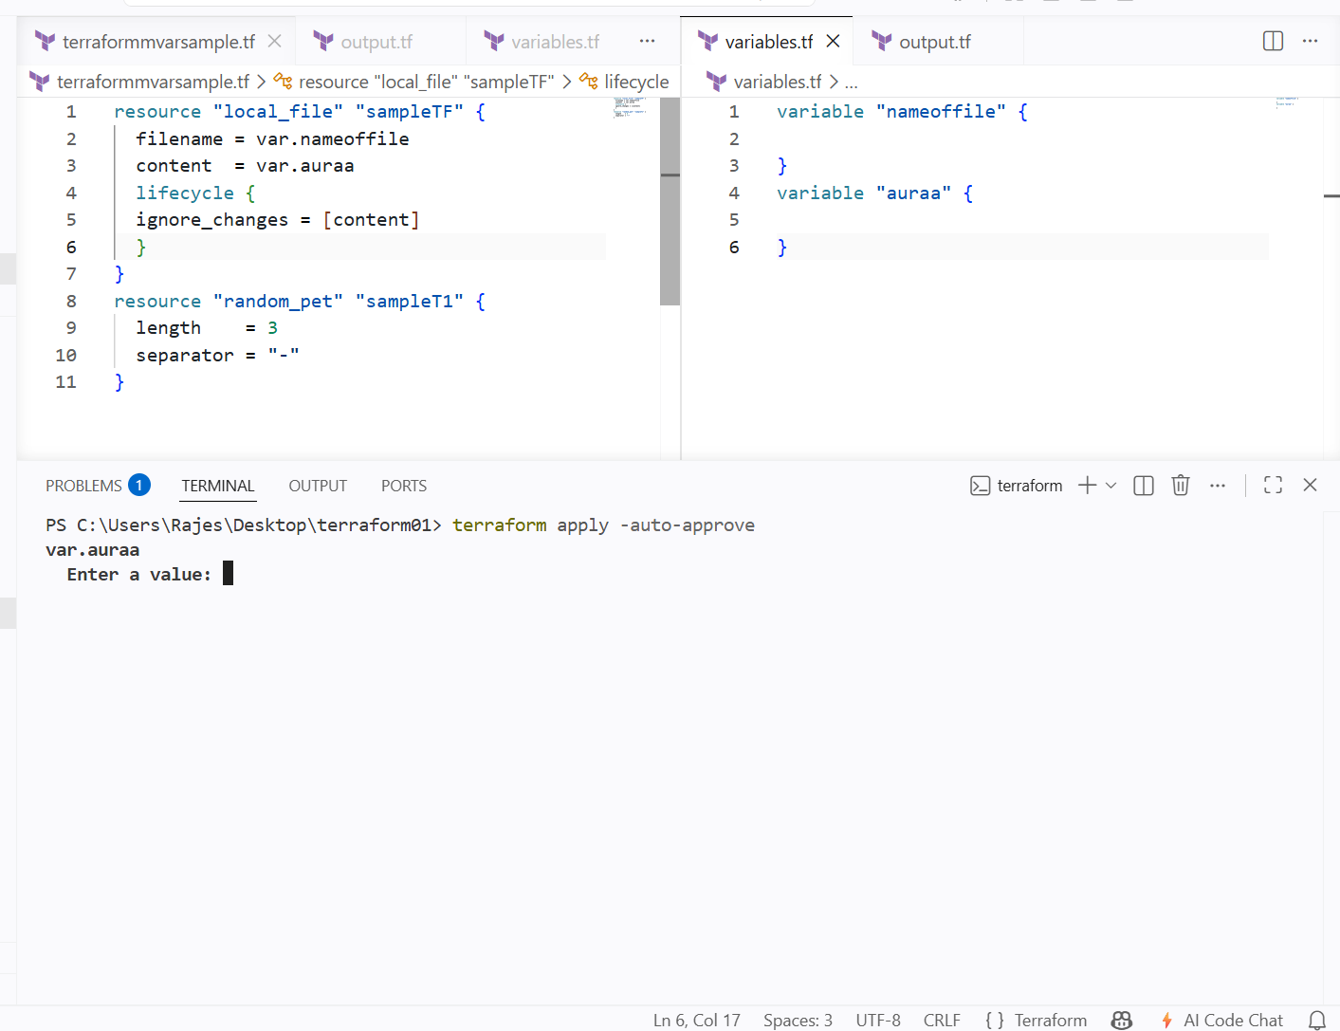

We can give the varibales directly to the syntax

------------>

I have declared the values directly to the syntax using the below syntax

And we can see the output

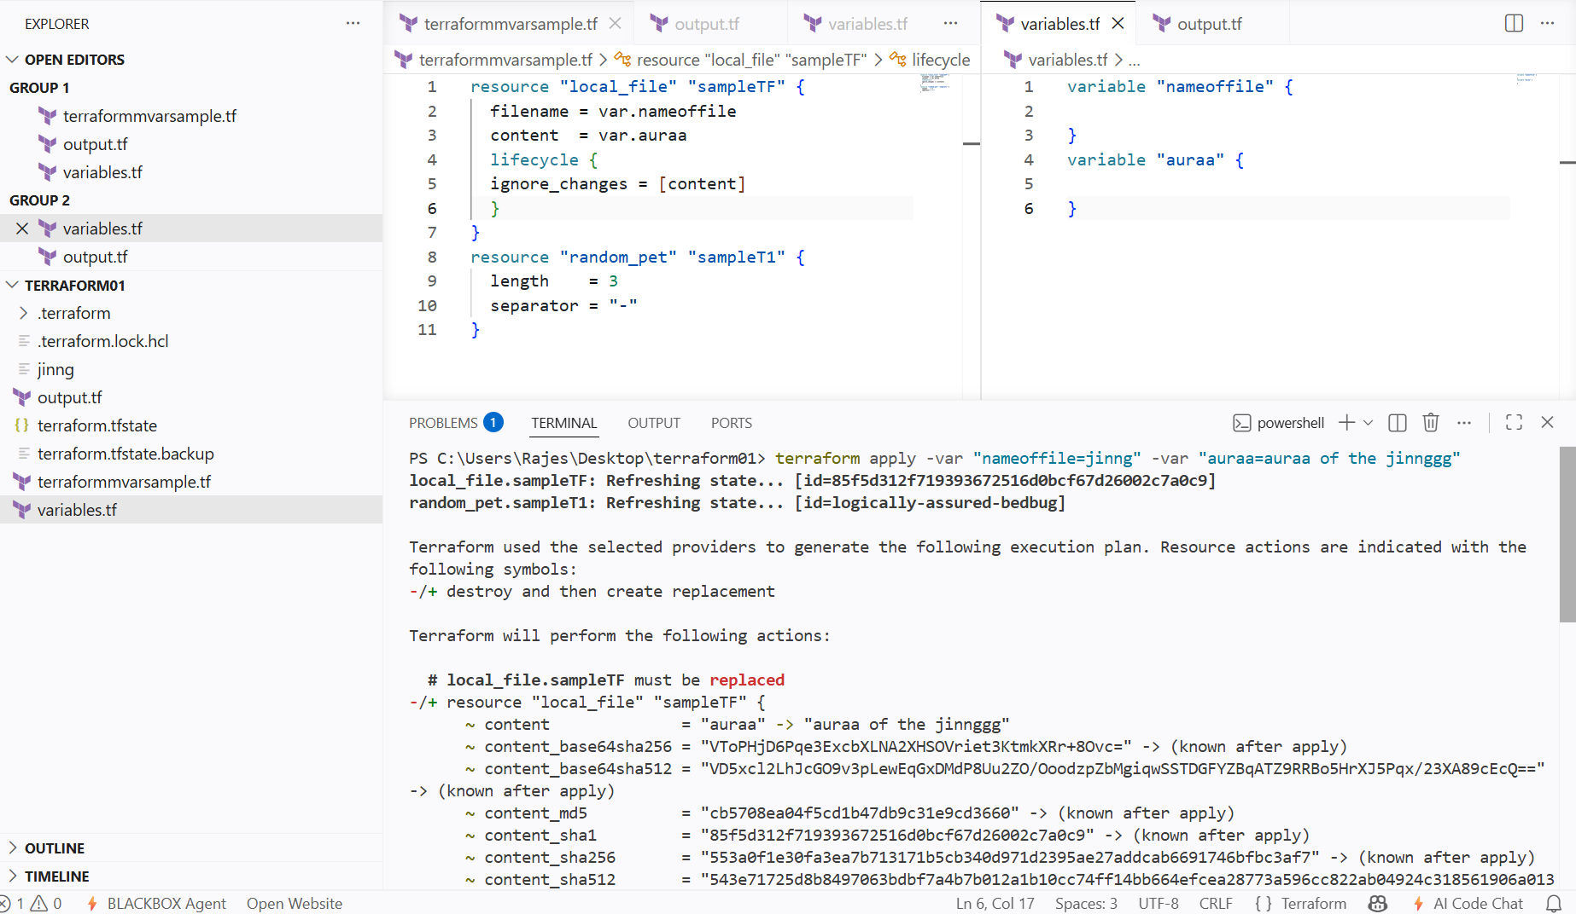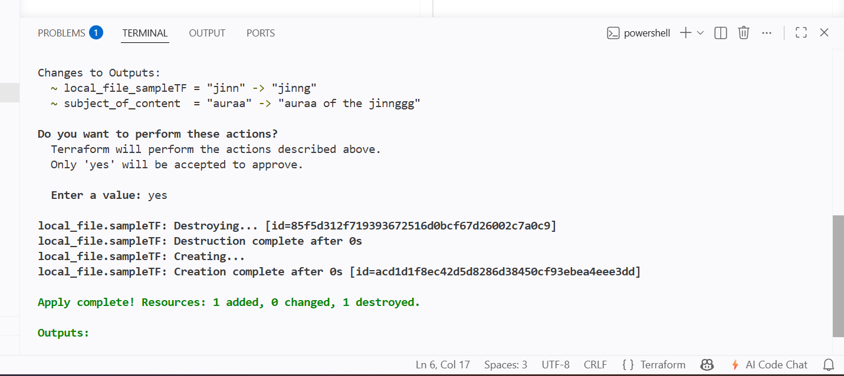

Integrate Terraform in Jenkins using the Terraform plugin

Installing the terraform in the jenkins server

Downloaded from the hashicorp website package

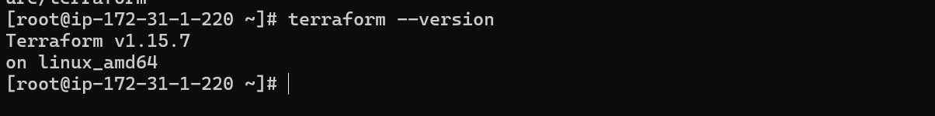

Download the plugins from the mange jenkins pulgins
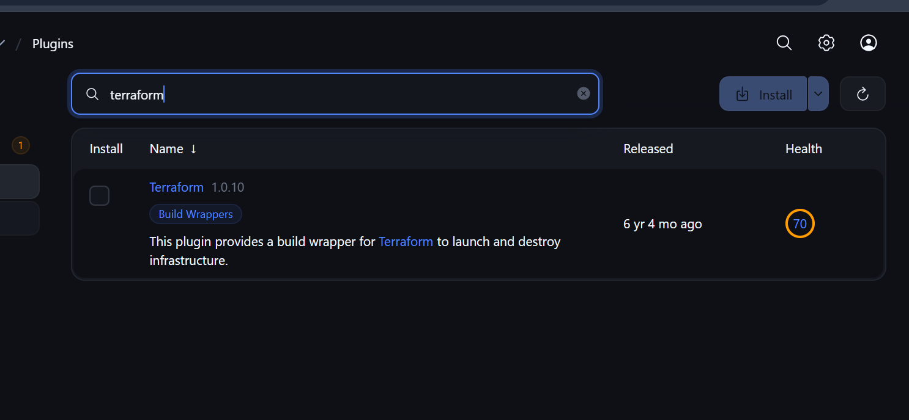

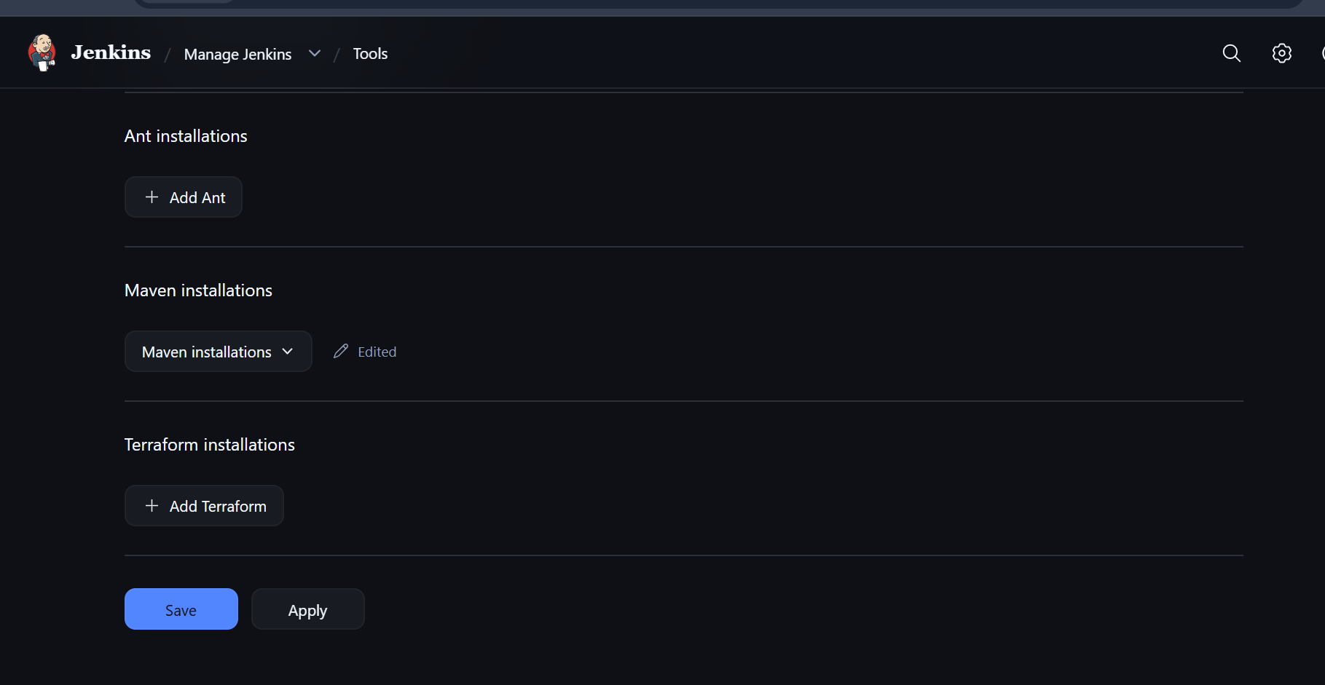

Then give the terraform path and name

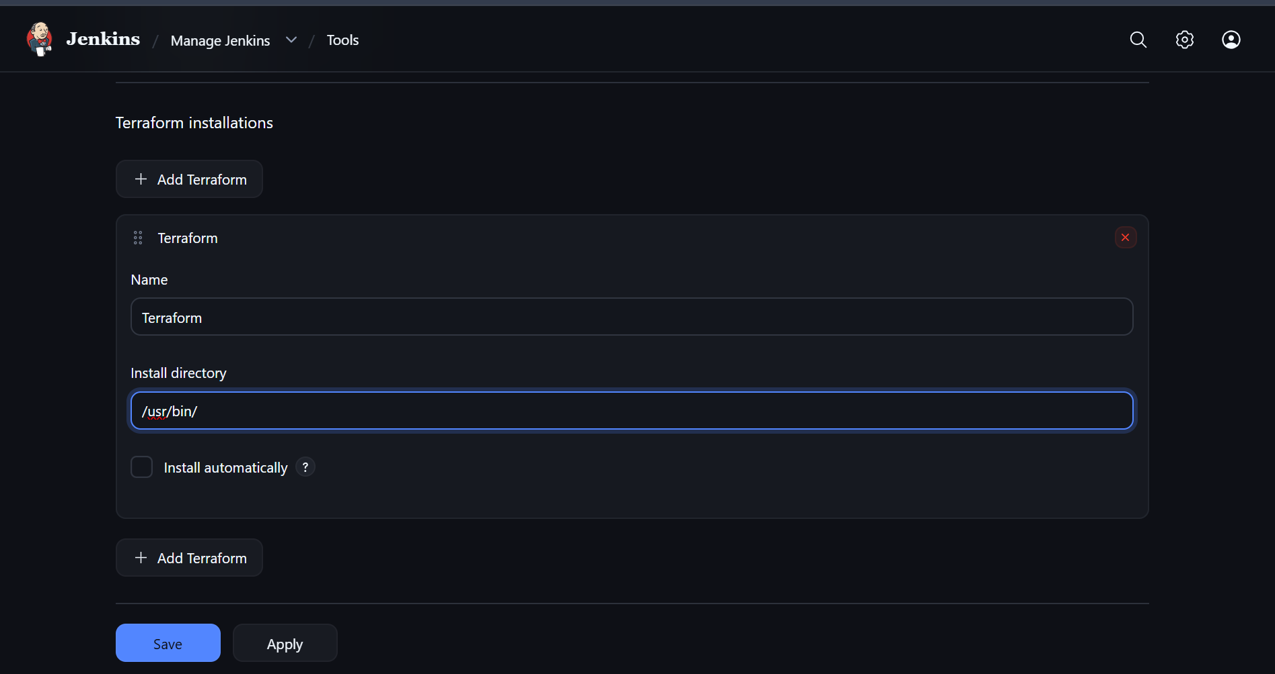

I have pushed to my repo and will clone the terraform .tf file

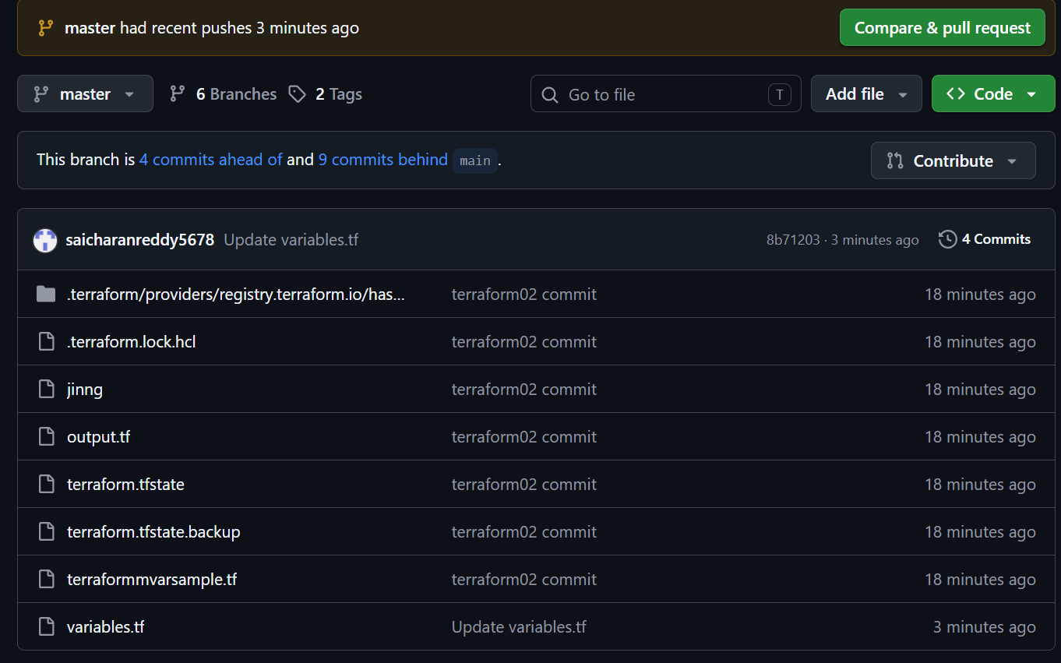

I have cloned the repo using git

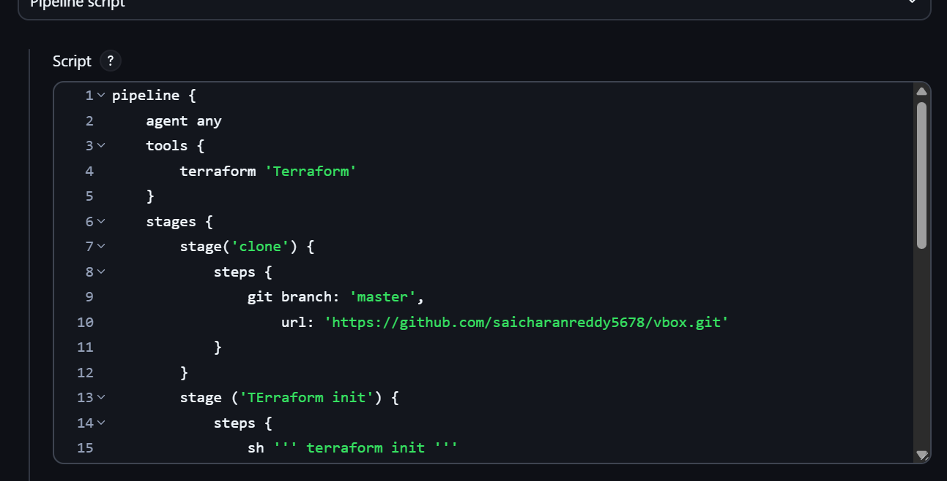

Then used shell to run the terraform commands

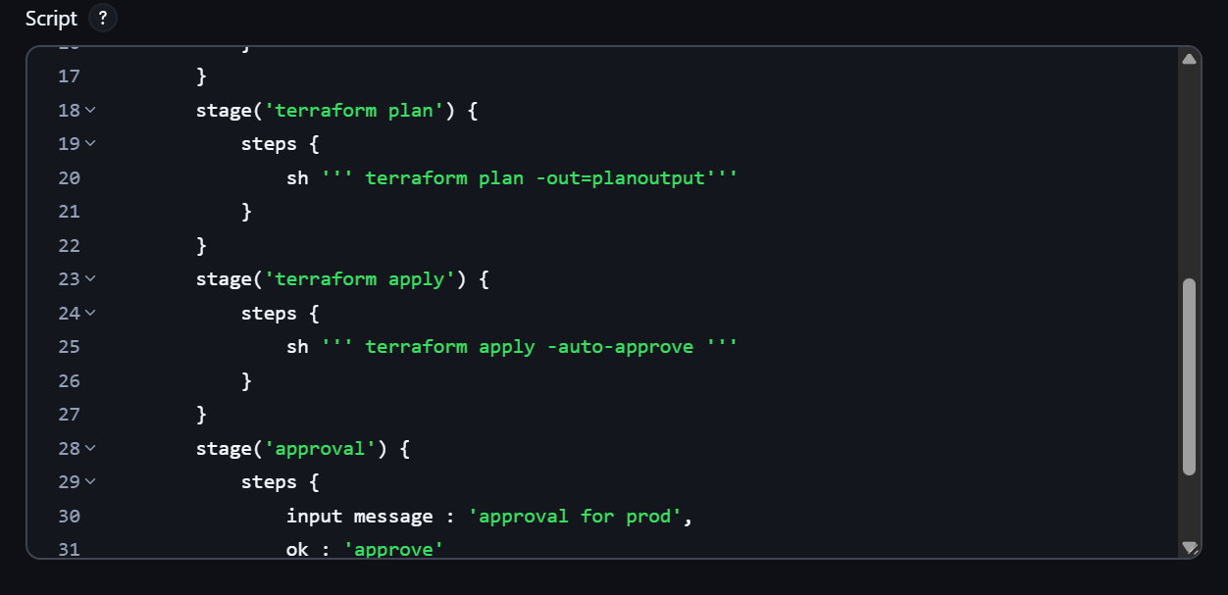

And finally added manual approval for final stage

To complete the build

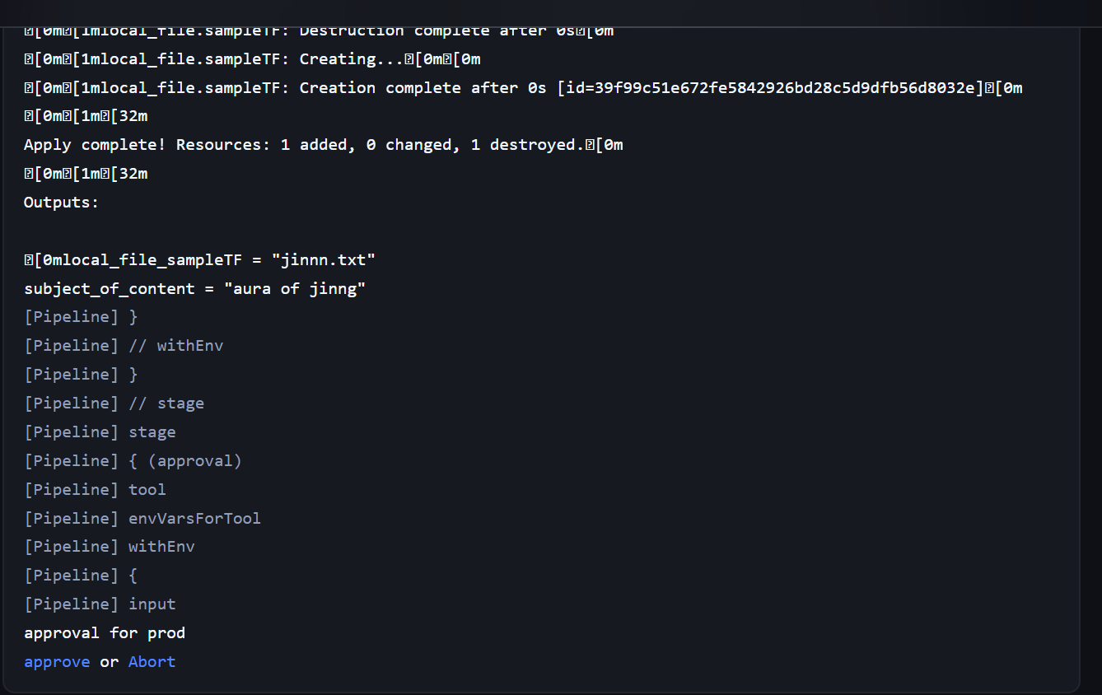

It has been waiting for approval

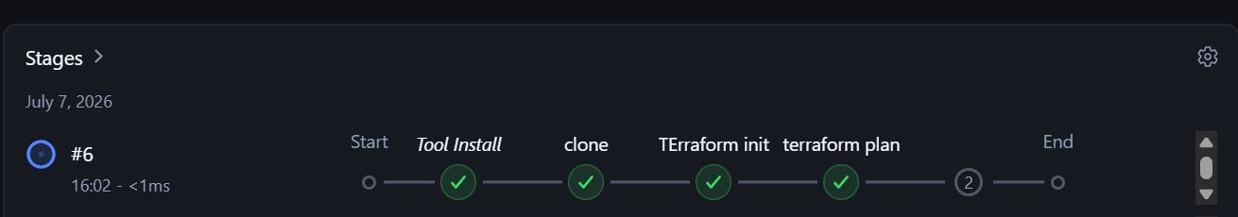

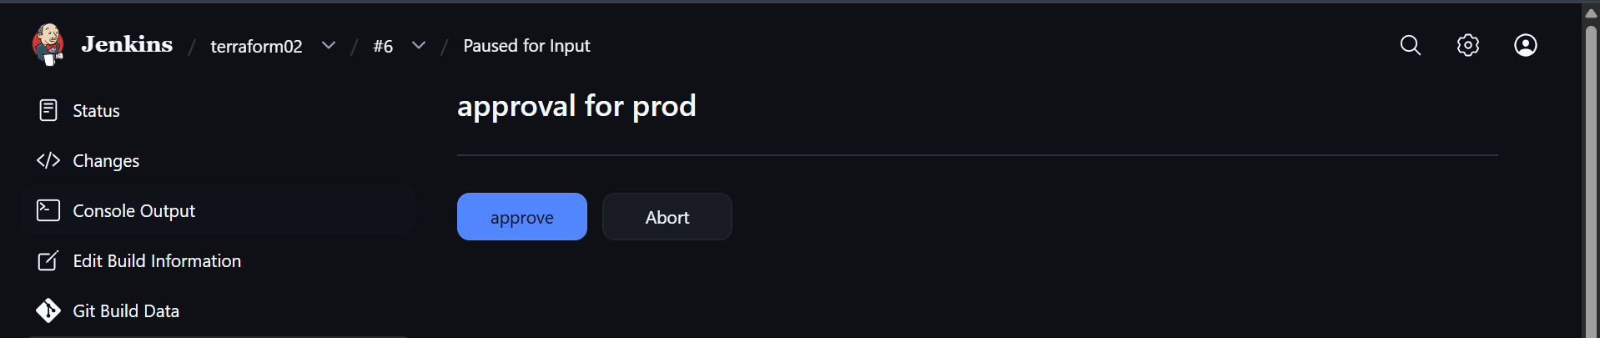

Now the build is successful

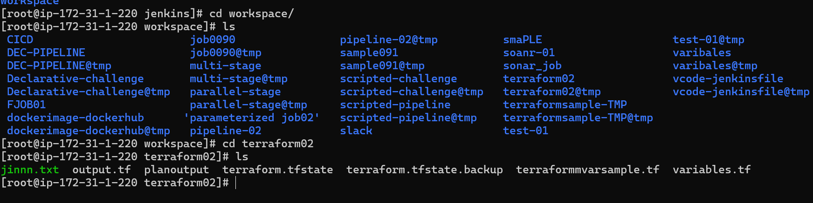

New file has been created and terraform plan output has also saved

