Setup one master and two worker nodes in ansible

Creating 3 new instances
One for master
2 for worker nodes

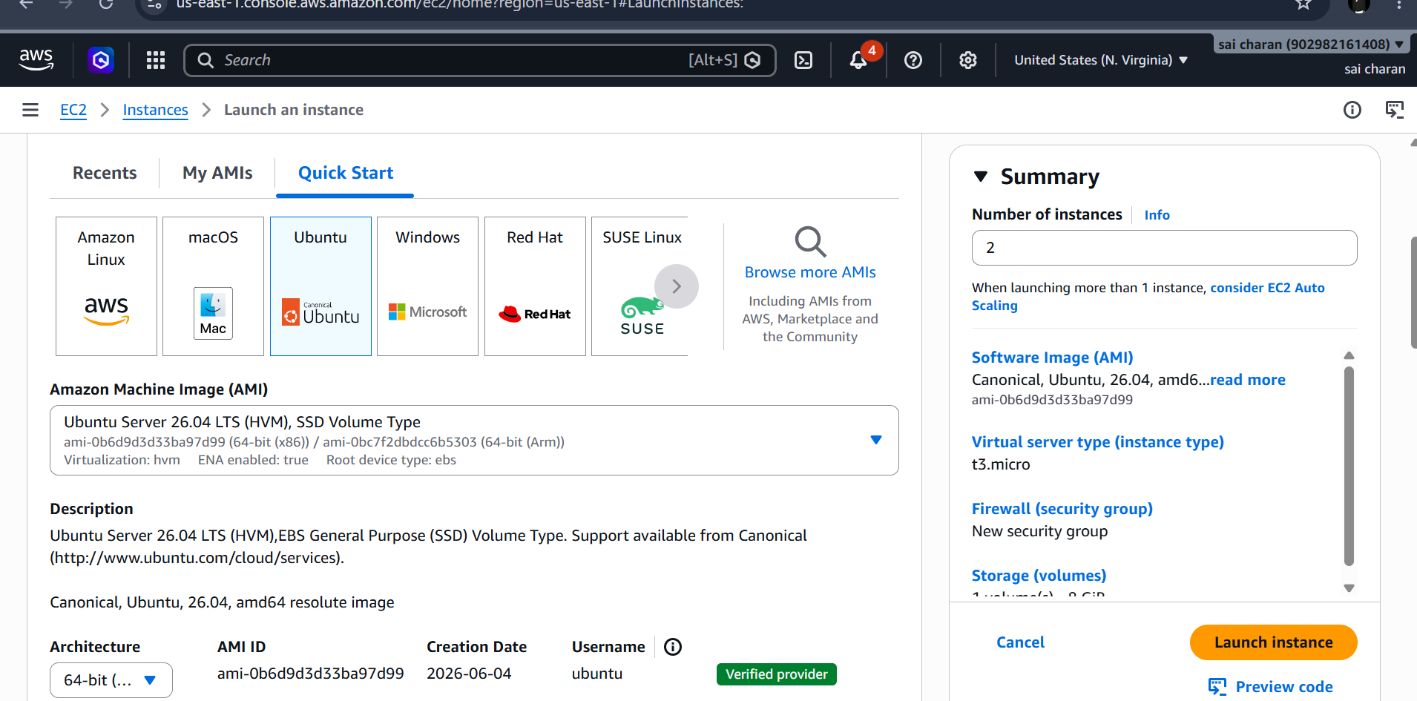

Installing ansible on master server
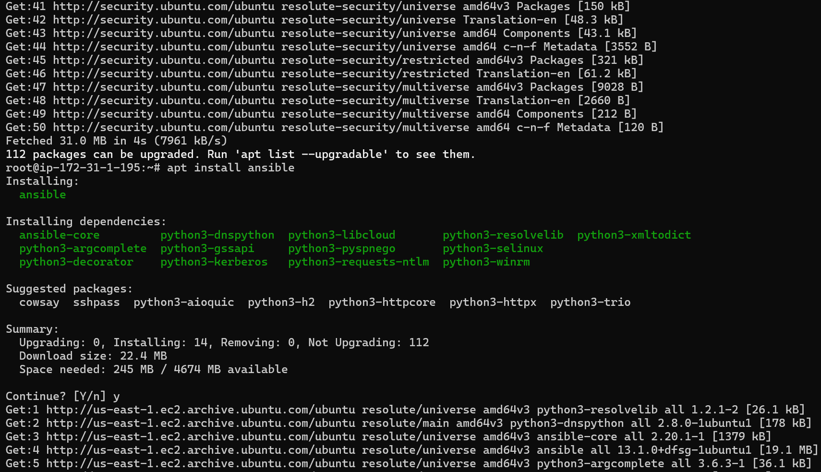
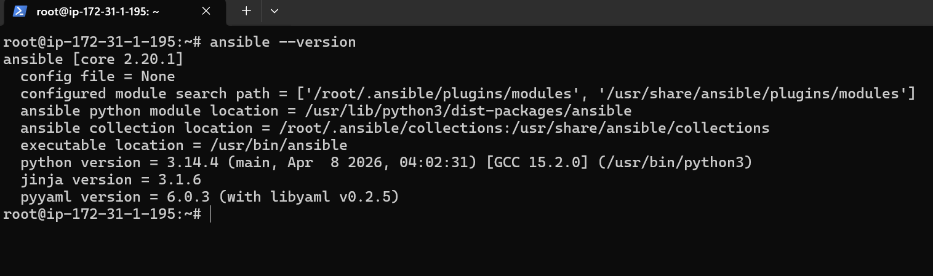

Ansible Control Node
192.168.1.10
|
| SSH key authentication
|
+----+----------------+
| |
Worker 1 Worker 2
192.168.1.11 192.168.1.12

This is how we setup ansible master and worker nodes

Next ssh keygen in master and add in both worker nodes inside the authorized_keys

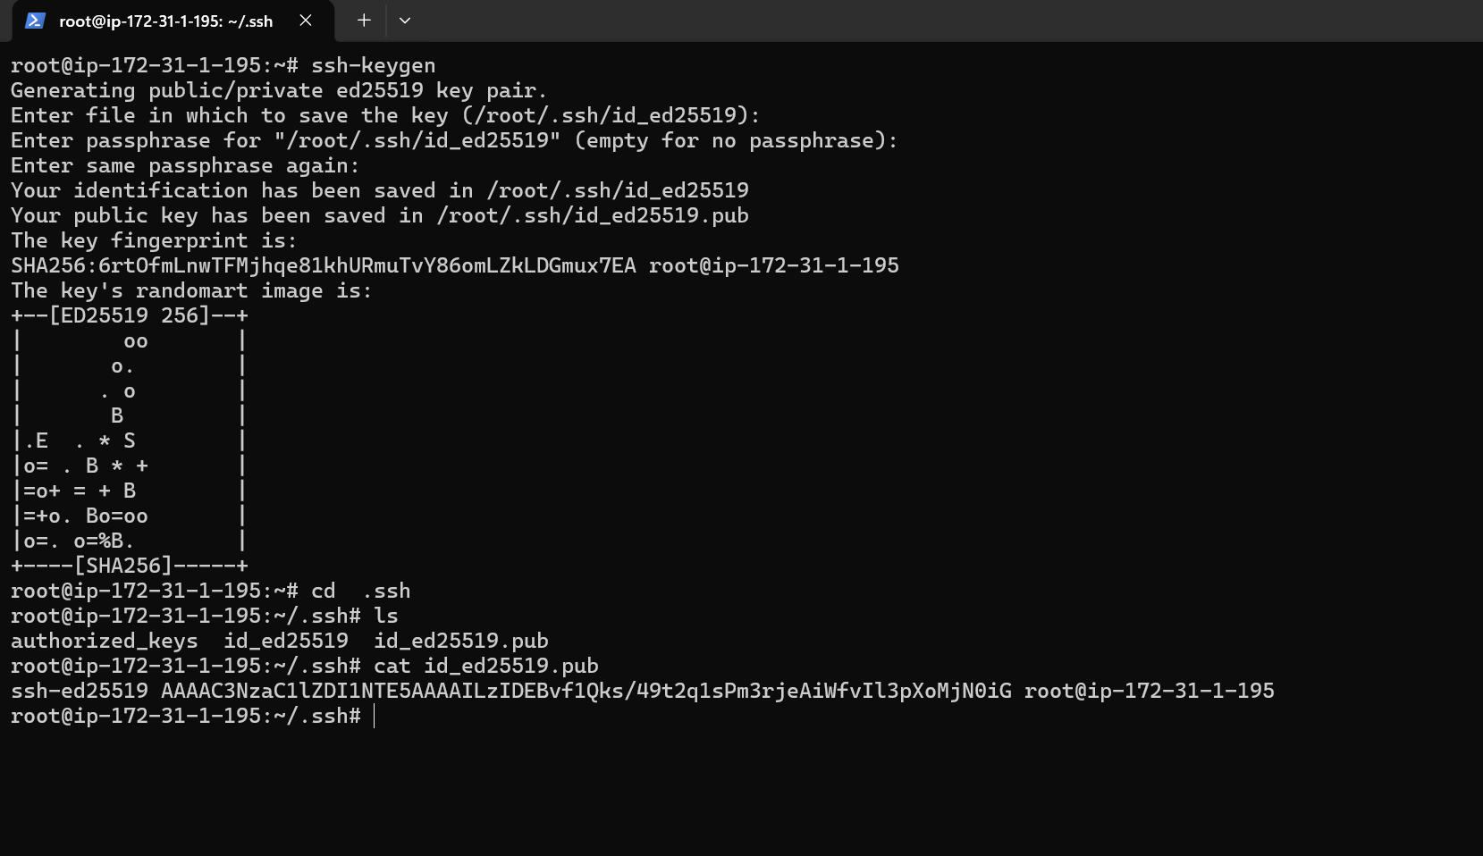

Adding the ssh key to the worker nodes

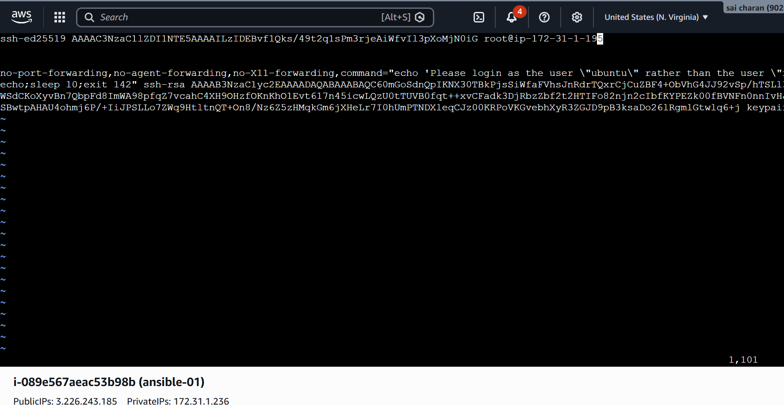

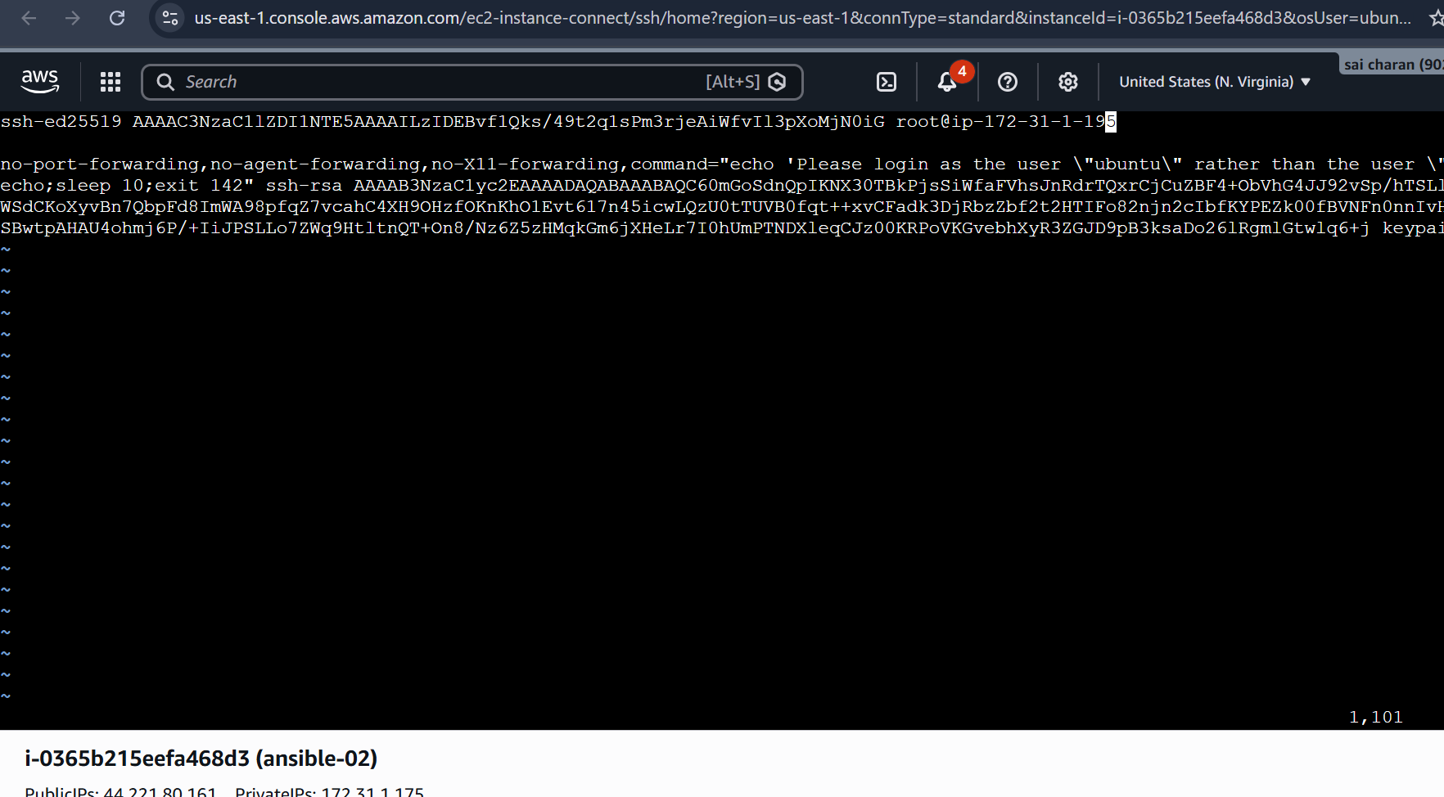

Added in both worker nodes

And chmod 600 .ssh in both worker nodes

Now creating the inventory in master nodes

And giving the ips of worker nodes in the master node inventory

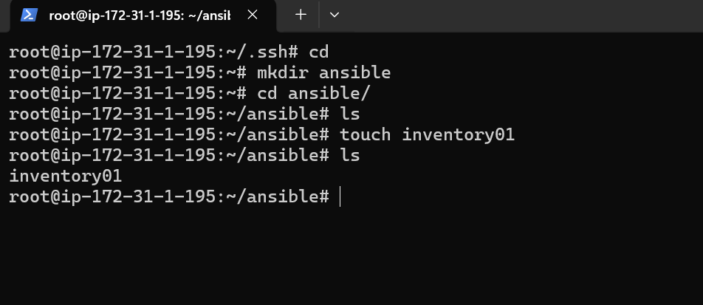

Created a new directory for ansible and created a new inventory file with random name and adding the ips of worker nodes

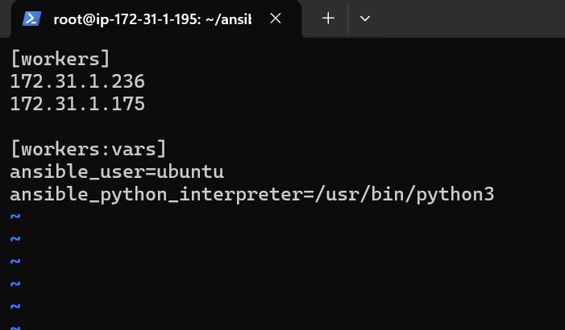

Added the private ip or public ip of worker nodes

Now checking the connectivity of worker nodes fromm ansible master node

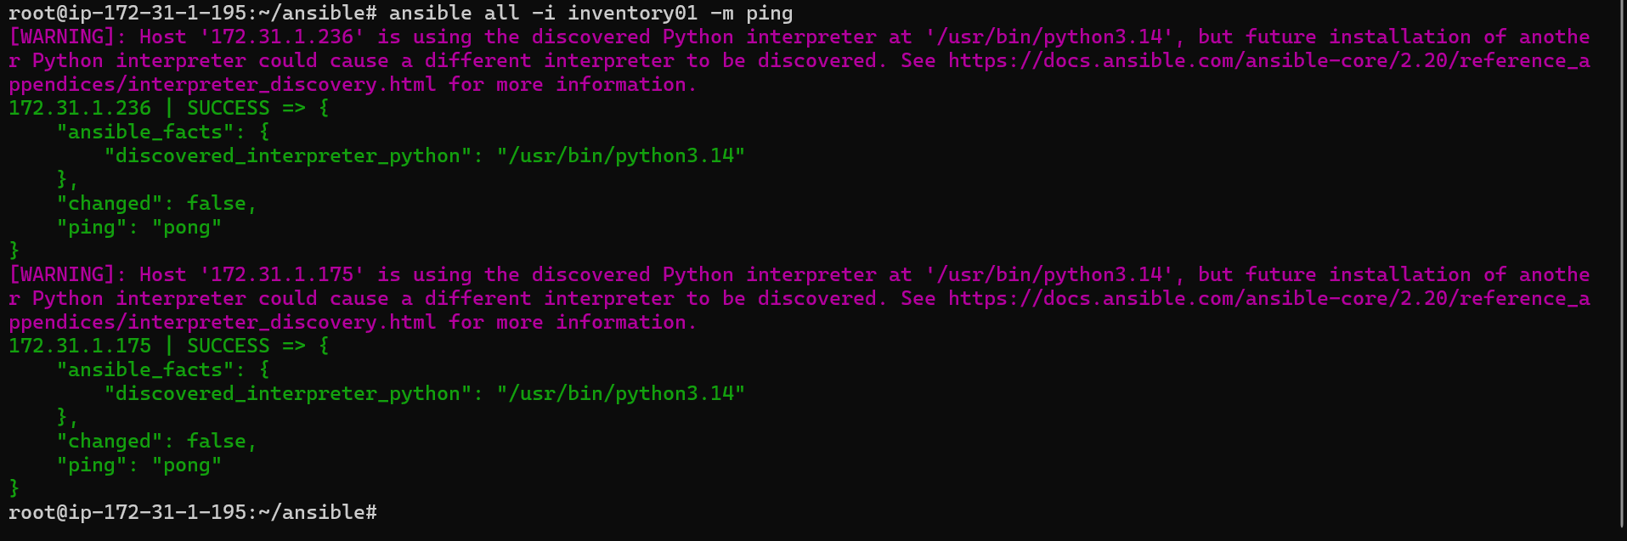

Connection has been established

Testing the adhoc commands

# To check the connetivity between slaves
ansible all -m ping
ansible all -m ping -i ansible_hosts

# How to gather facts of slave machine
ansible all -m setup
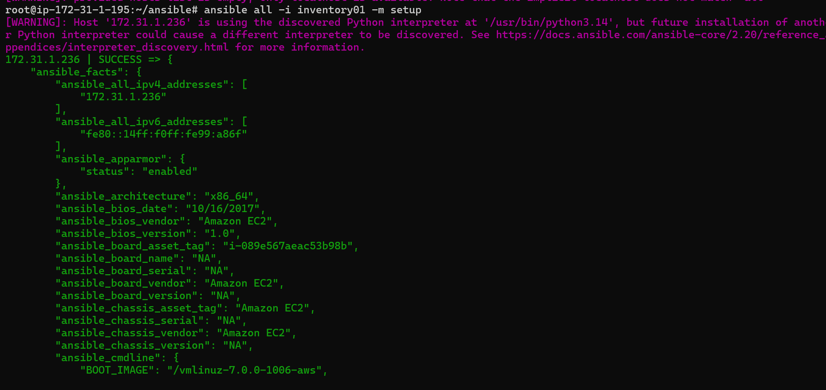

To get the info of slave machines

# Tips: -i is used if we are using more than one invertory file

# What if you do not have SSH key-based? How to pass username and password?

ansible all -m ping --user=ansadm --ask-pass
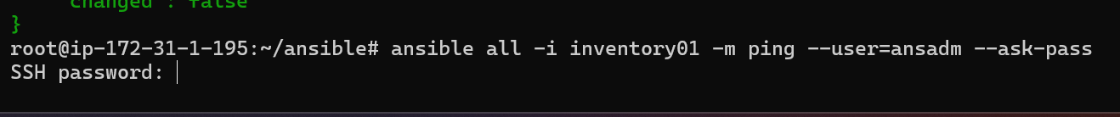

# TO checkthe uptime of a slave machine
ansible all -a uptime
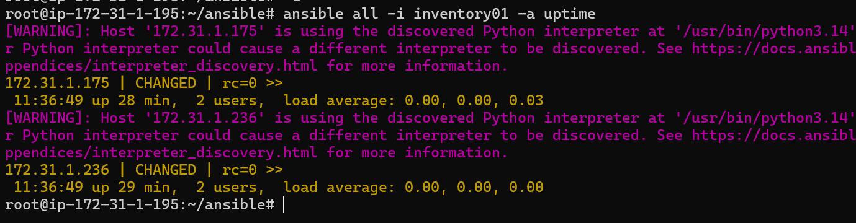

# Tips: -m is the module and -a should contain the command it should run
which goes as an argument to command and shell.

# check the free memory or memory usage of host
ansible all -a "free -m"
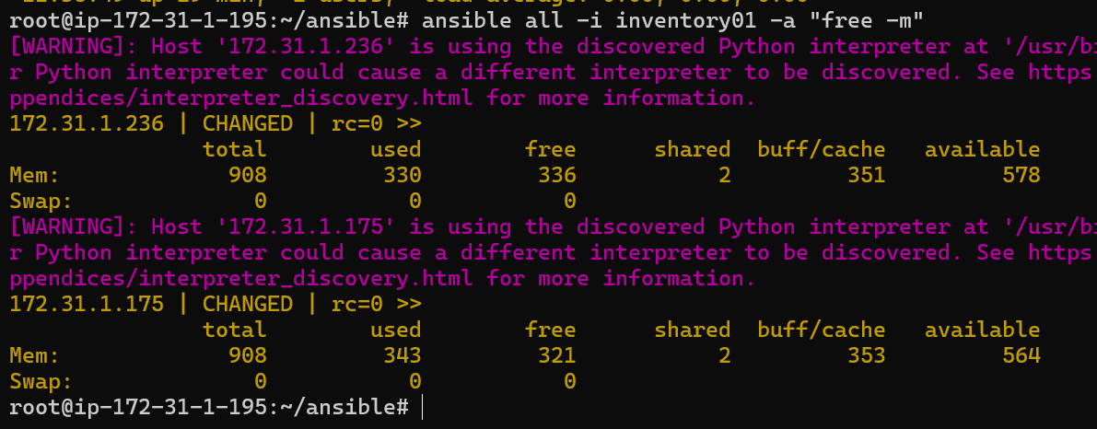
# Execute a command as root user (sudo) on host
ansible all -m shell -a "cat /etc/passwd|grep -i ansadm" -s --ask-sudo-pass

# Execute a command using become module
ansible all -m shell -a "cat /etc/passwd|grep -i ansadm" -b -K
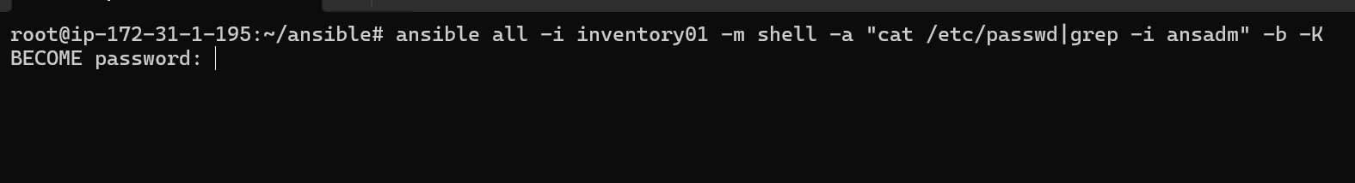
# Tips: -b is the option for become and by default it will become root user
–K is to tell ansible to ask for SUDO password

#Execute a command as a different user (sudo su)
ansible all -m file -a "path=/home/ansadm/test state=directory mode=0755" -b --become-user=ansadm

# Create a Linux user group
ansible all -m group -a "name=test state=present" -b

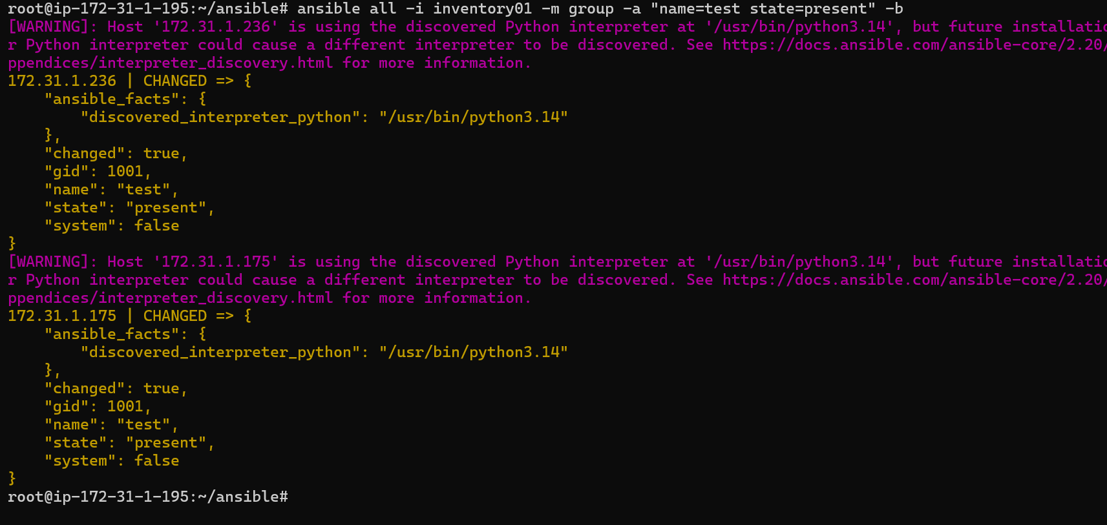

# Create a file with 755 permission
ansible all -m file -a "path=/home/dirname/testfile state=touch mode=0755"
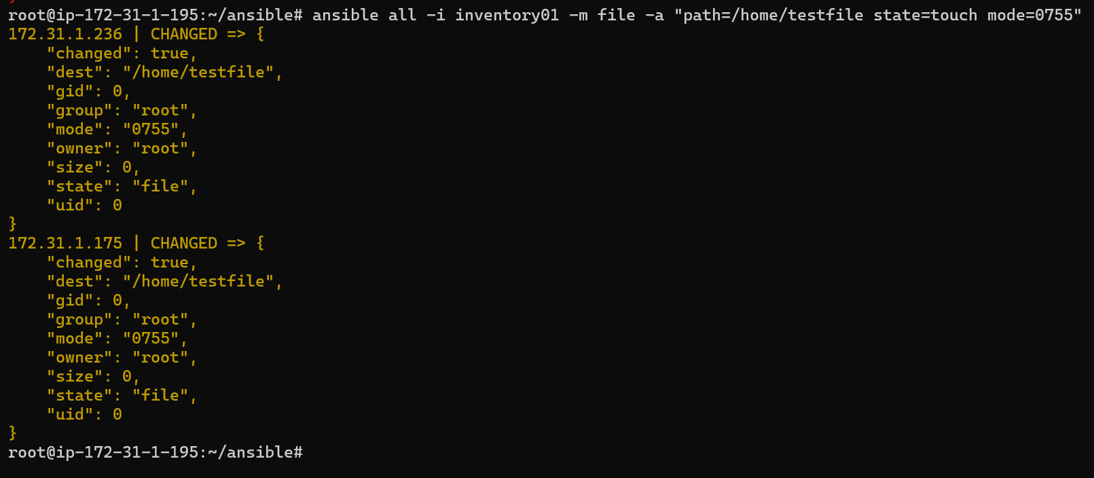

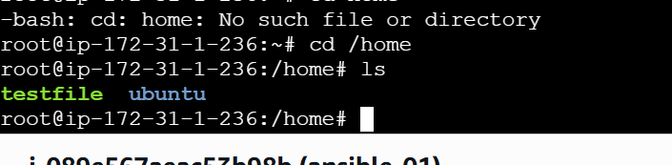

# Change ownership of a file
ansible all -m file -a "path=/home/testfile group=ubuntu owner=ubuntu" -b

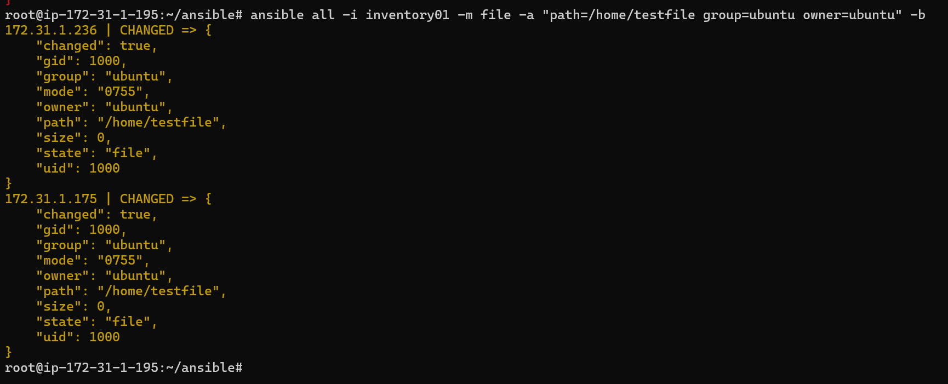
# Install a package using yum command
ansible all -i inventory01 -m apt -a "name=apache2 state=present"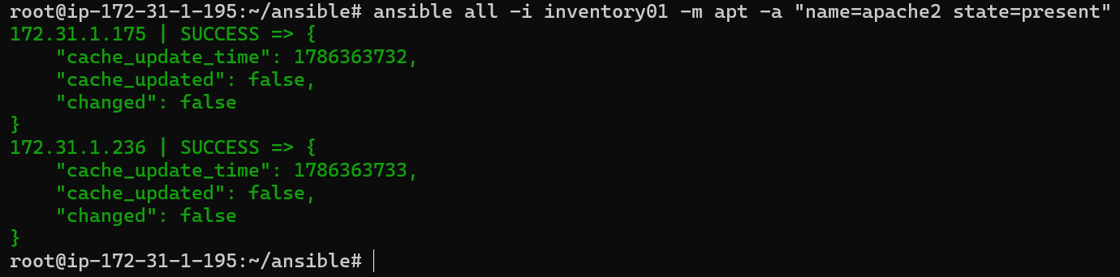
# Start or stop the service
# To Start
ansible all -i inventory01 -m service -a "name=apache2 state=started enabled=yes"

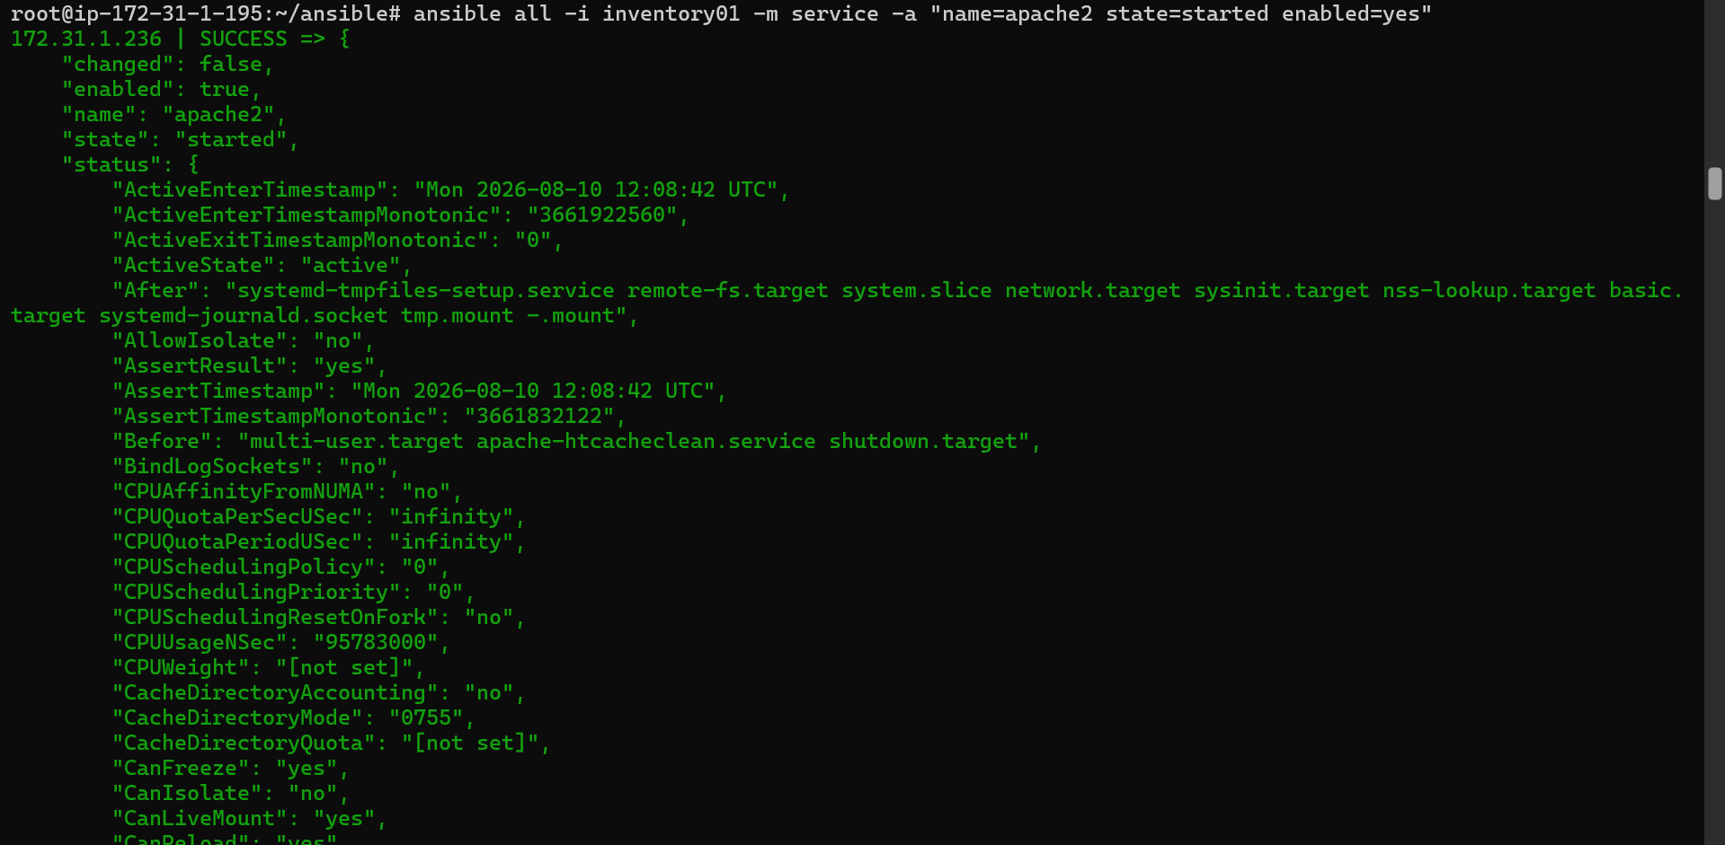
# To Stop
ansible all -m service -a "name=httpd state=stop enabled=yes"

