Write a single ansible playbook which will install apache and nginx. Note: Playbook should not be hardcoded and pass the variables from different file

Variables file: vars.yml
---
packages:
- apache2
- nginx

apache_port: 8080
nginx_port: 8081

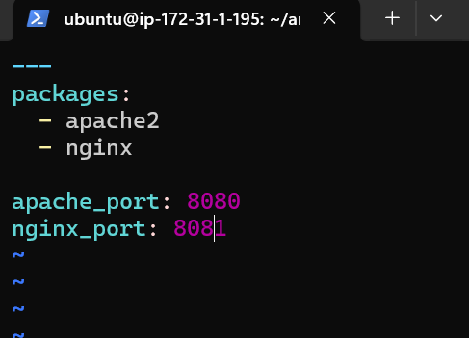

Playbook: install.yml

Write a playbook for both services

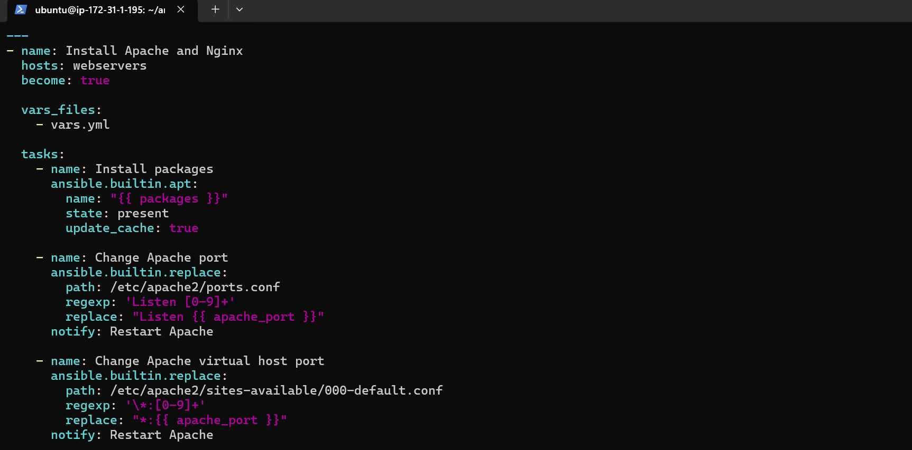
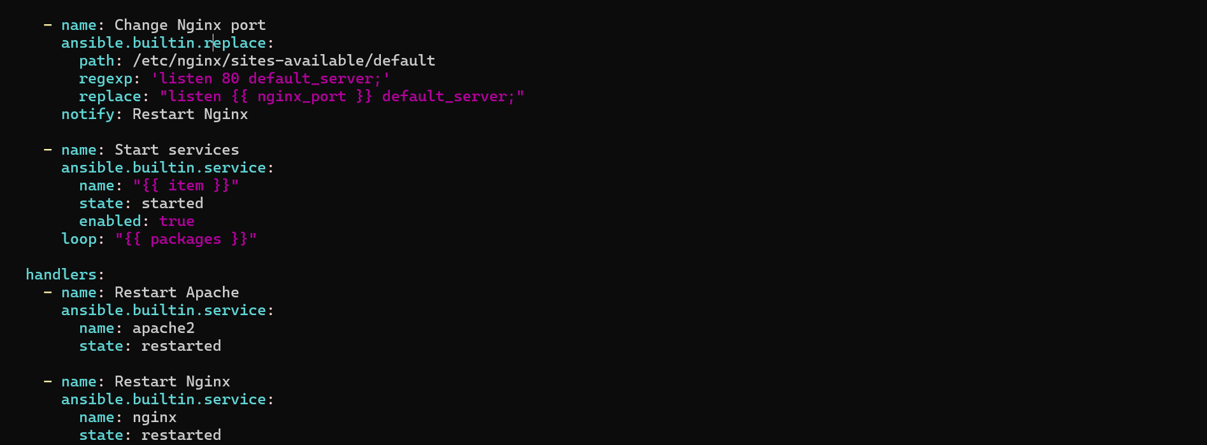

Inventory

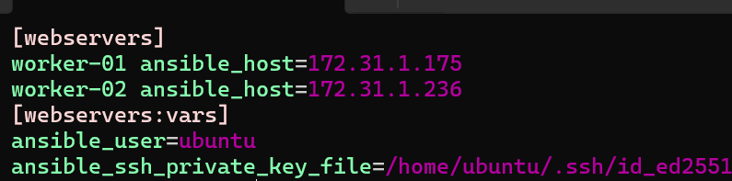
Run:
ansible-playbook -i inventory.ini install.yml
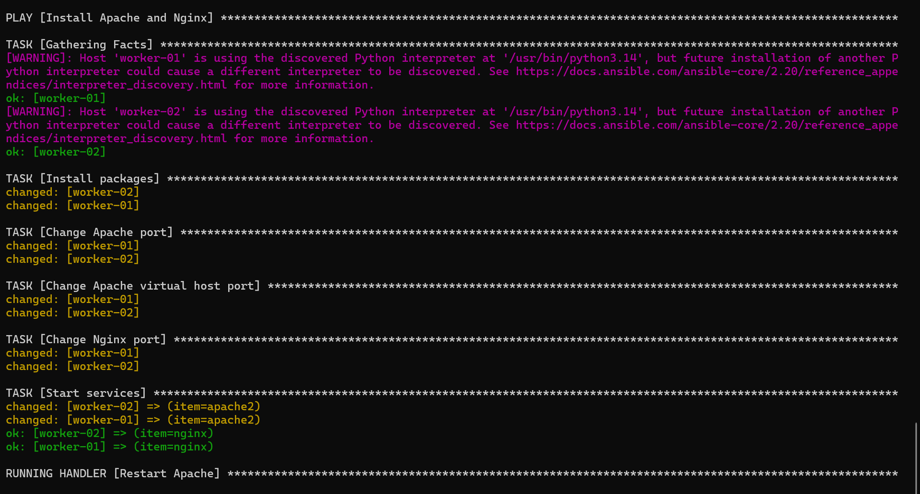
Verify:
curl http://SERVER-IP:8080

curl http://SERVER-IP:8081

Ansible playbook to create 10 different directories with minimal code and directory names should be passed as variables

Creating a new variables file for the directories

Variables file: vars.yml
---
directory_names:
- app
- config
- logs
- backup
- scripts
- data
- temp
- reports
- uploads
- archive
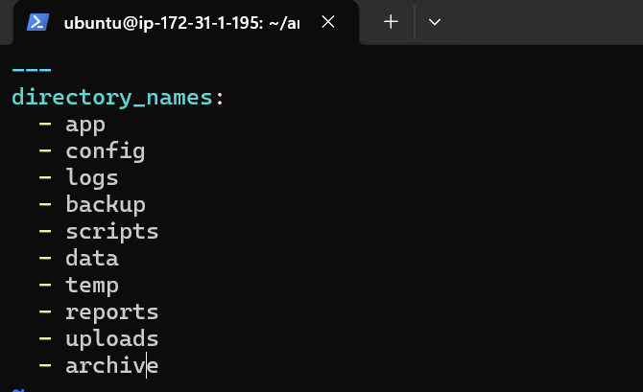

Now creating a new playbook

Playbook: directories.yml
---
- name: Create multiple directories
hosts: all
become: true

vars_files:
- vars.yml

tasks:
- name: Create directories
ansible.builtin.file:
path: "/opt/{{ item }}"
state: directory
mode: "0755"
loop: "{{ directory_names }}"

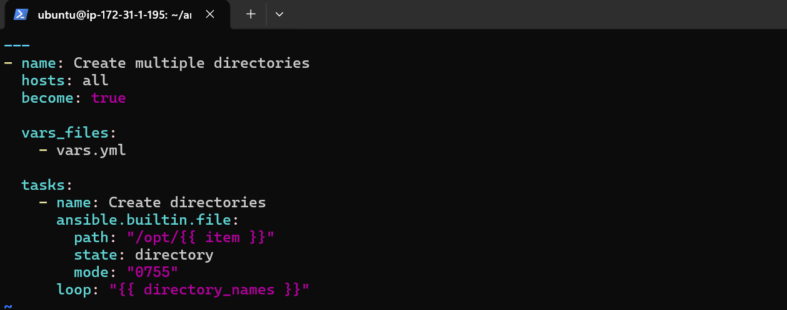
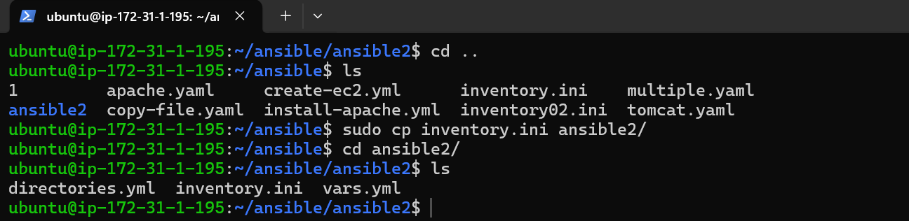

Run:
ansible-playbook -i inventory.ini directories.yml
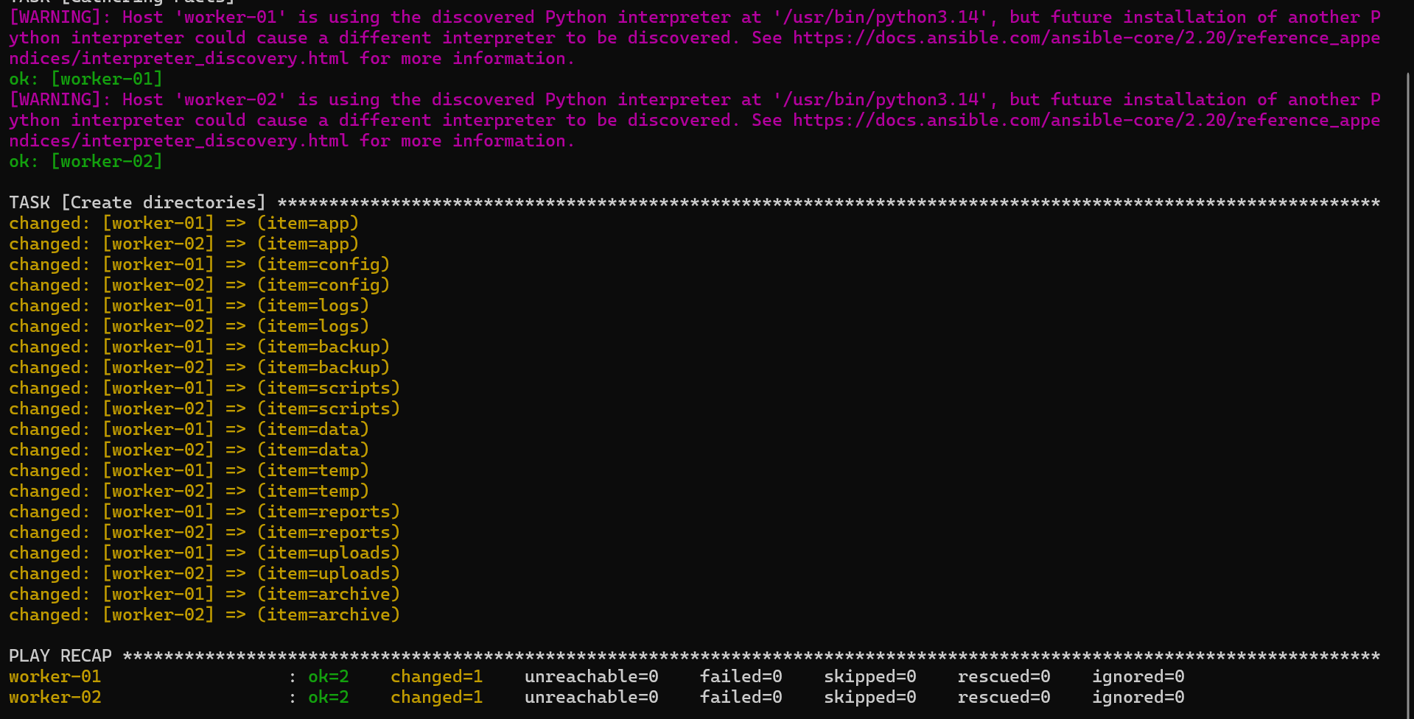
Ansible playbook to copy ssh-keygen from master to worker nodes. Note: a)Provision new 3 ec2 machines, one master and two worker nodes. b)Create common user called ansadm and provide sudo priviliges on 3 ec2 instances. c)Create ssh-keygen in master and your playbook should copy the keygen making it password less authentication

Creating aa playbook in my master to create a new ansible cluster

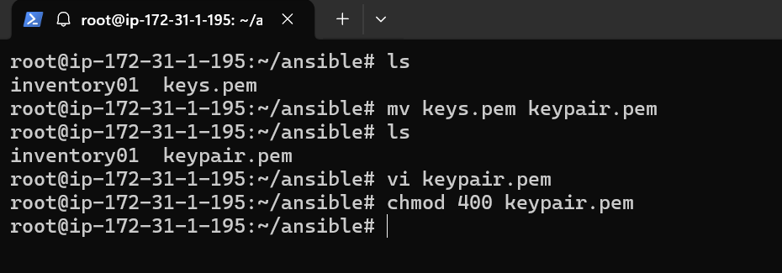

Created a new keypair for my new instances in the current instance that will be given inside the playbook

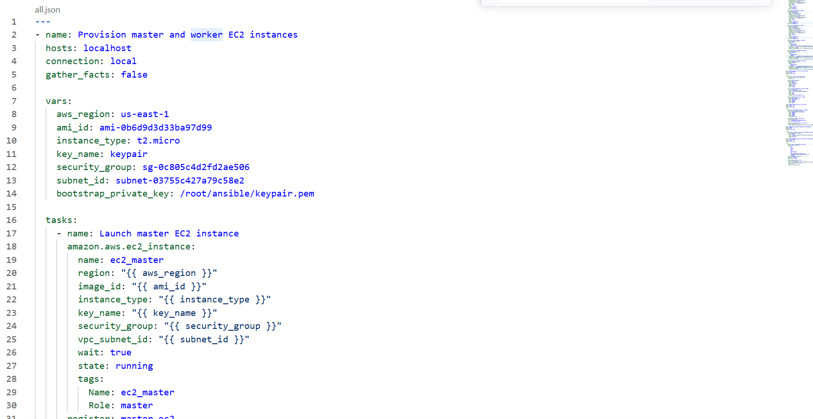
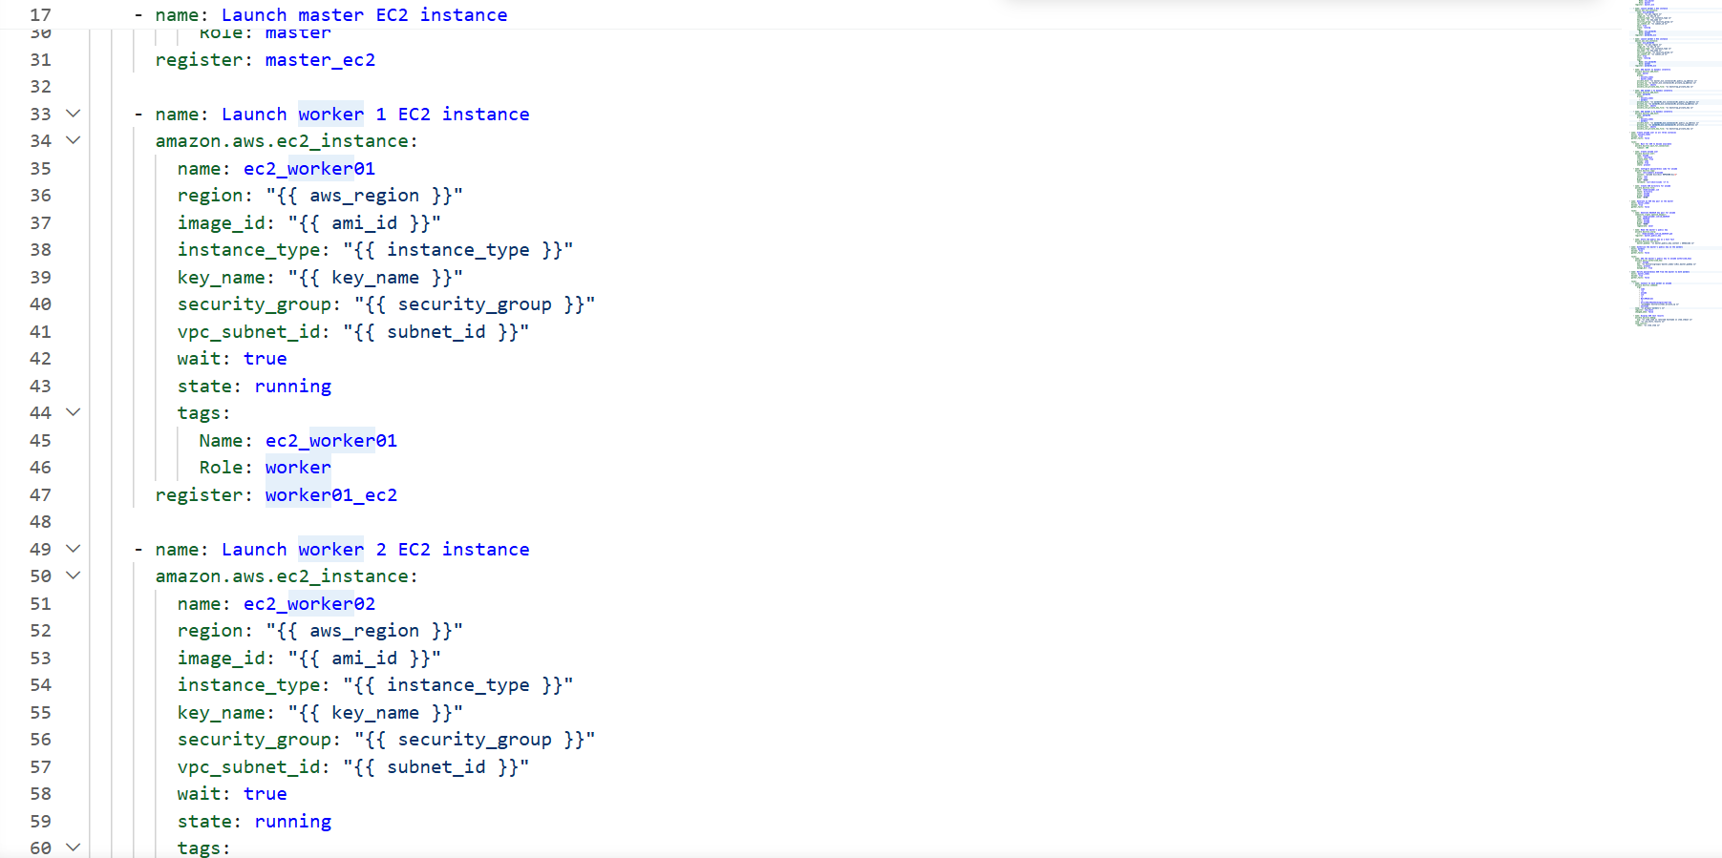

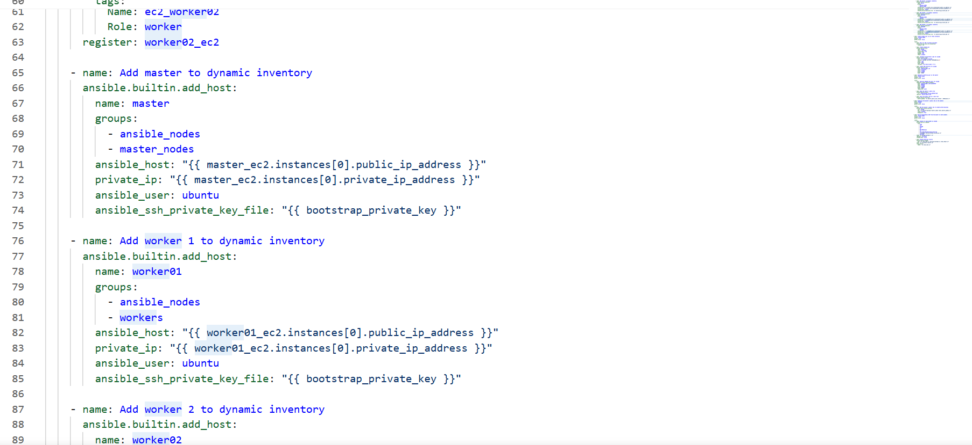
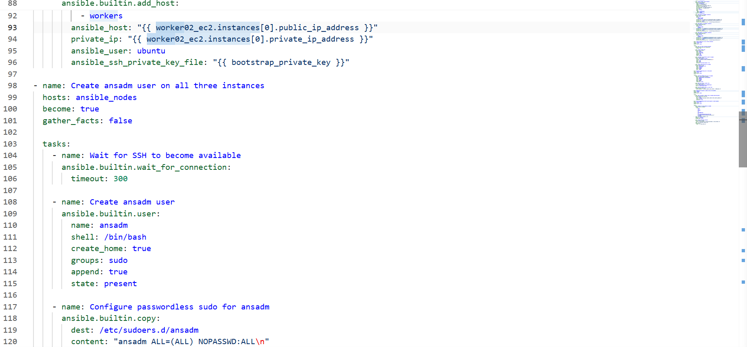
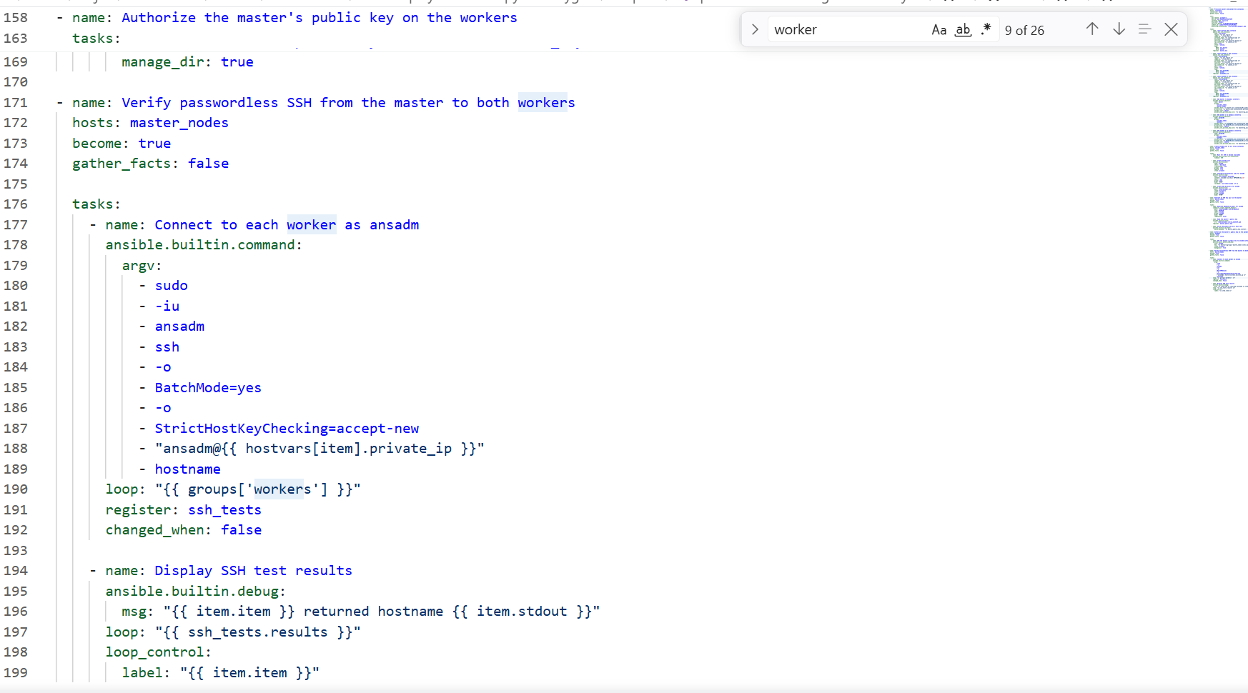

The playbook for creating new 3 instances and configuring the master and ansible worker nodes

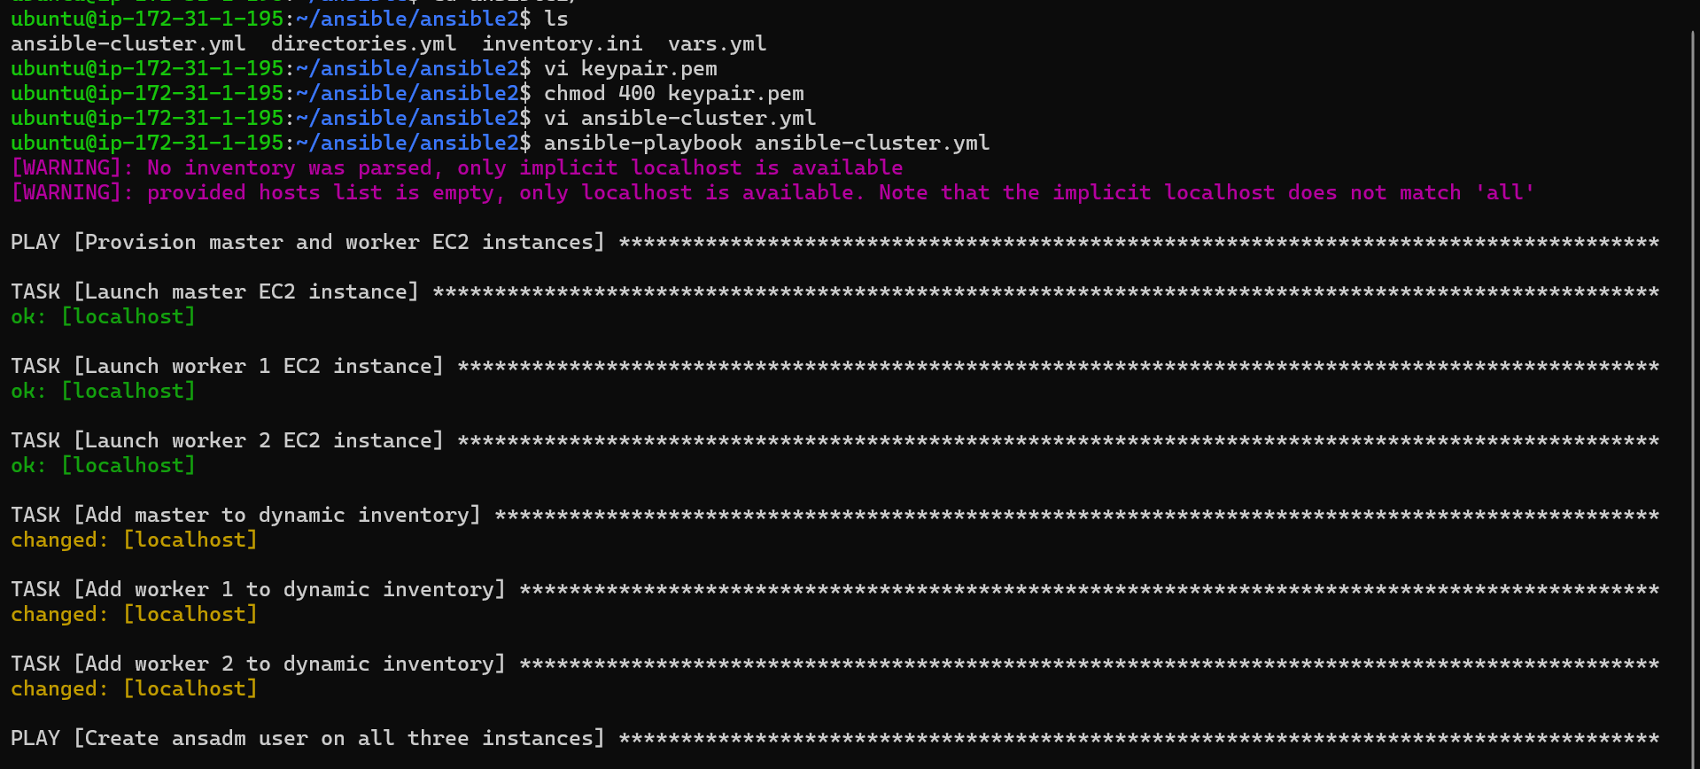

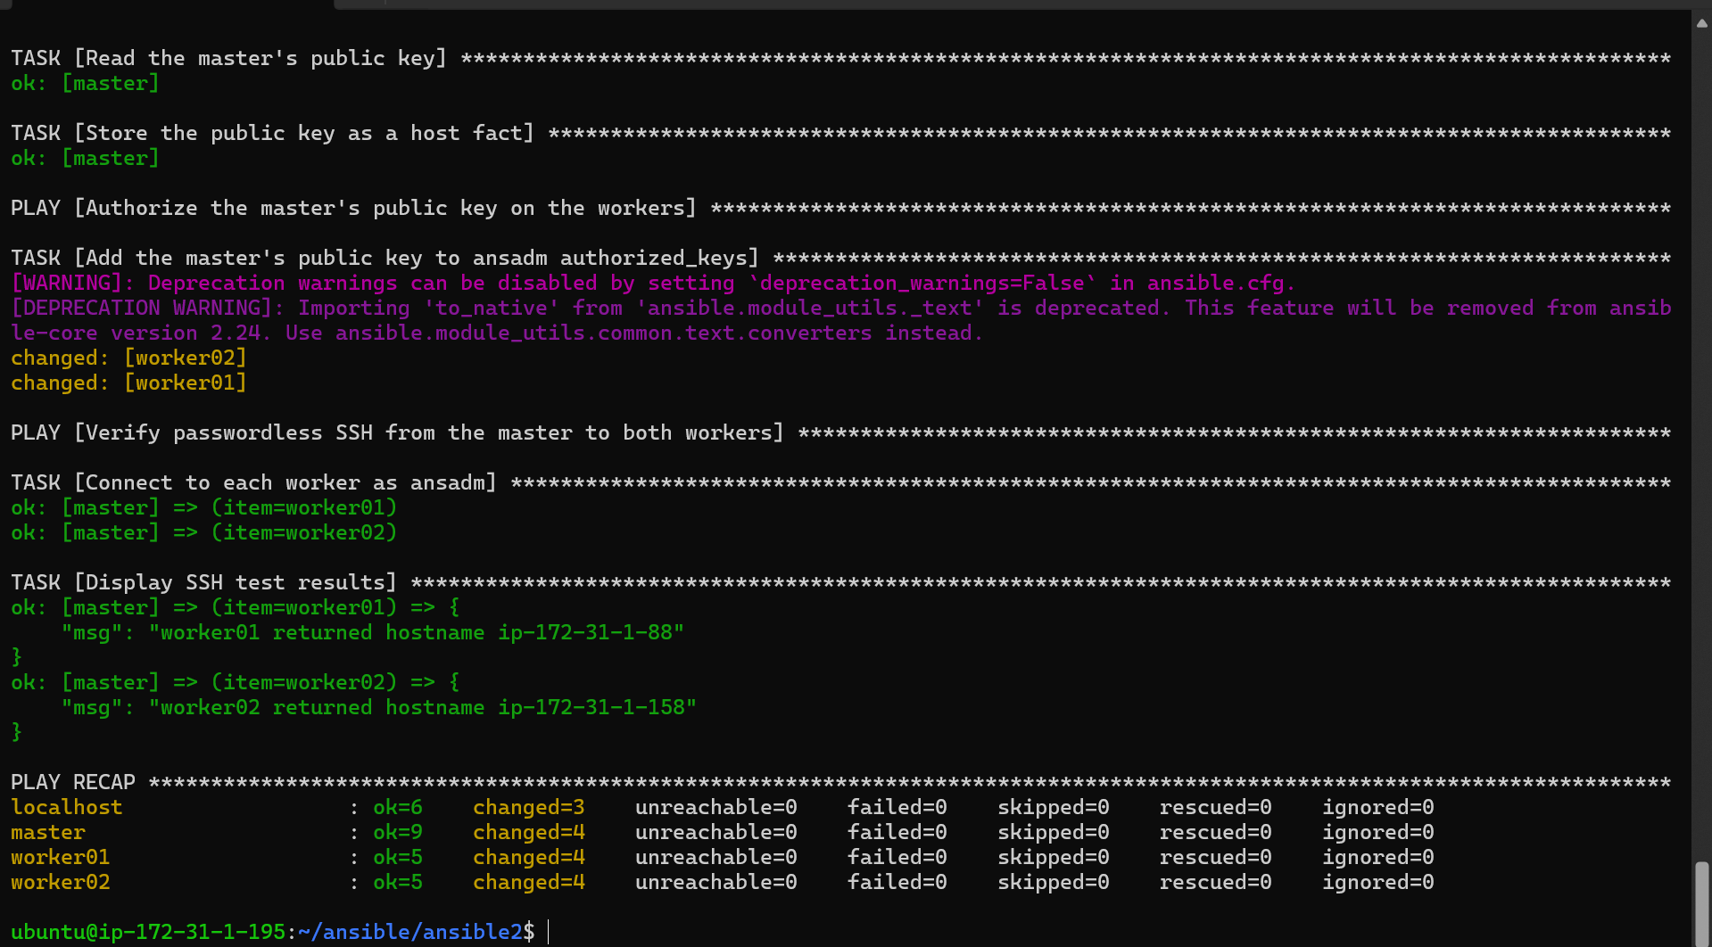

Playbook was successful
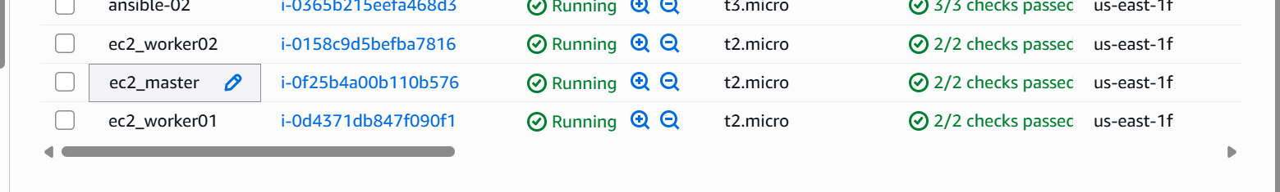

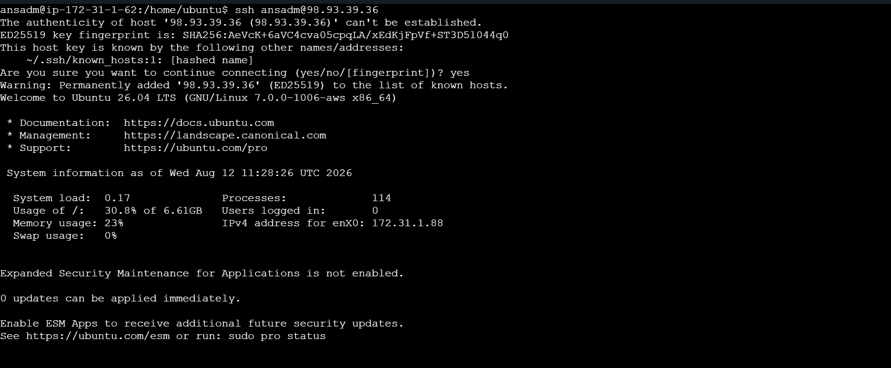

And can access the worker nodes from master

Ansible playbook to inject ansible vault variables

Ansible Vault Variables
Simple playbook example for injecting encrypted variables
Purpose: Keep sensitive variables encrypted and load them into a playbook using vars_files.
1. Create the Vault variables file
ansible-vault create vault.yml
Enter a Vault password, then add:
---
app_username: ansadm
app_password: ChangeMe123
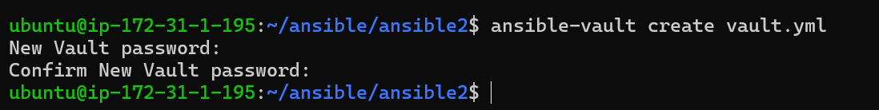
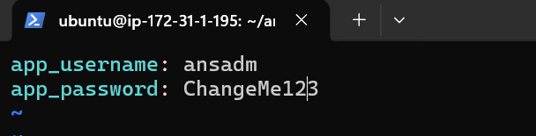
2. Create the playbook
---
- name: Use variables stored in Ansible Vault
hosts: localhost
connection: local
gather_facts: false
vars_files:
- vault.yml
tasks:
- name: Display the non-secret username
ansible.builtin.debug:
msg: "Configured user is {{ app_username }}"
- name: Confirm the secret was loaded without displaying it
ansible.builtin.assert:
that:
- app_password | length > 0
fail_msg: "Vault password variable is empty"
success_msg: "Vault variables loaded successfully"
no_log: true
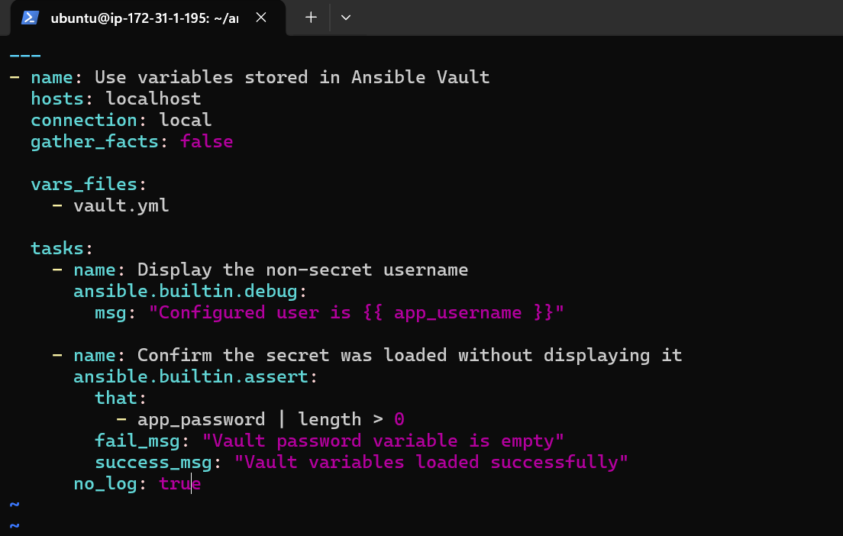
3. Run the playbook
ansible-playbook playbook-p.yml --ask-vault-pass
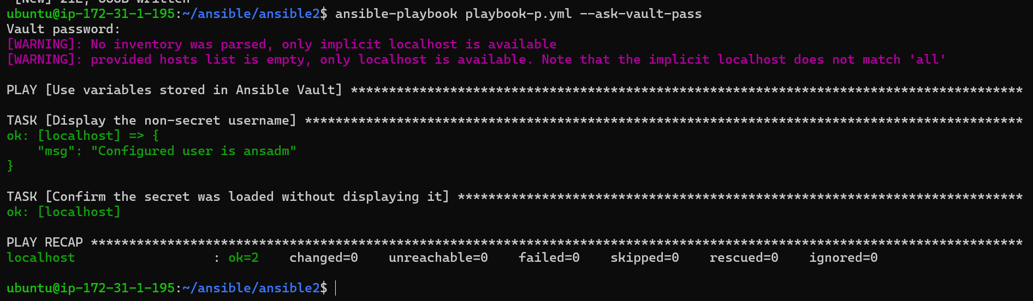
If I directly run the playbook then it wont run the playbook
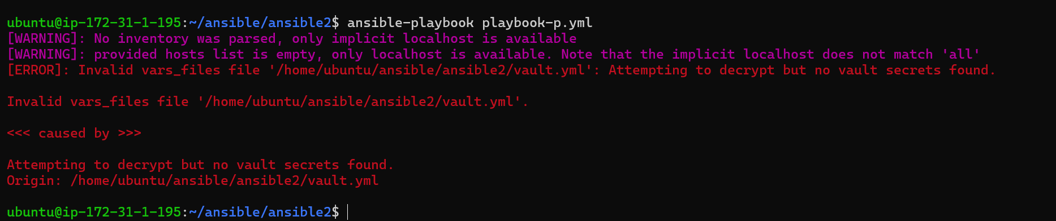
4. Edit or inspect the encrypted variables
ansible-vault edit vault.yml
ansible-vault view vault.yml

