Create a customized Docker image using a Dockerfile

Creating a docker file and using docker file creating a new image

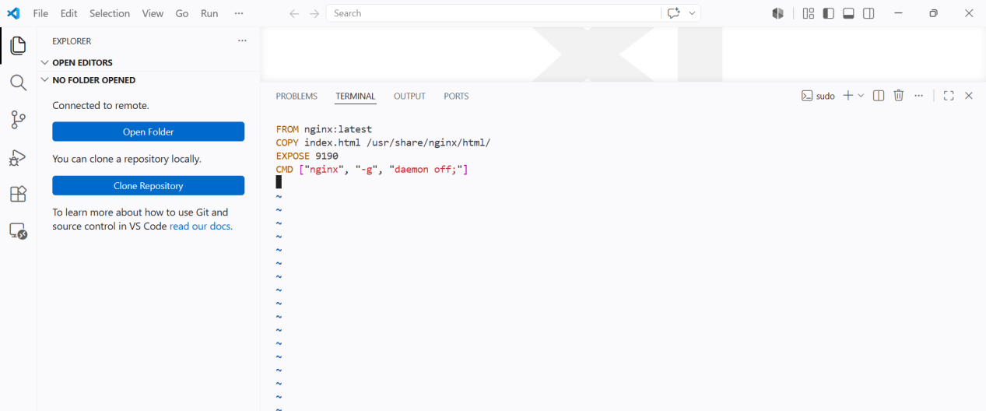
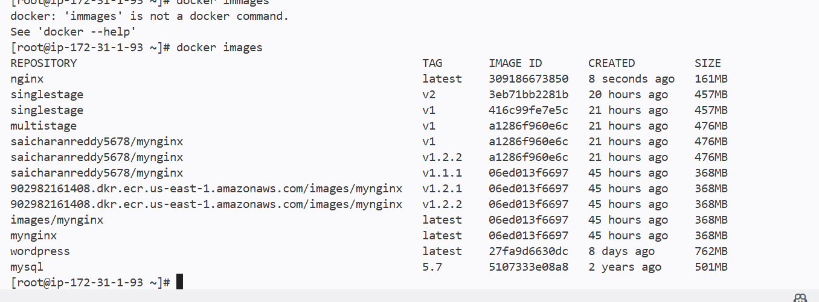

And I can run container from the newly created docker image

In docker file I have exposed nginx on 9190 and it should not be in 9190 the deafult nginx port is 80 even If I run on 9190 the connection wont be established

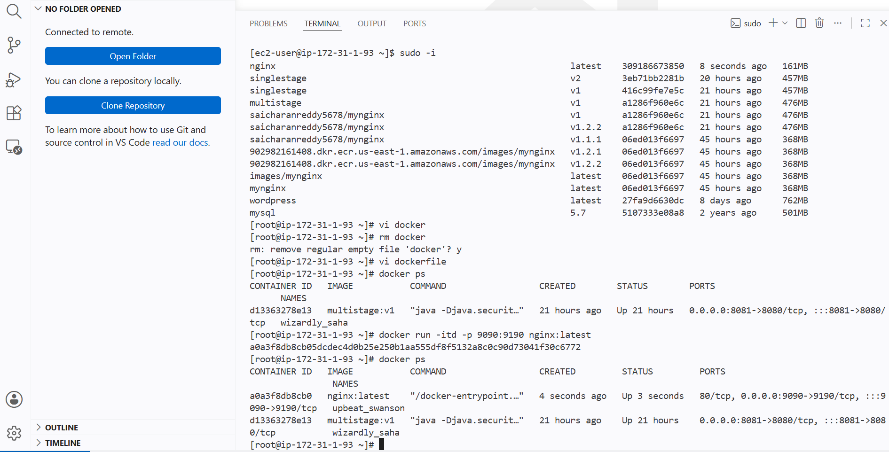

Push the image to Docker HUB

Pushing the newly created docker image to docker hub

Changing the image name to repo name
And giving the tag

Then push the image

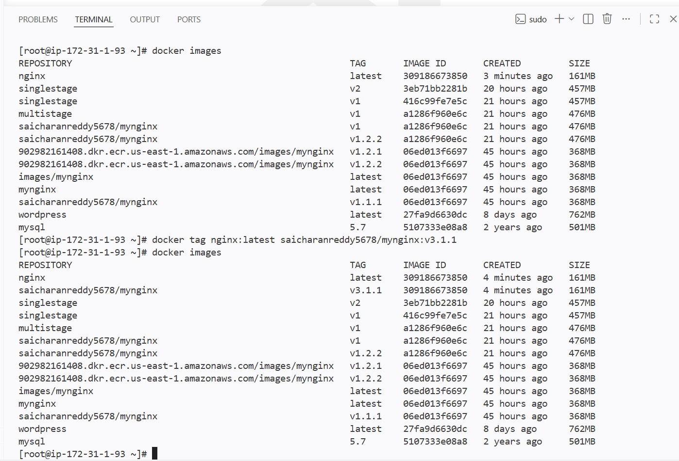

Synatx

Dcoker push imagename:version

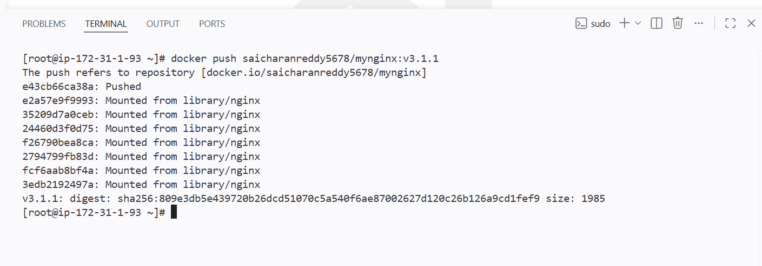

And it scans the newly pushed image in docker hub

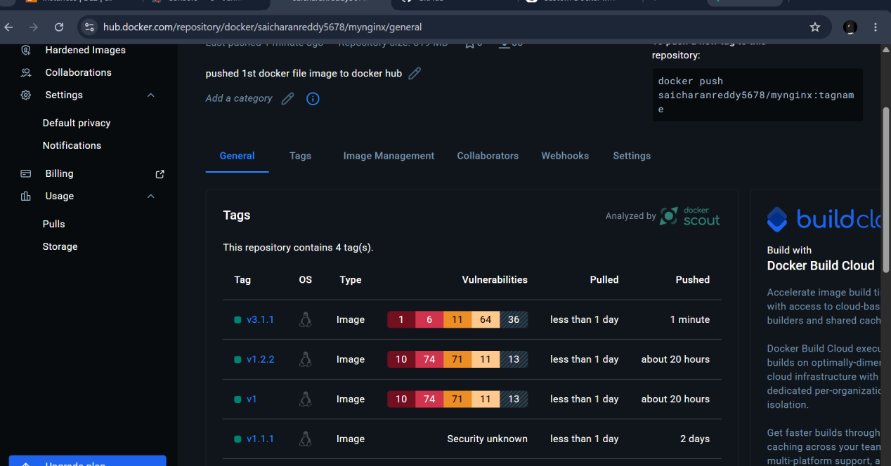

Push the same image to Amazon ECR

Pushing the same image to ecr

I will be changing the image name to the ecr repo name and pushing the image

First check for access key and security

do AWS CONFIGURE

Login to the aws

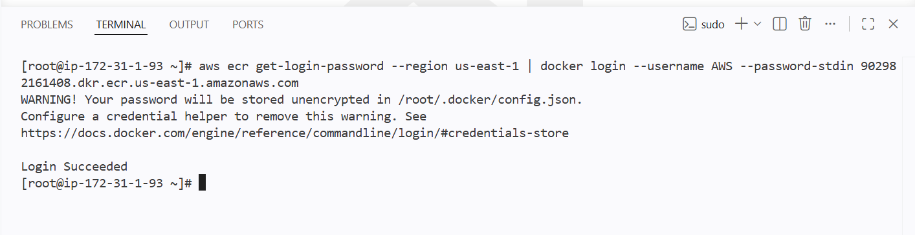

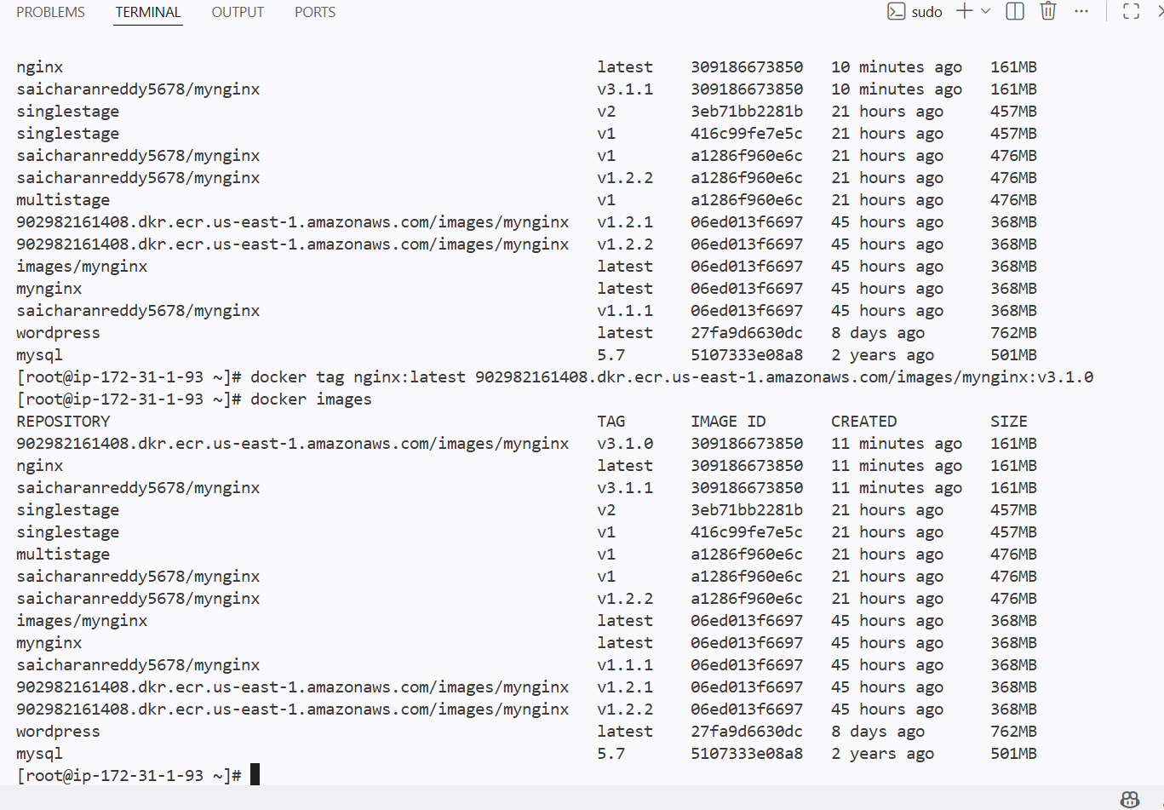

Giving version tag and pushing to the ecr

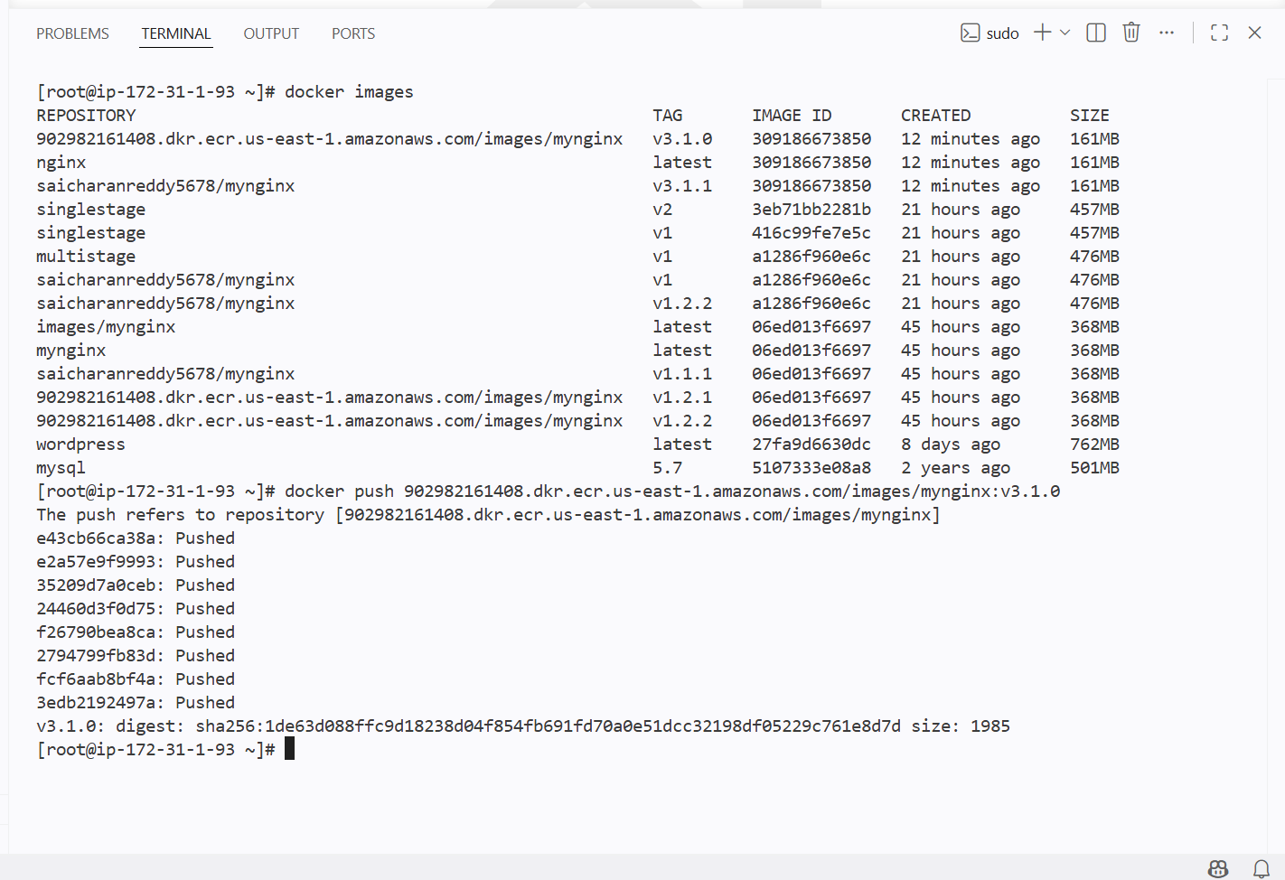

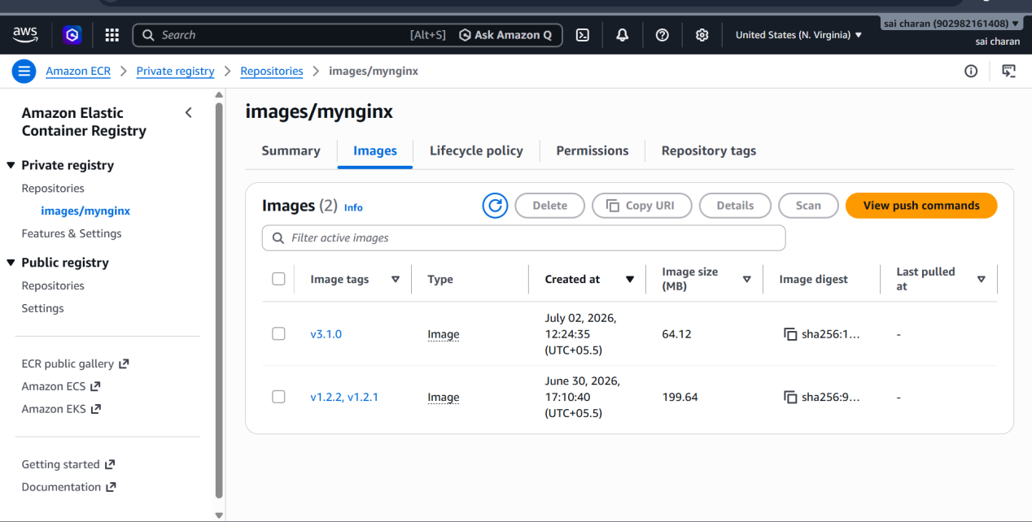

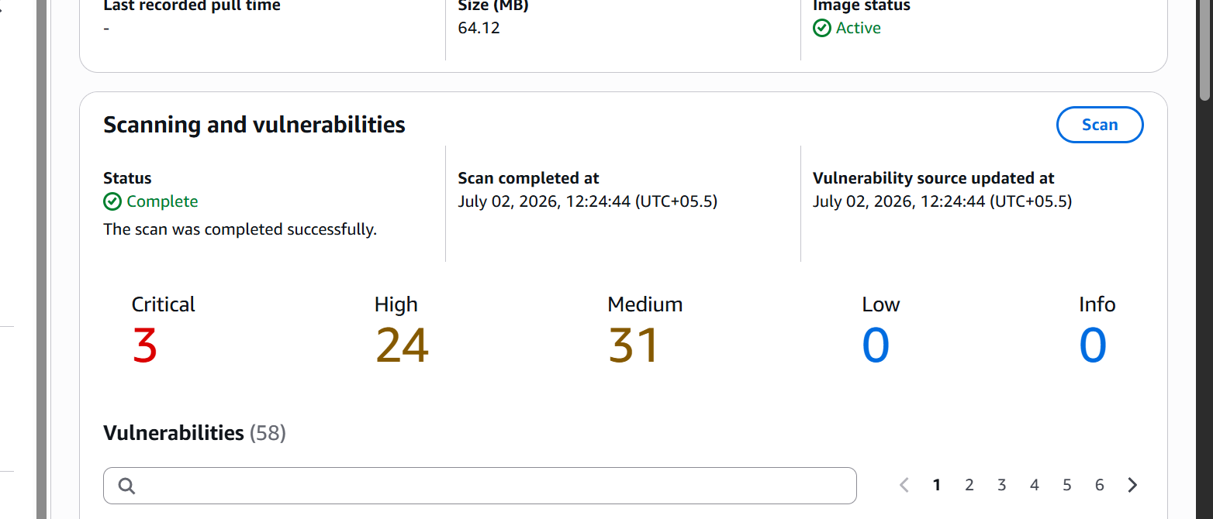

Provision one EC2 instance using Terraform and install Jenkins

The workflow of terraform :

Configuration (.tf files)
│
▼
terraform init
│
▼
terraform plan
│
▼
terraform apply
│
▼
Cloud Provider (AWS, Azure, GCP, etc.)

We can configure the Infrastructure in .tf files

First I will create a new file with extension .tf and add content to create a new instance

Created a new file named instance.tf

Then gave provide as aws
Region and required resources for creating an instance

Then after giving terraform init it will initialze the terraform

Then do terraform plan to compare the given resources and required resources

Terraform gives what actions it will do for creating an instance

If we want we can save the terraform apply actions

Then after doing terraform apply it creates the instance

To install the jenkins inside the instance I will be user_data for the instance

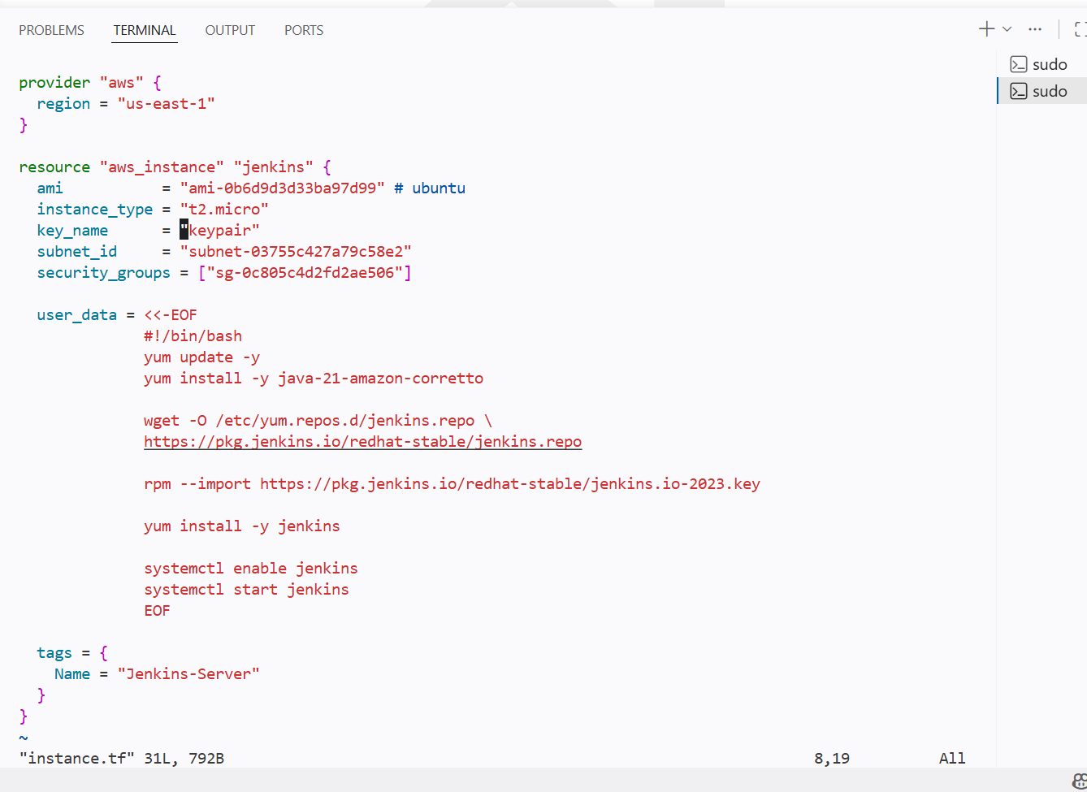
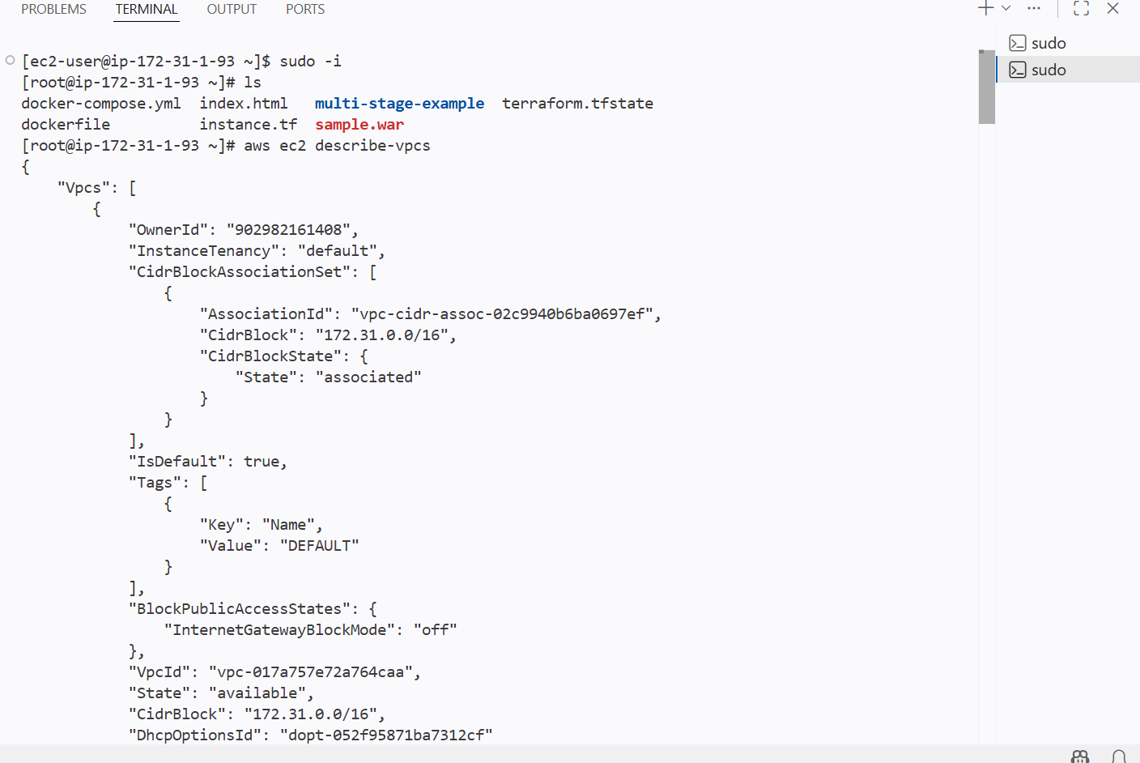

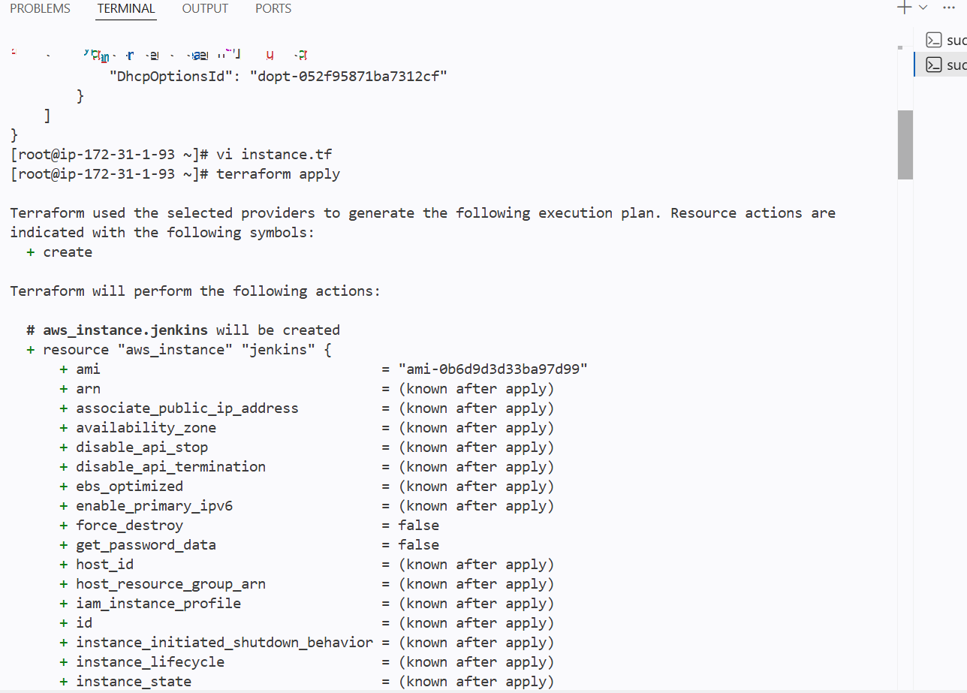
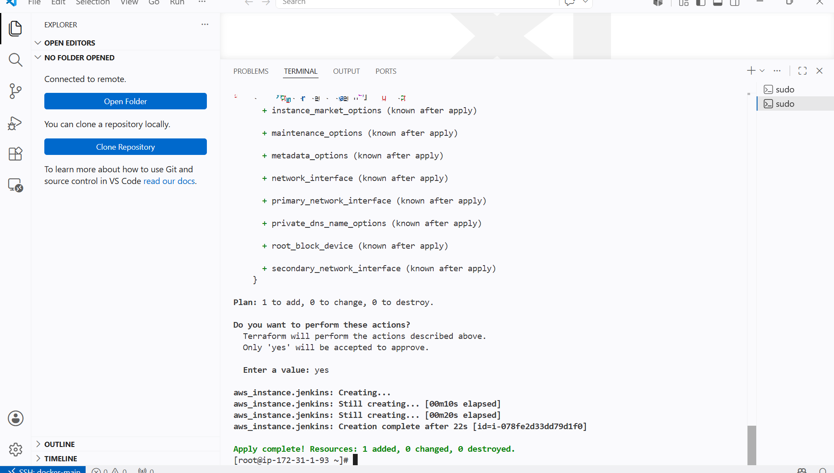

New instance has been created

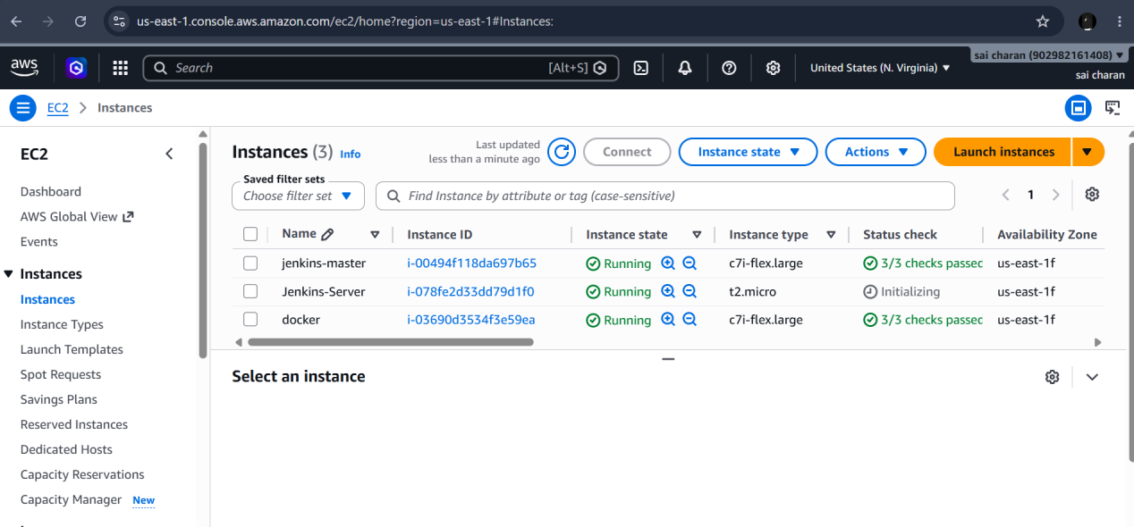

Create one Jenkins job to build and push the Docker image to Docker Hub

https://github.com/betawins/Python-app.git

Create a new job
Clone the repo
And in stage build and push the image

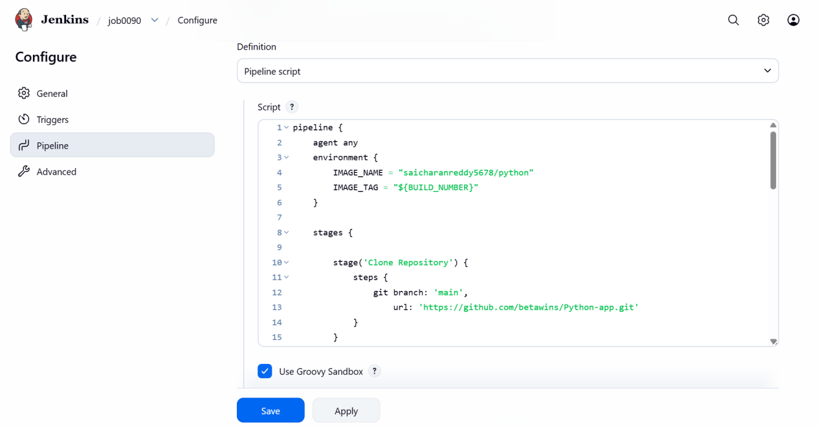

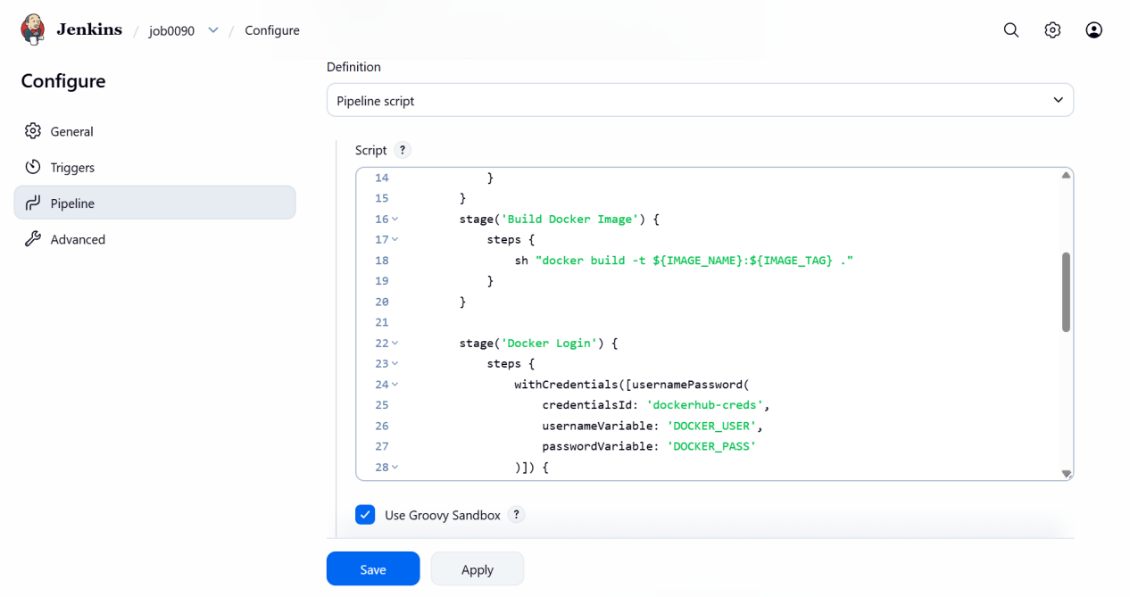

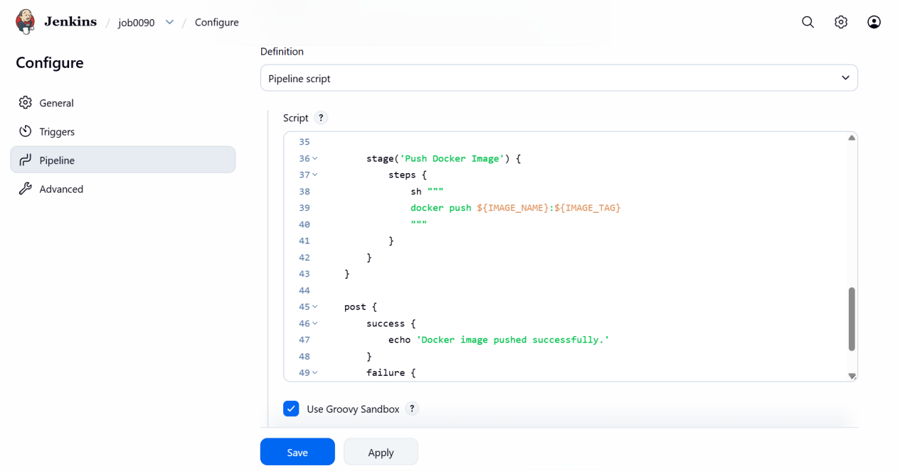

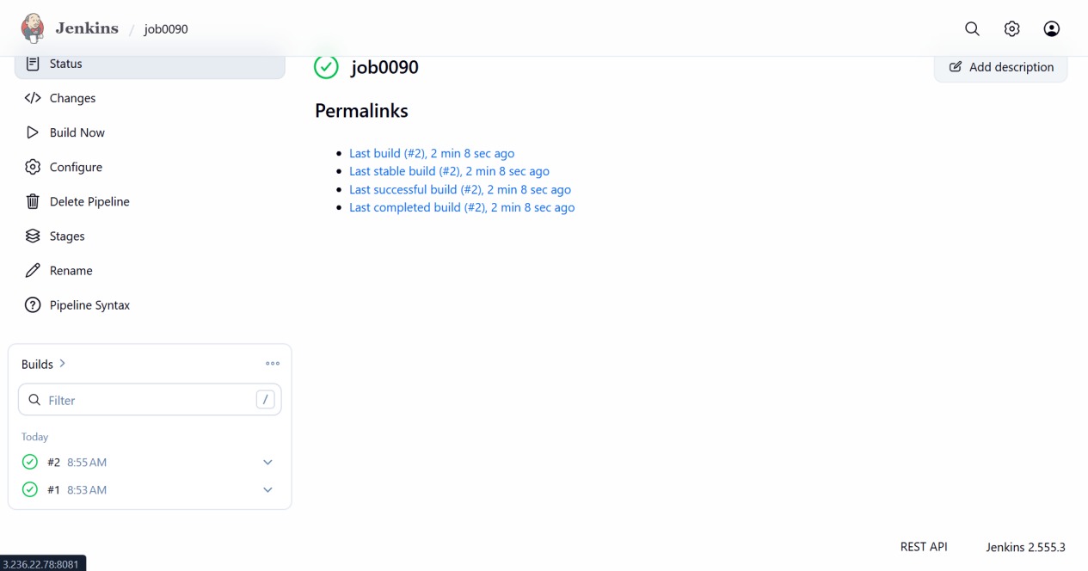

Dcoker image has been pushed succesfully

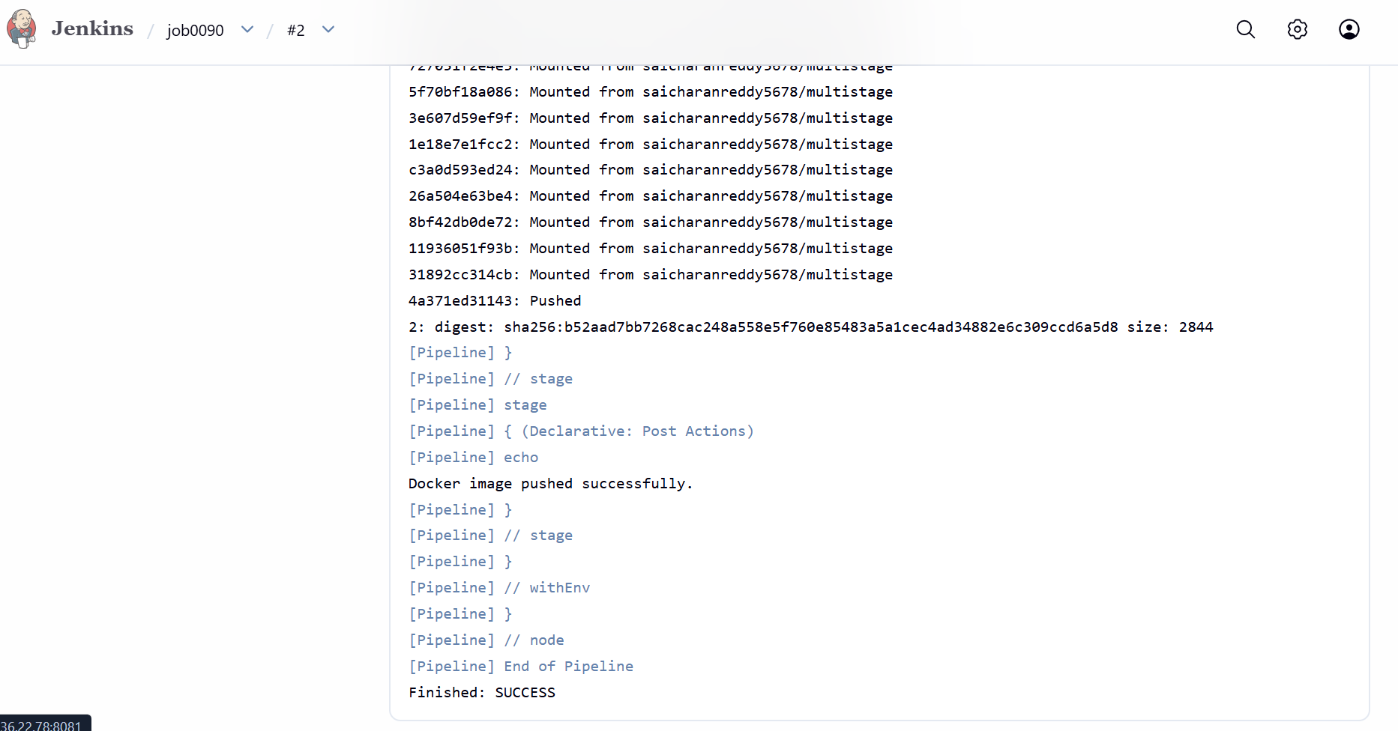

===================================================================================

Source Codes: https://github.com/betawins/docker-tasks.git

From the frontend source code, write a Dockerfile, build a Docker image, run it, and push that image to your Docker registry

From frontend source code

Create a new docker file

Then build the image

Run the container

Push the image

First I will clone the repo to my server

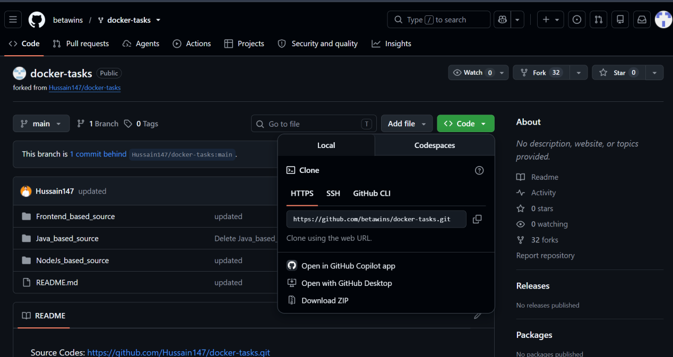

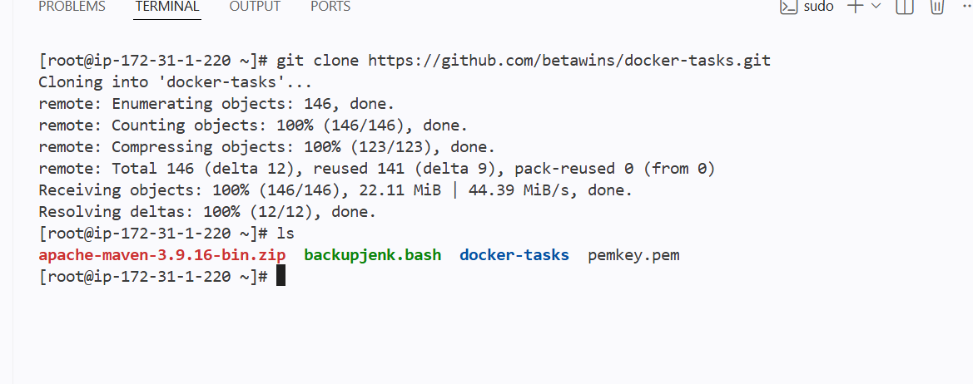

I have cloned the git repo

Now I will create the docker file in the frontend code

I will use nginx as base image

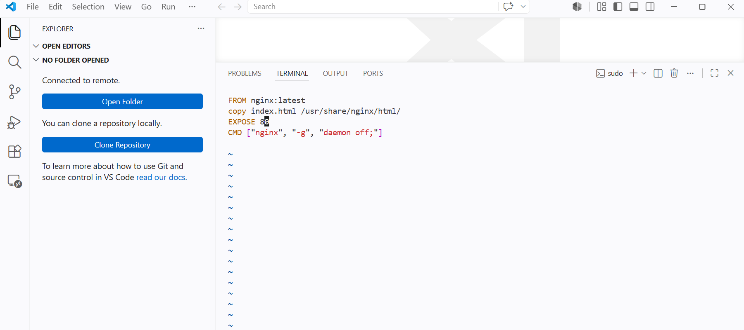
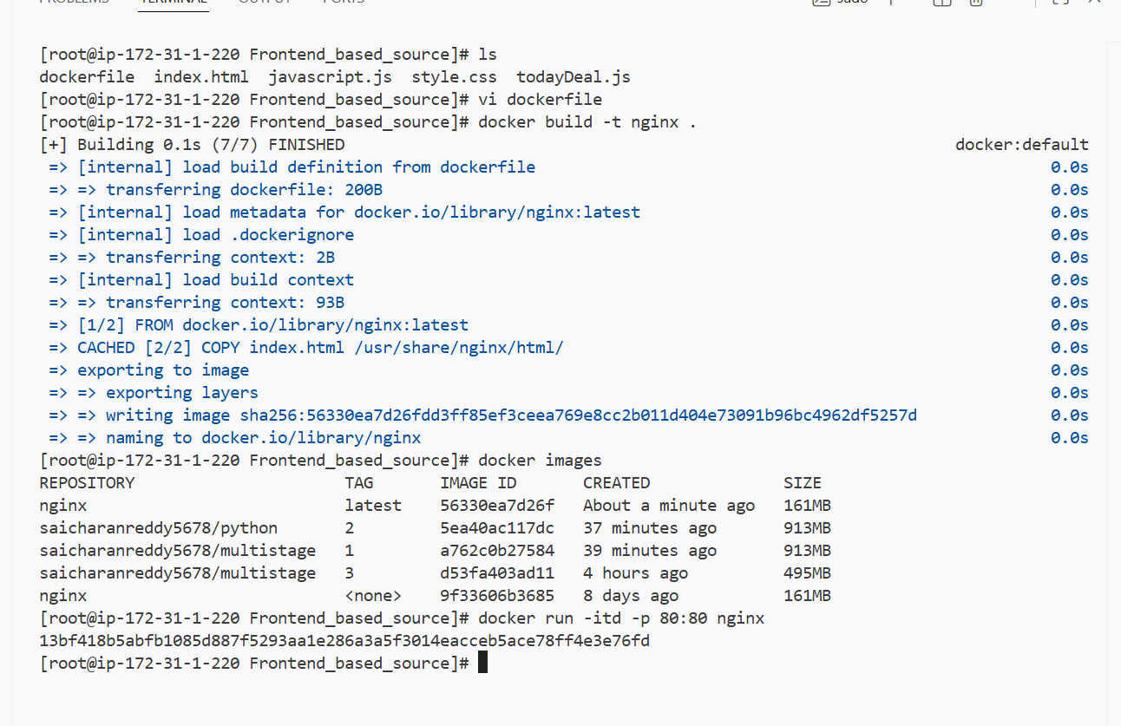

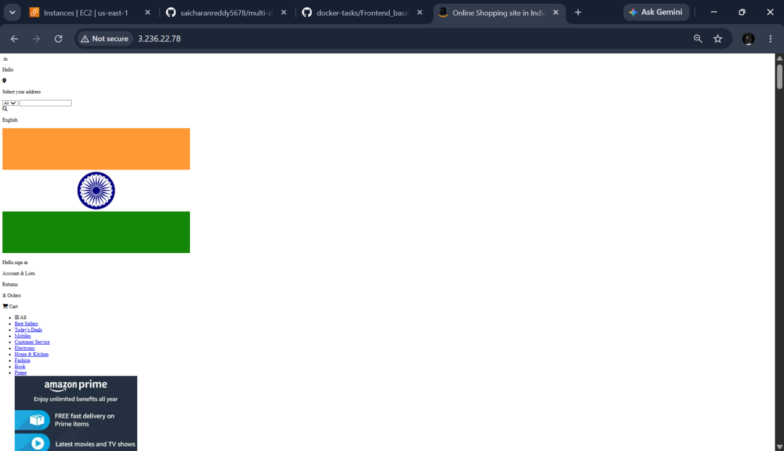

From theJava-based source code, write a Dockerfile, build, run, and push the image to the Docker registry

After cloning the repo creating a docker file in the inside the java-based source code

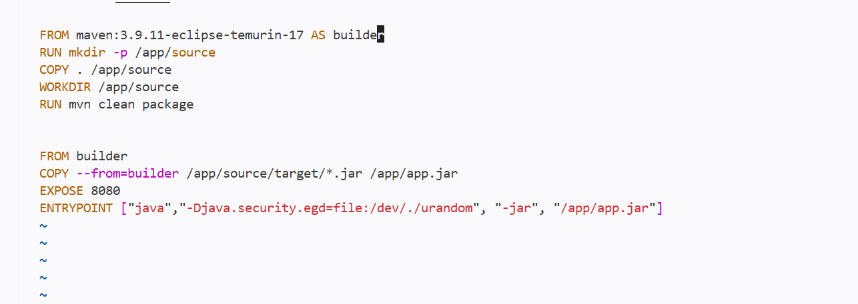

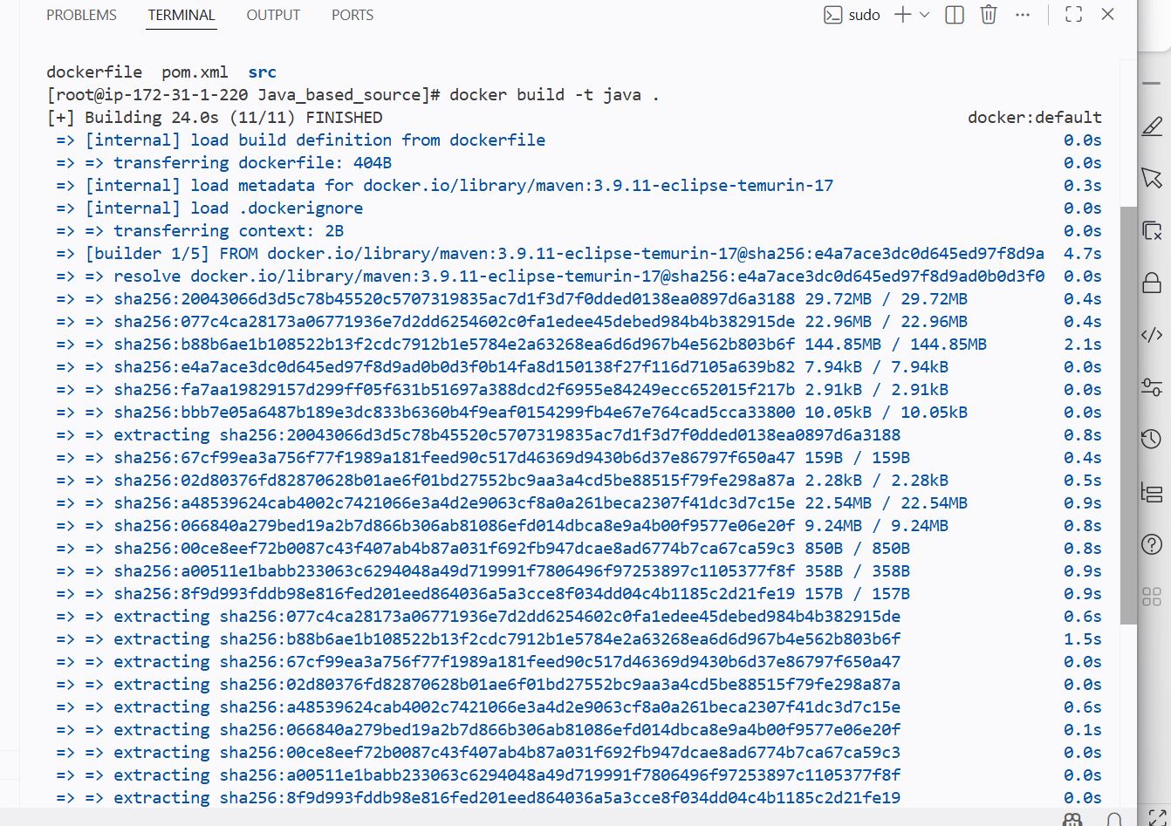

After running the comntainer
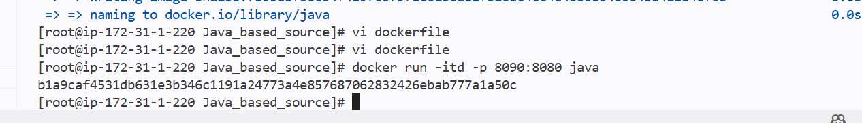

Ip:8090

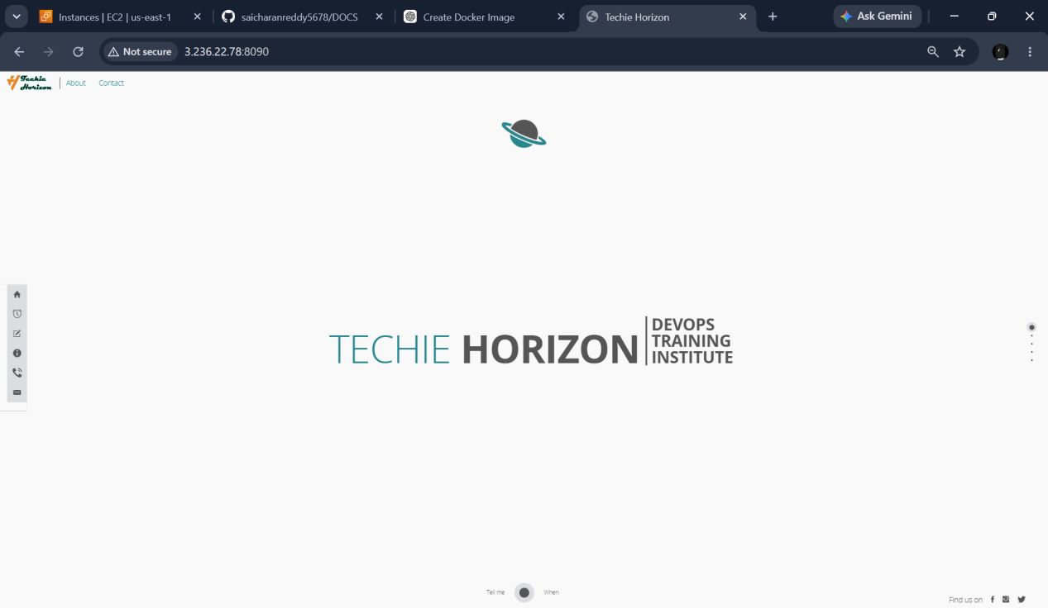

Pushed to the repo

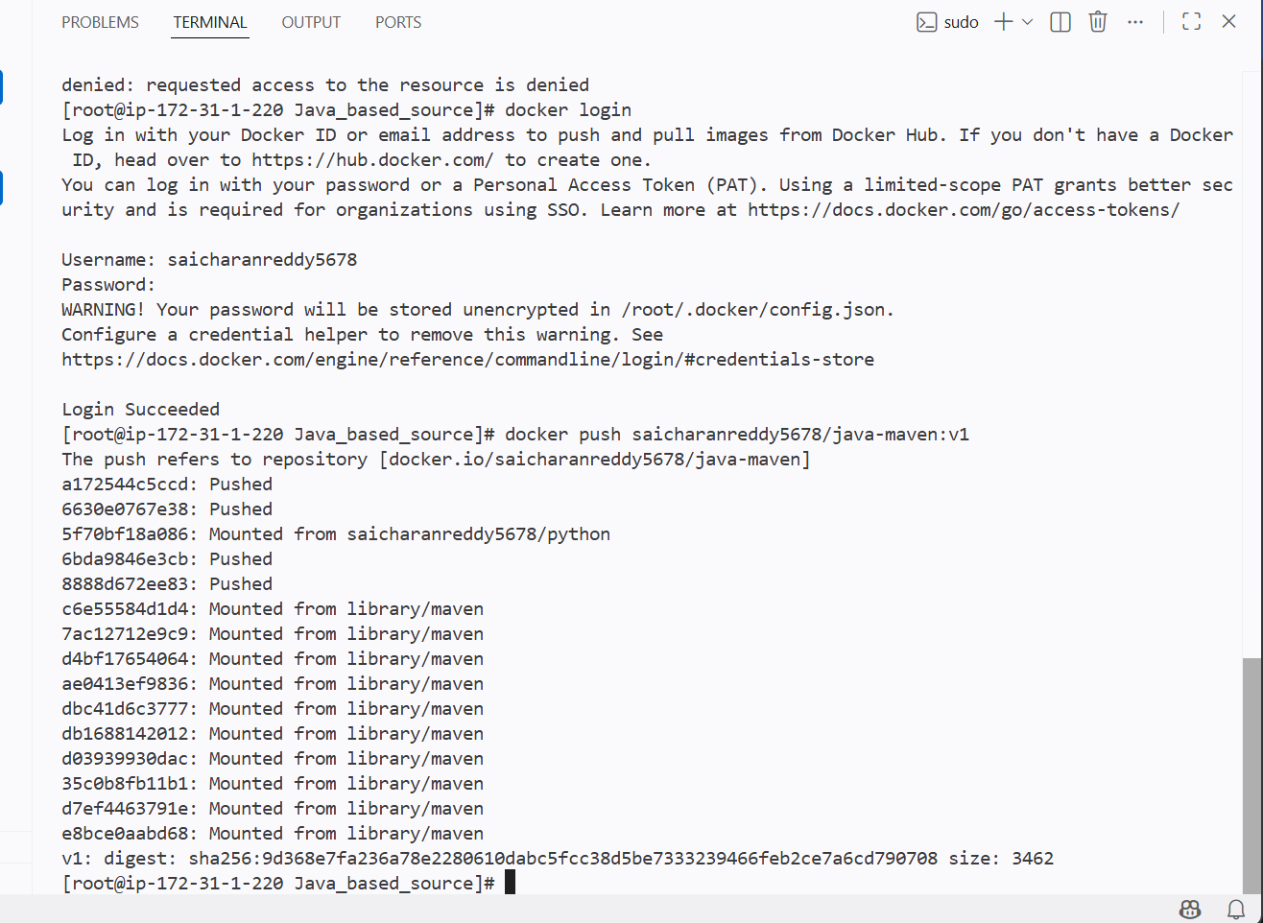

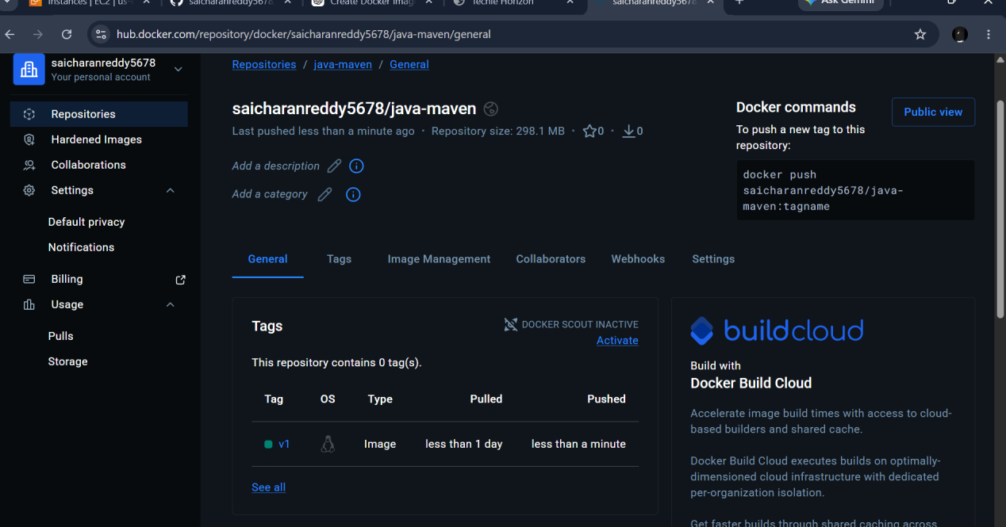

From theNode.js-based source code, write a Dockerfile, build with tag V1, run, and push it to the Docker registry

Creating a docker file inside node-js based souce code

As this is theNode.js based source code the mvn can be used so I will taking node:22-alpine as base

node:22-alpine

I have used npm
Working dir for the nodejs based src is /app
So copying *.json to ./

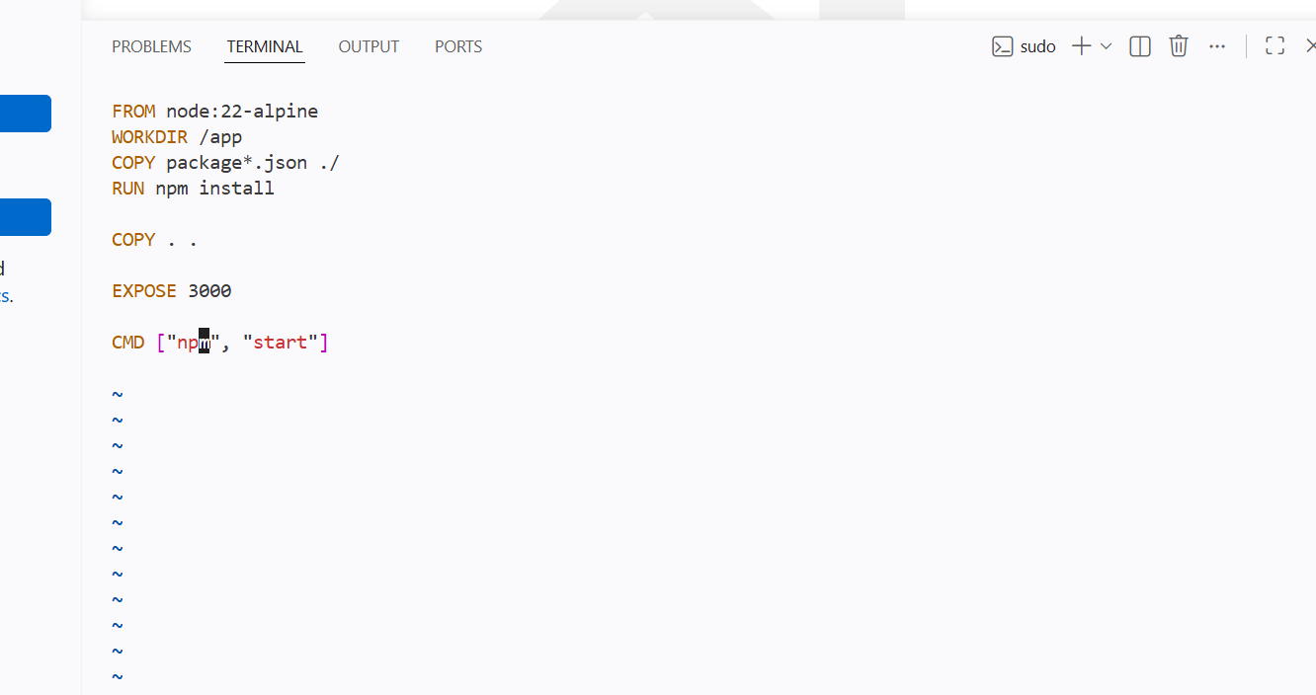
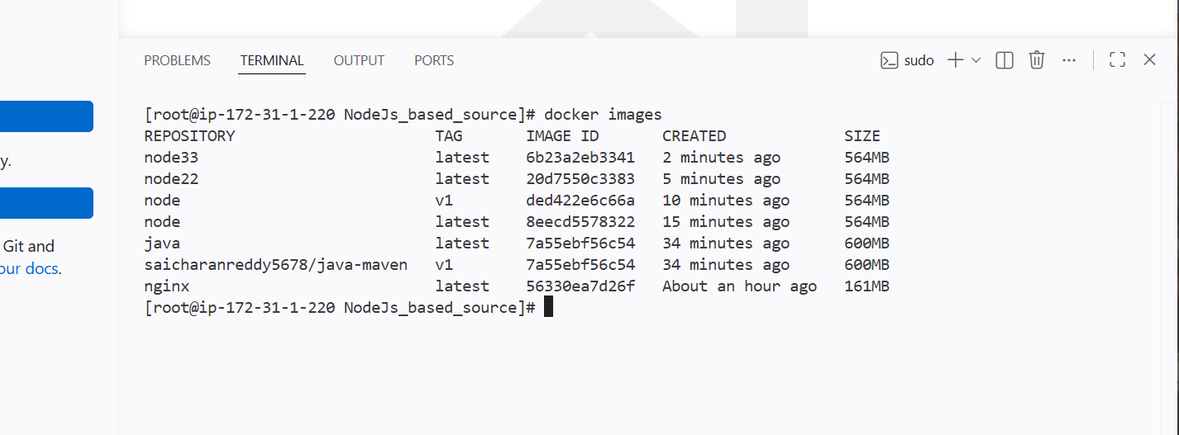

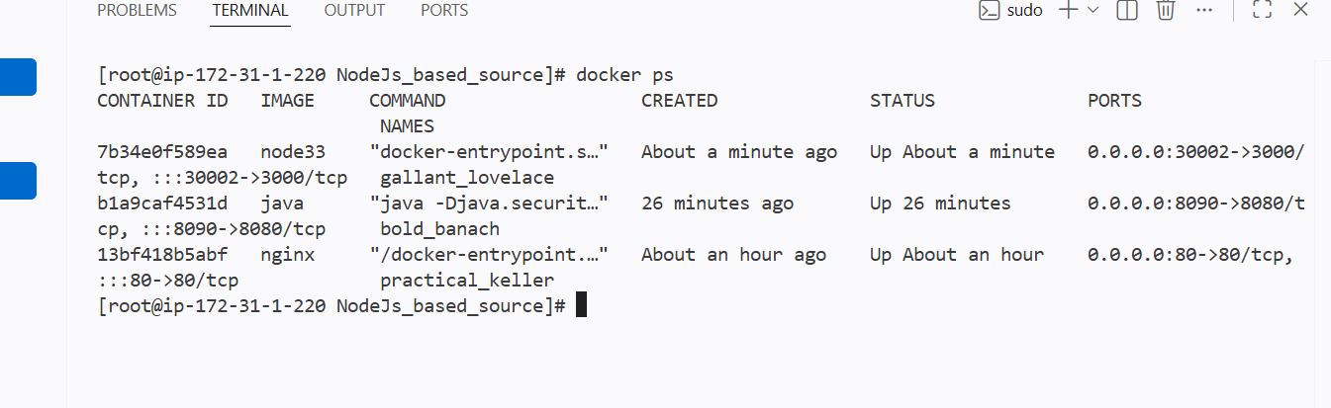



Pushing to the docker hub

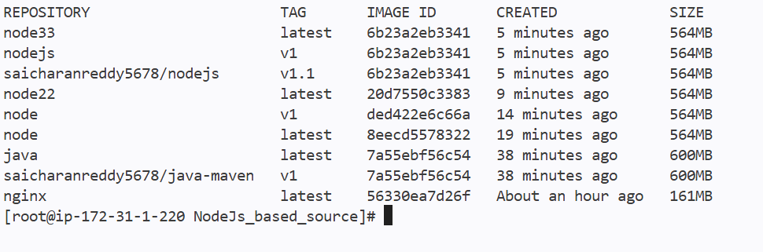
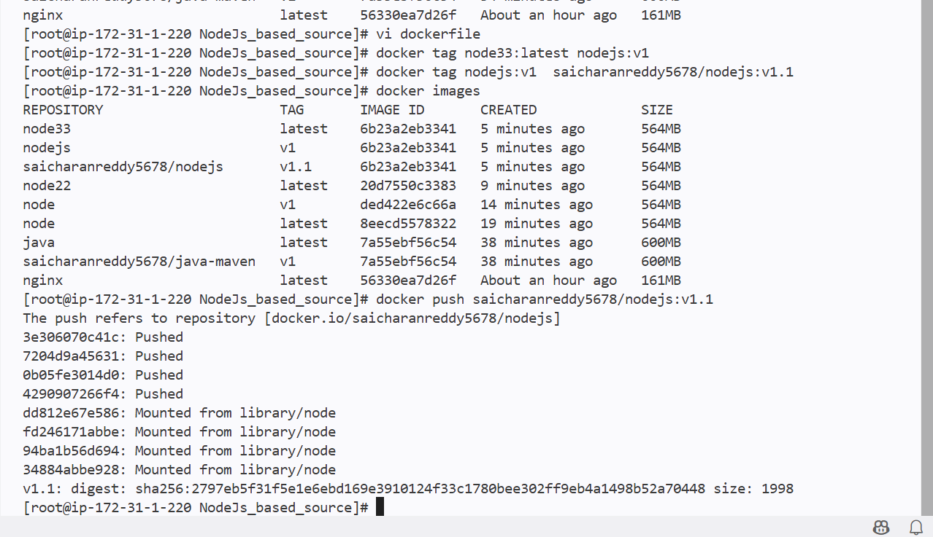

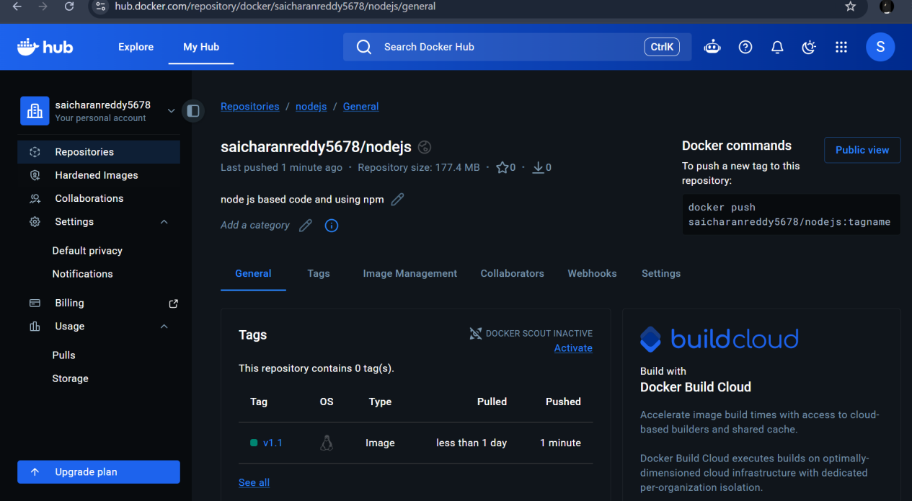

Write a docker-compose file to set up WordPress with a MySQL database

Default name for file is
Docker-compose.yml

And adding the content to the file

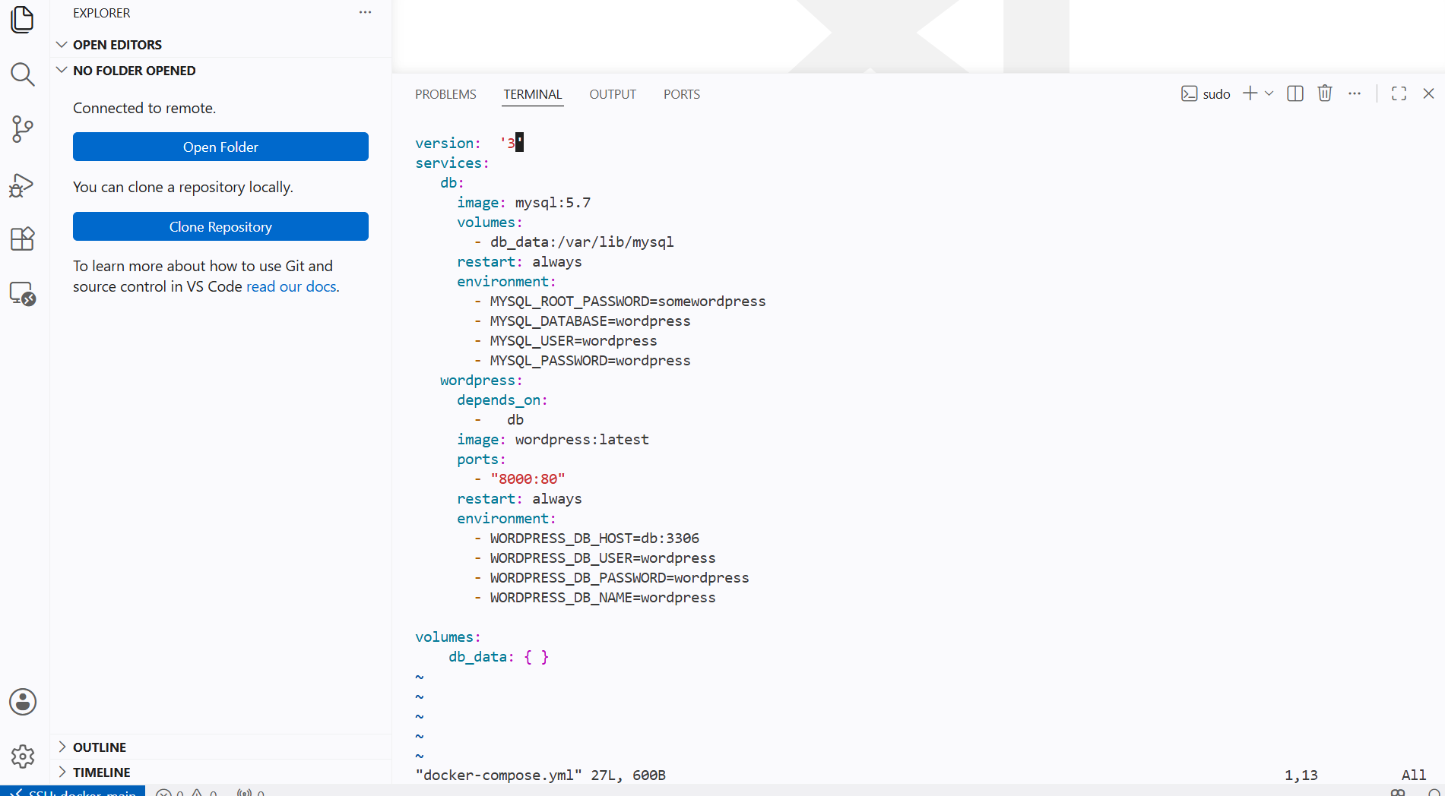

Then using docker-compose commands to scale in and scale out

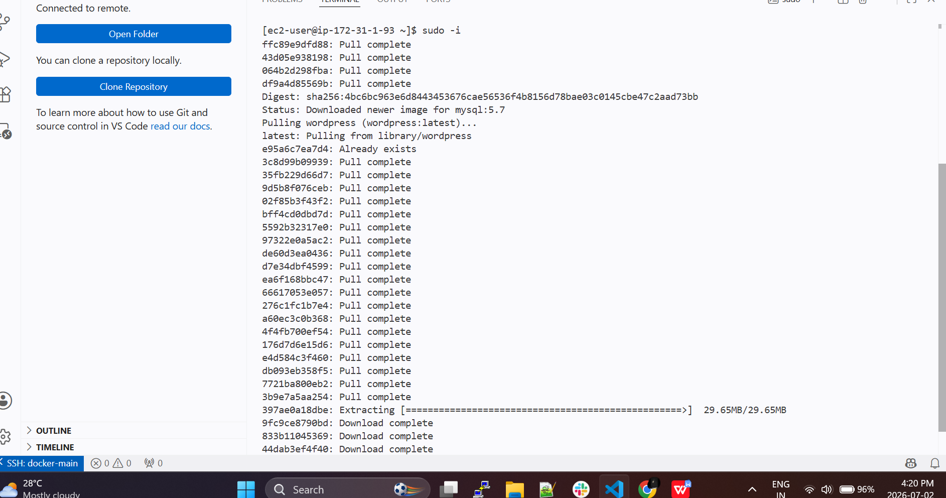

And it will creating the container and we can see the logs

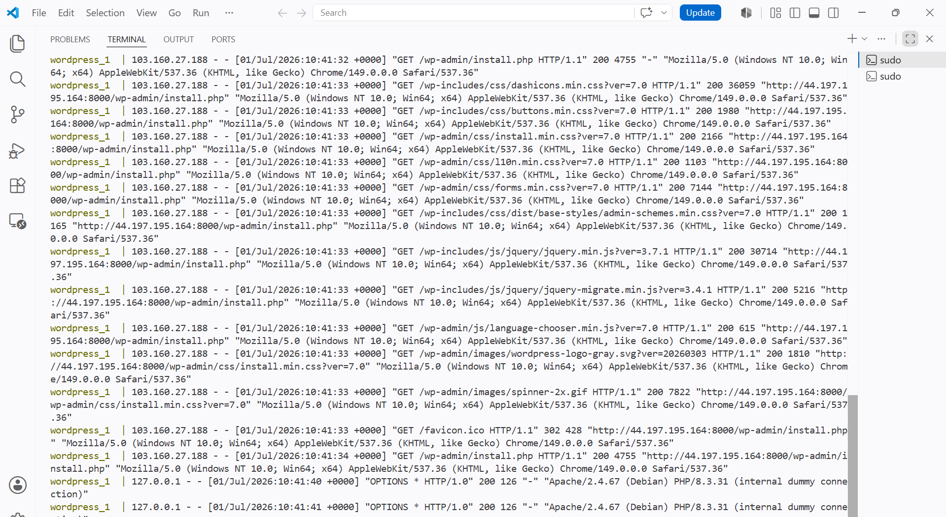

We can see wordpress hass been setup



