Install ingress-nginx controller to run the ingress and expose the pod through the domain

Using

kubectl apply -f https://raw.githubusercontent.com/kubernetes/ingress-nginx/controller-v1.15.1/deploy/static/provider/baremetal/deploy.yaml

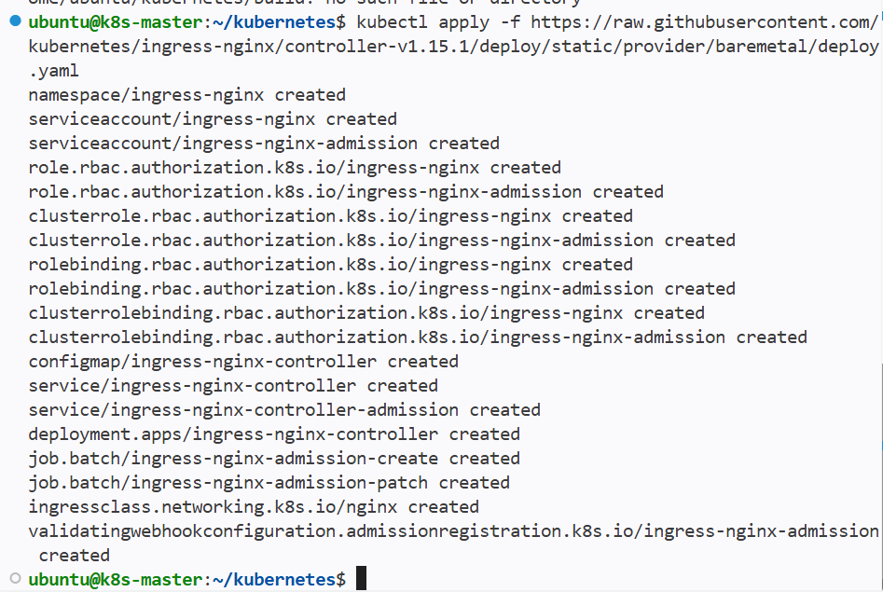

Check for the nginx-ingress pod status

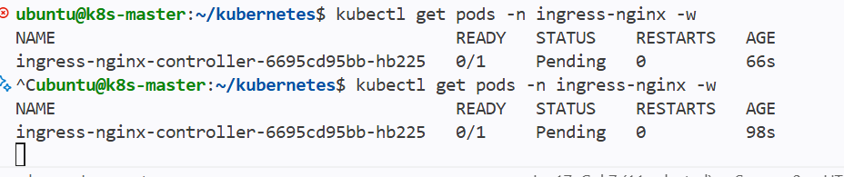

New namespace is created for the nginx-ingress controller
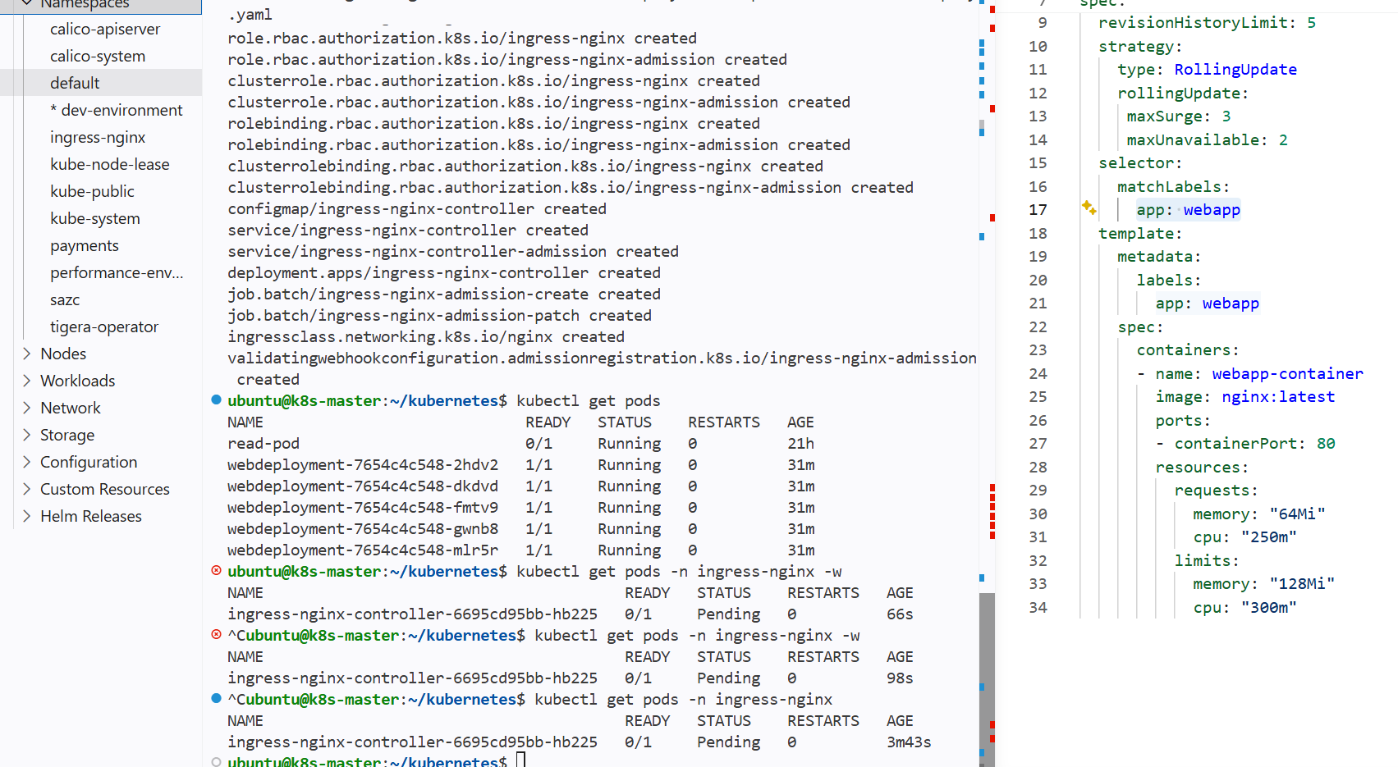

The ingress controller pod is running

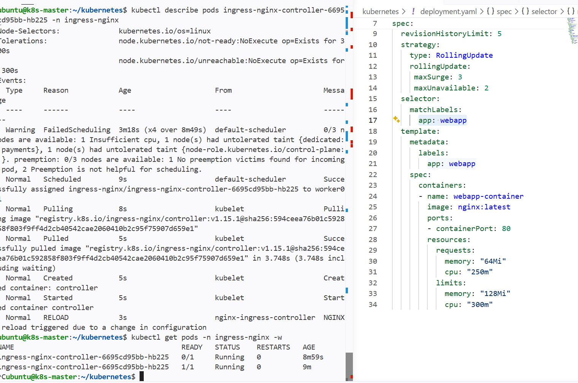

Ingressclass has been created

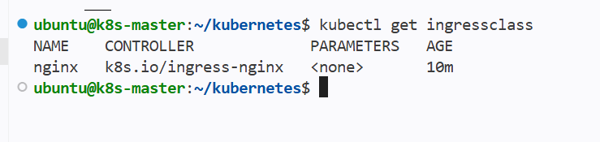

Assign this ingress class to the ingress resource yaml file

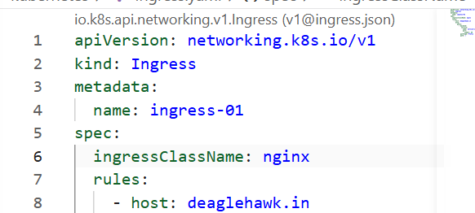

Ingress class has been mentioned in ingress yaml file

Then giving the yaml file for the ingress that hosts the domain path and routing of the applications

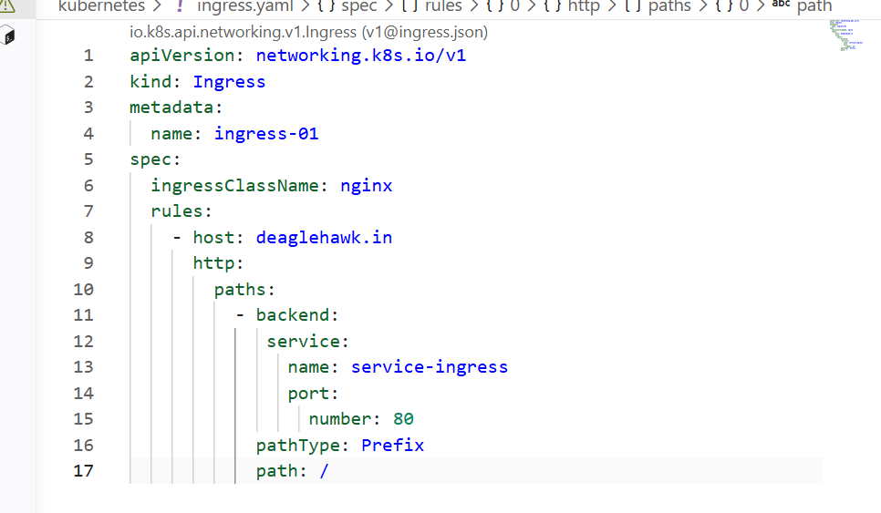
Host Is domain and attached the service to the ingress and pathtype as prefix and serivce port no should be given

Kubectl create -f ingress.yaml

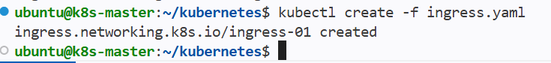

Then we need allow the tarffic from the domain to the ingress using load balancer

We need to create a new target group and a network load balancer

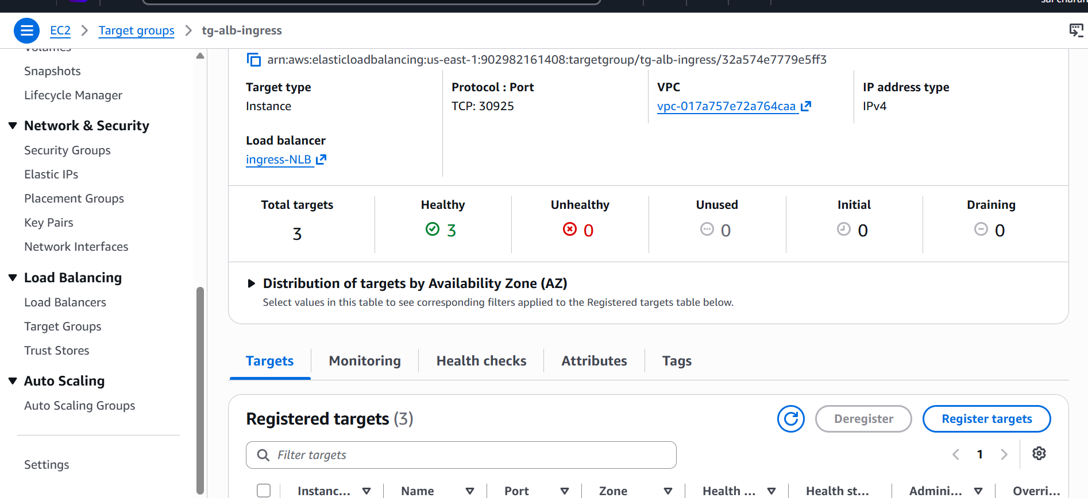

And the protocol port should be tcp and ingress port number

We are using ingress port because we have exposed the service throught the ingress nodeport

Then creating a network load balancer

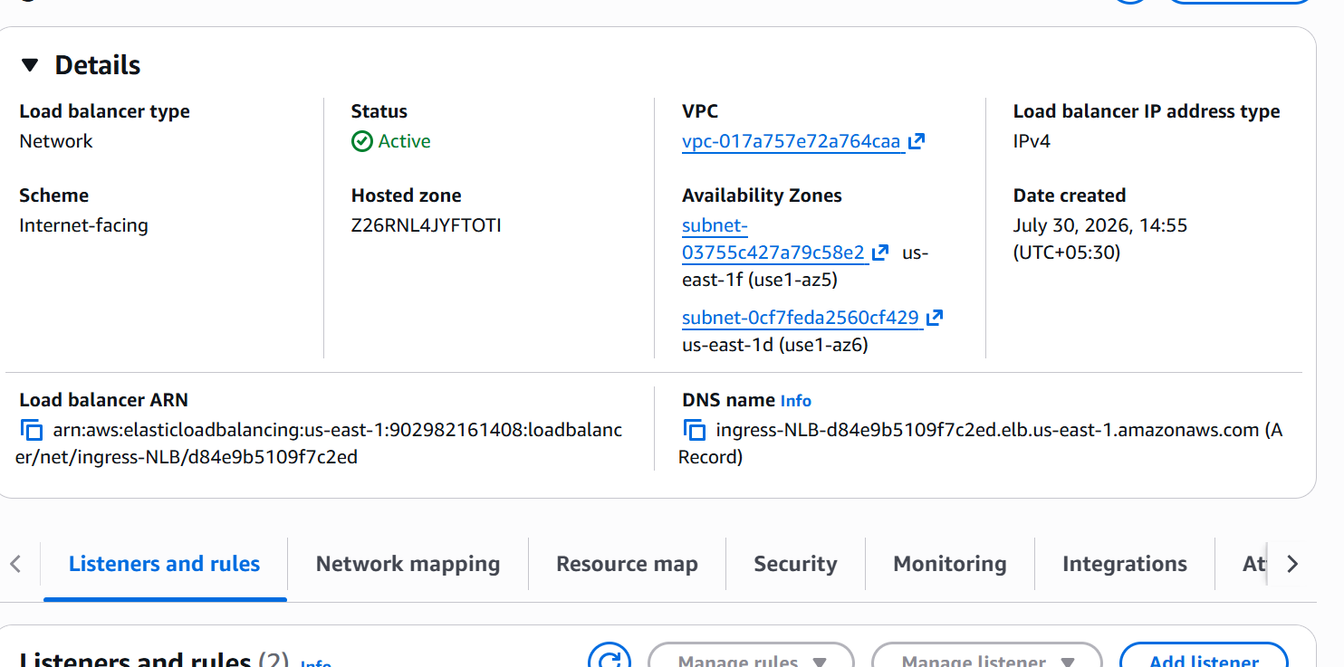

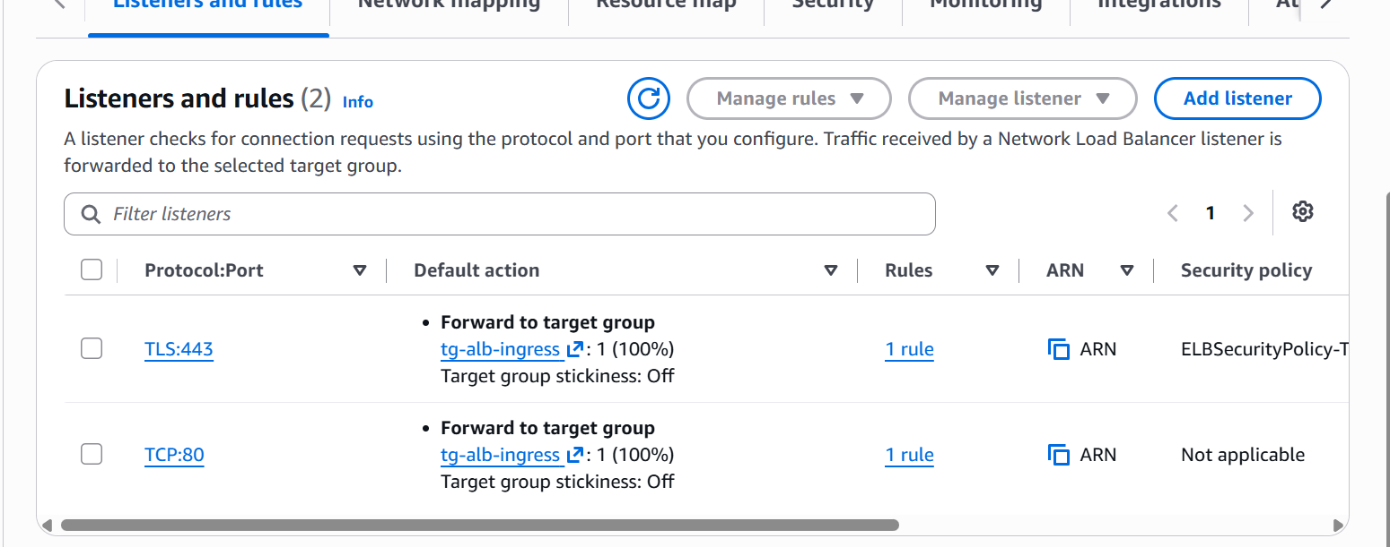

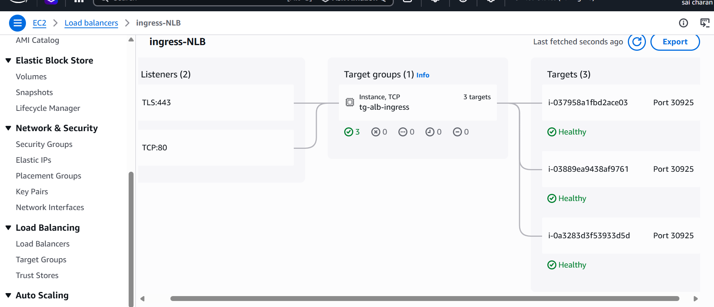

Now the load balancer is up and running in route53 I have created A record for my domain and alias to the network loadbalancer

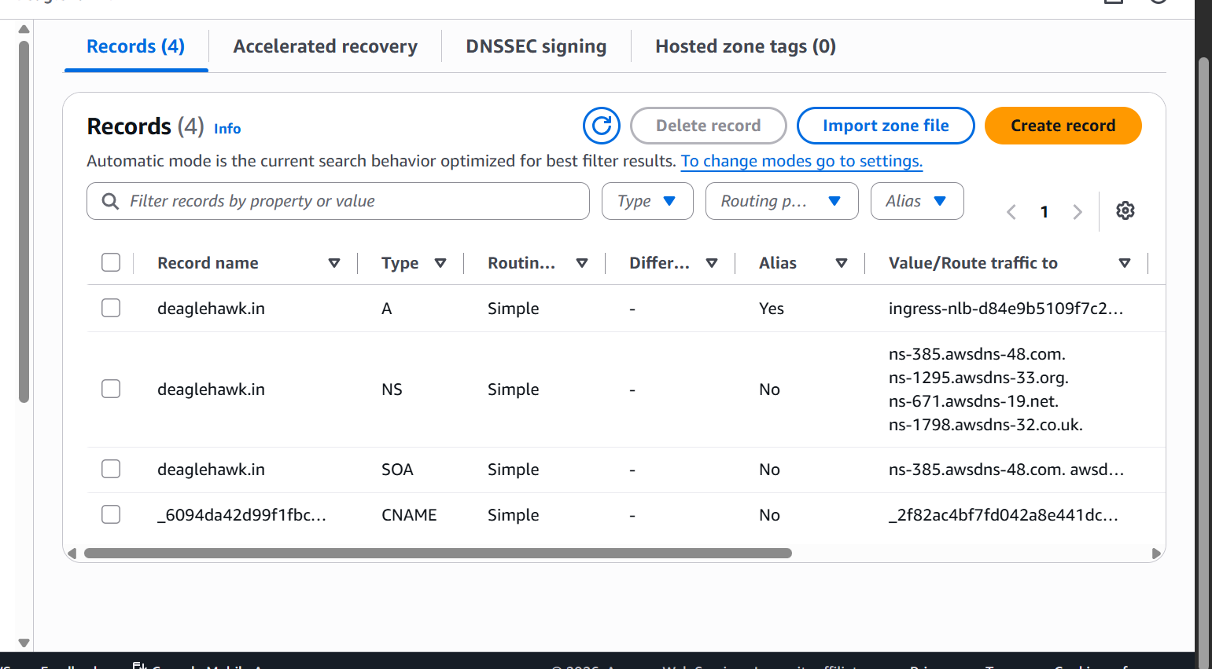

now the traffic from domain goes to the load balancer and from load balancer to the instance from instance to the pods using ingress nodeport

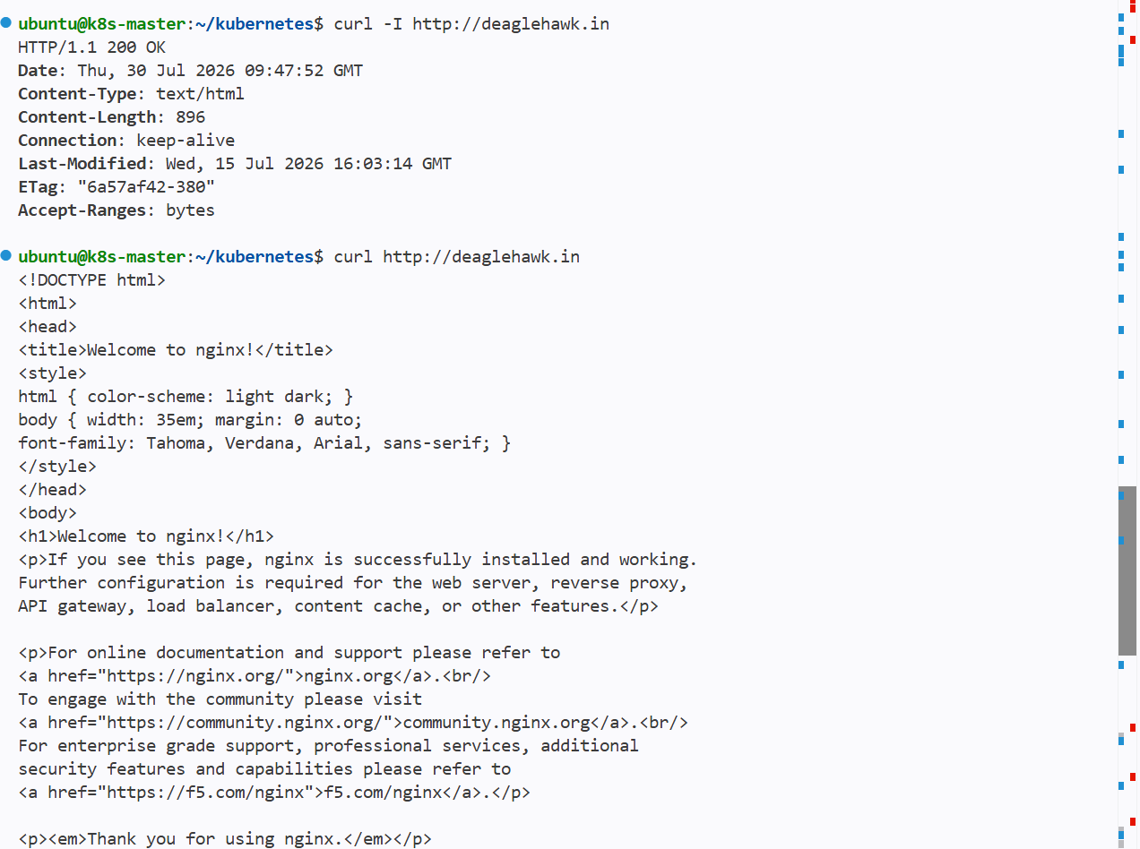

And we can see the output of curl and same will be in the browser

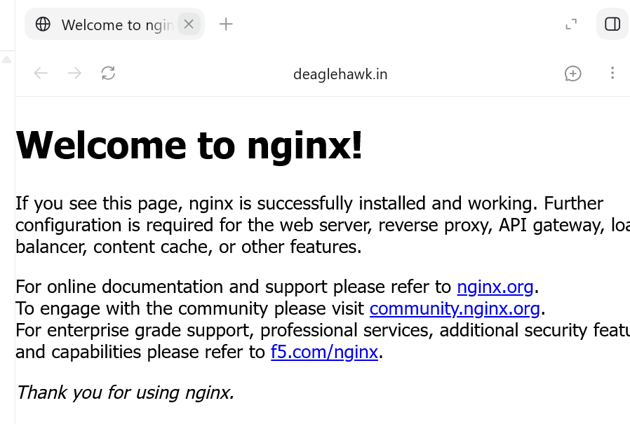

- Upgrade k8s cluster from v1.29.15 to 1.30 Version

To update we need to upgrade 3 components first

1 kubeadm
2 kubelet
3 kubectl

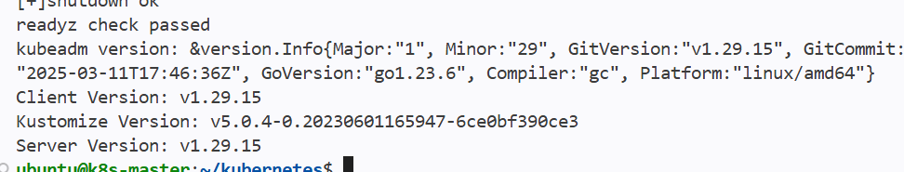

The current version of kubectl and kubeadm

Configure the Kubernetes 1.30 repository

Run on every node:

sudo mkdir -p -m 755 /etc/apt/keyrings

curl -fsSL https://pkgs.k8s.io/core:/stable:/v1.30/deb/Release.key |
sudo gpg --dearmor -o /etc/apt/keyrings/kubernetes-apt-keyring.gpg

echo 'deb [signed-by=/etc/apt/keyrings/kubernetes-apt-keyring.gpg] https://pkgs.k8s.io/core:/stable:/v1.30/deb/ /' |
sudo tee /etc/apt/sources.list.d/kubernetes.list

sudo apt-get update

apt-cache madison kubeadm

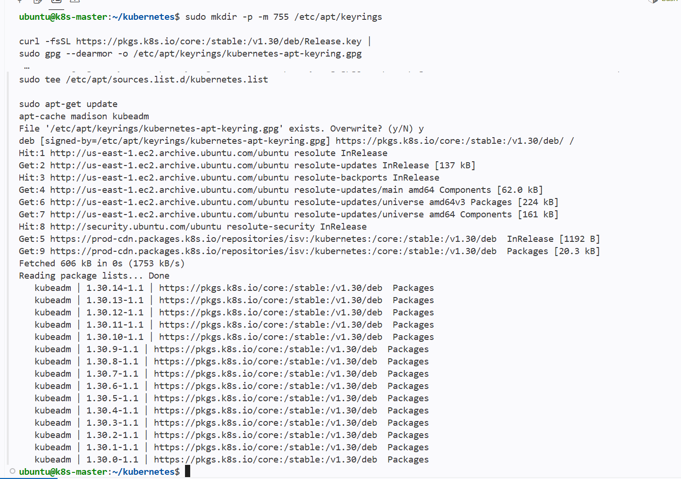

Run on all nodes

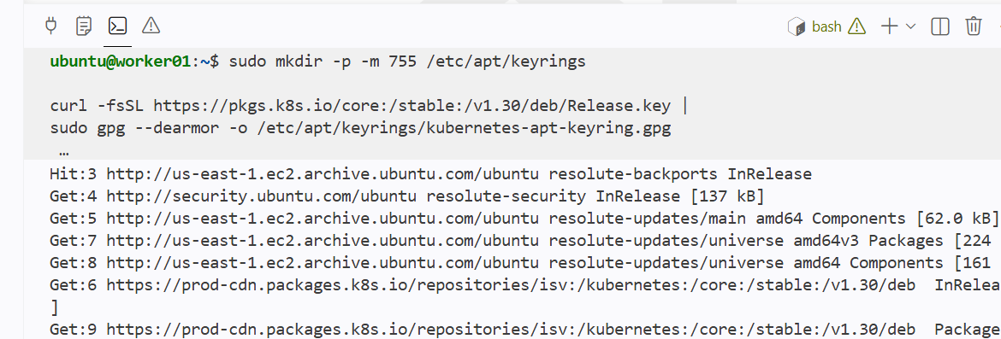

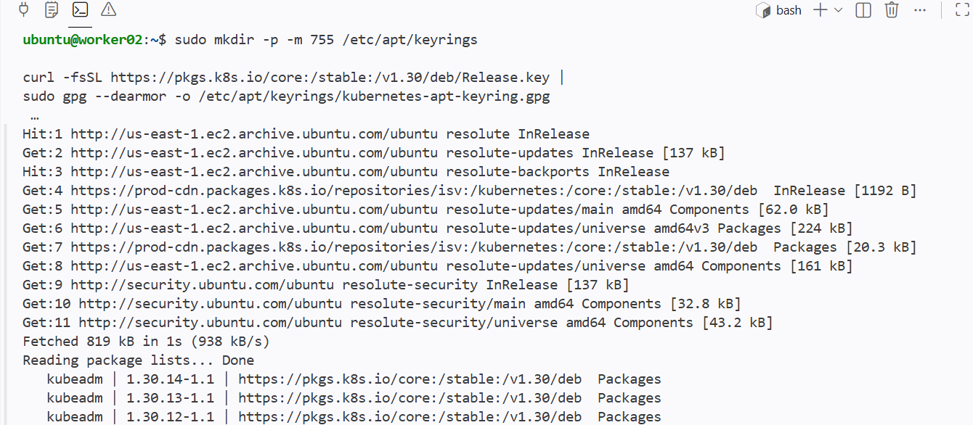

Select the package which we want to upgrade

Upgrade the first control-plane node
Set the exact package version returned by apt-cache madison

Add it as a varibale because we will call the variables whenever we need

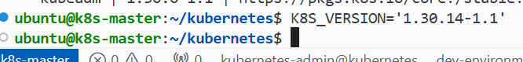

Now upgrade the kubeadm

sudo apt-mark unhold kubeadm
sudo apt-get install -y kubeadm="${K8S_VERSION}"
sudo apt-mark hold kubeadm

kubeadm version

sudo kubeadm upgrade plan

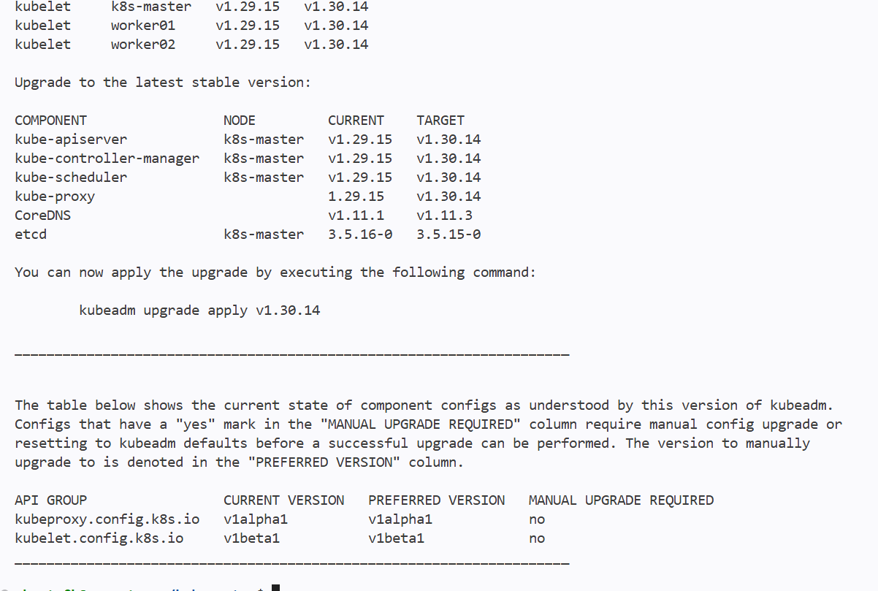

We can see the upgrade plan of kubeadm

Kubeadm upgrade apply v1.30.14

Drain the control-plane node:

kubectl drain "$(hostname)" \
--ignore-daemonsets \
--delete-emptydir-data

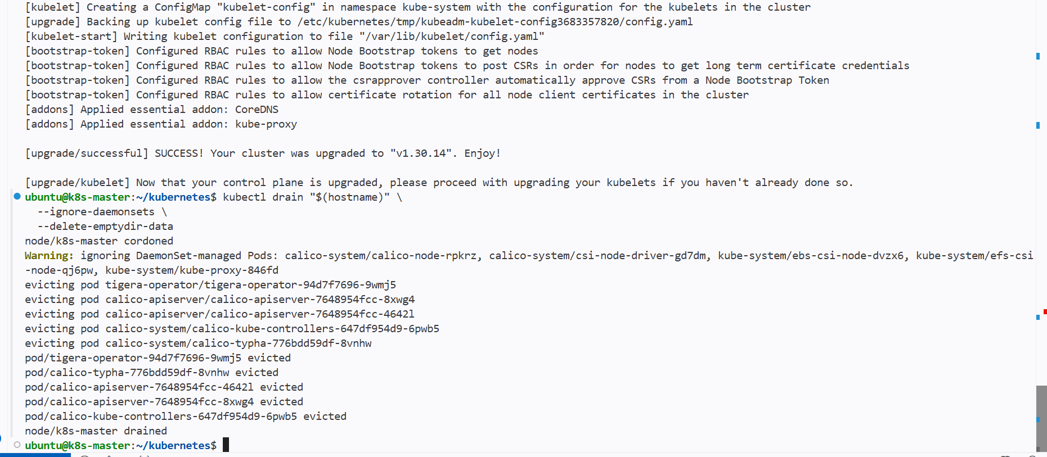

Kubeadm has been upgraded and draining the masteer node of the pods

Now upgrade kubelet and kubectl:==

sudo apt-mark unhold kubelet kubectl

sudo apt-get install -y \
kubelet="${K8S_VERSION}" \
kubectl="${K8S_VERSION}"

sudo apt-mark hold kubelet kubectl
sudo systemctl daemon-reload
sudo systemctl restart kubelet
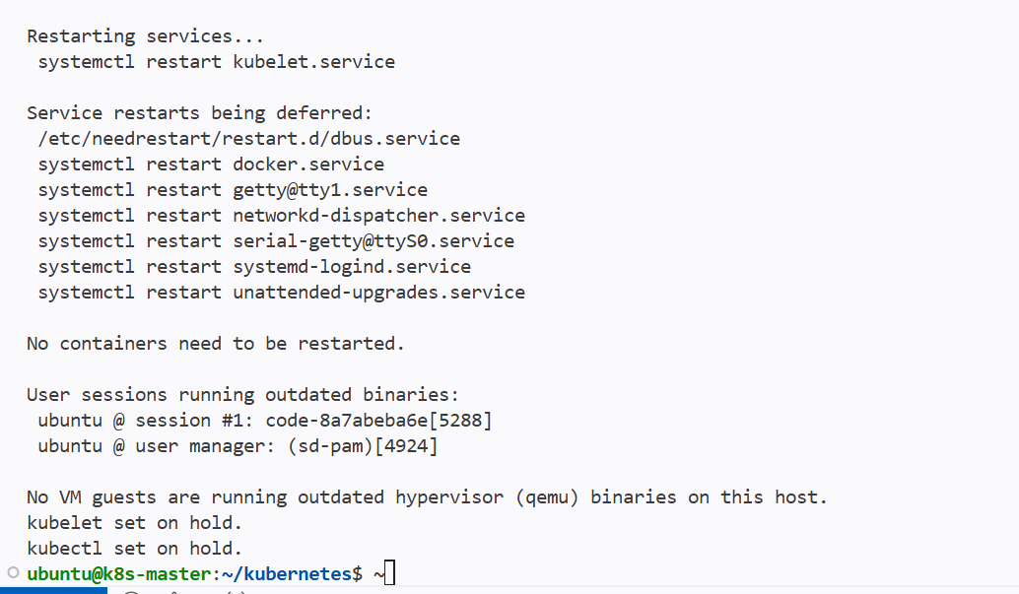

Kublet and kubectl has been upgraded and put on hold

Then restore sheduling:==

kubectl uncordon "$(hostname)"
kubectl get nodes
kubectl get pods -A

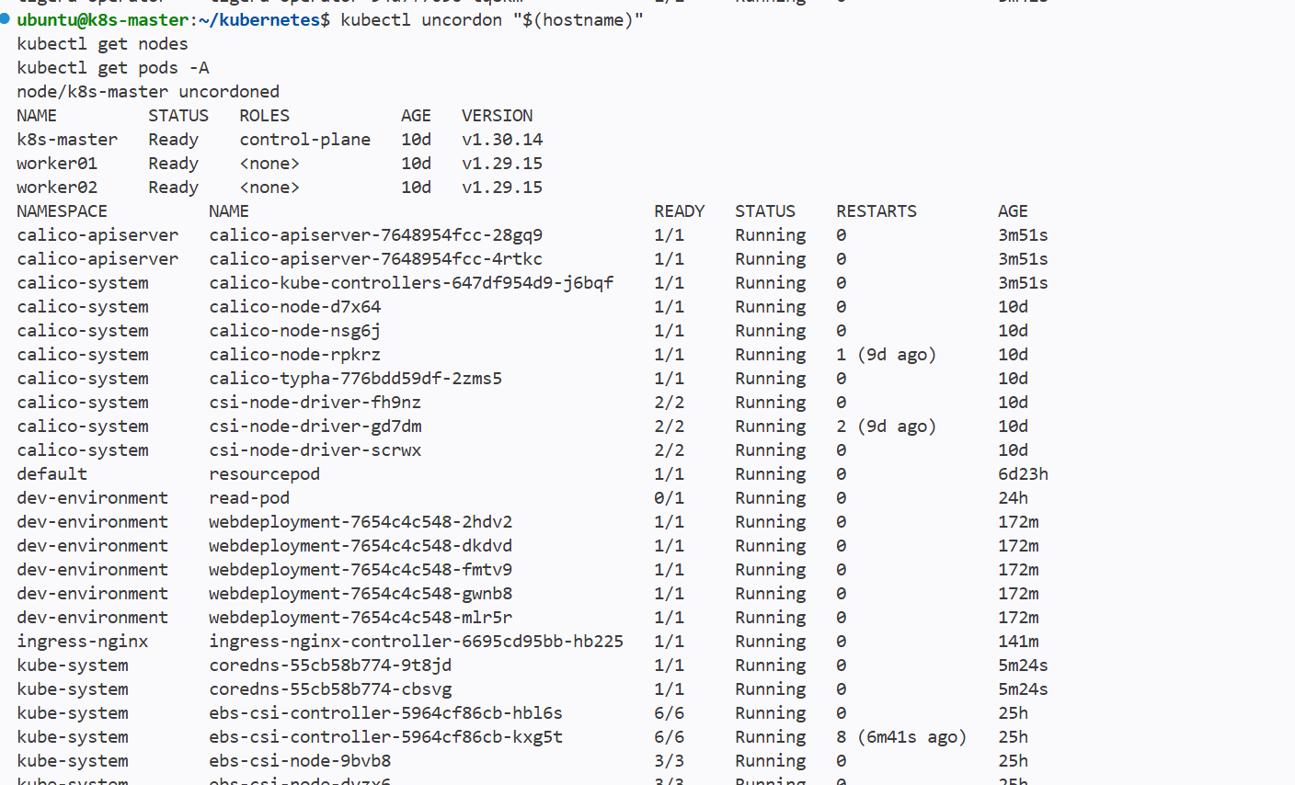

Upgrade worker nodes
Upgrade workers one at a time to preserve application availability.
Drain the worker:
kubectl drain <worker-node> \
--ignore-daemonsets \
--delete-emptydir-data

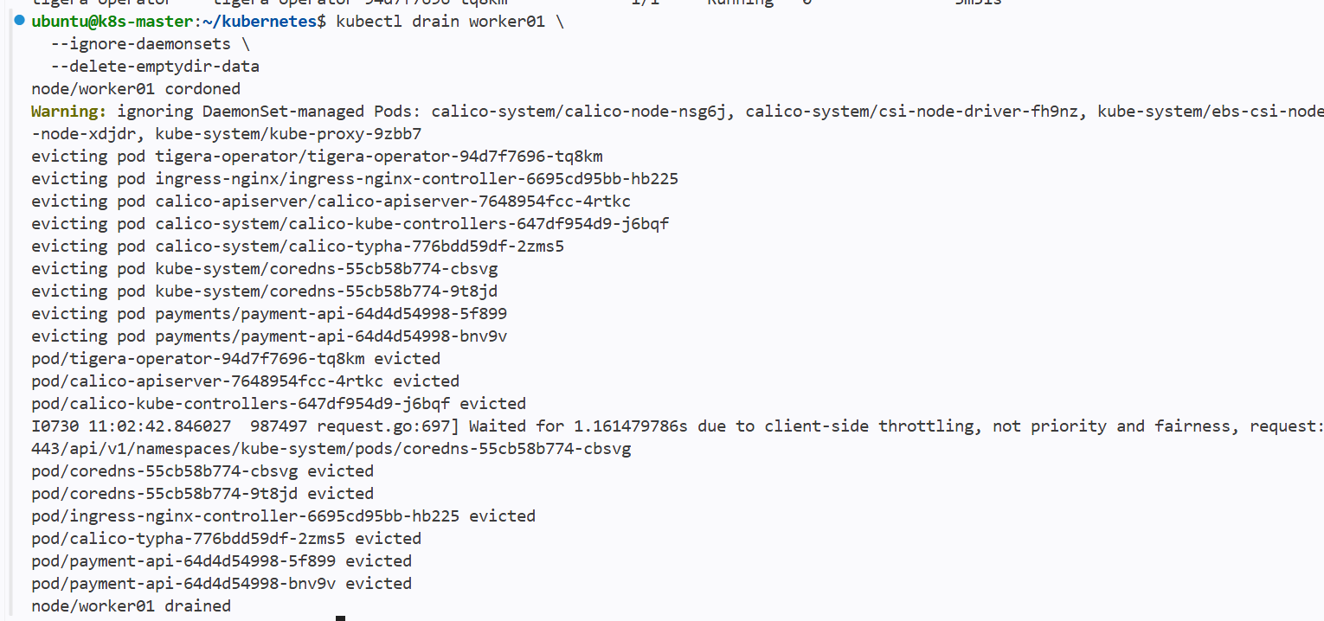

The worker01 has been drained

On that worker:

sudo apt-mark unhold kubeadm

sudo apt-get install -y kubeadm="${K8S_VERSION}"

sudo apt-mark hold kubeadm

sudo kubeadm upgrade node

sudo apt-mark unhold kubelet kubectl

sudo apt-get install -y \
kubelet="${K8S_VERSION}" \
kubectl="${K8S_VERSION}"

sudo apt-mark hold kubelet kubectl

sudo systemctl daemon-reload
sudo systemctl restart kubelet

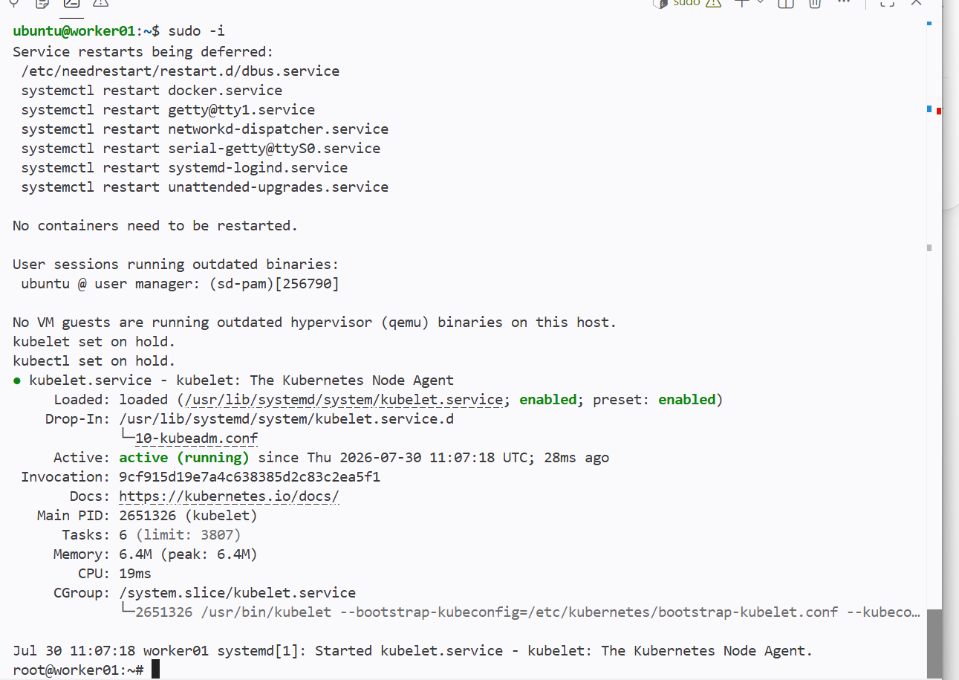

On the worker01 the kubelet and kubectl has been upgraded

And worker01 has been upgraded to 1.30.14

Upgrading the worker02 to 1.30.14

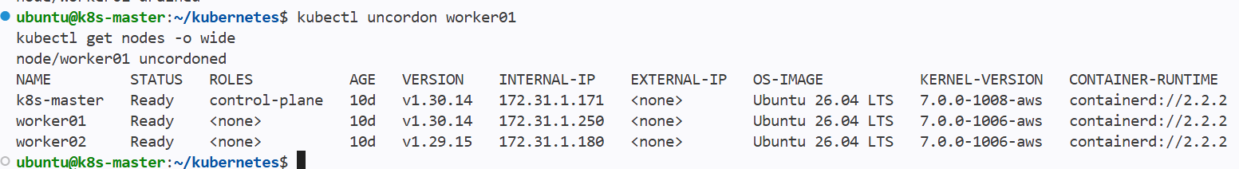

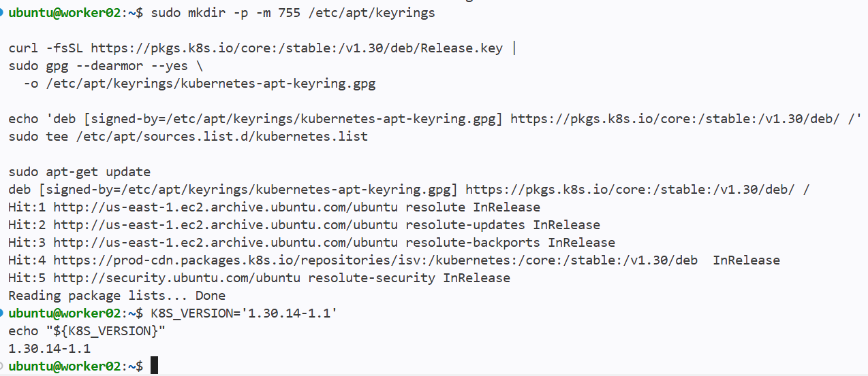

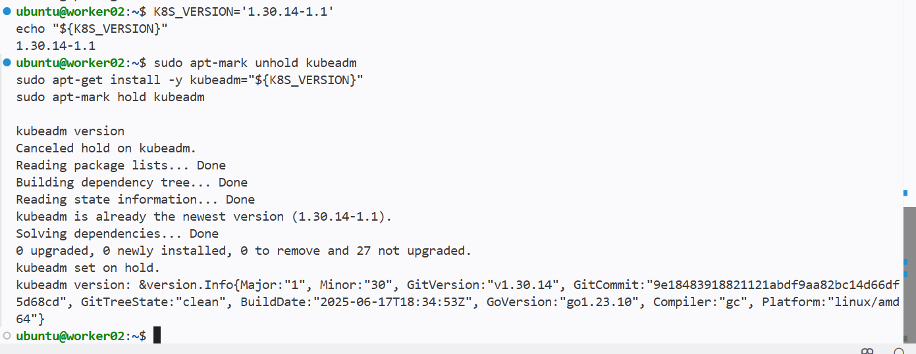

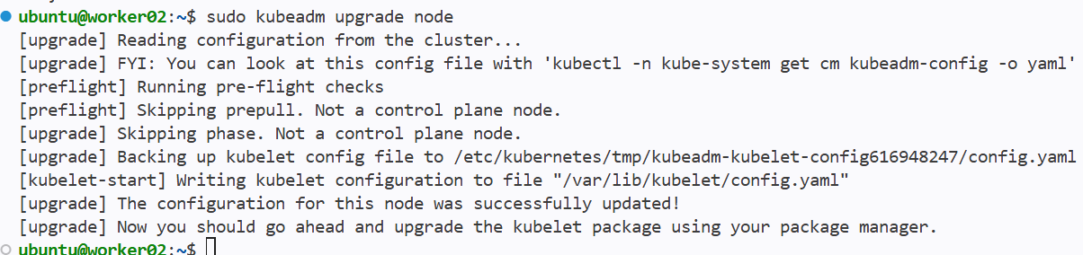

Then drain the worker02 from masternode

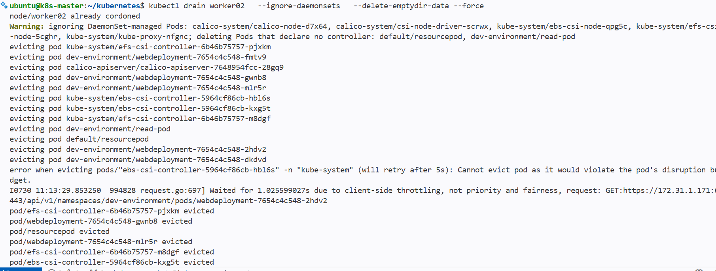

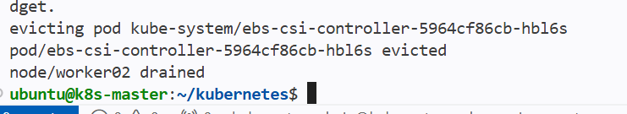

Now upgrade the kubelet and kubectl in worker02 node

Kubelet and kubectl has been upgraded

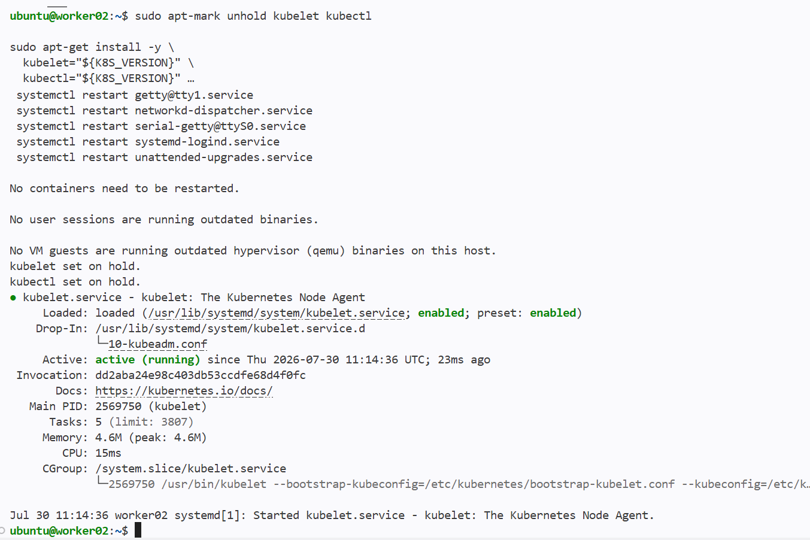

From the control plane use

kubectl uncordon worker02
kubectl get nodes -o wide

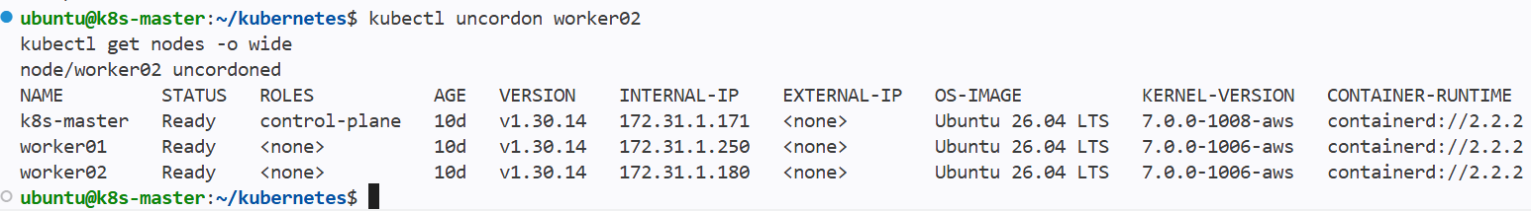

Now the worker02 has also been upgraded

