Create and Test a Kubernetes Pod with an EmptyDir Volume

Emptydir volume is assigned only to a container inside the pod

Disadvantage:
If container gets deleted or restarted then the volume gets deleted

Attached a new volume to the pod and mentioned it as emptydir
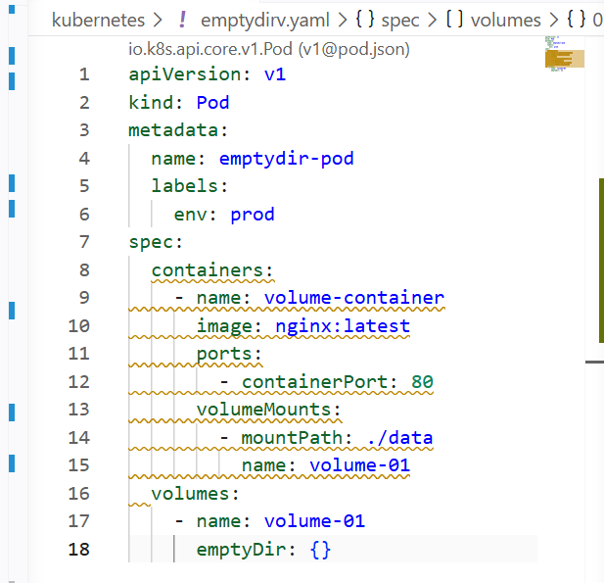
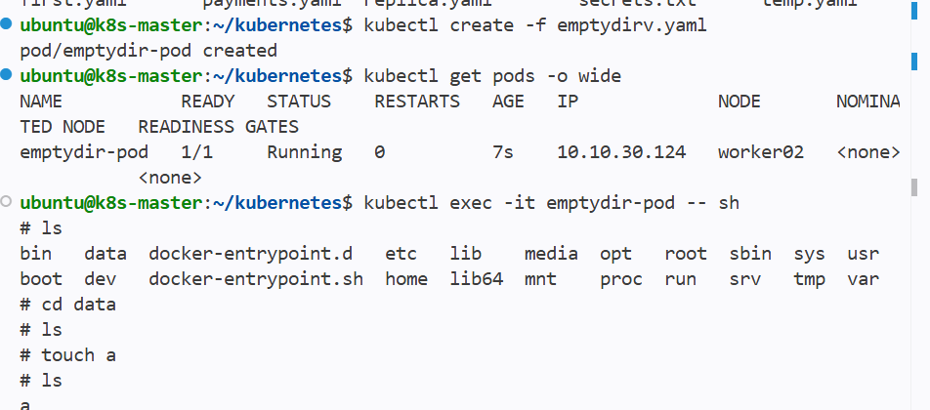
And if the pod gets deleted then the volume will also be lost

Configure a HostPath Volume in Kubernetes and Validate Data Persistence

Hostpath volume is created in the node and outside the pod

Even if the pod gets deleted then the volume will not get deleted

Disadvantage:-

But if the newly created pod is in other node then the new pod will not be able to access the hostpath volume

Hostpath is limited to only one node where it has been created

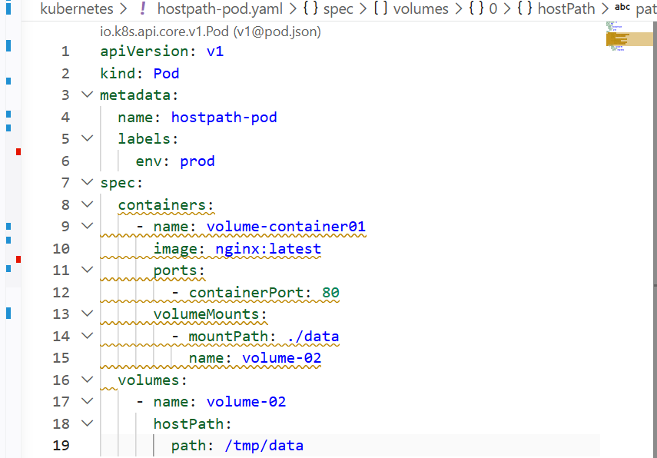

Attached the hostapth volume location to the node path

So that data in the container will be reflected on the node

And even if the pod gets deleted then the new pod created in the same node
Will have access to the hostpath volume

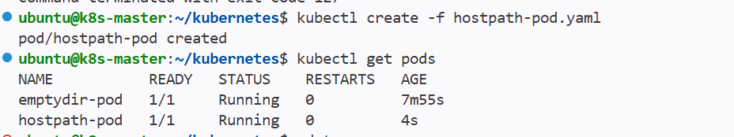

And in the worker node same data created in the container has reflected In the node

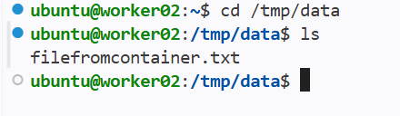

Deploy an Amazon EBS Volume Using Persistent Volume and Persistent Volume Claim (PVC)

We can use ebs as volume for the pod to eliminate the access restricted to one node

Advantage:- by this even if the pod created in other node can access the ebs volume as it is created outside the cluster

Disadvantage:- cannot access by two pods at the same time

Limited to only one pod at the same point of time

Setup:--

- Create a new ebs volume in aws

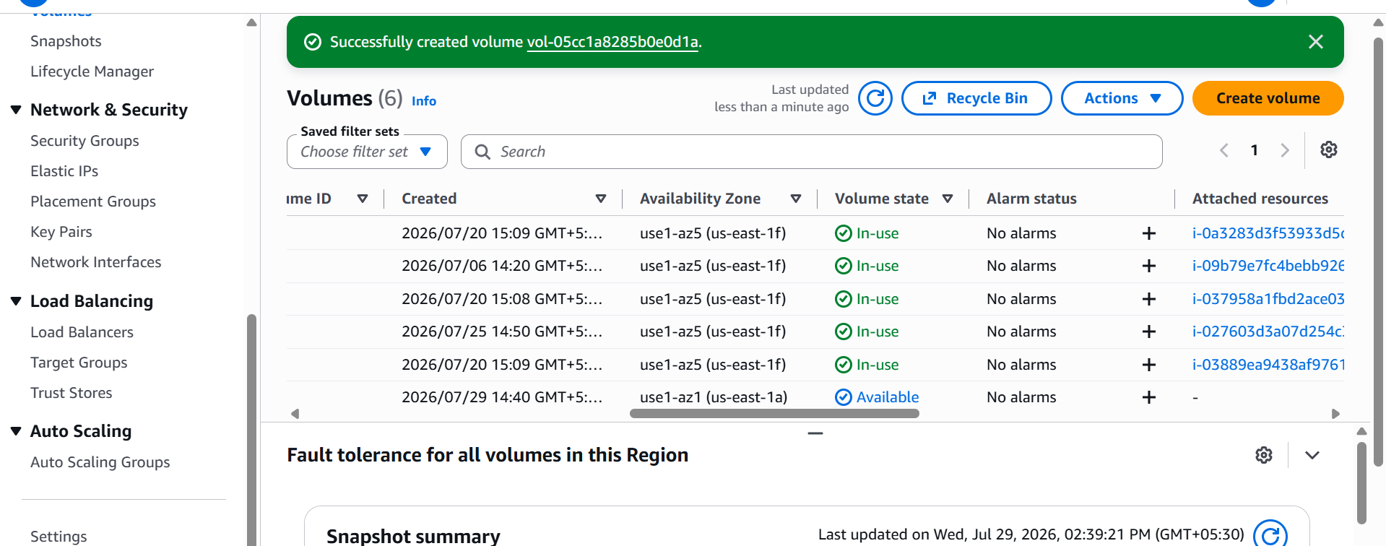

Created new ebs volume

Create one IAM role for aws-ebs-csi-driver

Search for = AmazonEBSCSIDriverPolicy and create one role and attach to all the nodes in k8s cluster

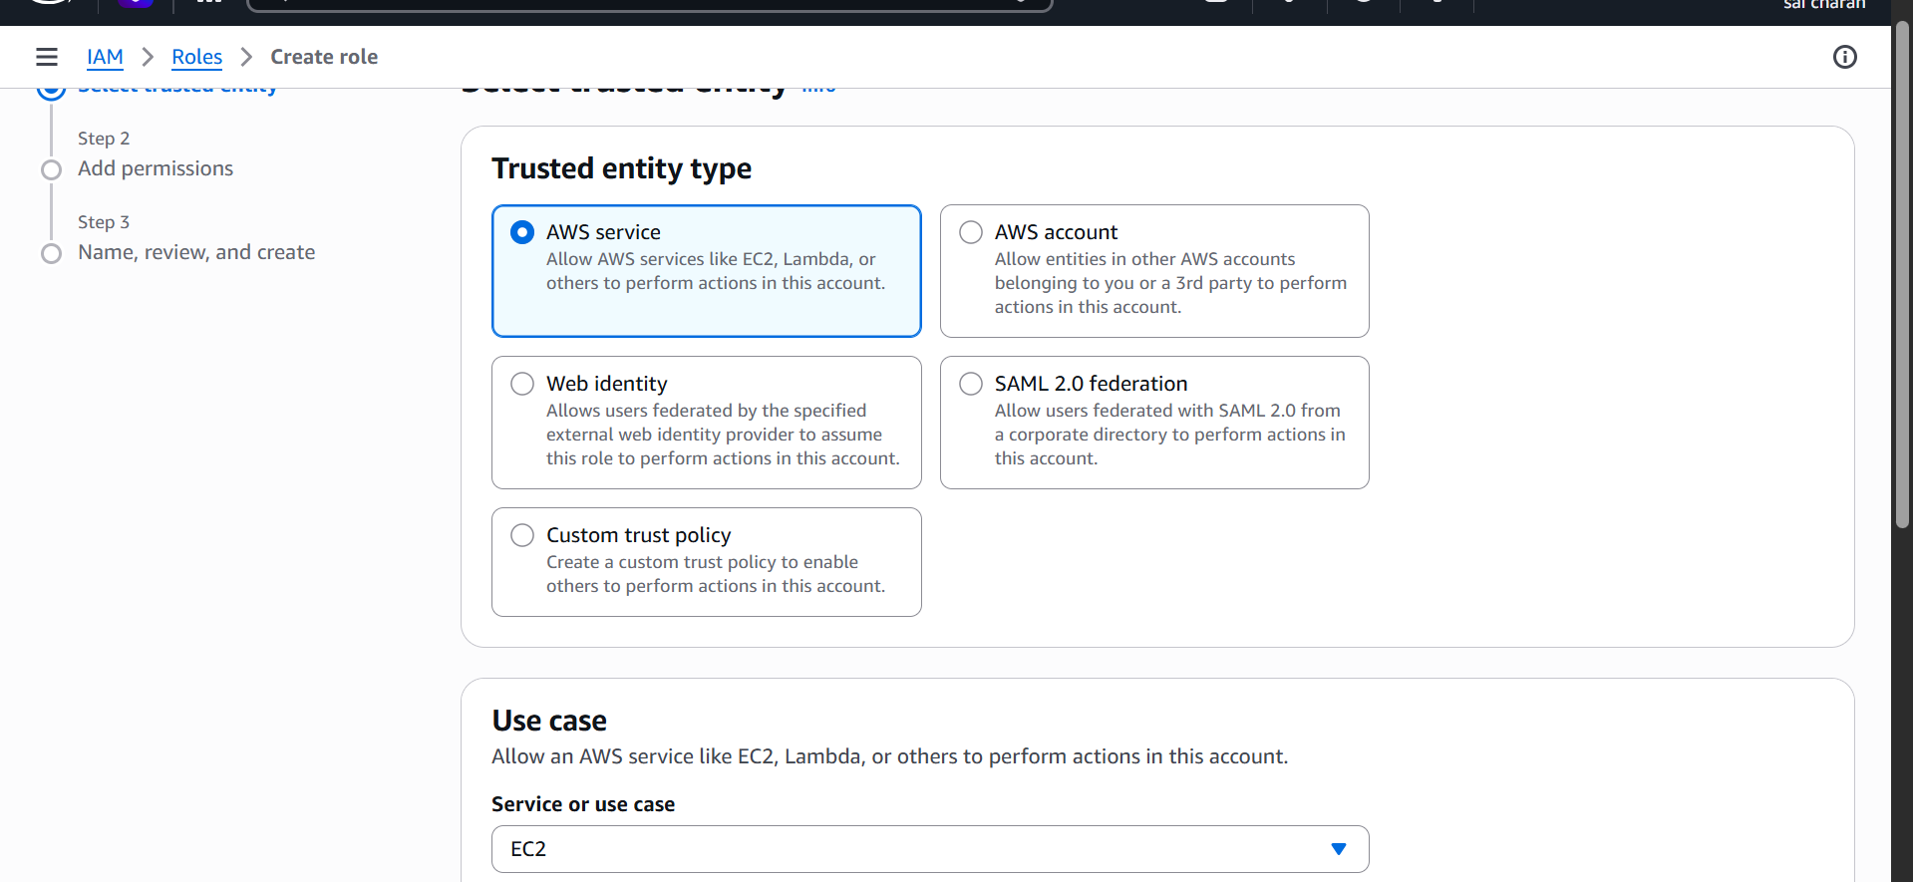

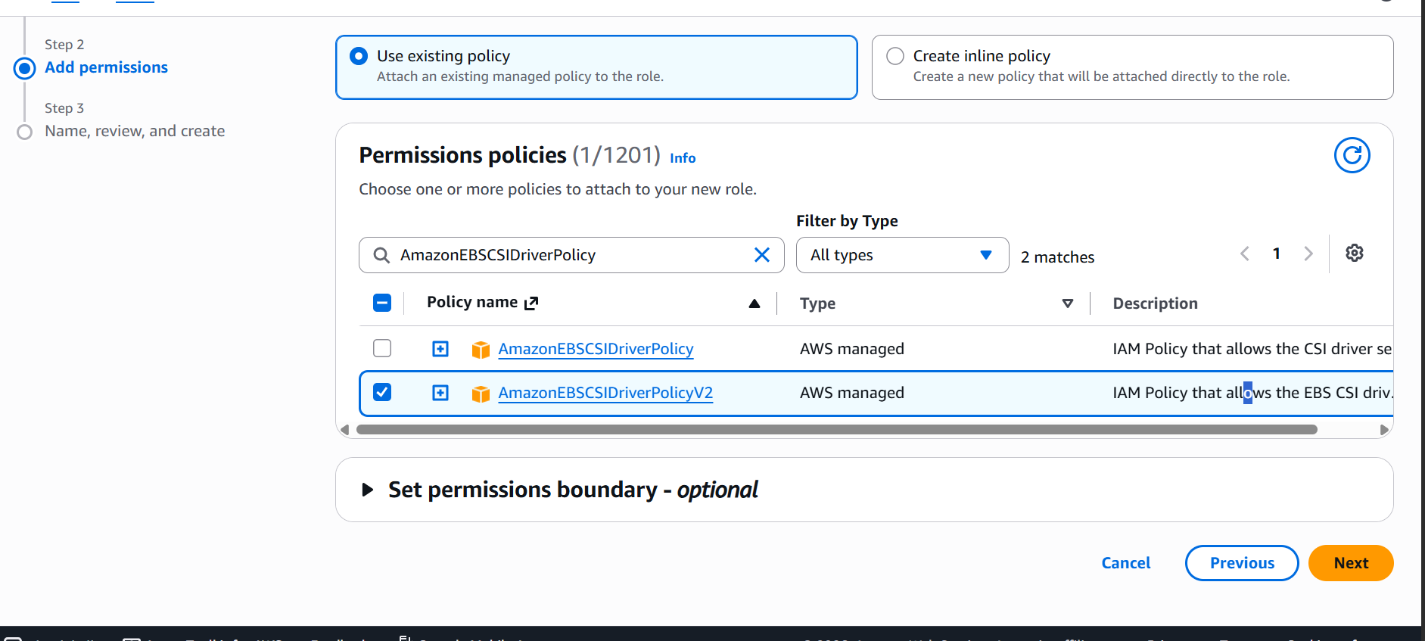

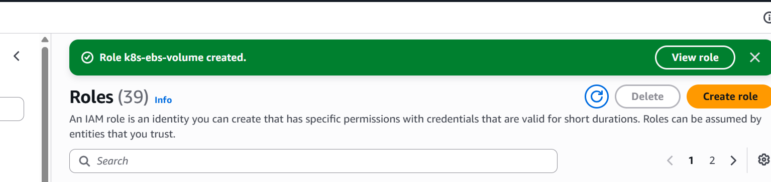

Now modify all the roles for the ec2 instance --- k8s cluster nodes

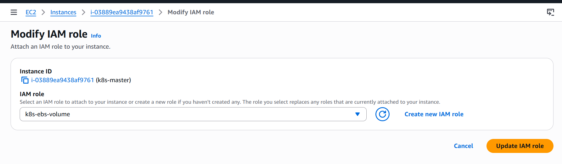

For all nodes modify

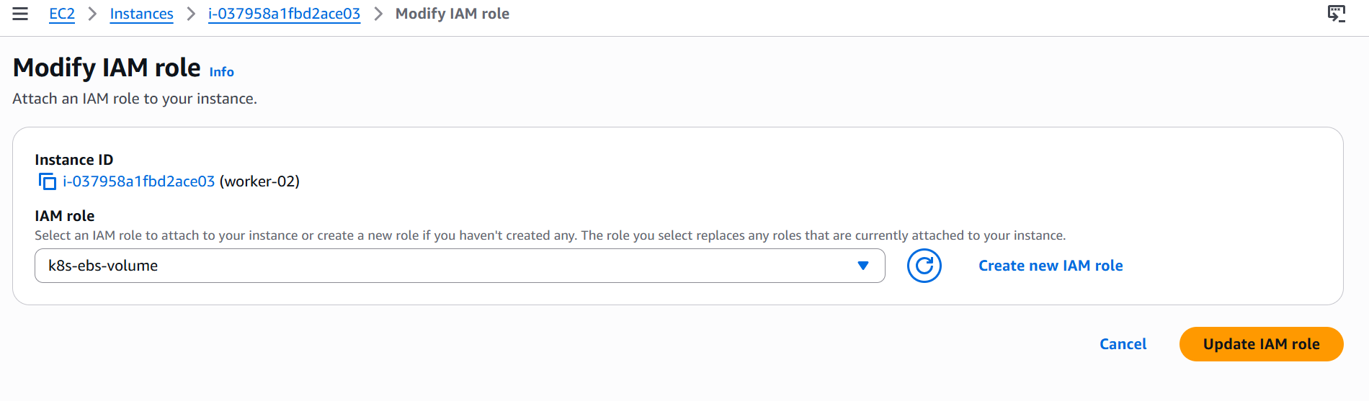

Install AWS EBS CSI driver on k8s master node.

#) git clone https://github.com/kubernetes-sigs/aws-ebs-csi-driver.git
#) cd aws-ebs-csi-driver
#) kubectl apply -k deploy/kubernetes/overlays/stable/
#) kubectl get pods -n kube-system
Driver has been installed in k8s master
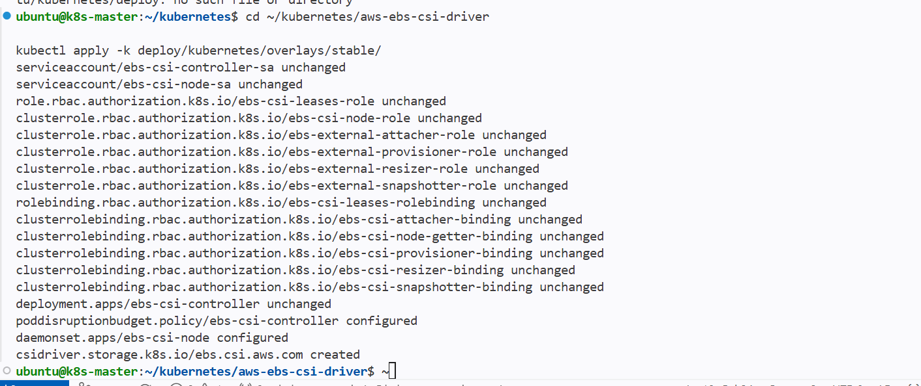
And new pods has been running in kube-system

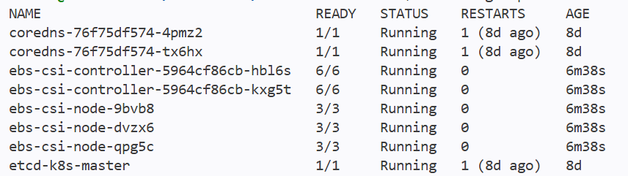

Next we need to create persistent volume

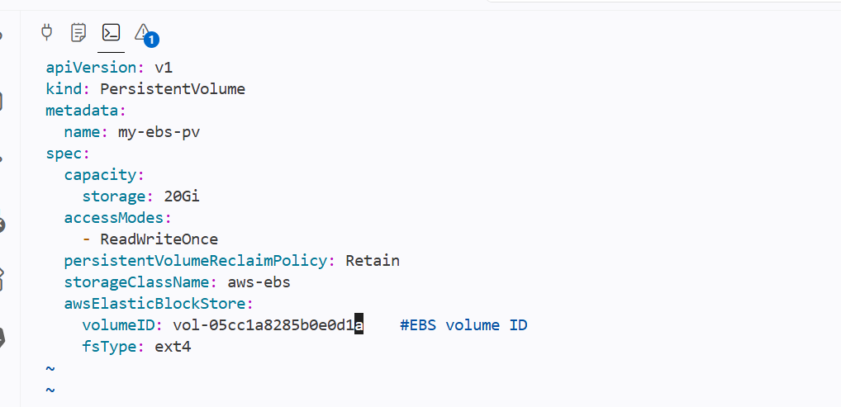

Give ebs volume id for pv yaml file

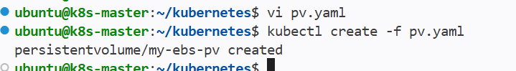

Persistent volume has been created

Next create persistent volume claim (PVC) for ebs

Yaml file for pvc

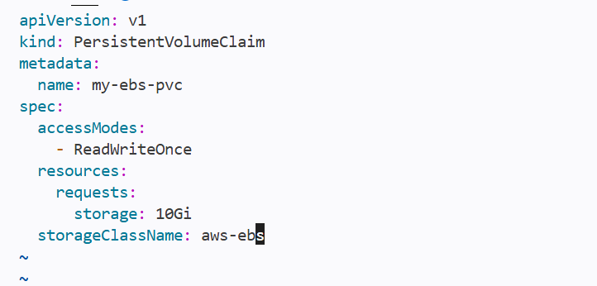

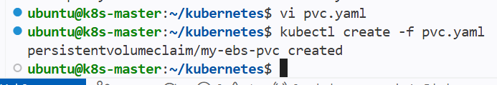

New pvc has been created this helps to give ebs volume for ebs

Next create the pod with pvc

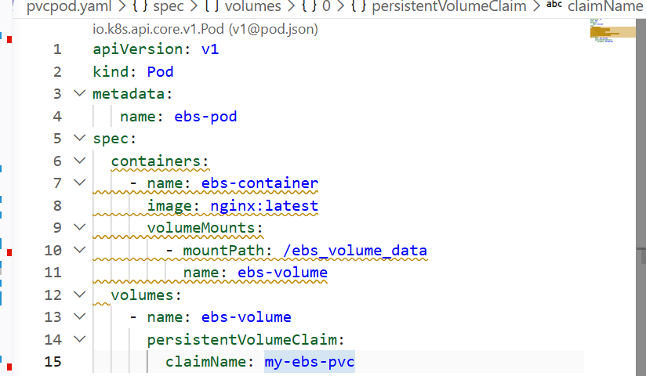

Pod has been created with ebs volume

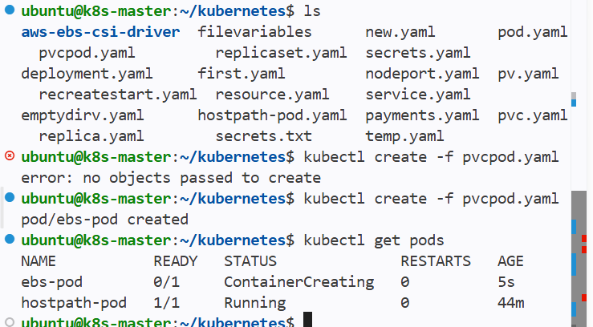

Now even if I delete my pod then wherever new pod gets created then it can access the ebs volume irrelevant of nodes

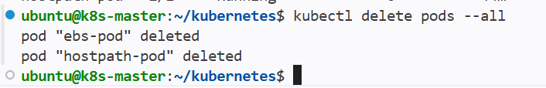

I have deleted the pod then the ebs volume will be In available state

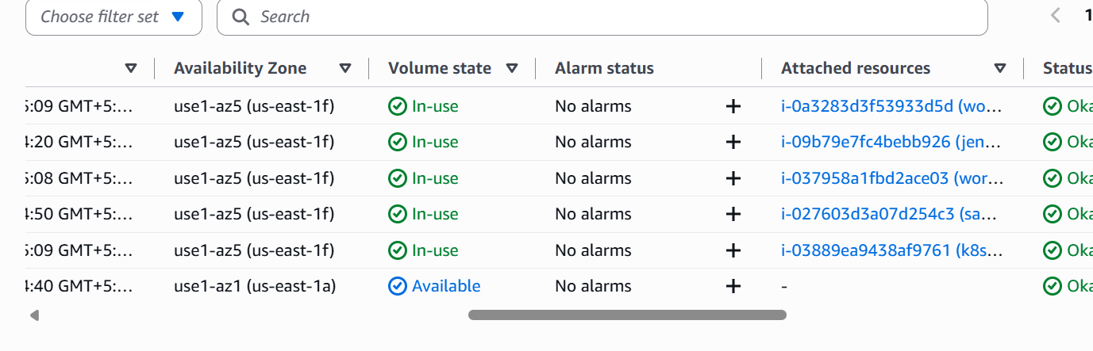

Now I will create a new pod then the new pod will get access to the ebs volume

Set Up an Amazon EFS Volume and Attach it to Multiple Pods

Efs is used to access by the multiple pods at the same time

While in ebs only one pod can be access to the volume at the same time

Create a new efs volume in aws

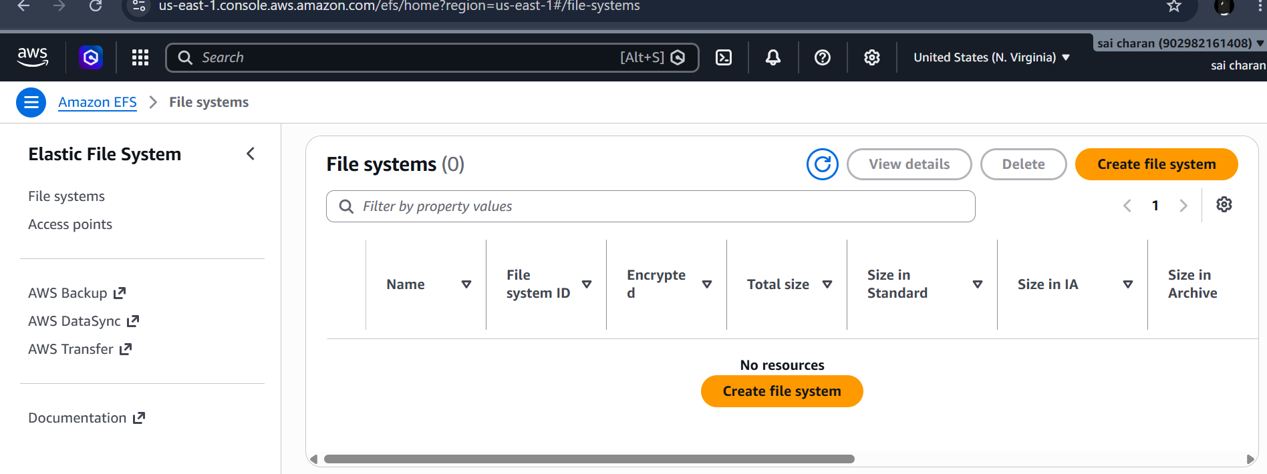

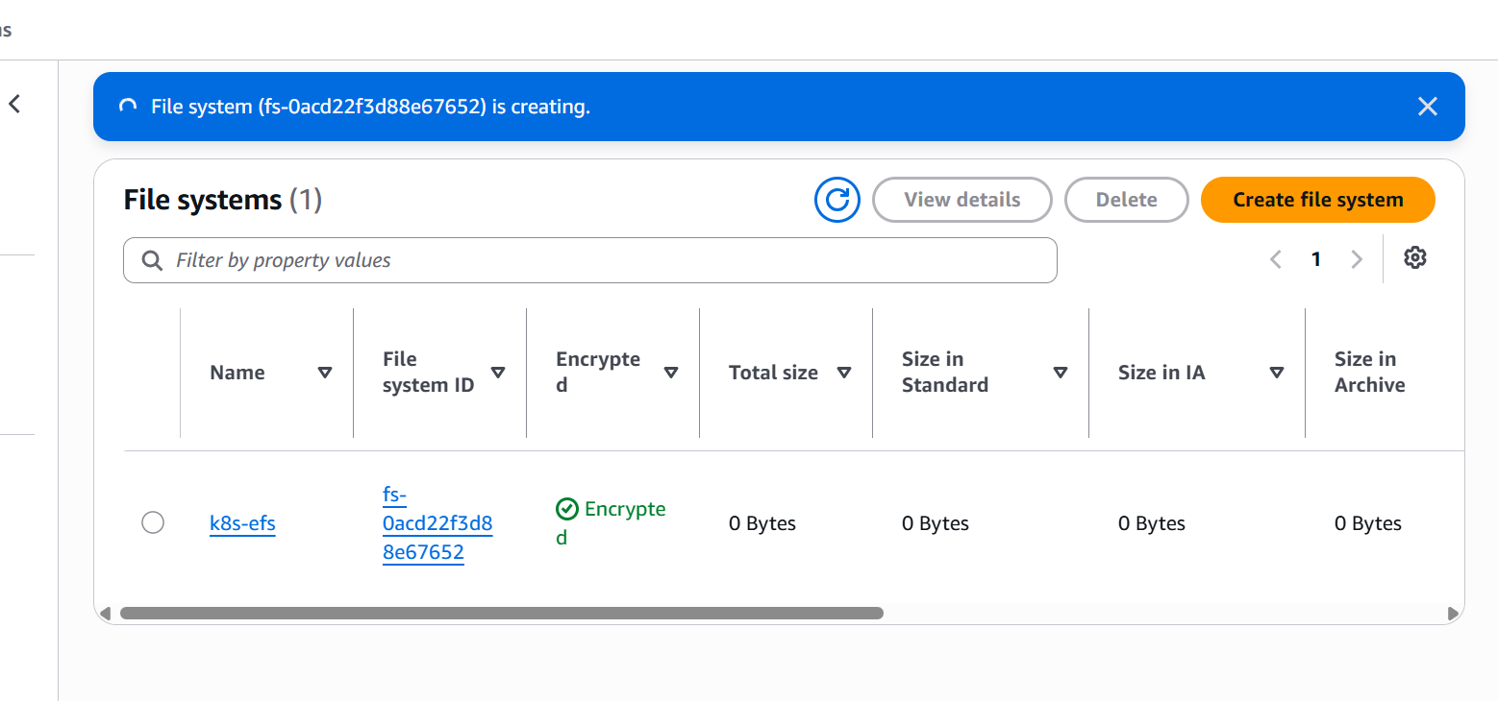

Created a new efs in aws

Create one access point to efs

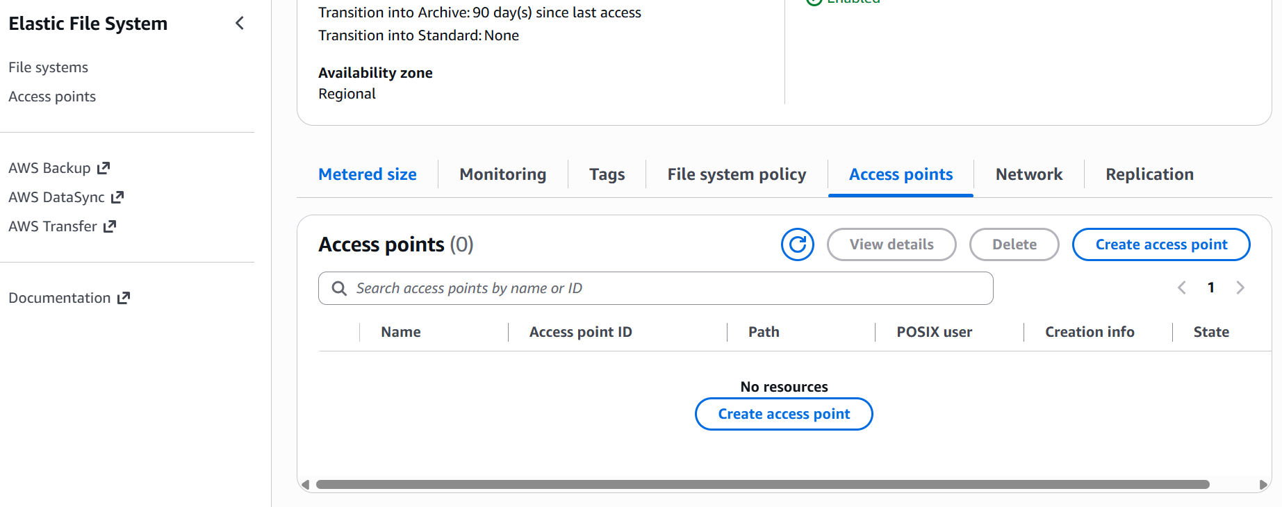

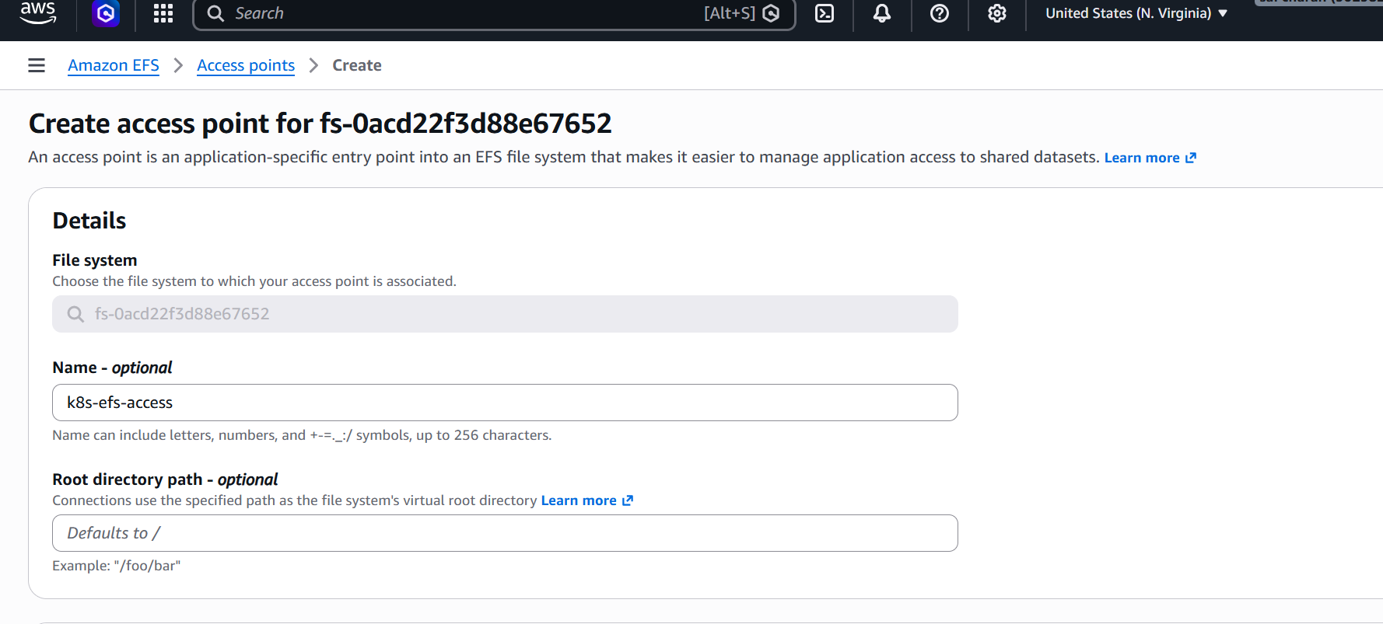

Also add mount targets same as worker node az

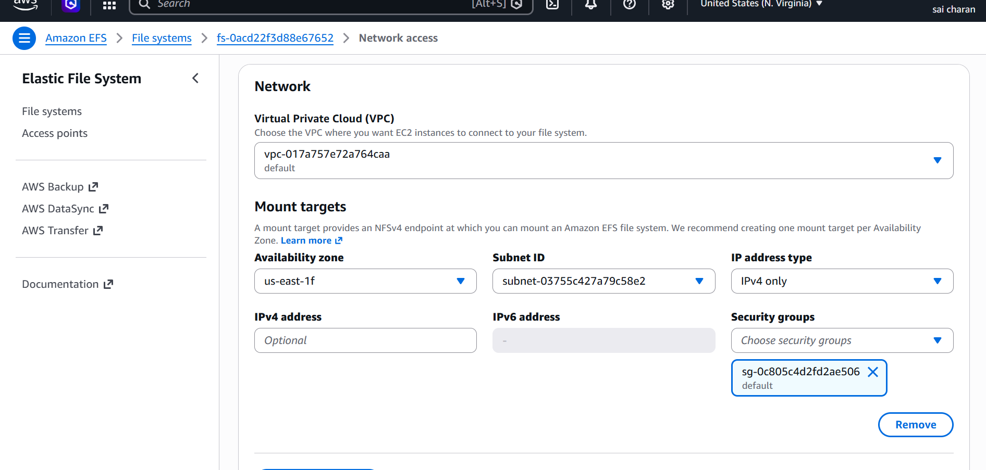

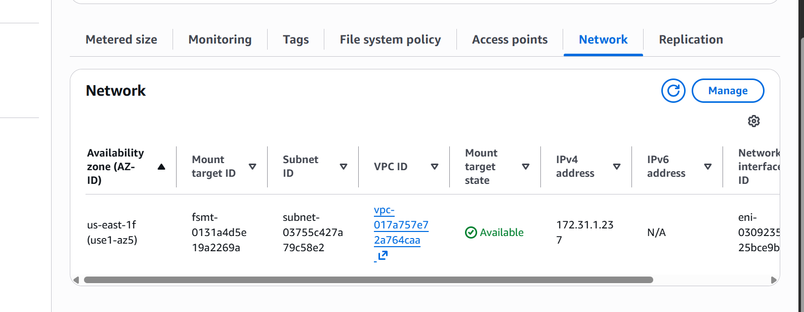

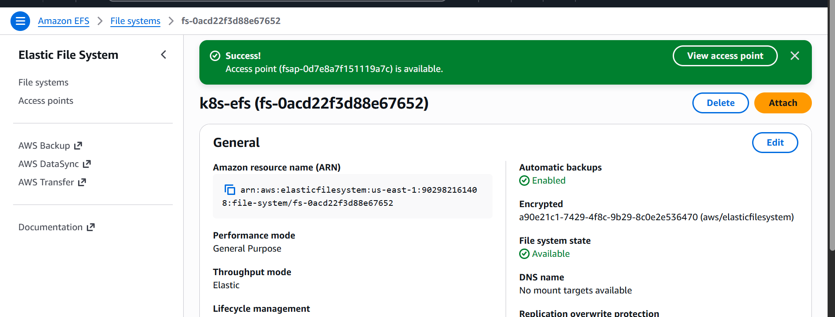

Install AWS EFS CSI driver on k8s master node.
#) git clone https://github.com/kubernetes-sigs/aws-efs-csi-driver.git
Apply the CSI Driver Manifests: Navigate to the cloned repository and apply the
Kubernetes manifests using the kubectl apply command:
# cd aws-efs-csi-driver/deploy/kubernetes/overlays/stable/

kubectl apply -k .

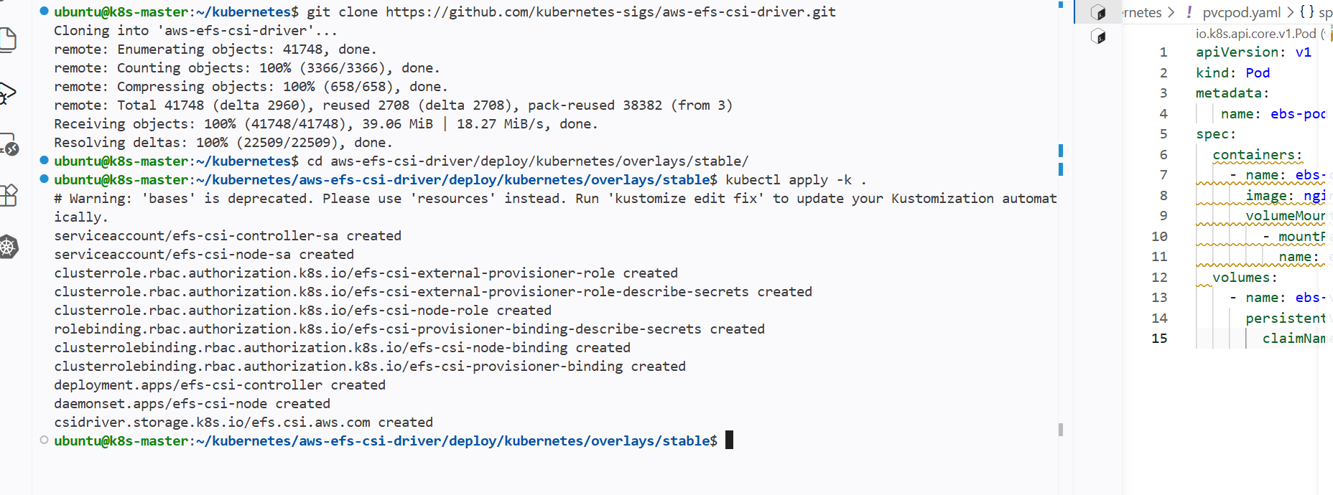

verify the installation.

#kubectl get pods -n kube-system -l app=efs-csi-controller

#kubectl get pods -n kube-system -l app=efs-csi-node

Create EFS Provisioner Storage Class: To dynamically provision EFS volumes,

you need to create a StorageClass that uses the EFS CSI driver.

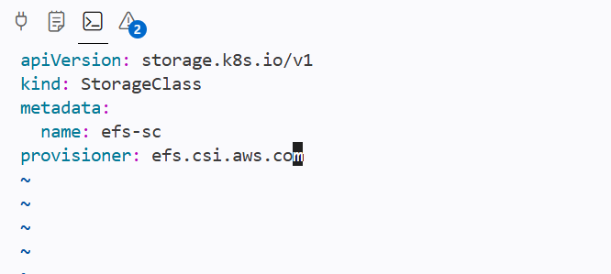

Storage class has been created

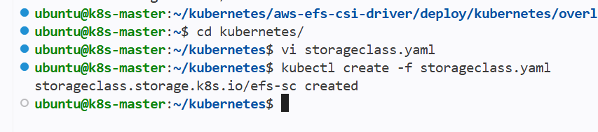

Now create a persistent volume for efs

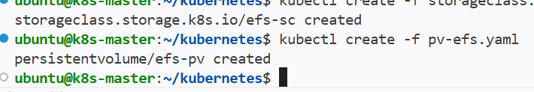

Created pv using below yaml file that has fs id and access point id

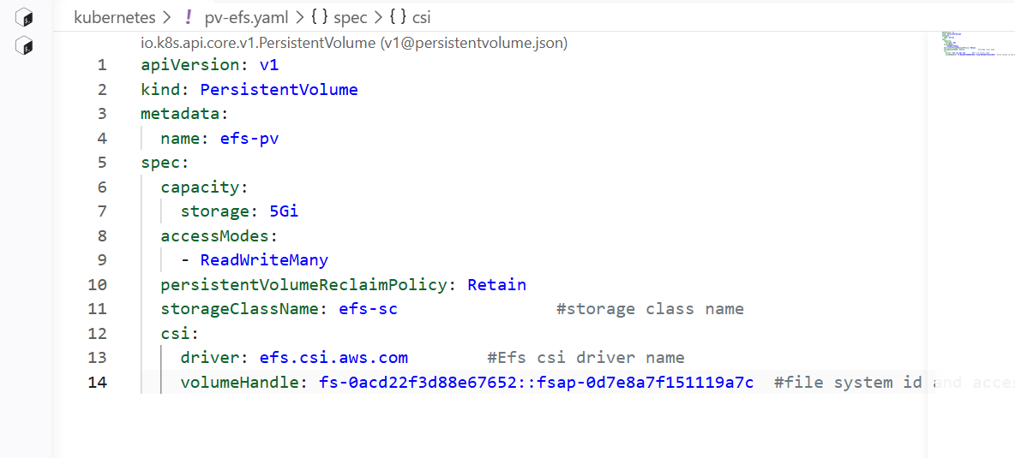

Create new pvc for efs

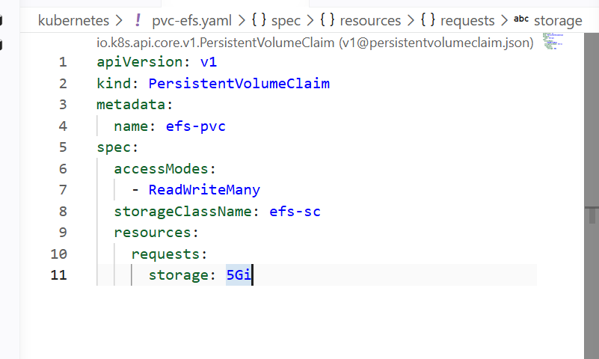

Pvc has been created

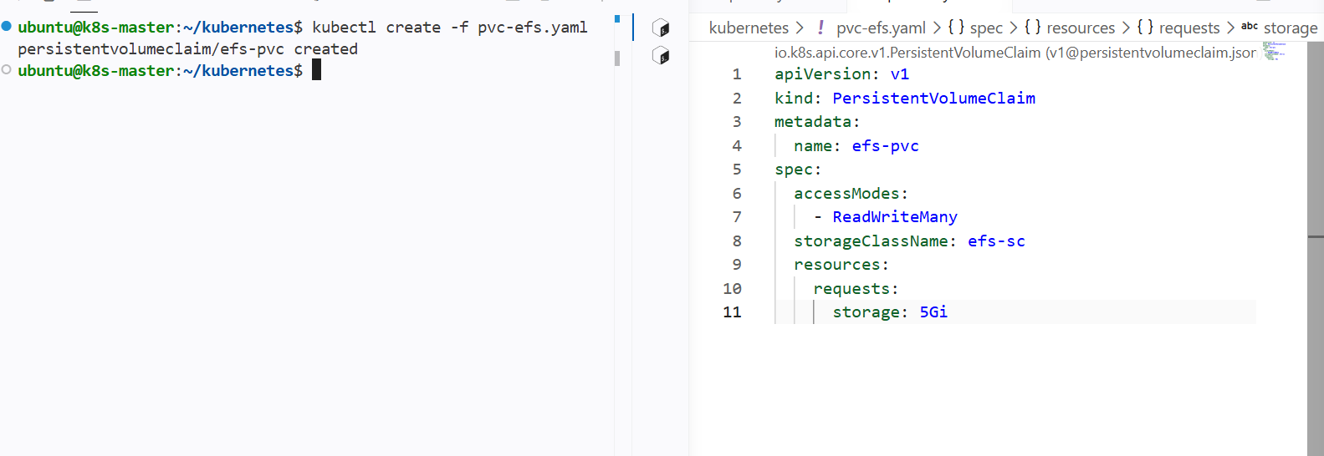

Creating pod with pvc

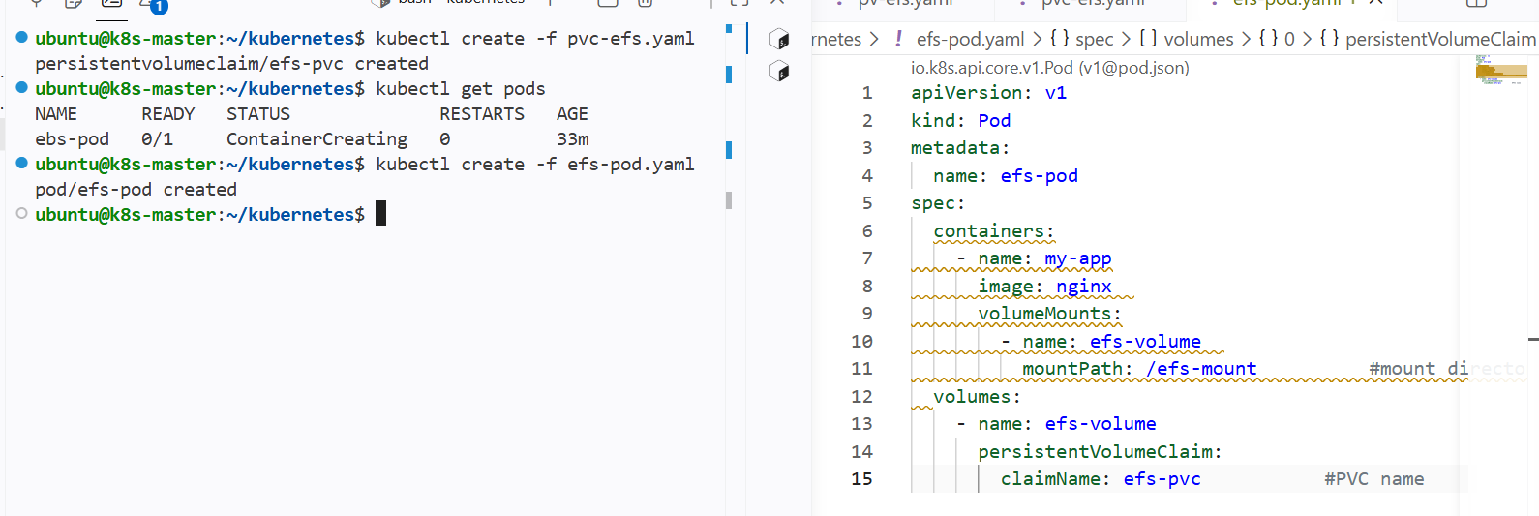

Pod with pvc has been created

Logging In to the container and checking the mount of volume

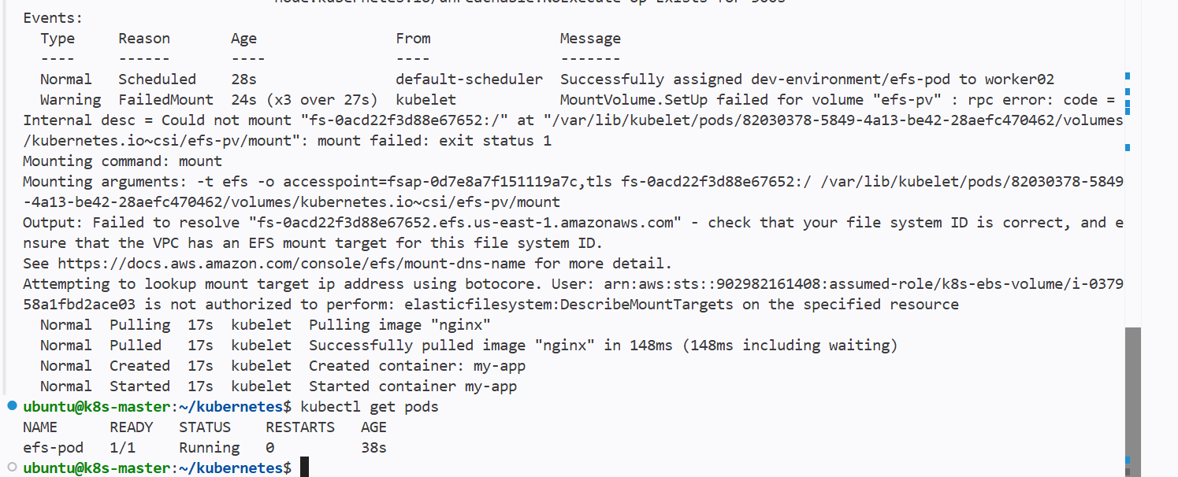

Pod is running successfully and logging into the container

Adding a new file in the container so that it will be stored in efs

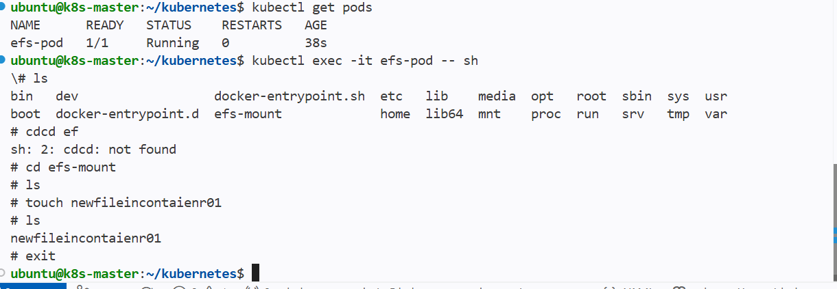

Now creating a new pod with same pvc and pv and checking for access to the efs

New pod has been created with new container

And both pods can access to the efs volume and data is same in the volumes

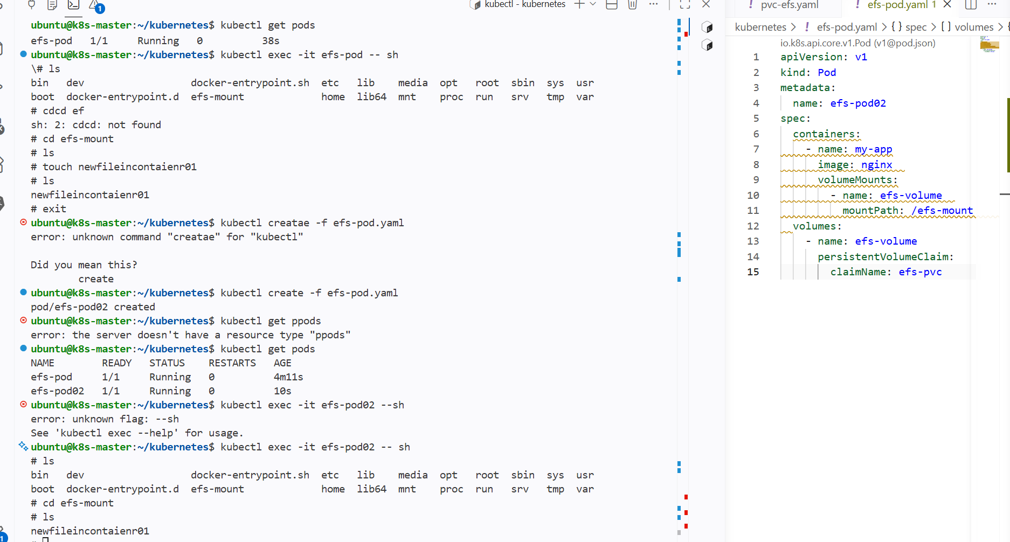

Implement and Test Liveness and Readiness Probes in a Kubernetes Pod

Liveness probes always checks for the health of pod

And then restarts the pod if it is unhealthy

Creating a new pod for checking the liveness probes

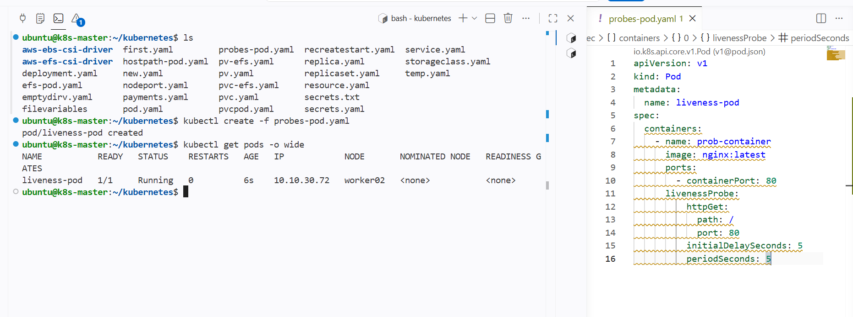

I have added liveness probe to the pod spec for containers so that it checks the container service health at given port number

And if I change the port to 8080 that nginx wont listen on 8080 so it should always restart the pod as it is unhealthy

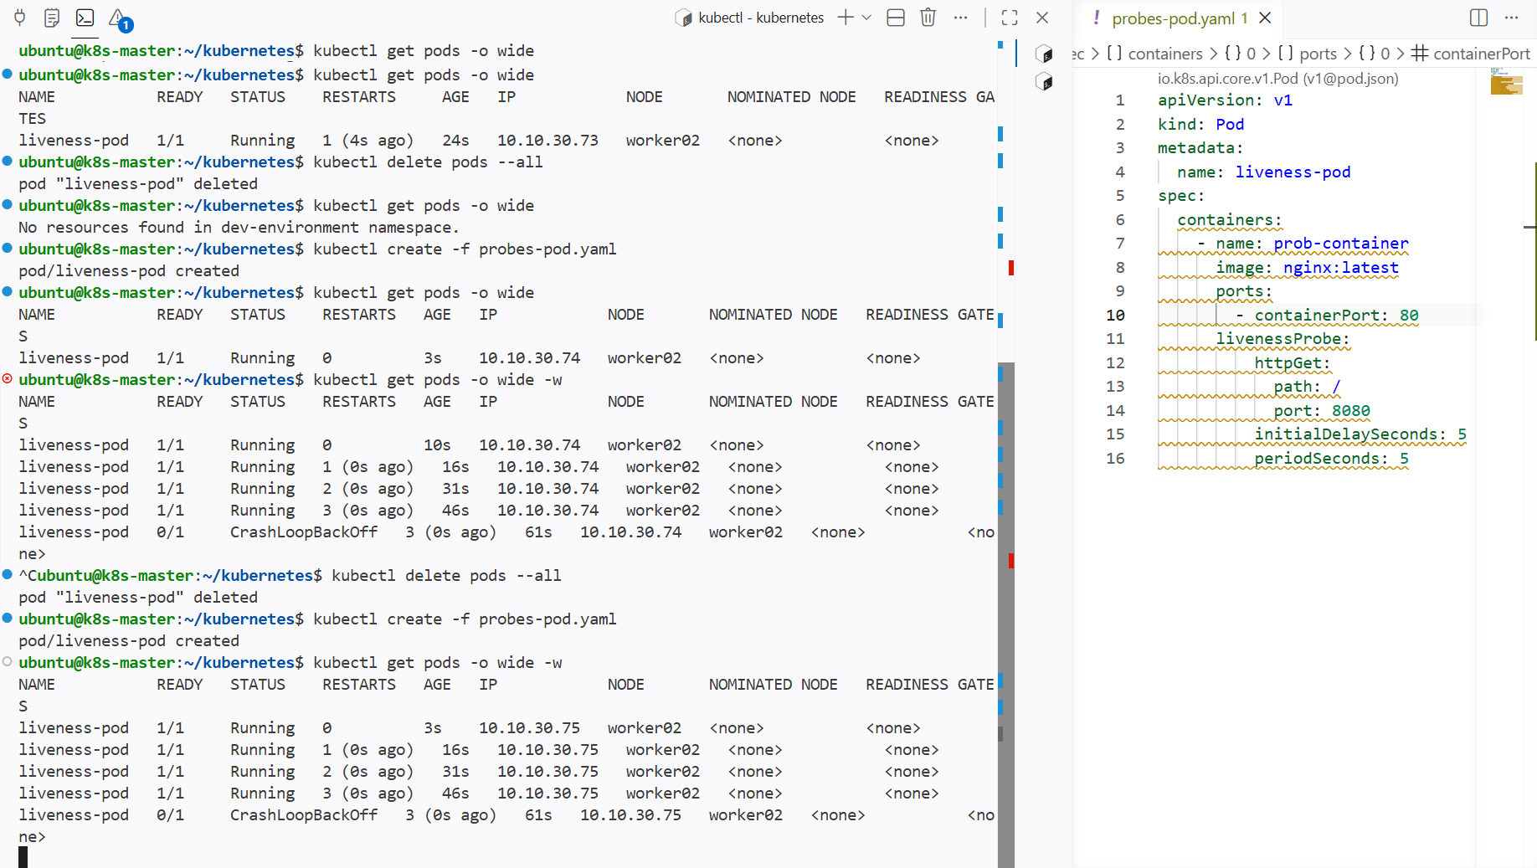

The pod is always restarting because the health check of the container port Is wrong

Readiness probes

Readiness probes also checks for the health of the pod and if it is unhealthy then it wont allow traffic to the pod until the pod becomes healthy

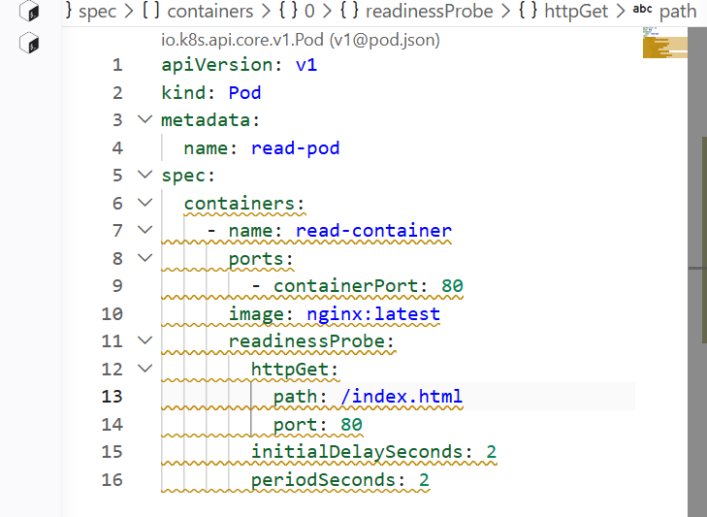

The yaml file contains the pod readiness probe

And I have given the path to health check is index.html and later after creating the pod I will delete the index.html file.it should be failed and traffic will not be allowed to the pod

And it will also remove pod from endpoint

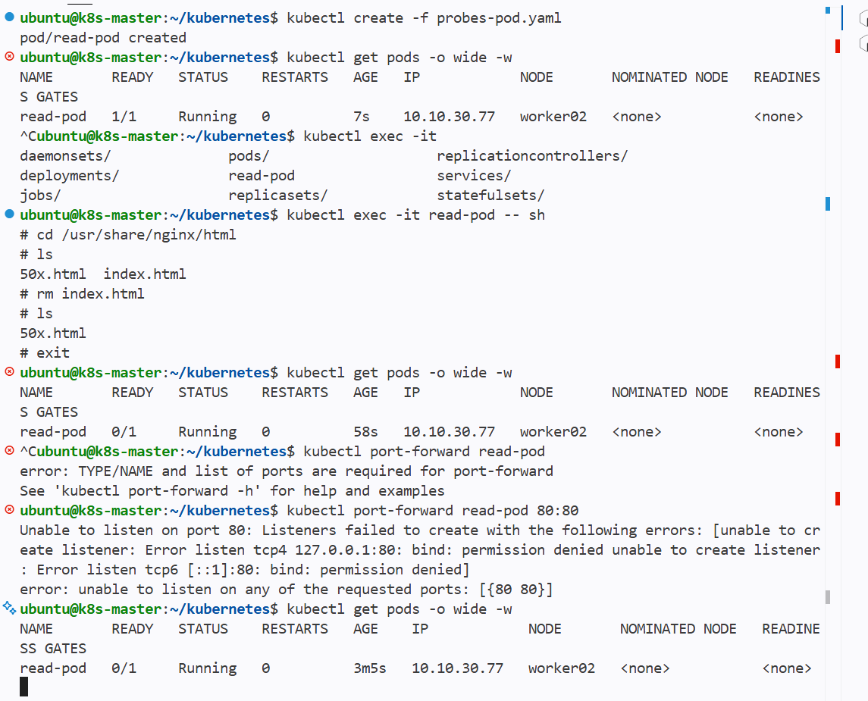

And after deleting the file it says the ready as 0/1

Readiness probe made pod as notready

