Create a Simple Pod Using YAML

Task: Write a YAML file to create a Pod named firstpod with an nginx container. Verify the Pod creation using kubectl get pods and check the logs of the container using kubectl logs firstpod

First writing a new yaml file that contains image name and container

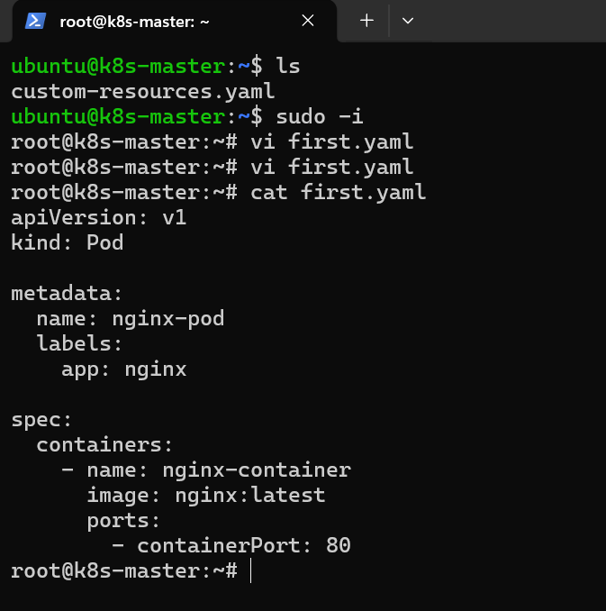

Created a new yaml file and running pod using yaml file

Syntax :-- kubectl create -f filename.yaml

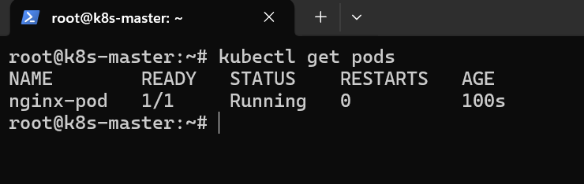

Created a new pod and can be seen using kubectl get pods

And the logs can bee seen through

Kubectl logs podname

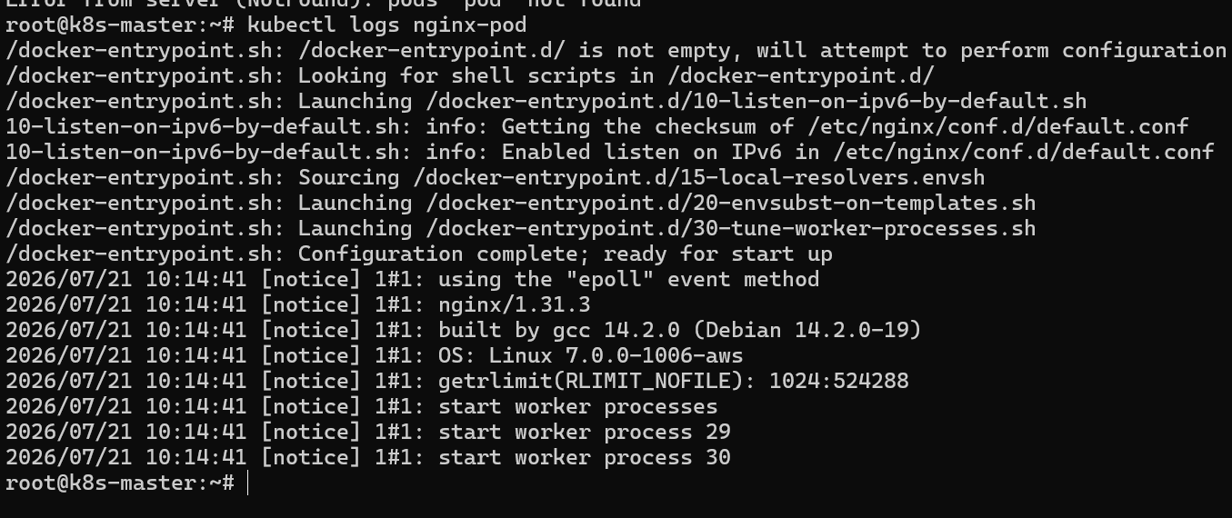

Set Environment Variables in a Pod

Task: Modify the YAML file to include environment variables myname: sabair and City: Hyderabad. Deploy the Pod and use kubectl exec <pod_name> -- env to check if the environment variables are set properly

Changing the environment variables in previously created yaml file

Adding the env for container with new environment variables

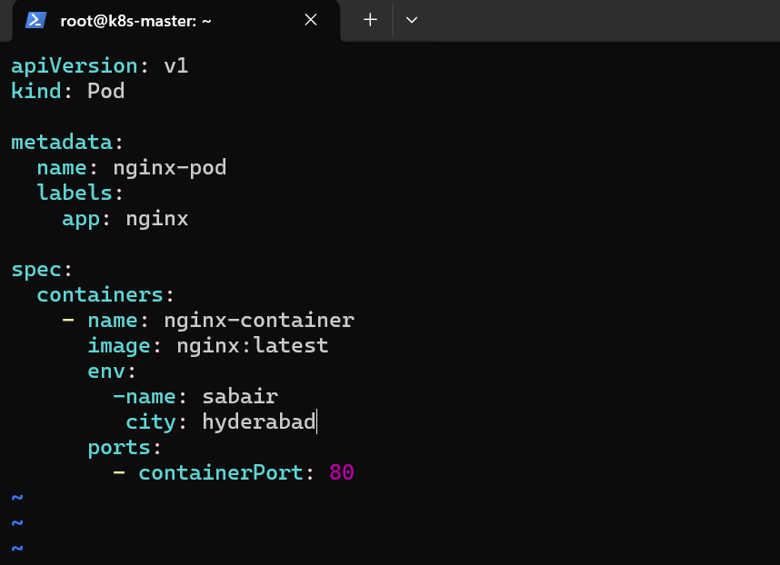

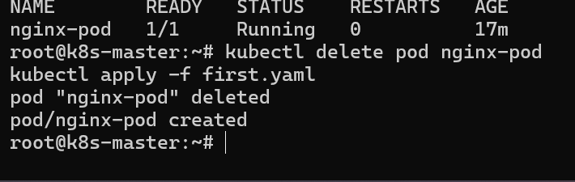

Deleted the old pod and creating a new pod with given env variables

We can see the newly added variables through syntax

Kubectl exec nginx-pod -- env

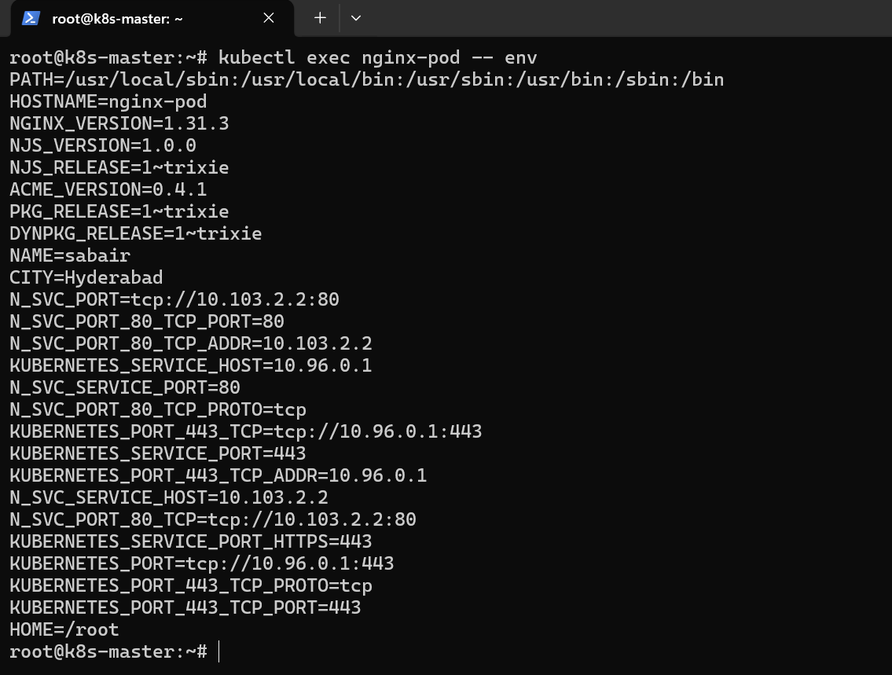

Deploy a Pod with Commands (Args) in YAML

Task: Modify the YAML file to add args that instruct the container to sleep for 50 seconds. Deploy the Pod and use kubectl describe pod to verify the args are correctly passed to the container

Adding the arguments for the yaml file to execute commands inside the yaml file that runs for pod

Editing the old yaml file and adding the arguments

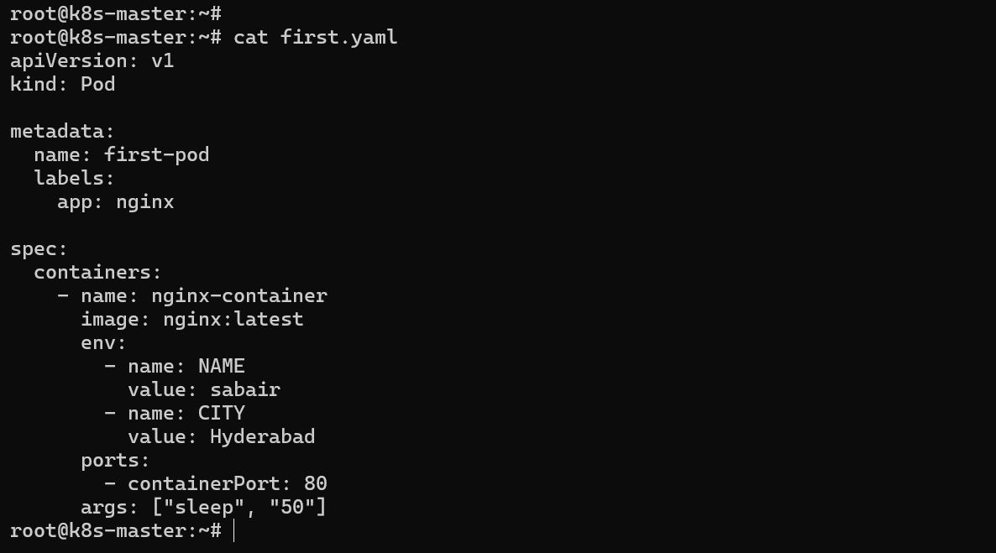

Added new arguments for the yaml file so that the pod sleeps for 50 sec before getting created

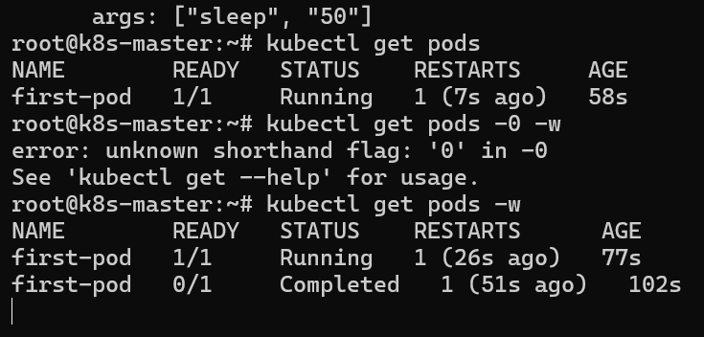

We can see that pods waited for 50 sec

Now the contaiiner restarts for every 50 sec a
Inorder to bypass or remove the crashloopbackoff

Add restartpolicy: never in spec

Create a Pod with Two Containers

Task: Create a YAML file to define a Pod with two nginx containers inside. Use kubectl exec to access both containers and verify that both containers can communicate through the same network (e.g., using telnet between them)

I will be giving two contaianers for a single pod

But I have nginx and httpd

So both of them listens on 80 so I will be changing the port number of httpd using sed -i command

And passed through arguments

Now the httpd will listen on 90 and nginx on 80

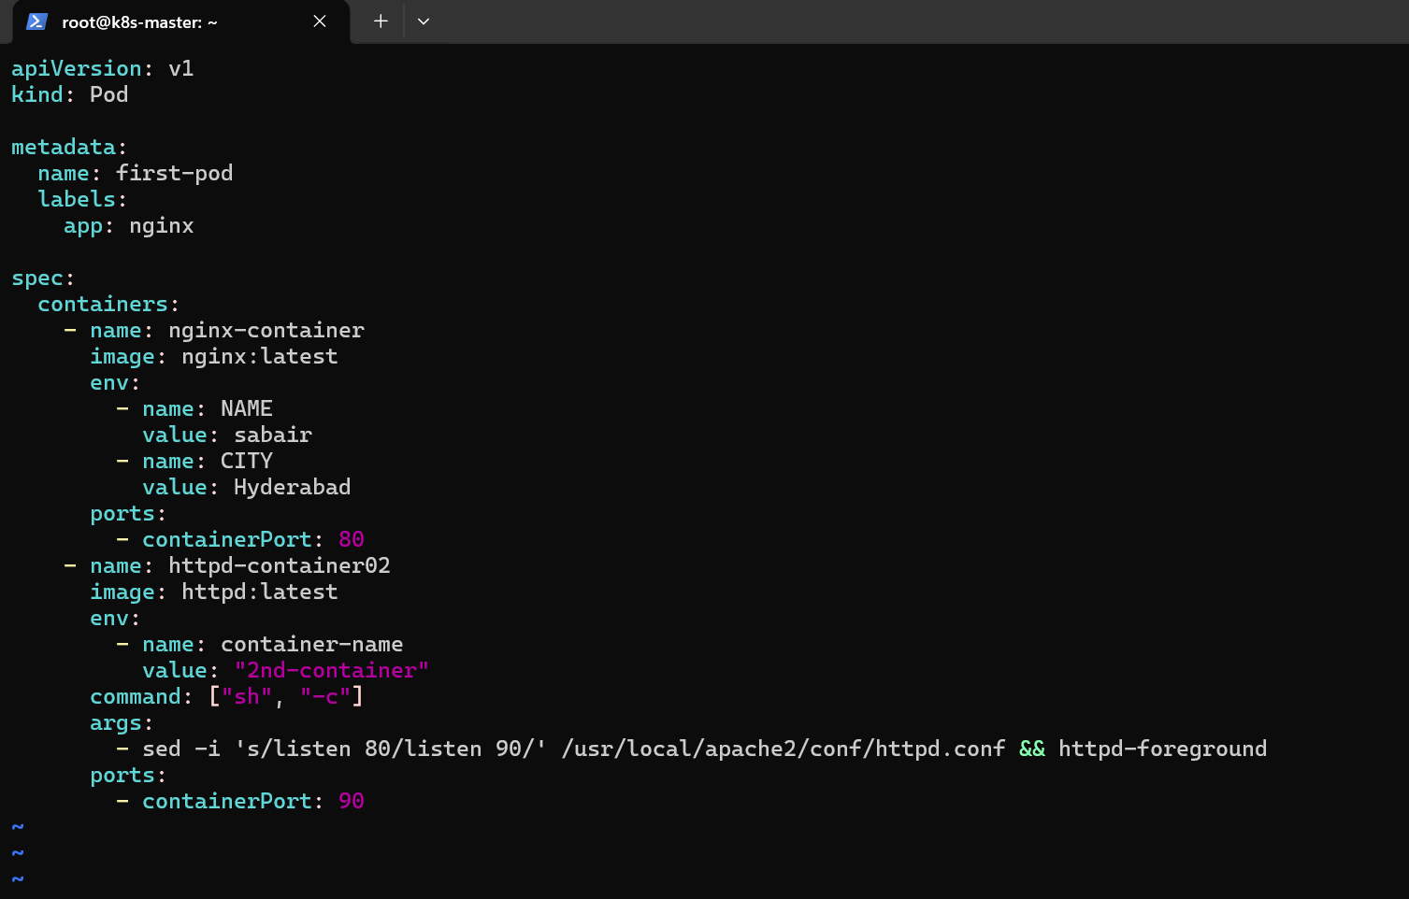

New pod has been created and it has 2 containers

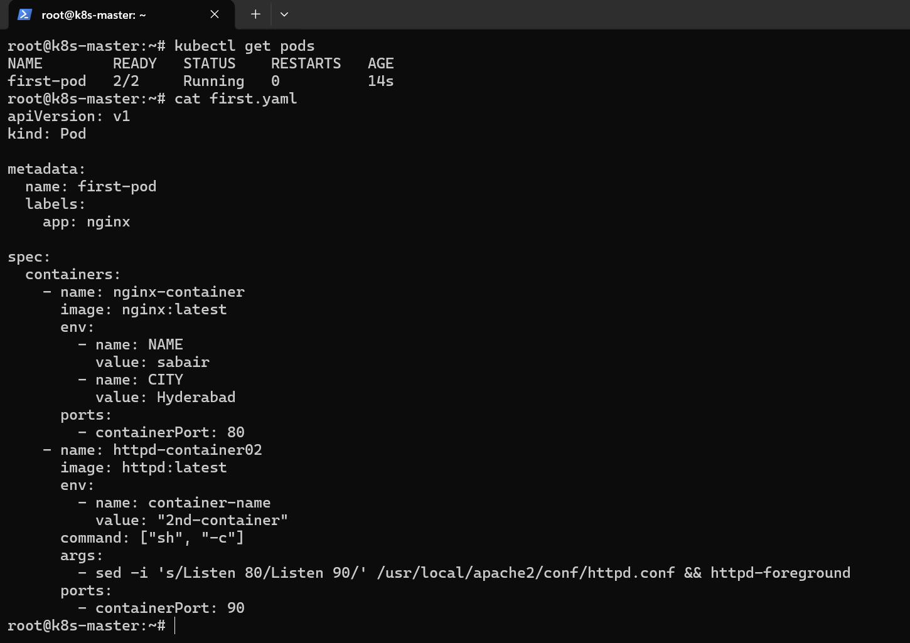

using

kubectl exec -it podname -c containername bash

And logged into the conatiner and check the connection using curl

I have used

Curl localhost to see the present contianer output

And

Curl localhost:90 to see the other container output from this container

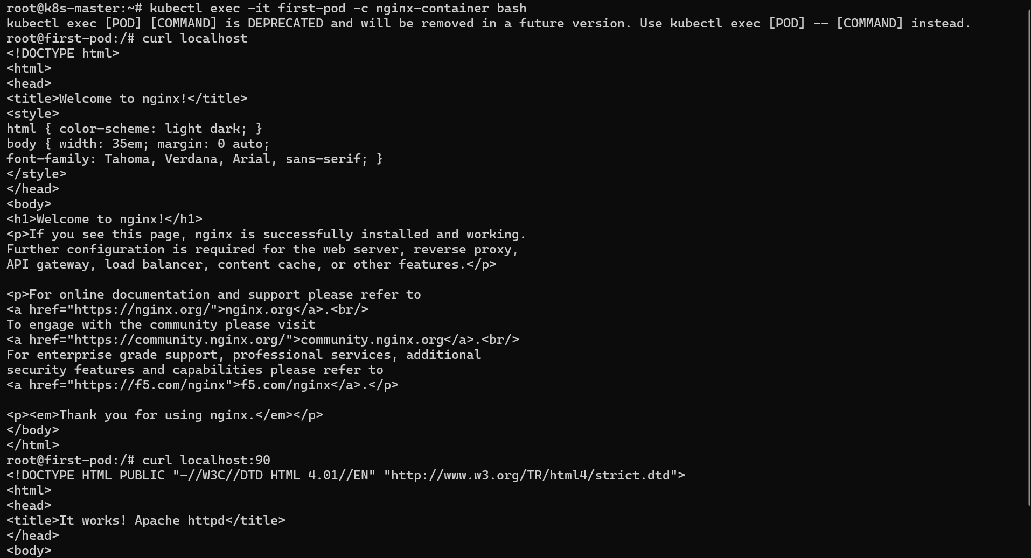

We can see I using curl both container output can be seen

Set Up an Init Container in a Pod

Task: Modify the YAML to include an init container that sleeps for 30 seconds before the main containers start. Verify the init container's execution using kubectl describe pod and check the logs to confirm its completion

Init container are used for running the container before the main container

Mostly we use init containers to download dependencies for the main containers like pulling source code form the github

Now we are modifying the previous yaml file for adding the new init containers

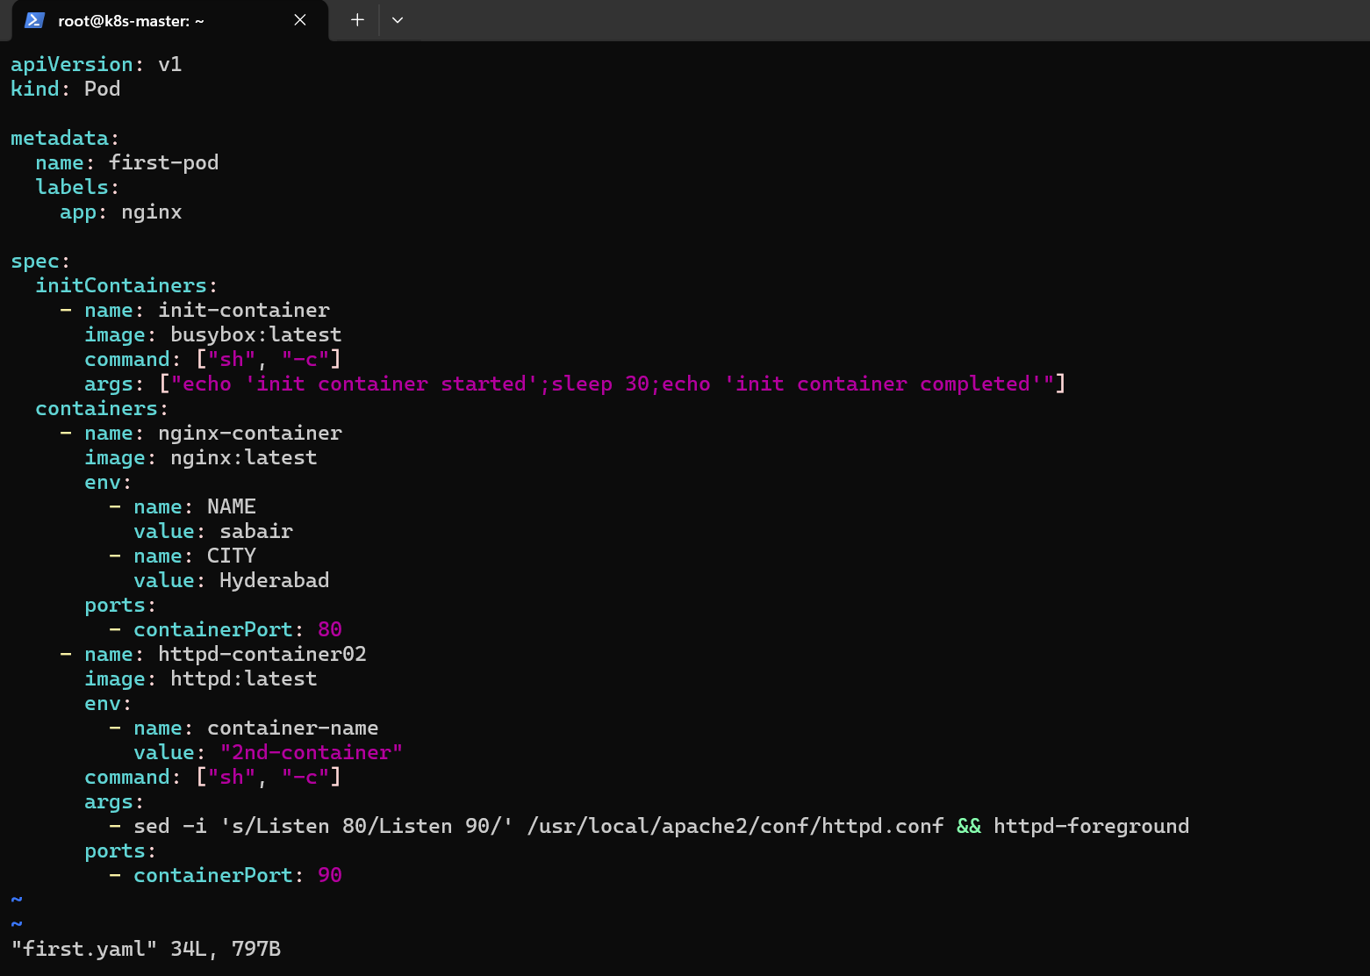

I have given init container at the spec starting

The command is to run the shell commands using arguments so that the init container sleeps for 30 sec and can be seen through the logs of the pod

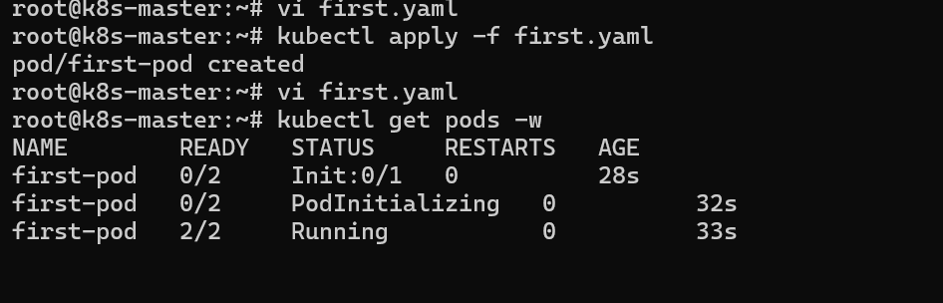

The 2 main contianers has waited till the intialization of init containers and after the two main container has been created

And also we can see the pods describe to the events
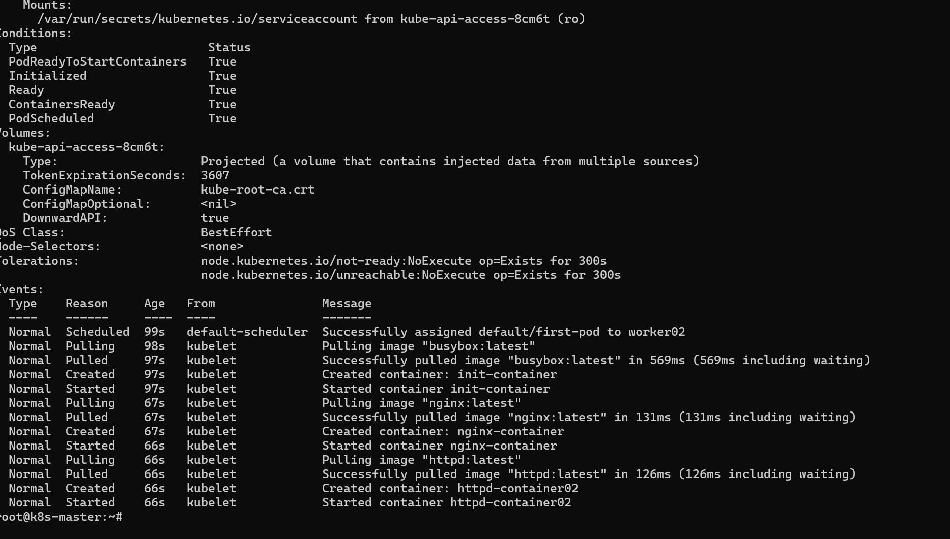

Run a Dry Run Command to Generate YAML

Task: Use the kubectl run nginx --image=nginx --dry-run=client -o yaml command to generate a Pod YAML definition. Modify the generated YAML to suit specific requirements (e.g., labels or environment variables) and deploy it

We use dry run to see the output of the command so that we can see what changes will be made

I have used dry run for nginx default image and see the output through the yaml
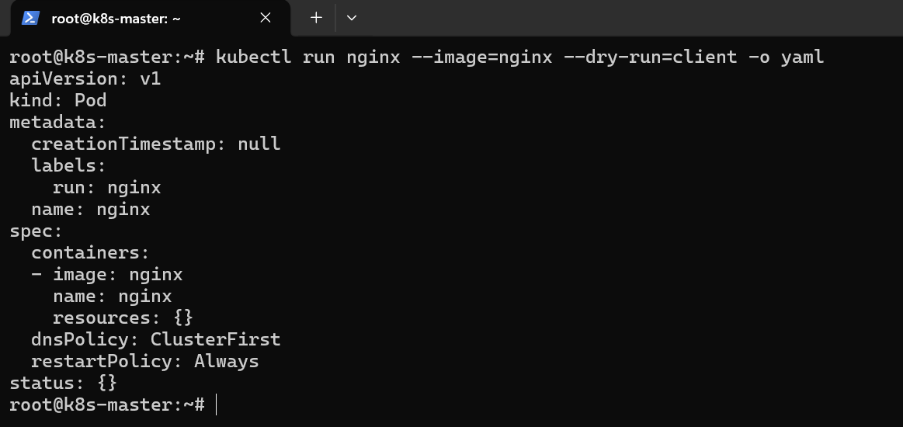

Now I will be saving the output of the command to a yaml file and make changes to the yaml file adding the env and labels

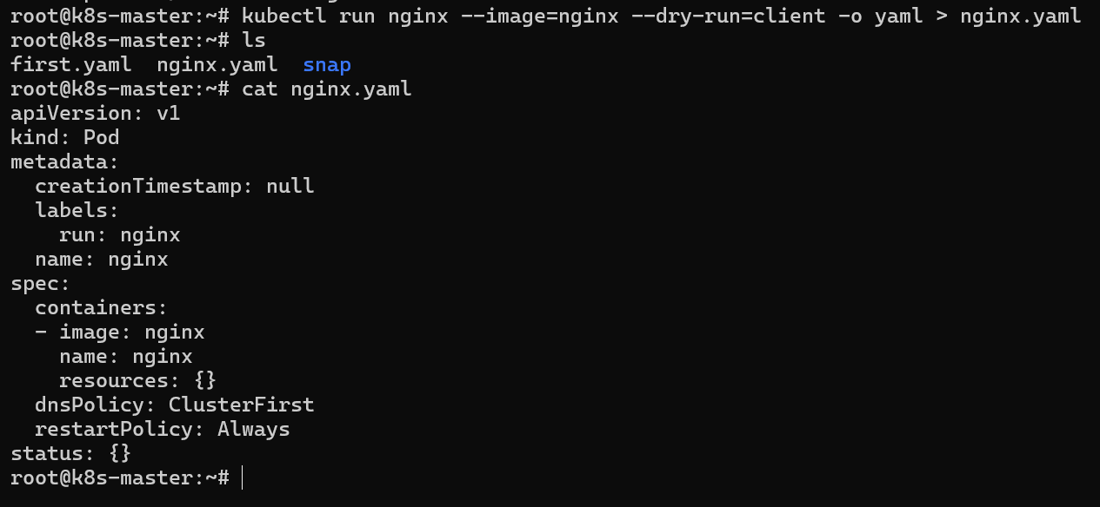

I have saved it to the file and making changes in the file and creating a pod with new changes

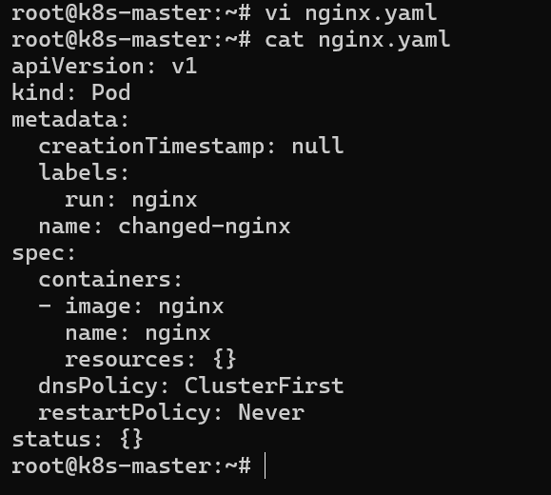

I have changed the name in labels and creating the new pod

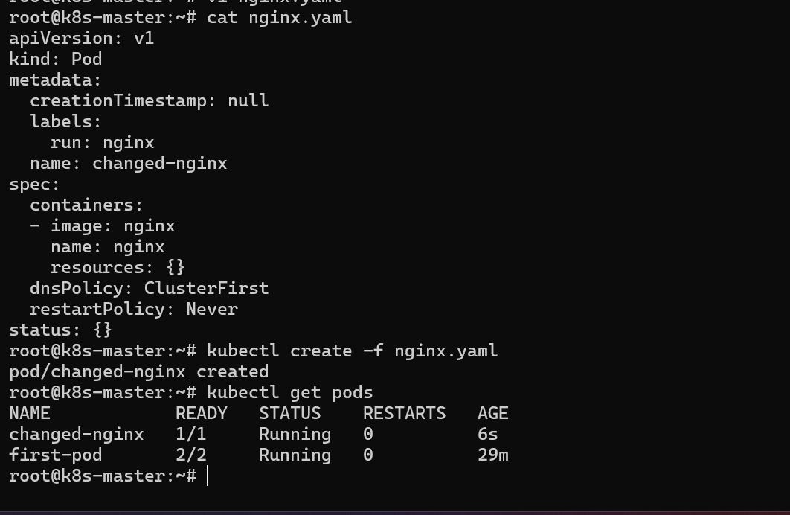

And new pod with new changes in yaml has been created

Use kubectl apply vs kubectl create

Task: Create a YAML file to define a Pod. First, deploy it using kubectl create -f <file_name>.yml and then modify the YAML (e.g., change the image version). Use kubectl apply to redeploy and verify the difference between both commands

Creating a new yaml file and creating a pod kubectl create

Then making changes in yaml file

using kubectl apply to redeploy the pod with changes

Sample yaml file for kubectl create

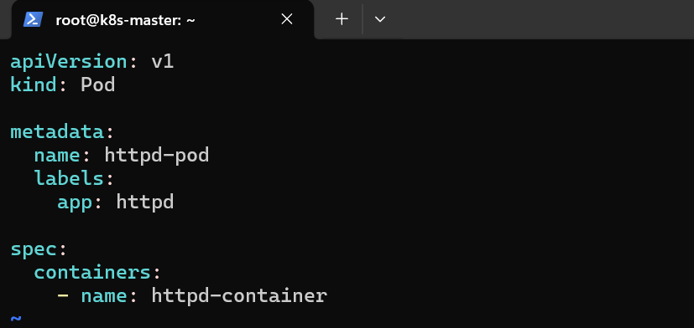

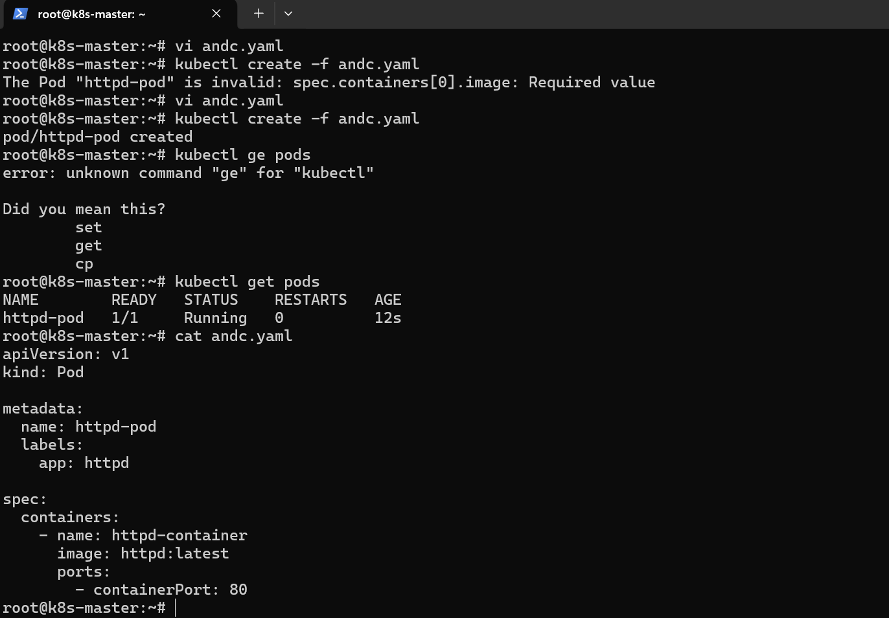

Created an httpd container using kubectl create -f filename.yaml

Now will make changes to the yaml file

And now we cannot use kubectl create because it is imperative object
So we will be using kubectl apply
For updating pod with updated changes in the yaml file

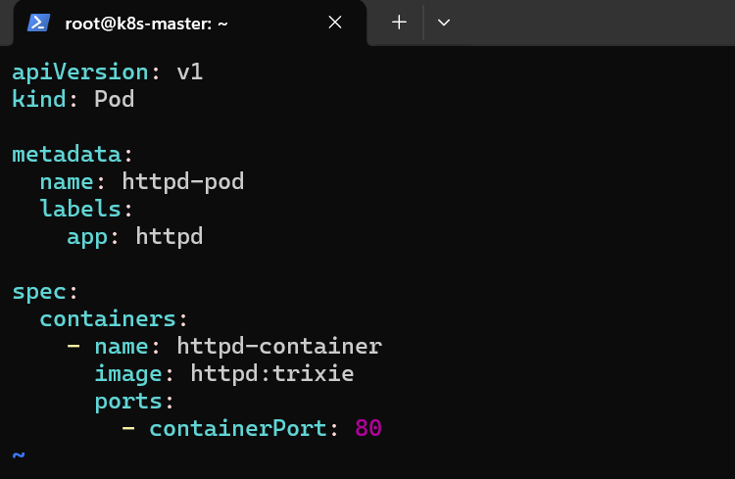

Made changes httpd with different tag

Now we will use kubectl apply command to update the pod

If we use create then pod wont update we should use apply

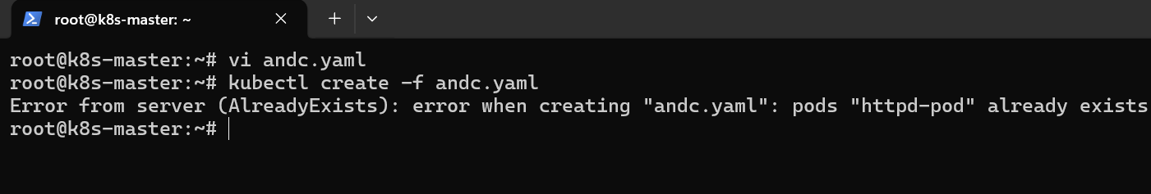

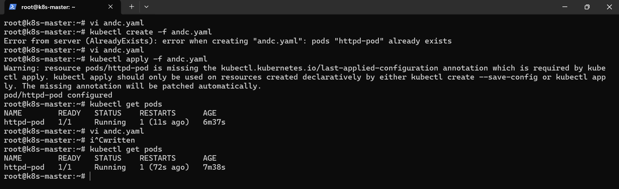

We can see the pod hass been redeployed with updated changes and restarted

Edit an Existing Pod Configuration

Task: Use kubectl edit pod <pod_name> to modify the running Pod's environment variables or image. After making the changes, verify if they took effect by checking the container logs or environment variables using kubectl exec

As I have deployed a pod

Now using the kubectl edit I will edit the pod configuration like giving the environment variables or an new image

As we know pod has been deployed with httpd image from previous step

We use

Kubectl edit pod podname

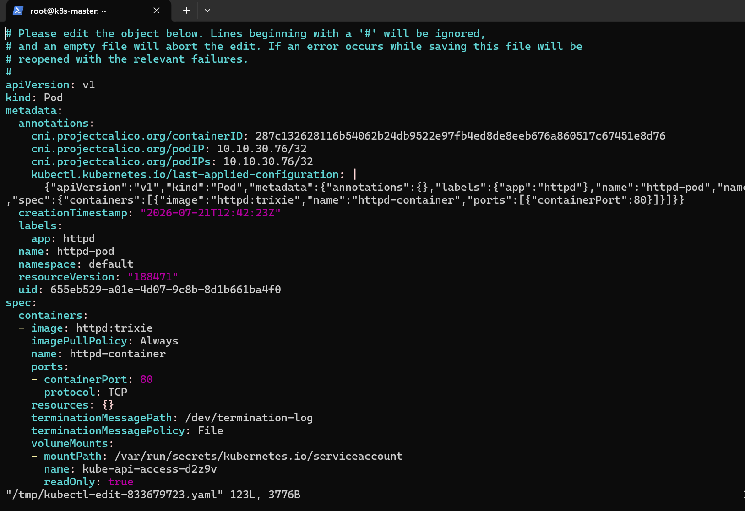

I have edited the label and

Image tag to latest and changes has been made and can be seen through describe pod

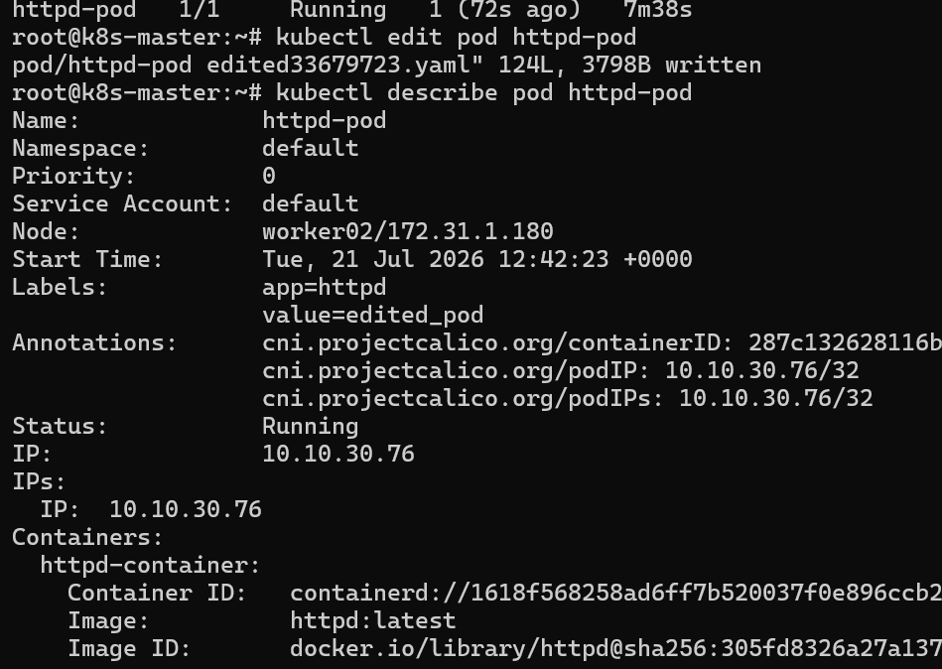

We can see the image id has been changed and label

Expose a Pod Using a Service

Task: Create a YAML file to expose your firstpod using a Service (ClusterIP). Ensure that your service is exposing the Pod on port 80 and verify it using kubectl get svc.

Creating a new pod and service using yaml file and exposing the pod on port no 80

As I have mentioned label for the pod

And in service I need to give the same label of pod to the selector in service

And assinging the nodeport manually or automatically

In either way we can give nodeport

And mentioned the target port and port of pod and service

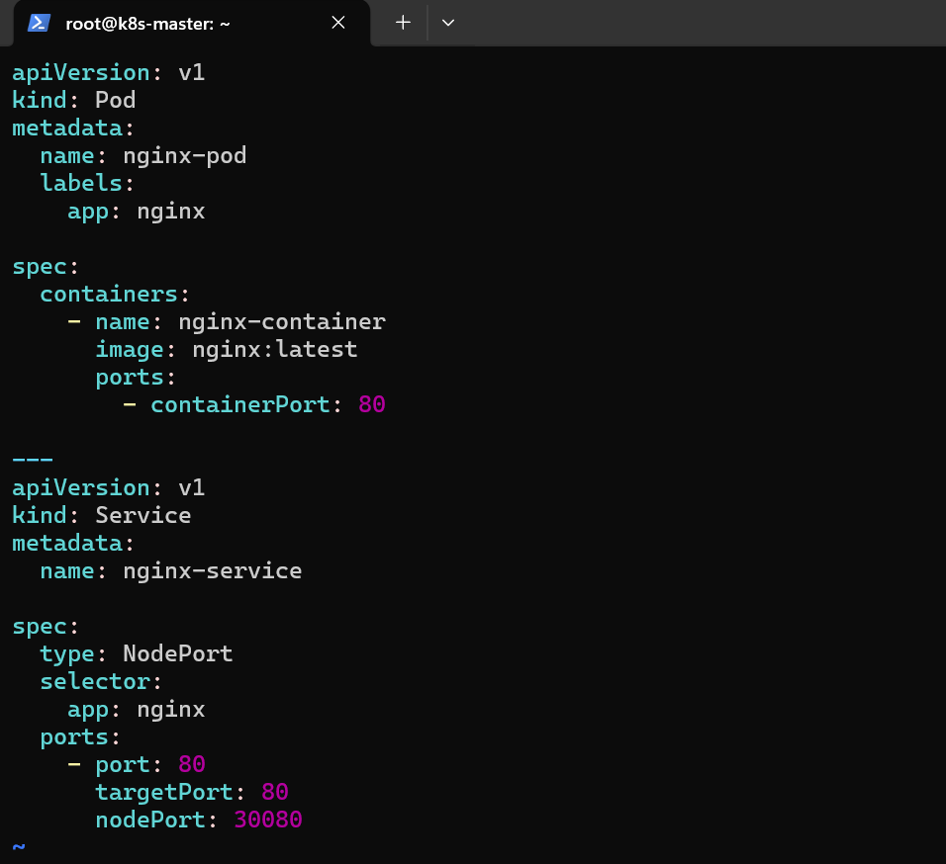

And using kubectl create

Created the pod and service

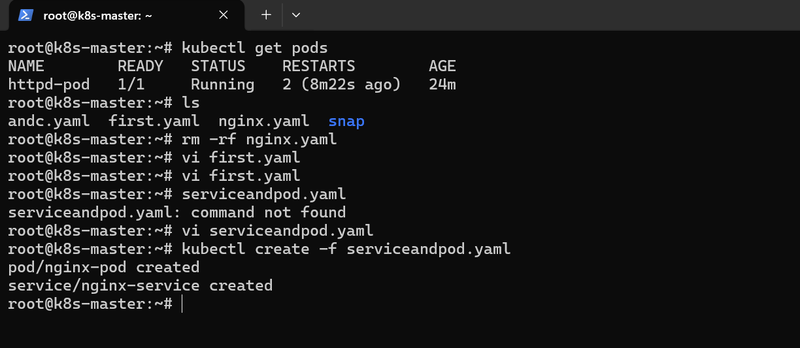

Pod has been created

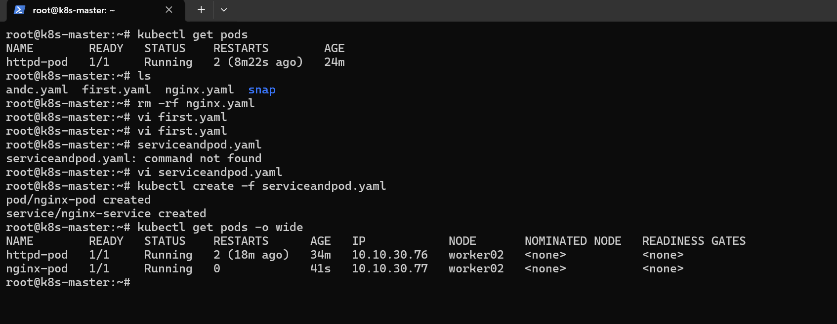

And service also created

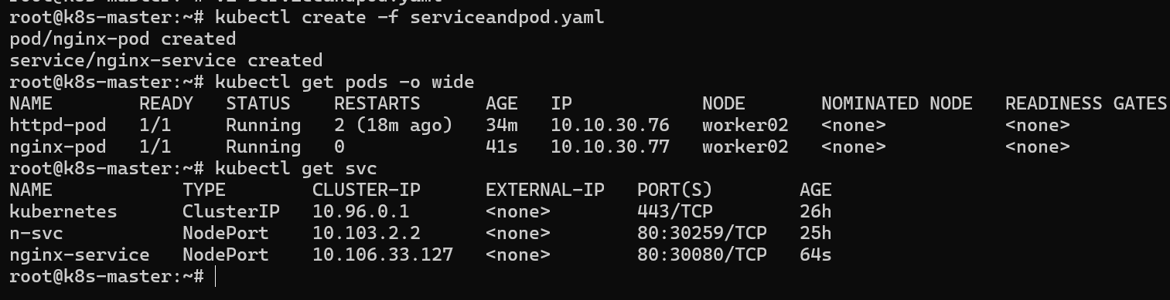

And using worker02 public nginx is accessible form nodeport port no

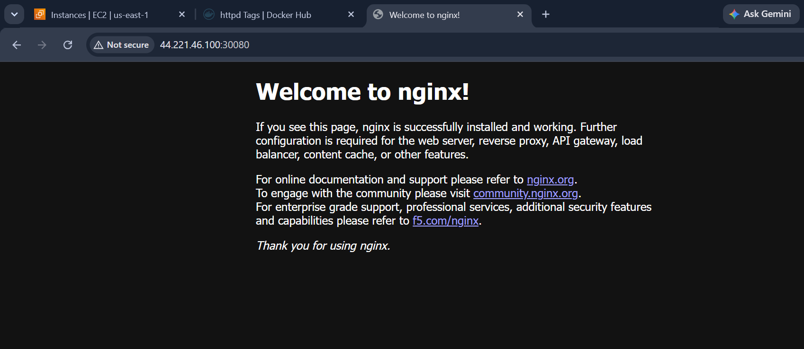

Pod with Resource Limits and Requests

Task: Add resource requests and limits to the containers in your YAML file. Specify CPU and memory requests/limits for both containers and deploy the Pod. Use kubectl describe pod to verify if the resource configurations are correctly applied.

Adding the resources

Requests and limits for the pod

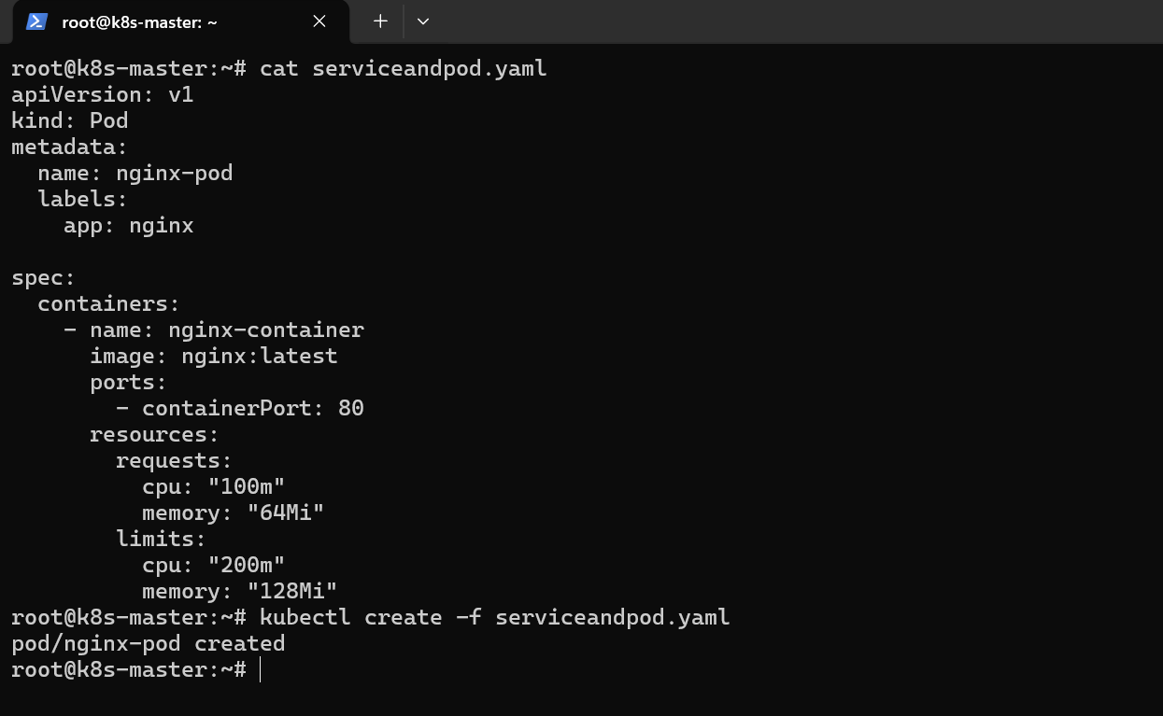

And the limits and requests has been updated

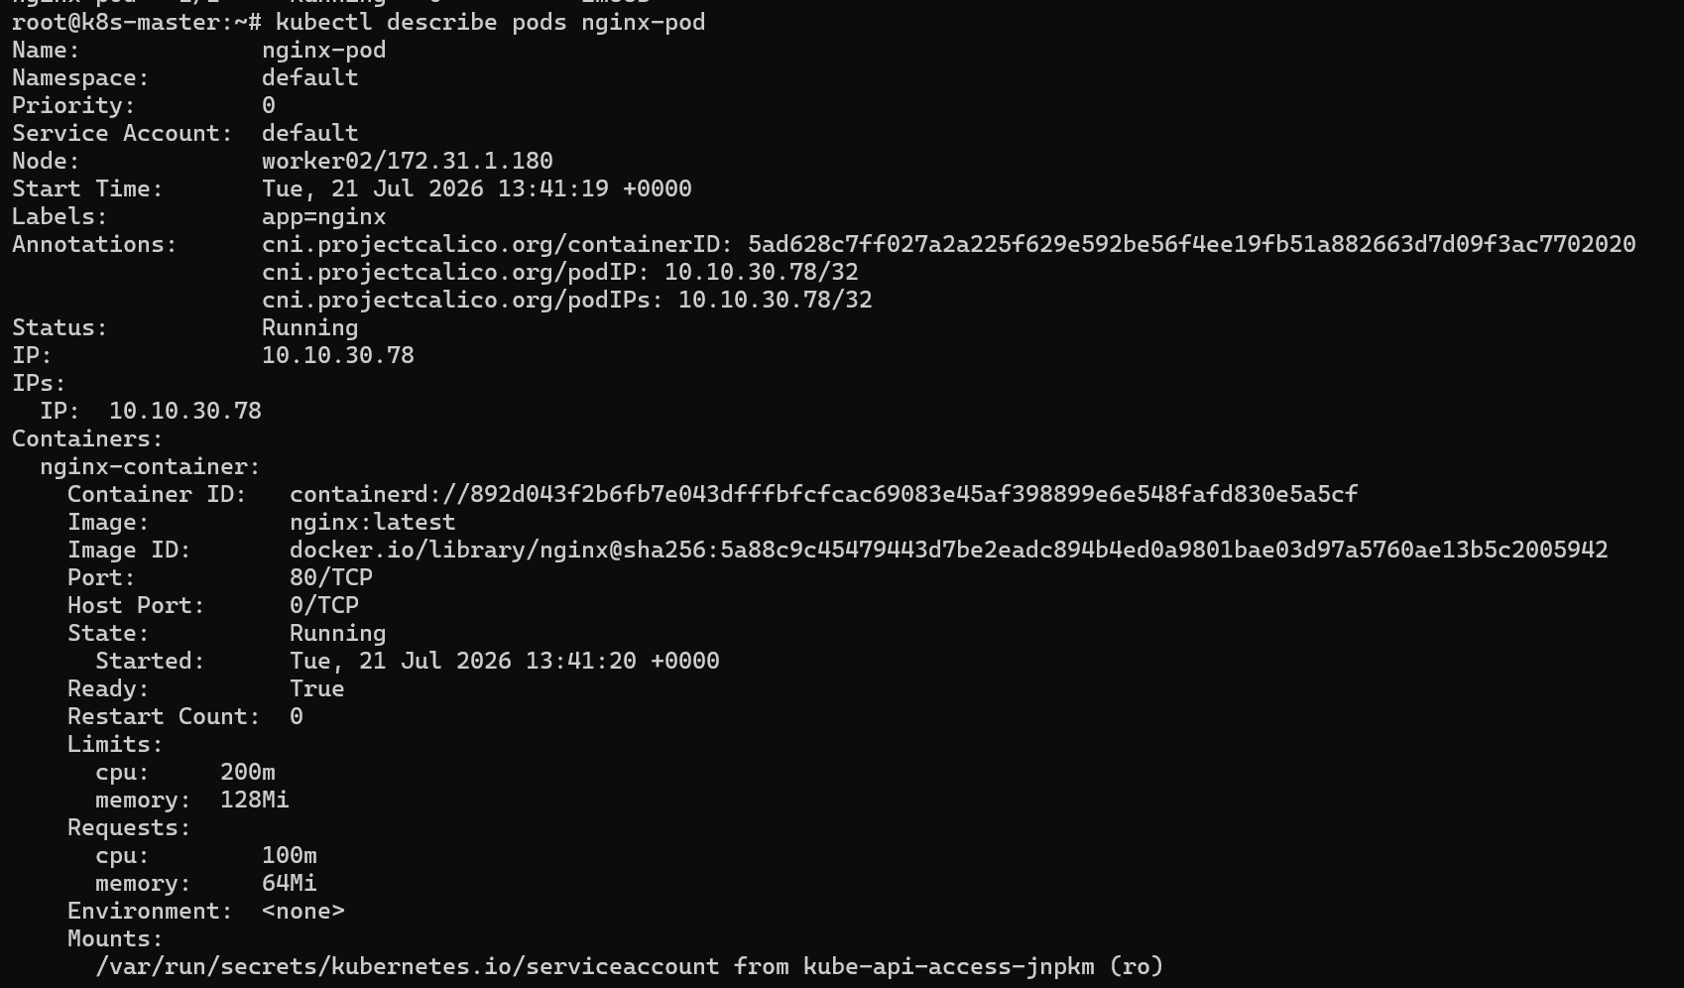

We can see through kubectl describe pods podname

And the resource can be seen

