Create a namespace dev-environment and apply a resource-based quota that restricts the number of pods to 3 and services to 2

Step 1:-

Creating a new namespace named= dev-environment

Then writing a yaml file for limiting or restricting the creation of pods and services to 3 and 2 using the resource-based-QUOTA

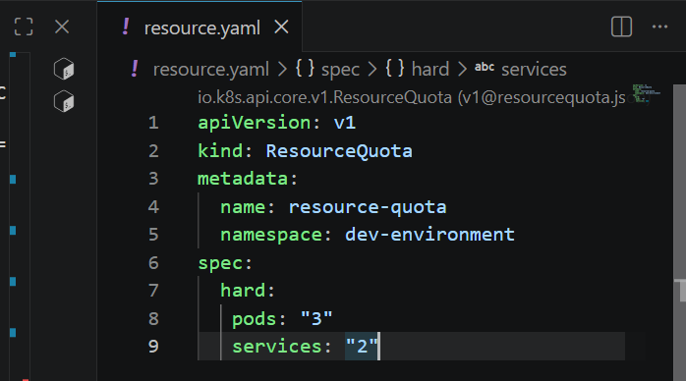

It describes as 3 pods and 2 services are limited to the namespace

We can see that it has limited to pods 3 and service to 2

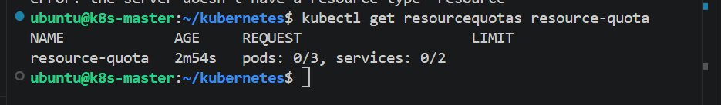

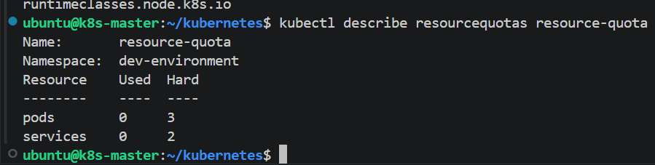

Create a pod in the prod-environment namespace with 0.2 CPU and 200Mi memory requests, and 0.5 CPU and 500Mi memory limits

Writing a new yaml for creating a pod in another namespace and limiting its resource requests and limits

Resource requests
Cpu 0.2
Memory 200mi
Limits
Cpu 0.5
Memory 500mi

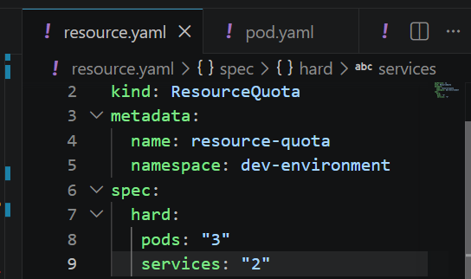

Creating the pod using yaml file

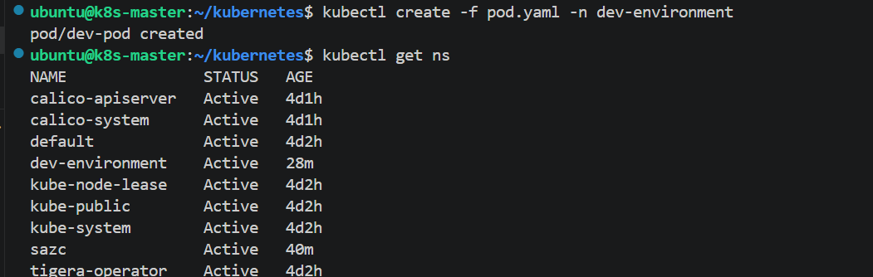

And we can see the pods in the dev-environment and pod has been created
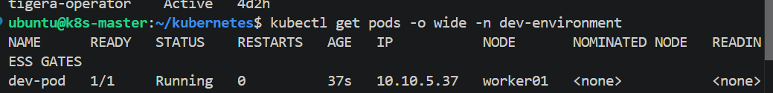

And if I describe the pod we can see the resource limits and requests

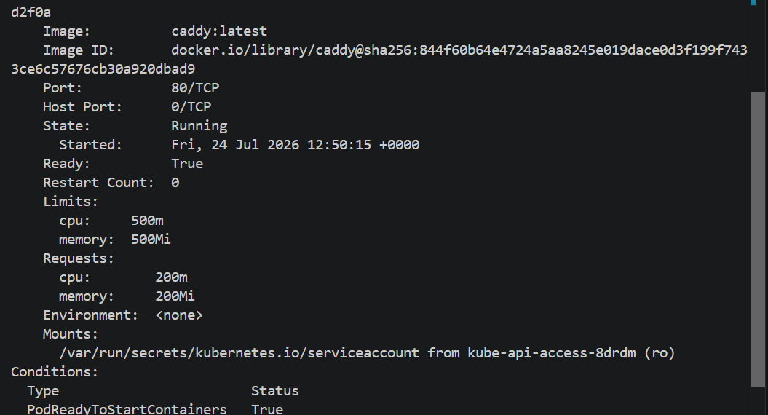

In the staging-environment namespace, set a LimitRange that assigns default CPU and memory limits (300m CPU, 600Mi memory) and applies a minimum and maximum CPU

I have given default limits for the namespace and if I create a new pod without the resource requests and limtis this will assign the given default values for the pod in the namespace

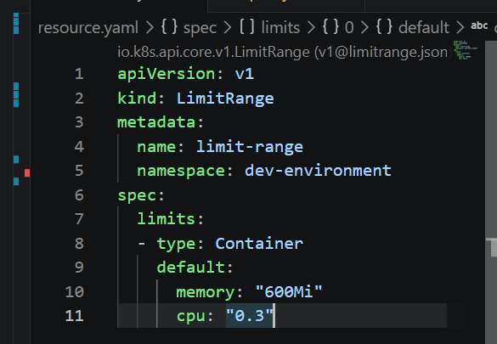

And pod yaml file don’t have any values

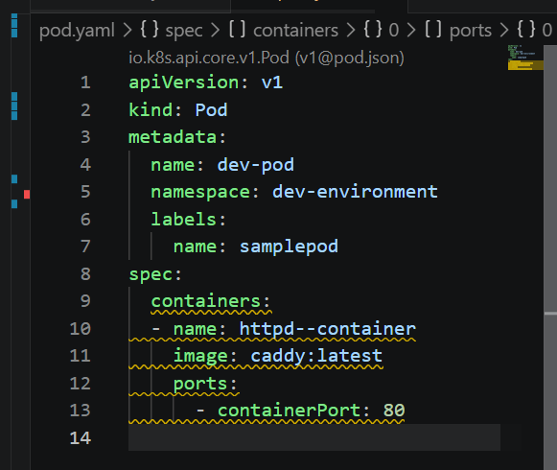

And it should assign the default values for the pod that the limit range has assigned

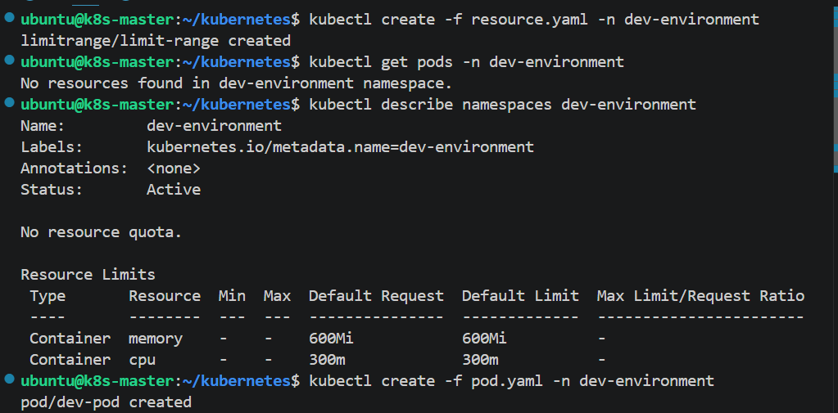

And the pod has the limitrange default values

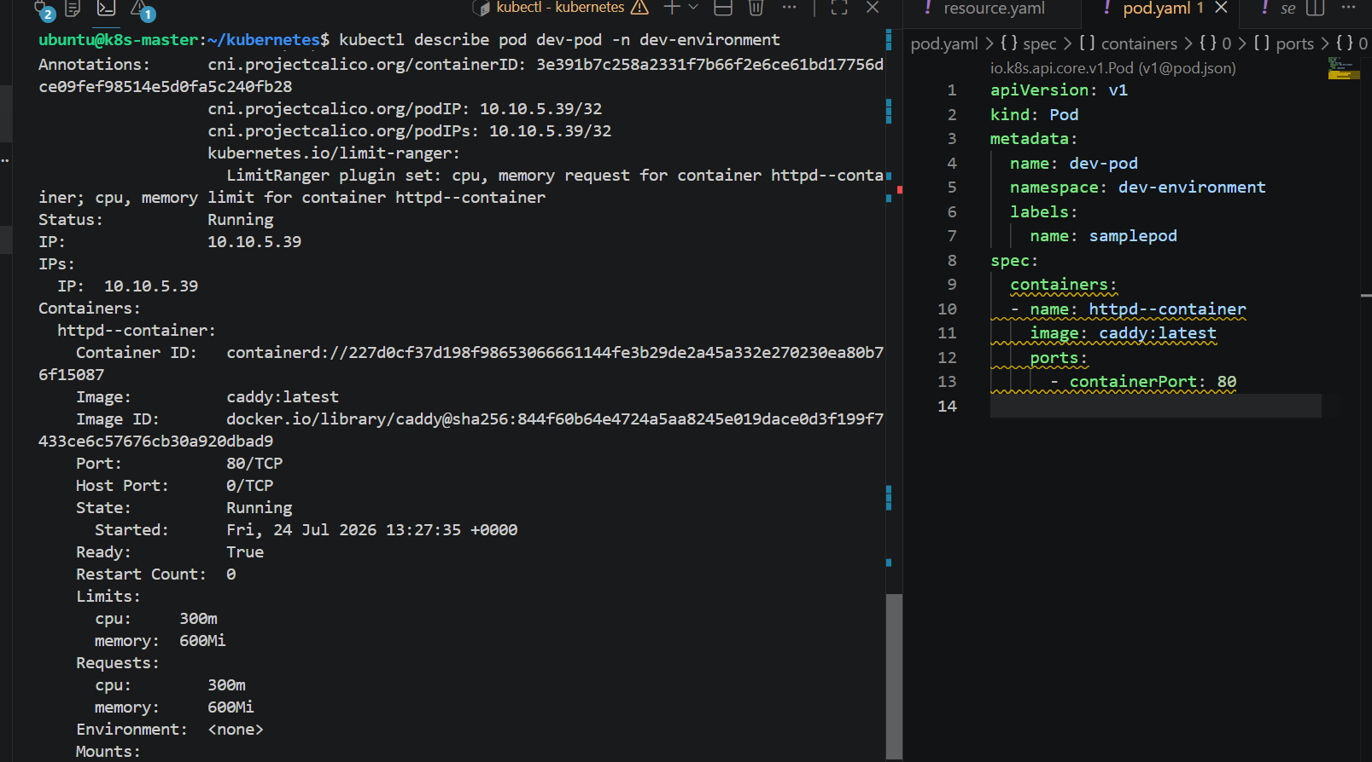

Create a pod and a NodePort service in the default namespace, then create another pod in the test namespace and communicate between them using Service DNS

Created two pods in default namespace and in dev-environment namespace

And exposed using the nodeport

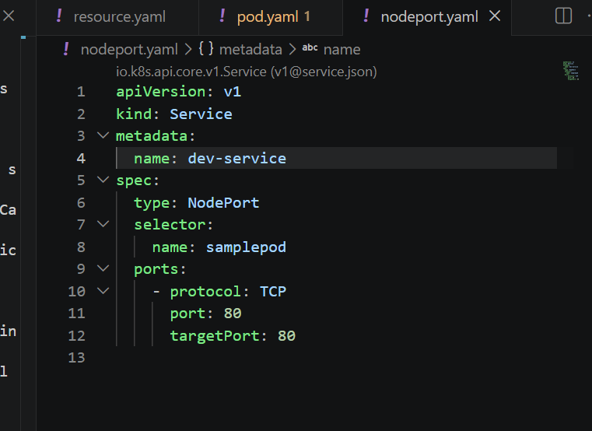
Using curl

Curl servicename.namespace.svc.cluster.local

If it displays the web server then we can know that the communication b/w two pods in different namespace has been developed

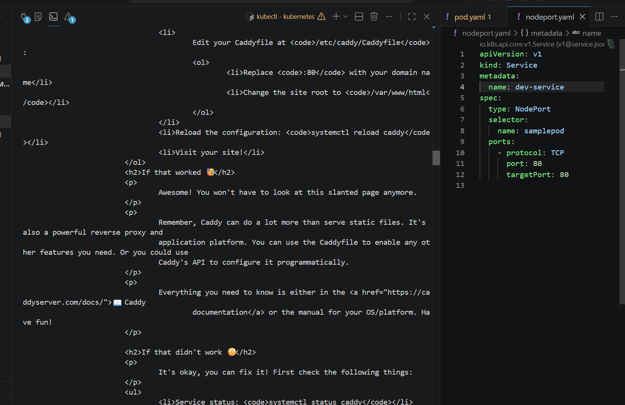

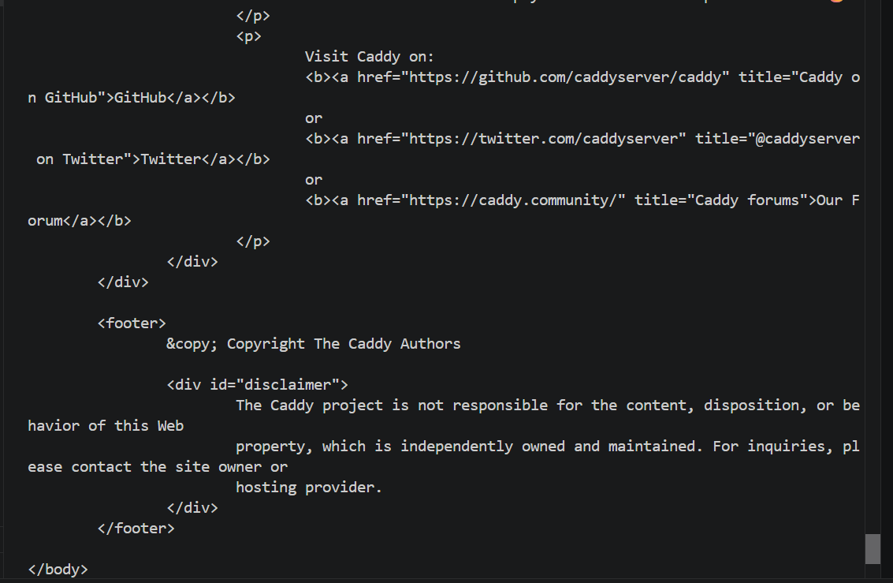

By using curl we can see the pod in other namespace has been communicating with pod in this namespace

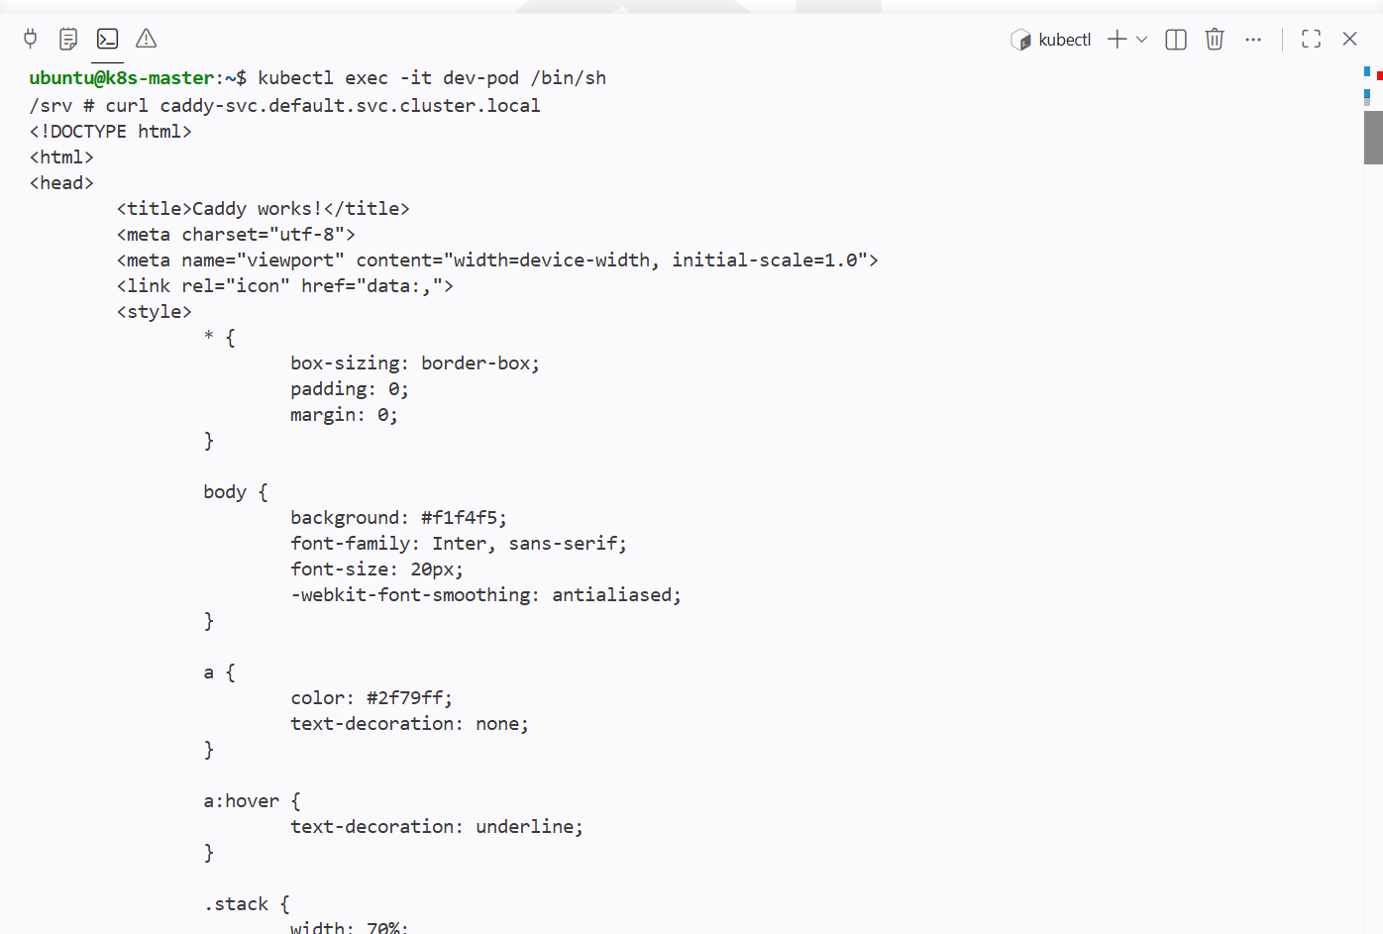

Apply a LimitRange with a max limit/request ratio of 2 for memory in the performance-environment namespace, and test by creating a pod with mismatched resource requests and limits

Writing a yaml file for maxlimitrequestration of 2 for memory

Namespace: performance-environment

Kind: limit range
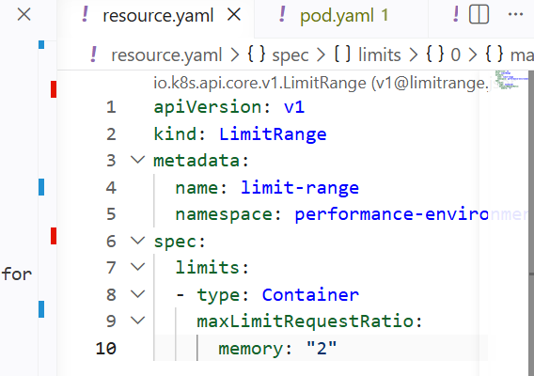

And creating the limitrange for the namespace performance-environment

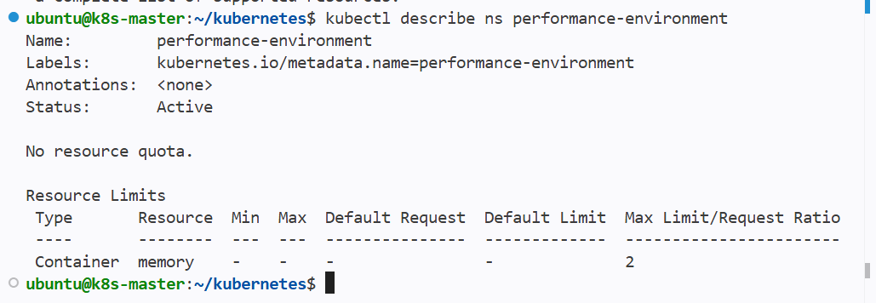

And we can see the namespace max limit request ration as 2

If I create a new pod with mismatched config for pod resource then the pod wont get created

It should satisfy the given ratio of 2

If the ratio id more than 2 then pod should not create

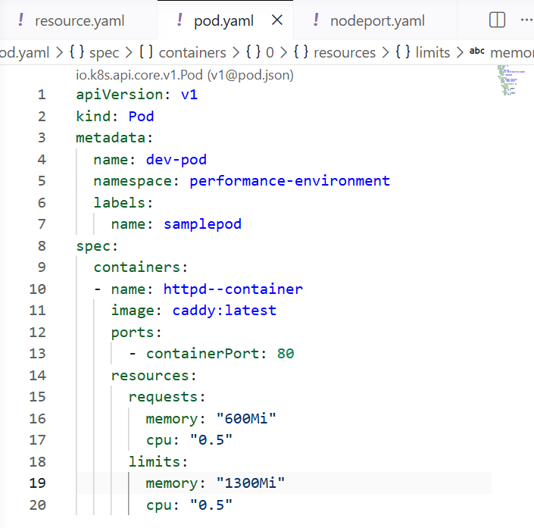

The pod memory configuration cannot satisfy the ratio of 2
The ratio of requests and limits memory is more than 2

And the pod is not getting created

