Deploy an application using a Deployment with 3 replicas and a rolling update strategy

Creating a new yaml file and deplying an application using deployment

It should contain 3 replicas

Strategy:- rolling update

New yaml file for deployment

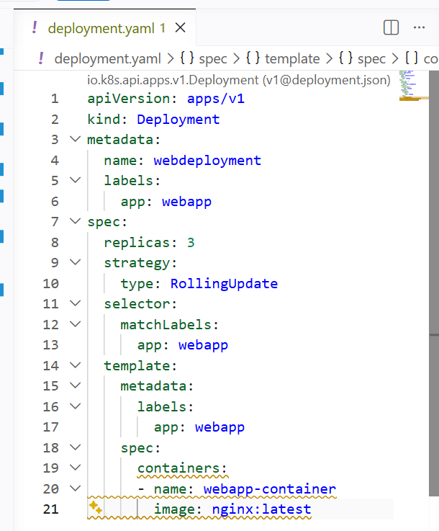

I have configured replicas as 3

Startegy as rolling update

Then creating the deployment

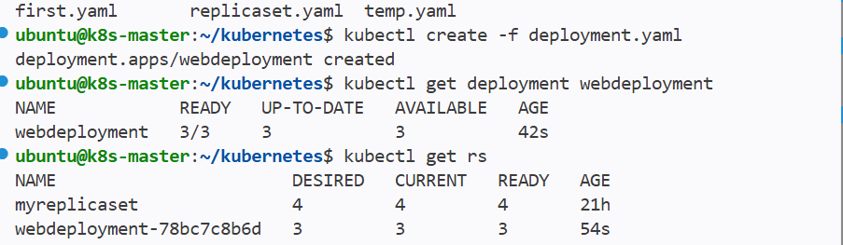

It has created a deployment and replicaaset and pods

And If I do describe deployment it give the entire info about my deployment

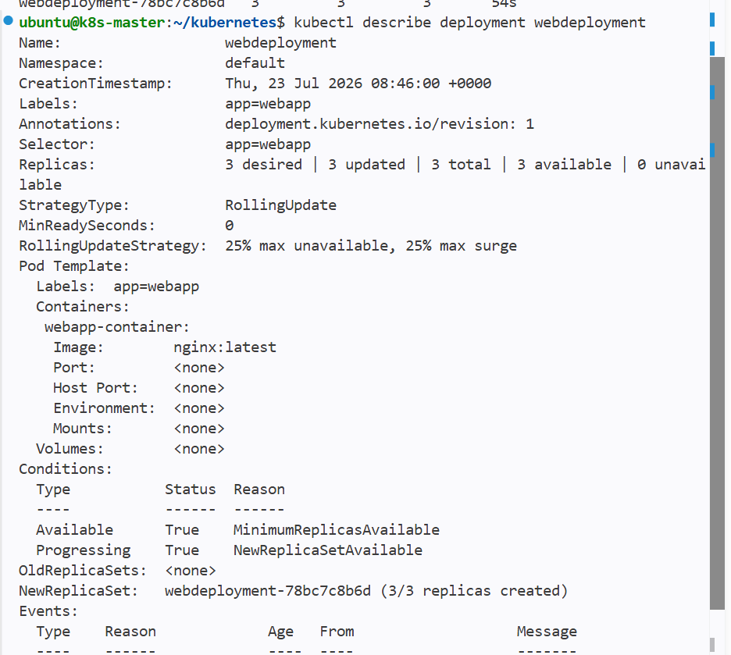

We can see that it has startegy as rolling update

Configure a Deployment with a Recreate strategy and observe the downtime

Configuring a deployment with recreate startegy

And this startegy has downtime when ever we update the deployment

Created new yaml file for recreate strategy

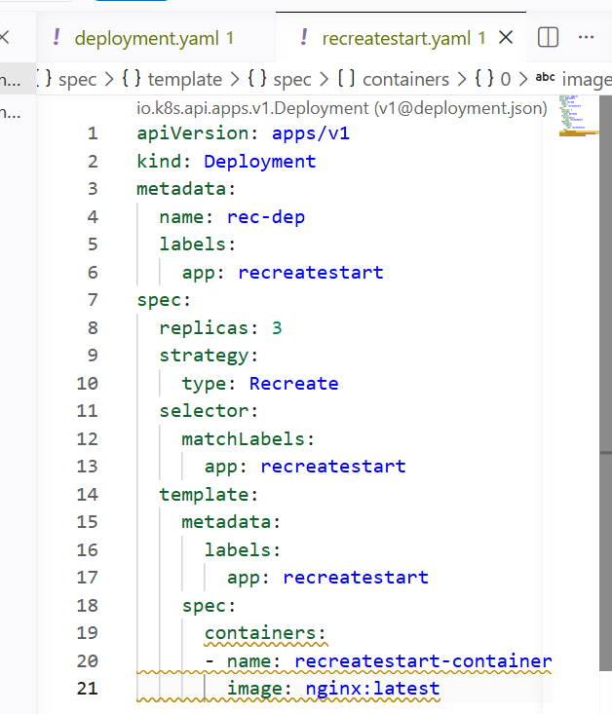

Mentioned startegy as recreate

This strategy has downtime whenever we update deployment

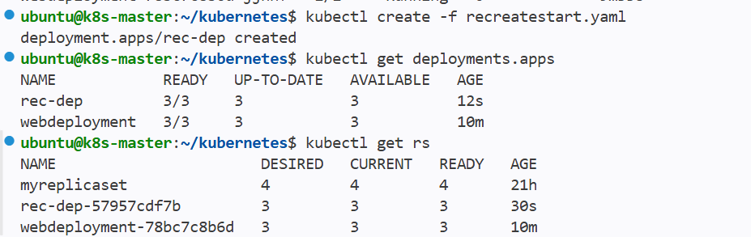

It has created a new deployment and replicaset

Observing downtime for recreate strategy

Now I will update the deployment and watch the downtime for pods and replicaset

I have changed the image name in deployment yaml file

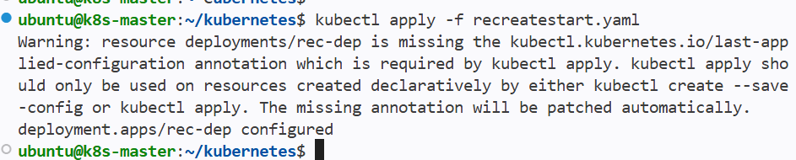

We can see that replicaset created 3 pods

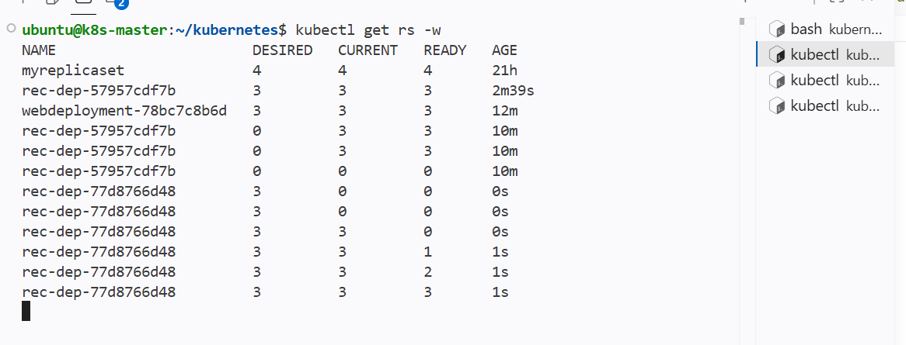

And while seeing the pods creation then we can observe a slight downtime for pods creation

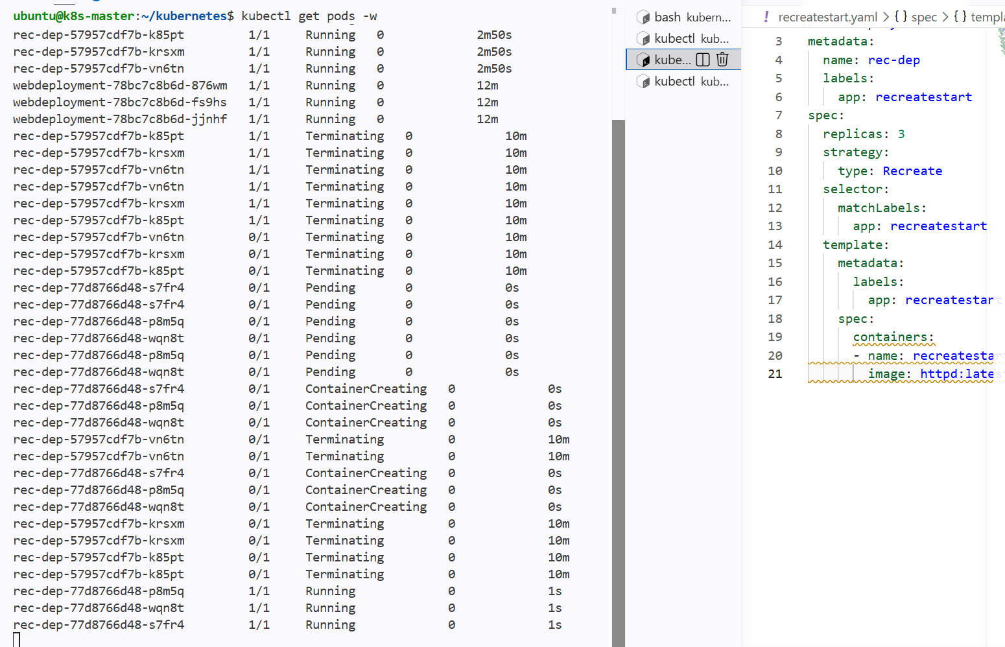

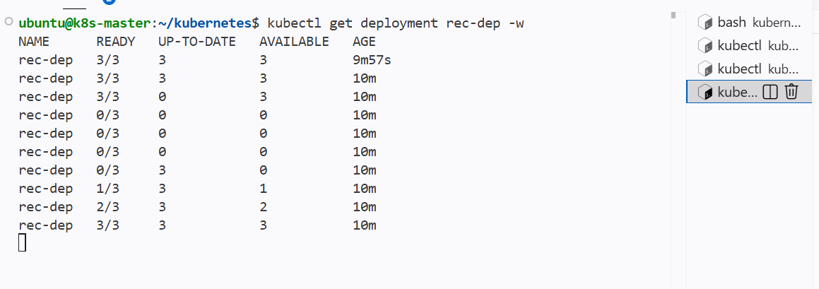

Update an existing Deployment and perform a rollback to the previous version

As I have updated a recreate strategy deployment earlier I will roll back to the previous update

That my updated image httpd should be changed to the nginx image

First checking the revisions of my deployment

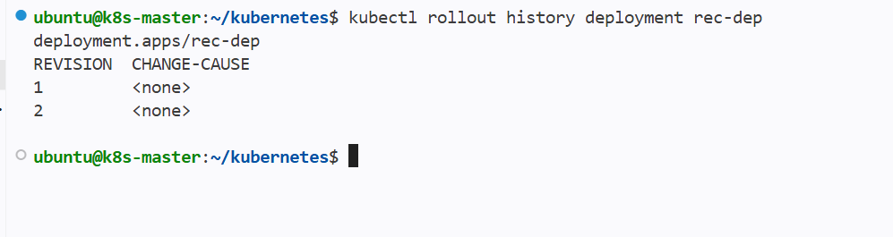

As I have 2 revisions and 2 is my latest update

We need to roll back to the last revision that is 1

Syntax:--

Kubectl rollout undo --to-revision=1 deployment <deployment name>

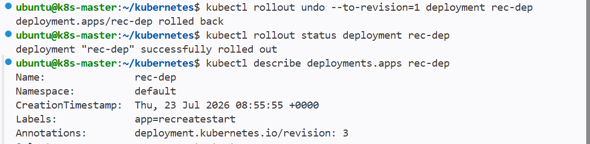

We can see the deployment has been rolled back and in annotation it says revision 3

Andx in below ss we can see the image has been changed to nginx that is before updated deployment

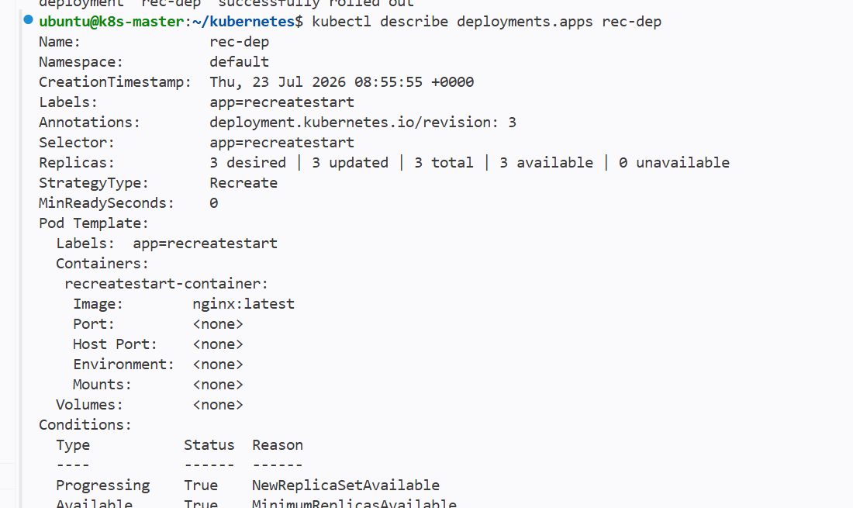

If we check history it generated a new revision no 3

We can also specify how many revisions we can see through cli

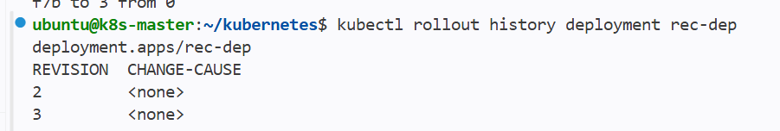

And still my file has current update configurations

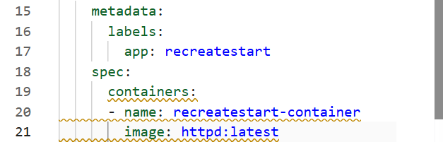

Modify a Deployment to add resource requests and limits for CPU and memory

Adding the resource requsts for deployment

So that pod will get specific allocated cpu and memory from the node

The sheduler checks for the given cpu and memory

After checking the space from node the sheduler assigns it to the node

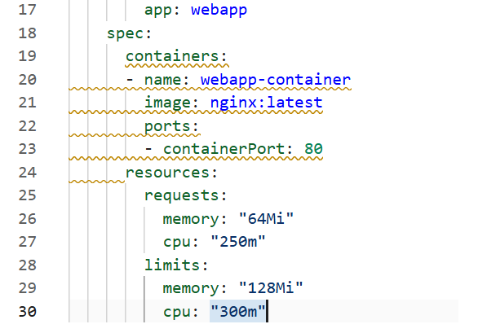

Added resource requests to the container so that this pod has only mentioned cpu and memory

And requests is minimum and

Limits is maximum for a pod and sheduler checks for this memory in the node and assigns

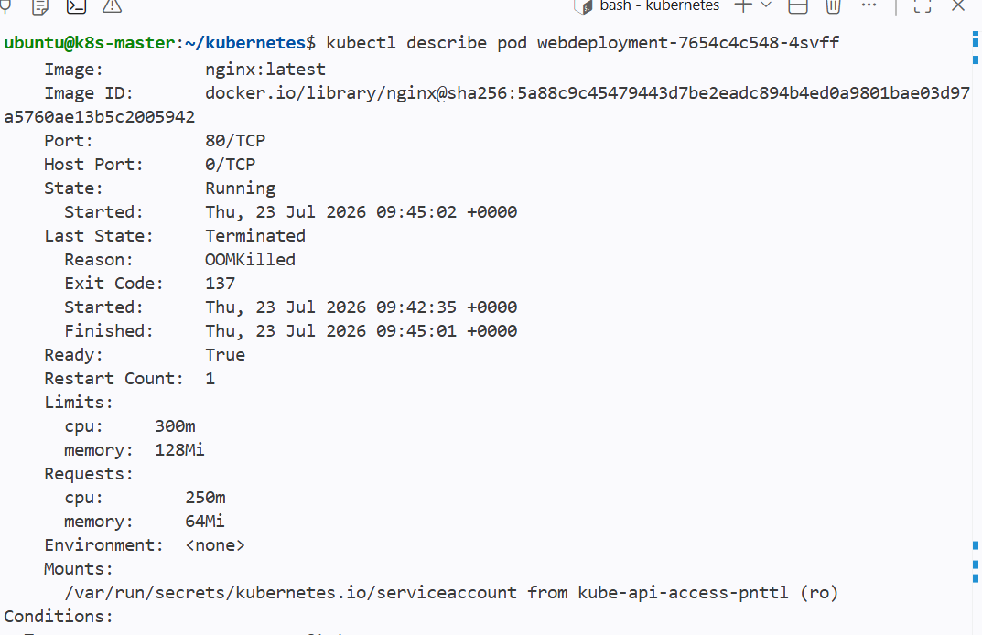

Using the describe pod we can see that pod has its resource requests and limits

Create a Deployment with MaxSurge and MaxUnavailable configurations

We can use maxsurge and maxunavailable for the update strategy

Maxunavailable:

It is an optional field that specifies the maximum number of Pods that can be unavailable during the update process

We can give value as number or percentage

Maxsurge:
If maxsurge is 2 then kubernetes will temporarily create 2 new pods at the point of time and after the update is finished it deleted the temporary pods so that the users still access the application.Maxsurge specifies the maximum number of Pods that can be created over the desired number of Pods

If I have replica pods as 10 and gave maxsurge as 2 then total 12 pods will be created and after the update the 2 pods will be deleted and only given replica pods will be present

Giving maxsurge and maxunavailable in yaml file for the update

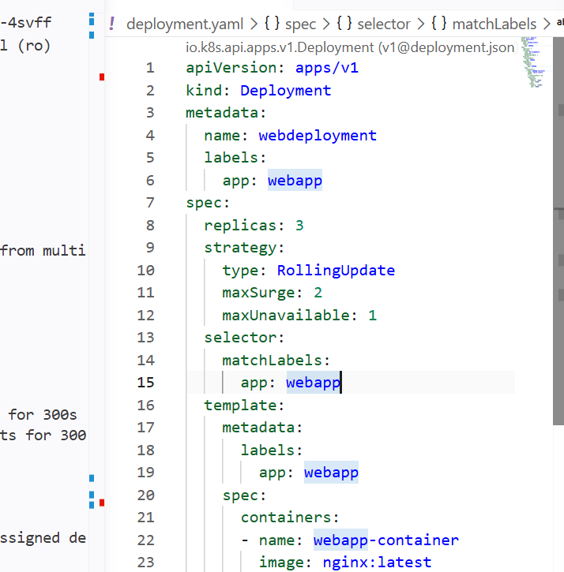

Mentioned maxsurge as 2

Maxunavailable as 1

so whenever we update the deployment then the 1 pod will be down and new one pod will get created with new update and during the update it should create 2 new pods as mentioned in the maxsurge.

Updating the deployment and checking the logs

Changing the yaml with container image from nginx to httpd

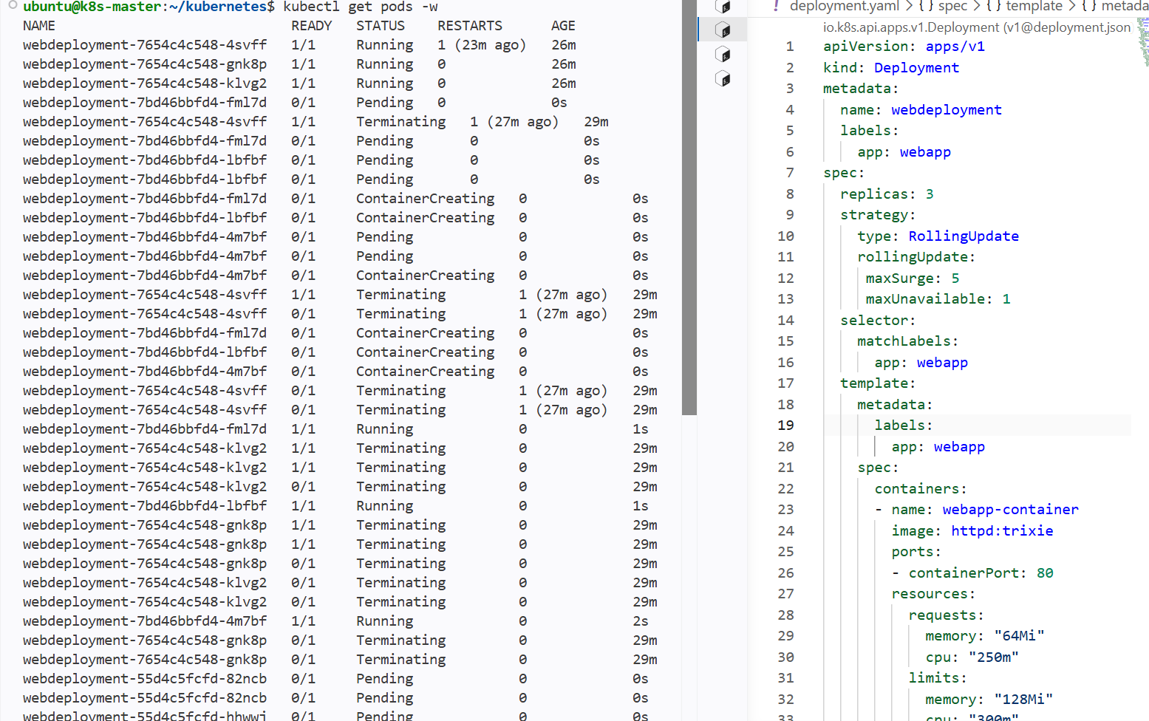

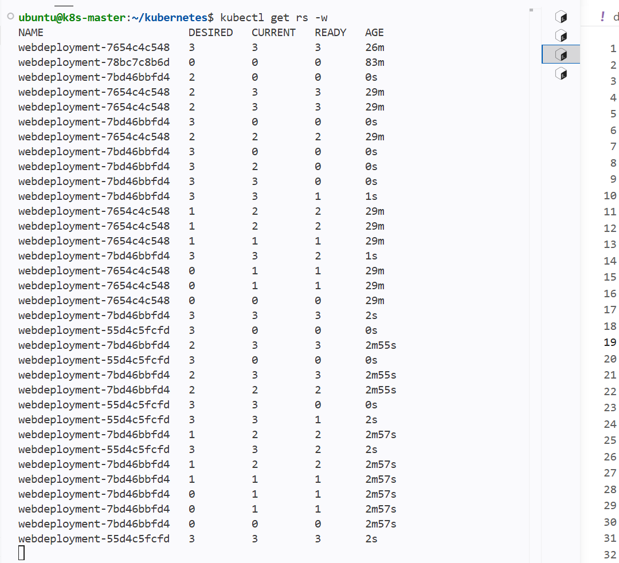

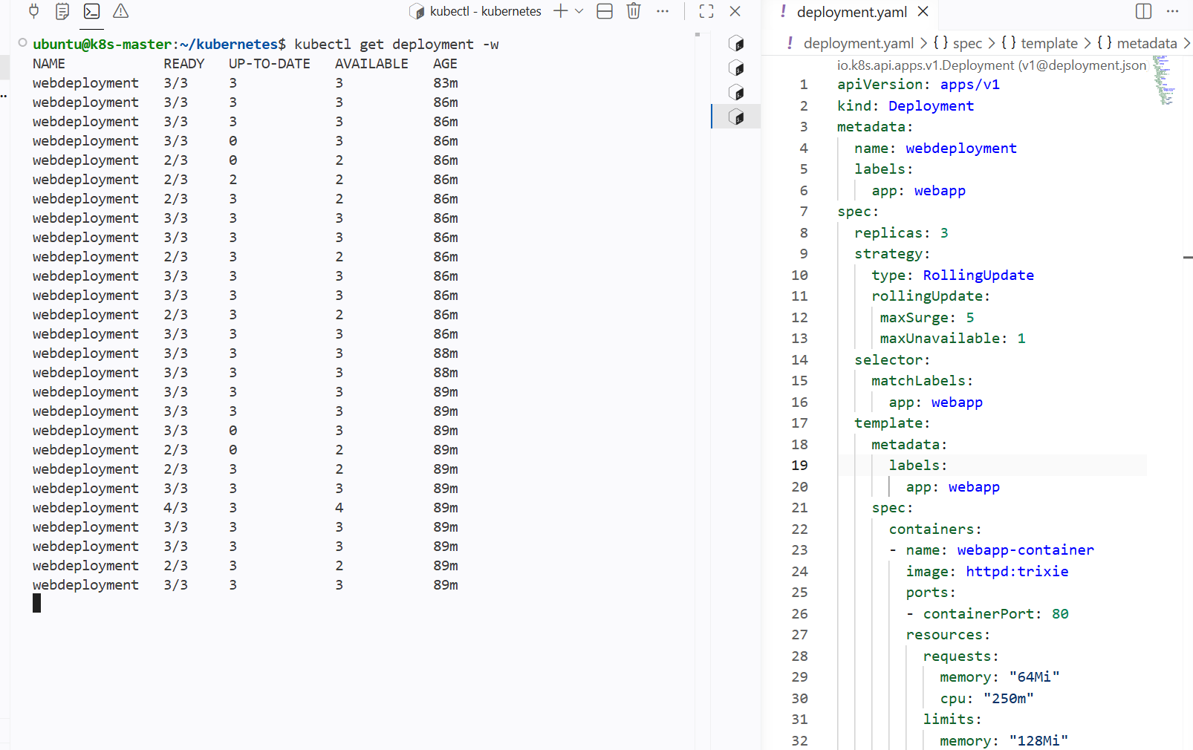

Her we can see that new pod has been creating and 2 pods are running so that it staisfies maxunavailable and only one pod has been terminated and deleted

And again updated with maxsurge as 5 then it did not create new 5 pods because the pods 2 were already running and 1 was pending so it called only one

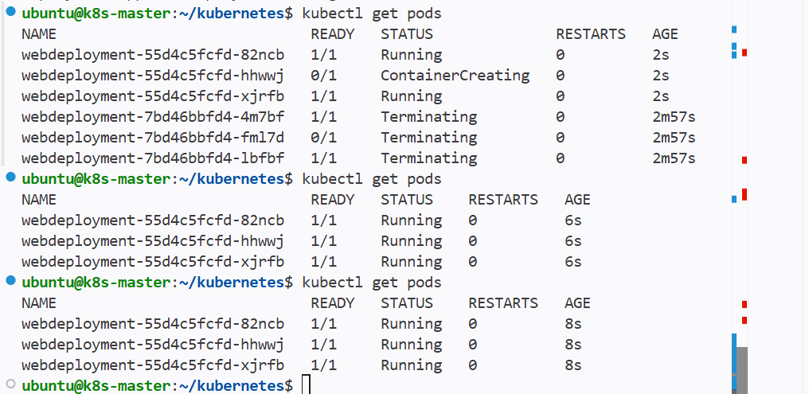

Set up a Deployment with a custom revision history limit

Whenever we see the history of a deployment it only shows 2

We can change the revision history limit in the yaml file

By this we can see the revision limit in history as given

Configured the revisionhistorylimit under specs of deployment to 5
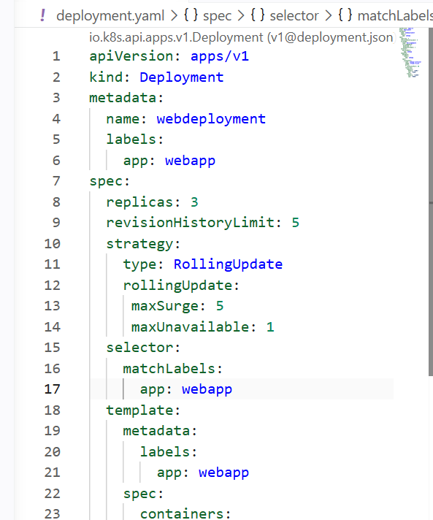

Now it shows the 5 revision history

As the update done for deployment is 4 then only 4 revisions can be seen

If it is 5 times then we can see 5 revision and we can increase the limit if we want

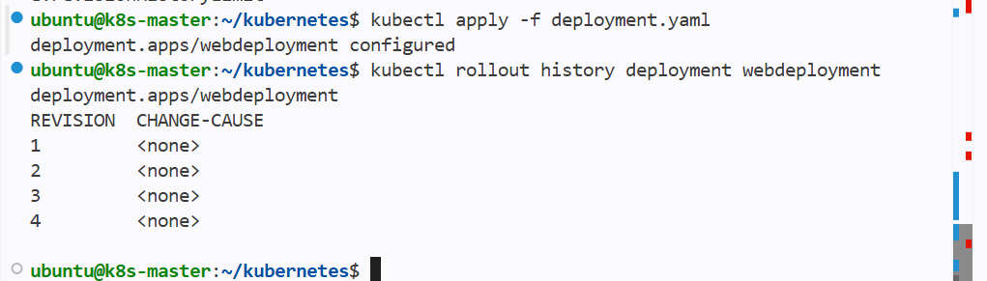

Pause a Deployment during an update, and then resume it

We can pause and resume the deployment

Updating the deployment

And then pausing the update and then resuming update

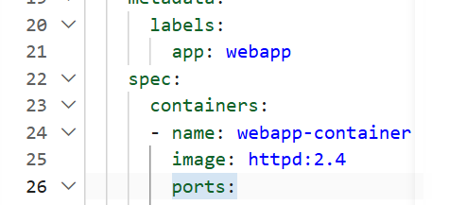

Changed the image tag and replicas to 10 from 5

Now rolling out the update of deployment

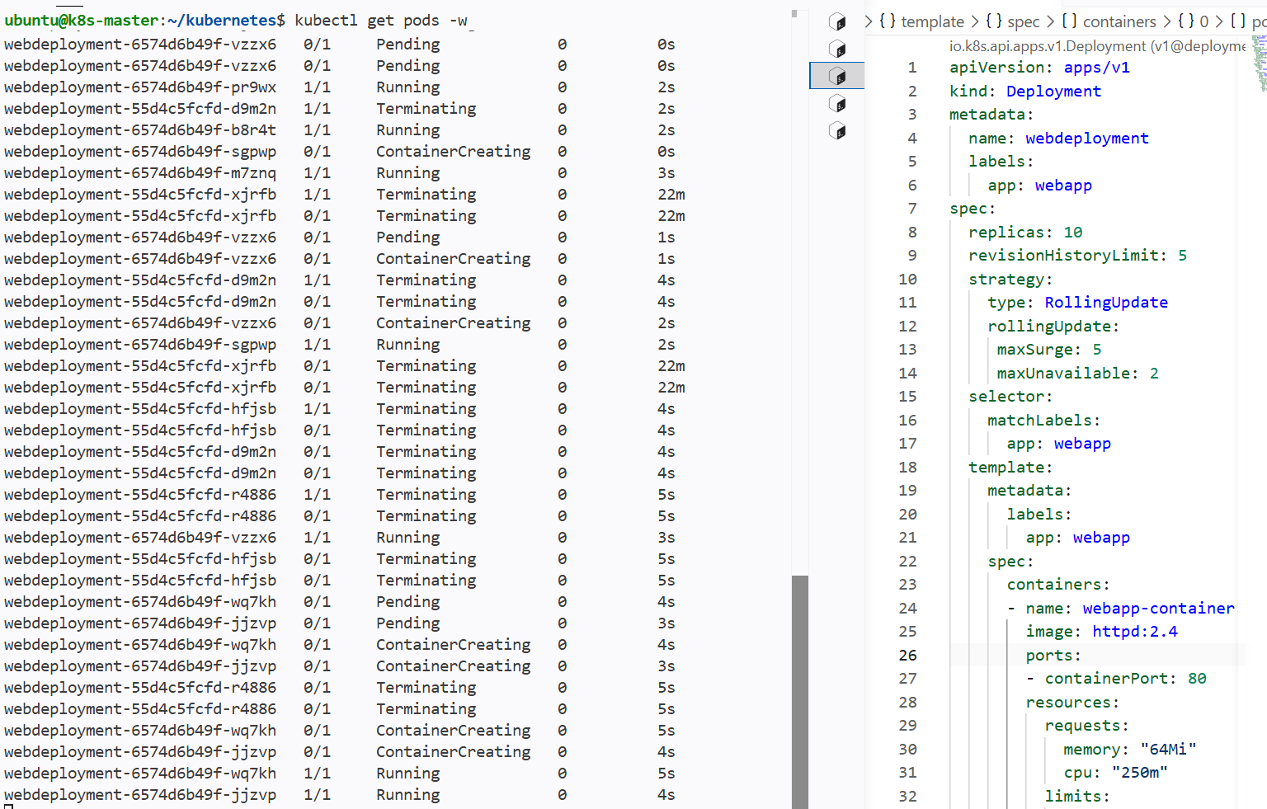

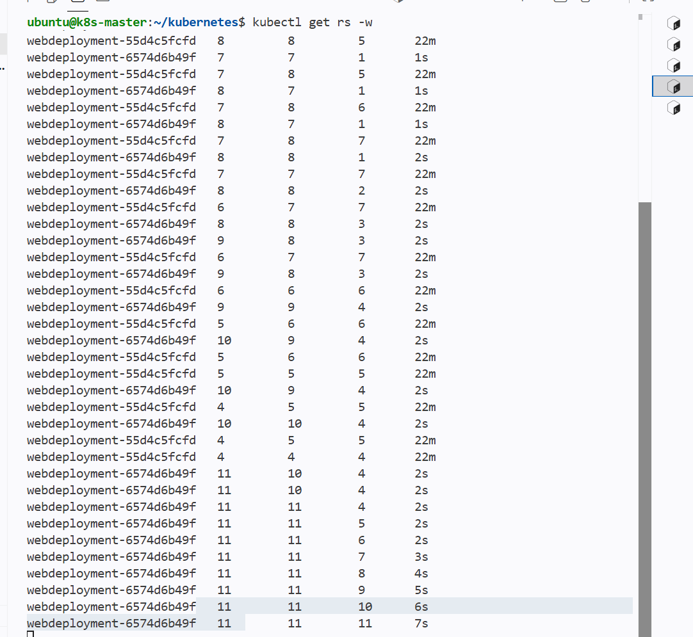

If we check the status then it says 4 old replicas are pending termination

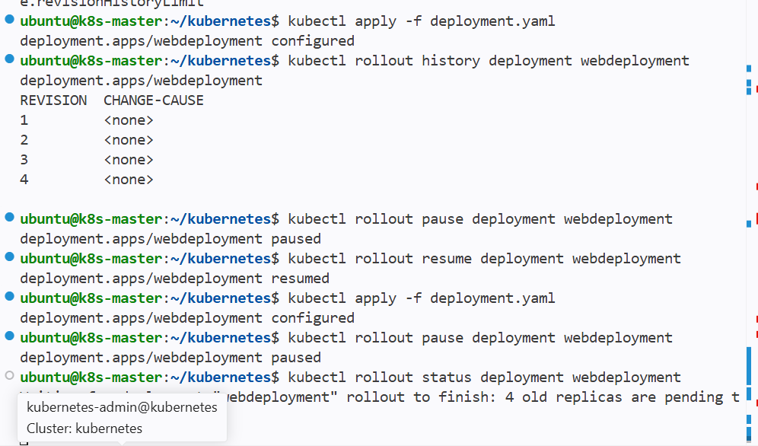

If resume then the 4 old replicas will be deleted and new version will be updated in all pods

When I resumed it deleted the 5 maxsurge pods and back to the replicas given state

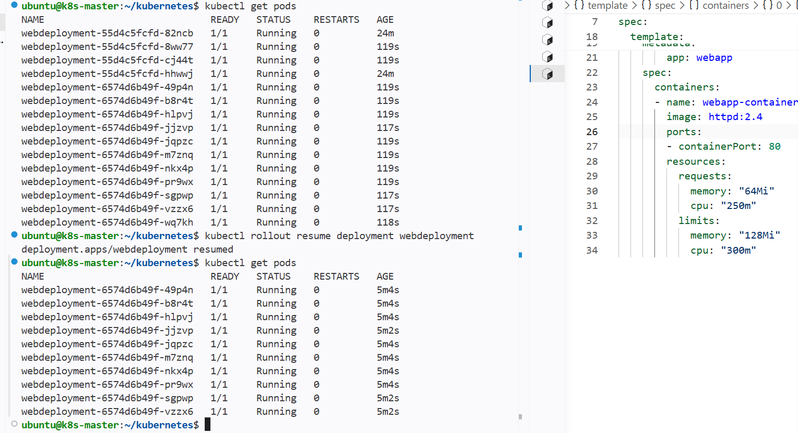

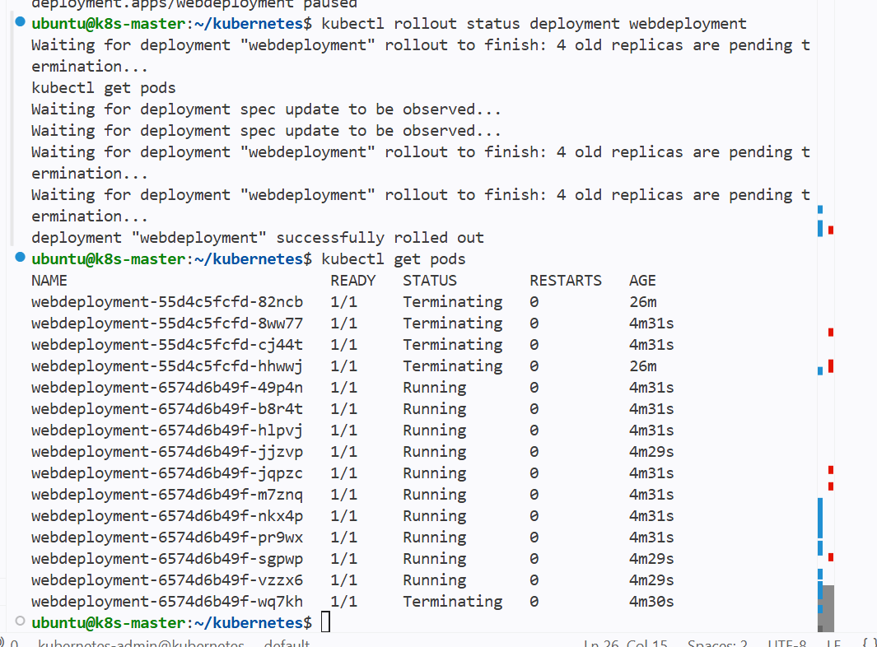

Create a pod using resource requests for memory and CPU, and observe how the scheduler assigns it to a node

Creating a new pod using yaml

Assigning the resource requests and limits to the pod

And watching how sheduler assigns it to a node

We can see through events

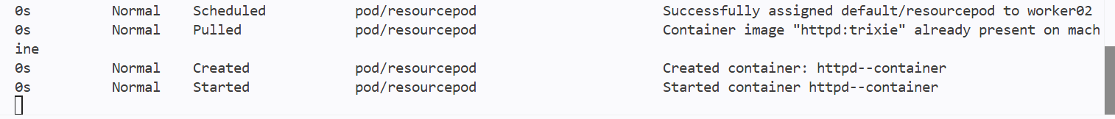
This is from events -w watching events live for pods assigning

And we can see through the pods -w

We can see the events for other pods


